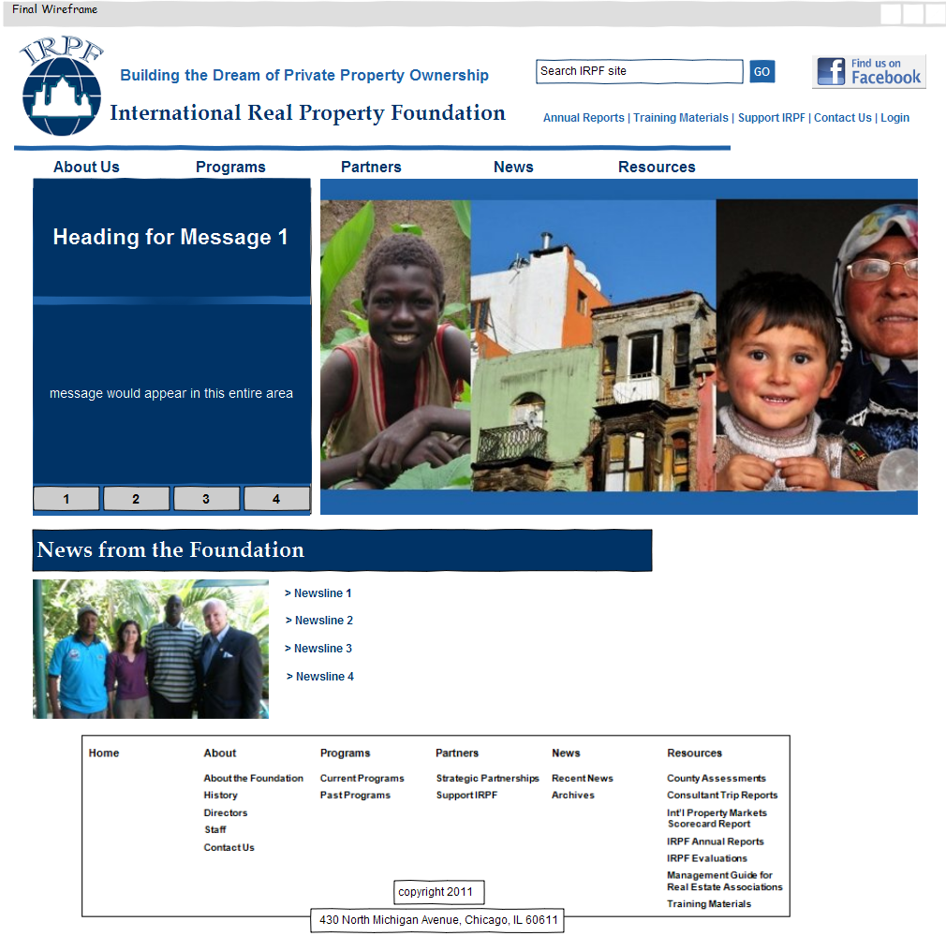
Link to eCommerce or PayPal
Msg 1:
Institutional Capacity

IRPF has established over 85 self-sustaining real estate associations representing over 170,000 practitioners worldwide

Msg 2:
Partners

Key to the success of the Foundation’s efforts has been the strategic partnerships it has forged with a wide network of organizations and recognized experts in the real property field. These partnerships provide funding and assistance which enables the Foundation to access the top real estate and appraisal professionals who provide technical assistance in developing economies around the world.

Login for those that need to access Country Assessments; Consultant Trip Reports; Management Guide for Real Estate Associations; and Training Materials.

Msg 3:
Cost Effective Programming

“IRPF has been one of the most cost effective programs I have seen within USAID. By acting as a catalyst for development, IRPF has built ownership and capacity within the institutions and markets it has supported while fielding top flight professionals in a very cost effective and responsible fashion in support of a critical component of partner countries' economic infrastructure.”
-Chris Barltrop, USAID Cognizant Technical Officer to IRPF from 2007-2010

Notes:

Keep all text sans serif

Currently using Arial and Book Antiqua

Msg 4:
Assessments

IRPF has conducted real estate market assessments in 24 countries worldwide.

IRPF.ORG SUGGESTED SITE NAVIGATION MAY 2, 2011

Home | About | Programs | Partners | News | Resources

Home  About the Foundation  History  Directors  Staff  Contact Us | About | Programs | Partners | News | Resources

Home | About  Current Programs  Past Programs | Programs | Partners | News | Resources

Home | About | Programs  Strategic Partnerships  Support IRPF | Partners | News | Resources

IRPF.ORG SUGGESTED SITE NAVIGATION MAY 2, 2011

Home | About | Programs | Partners | News | Resources
Recent News
Archives

Home | About | Programs | Partners | News | Resources
County Assessments
Consultant Trip Reports
International Property Markets Scorecard Report
IRPF Annual Reports
IRPF Evaluations
Management Guide for Real Estate Associations
Training Materials
- Topical Resources
- Association Evaluation
- Association Management
- Brokerage & Sales
- Appraisal
- Consultant Presentations

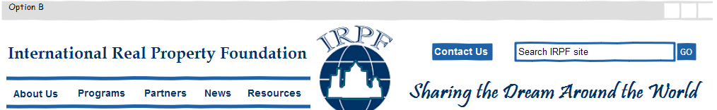
Fb
Home > About Us > About the Foundation

About the Foundation

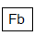
About the Foundation

History

Directors

Staff

Contact Us

Home > About Us > History

History

Fb
About the Foundation

History

Directors

Staff

Contact Us

Home > About Us > Directors

Directors

Fb
About the Foundation

History

Directors

Staff

Contact Us

IRPF.ORG

Home > About Us > Staff

Staff

Fb
About the Foundation

History

Directors

Staff

Contact Us

Home > About Us > Contact Us

Contact Us

Fb
About the Foundation

History

Directors

Staff

Contact Us

IRPF.ORG

Home > Programs > Current Programs

Current Programs

Fb
Current Programs

Past Programs

Home > Programs > Past Programs

Past Programs

Fb
Current Programs

Past Programs

IRPF.ORG

Home > Partners > Strategic Partners

Strategic Partners

Fb
Strategic Partners

Support IRPF

IRPF.ORG

Home > Partners > Support IRPF

Support IRPF

Fb
Strategic Partners

Support IRPF

IRPF.ORG

Home > News > Recent News

Recent News

Fb
Recent News

Archives

IRPF.ORG

Home > News > Archives

Archives

Fb
Recent News

Archives

IRPF.ORG

Home > Resources > County Assessments

County Assessments

Fb

County Assessments

Consultant Trip Reports

International Property
Markets Scorecard Reports

IRPF Annual Reports

IRPF Evaluations

Management Guide for Real Estate Associations

Training Materials
- Topical Resources
- Association Evaluation
- Association Management
- Brokerage & Sales
- Appraisal
- Consultant Presentations

IRPF.ORG

Home > Resources > Consultant Trip Reports

Consultant Trip Reports

Fb
County Assessments

Consultant Trip Reports

International Property
Markets Scorecard Reports

IRPF Annual Reports

IRPF Evaluations

Management Guide for Real Estate Associations

Training Materials
- Topical Resources
- Association Evaluation
- Association Management
- Brokerage & Sales
- Appraisal
- Consultant Presentations

IRPF.ORG

Home > Resources > Consultant Trip Reports

Consultant Trip Reports

Fb
County Assessments

Consultant Trip Reports

International Property
Markets Scorecard Reports

IRPF Annual Reports

IRPF Evaluations

Management Guide for Real Estate Associations

Training Materials
- Topical Resources
- Association Evaluation
- Association Management
- Brokerage & Sales
- Appraisal
- Consultant Presentations

IRPF.ORG

Home > Resources > International Property Markets Scorecard Reports

Markets Scorecard Reports

Fb
County Assessments

Consultant Trip Reports

International Property
Markets Scorecard Reports

IRPF Annual Reports

IRPF Evaluations

Management Guide for Real Estate Associations

Training Materials
- Topical Resources
- Association Evaluation
- Association Management
- Brokerage & Sales
- Appraisal
- Consultant Presentations

IRPF.ORG

Home > Resources > IRPF Annual Reports

IRPF Annual Reports

Fb
County Assessments

Consultant Trip Reports

International Property
Markets Scorecard Reports

IRPF Annual Reports

IRPF Evaluations

Management Guide for Real Estate Associations

Training Materials
- Topical Resources
- Association Evaluation
- Association Management
- Brokerage & Sales
- Appraisal
- Consultant Presentations

IRPF.ORG

Home > Resources > IRPF Evaluations

IRPF Evaluations

Fb
County Assessments

Consultant Trip Reports

International Property
Markets Scorecard Reports

IRPF Annual Reports

IRPF Evaluations

Management Guide for Real Estate Associations

Training Materials
- Topical Resources
- Association Evaluation
- Association Management
- Brokerage & Sales
- Appraisal
- Consultant Presentations

IRPF.ORG

Home > Resources > Management Guide for Real Estate Associations

Management Guide for Real Estate Associations

Fb
County Assessments

Consultant Trip Reports

International Property
Markets Scorecard Reports

IRPF Annual Reports

IRPF Evaluations

Management Guide for Real Estate Associations

Training Materials
- Topical Resources
- Association Evaluation
- Association Management
- Brokerage & Sales
- Appraisal
- Consultant Presentations

IRPF.ORG

Home > Resources > Training Materials

Training Materials

Fb
County Assessments

Consultant Trip Reports

International Property
Markets Scorecard Reports

IRPF Annual Reports

IRPF Evaluations

Management Guide for Real Estate Associations

Training Materials
- Topical Resources
- Association Evaluation
- Association Management
- Brokerage & Sales
- Appraisal
- Consultant Presentations

IRPF.ORG

Home > Resources > Training Materials > Topical Resources

Topical Resources

Fb
Training Materials
- Topical Resources
- Association Evaluation
- Association Management
- Brokerage & Sales
- Appraisal
- Consultant Presentations

Home > Resources > Training Materials > Association Evaluation

Association Evaluation

Fb
Training Materials
- Topical Resources
- Association Evaluation
- Association Management
- Brokerage & Sales
- Appraisal
- Consultant Presentations

IRPF.ORG

Home > Resources > Training Materials > Association Management

Association Management

Fb
Training Materials
- Topical Resources
- Association Evaluation
- Association Management
- Brokerage & Sales
- Appraisal
- Consultant Presentations

IRPF.ORG

Home > Resources > Training Materials > Brokerage & Sales

Brokerage & Sales

Fb
Training Materials
- Topical Resources
- Association Evaluation
- Association Management
- Brokerage & Sales
- Appraisal
- Consultant Presentations

IRPF.ORG

Home > Resources > Training Materials > Appraisal

Appraisal

Fb
Training Materials

- Topical Resources

- Association Evaluation

- Association Management

- Brokerage & Sales

- Appraisal

- Consultant Presentations

Home > Resources > Training Materials > Consultant Presentations

Consultant Presentations

Fb
Training Materials

- Topical Resources

- Association Evaluation

- Association Management

- Brokerage & Sales

- Appraisal

- Consultant Presentations

IRPF.ORG

MEGA – FOOTER

Home | About | Programs | Partners | News | Resources
 | About the Foundation  History  Directors  Staff  Contact Us | Current Programs  Past Programs | Strategic Partnerships  Support IRPF | Recent News  Archives | County Assessments  Consultant Trip Reports  Int’l Property Markets Scorecard Report  IRPF Annual Reports  IRPF Evaluations  Management Guide for Real Estate Associations  Training Materials

