

Technical Requirements Document

Administrator Utilities Page
1.0

TABLE OF CONTENTS

TRACKING 0
Revision History 0
Approvals 0
OVERVIEW 0
Purpose 0
Definitions, Acronyms, & Abbreviations 0
Scope 0
Requirements Numbering Format 0
TECHNICAL REQUIREMENTS 0
Requirements Overview 0
Phase 1 Error! Bookmark not defined.
Phase 2 (if applicable) Error! Bookmark not defined.
Phase 3 (if applicable) Error! Bookmark not defined.
Detailed Requirements 0
1. Enter name of High-Level Requirement #1 Error! Bookmark not defined.
2. Enter name of High-Level Requirement #2 Error! Bookmark not defined.
3. Enter name of High-Level Requirement #3 Error! Bookmark not defined.
4. …and so on for each high-level requirement Error! Bookmark not defined.
5. Miscellaneous Error! Bookmark not defined.
OPEN ISSUES 0
REFERENCES 0

TRACKING

Revision History
The purpose of this section is to track the revision history of the document.
Revision | Date | Author | Description
1.0 | 3/16/00 | Melinda Barr | Initial Draft
1.1
1.2

Approvals
Title | Name | Signature | Date
Ann Dawkins
Internet Systems Analyst | Melinda Barr

OVERVIEW

Purpose
The purpose of this document is to state and manage the requirements for the administration utility page.

Definitions, Acronyms, & Abbreviations
The following acronyms will be used throughout this document:

BV - BlackVoices.com
TI -Tribune Interactive

Scope
Enter the scope of the software requirements here.

Requirements Numbering Format
The purpose of this section is to describe the format of the requirements numbering. Each requirement listed in this document and for future requirements documentation will have the following format:

A.BBB.

Letter | Description
A | High Level Requirement Number
BBB | Detail Requirement Number

TECHNICAL REQUIREMENTS

Requirements Overview
The BV admin utility page will provide a means by which BV staff can access aggregated data, perform administrative functions and gain admittance to information and productivity tools pertinent to their departmental needs.

Detailed Requirements

Admin Menu Page

  - The following links will appear on the Admin Menu page. More links can be added in the future as needed.
Table 1: Amin Menu Page
Link | Visible To ( Dept) | Comment
Member Photos | BV Tech ; Customer Service | Administer Member Photos
Tables | BV Tech | Administer Join Tables ( Metros, Ethnicitys, etc. )
Join | BV Tech | Administer Join ( member by date, etc.)
ECard | All | Administer eCards
Customer Service | BV Tech ; Customer Service | Customer Accounts
Production Requests | All | Production Dept work request
Technology Requests | All | Technology Dept work request
BV Site Defect Report Form | All | Report BV Site defects
BV for Dummys | All | BV Guidelines; Processes; General Info
Daily Statistics | All | General member statistics
Custom Queries | BV Tech ; Sales | Build custom queries on member data
Off Line Events | BV Tech ; Off Line Events | Create off line events
Polls | BV Tech ; Production | Create Polls

Admin Page Security
  - Access to the Admin Menu page shall be password protected.
  - Each department within BV shall have it’s own login account
  - Only the links applicable to each department is displayed on the Admin Menu page refer to Table 1: Amin Menu Page. The display of links shall be associated with the departmental login account.

Detailed Data

Enter detailed data elements

  - Data Elements/Fields
Administrator table
Field | type | Values
iLoginID | integer
sLogin | character(30)
sPassword | character(30)
sAccess | character(1) | S, T, P

  - Error Checking and Messages
    - Incorrect Login – The login you have entered is not in out records.
    - Incorrect Password – You have entered an invalid password.

  - Layout
    - Login Page – Figure 1.
    - Administrative Functions Page – Figure 2.

Performance Requirements
Refer to BV performance standards – BV Technology group

Reliability Requirements
Refer to BV reliability standards – BV Technology group

OPEN ISSUES

Date Opened | Assigned To | Description | Resolution | Date Closed

REFERENCES
Figure 1.

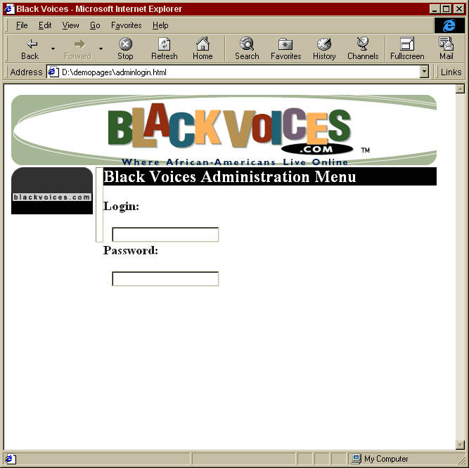

Figure 2.

