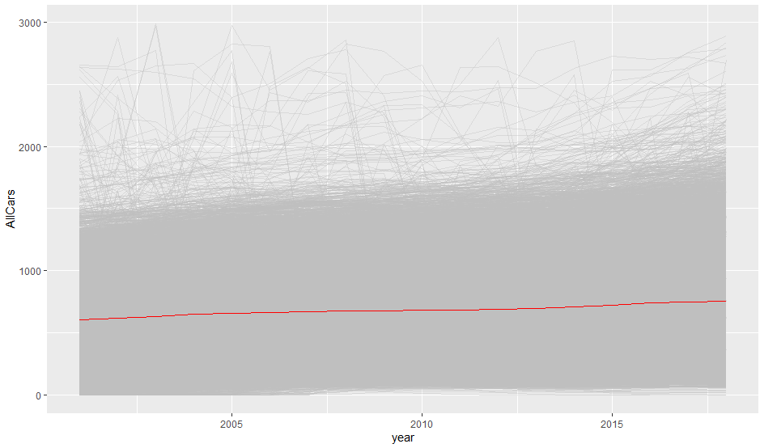

Plot of cars per LSOA with average shown in Red. Few LSOAs with more than 3000 cars removed (about 0.2% of LSOAs).

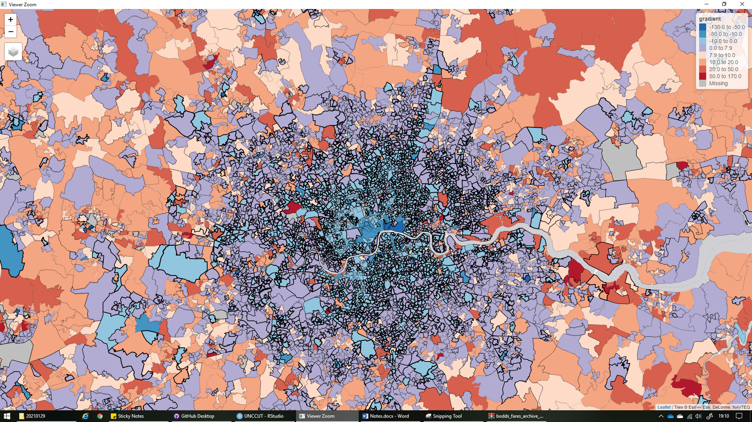

Change in cars gardeitn (blue decreasing, red increasing, purple, increasing but slower than average). Link thickness based on R squared . Thick line low correlation, thin line high correlation. Poor correlation can be cause by non-linear change e.g. step change or data error.