Particle Image Velocimetry

for a

small scale bluff/arbitrary body

Medam Mahesh

15AE10017

Department of Aerospace Engineering

(B.Tech 3rd Yaar)

Guided By: Prof. Sandeep Saha

**Aim :-**

Flow visualization and velocity field qualification using Particle Image velocimetry for flow over a bluff bodies.

**Apparatus :-**

* Educational-PIV (e-PIV) include Laser, Digital camera, Lenses
* Small scale bluff bodies or geometry.
* Filtered water
* Seeding particles
* Image processing software.

**Specifications :-**

* Camera: 640X480 pixel digital camera, 30fps.
* Laser: Class III b Laser with line generating lenses, wavelength 532 nm
* Geometry dimensions: 30mm long X 25mm wide X 5mm high
* Seeding particles: Polyamide (diameter = 50μ, specific gravity = 1.03)
* Image processing software: FLOWREX

**Theory :-**

**PIV** is a flow measurement technique that measures a planar velocity field over a designated region of interest. The flow is uniformly seeded with tracer particles, which serve to track the flow. A planar laser light sheet is placed in the region of interest to illuminate the particles, and a digital camera is oriented orthogonally to the light sheet. The camera is uniformly focused over the region of interest. The seeded flow field is then illuminated twice within a small pulse separation time (Δt), which is of the order of microseconds. The camera is then digitally synchronized with the laser and camera to capture the two successive images.

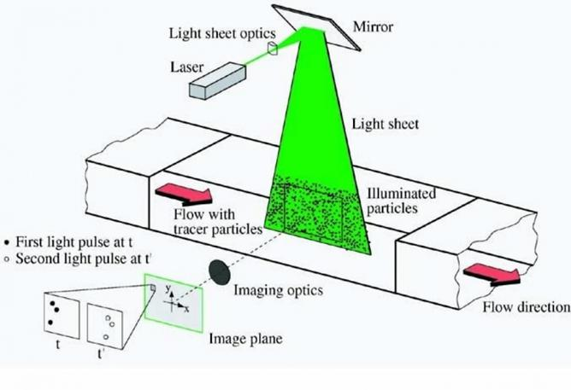The pair of images contains the pixel displacement of the particles for the selected pulse separation time. First, the images are divided into smaller interrogation windows, then a cross-correlation [1] procedure is used to match the intensities of the particles between the two images within each small window. Based on these correlations the magnitudes and directions of the displacements are obtained and consequently the velocities.

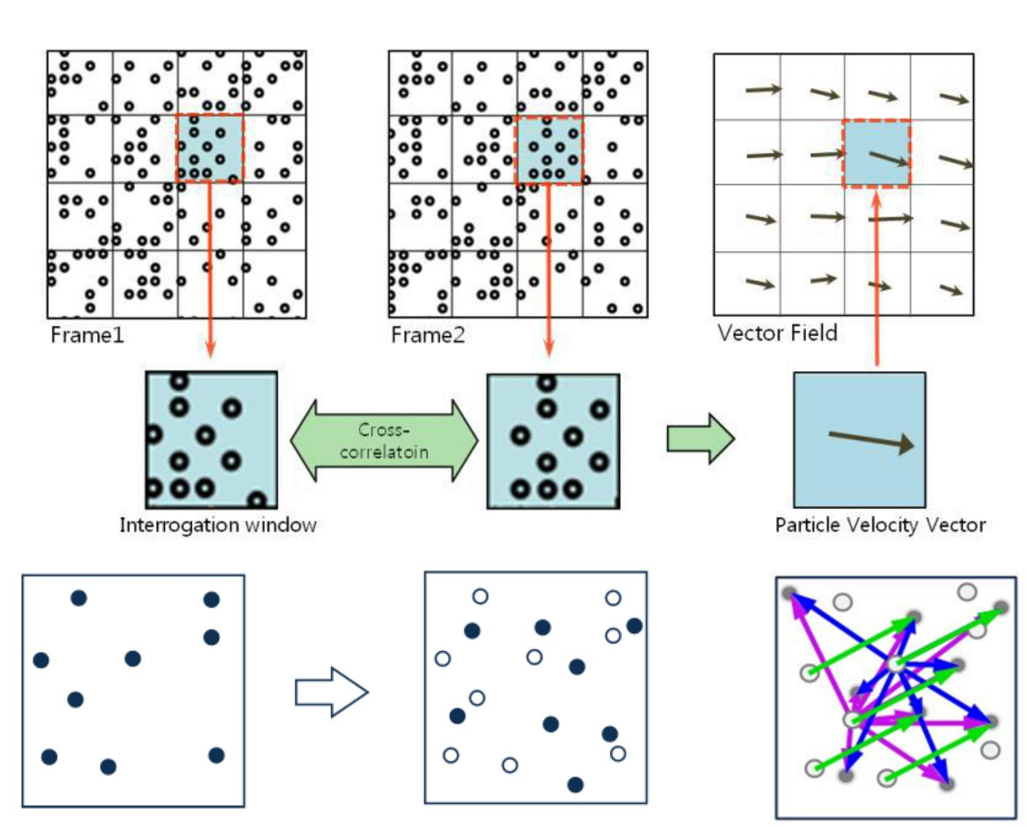

**Procedure :-**

1. Calibrate the PIV apparatus at a low velocity.
2. Introduce Poly-amide particles into the stream.
3. Place a small bluff body in test section.
4. Run FLOWREX after setting appropriate flow parameters.
5. Take the readings and observe the plots of velocity contours obtained.

**Observations :-**

|  |  |  |  |
| --- | --- | --- | --- |
| x | y | u | v |
| 2.02 | 2.12 | 5.509 | -0.3017 |
| 4.08 | 2.12 | 9.759 | -0.8443 |
| 6.15 | 2.12 | 12.49 | -0.4331 |
| 8.22 | 2.12 | 12.68 | -0.5683 |
| 10.3 | 2.12 | 14.31 | -0.9344 |
| 12.3 | 2.12 | 15.65 | -0.6893 |
| 14.4 | 2.12 | 17.67 | -0.9812 |
| 16.5 | 2.12 | 18.26 | -0.9703 |
| 18.5 | 2.12 | 19.17 | -0.995 |
| 20.6 | 2.12 | 19.35 | -0.183 |
| 22.7 | 2.12 | 19.06 | -0.09365 |
| 24.7 | 2.12 | 20.01 | 0.04455 |
| 26.8 | 2.12 | 21.61 | 0.361 |
| 28.9 | 2.12 | 24.39 | 0.9703 |
| 30.9 | 2.12 | 24.86 | 0.8362 |
| 33 | 2.12 | 18.51 | 0.8156 |
| 35.1 | 2.12 | 17.24 | 1.091 |
| 37.1 | 2.12 | 13.89 | 1.868 |
| 39.2 | 2.12 | 14.15 | 2.68 |
| 2.02 | 4.18 | 7.422 | -0.7931 |
| 4.08 | 4.18 | 12.93 | -1.006 |
| 6.15 | 4.18 | 14.76 | -0.9331 |
| 8.22 | 4.18 | 14.68 | -0.8889 |
| 10.3 | 4.18 | 15.71 | -1.36 |
| 12.3 | 4.18 | 16.52 | -1.152 |
| 14.4 | 4.18 | 17.23 | -1.047 |
| 16.5 | 4.18 | 18.33 | -1.412 |
| 18.5 | 4.18 | 19.98 | -1.506 |
| 20.6 | 4.18 | 20.92 | -0.7726 |
| 22.7 | 4.18 | 20.06 | -0.2572 |
| 24.7 | 4.18 | 21.23 | -0.07729 |
| 26.8 | 4.18 | 25.07 | 0.2647 |
| 28.9 | 4.18 | 27.45 | 1.089 |
| 30.9 | 4.18 | 27.6 | 1.195 |
| 33 | 4.18 | 24.24 | 1.68 |
| 35.1 | 4.18 | 18.26 | 1.717 |
| 37.1 | 4.18 | 15.14 | 2.189 |
| 39.2 | 4.18 | 15.56 | 3.046 |
| 2.02 | 6.25 | 16.4 | -1.754 |
| 4.08 | 6.25 | 16 | -1.855 |
| 6.15 | 6.25 | 15.84 | -2.037 |
| 8.22 | 6.25 | 16.15 | -2.246 |
| 10.3 | 6.25 | 16.94 | -2.564 |
| 12.3 | 6.25 | 18.28 | -3.001 |
| 14.4 | 6.25 | 18.03 | -3.16 |
| 16.5 | 6.25 | 18.85 | -2.825 |
| 18.5 | 6.25 | 20.84 | -2.933 |
| 20.6 | 6.25 | 23.88 | -2.648 |
| 22.7 | 6.25 | 26.86 | -1.836 |
| 24.7 | 6.25 | 26.7 | -0.6825 |
| 26.8 | 6.25 | 27.83 | 0.2415 |
| 28.9 | 6.25 | 29.03 | 1.091 |
| 30.9 | 6.25 | 29.6 | 1.712 |
| 33 | 6.25 | 30.33 | 2.571 |
| 35.1 | 6.25 | 28.6 | 3.817 |
| 37.1 | 6.25 | 27.53 | 4.36 |
| 39.2 | 6.25 | 26.77 | 5.81 |
| 2.02 | 8.32 | 14.91 | -1.947 |
| 4.08 | 8.32 | 15.14 | -2.177 |
| 6.15 | 8.32 | 15.31 | -2.377 |
| 8.22 | 8.32 | 15.46 | -2.82 |
| 10.3 | 8.32 | 16.07 | -3.39 |
| 12.3 | 8.32 | 18.24 | -4.204 |
| 14.4 | 8.32 | 18.56 | -4.723 |
| 16.5 | 8.32 | 20.24 | -5.208 |
| 18.5 | 8.32 | 22.27 | -5.476 |
| 20.6 | 8.32 | 26.14 | -4.825 |
| 22.7 | 8.32 | 26.94 | -3.273 |
| 24.7 | 8.32 | 28.35 | -1.566 |
| 26.8 | 8.32 | 27.53 | 0.2438 |
| 28.9 | 8.32 | 29.68 | 1.45 |
| 30.9 | 8.32 | 29.68 | 2.535 |
| 33 | 8.32 | 28.38 | 3.298 |
| 35.1 | 8.32 | 27.68 | 4.489 |
| 37.1 | 8.32 | 27.18 | 5.651 |
| 39.2 | 8.32 | 26.85 | 6.392 |
| 2.02 | 10.4 | 15.32 | -2.283 |
| 4.08 | 10.4 | 15.75 | -2.714 |
| 6.15 | 10.4 | 14.96 | -2.859 |
| 8.22 | 10.4 | 15.16 | -3.378 |
| 10.3 | 10.4 | 16.42 | -4.483 |
| 12.3 | 10.4 | 17.87 | -5.636 |
| 14.4 | 10.4 | 18.28 | -6.905 |
| 16.5 | 10.4 | 18.93 | -7.957 |
| 18.5 | 10.4 | 21.36 | -8.735 |
| 20.6 | 10.4 | 25.62 | -7.86 |
| 22.7 | 10.4 | 29.46 | -5.248 |
| 24.7 | 10.4 | 29.22 | -1.714 |
| 26.8 | 10.4 | 28.01 | 0.1688 |
| 28.9 | 10.4 | 28.91 | 1.628 |
| 30.9 | 10.4 | 28.32 | 3.093 |
| 33 | 10.4 | 27.57 | 4.731 |
| 35.1 | 10.4 | 27.31 | 5.801 |
| 37.1 | 10.4 | 26.41 | 6.66 |
| 39.2 | 10.4 | 26.79 | 7.008 |
| 2.02 | 12.5 | 13.42 | -2.594 |
| 4.08 | 12.5 | 13.11 | -2.663 |
| 6.15 | 12.5 | 13.26 | -3.063 |
| 8.22 | 12.5 | 13.39 | -3.629 |
| 10.3 | 12.5 | 14.84 | -4.985 |
| 12.3 | 12.5 | 15.91 | -6.477 |
| 14.4 | 12.5 | 15.17 | -7.618 |
| 16.5 | 12.5 | 17.71 | -11.38 |
| 18.5 | 12.5 | 20.62 | -13.35 |
| 20.6 | 12.5 | 25.13 | -9.386 |
| 22.7 | 12.5 | 16.99 | -2.48 |
| 24.7 | 12.5 | 15.06 | 0.1744 |
| 26.8 | 12.5 | 22.33 | 0.3772 |
| 28.9 | 12.5 | 19.86 | 1.42 |
| 30.9 | 12.5 | 17.2 | 3.139 |
| 33 | 12.5 | 18.9 | 4.128 |
| 35.1 | 12.5 | 21.97 | 5.325 |
| 37.1 | 12.5 | 21.92 | 6.348 |
| 39.2 | 12.5 | 21.66 | 6.828 |
| 2.02 | 14.5 | 12.23 | -2.36 |
| 4.08 | 14.5 | 12.8 | -2.696 |
| 6.15 | 14.5 | 12.41 | -3.327 |
| 8.22 | 14.5 | 12.06 | -3.849 |
| 10.3 | 14.5 | 13.66 | -5.025 |
| 12.3 | 14.5 | 12.86 | -6.47 |
| 14.4 | 14.5 | 13.47 | -8.584 |
| 16.5 | 14.5 | 9.949 | -11.72 |
| 18.5 | 14.5 | 11.14 | -15.13 |
| 20.6 | 14.5 | 13.57 | -7.636 |
| 22.7 | 14.5 | 6.173 | -0.2992 |
| 24.7 | 14.5 | 4.823 | -0.1836 |
| 26.8 | 14.5 | 1.816 | 0.2655 |
| 28.9 | 14.5 | 2.258 | 1.03 |
| 30.9 | 14.5 | 3.584 | 1.459 |
| 33 | 14.5 | 8.709 | 2.861 |
| 35.1 | 14.5 | 11 | 3.916 |
| 37.1 | 14.5 | 16.67 | 5.553 |
| 39.2 | 14.5 | 17.85 | 6.153 |
| 2.02 | 16.6 | 13.51 | -2.595 |
| 4.08 | 16.6 | 12.81 | -2.659 |
| 6.15 | 16.6 | 11.19 | -2.918 |
| 8.22 | 16.6 | 10.47 | -3.54 |
| 10.3 | 16.6 | 10.06 | -4.117 |
| 12.3 | 16.6 | 10.85 | -5.989 |
| 14.4 | 16.6 | 7.722 | -6.537 |
| 16.5 | 16.6 | 4.385 | -8.287 |
| 18.5 | 16.6 | 2.133 | -9.544 |
| 20.6 | 16.6 | -0.5441 | -1.489 |
| 22.7 | 16.6 | -0.3103 | -0.5545 |
| 24.7 | 16.6 | -0.7448 | -0.5323 |
| 26.8 | 16.6 | 0.1637 | -0.4704 |
| 28.9 | 16.6 | 0.3758 | -0.2206 |
| 30.9 | 16.6 | 0.7618 | 0.2942 |
| 33 | 16.6 | 1.595 | 0.889 |
| 35.1 | 16.6 | 3.87 | 2.073 |
| 37.1 | 16.6 | 5.019 | 3.174 |
| 39.2 | 16.6 | 6.824 | 3.781 |
| 2.02 | 18.7 | 13.32 | -2.312 |
| 4.08 | 18.7 | 12.92 | -2.346 |
| 6.15 | 18.7 | 11.25 | -2.848 |
| 8.22 | 18.7 | 8.45 | -3.047 |
| 10.3 | 18.7 | 8.752 | -3.781 |
| 12.3 | 18.7 | 8.719 | -5.018 |
| 14.4 | 18.7 | 6.01 | -5.126 |
| 16.5 | 18.7 | 3.377 | -5.416 |
| 18.5 | 18.7 | 0.03373 | -4.318 |
| 20.6 | 18.7 | -0.3022 | -1.328 |
| 22.7 | 18.7 | 0.1618 | 0.554 |
| 24.7 | 18.7 | 0.1299 | -0.2366 |
| 26.8 | 18.7 | -0.01594 | -0.427 |
| 28.9 | 18.7 | -0.0965 | -0.3692 |
| 30.9 | 18.7 | -0.03444 | -0.1324 |
| 33 | 18.7 | 0.2378 | 0.2027 |
| 35.1 | 18.7 | 0.1625 | 0.5315 |
| 37.1 | 18.7 | 0.768 | 1.054 |
| 39.2 | 18.7 | 3.696 | 2.449 |
| 2.02 | 20.7 | 11.83 | -1.896 |
| 4.08 | 20.7 | 11.2 | -1.928 |
| 6.15 | 20.7 | 8.351 | -2.197 |
| 8.22 | 20.7 | 7.552 | -2.377 |
| 10.3 | 20.7 | 6.474 | -2.562 |
| 12.3 | 20.7 | 5.178 | -2.892 |
| 14.4 | 20.7 | 4.238 | -2.904 |
| 16.5 | 20.7 | 1.54 | -2.236 |
| 18.5 | 20.7 | -0.3214 | -1.313 |
| 20.6 | 20.7 | -0.2573 | -0.2704 |
| 22.7 | 20.7 | -0.1188 | 0.0827 |
| 24.7 | 20.7 | 0.04483 | -0.1671 |
| 26.8 | 20.7 | 0.02548 | -0.4074 |
| 28.9 | 20.7 | -0.1253 | -0.3111 |
| 30.9 | 20.7 | -0.1789 | -0.2169 |
| 33 | 20.7 | -0.1439 | -0.08739 |
| 35.1 | 20.7 | -0.1143 | 0.1628 |
| 37.1 | 20.7 | -0.1643 | 0.4189 |
| 39.2 | 20.7 | -0.4676 | 0.4431 |
| 2.02 | 22.8 | 9.031 | -1.364 |
| 4.08 | 22.8 | 8.325 | -1.445 |
| 6.15 | 22.8 | 7.241 | -1.423 |
| 8.22 | 22.8 | 5.682 | -1.514 |
| 10.3 | 22.8 | 4.586 | -1.563 |
| 12.3 | 22.8 | 3.964 | -1.61 |
| 14.4 | 22.8 | 2.162 | -1.356 |
| 16.5 | 22.8 | 0.8326 | -0.8487 |
| 18.5 | 22.8 | -0.1722 | 0.1725 |
| 20.6 | 22.8 | 0.06149 | -0.05708 |
| 22.7 | 22.8 | -0.06618 | 0.06661 |
| 24.7 | 22.8 | -0.00214 | -0.1211 |
| 26.8 | 22.8 | 0.04441 | -0.2561 |
| 28.9 | 22.8 | -0.04882 | -0.2339 |
| 30.9 | 22.8 | -0.1321 | -0.2294 |
| 33 | 22.8 | -0.2173 | -0.1124 |
| 35.1 | 22.8 | -0.3086 | 0.02377 |
| 37.1 | 22.8 | -0.3773 | 0.1829 |
| 39.2 | 22.8 | -0.5205 | 0.5124 |
| 2.02 | 24.9 | 5.927 | -1.279 |
| 4.08 | 24.9 | 6.228 | -1.526 |
| 6.15 | 24.9 | 3.356 | -0.6179 |
| 8.22 | 24.9 | 2.711 | -0.5955 |
| 10.3 | 24.9 | 2.356 | -0.6912 |
| 12.3 | 24.9 | 1.068 | -0.1715 |
| 14.4 | 24.9 | 0.5323 | -0.2121 |
| 16.5 | 24.9 | 0.2279 | -0.2311 |
| 18.5 | 24.9 | -0.06547 | 0.01822 |
| 20.6 | 24.9 | -0.02662 | -0.0427 |
| 22.7 | 24.9 | -0.01281 | 0.07971 |
| 24.7 | 24.9 | 0.01537 | -0.07942 |
| 26.8 | 24.9 | -0.00598 | -0.1448 |
| 28.9 | 24.9 | 0.01494 | -0.078 |
| 30.9 | 24.9 | -0.08782 | -0.09052 |
| 33 | 24.9 | -0.202 | -0.03217 |
| 35.1 | 24.9 | -0.2542 | 0.02334 |
| 37.1 | 24.9 | -0.3629 | 0.05907 |
| 39.2 | 24.9 | -0.544 | 0.2684 |
| 2.02 | 26.9 | 1.193 | -0.5407 |
| 4.08 | 26.9 | 1.349 | -0.4146 |
| 6.15 | 26.9 | 0.7868 | -0.2502 |
| 8.22 | 26.9 | 0.8493 | -0.1318 |
| 10.3 | 26.9 | 0.163 | -0.2888 |
| 12.3 | 26.9 | 0.1768 | 0.003985 |
| 14.4 | 26.9 | 0.1828 | -0.02761 |
| 16.5 | 26.9 | 0.07672 | -0.05793 |
| 18.5 | 26.9 | -0.06291 | -0.04227 |
| 20.6 | 26.9 | 0.06263 | -0.1472 |
| 22.7 | 26.9 | 0.2364 | -0.08113 |
| 24.7 | 26.9 | 0.01224 | -0.05138 |
| 26.8 | 26.9 | -0.00683 | -0.07515 |
| 28.9 | 26.9 | -0.02932 | -0.03032 |
| 30.9 | 26.9 | -0.06718 | -0.03772 |
| 33 | 26.9 | -0.184 | 0.01879 |
| 35.1 | 26.9 | -0.1798 | 0.03231 |
| 37.1 | 26.9 | -0.1738 | 0.05053 |
| 39.2 | 26.9 | -0.3745 | 0.186 |
| 2.02 | 29 | -4.889 | 1.701 |
| 4.08 | 29 | -4.514 | 2.525 |
| 6.15 | 29 | 0.7129 | 0.007401 |
| 8.22 | 29 | -0.0205 | 0.02534 |
| 10.3 | 29 | -0.2992 | 0.09622 |
| 12.3 | 29 | 0.0491 | 0.01936 |
| 14.4 | 29 | 0.06789 | 0.02534 |
| 16.5 | 29 | 0.02462 | 0.01053 |
| 18.5 | 29 | -0.0232 | 0.05508 |
| 20.6 | 29 | 0.7226 | -8.012 |
| 22.7 | 29 | 0.2385 | -0.772 |
| 24.7 | 29 | 0.007401 | 0.08924 |
| 26.8 | 29 | 0.01366 | 0.1113 |
| 28.9 | 29 | 0.003416 | 0.0474 |
| 30.9 | 29 | -0.01708 | -0.05323 |
| 33 | 29 | -0.1994 | -0.04697 |
| 35.1 | 29 | -0.04683 | -0.0242 |
| 37.1 | 29 | -0.0316 | 0.01139 |
| 39.2 | 29 | -0.2343 | 0.0669 |

**Plots :-**

**Using Quiver Function in MATLAB**

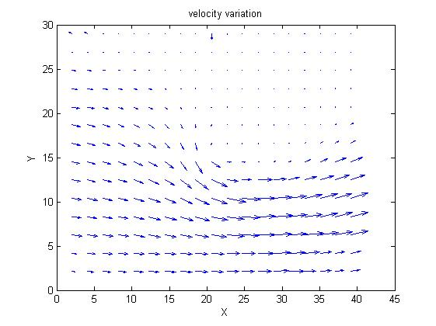

**Discussion :-**

**Why PIV measurements are better ?**

PIV measurements provide better and more accurate information than other methods. PIV produces two-dimensional or even three-dimensional vector fields, while the other techniques measure the velocity at a point. Optical measurement avoids the need for Pitot tubes, intrusive Flow measurement probes. The method is capable of measuring an entire two-dimensional cross section (geometry) of the flow field simultaneously without affecting the flow field.

**Which lens is used to convert the laser beam to a laser sheet ?**

A proper combination of spherical and cylindrical lenses is used to convert the laser beam into a laser sheet.

**Why do we discretize the image into smaller windows called Interrogation windows?**

The interrogation windows are required to break the images in pieces and focus on the pair of interrogation windows to find the velocity field direction. The interrogation windows are then merged to give velocity field for the whole flow.

**How to fix the size of interrogation window. What happens if the size is small or large?**

There is a trade-off in choosing the size. If we choose it too small, the no. of interrogation windows is more. Hence, the time complexity or runtime of the algorithm used for interrogation, increases significantly. If the interrogation grid is too coarse, we are basically losing out on accuracy. Accuracy is low hence we have more points for cross-correlation. Therefore, the cross-correlation technique would give out erroneous results when the grid is coarse.

**How to improve the quality of the raw images without upgrading the PIV system?**

We can improve the quality of the raw images by ensuring that the fluid which is flowing is perfectly transparent and less viscous. This will ensure a better observation of the poly-amide particles.

Flow velocity should be kept small. It should be chosen taking the Frames per second rate (fps) of the camera into account. If the flow velocity is high we get to see trails of particles in snapshots instead of the stagnant particle.

**What are the parameters that we iterate to get better quality flow field plot or results?**

Window size, Vector Spacing

**Is it possible to measure all three velocity components by PIV technique? Explain.**

It is not possible to measure all three components of velocity using the PIV setup because the mounted cameras only capture the top view of the test section. Thus we can only obtain the x and y components of the velocities (2D).

**Is PIV technique perfectly non-intrusive? Explain briefly**

The tracking (seeding) particles chosen have density close to that of water, thus will flow along without settling down, causing least deviation in the general flow characteristics. But as we are altering the contents of the flow it is not justifiable to claim that PIV technique is completely non-intrusive.

**References :-**

* Raffel M, Willert CE, Wereley S, Kompenhans J. Particle image velocimetry: a practical guide. Springer; 2013 Dec 19.
* URL: http://www.uwyo.edu/mechanical/facilities/aerodynamics/piv/.
* Chai, S. M., Kim, W.H., cote, D., Park, C and Lee, H., “Blood Cell Assisted in vivo Particle Image Velocimetry using the Confocal Laser Scanning Microscope,” *Optics Express,* Vol. 19, No. 5, 2011, pp. 4357-4368.