Shadowgraphy Technique

to determine the

Mach Number in Test Section

Medam Mahesh

15AE10017

Department of Aerospace Engineering

(B.Tech 3rd Yaar)

Guided By: Prof. Sandeep Saha

**Aim :-**

(i) To perform flow visualization using Shadowgraphy technique and determine inlet Mach number in a supersonic wind tunnel using 𝜃𝜃−𝛽𝛽−𝑀𝑀relationship and a wedge.   
  
(ii) Determination of stagnation conditions from the inlet Mach number.

**Apparatus :-**

* Supersonic wind tunnel
* Wedge
* Shadowgraphy setup

**Theory :-**

**Shadowgraph** is an optical method that reveals non-uniformities in [transparent](https://en.wikipedia.org/wiki/Transparency_and_translucency) media like air, water, or glass. It is related to, but simpler than, the [schlieren](https://en.wikipedia.org/wiki/Schlieren" \o "Schlieren) and [schlieren photography](https://en.wikipedia.org/wiki/Schlieren_photography" \o "Schlieren photography) methods that perform a similar function. Shadowgraph is a type of [flow visualisation](https://en.wikipedia.org/wiki/Flow_visualisation).

In principle, we cannot directly see a difference in temperature, a different gas, or a [shock wave](https://en.wikipedia.org/wiki/Shock_wave) in the transparent air. However, all these disturbances [refract](https://en.wikipedia.org/wiki/Refract) light rays, so they can cast [shadows](https://en.wikipedia.org/wiki/Shadows). The plume of hot air rising from a [fire](https://en.wikipedia.org/wiki/Fire), for example, can be seen by way of its shadow cast upon a nearby surface by the uniform [sunlight](https://en.wikipedia.org/wiki/Sunlight).

**Shadowgraphy technique**

The shadowgraph arrangement depends on the change in the light intensity arising from beam displacement from its original path. When passing through the test field under investigation, the individual light rays are refracted and bent out of their original path. The rays traversing the region that has no gradient are not deflected, whereas the rays traversing the region that has non zero gradients are bent up. Figure illustrates the shadowgraph effect using simple geometric ray tracing. Here a plane wave traverses a medium that has a non-uniform index of refraction distribution and is allowed to illuminate a screen. The resulting image on the screen consists of regions where the rays converge and diverge; these appear as light and dark regions respectively. It is this effect that gives the technique its name because gradients leave a shadow, or dark region, on the viewing screen. A particular deflected light ray that arrives at a point different from the original point of the recording plane should be traced. It leads to a distribution of light intensity in that plane altered with respect to the undistributed case.

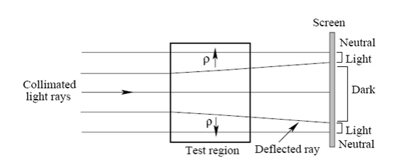

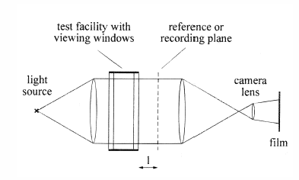

Shadowgraphy setupwith a beam of parallel light transmitted through the test section of a flow facility

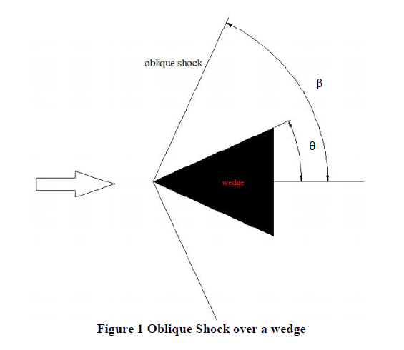

The 𝜃−𝛽−𝑀 relation describes the relation between shock angle, wedge angle and the upstream Mach number for an oblique shock wave:-

$tanθ=\frac{2}{tanβ}\frac{M_{1}^{2}\sin^{2}β-1}{M_{1}^{2}\left(γ+\cos\left(2β\right)\right)+2} -$ (1)  
θ – Geometric angle (wedge)

β – Angle of shock

M1 – Mach number upstream of shock

γ – Ratio of specific heats for a perfect gas

**Procedure :-**

1.Shadowgraphy system is arranged and wedge is placed in the test section.

2.Wind tunnel is started.

3.We have visualized the flow field or shock on the display screen.

4.Using Shadowgraphy technique we have observed that the oblique shock wave attached to the wedge and approximate wedge angle and wave angle is noted.

5.Using above angles we can calculate other properties.

**Observations :-**

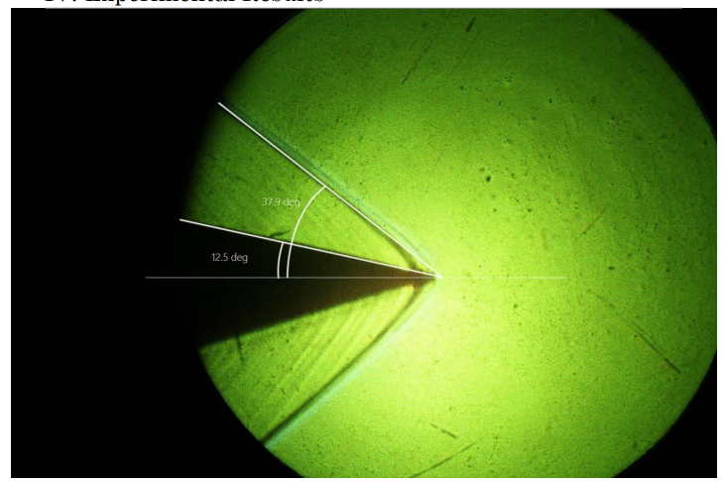

Thus, from the picture we can approximate

Flow Turning angle θ = 12.5o

Shock angle β = 38o

Ratio of Specific heats for a perfect gas = 1.4

Therefore, from the relation



We obtain M1 = 2.26

The equations that give relation between flow parameters across a shock are:

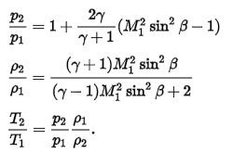

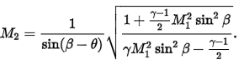

We get,

(ρ2/ ρ1) = 1.674 T2/T1 = 1.249

M2= 1.7589 P2/P1= 2.09

From Area-Mach Relation

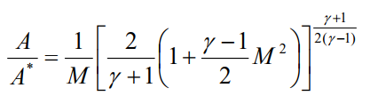

M=M1= 2.26

So we get,

**A/A*=2.1153**

A = Area of Test section

A* = Area of throat

**Discussion :-**

**Oblique Shock**  For particular deflection angle (θ) we have two oblique solution, small values of wave angle (β) corresponds to the weak shock and larger value of wave angle (β) corresponds to the strong shock solution. In nature weak oblique shock solution usually prevails.shock wave which is at an angle (β) to the flow direction is called as oblique.

**Normal Shock** A shock wave which is normal to flow direction is termed as normal shock. Normal shock is the strongest possible shock wave.

**Shock Angle** Angle between the shock wave and upstream flow direction is termed as shock angle (β). Keeping M1 constant as we increase θ (deflection angle), shock angle (β) also increases, thus the strength of the shock also increases and keeping θ constant as we increase M1, shock angle decreases, but shock strength increases.

**Deflection Angle** Angle between the downstream flow and upstream flow is known as deflection angle (θ). It is defined as the amount of the angle by which downstream flow is deflected through the shock with respect to the upstream flow.

**Techniques to find Mach Number in the Wind Tunnel :-**

* Shadowgraphy Technique
* Pitot Probe
* Signal Conditioning Amplifier and Transducer

**Equations for 𝑃2/𝑃1, T2/T1, 𝜌2/𝜌1 and M2 where the subscript ‘2’ represent the conditions downstream of an oblique shock.**





**References :-**

[1] Anderson Jr, J.D., “Fundamentals of Aerodynamics,” 5th ed., McGraw-Hill, Singapore, 1990, pp. 612.