Smoke Flow Visualisation over a Delta Wing

Medam Mahesh
15AE10017 Department of Aerospace Engineering (B.Tech 3rd Year)
Guided by: Prof. Sandeep Saha

1. Aim :-
To visualize leading edge vortices and their breakdown in the flow past a delta wing using smoke and laser sheet.

2. Apparatus :-
- Wind tunnel
- Model of a Delta wing
- Smoke-Flow Generator
- Laser-Sheet Map

3. Introduction :-
Flow visualization is the art of making flow patterns visible. Most fluids (air, water, etc.) are transparent, thus their flow patterns are invisible to the naked eye without methods to make them visible.
It is of extreme importance before attempting to analyse an aerodynamic flow is to understand the behaviour of the flow. This can be done by making the flow visible. The introduction of smoke lines to follow the airflow, allows the investigator to “see” what is happening. These visualisations can then be used to infer the nature of the flow in terms of circulation, vortex effects, flow separations and turbulence. This allows appropriate choices or simplifications of the equations used to solve the flow. Without such visualisation, incorrect assumptions will lead to the solution of flow cases that may not be directly relevant to the problem being considered and hence may lead to large errors.

4. Experimental Setup :-
- A smoke generator is placed at the intake of wind-tunnel.
- From this the smoke is fed to the wind-tunnel. The smoke enters the test-section as a jet. The smoke moves with the air and deforms, describing the flow behaviour.
- The ability to see flow pattern on a model often gives insight into an observation of an aerodynamic phenomenon.
5. Procedure :-
- Mount the Delta Wing in the test section.
- Wind Tunnel is turned on and a smoke generator is placed to intake of wind-tunnel.
- Turn off the lights in the test-section and turn on the Laser sheet perpendicular to the flow in test section.
- Test the delta wing at different angles of attack.

5. Plots and Figures :-
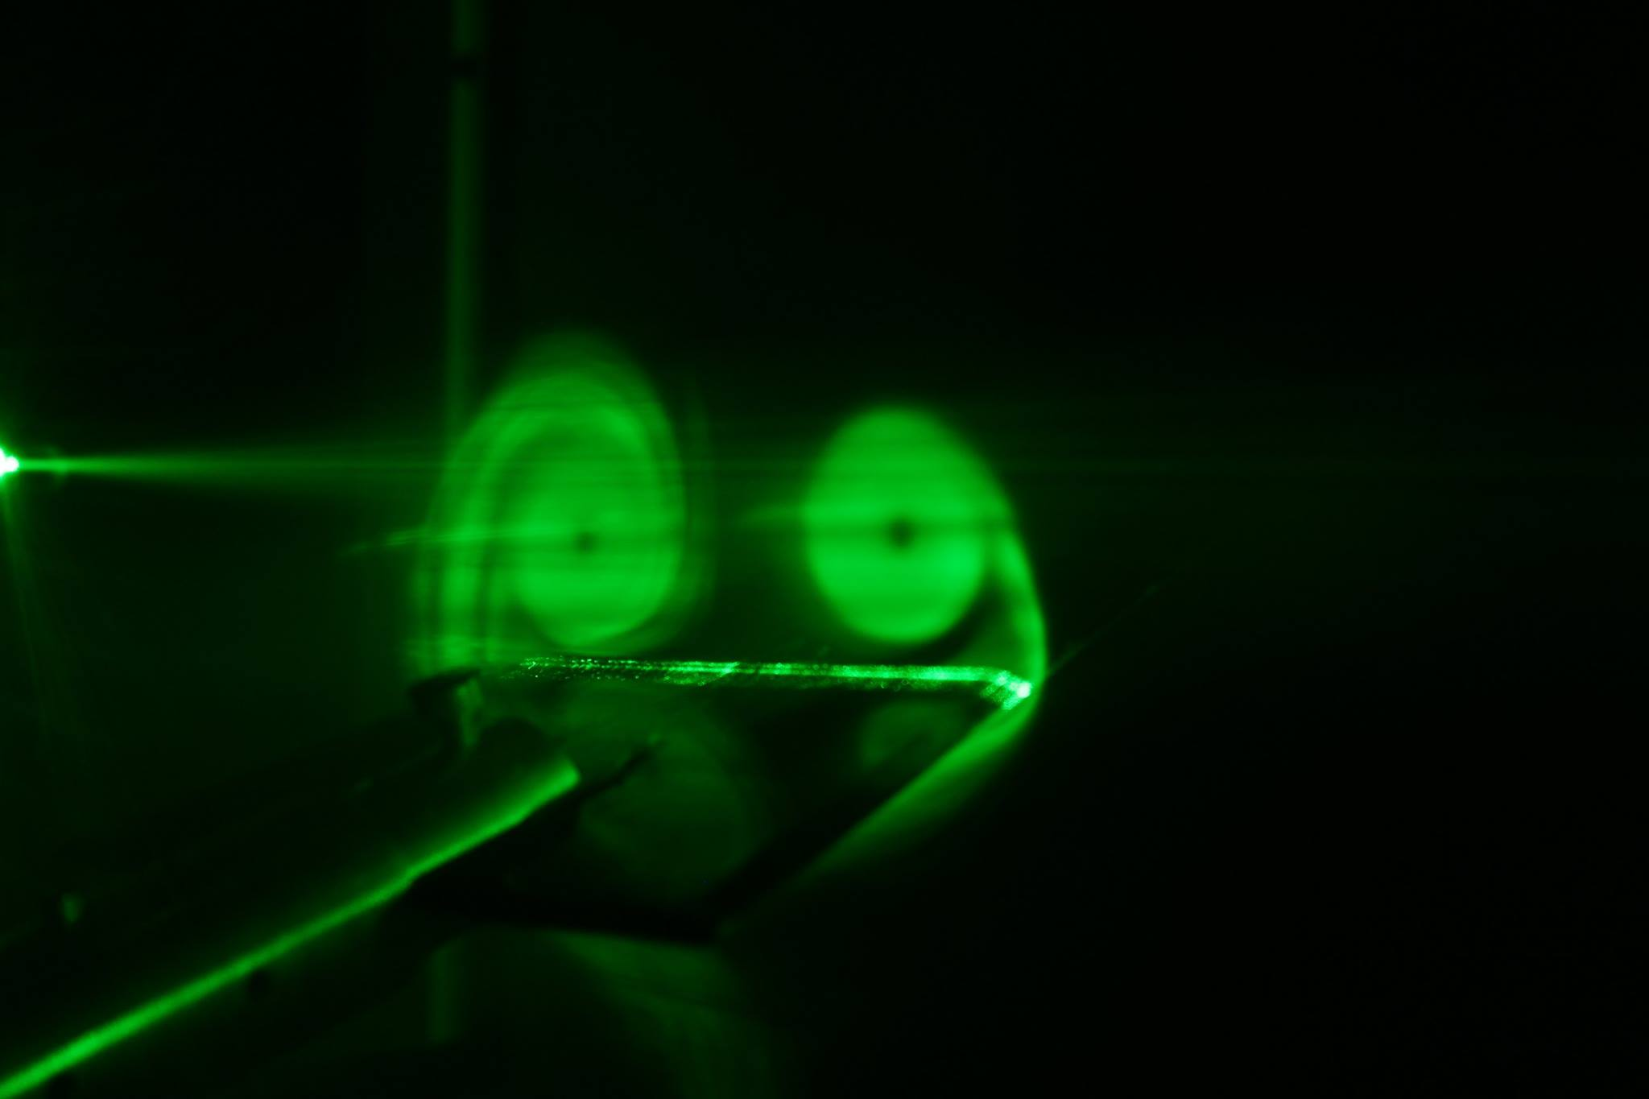

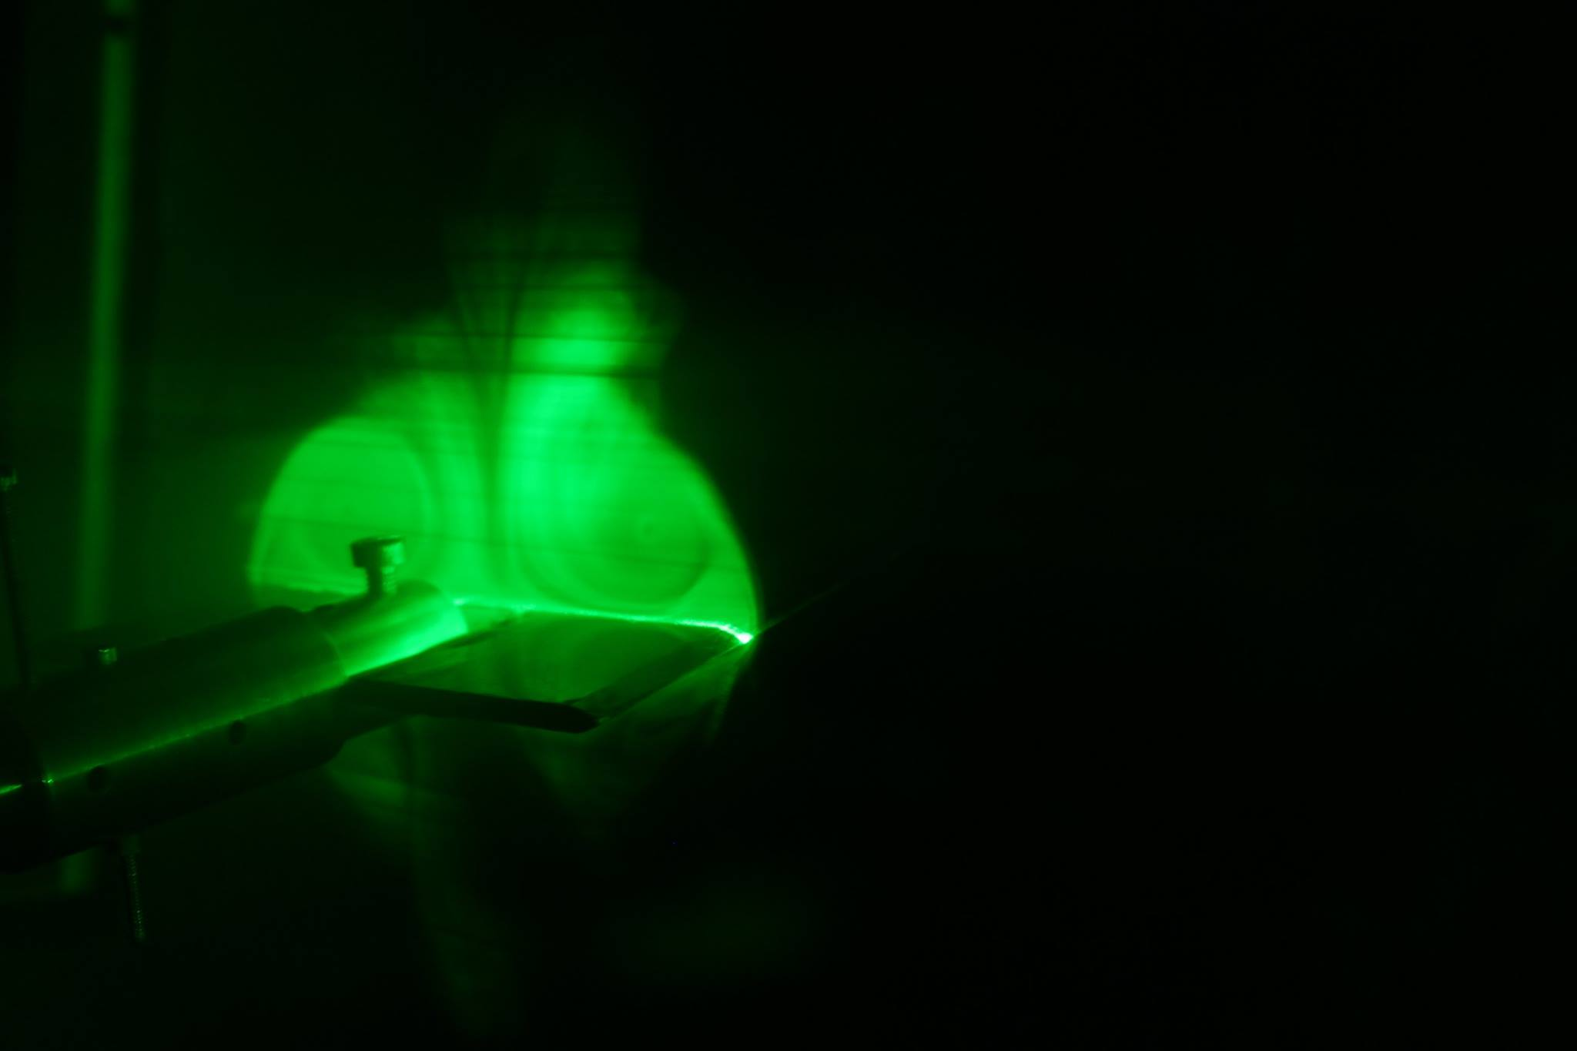

6. Discussion :-
(i) Different methods of flow visualisation :-
In experimental fluid dynamics, flows are visualized by three methods:
Surface flow visualization: This reveals the flow streamlines in the limit as a solid surface is approached. Colored oil applied to the surface of a wind tunnel model provides one example (the oil responds to the surface shear stress and forms a pattern).
Particle tracer methods: Particles, such as smoke or microspheres, can be added to a flow to trace the fluid motion. We can illuminate the particles with a sheet of laser light in order to visualize a slice of a complicated fluid flow pattern. Assuming that the particles faithfully follow the streamlines of the flow, we can not only visualize the flow but also measure its velocity using the particle image velocimetry or particle tracking velocimetry methods. Particles with densities that match that of the fluid flow will exhibit the most accurate visualization.
Optical methods: Some flows reveal their patterns by way of changes in their optical refractive index. These are visualized by optical methods known as the shadowgraph, schlieren photography, and interferometry. More directly, dyes can be added to (usually liquid) flows to measure concentrations; typically employing the light attenuation or laser-induced fluorescence techniques.
(ii) Advantages and Disadvantages of smoke flow visualisation:-
a. Advantages :-
- Easy setup
- Quick repositioning of the probe allows for viewing flow patterns around any portion of the model.
b. Disadvantages :-
- Extended use fills the tunnel with smoke. The tunnel must be vented to remove the smoke before further flow visualization can be used. An oily residue is left on whatever the smoke touches. Furthermore, pressure taps must be protected to prevent clogging.
(iii) Advantages and Disadvantages of using a Delta wing as the lifting surface over a conventional wing :-

a. Advantages of a delta wing:
- Due to the large root chord, a delta wing combines low relative wing thickness with a sufficiently thick wing spar for a lightweight structure. Since a low relative thickness keeps wave drag down (a drag component which occurs only in supersonic flow), this makes delta wings especially attractive for supersonic aircraft.
- The large root chord also provides it with a large surface area which helps to bring the minimum speed of the aircraft down.
- With sufficient leading edge sweep, a delta wing produces vortex lift, so flow separation can be turned into a means of increasing lift.
- A delta wing is naturally stable in pitch, therefore it does not require a separate tail surface.

b. Disadvantages of a delta wing:
- The large wing area causes more viscous drag for the same amount of lift compared to a high aspect ratio wing. Swept wings have a better lift-to-drag ratio (L/D) than delta wings.
- High-lift devices like fowler flaps are hard to integrate into delta wings. The higher relative thickness of regular airliner wings allows to integrate large flaps more easily, and the rearward location of the trailing edge of a delta wing will produce intolerable pitching moments if such flaps would be deflected.
(iv) Vortices over a delta wing :-
The two spiralling vortices on a delta wing are formed. from the separated shear layers which originate from the leading edge.
- On a wing with rounded leading edge, Earnshaw and Lawford (1964) found that these vortices did not appear until the angle of attack was more than 5°.
- For sharp leading wing, the separation vortices start at smaller angle of attack (Ericsson and Reding 1977).
- Under the L. E. vortices and slightly outboard from the cores, there is a pair of secondary vortices, induced by the primary vortices.
- Vortex Breakdown:- At large angles of attack, the L.E. vortices will suddenly expand in size. This is coupled with a sharp increase of the dynamic pressure and a decrease in axial velocity. This phenomenon is called vortex burst or breakdown.

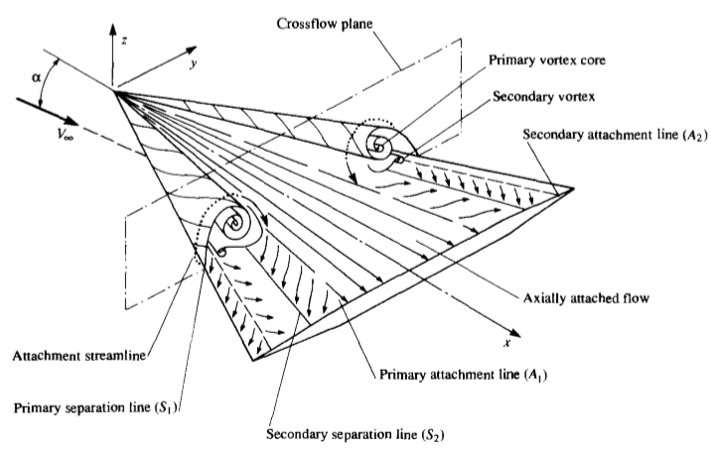

7. Reference :-
- Fundamental of Aerodynamics - J. D. Anderson
- https://link.springer.com/content/pdf/10.1007%2F978-3-642-83831-6_8.pdf
- https://en.wikipedia.org/wiki/Flow_visualization
- https://www.aa.washington.edu/AERL/KWT/techguide/flowviz
- https://aviation.stackexchange.com/questions/22198/what-are-the-advantages-and-disadvantages-of-a-delta-wing-compared-to-a-swept-wi

