Flow visualization on Laminar flow table

Medam Mahesh
15AE10017 Department of Aerospace Engineering (B.Tech 3rd Year)
Guided by: Prof. Sandeep Saha

1. Aim :-
(i) To visualize the streamlines in potential flows and flows formed by combining the fundamental elements of potential flows.
(ii) To visualize streamlines past a circular cylinder and an airfoil.

2. Apparatus :-
- Laminar flow table
- Dye
- Models (cylinder and airfoil)
3. Introduction :-
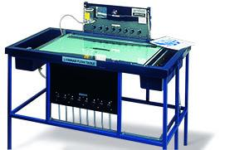
The Laminar Flow Table is an improved version of the classical Hele-Shaw apparatus with the addition of sinks and sources. The Armfield Laminar Flow Table is designed to simulate ideal fluid flow. The table creates two-dimensional laminar flow between two glass plates by the combination of low fluid velocity and the narrow gap between the plates. The resulting flow is free from turbulence and a close approximation to potential flow. Because the flow is driven by a potential field, (i.e. a pressure gradient that exist between two points of interest) the apparatus can be used to model some physical systems that obey Laplace’s equation.

(i) Elementary flows associated with potential flow theory :-

Potential Flow :-
In fluid dynamics, potential flow describes the velocity field as the gradient of a scalar function: the velocity potential. A potential flow is characterized by an irrotational velocity field, which is a valid approximation for several applications. Potential flow is irrotational. This is due to the curl of scalar gradient is always zero.

In incompressible flow the velocity potential satisfies Laplace's equation, and potential theory is applicable. However, potential flows can also describe compressible flows. The potential flow approach is used in the modeling of both stationary as well as nonstationary flows.
Applications of potential flow are for instance: the outer flow field for aerofoils, water waves, electroosmotic flow, and groundwater flow. For flows (or parts thereof) with strong vorticity effects, the potential flow approximation is not applicable.
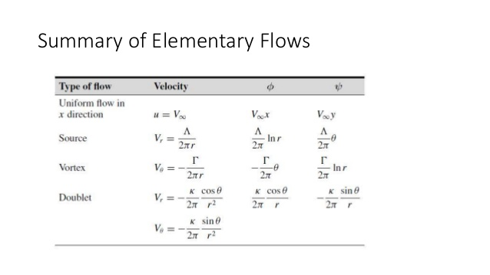
(ii) Flow past a circular cylinder:-
A stagnation point is formedd at the leading edge of the cylinder where the oncoming flow is brought to rest. The pressure at this point is stagnation pressure. On either side of the staagnation point the flow accelerates around theforward surface of the cylinder which results in the reduction of pressure. Immediately adjacent to the cylinder surface a thin boundary layer is formed. The boundary layer is the region where the velocity of the flow drops rapidly to zero to satisfy the no slip condition on the cylindrical surface .The effects of viscosity are felt only within this boundary layer.

Re = Reynolds Number

Re < 400,000
Boundary layer remains laminar from the stagnation point at the front of the cylinder up to the point where it separates. The resulting flow pattern is termed as Subcritical and is associated with larger drag on the cylinder because in this case wake region behind the cylinder is more.

Re > 400,000
Flow becomes turbulent. The resulting flow pattern is termed as
Supercritical and is associated with lower drag on the cylinder Because due to
the turbulence flow, It will remain attached with the surface of the cylinder and
therefore drag will be less due to less wake region in this case. If the surface of
the cylinder is smooth, the flow will be laminar and friction drag will be less,
pressure drag will be high compared to the turbulent flow. In case of potential
flow over a circular cylinder using Bernoulli’s equation we can get easily the
pressure distribution over the cylindrical surface.

4. Theory :-

Potential flows are governed by Laplace’s equation , which is a linear partial differential equation. It therefore follows that the various fundamental elements’ velocity potential and stream function can be combined to form potentials and stream functions of more complex flow patterns. Thus, we can combine fundamental elements’ velocity potentials or stream functions to yield streamlines that corresponds to flow past a particular body and that combination can be used to describe the details of the flow. This method of solving some interesting flow problems, commonly called the method of superposition

Let us consider slow uni-directional flow of an incompressible viscous fluid occupying some domain Ω(t), between two parallel plates fixed at a distance h apart. Let the velocity u of the fluid be generated from some external mechanism, e.g. injection of fluid. The flow profile between the plates is that of Poiseuille flow since we have the no-slip condition on the surface of each plate.

we consider the Navier-Stokes equations, where external body forces are neglected for simplicity,

i.e. fb = 0,

Assume the injection of fluid is slow such that the flow remains approximately steady and parallel to the plates. That is, there is no vertical fluid motion, i.e. u3 = 0, and
∂u/∂t = 0.

So the momentum equation becomes:

With no slip condition at upper and lower plates,

Now we consider a dimensional analysis of momentum equation. Let the typical velocity scale in the x1 and x2 directions be U_{d}, let the typical length scale in the x1 and x2 directions be L_{d}, and the typical length scale in the x3 direction be h. Then, the inertial terms on the left hand side of 1st two equations of momentum equation have orders of magnitude

The viscous terms become:

Hence, for h/L_{d}<< 1 the derivatives of u1 and u2 with respect to x1 and x2 are negligible as compared to the derivative w.r.t. x3. Thus momentum equation becomes:

The 1st two Equations represent Stokes flow in two dimensions, whilst third equation states that the pressure p is independent of x3, i.e. p = p(x1, x2, t). Hence, integrating and applying the boundary condition we have:

Taking the mean over the gap between the parallel plate’s yields:

This describes a 2D potential velocity field, is known as the Hele-Shaw equation and the coefficient k = h²/12μ is the mobility of the fluid. The flow field is identical to that of a hypothetical 2D flow of inviscid fluid with zero vorticity. The Hele-Shaw equation is a useful analogue for the study of inviscid potential flow in porous media, governing flow in 2D porous media with permeability h²/12.

Using the 2-D continuity equation we obtain:

Which implies: ∇²P= 0 hence p is a harmonic satisfying the laplacian. Thus we can see the analogy between the potential function 𝜙 from potential flows and the pressure p in flow of fluid in Hele-Shaw cell as we have ∇²𝜙 = 0 in potential flows as well.

5. Procedure :-
- Turn on the pump to start the water flow.
- Ink is passed into the flowing water through jets.
- Turn on the knobs of source, sink and doublet as per requirement.
- Wait for a few seconds to let the flow streamlines form and take pictures of the flow for future reference.
- After this, put the airfoil profiles, cylinder profiles one at a time to observer how the streamlines form around these profiles.

6. Observation :-
Flow past a circular cylinder :-
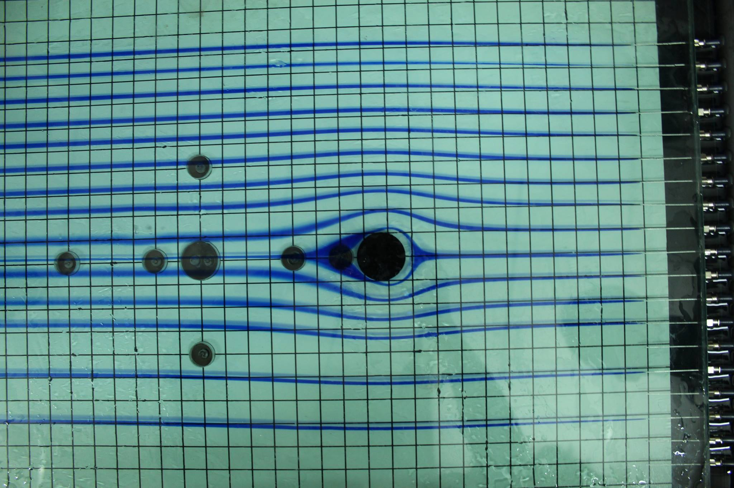

Flow past an airfoil at 0⁰ angle of attack :-
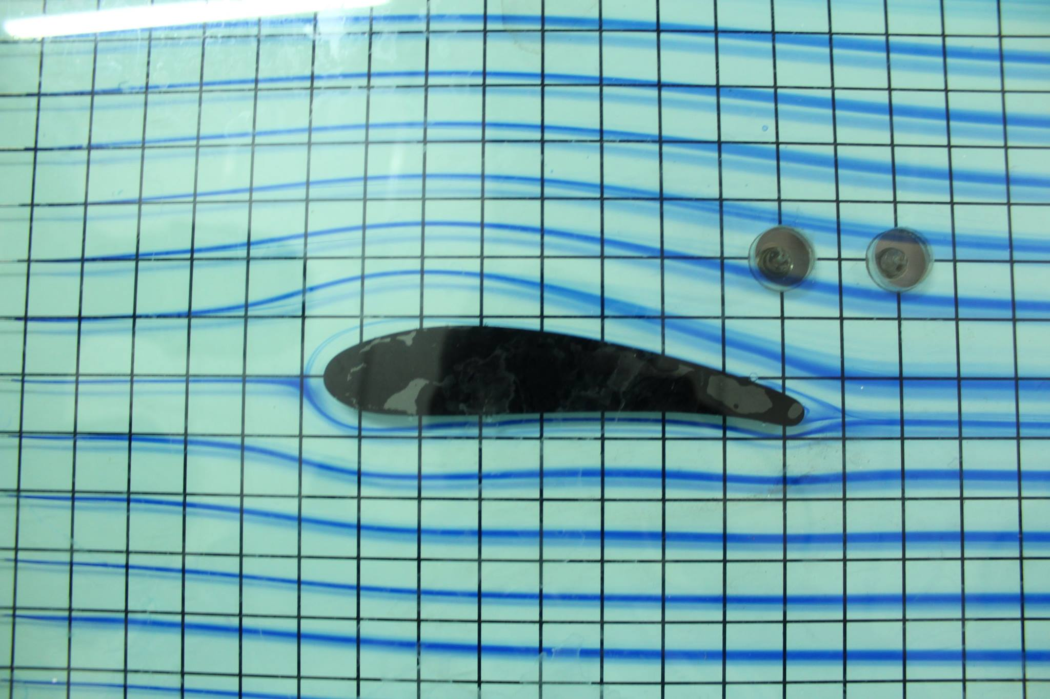

Flow past an airfoil at 30⁰ - 45⁰ angle of attack :-
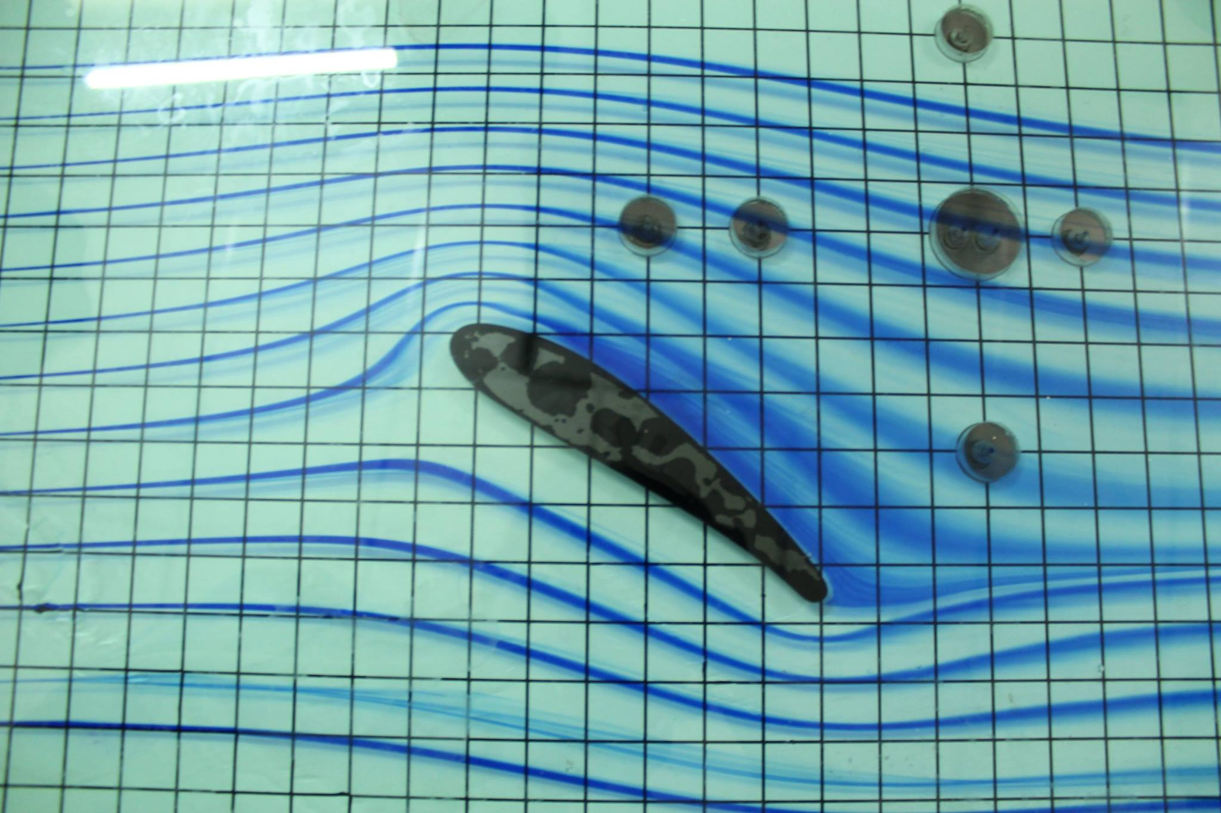

Flow past an airfoil at ~90⁰ angle of attack :-
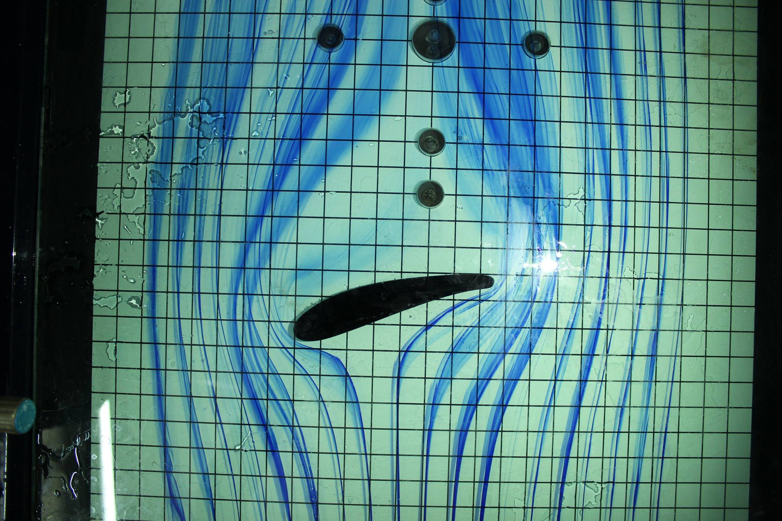

7. Discussion :-

Following assumptions were made in the Hele Shaw Cell :
- Fluid injection must be slow do that flow remains approximately steady and parallel to both the plates.
- There should be no vertical fluid motion
- Body forces are neglected.
- Fluid used is incompressible.

Difference between viscous and inviscid flows observable
in the laminar flow table :
- Flow seperation around the models is diffferent for these kind of flows.
- For inviscid flows, there is no such separation in the wake region.
- For viscid flows, there will be flow separation.

Are dye lines laminar ??
- The dye lines thickens due to Turbulence .As the flow becomes turbulent the transverse momentum of fluid particle increases and randomness in motion increases. To reduce the thickening we can reduce the velocity of flow so that the flow becomes completely laminar.

Overcoming problems encountered while conducting the experiments :
- The major problem was due to the formation of air bubbles between the two plates and they were removed by using a thin tube Models were disturbed initially when the flow passed them as a result we could not achieve each angle of attack .Mechanism such that model adhere to the plates should be used.

8. Reference :-
- https://en.wikipedia.org/wiki/Potential_flow
- http://web.mit.edu/2.016/www/handouts/2005Reading4.pdf
- J D Anderson
- http://armfieldonline.com/en/products/view/c10/laminar-flow-table.

