Force Measurement over a Delta Wing

Medam Mahesh
15AE10017 Department of Aerospace Engineering (B.Tech 3rd Year)
Guided by: Prof. Sandeep Saha

1. Aim :-
To determine Lift, Drag and Pitching moment over a delta wing

2. Apparatus :-
- Slender delta wing
- Six-component strain gauge sting balance
- Wind tunnel
- Digital multi-meter

3. Introduction :-
(i) History :-
Until the 1930s the vast majority of aircraft featured rectangular, trapezoidal or elliptical wings.Delta wings started being studied in the 1930s by Alexander Lippisch in Germany. Lippisch wanted to create tail-less aircraft, and Delta wings were one of the solutions he proposed. The photo below shows a glider prototype version of Delta Lippisch DM-1.

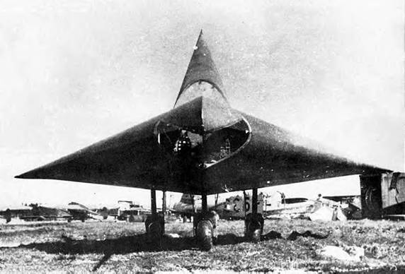

(ii) Delta wing Geometry :-

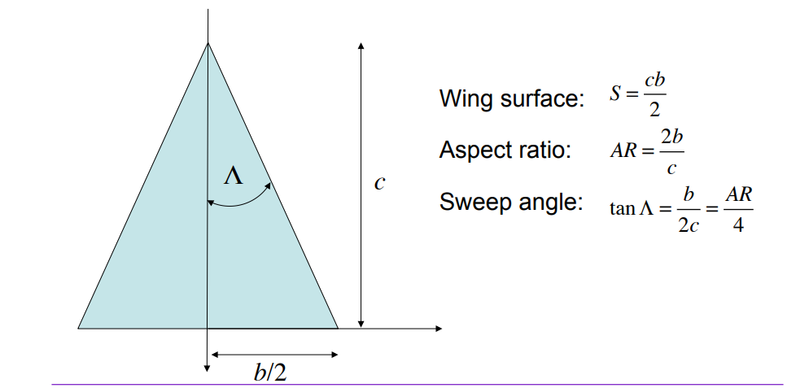

The above figure of Pure delta wing suffers from some undesirable characteristics such as flow separation at high angles of attack and high drag at low altitudes. And hence, delta wings are primarily used in aircrafts needing high speed, high altitude interception. These limitations of delta wing have been overcome by changing the structures of delta wing :
Canard delta – Many modern fighter aircraft, such as the JAS 39 Gripen, the Eurofighter Typhoon and the Dassault Rafale use a combination of canards and a delta wing.
Tailed delta – This is much more easily mauevarable to the traditional model because of the addition of the traditional tailplane. Common on Soviet types such as the Mikoyan-Gurevich MiG-21.
Cropped delta – There is no tip in this model which avoids tip drag at high angles of attack. Used for example in all three Eurocanards (cropped, tailless delta combined with a canard).

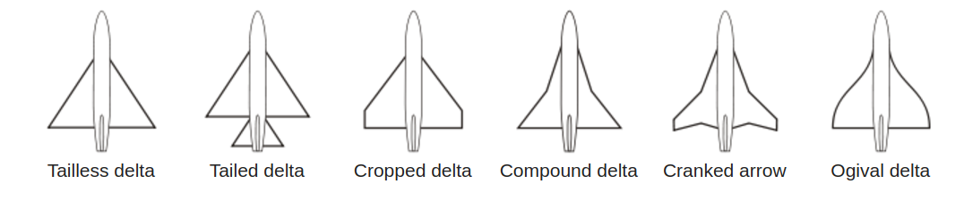
Sting Balance :-
In wind tunnel testing, aerodynamic forces and moments acting on a model can be accurately measured using balances. The location of the device affects the choice of mounting system for the model and the data reduction necessary to determine the aerodynamic forces. There are two types of balances
(i) Internal balance or sting balance
(ii) External balance.
Internal balance resides inside the test model while the external balance resides outside the test section. Sting balance is universally used in supersonic and transonic tunnels.
However they are used in subsonic tunnel also. To completely describe the condition of a model we must have to measure all six components, three forces (lift, drag, yaw) and three moments (pitch, yaw, roll).
In the present experiment, strain gauge based six component sting balance would be used. A four component consists of two Normal and Side forces, one axial force and one roll moment. The strain gages are connected initially in a balanced Wheatstone-bridge arrangement. Each gauge measures the force by the stretching of an electrical element in the gauge. The stretching changes the resistance which changes the measured current through the gauge using ohm’s law. Thus results an unbalanced Wheatstone-bridge. Wires carry the electricity to the gages through the hollow sting and carry the resulting signal back to the recording devices which give us the resulting change in voltage. This change in voltage is the measure of the forces or
moment acting on the model. In general, a Wheatstone-bridge differential circuit is used for measurement of force and a summing circuit is used for measurement of moment.
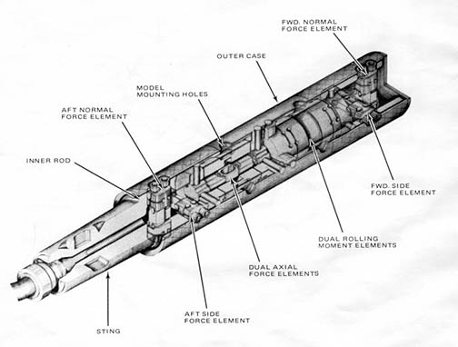

4. Procedure :-
- Mount the Delta Wing in the test section.
- Angle of Attack is changed by rotating an apparatus fixed under the wind tunnel and the value is read using a digital protractor.
- The offset offered by forces other than the aerodynamic forces was recorded before the starting the wind tunnel.
- The wind tunnel was turned on and values are recorded.
- Repeat the above four steps for different angles of attack.
- Using the conversion matrix, the readings were converted into force and then lift, drag and pitching moment were calculated in Newtons.

5. Observations and Plots :-
Velocity = 19.829 m/s
Density = 1.119 kg/m³
Wing area = 0.026425 m²
Chord length = 0.35 m
Reynolds No. = 404544
Excited voltage = 2.5 volts

Angle of Attack | Multimeter reading  ( After subtracting from offset) |  |  | After conversion to force (in Kg)
Angle of Attack | Axial  (A) | Normal1  (N1) | Normal2  (N2) | Axial  (A) | Normal1  (N1) | Normal2  (N2)
-5 | -0.0044 | -0.0128 | -0.0078 | -0.00988 | -0.17510 | -0.10707
0 | 0.0088 | -0.0004 | -0.0004 | 0.01983 | -0.00787 | -0.00330
10 | 0.0140 | 0.0356 | 0.0212 | 0.03146 | 0.48656 | 0.29302
20 | 0.0212 | 0.0760 | 0.0464 | 0.04759 | 1.04097 | 0.63896
30 | 0.0268 | 0.1196 | 0.0728 | 0.06011 | 1.63994 | 1.00094
40 | 0.0300 | 0.1372 | 0.0832 | 0.06727 | 1.88150 | 1.14379
43 | 0.0284 | 0.1316 | 0.0804 | 0.06368 | 1.80475 | 1.10513

Angle of Attack | Aerodynamic Forces |  |  | Aerodynamic Coefficients
Angle of Attack | Lift (in N) | Drag (in N) | Pitching Moment  (in N-m) | C_{L} | C_{D} | C_{M}
-5 | -2.7651 | 0.1446 | -0.0434 | -0.4710 | 0.0246 | -0.0211
0 | -0.1095 | 0.1945 | -0.0029 | -0.0187 | 0.0331 | -0.0014
10 | 7.4754 | 1.6314 | 0.1234 | 1.2733 | 0.2779 | 0.0600
20 | 15.3213 | 6.0732 | 0.2563 | 2.6098 | 1.0345 | 0.1247
30 | 22.1338 | 13.4596 | 0.4073 | 3.7702 | 2.2927 | 0.1982
40 | 22.3029 | 19.5756 | 0.4702 | 3.7991 | 3.3345 | 0.2289
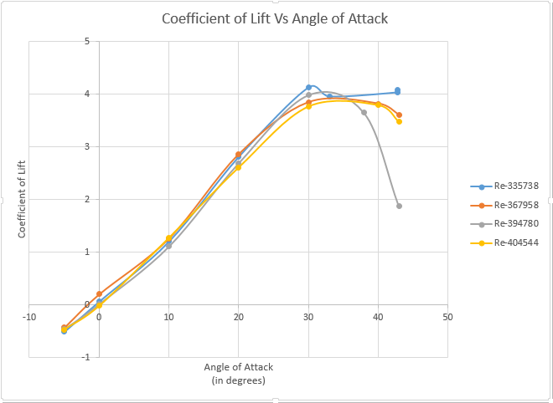  43 | 20.4441 | 19.9184 | 0.4460 | 3.4824 | 3.3929 | 0.2170

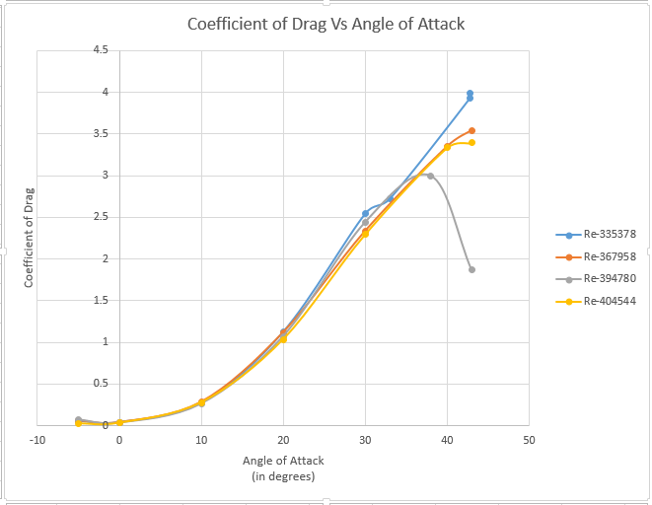

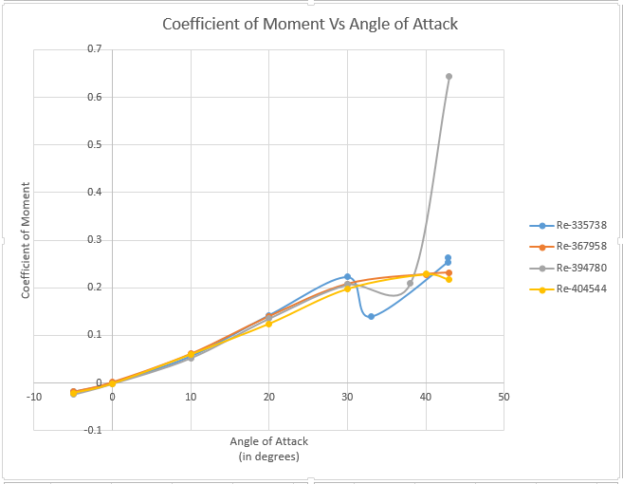

6. Discussion :-
(i) Force Measuring Equipment :-
Strain Gauge Load Cells :-
Strain Gauge Load Cells are the most commonly seen form of force transducer. Their geometric shape and modulus of elasticity of the element determine the magnitude of the strain produced due to the applied force. Each strrain gauge resonds to their local strain and the measurement of force is determined from the integration of these individual measurements of strain.
Other strain gauges :- Foil strain gauge, electric resistance strain gauge, semiconductor strain gauge, thin film strain gauge, wire strain gauge etc.,

Piezoelectric transducers :-
Their working principle is :
“Electric charges are formed on the crystal surface in proportion to the rate of change of applied force.”
To use this device, a charge amplifier is required to integrate the electric charges to give a signal proportional to the force and big enough to measure. Quartz is the piezoelectric material used.

Measuring force through pressure :-
Hydraulic Load Cell works on the principle :
“Application of force on the loading member increases the fluid pressure which is measured by a pressure transducer or displayed on a pressure gauge dial via a Bourdon tube”
Pneumatic Load Cell works on the princple :
“Force applied on one side of the piston or a diaphragm of flexiblle material and balanced by pneumatic pressure on the other side. This counteracting presssure is proportional to the force and is displayed on a pressure dial.”
(iii) Lift Mechanism in a Delta wing :-
The lift generated by such wings at low speeds can be split into two components:
1. Potential Flow Lift
2. Vortex Lift
Potential flow lift can be explained through slender wing theory in which flow around each segment is modeled as a 2D flow past a flat plate perpendicular to the free stream.
Slender body theory is only valid for low angles of attack. Unfortunately, due to the low aspect ratio, Delta wings do not produce a lot of lift at low angles of attack Higher angles of attack must be used, but these are not modeled properly by slender body theory. A vortex lift term can be added to the potential lift to account for high angles of attack.
At higher angles of attack, strong vortices are generated at the leading edge. They generate high-speed flow and increase the lift significantly.
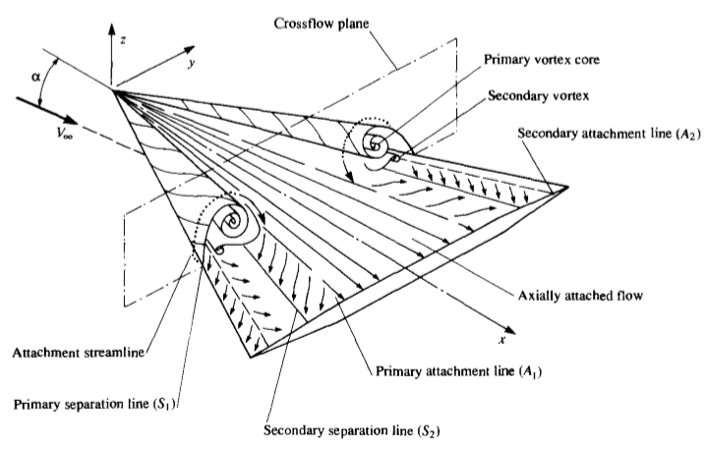
(iv) Applications of Delta Wings :-
Delta wings are mainly used for military purposes and in some cases for experimental purposes. They are built to deal with the limitations of high speed maneuverability and working at high angles of attack posed by the normal aircrafts.

7. Reference :-
- https://en.wikipedia.org/wiki/Delta_wing
- http://www.ltas-aea.ulg.ac.be/cms/uploads/Expaero04.pdf
- Fundamental of Aerodynamics - J. D. Anderson
- https://www.grc.nasa.gov/www/K-12/airplane/tuntest.html
- http://www.npl.co.uk/reference/faqs/how-many-different-types-of-force-transducer-are-there-(faq-force)
- https://www.grc.nasa.gov/www/k-12/airplane/tunbalint.html

