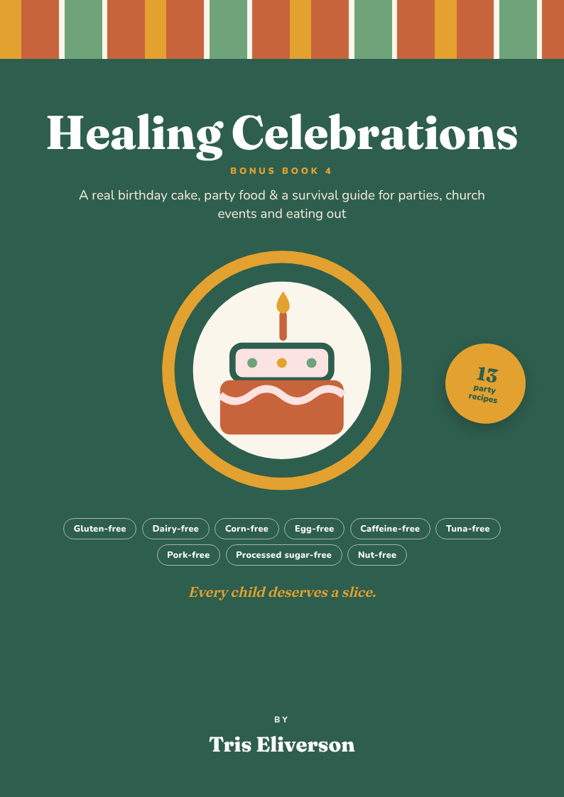

Welcome

Every child deserves a slice

Dear Mama, dear Papa,
Birthdays, owambes, Christmas, Eid, school parties — they should be full of joy. But when your child has allergies, they can be full of worry instead. Will there be anything they can eat? Will they feel left out?
This little book is my answer. A real birthday cake your child can blow candles out on. Party food the whole room will enjoy — not “special” food that looks different. And a simple plan for every party, church event and day out.
Every recipe is free from gluten, dairy, corn, eggs, caffeine, tuna, pork, processed sugar and nuts.
Every child deserves a slice. ♥
With love, Tris Eliverson
Autism mum · Recipe creator

Inside this book
Contents
Right-click here and choose “Update Field” to show the contents with page numbers.

The star of the party

A real birthday cake
Every child deserves to blow out candles on a cake they can actually eat.

Celebration Vanilla Berry Cake
Birthday · 1 hr + cooling · one 20 cm / 8 in cake
You need
- ☐ 1 cup (140 g) brown rice flour
- ☐ ½ cup (60 g) tapioca flour + ½ cup (80 g) potato starch
- ☐ 1 tsp psyllium husk powder
- ☐ ½ cup pure maple syrup
- ☐ 1 tsp baking soda, ¼ tsp salt
- ☐ ¾ cup coconut milk or water
- ☐ ⅓ cup light olive or avocado oil
- ☐ 1 tbsp apple cider vinegar + 1 tsp pure vanilla powder
Steps
- Heat oven to 180 °C / 350 °F. Line a round tin with parchment.
- Whisk all the dry ingredients together.
- Add the milk, oil, vinegar and vanilla. Mix just until smooth.
- Bake 30–35 min until a skewer comes out clean. Cool completely.
- Frost with chilled whipped coconut cream + 1 tbsp maple syrup. Top with berries and candles!
Why it helps: No egg, dairy, gluten, corn, nuts or processed sugar — every child at the party can have a slice.
Cupcakes: Makes 12 cupcakes too — bake 18–20 min. Many vanilla extracts use corn alcohol, so use pure vanilla powder.

Fluffy coconut frosting
- Chill 2 tins of full-fat coconut milk overnight.
- Scoop out only the thick cream on top.
- Whisk 2 min with 1 tbsp maple syrup until fluffy.
- Keep the cake in the fridge until party time.

Decorate without food colouring
- Pink: a spoon of beetroot juice or blended strawberries.
- Yellow: a pinch of turmeric.
- Purple: blended blueberries.
- Top with fresh berries, mango stars and coconut flakes.
Freeze slices for school birthdays — your child will always have their own cake when classmates celebrate.

Carob Birthday Cupcakes
Party · 45 min · makes 12
You need
- ☐ 1 batch Celebration Cake batter (see the cake page)
- ☐ 3 tbsp carob powder (add to the dry ingredients)
- ☐ Frosting: cream from 2 chilled tins coconut milk
- ☐ 2 tbsp carob powder + 1 tbsp pure maple syrup
- ☐ Berries or coconut flakes, to decorate
Steps
- Heat oven to 180 °C / 350 °F. Line a muffin tin with 12 cases.
- Make the cake batter, adding the carob to the dry ingredients.
- Fill the cases ⅔ full. Bake 18–20 min. Cool.
- Whisk coconut cream, carob and maple until fluffy.
- Pipe or spread on top and decorate.
Why it helps: Chocolate-style cupcakes with no cocoa, caffeine, dairy, egg or nuts.

Party Jollof Rice (serves 12)
Party · 1 hr 15 min
You need
- ☐ 6 cups long-grain parboiled rice
- ☐ 12 tomatoes, 6 red peppers, 2 onions, 2 scotch bonnets — blended
- ☐ 4 tbsp tomato paste, ½ cup olive oil
- ☐ 2 tsp thyme, 2 tsp pure curry powder, 4 bay leaves
- ☐ 4 tsp Healing Seasoning Mix, salt
- ☐ 6 cups chicken stock
Steps
- Cook the blend in a large pot 20 min until thick.
- Fry tomato paste in the oil 3 min, add the blend and spices. Cook 10 min.
- Add stock and washed rice. Cover tightly with parchment and a lid.
- Cook on low 30–35 min, stirring gently once.
- Let it rest 10 min, then fluff and serve.
Why it helps: The heart of every Naija party — made without stock cubes or MSG.
Party secret: For the smoky “party” taste, let the bottom catch very slightly at the end.

Baked Peppered Chicken
Party · 1 hr
You need
- ☐ 2 kg chicken pieces
- ☐ 2 tsp Healing Seasoning Mix, 1 tsp thyme, salt
- ☐ 4 red peppers, 1 scotch bonnet, 1 onion — blended
- ☐ 3 tbsp olive oil
- ☐ 1 tsp paprika
Steps
- Season chicken and bake at 200 °C / 400 °F for 35 min.
- Cook the pepper blend in oil with paprika 10 min until thick.
- Toss the baked chicken in the pepper sauce.
- Return to the oven 10 min to glaze.
Why it helps: Party chicken that’s baked, not deep-fried — but still saucy and delicious.

Mini Moi Moi Cups
Party · 1 hr 15 min · makes 18
You need
- ☐ 3 cups black-eyed beans, soaked & peeled
- ☐ 2 red peppers, 1 scotch bonnet, 1 onion
- ☐ 4 tbsp red palm oil
- ☐ 1 tbsp crayfish, 2 tsp seasoning mix, salt
- ☐ About 1½ cups warm water
- ☐ Silicone cupcake cases
Steps
- Blend beans, peppers and onion with water until very smooth.
- Stir in oil, crayfish, seasoning and salt.
- Fill silicone cases ⅔ full and set in a steamer.
- Steam 35–40 min until firm.
- Cool slightly and pop out.
Why it helps: Egg-free, perfectly portioned and easy for little hands at a party.

Baked Plantain Puff-Puff Bites
Party · 30 min · makes 24
You need
- ☐ 2 very ripe plantains
- ☐ 1 cup cassava flour
- ☐ ½ cup coconut milk
- ☐ ½ tsp nutmeg, pinch of salt
- ☐ ½ tsp baking soda + 1 tsp lemon juice
- ☐ Coconut oil, for the tin
- ☐ Cinnamon, for dusting
Steps
- Heat oven to 200 °C / 400 °F. Oil a mini muffin tin well.
- Blend plantain and coconut milk until smooth.
- Stir in flour, nutmeg, salt and baking soda, then the lemon juice.
- Spoon into the tin. Bake 15–18 min until golden.
- Dust with a little cinnamon while warm — the plantain is sweet enough.
Why it helps: Puff-puff without wheat, egg or deep frying — so your child can join the party plate.

Crunchy Cassava Chin Chin
Party · 40 min
You need
- ☐ 2 cups cassava flour
- ☐ 3 tbsp pure maple syrup
- ☐ ½ tsp ground nutmeg, pinch of salt
- ☐ ⅓ cup solid coconut oil
- ☐ About ⅓ cup coconut milk
Steps
- Heat oven to 180 °C / 350 °F. Line 2 trays with parchment.
- Mix flour, nutmeg and salt. Rub in the coconut oil with your fingers.
- Add the maple syrup, then coconut milk a little at a time, to make a firm dough.
- Roll out 5 mm thick and cut into small squares.
- Bake 15–20 min, stirring once, until golden. They crisp as they cool.
Why it helps: The chin chin every Nigerian child knows — with no wheat, no egg, no processed sugar and no deep frying.
Picky eater trick: Let your child cut the squares with a blunt knife. Kids eat what they make.

Nut-Free Chicken Suya Skewers
Party · 30 min + marinating
You need
- ☐ 600 g chicken breast, cut into strips
- ☐ 2 tsp paprika, 1 tsp ground ginger
- ☐ 1 tsp garlic powder, 1 tsp onion powder
- ☐ ½ tsp cayenne (less for kids), 1 tsp salt
- ☐ 2 tbsp olive oil
- ☐ Sliced onion, tomato & cucumber
Steps
- Mix spices, salt and oil. Rub over the chicken. Rest 30 min.
- Thread onto soaked wooden skewers.
- Bake at 220 °C / 425 °F for 12–15 min, turning once.
- Serve with fresh onion, tomato and cucumber.
Why it helps: Classic suya spice uses groundnut (kuli kuli). This version is nut-free and party-safe.

Rainbow Fruit Wands
Party · 15 min
You need
- ☐ Strawberries, pineapple, mango, kiwi, grapes, blueberries
- ☐ Watermelon slices
- ☐ Paper straws or blunt skewers
- ☐ Star cookie cutter
Steps
- Cut fruit into chunks, in rainbow order.
- Cut stars from the watermelon slices.
- Thread the fruit onto straws and top each with a star.
- Chill until party time.
Why it helps: Children who won’t touch a fruit bowl will happily eat a magic wand.

Zobo Party Punch
Party · 20 min + chilling
You need
- ☐ 1 cup dried hibiscus (zobo) leaves
- ☐ 8 cups water
- ☐ 1 thumb ginger, sliced, 4 cloves
- ☐ ½ pineapple, peeled (keep the peel too)
- ☐ 6 dates (to sweeten)
- ☐ Orange slices, to serve
Steps
- Rinse the zobo. Boil with water, ginger, cloves and pineapple peel for 15 min.
- Add the dates, turn off the heat and steep 30 min.
- Strain well. Blend the pineapple flesh and stir it in.
- Chill and serve with orange slices and ice.
Why it helps: Bright red, fruity and naturally caffeine-free — a party drink everyone can share.

Coconut Mango Ice Pops
Party · No processed sugar · 10 min + freezing
You need
- ☐ 2 ripe mangoes, peeled & chopped
- ☐ 1 cup coconut milk
- ☐ Juice of ½ lime
- ☐ 1 tbsp honey (optional — not for babies under 1)
Steps
- Blend everything until smooth.
- Pour into ice-pop moulds or small cups.
- Freeze for 6 hours or overnight.
- Run the mould under warm water for 10 seconds to pop out.
Why it helps: A sweet, cold treat with no dairy, no processed sugar and a big dose of vitamin C.
Sweet moment: Let your child pour the mix into the moulds — helping makes them want to taste.

Carob Fudge Bites
Party · No processed sugar · 15 min + chilling
You need
- ☐ 1 cup soft pitted dates
- ☐ 3 tbsp carob powder
- ☐ 3 tbsp sunflower-seed butter
- ☐ 2 tbsp coconut oil
- ☐ Desiccated coconut, for rolling
Steps
- Blend dates, carob, seed butter and oil until sticky.
- Roll into small balls.
- Roll in coconut and chill 1 hour.
Why it helps: Tastes like chocolate fudge — no cocoa, no caffeine, no nuts.

Strawberry Coconut Cheesecake Cups
Party · No processed sugar · 20 min + chilling
You need
- ☐ Base: 1 cup dates + ½ cup sunflower seeds + ½ cup gluten-free oats
- ☐ 2 cups thick coconut yogurt
- ☐ 1 tbsp pure maple syrup
- ☐ 1 cup strawberries, chopped
- ☐ Squeeze of lemon
Steps
- Blitz the base ingredients and press into 6 small cups.
- Mix yogurt, maple and lemon. Spoon on top.
- Top with strawberries. Chill 1 hour.
Why it helps: No-bake, no dairy, no nuts — a party-worthy treat.

Plan it

Party menus & make-ahead plan
Three ready-made party menus. Mix and match — every dish is in this book.

Kids' birthday
- Celebration Vanilla Berry Cake
- Carob Birthday Cupcakes
- Nut-Free Chicken Suya Skewers
- Rainbow Fruit Wands
- Coconut Mango Ice Pops
- Zobo Party Punch

Naija party & owambe
- Party Jollof Rice
- Baked Peppered Chicken
- Mini Moi Moi Cups
- Baked Plantain Puff-Puff Bites
- Crunchy Cassava Chin Chin
- Zobo Party Punch

Christmas, Eid & holidays
- Party Jollof Rice
- Baked Peppered Chicken
- Suya Skewers
- Strawberry Coconut Cheesecake Cups
- Carob Fudge Bites
- Rainbow Fruit Wands

Make-ahead plan

One week before
- Bake and freeze the cake or cupcakes (un-iced).
- Make chin chin and fudge bites — store airtight.
- Make a batch of Healing Seasoning Mix.

The day before
- Steam the moi moi cups.
- Make zobo punch and chill.
- Marinate the chicken. Freeze ice pops.
- Chill coconut milk for frosting.

On the day
- Cook jollof and bake the chicken.
- Bake puff-puff bites.
- Frost the cake, make fruit wands.
- Breathe — and enjoy the party!

Be prepared

Party survival guide
Parties, owambes, church events and school trips can feel scary. With a little planning, your child can join in — and feel included.

Before the party
- Message the host early. Share the allergy card from the Printables pack.
- Ask what will be served — then offer to bring one safe dish to share.
- Feed your child a proper meal first, so they're never hungry and tempted.

Pack a “party box”
- A slice of the Celebration Cake, frozen ahead in portions.
- Nuggets, plantain chips, fruit kebabs, a juice from Healing Sips.
- Make it look special — a bright box, a sticker, a party napkin.

At the party
- Stay close to the food table for younger children.
- Teach a simple line: “No thank you, I have my own special snack.”
- Watch for shared bowls of sweets, chin chin and puff-puff.

Eating out
- Choose grilled chicken or fish, plain rice, boiled potatoes, salad.
- Ask: “Is there wheat, milk, butter, egg or corn starch in this?”
- Avoid sauces, gravies, batters and anything deep-fried in shared oil.
Sensory overwhelm is real
Loud music and crowds can be a lot. Arrive early when it's quiet, find a calm corner, and plan a gentle exit time. Leaving happy is a win.

Printable

Letter to the party host
Print, fill in and send to the party host a few days before. Keep a copy in your bag.
Dear ,
Thank you so much for inviting to the party — we are really looking forward to it!
My child has food allergies and cannot eat: ☐ Gluten (wheat) ☐ Dairy (milk) ☐ Corn ☐ Egg ☐ Caffeine ☐ Tuna ☐ Pork ☐ Nuts ☐ Processed sugar
Other:
To make it easy for you, I will bring:
Could you please let me know what food will be served, so I can make sure my child has something similar? It means a lot that they can join in like everyone else.
If you have any questions, please call me on:
Thank you for helping keep my child safe and happy! ♥
From:

Celebrate

Here’s to every celebration
Every candle blown out, every party joined, every “yes, you can have that” — these are the moments we heal for.

Remember
- Freeze cake slices for surprise school birthdays.
- Always pack a “party box” — just in case.
- Share the host letter and allergy card ahead of time.

The whole series
- Healing Plates — the 30-day family meal plan
- Healing Lunch Box — 30 days of school lunches
- Healing Sips — 30 gentle detox drinks
- Healing Printables — cards, trackers & planners
With love, Tris Eliverson
Autism mum · Recipe creator
© Tris Eliverson. All rights reserved. For personal use only — please do not share or resell. This book shares recipes and ideas from personal experience and is not medical advice. Always check food labels, and always supervise children with food allergies at parties.

