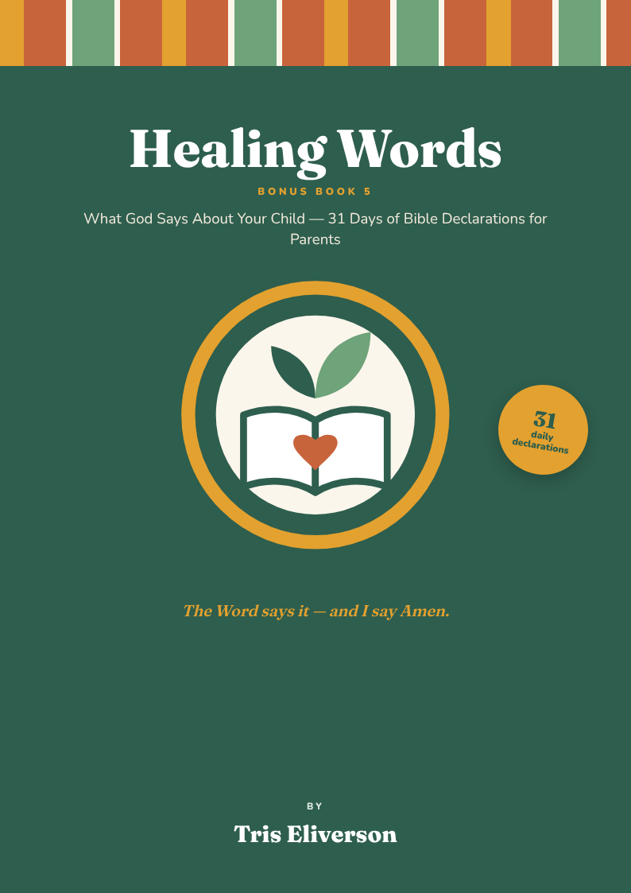

Welcome

What God says about your child

Dear Mama, dear Papa,
Some days the reports, the waiting rooms and the worries are loud. On those days, I needed something louder: what God says about my child.
These 31 Bible verses are the ones I spoke over my own child — about healing, deliverance, restoration, speech, understanding, peace and strength. Each day has the verse, a simple explanation of what God is saying, and a declaration for you to speak out loud.
Say it over your child as they sleep, on the school run, or while you cook. Put their name in every declaration. And end each one the way I do:
“The Word says it — and I say Amen.” ♥
With love, Tris Eliverson
Autism mum · Recipe creator

Inside this book
Contents
Right-click here and choose “Update Field” to show the contents with page numbers.

Start here

How to use this book
Five minutes a day. One verse. One declaration. Spoken in faith over your child.
Step 1

Read the verse
Read it slowly — out loud if you can. All verses are from the King James Version (KJV).
Step 2

Understand what God is saying
The simple explanation helps you see what the verse means for your child today.
Step 3

Speak the declaration
Put your child's name in the blank and declare it with faith. Lay your hand on them if they are comfortable with touch.
Step 4

Say Amen
“The Word says it — and I say Amen.” Amen means “so be it”. You are agreeing with God.
Step 5

Write it down
Use the lines at the bottom of each page to note prayers, answers and small victories.
My child's name
Write it here, and speak it every day:
Faith and good care walk together. Keep walking with your child's doctors, therapists and teachers — God works through them too.

Day 1 · Who my child is

Wonderfully made
“I will praise thee; for I am fearfully and wonderfully made: marvellous are thy works; and that my soul knoweth right well.”
Psalm 139:14 · King James Version (KJV)

What God is saying
God made your child on purpose, with great care. Nothing about them is a mistake. Their mind, their body and their way of seeing the world are His marvellous work.

Today’s declaration
Father, Your Word says my child is fearfully and wonderfully made.
Over ________________ (my child’s name):
I declare that my child is wonderfully made. They are not a mistake, not a problem to fix and not less than anyone. They are God’s marvellous work, and I praise Him for them.
The Word says it — and I say Amen.

My prayer notes

Day 2 · Who my child is

A gift from God
“Lo, children are an heritage of the LORD: and the fruit of the womb is his reward.”
Psalm 127:3 · King James Version (KJV)

What God is saying
Your child is a gift and a reward from God — not a burden. He chose you to carry, raise and love this precious child.

Today’s declaration
Father, Your Word says my child is a heritage of the LORD.
Over ________________ (my child’s name):
I declare that my child is a gift from God to our family. I receive them with joy and thanksgiving. I was chosen to be their parent, and God will give me grace for every day.
The Word says it — and I say Amen.

My prayer notes

Day 3 · Who my child is

A good future
“For I know the thoughts that I think toward you, saith the LORD, thoughts of peace, and not of evil, to give you an expected end.”
Jeremiah 29:11 · King James Version (KJV)

What God is saying
God already has good plans for your child's future. Whatever the reports say today, His thoughts towards them are peace and hope.

Today’s declaration
Father, Your Word says God’s thoughts toward my child are thoughts of peace and a good future.
Over ________________ (my child’s name):
I declare that my child has a good future. God’s plans for them are peace, not evil. No diagnosis has the final word — God has the final word, and His word is hope.
The Word says it — and I say Amen.

My prayer notes

Day 4 · Who my child is

Welcomed by Jesus
“But Jesus said, Suffer little children, and forbid them not, to come unto me: for of such is the kingdom of heaven.”
Matthew 19:14 · King James Version (KJV)

What God is saying
Jesus welcomes every child — including children who are loud, quiet, different or still learning. Nobody can stop your child from coming to Him.

Today’s declaration
Father, Your Word says Jesus welcomes my child.
Over ________________ (my child’s name):
I declare that my child belongs. Jesus welcomes them with open arms. They are loved in God’s house and nothing can keep them from His love.
The Word says it — and I say Amen.

My prayer notes

Day 5 · Who my child is

God finishes what He starts
“Being confident of this very thing, that he which hath begun a good work in you will perform it until the day of Jesus Christ.”
Philippians 1:6 · King James Version (KJV)

What God is saying
God has started a good work in your child, and He will not stop halfway. Every small step forward is part of His bigger work.

Today’s declaration
Father, Your Word says God will complete the good work He began in my child.
Over ________________ (my child’s name):
I declare that God is finishing the good work He started in my child. I celebrate every small step. What He has begun, He will complete.
The Word says it — and I say Amen.

My prayer notes

Day 6 · Who my child is

Never alone
“Fear thou not; for I am with thee: be not dismayed; for I am thy God: I will strengthen thee; yea, I will help thee; yea, I will uphold thee with the right hand of my righteousness.”
Isaiah 41:10 · King James Version (KJV)

What God is saying
On the hard days, God is right there with you and your child. He promises to strengthen, help and hold you up.

Today’s declaration
Father, Your Word says God is with my child, and He will strengthen, help and uphold them.
Over ________________ (my child’s name):
I declare that my child is never alone. God is with them at home, at school and everywhere they go. He strengthens them, helps them and holds them up.
The Word says it — and I say Amen.

My prayer notes

Day 7 · Who my child is

Taught by the Lord
“And all thy children shall be taught of the LORD; and great shall be the peace of thy children.”
Isaiah 54:13 · King James Version (KJV)

What God is saying
God Himself is your child's teacher. He promises them great peace.

Today’s declaration
Father, Your Word says my child shall be taught of the LORD and great shall be their peace.
Over ________________ (my child’s name):
I declare that my child is taught by the Lord. They will learn, understand and grow. Great is the peace of my child — in their mind, their body and their home.
The Word says it — and I say Amen.

My prayer notes

Day 8 · Healing

The Lord who heals
“…for I am the LORD that healeth thee.”
Exodus 15:26 · King James Version (KJV)

What God is saying
One of God's names is “the Lord who heals”. Healing is not just something He does — it is who He is.

Today’s declaration
Father, Your Word says the LORD is the One who heals my child.
Over ________________ (my child’s name):
I declare that the Lord is my child’s healer. Healing is God’s nature, and I invite Him into every part of my child’s body and mind today.
The Word says it — and I say Amen.

My prayer notes

Day 9 · Healing

Health restored
“For I will restore health unto thee, and I will heal thee of thy wounds, saith the LORD…”
Jeremiah 30:17 · King James Version (KJV)

What God is saying
God promises to bring back health and to heal every wound — the ones we can see, and the ones we can't.

Today’s declaration
Father, Your Word says God will restore health to my child and heal every wound.
Over ________________ (my child’s name):
I declare that God is restoring health to my child. Every weak and wounded place is being healed — in the gut, the brain, the nervous system and every cell.
The Word says it — and I say Amen.

My prayer notes

Day 10 · Healing

By His stripes
“But he was wounded for our transgressions, he was bruised for our iniquities: the chastisement of our peace was upon him; and with his stripes we are healed.”
Isaiah 53:5 · King James Version (KJV)

What God is saying
Jesus carried our pain so that we could have peace and healing. Your child's healing has already been paid for on the cross.

Today’s declaration
Father, Your Word says by the stripes of Jesus my child is healed.
Over ________________ (my child’s name):
I declare that by the stripes of Jesus, my child is healed. Jesus carried their pain and sickness, so that they can walk in peace and wholeness.
The Word says it — and I say Amen.

My prayer notes

Day 11 · Healing

Who heals all diseases
“Bless the LORD, O my soul, and forget not all his benefits: Who forgiveth all thine iniquities; who healeth all thy diseases.”
Psalm 103:2–3 · King James Version (KJV)

What God is saying
Healing is one of God's good gifts — one of His “benefits”. He heals all diseases, not just some.

Today’s declaration
Father, Your Word says God heals all of my child’s diseases.
Over ________________ (my child’s name):
I bless the Lord and I will not forget His goodness. I declare that He heals all my child’s diseases — every allergy, every illness, every weakness.
The Word says it — and I say Amen.

My prayer notes

Day 12 · Healing

He sent His word
“He sent his word, and healed them, and delivered them from their destructions.”
Psalm 107:20 · King James Version (KJV)

What God is saying
God's word carries healing power. When you speak His word over your child, you are sending healing into their life.

Today’s declaration
Father, Your Word says God sends His word to heal and deliver my child.
Over ________________ (my child’s name):
I declare that God’s word is at work in my child right now. His word heals them and delivers them from everything that tries to destroy them.
The Word says it — and I say Amen.

My prayer notes

Day 13 · Healing

Health and cure
“Behold, I will bring it health and cure, and I will cure them, and will reveal unto them the abundance of peace and truth.”
Jeremiah 33:6 · King James Version (KJV)

What God is saying
God doesn't just ease the symptoms — He brings health, cure and an overflow of peace.

Today’s declaration
Father, Your Word says God brings health, cure and abundant peace to my child.
Over ________________ (my child’s name):
I declare health and cure over my child. God is revealing to them an abundance of peace and truth. Their body is coming into order.
The Word says it — and I say Amen.

My prayer notes

Day 14 · Healing

Prosper and be in health
“Beloved, I wish above all things that thou mayest prosper and be in health, even as thy soul prospereth.”
3 John 1:2 · King James Version (KJV)

What God is saying
God's desire for your child is that they thrive in every way — body, mind and spirit.

Today’s declaration
Father, Your Word says God wants my child to prosper and be in health.
Over ________________ (my child’s name):
I declare that my child prospers and is in good health. Their body, mind and spirit are thriving, because this is God’s desire for them.
The Word says it — and I say Amen.

My prayer notes

Day 15 · Speech, learning & understanding

God is with your mouth
“Now therefore go, and I will be with thy mouth, and teach thee what thou shalt say.”
Exodus 4:12 · King James Version (KJV)

What God is saying
When Moses struggled to speak, God promised to be with his mouth and teach him what to say. God made our mouths, and He can help every child communicate.

Today’s declaration
Father, Your Word says God is with my child’s mouth and teaches them what to say.
Over ________________ (my child’s name):
I declare that God is with my child’s mouth. He teaches them what to say. Words, sounds and communication are opening up in Jesus’ name.
The Word says it — and I say Amen.

My prayer notes

Day 16 · Speech, learning & understanding

The tongue shall sing
“Then the eyes of the blind shall be opened, and the ears of the deaf shall be unstopped. Then shall the lame man leap as an hart, and the tongue of the dumb sing…”
Isaiah 35:5–6 · King James Version (KJV)

What God is saying
God's kingdom brings open eyes, open ears, strong legs and singing tongues. What seems stuck can be set free.

Today’s declaration
Father, Your Word says my child’s ears are open and their tongue shall sing.
Over ________________ (my child’s name):
I declare that my child’s ears are open to hear and understand. Their legs are strong. Their tongue will speak and sing and praise God.
The Word says it — and I say Amen.

My prayer notes

Day 17 · Speech, learning & understanding

He makes the silent speak
“And were beyond measure astonished, saying, He hath done all things well: he maketh both the deaf to hear, and the dumb to speak.”
Mark 7:37 · King James Version (KJV)

What God is saying
Jesus healed a man who could not hear or speak, and the people said, “He has done all things well.” He still does all things well today.

Today’s declaration
Father, Your Word says Jesus does all things well and makes the silent to speak.
Over ________________ (my child’s name):
I declare that Jesus does all things well in my child’s life. Their ears hear and their mouth speaks. Our family will be astonished at God’s goodness.
The Word says it — and I say Amen.

My prayer notes

Day 18 · Speech, learning & understanding

Knowledge and understanding
“For the LORD giveth wisdom: out of his mouth cometh knowledge and understanding.”
Proverbs 2:6 · King James Version (KJV)

What God is saying
Wisdom, knowledge and understanding are gifts that come straight from God.

Today’s declaration
Father, Your Word says the LORD gives my child wisdom, knowledge and understanding.
Over ________________ (my child’s name):
I declare that my child receives wisdom, knowledge and understanding from the Lord. Their mind is clear and their brain is learning, growing and making new connections.
The Word says it — and I say Amen.

My prayer notes

Day 19 · Speech, learning & understanding

Wisdom freely given
“If any of you lack wisdom, let him ask of God, that giveth to all men liberally, and upbraideth not; and it shall be given him.”
James 1:5 · King James Version (KJV)

What God is saying
God gives wisdom generously and never makes us feel bad for asking. Ask Him for wisdom for your child — and for yourself as a parent.

Today’s declaration
Father, Your Word says God gives wisdom generously to my child and to me.
Over ________________ (my child’s name):
Lord, I ask You for wisdom. I declare that You give it freely — to my child to learn, and to me to guide them. Thank You for showing me what my child needs.
The Word says it — and I say Amen.

My prayer notes

Day 20 · Speech, learning & understanding

Skill in all learning
“As for these four children, God gave them knowledge and skill in all learning and wisdom: and Daniel had understanding in all visions and dreams.”
Daniel 1:17 · King James Version (KJV)

What God is saying
God gave these young people knowledge and skill in all learning. He can give your child the same.

Today’s declaration
Father, Your Word says God gives my child knowledge and skill in all learning.
Over ________________ (my child’s name):
I declare that God gives my child knowledge and skill in all learning. They will do well at school and at home, and they will understand what they are taught.
The Word says it — and I say Amen.

My prayer notes

Day 21 · Speech, learning & understanding

Growing in wisdom
“And Jesus increased in wisdom and stature, and in favour with God and man.”
Luke 2:52 · King James Version (KJV)

What God is saying
Even Jesus grew step by step — in wisdom, in body and in friendships. Growth is God's way.

Today’s declaration
Father, Your Word says my child increases in wisdom and stature, and in favour with God and man.
Over ________________ (my child’s name):
I declare that my child grows in wisdom and in body. They have favour with God and with people — with teachers, friends, family and helpers.
The Word says it — and I say Amen.

My prayer notes

Day 22 · Peace, sleep & strength

A sound mind
“For God hath not given us the spirit of fear; but of power, and of love, and of a sound mind.”
2 Timothy 1:7 · King James Version (KJV)

What God is saying
God gives power, love and a sound mind. Fear and confusion do not come from Him.

Today’s declaration
Father, Your Word says God has given my child power, love and a sound mind.
Over ________________ (my child’s name):
I declare that my child has a sound mind. Fear has no place in them. They are filled with God’s power and love, and their thoughts are calm and clear.
The Word says it — and I say Amen.

My prayer notes

Day 23 · Peace, sleep & strength

Peace that guards
“And the peace of God, which passeth all understanding, shall keep your hearts and minds through Christ Jesus.”
Philippians 4:7 · King James Version (KJV)

What God is saying
God's peace stands like a guard over your child's heart and mind — even when things around them feel loud and overwhelming.

Today’s declaration
Father, Your Word says the peace of God guards my child’s heart and mind.
Over ________________ (my child’s name):
I declare that God’s peace guards my child’s heart and mind. In noisy places, in new places and in hard moments, His peace keeps them calm.
The Word says it — and I say Amen.

My prayer notes

Day 24 · Peace, sleep & strength

Perfect peace
“Thou wilt keep him in perfect peace, whose mind is stayed on thee: because he trusteth in thee.”
Isaiah 26:3 · King James Version (KJV)

What God is saying
When our minds rest on God, He keeps us in perfect peace — not a little peace, but perfect peace.

Today’s declaration
Father, Your Word says God keeps my child in perfect peace.
Over ________________ (my child’s name):
I declare perfect peace over my child. Meltdowns are replaced with calm. Their mind rests in God, and our home is filled with His peace.
The Word says it — and I say Amen.

My prayer notes

Day 25 · Peace, sleep & strength

Lie down in peace
“I will both lay me down in peace, and sleep: for thou, LORD, only makest me dwell in safety.”
Psalm 4:8 · King James Version (KJV)

What God is saying
Bedtime can be a battle — but God promises peace and safety through the night.

Today’s declaration
Father, Your Word says my child will lie down in peace and sleep in safety.
Over ________________ (my child’s name):
I declare that my child lies down in peace and sleeps. The Lord keeps them safe all night long. Our nights are restful and our mornings are bright.
The Word says it — and I say Amen.

My prayer notes

Day 26 · Peace, sleep & strength

Sweet sleep
“When thou liest down, thou shalt not be afraid: yea, thou shalt lie down, and thy sleep shall be sweet.”
Proverbs 3:24 · King James Version (KJV)

What God is saying
God's promise for bedtime: no fear, and sweet sleep.

Today’s declaration
Father, Your Word says my child will not be afraid and their sleep shall be sweet.
Over ________________ (my child’s name):
I declare that my child is not afraid when they lie down. Their sleep is sweet, deep and peaceful. They wake up rested and refreshed.
The Word says it — and I say Amen.

My prayer notes

Day 27 · Peace, sleep & strength

Strength for the weak
“He giveth power to the faint; and to them that have no might he increaseth strength.”
Isaiah 40:29 · King James Version (KJV)

What God is saying
When your child — or you — feel weak and tired, God gives power and increases strength.

Today’s declaration
Father, Your Word says God gives power and increases strength to my child.
Over ________________ (my child’s name):
I declare that God gives my child power and strength. Weak muscles grow strong, tired bodies are refreshed, and I too am strengthened for this journey.
The Word says it — and I say Amen.

My prayer notes

Day 28 · Peace, sleep & strength

Restoration
“And I will restore to you the years that the locust hath eaten…”
Joel 2:25 · King James Version (KJV)

What God is saying
God can give back what was lost — lost time, lost skills, lost sleep, lost joy. He is the God of restoration.

Today’s declaration
Father, Your Word says God restores to my child everything that was lost.
Over ________________ (my child’s name):
I declare restoration over my child. Every lost year, every lost skill, every lost word is being restored. God is making up for lost time.
The Word says it — and I say Amen.

My prayer notes

Day 29 · Restoration, protection & blessing

Delivered from all troubles
“The righteous cry, and the LORD heareth, and delivereth them out of all their troubles.”
Psalm 34:17 · King James Version (KJV)

What God is saying
God hears every cry — every prayer whispered at night. And He delivers from all troubles.

Today’s declaration
Father, Your Word says the LORD hears my cry and delivers my child out of all their troubles.
Over ________________ (my child’s name):
I declare that the Lord hears my prayers for my child. He delivers them out of all their troubles — every sickness, every struggle, every fear.
The Word says it — and I say Amen.

My prayer notes

Day 30 · Restoration, protection & blessing

Angels keep you
“There shall no evil befall thee, neither shall any plague come nigh thy dwelling. For he shall give his angels charge over thee, to keep thee in all thy ways.”
Psalm 91:10–11 · King James Version (KJV)

What God is saying
God surrounds your child with protection. He sends His angels to watch over them wherever they go.

Today’s declaration
Father, Your Word says no evil shall befall my child, and God’s angels keep them in all their ways.
Over ________________ (my child’s name):
I declare that no evil will come near my child. God’s angels watch over them at home, at school, on the road and at play. My child is safe in God’s care.
The Word says it — and I say Amen.

My prayer notes

Day 31 · Restoration, protection & blessing

The Lord bless you
“The LORD bless thee, and keep thee: The LORD make his face shine upon thee, and be gracious unto thee: The LORD lift up his countenance upon thee, and give thee peace.”
Numbers 6:24–26 · King James Version (KJV)

What God is saying
This is God's own blessing over His children. Speak it over your child every night.

Today’s declaration
Father, Your Word says the LORD blesses my child, keeps them, shines on them and gives them peace.
Over ________________ (my child’s name):
I bless my child in the name of the Lord. The Lord bless you and keep you. The Lord make His face shine on you and be gracious to you. The Lord lift His face towards you and give you peace.
The Word says it — and I say Amen.

My prayer notes

Amen

Keep speaking life
Thirty-one days of speaking life over your child. The words you have spoken are seeds — keep watering them.

Keep going
- Start again at Day 1 next month.
- Choose a “verse of the week” and stick it on the fridge.
- Teach your child a short verse to say with you.

Remember
- God hears every whispered prayer.
- Celebrate every answer — big or small.
- You are not alone on this journey.
“The LORD bless thee, and keep thee.”Numbers 6:24 · KJV
With love, Tris Eliverson
Autism mum · Recipe creator
© Tris Eliverson. All rights reserved. For personal use only — please do not share or resell. Scripture quotations are from the King James Version (KJV), which is in the public domain. This book is for encouragement and prayer and does not replace medical care.

