KNN, SVM, MLP, AND XGBOOST ON HIGGS DATASET

234308005 Memed Sarp Solakoglu

The initial part of the analysis is to upload the data and select 100000 rows randomly. After selecting the data I checked for the distribution of the first column, that is, our dependent variable for what we will try to build a classification model. Below are the pairwise plots for the first 14 columns with first column defining the class of the data points.
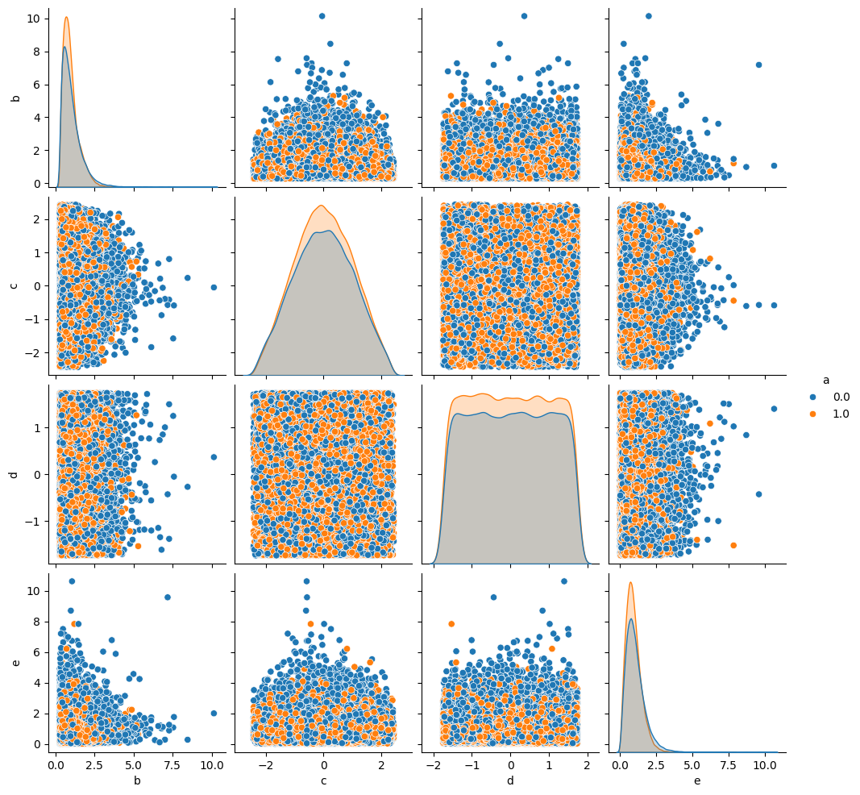

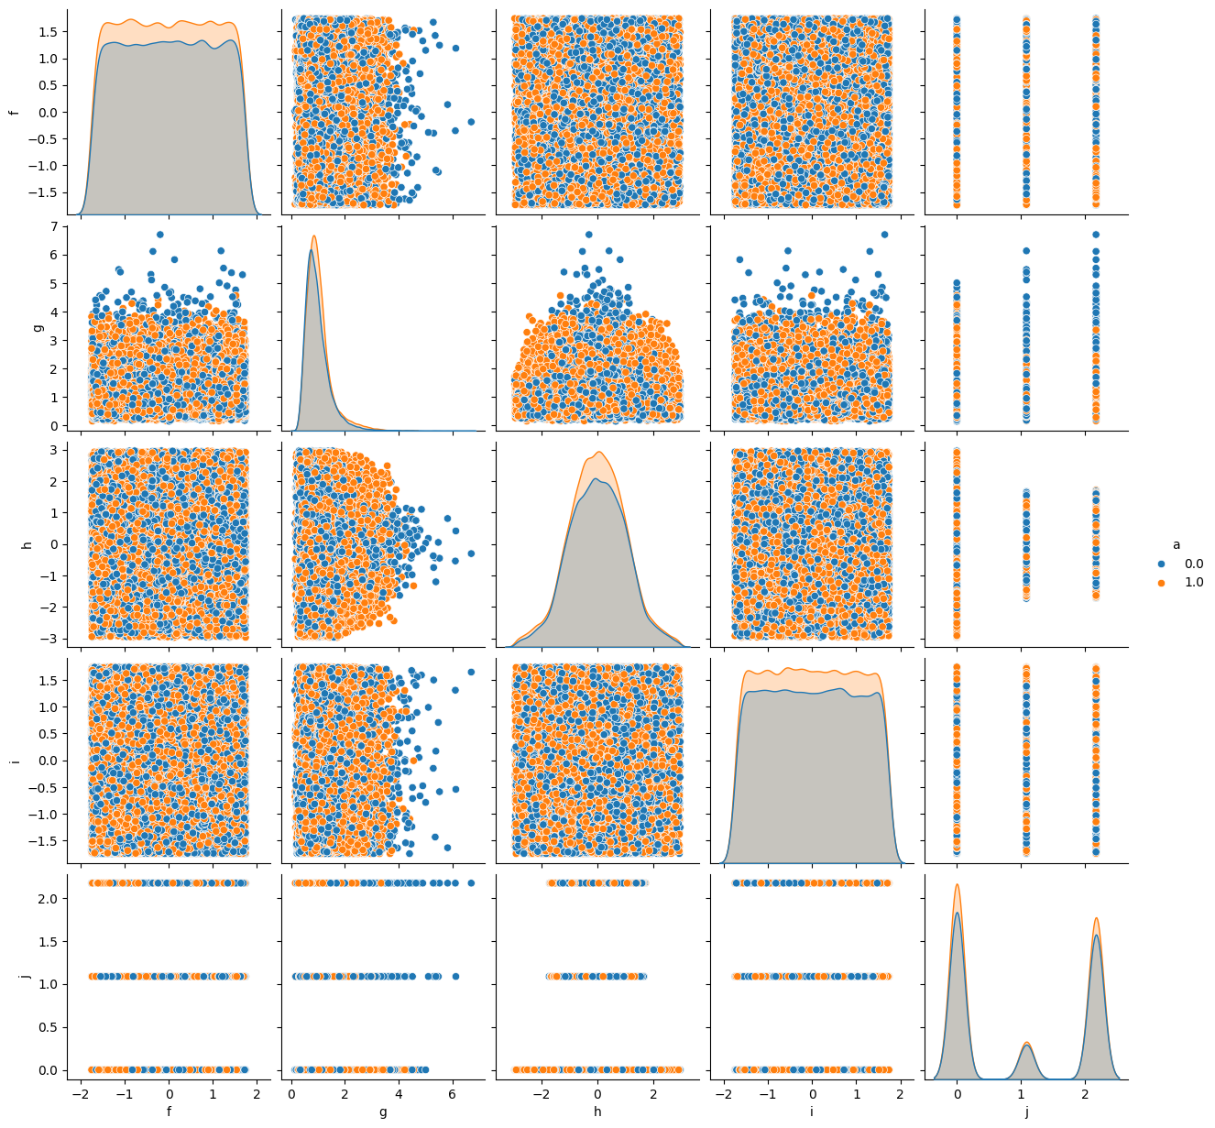

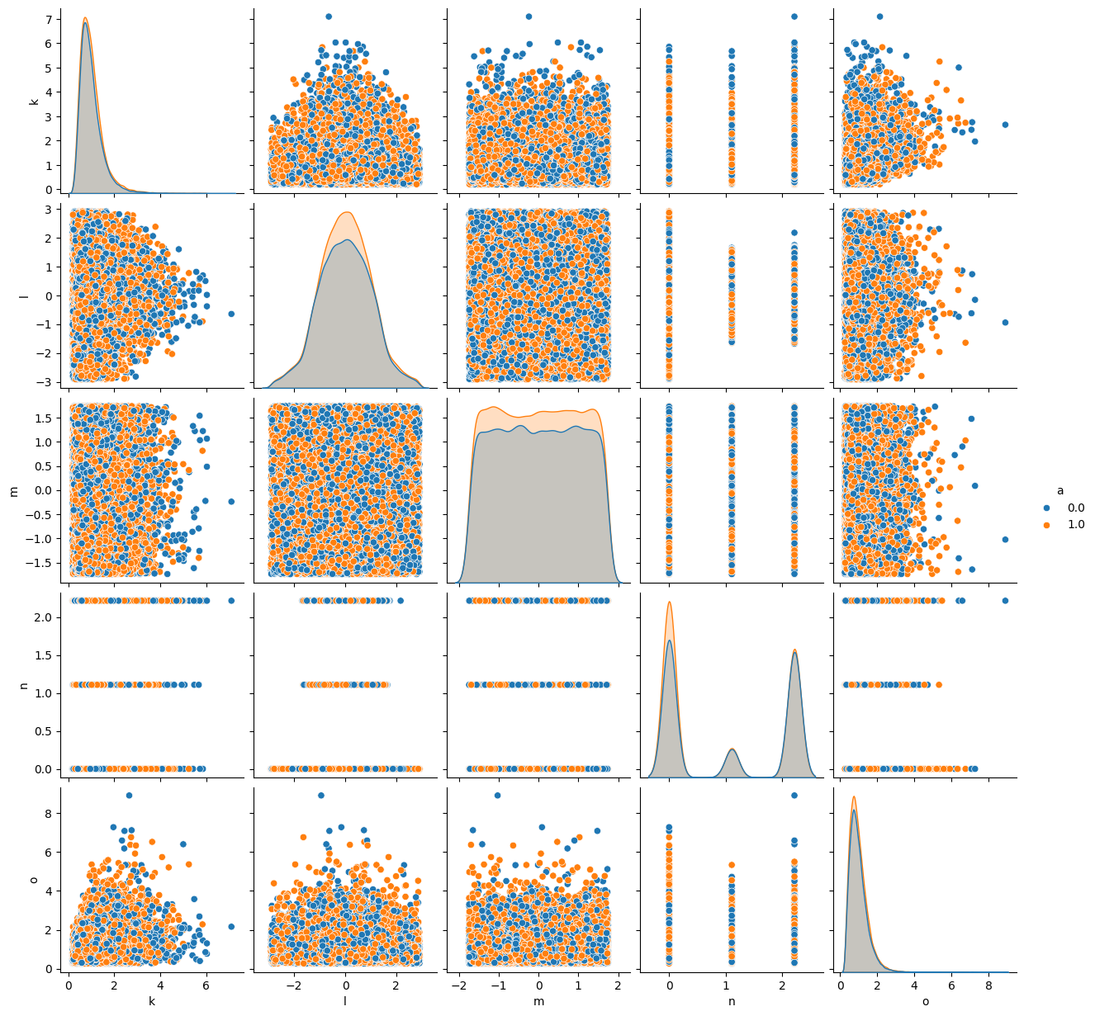

The initial visual analysis of the features’ interactions with each other fails for it is obvious from the plots that, at least for the first 14 column, there seem to be none meaningful distribution or clustering. However, this is no excuse for not implementing a statistical analysis, which is, in this homework, done by sklearn.feature_selection’s ANOVA test. But before starting off with that, I had first cleaned the outliers by applyting inter quartile ranges. Wherever the feature has a value below or above 1.5 IQR of either the lowest or the highest point, its values is adjusted to the min or max point defined, again, by IQR. Later did I apply min max scaling provided by, again, sklearn.preprocessing’s MixMaxScaler function. And only then did I select the 15 best features determined by sklearn.feature_selection’s SelectKBest function aided by f_classif.

In order to evaluate the model utilizing GridSearch, I first defined the models to be used as well as the parameters provide by the professor. When the search was run, the below results are obtained:

Model | Best_Score | Best_Parameter
KNN | 0.609 | n_neigbours=11
SVM | 0.660 | C=10; Kernel=RBF
MLP | 0.681 | Activation=”Relu”; HLS=100
XGBOOST | 0.676 | No parameter was provided

Therefore, I will continue with MLP with ReLU as the activation function parameter and 100 neurons as the hidden layer size.

Below are the accuracy, precision, recall, and F1 score for the selected model:

Model | Accuracy | Precision | Recall | F1
MLP | 0.680 | 0.688 | 0.719 | 0.703

The confusion matrix for the results can be seen in the table below:

 | True | False
True | 9036 | 5148
False | 4445 | 11371

Since the Recall is slightly higher than the Accuracy, it can be said that the model has strength over detecting when its not a particle rather than classifying the particles correctly. This is to say, the model has higher type-2 error.

And the ROC curve for the model utilized is below:

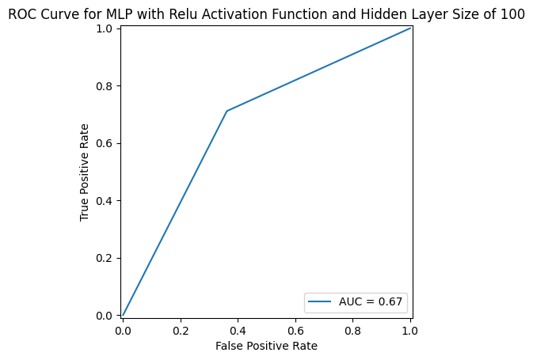

APPENDIX – CODE

import pandas as pd
import numpy as np

import matplotlib.pyplot as plt
import seaborn as sns

# Data Importing
df = pd.read_csv("final.csv")

df.head()

# Checking if the Dependent Variable (column a) is Selected Uniformly

df["a"].value_counts()

# Visualization the Distributions of Pairs of Columns
# to get a better grasp on what's in the data

sns.pairplot(df.iloc[:,0:5], hue="a")

# Visualization the Distributions of Pairs of Columns
# to get a better grasp on what's in the data

sns.pairplot(df.iloc[:,[0,5,6,7,8,9]], hue="a")

# Visualization the Distributions of Pairs of Columns
# to get a better grasp on what's in the data

sns.pairplot(df.iloc[:,[0,10,11,12,13,14]], hue="a")

# IQR

num_outliers_per_column = []

for column in df.columns:
if column=="a":
continue

print(f"Column: {column}")
Q1 = np.percentile(df[column], 25, interpolation = 'midpoint')
Q2 = np.percentile(df[column], 50, interpolation = 'midpoint')
Q3 = np.percentile(df[column], 75, interpolation = 'midpoint')

print(f"Q1 25 percentile of the given data is, {Q1}")
print(f"Q1 50 percentile of the given data is, {Q2}")
print(f"Q1 75 percentile of the given data is, {Q3}")

IQR = Q3 - Q1
print(f"Interquartile range is {IQR}")

low_lim = Q1 - 1.5 * IQR
up_lim = Q3 + 1.5 * IQR
print(f"low_limit is {low_lim}")
print(f"up_limit is {up_lim}")

outlier =[]
for i in range(len(df[column])):
if df[column][i]> up_lim:
outlier.append(df[column][i])
df.loc[i,column] = up_lim

elif df[column][i]< low_lim:
outlier.append(df[column][i])
df.loc[i,column] = low_lim

num_outliers_per_column.append(len(outlier))

print(f"Number of Outliers in column {column} is {len(outlier)}")

print("********************\n\n\n")

# MinMax Scaler

from sklearn.preprocessing import MinMaxScaler

for column in df.columns:
if column=="a":
continue
scaler = MinMaxScaler()
df[column] = scaler.fit_transform(np.array(df[column]).reshape(-1,1))

df.head()

from sklearn.feature_selection import SelectKBest, f_classif

selector = SelectKBest(f_classif, k=15)
selector.fit(df.iloc[:,1:], df.iloc[:,0])

selector.scores_

cols = selector.get_support(indices=True)
df.columns[cols]

df = df.iloc[:,cols]
df.head()

from sklearn.model_selection import train_test_split
X_train, X_test, y_train, y_test = train_test_split(df.iloc[:,1:], df.iloc[:,0], test_size=.3)
from sklearn.model_selection import GridSearchCV

from sklearn.neighbors import KNeighborsClassifier
from sklearn.svm import SVC
from sklearn.neural_network import MLPClassifier
from sklearn.ensemble import GradientBoostingClassifier

model_params = {
"knn": {
"model": KNeighborsClassifier(),
"params": {
"n_neighbors": range(3,12)
}
},
"svm": {
"model": SVC(),
"params": {
"C": [0.1, 1, 10],
"kernel": ['linear', 'rbf']
}
},
"mlp": {
"model": MLPClassifier(),
"params": {
"hidden_layer_sizes": [(50,), (100,)],
"activation": ["relu", "tanh"]
}
},
"XGBoost": {
"model": GradientBoostingClassifier(),
"params": {
"loss":['log_loss']
}
}
}

scores = []

for model, mp in model_params.items():
if model != "XGBoost":
continue
clf = GridSearchCV(mp["model"], mp["params"], cv=5, return_train_score=False)
clf.fit(df.iloc[:,1:], df.iloc[:,0])
scores.append({
"model": model,
"best_score": clf.best_score_,
"best_params": clf.best_params_
})
print(model)

#res = pd.DataFrame(scores, columns=["model", "best_score", "best_params"]).copy()
res

res.iloc[2,2]["hidden_layer_sizes"]
# MLP with relu activation function and hidden layer size of 100 seems to have a better score, thus, it will be utilized from now on

model = MLPClassifier(activation=res.iloc[2,2]["activation"],
hidden_layer_sizes=res.iloc[2,2]["hidden_layer_sizes"])

model.fit(X_train, y_train)

result = model.predict(X_test)
# Accuracy Rate
(np.array(y_test) == result).sum() / len(result)

from sklearn.metrics import accuracy_score, precision_score, recall_score, f1_score, RocCurveDisplay, confusion_matrix, roc_auc_score, roc_curve

# Accuracy Score

accuracy_score(y_test, result)

# Precision Score

precision_score(y_test, result)

# Recall Score

recall_score(y_test, result)

# F1 Score
f1_score(y_test, result)

# Confusion Matrix

confusion_matrix(y_test, result)

# ROC-AUC Score

roc_auc_score(y_test, result)

# ROC Curve

roc_curve(y_test, result)

from sklearn.metrics import RocCurveDisplay, auc

fpr, tpr, threshold = roc_curve(y_test, result)
roc_auc = auc(fpr, tpr)

display = RocCurveDisplay(fpr=fpr, tpr=tpr, roc_auc=roc_auc)
display.plot()

plt.show()

