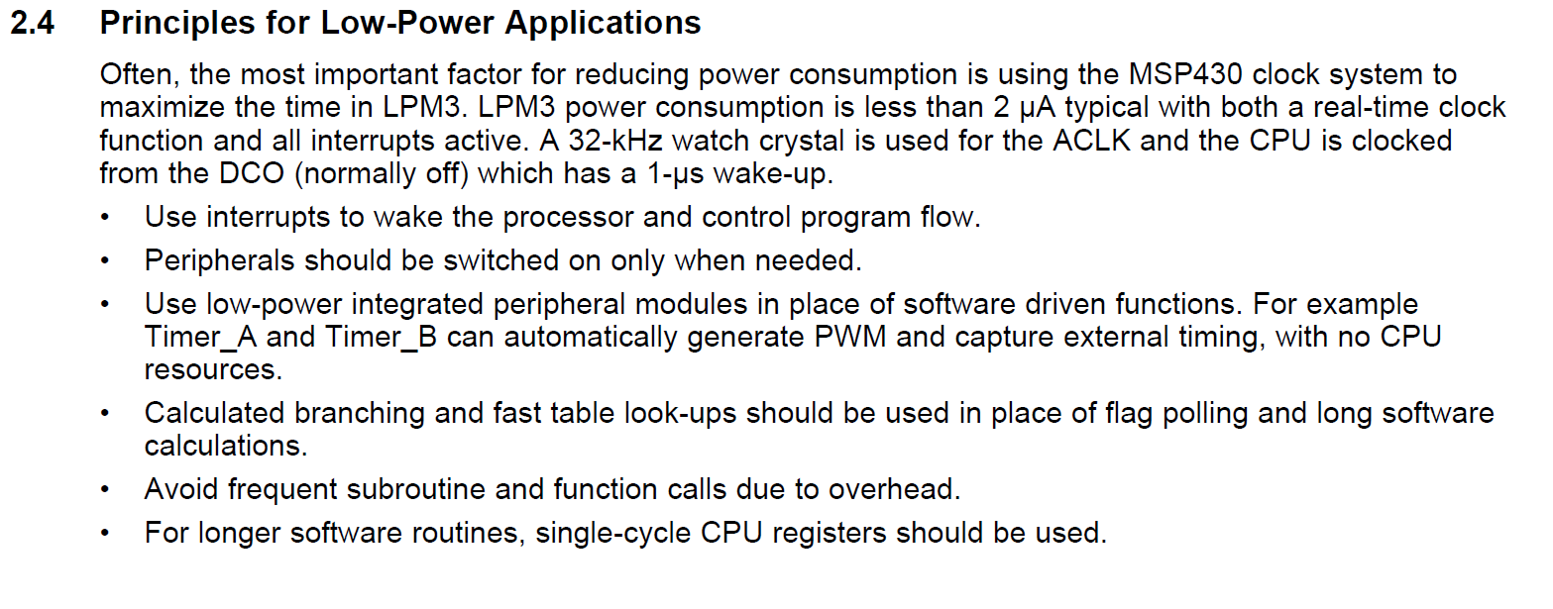

**Cum sa calculezi puterea consumata de un MCU?**

**Total power consumed = Active mode power + Standby (sleep) mode power + Wake-up power**

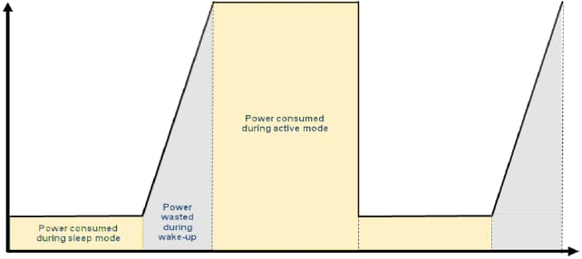

**MSP432P401R**

PRET: 12.99 $

CONSUM: Supply Voltage Range 1.62V to 3.7V Active 80 Ua/MHz

Max freq: 48MHz

* Low-Frequency Active: 83 µA at 128 kHz (Typical)
* LPM3 (With RTC): 660 nA (Typical)
* LPM3.5 (With RTC): 630 nA (Typical)
* LPM4: 500 nA (Typical)
* LPM4.5: 25 nA (Typical)

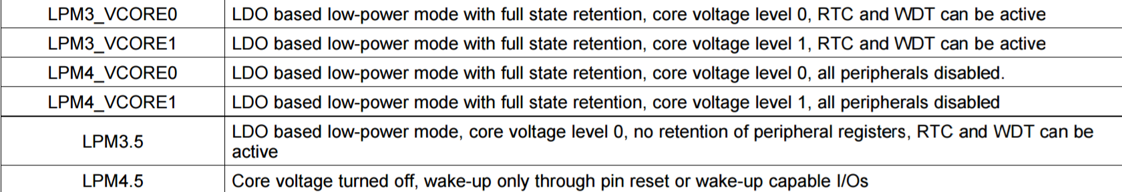

**MSP430F5517**

|  |  |
| --- | --- |
|  |  |

**Max freq: 32Mhz**

ARDUINO UNO v3

Operating Voltage: – 1.8 - 5.5V

Power Consumption at 1 MHz, 1.8V, 25°C:

– Active Mode: 0.2 mA

– Power-down Mode: 0.1 µA

– Power-save Mode: 0.75 µA (Including 32 kHz RTC)

The Power-down mode saves the register contents but freezes the Oscillator, disabling all other chip functions until the next interrupt or hardware reset.

In Power-save mode, the asynchronous timer continues to run, allowing the user to maintain a timer base while the rest of the device is sleeping.

Max freq: 20MHz

Raspberry Pi 3 Model B SBC

Boot- 0.75A MAX & 0.35A AVG

IDLE – 0.3A

Stress – 1.34A MAX & 0.85A AVG

Max Freq: 1.2GHz

Discovery kit with STM32F407VG MCU

Power consumption :

– Run 146 µA/MHz (peripheral off)

– Stop (Flash in Stop mode, fast wakeup time): 42 µA Typ @ 25C; 65 µA max @25 °C

– Stop (Flash in Deep power down mode, fast wakeup time): down to 10 µA @ 25 °C; 30 µA max @25 °C

– Standby: 2.4 µA @25 °C / 1.7 V without RTC; 12 µA @85 °C @1.7 V – VBAT supply for RTC: 1 µA @25 °C 84 MHz

Low-Power Wireless Technologies

**Bluetooth low-energy vs ANT vs ANT+ vs ZigBee vs ZigBee RF4CE vs Wi-Fi vs Nike+ vs IrDA vs NFC**

Bluetooth Low-Energy(LE)

The aim of this technology is to enable power sensitive devices to be permanently connected to the Internet. LE sensor devices are typically required to operate for many years without needing a new battery. They commonly use a coin cell, for example, the popular [CR2032](http://www.digikey.com/product-detail/en/CR2032/P189-ND/31939).

ANT and ANT+

ANT™ is a low-power proprietary wireless technology which operates in the 2.4 GHz spectrum. Typically, the ANT transceiver device is treated as a black box and shouldn't require much design effort to implement into a network. Its primary goal is to allow sports and fitness sensors to communicate with a display unit, for example a watch or cycle computer. ANT+™ has taken the ANT protocol and made the devices interoperable in a managed network, thereby guaranteeing that all ANT+ branded devices work seamlessly.  Similar to LE, ANT devices may operate for years on a coin cell.

ZigBee

It introduces mesh networking to the low-power wireless space and is targeted towards applications such as smart meters, home automation, and remote control units. ZigBee's complexity and power requirements do not make it particularly suitable for unmaintained devices that need to operate for extensive periods from a limited power source. ZigBee channels are similar to those for LE in that they are 2 MHz wide. However, they are separated by 5 MHz, thus wasting spectrum somewhat. ZigBee is not a frequency hopping technology, therefore and requires careful planning during deployment in order to ensure that there are no interfering signals in the vicinity.

ZigBee RF4CE

 ZigBee RF4CE is based on ZigBee. RF4CE's intended use is as a device remote control system, for example for television set-top boxes. The intention is that it overcomes the common problems associated with infrared: interoperability, line-of-sight, and limited enhanced features.

 Wi-Fi

Although Wi-Fi is a very efficient wireless technology, it is optimized for large data transfer using high-speed throughput and is not really suitable for coin cell operation. Some companies are attempting to use Wi-Fi for HUD devices.

 NIKE+

Nike+® is a proprietary wireless technology developed by Nike and Apple to allow users to monitor their activity levels while exercising. Its power consumption is relatively high, returning only 41 days of battery life from a coin cell. Being a proprietary radio, it will only work between Nike and Apple devices.

IrDA

The Infrared Data Association (IrDA) has recently announced an ultra-high-speed connectivity version, yielding 1 Gbps. However, it only works over a distance of less than 10 cm. One of the main problems with infrared (IR) is its line-of-sight requirement, which RF4CE was established to overcome. IrDA® is also not particularly power efficient (power per bit) when compared against radio technologies.

 NFC

Near field communication (NFC) only works up to a range of approximately 5 cm and consumes relatively more power. Passive NFC tags can be completely unpowered, only becoming active when an NFC field is present. That eliminates NFC from many of the use cases discussed here. NFC is a perfect fit for its intended use cases and just that.

Network topologies

* **Broadcast:** A message is sent from a device in the hope that it is received by a receiver within range. The broadcaster doesn't receive signals.
* **Mesh:** A message can be relayed from one point in a network to any other by hopping through multiple nodes.
* **Star:** A central device can communicate with a number of connected devices — Bluetooth is a common example.
* **Scanning:** A scanning device is constantly in receive mode, waiting to pick up a signal from anything transmitting within range.
* **Point-to-Point:** In this mode, a one-to-one connection exits, where only two devices are connected, similar to a basic phone call.

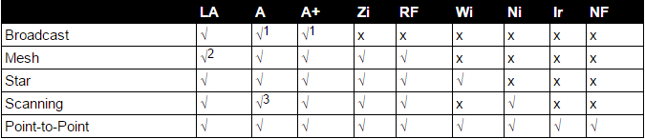

Legend:  **LE** (Bluetooth low energy), **A** (ANT), **A+** (ANT+), **Zi** (ZigBee), **RF** (RF4CE), **Wi** (Wi-Fi), **Ni**(Nike+), **Ir** (IrDA), **NF** (NFC)

Power efficiency

ANT  
An ANT device is configured to transmit 32 bytes/second and consumes 61 μA. (0.686W)

* A byte consists of 8 bits, therefore 32 x 8 = 256 bits/second
* Power = VI = 3 V x 61 μA = 0.183 mW
* Energy per bit = 0.183 mW/256 bits/second = 0.71 μJ/bit

Bluetooth low energy  
Connectable advertising packets (adverts) are broadcast every 500 ms. Each packet has 20 bytes of useful payload and consumes 49 μA at 3 V. For this particular setup, adverts are spread across all three channels, with the positive side effect of increasing robustness over a single-channel technology.

* Power consumption = 49 μA x 3 V = 0.147 mW
* Bytes per second = 20 x (1 second/500 ms) x 3 channels = 120 bytes/second
* Bits per second = 120 bytes/second x 8 = 960 bits/second
* Energy per bit = 0.147 mW/960 bits/second = 0.153 μJ/bit

It should be noted that this configuration uses connectable packets. Therefore, the advertising device is also scanning after each advert. This consumes significant power, but is still lower than its nearest competitor.

IrDA  
A television remote control sends a 14-bit payload. This is implemented with an ultra-low-power processor (consuming 0.1 μA during sleep, allowing for its negligible power consumption to be ignored for this calculation). The transaction takes 1.5 ms at 170 μA, then 114 ms at 55 μA.  This is equivalent to 121 bits/second at 1.948 mA if continually transmitting. Assuming a 3 V battery source, this works out to be 5.844 mW of power consumed to transmit 121 bits of data.

* Power = 5.844 mW
* Bits = 121 bits/second
* Energy per bit = 5.844 mW/121 bits/second = 48.2 μJ/bit

Nike+  
A foot pod lasts 1000 hours and transmits its payload every second. The payload is 34 bytes. A typical CR2032 has 225 mAh.

* Current drawn = 225 mAh/1000 hours = 0.225 mA
* Power = 3 x 0.225 mA = 0.675 mW
* Bits per second = 34 x 8 = 272 bits/second
* Energy per bit = 0.675 mW/272 bits/second = 2.48 μJ/bit

Wi-Fi  
Wi-Fi consumes approximately 116 mA at 1.8 V when transmitting a 40 Mbps(40.000.000bps) User Datagram Protocol (UDP) payload. Unfortunately, current consumption does not reduce when throughput is reduced in a Wi-Fi chipset.

* Power = 116 mA x 1.8 V = 0.210 W
* Energy per bit = 0.210 W/40,000,000 bits/second = 0.00525 μJ/bit

Zigbee  
A Zigbee device consumes 0.035706 W when transferring 24 bytes of data. (0.178W)

* Bits per second = 24 x 8 = 192 bits
* Energy per bit = 0.035706 W/192 bits/second = 185.9 μJ/bi

Conclusion: From the above calculations it is clear that Wi-Fi is the most power efficient technology and would be ideally suited to large file downloads. Unfortunately, its peak current consumption is far beyond the capabilities of a coin cell and would need to be provided with a large battery. Work is being conducted in Wi-Fi groups to lower power consumption, enabling use with HID devices. Currently, proprietary drivers are needed, with the technology only applicable to the personal computer market where receiver power budgets are higher. LE is second, requiring approximately a quarter of the power of its closest competitor, ANT. It is surprising to see how much energy is wasted by infrared remote controls currently in wide global use.

**Range**

* NFC – 5 cm
* IrDA – 10 cm
* Nike+ – 10 m
* ANT(+) – 30 m
* ZigBee – 100 m
* RF4CE based on ZigBee – 100 m
* Wi-Fi – 150 m
* Bluetooth LE – 280 m

**Throughput (** a measure of how many units of information a system can process in a given amount of time **)**

* IrDA ~1 Gbps
* Wi-Fi (lowest power 802.11b mode) ~6 Mbps
* NFC ~424 kbps
* Bluetooth LE ~305 kbps
* ZigBee ~100 kbps
* RF4CE (same as ZigBee)
* ANT+ ~20 kbps
* Nike+ ~272 bps

**Peak power consumption**

|  |  |
| --- | --- |
| * IrDA peak current draw ~ 10.2 mA CR2032 OK |  |
| * Nike+ peak current draw ~ 12.3 mA CR2032 OK |  |
| * LE peak current draw ~ 12.5 mA CR2032 OK |  |
| * ANT peak current draw ~ 17 mA CR2032 OK |  |
| * RF4CE peak current draw ~ 40 mA Too much current demand |  |
| * NFC ~ 50 mA Too much current demand |  |
| * Wi-Fi peak current draw ~ 116 mA (@1.8 V) Too much current demand |  |

**Summary**

ANT is a good example of a technology that is already in mass production and has begun to establish itself as the "sports and fitness" technology. However, it has only managed to sell approximately 15 million chips to date, beginning in 2004 and has only been integrated into three mobile handsets. ANT makes a good attempt at operating from limited power sources and has built a niche ecosystem.

LE is the closest competitor and will be competing in the same markets and many others, offering mobile handset manufacturers a route to a larger ecosystem. LE also provides the best power per bit requirements of the personal space technologies, beaten only by Wi-Fi.

Wi-Fi is normally intended for bulk traffic transfer at high speed. Work is in progress to enable special Wi-Fi chips to operate in HID equipment. However, currently available chipsets for HID over Wi-Fi are proprietary and require a special driver to be installed on Microsoft Windows® 7 PCs. In addition, such systems are likely to consume significant power at the PC end of the link to minimize latency.  
  
ZigBee and RF4CE are virtually the same technology and appear positively power hungry compared with the other radio technologies.  
  
NFC is not seen as a competitor to most low-power wireless technologies, because it brings new use cases to the mobile scene. It is a short range (~5 cm) radio which is ideally suited to "Touch to <action>" applications.  
  
The cost of implementing IR transmit-only is very cheap and may still remain a viable option in low-end televisions for the near future. IR has been around for a long time and is being replaced in most areas by non-line-of-sight radio technology. It is also relatively power hungry. By switching to radio, running costs for traditional IR products will be reduced considerably. In an increasingly environmentally conscious world, this reduction in power consumption is a good thing — it's 'Green.'

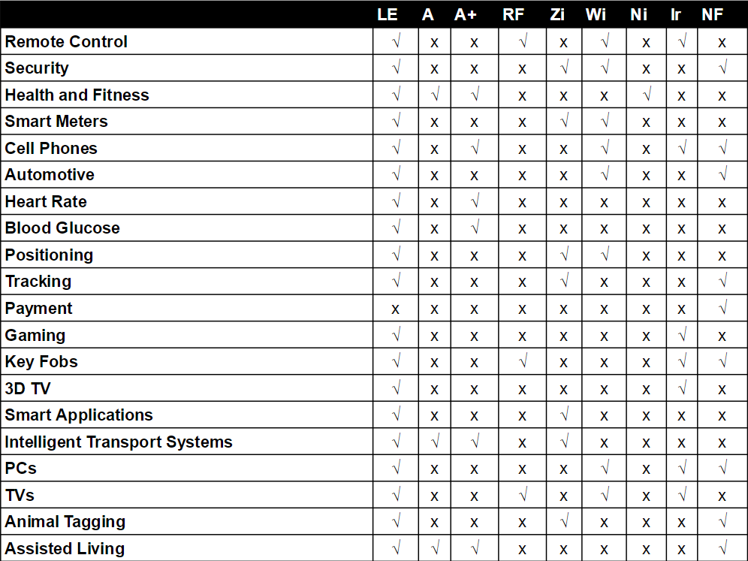

**Consum:**

# ANT (nRF24AP2-8CH)

* 14µA average for Broadcast TX at 0.5Hz message rate
* 54µA average for Broadcast TX at 2Hz message rate
* 11µA average for Broadcast RX at 0.5Hz message rate
* 42µA average for Broadcast RX at 2Hz message rate
* 18µA average for Acknowledged TX at 0.5Hz message rate
* 70µA average for Acknowledged TX at 2Hz message rate
* 13µA average for Acknowledged RX at 0.5Hz message rate
* 52µA average for Acknowledged RX at 2Hz message rate
* 5.9mA average for 20kbps Burst mode
* 500nA deep sleep state
* 2.0µA suspend state
* 15mA Active TX peak current at 0dBm
* 17mA Active RX peak current

# Bluetooth LE (CC2640)

* Active-Mode RX: 5.9 mA
* Active-Mode TX at 0 dBm: 6.1 mA
* Active-Mode TX at +5 dBm: 9.1 mA
* Active-Mode MCU: 61 µA/MHz
* Active-Mode MCU: 48.5 CoreMark/mA
* Active-Mode Sensor Controller: 8.2 µA/MHz
* Standby: 1 µA (RTC Running and RAM/CPU Retention)
* Shutdown: 100 nA (Wake Up on External Events)

# Zigbee (ETRX35x-LRS)

# 

# VCC = 3.0V, TAMB = 25°C, NORMAL MODE unless otherwise stated

# Wi-fi(ESP8266EX)

# 

# The following current consumption is based on 3.3V supply, and 25°C ambient, using internal regulators

# Infrared(RPM873)

# 

SENSORS

**Temperature-TMP102**

The TMP102 is a digital sensor (I2C a.k.a. TWI), has a resolution of 0.0625°C, and is accurate up to 0.5°C. This is a very handy sensor that requires a very low-current. The device is specified for operation over a temperature range of –40°C to +125°C. Communication with the TMP102 is achieved through a two-wire serial interface. There is no on-board voltage regulator, so supplied voltage should be between 1.4 to 3.6VDC.

**Features:**

* 12-bit, 0.0625°C resolution
* Accuracy: 0.5°C - 2°C (-25°C to +85°C) & 1°C - 3°C (-40°C to +125°C)
* Low quiescent current
  + 10µA Active (max)
  + 1µA Shutdown (max)
* 1.4V to 3.6VDC supply range
* Two-wire serial interface

|  |  |  |  |  |  |  |
| --- | --- | --- | --- | --- | --- | --- |
| Conversion Time |  |  |  | 26 | 35 | ms |
| Conversion Modes |  | CR1 = 0, CR0 = 0 |  | 0.25 |  | Conv/s |
|  |  | CR1 = 0, CR0 = 1 |  | 1 |  | Conv/s |
|  |  | CR1 = 1, CR0 = 0 (default) |  | 4 |  | Conv/s |
|  |  | CR1 = 1, CR0 = 1 |  | 8 |  | Conv/s |

**CO2** **- K-30 10,000ppm**

The K-30 Sensor Module is a maintenance-free transmitter module intended to be built into different host devices that require CO2 monitoring data. It is an accurate, yet low-cost solution for OEMs who want to integrate CO2 sensing into their products. The compact size, low-power requirements and multiple output options are intended to be easily implement into analog or microprocessor-based controls and equipment.

**Features:**

* CO2 Measurement: non-dispersive infrared (NDIR)
* Measurement Range: 0 – 10,000 ppm (0-5,000 ppm within specifications)
* Rate of Measurement: 2 seconds
* Response Time: 20 seconds diffusion time; 2 seconds @ .5 l/min tube gas flow
* 4 outputs. 2 analog/ digital selectable and 2 digital only.
* Scalable Analog voltage outputs
* Each digital output has threshold and hysteresis
* Programmable Range: 0-10,000 ppm (custom configuration required)
* Repeatability: ± 20 ppm ± 1 % of measured value within specifications
* Accuracy: ± 30 ppm ± 3 % of measured value within specifications
* Sensor Life Expectancy: > 15 years
* Maintenance Interval: no maintenance required
* Self-Diagnostics: complete function check of the sensor module
* Warm-up Time: < 1 min. (@ full specs < 15 min)
* ABC (Automatic Background Calibration enabled (unless specified OFF))

**ELECTRICAL CHARACTERISTICS**

Power Input.................................................. 5‐14 VDC, stabilized to within 10%

Current Consumption .................................. 40 mA average < 150 mA peak current (averaged during IR lamp ON, 120 msec) < 300 mA peak power (during IR lamp start‐up, the first 50 msec)

Dimensions .................................................. 5.1 x 5.7 x 1.4 cm (Length x Width x approximate Height) Electrical Connections ………......................... Terminals not mounted (G+, G0, OUT1, OUT2, Din1, Din2, Status, TxD, RxD)

**Humidity-** **HDC1080**

The HDC1080 is a digital humidity sensor with integrated temperature sensor that provides excellent measurement accuracy at very low power. The HDC1080 operates over a wide supply range, and is a low cost, low power alternative to competitive solutions in a wide range of common applications. The humidity and temperature sensors are factory calibrated.

## Features

* Relative Humidity Accuracy ±2% (typical)
* Temperature Accuracy ±0.2°C (typical)
* 14 Bit Measurement Resolution
* 100 nA Sleep Mode Current
* Average Supply Current:
  + 710 nA @ 1sps, 11 bit RH Measurement
  + 1.3 µA @ 1sps, 11 bit RH and Temperature   
    Measurement
* Supply Voltage 2.7 V to 5.5 V
* I2C Interface

|  |  |  |  |  |  |  |  |  |
| --- | --- | --- | --- | --- | --- | --- | --- | --- |
| **RELATIVE HUMIDITY SENSOR** | |  |  |  |  |  |  |  |
| RH | Response Time(9) | t | 63 | % (10) |  | 15 |  | s |
| RT |  |  |  |  |  |  |  |
| RH | Conversion Time(7) | 8 bit resolution | | |  | 2.50 |  | ms |
| CT |  |  |  |  |  |  |  |  |
|  |  | 11 bit resolution | | |  | 3.85 |  | ms |
|  |  | 14 bit resolution | | |  | 6.50 |  | ms |
| **TEMPERATURE SENSOR** | |  |  |  |  |  |  |  |
| TEMPACC | Accuracy(7) | 5°C < TA< 60°C | | |  | ±0.2 | ±0.4 | °C |
| TEMPREP | Repeatability(7) | 14 bit resolution | | |  | ±0.1 |  | °C |
| TEMPCT | Conversion Time(7) | 11 bit accuracy | | |  | 3.65 |  | ms |
|  |  | 14 bit accuracy | | |  | 6.35 |  | ms |

**Light -** **TSL2561**

The TSL2561 luminosity sensor is an advanced digital light sensor, ideal for use in a wide range of light situations. Compared to low cost CdS cells, this sensor is more precise, allowing for exact lux calculations and can be configured for different gain/timing ranges to detect light ranges from up to 0.1 - 40,000+ Lux on the fly. The best part of this sensor is that it **contains both infrared and full spectrum diodes**! That means you can separately measure infrared, full-spectrum or human-visible light. Most sensors can only detect one or the other, which does not accurately represent what human eyes see (since we cannot perceive the IR light that is detected by most photo diodes).

* 16-Bit Digital Output with SMBus (TSL2560) at 100 kHz or I2C (TSL2561) Fast-Mode at 400 kHz
* Programmable Analog Gain and Integration Time Supporting 1,000,000-to-1 Dynamic Range
* Automatically Rejects 50/60-Hz Lighting Ripple
* Low Active Power (0.75 mW Typical) with Power Down Mode

|  |  |  |  |  |  |  |  |  |  |  |  |  |  |
| --- | --- | --- | --- | --- | --- | --- | --- | --- | --- | --- | --- | --- | --- |
|  | | **PARAMETER** | | **TEST CONDITIONS** | | **MIN TYP** | | | **MAX** | | **UNIT** | |  |
|  | |  | |  | |  | | |  | |  | |  |
| IDD | | Supply current | | Active | | 0.24 | | | 0.6 | | mA | |  |
|  | |  | | |  | |  | |  |
| Power down | | 3.2 | | | 15 | | μA | |  |
|  | |  | |  |
|  | |  | |  | |  | | |  | |  | |  |
| VOL | | INT, SDA output low voltage | | 3 mA sink current | | 0 | | | 0.4 | | V | |  |
|  | |  | | |  | |  | |  |
| 6 mA sink current | | 0 | | | 0.6 | | V | |  |
|  | |  | |  |
|  | |  | |  | |  | | |  | |  | |  |
|  | |
| t(CONV) | | | | Conversion time | |  | 12 | 100 | 400 | | ms | |

# 