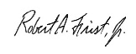

2017

Year

Certificate is awarded to

Matt Emerson

in recognition as a

Super Star Winner

Thank you for providing an outstanding example of HealthStream’s values-in-action.

Robert A. Frist, Jr., Chief Executive Officer, HealthStream