Web-based Appointment System for
Kaye’s Hair Salon and Spa

A CAPSTONE PROJECT
Presented to
The Faculty of Computer Science and Information Technology Department
Negros Oriental State University, Main Campus I, Dumaguety City

In Partial fulfillment of the Requirements
for the Degree of Bachelor of Science in Information Technology

By
Sapan, Ruffa S.
Torres, Charlotte B.
Tubat, Analiza Y.

MAY 2026
ABSTRACT

CHAPTER 1
INTRODUCTION
Project Context
In today’s technology-driven world, service-oriented businesses are increasingly required to adopt digital solutions to remain competitive, efficient, and responsive to customer needs. As client expectations shift toward faster transactions, organized scheduling, and convenient service access, traditional manual systems become insufficient in handling growing operational demands. Appointment management, in particular, plays a critical role in ensuring smooth workflow, minimizing waiting time, and maintaining service reliability. However, businesses that continue to rely on manual booking processes often experience scheduling conflicts, record inaccuracies, and operational delays, which ultimately affect customer satisfaction and overall service quality (Leony and Prayitno, 2025). These realities highlight the growing need for structured and automated appointment management systems in service industries such as beauty and wellness salons.
Kaye’s Hair Salon and Spa, located in Dumaguete City, Negros Oriental, is a local beauty establishment that offers various hair and wellness services to a steadily increasing clientele. At present, the salon manages appointments using handwritten logbooks and direct communication through phone calls or social media messages. While this method was manageable during periods of lower customer volume, it has become increasingly challenging as the number of clients grows. The salon faces issues such as double bookings, delayed appointment confirmations, and challenges in maintaining organized customer records. These operational inefficiencies disrupt workflow coordination and may lead to longer waiting times and inconsistent service experiences.
To address these challenges, the researchers propose the development of a Web-Based Appointment System specifically designed for Kaye’s Hair Salon and Spa. The system aims to digitize appointment scheduling, centralize customer records, and provide structured access to scheduling information through role-based authentication for administrators and managers. By implementing an organized digital platform, the system seeks to reduce human error, prevent booking conflicts, improve availability monitoring, and enhance service coordination.
Purpose and Description
Appointment management systems have become essential tools in various industries, including healthcare, hospitality, and personal care services. Globally and locally, web-based platforms are widely adopted due to their accessibility, scalability, and cost-effectiveness. These systems allow users to access services through internet-enabled devices without requiring installation, making them suitable for small and medium-sized enterprises.
Modern appointment systems typically include features such as online booking, real-time availability checking, automated confirmations, centralized databases, and controlled user access. These technologies improve scheduling accuracy, minimize manual errors, and enhance coordination between service providers and clients. Despite the availability of commercial solutions, many small businesses face challenges in adopting such systems due to cost constraints,
lack of customization, and complexity of implementation. Some existing software solutions may not align with specific operational workflows, limiting their effectiveness for local establishments.
In the case of Kaye’s Hair Salon and Spa, the absence of a structured digital appointment platform results in scheduling inefficiencies, and inconsistent record management. These limitations demonstrate the need for a tailored, web-based solution that directly addresses the salon’s operational challenges. The proposed Web-Based Appointment System is intended to provide appointment lifecycle management, role-based access control, service listing management, availability monitoring, and centralized data storage. By addressing these existing gaps, the system aims to improve operational efficiency, scheduling reliability, and customer experience.
Objectives
The study aimed to achieve the following general and specific objectives for developing and implementing the Web-Based Appointment System for Kaye’s Hair Salon and Spa. The general objective of this study is to design, develop, and implement a Web-Based Appointment System that improves scheduling efficiency and service coordination at Kaye’s Hair Salon and Spa within the project development period.
Specific Objectives
To accomplish the general objective, the study aims to:
- To analyze the existing manual appointment scheduling process of Kaye’s Hair Salon and Spa within the initial phase of the project to identify operational inefficiencies and define system requirements.
- To design a secure and user-friendly web-based system architecture that supports appointment booking, role-based authentication, service management, and availability monitoring.
- To develop and integrate appointment lifecycle management functionalities, including booking, confirmation, rescheduling, cancellation, completion tracking, and appointment record generation.
- To implement controlled access mechanisms for administrators and managers to ensure secure and organized system usage.
- To test the developed system through functional and usability testing to ensure reliability, accuracy, and user satisfaction.
Scope and Limitations
Scope
This study covers the design, development, and implementation of a Web-Based Appointment System specifically tailored to the operational workflow of Kaye’s Hair Salon and Spa. The system focuses on automating appointment scheduling and organizing customer records within a centralized digital database.
The system includes functionalities such as online appointment booking, appointment lifecycle management, service listing and selection, role-based authentication for administrators, managers, availability monitoring, holiday and non-working day management, ratings and reviews submission with moderation, dashboard monitoring tools, and appointment confirmation record generation. The system is accessible through internet-enabled devices and is intended for use by salon management and customers. The project development, testing, and evaluation are conducted within the academic timeframe allocated for the capstone project.

Limitations
The researchers focused on developing a Web-Based Appointment System aimed at enhancing the efficiency and effectiveness of Kaye’s Hair Salon and Spa by automating appointment scheduling and improving customer record management. The system is limited to appointment scheduling, service coordination, and customer record management functionalities. Advanced enterprise-level modules such as comprehensive payroll processing, full financial accounting systems, and large-scale automated inventory management are not included within the scope of this project.
The system requires stable internet connectivity and server hosting to operate effectively. Interruptions caused by network issues, hardware failure, or third-party service disruptions are beyond the control of the researchers. Furthermore, the system is customized specifically for Kaye’s Hair Salon and Spa and may require structural modifications for implementation in other establishments with different operational workflows.
Although a mobile application could further enhance accessibility and convenience, it is not included in the current implementation. The development of a mobile-based platform is recommended as a future enhancement to expand system accessibility and improve user experience.
Significance of the Project
This project aims to enhance the efficiency and effectiveness of Kaye’s Hair Salon and Spa’s operations by automating appointment scheduling and improving customer record management through a web-based platform. By focusing on the development of a structured appointment management system, the project addresses key administrative challenges while promoting organized and reliable service delivery. The system demonstrates how web-based technologies can be applied to modernize traditional manual processes in service-oriented businesses.
For the Salon Owner and Manager. The system provides organized and real-time access to appointment records and customer information. This supports informed decision-making, improves schedule coordination, and enhances overall operational oversight.
Customers. The system offers a convenient and structured way to book appointments, view scheduling information, and receive confirmations. This improves accessibility, reduces waiting times, and enhances overall service experience.
Business and Local Community. The implementation of a web-based appointment system strengthens the salon’s professional image and contributes to improved service efficiency within the local service industry. It encourages digital adoption among small enterprises and promotes the modernization of business practices.
For the Field of Information Technology and Future Developers. The project serves as a practical example of applying web-based system development, database management, and role-based access control to solve real-world operational challenges. It highlights the importance of customized system design in addressing specific business workflows rather than relying solely on generic commercial software solutions.

CHAPTER II
REVIEW OF RELATED LITERATURE AND SYSTEMS
This chapter reviews some of the related literature and studies made by other researchers. This review aims to consolidate insight from various studies, providing a comprehensive overview and offering insight into best practices for further research and improvement.
Related Literature
Customization has been recognized as an important innovation strategy for appointment scheduling applications (ASA) used by service providers such as hair salons, dentists, spas, and physicians. A study conducted to determine whether foreign-developed scheduling systems should be adapted to meet the specific requirements of the Serbian market highlighted the importance of contextual system design (Stamatović et al., 2020). Using strategic analysis tools such as SWOT, PESTEL, strategic group mapping, and the Delphi method, the researchers evaluated both environmental factors and internal organizational capabilities. The findings indicated that off-the-shelf global applications did not sufficiently address local needs, particularly in terms of language support, payment integration, and technical infrastructure limitations. The study emphasized that customization improves system usability and enhances customer experience, increasing the likelihood of adoption among service providers.
Online reservation systems have become increasingly important in enhancing customer satisfaction and encouraging continued usage in beauty salons. In an empirical investigation involving 350 beauty salon consumers in Seoul, researchers analyzed how convenience and additional service features influence perceptions of system quality (Moon & Yang, 2021). The study applied statistical techniques such as factor analysis, correlation analysis, and regression analysis to examine the relationships among variables. Results showed that higher perceived system quality significantly increases customer satisfaction, which subsequently strengthens users’ intention to continue using the reservation system. Features such as online payment options, designer selection, and promotional benefits were identified as key contributors to positive user experiences. The findings suggest that continuous improvement of the reservation system quality is essential for fostering customer loyalty and ensuring the sustained use of digital booking platforms in the beauty industry.
Digitalization has increasingly transformed the professional hairdressing industry by reshaping business operations and stakeholder interactions. The factors that drive the adoption of digital technologies in professional haircare services are examined, and how these changes influence consumer engagement. Using a mixed-methods approach, the researchers gathered quantitative data through online surveys and qualitative insights from virtual interviews with industry participants. The findings revealed that digitalization significantly enhances operational efficiency and improves consumer experiences by enabling more convenient and streamlined interactions. The results further emphasized that digital tools positively influence how services are delivered and perceived, indicating that industry stakeholders benefit substantially from integrating digital systems into their operations (Kokong & Naidoo, 2022).
Reservation systems have become an important tool for improving customer experience and operational efficiency in the salon and spa industry. (Permatasari et al., 2023) analyzed the role of reservation systems through a literature review that examined the benefits, challenges, and best practices associated with digital booking platforms. The findings revealed that reservation systems enhance operational efficiency, minimize cancellations and no-shows, and improve customer convenience through features such as real-time scheduling, automated reminders, and personalized services. The study also highlighted the importance of customer data management and analytics in supporting better business decision-making. However, several challenges were identified, including technological readiness, the need for staff training, customer adaptation to digital platforms, and concerns regarding data security. The study concluded that implementing integrated and user-friendly reservation systems can significantly improve service quality and customer satisfaction in salon and spa businesses.
Customer trust has become an important factor in the adoption of digital reservation systems in the salon industry, especially after the shift toward contactless services. The impact of beauty salon reservation systems and service quality on customer trust in the post-COVID-19 environment was examined by (Jeon and Jin, 2023). The research involved a survey of 301 respondents, and statistical analyses such as factor analysis, reliability testing, and multiple regression were performed using SPSS. The results showed that reservation system factors, particularly convenience and speed, significantly increased customer trust. In addition, service quality dimensions, including responsiveness, tangibility, and reliability, were also found to positively affect trust levels. These findings suggest that efficient reservation processes and high service quality strengthen customer confidence in salon services. The study concluded that improving the quality of online and contactless reservation systems is essential for enhancing customer trust and sustaining salon operations in the evolving digital environment.
Electronic appointment systems are widely used to improve scheduling efficiency and service accessibility in various organizations. In a study that assessed patient satisfaction with an electronic appointment system in a public hospital in Thessaloniki (Kitsios et al., 2023) analyzed survey data focusing on perceived service quality, website quality, and overall system satisfaction. The findings revealed that users were generally dissatisfied with the system, particularly with usability and service quality. The results also indicated that website quality significantly influenced patient satisfaction and the acceptance of the system. Furthermore, usability issues and ineffective service delivery were ide ntified as key barriers to system adoption. Based on these results, the researchers recommended improvements in system design and communication to enhance the effectiveness of electronic appointment platforms.
User satisfaction plays an important role in the continued use of digital reservation platforms across service industries. A study on user dissatisfaction with a restaurant mobile booking platform utilized importance–performance analysis to evaluate both functional features and user experience factors that influence continued usage of reservation applications (Clemente et al., 2023). The analysis identified several performance attributes that were considered important by users but were not meeting their expectations, indicating areas that require improvement. These gaps were highlighted as priority concerns for system developers and service providers. The researchers recommended targeted improvements focusing on usability, reliability, and system responsiveness to enhance user experience. The study also contributed a practical evaluation framework for assessing mobile reservation platforms.
(Lee and Ko, 2023) examined the moderating effect of consumer behavior on the relationship between consumer perception of beauty salon reservation systems and revisit intention. The study aimed to determine whether consumer behavior strengthens the influence of reservation system perception on customers’ intention to return to a salon. Data were collected from 298 respondents residing in Daejeon, and statistical analyses were conducted using SPSS and the PROCESS macro to test regression and moderation effects. The findings revealed that consumer perception of the beauty salon reservation system had a significant positive effect on both consumer behavior and revisit intention. Furthermore, consumer behavior was found to significantly influence revisit intention and to moderate the relationship between perception and revisit intention. The results suggest that when customers perceive the reservation system as convenient, efficient, and easy to use, they are more likely to engage in positive consumption behaviors such as repeat purchases and word-of-mouth promotion, ultimately increasing revisit intention.
Consumer perception of digital reservation systems can influence customer loyalty and their intention to revisit service establishments. (Lee and Ko, 2023) examined the moderating effect of consumer behavior on the relationship between consumer perception of beauty salon reservation systems and revisit intention. Data were collected from 298 respondents residing in Daejeon, and statistical analyses were conducted using SPSS and the PROCESS macro to test regression and moderation effects. The findings showed that consumer perception of the beauty salon reservation system had a significant positive effect on both consumer behavior and revisit intention. Furthermore, consumer behavior was found to significantly influence revisit intention and to moderate the relationship between perception and revisit intention. The results suggest that when customers perceive the reservation system as convenient, efficient, and easy to use, they are more likely to engage in positive consumption behaviors such as repeat purchases and word-of-mouth promotion, which ultimately increases their intention to revisit the salon.
Automation technologies are increasingly being adopted to improve operational efficiency in service-based businesses such as salons. The study “Optimizing Salon Services: Reducing Scheduling Errors and Wait Times Through Automation” (Choudhary et al., 2025) examined how automation can address common problems in salon operations, including scheduling conflicts, long waiting times, and inefficient resource utilization caused by manual booking systems. The research applied Business Process Reengineering (BPR) and simulation modeling to compare traditional processes with automated and AI-enhanced appointment management models. The findings showed that automation significantly reduced service delays and improved staff utilization, while the integration of artificial intelligence further enhanced operational efficiency and customer satisfaction. The study emphasized the importance of adopting technology-based appointment systems to streamline salon service management and improve overall operational performance.
Related Systems
A web-based appointment booking system was developed to address inefficiencies caused by manual scheduling processes, including long waiting times, double bookings, and difficulties in managing customer records (Ningrum et al., 2023). The study applied the Waterfall development methodology, beginning with requirements analysis, system design, implementation, testing, and deployment. The system was developed using PHP for backend programming and MySQL as the database management system to ensure structured and centralized data storage. Core features included user registration and login authentication, service selection, online appointment scheduling, administrative monitoring of bookings, and automated data management. Functional testing results indicated that the system effectively reduced scheduling conflicts and improved accuracy in managing customer appointments. The implementation streamlined the booking process, minimized manual errors, centralized customer information, and enhanced overall operational efficiency. The findings demonstrated that transitioning from a manual reservation process to a web-based appointment system significantly improves service management and customer convenience in service-oriented businesses.
The L Six Hair Studio Management System was developed as a web-based application designed to enhance salon operational efficiency by addressing limitations of manual appointment booking, fragmented customer record management, and unstructured service coordination (Lim and Nawi, 2023). The study aimed to centralize business processes into a unified online platform accessible to customers, employees, and administrators. The system was developed using web-based technologies to support structured database management and real-time appointment monitoring. Core features included customer registration and login authentication, online appointment scheduling, service information management, administrative dashboards for monitoring bookings, and centralized data storage to ensure accurate record keeping. System evaluation demonstrated that the implementation effectively minimized scheduling conflicts, improved the accuracy of customer data, and streamlined communication between salon staff and clients. The findings indicated that transitioning from a manual system to a web-based salon management platform significantly improves operational workflow, booking efficiency, and overall service quality in hair studio businesses.
A secure web-based booking appointment system with graphical password authentication was developed for Diva Hair Salon to address inefficiencies caused by manual booking methods, including walk-in reservations, phone calls, and social media messaging, which led to scheduling conflicts, disorganized records, and weak data security (Roslan and Abd Warif, 2023). The study applied the Agile development methodology, incorporating iterative phases such as planning, requirement analysis, design, implementation, testing, and deployment to ensure flexibility and system reliability. The system was developed using HTML, CSS, PHP, and JavaScript, supported by XAMPP and phpMyAdmin for database management. Core features included user registration and login authentication with both text-based and graphical passwords, hashing and salting of user credentials, role-based access control for admin, staff, and customers, online appointment scheduling, payment receipt upload, QR code verification for attendance tracking, report generation, and a first-time login password reset module. Functional testing and user acceptance testing demonstrated that the system effectively minimized booking conflicts, improved appointment organization, enhanced data security, and streamlined communication between customers and salon staff. The implementation centralized business operations, reduced manual errors, strengthened authentication mechanisms, and improved overall operational efficiency. The findings demonstrated that integrating graphical password authentication and security features into a web-based booking system significantly enhances system security, booking accuracy, and service management in salon businesses.
Manual booking processes in salons often require phone calls or in-person reservations, which can result in long waiting times and greater effort for customers. To address these limitations, an online salon booking system was developed to modernize appointment scheduling and improve interaction between clients, salons, and stylists through a web-based application (Kannake et al., 2023). The system allows users to browse salons and stylists, make or cancel appointments, and view schedules in an organized online environment. Its architecture utilized MySQL as the backend database and PHP for server-side development to centralize data handling and ensure reliable storage of booking information, while HTML, CSS, and JavaScript were used to create an intuitive user interface. Key functionalities include user account registration and authentication, appointment scheduling, stylist and service listings, and review and rating features that enhance user experience and support salon business growth. By enabling customers to interact with salon services online without physical presence, the system reduces queue times and improves service delivery. The study concluded that implementing an online salon booking platform can streamline operational workflows, increase customer satisfaction, and support data-driven decision-making for salon administrators.
An Online Salon Appointment and Management System for FOREVER18 Hair Salon was developed to address inefficiencies caused by manual appointment recording, including scheduling conflicts, missed appointments, and limited tracking of customer preferences (Khoo and Omar, 2024). The study applied the Waterfall development methodology, consisting of planning, analysis, design, implementation, and testing phases to ensure structured system development. The system was developed as a web-based platform that integrates customer and administrative modules supported by a centralized database for organized data management. Core features included user registration and login authentication, calendar-based appointment booking with time slot and hair cutter selection, appointment management on the administrator side, service management, customer records tracking, invoice generation, product management, employee management, review management, and sales report generation with service popularity visualization through pie charts. Functional testing and user acceptance testing results indicated that the system effectively reduced missed appointments, minimized scheduling conflicts, and improved operational workflow. The implementation streamlined salon operations, enabled tracking of service trends and customer preferences, centralized appointment and sales data, and enhanced decision-making through automated reporting. The findings demonstrated that transitioning from a manual booking process to an integrated online appointment and management system significantly improves operational efficiency, customer satisfaction, and data-driven business management in salon enterprises.
Manual booking processes in salons often lead to scheduling conflicts, human errors, difficulty in managing appointments, and risks related to data security. To address these issues, an Appointment Management System with Two-Factor Authentication (2FA) was developed for Elvira True Beauty Salon (Yeap and Foozy, 2024). The study applied the System Development Life Cycle (SDLC) Prototype Model to analyze requirements and iteratively develop the system through planning, analysis, design, implementation, and testing phases. The system was built using PHP for backend programming and HTML, CSS, and JavaScript for front-end development, supported by a MySQL database and hosted using InfinityFree. Key features included user registration and login authentication, online appointment booking with conflict checking, rescheduling and cancellation options, dashboard monitoring for staff and administrators, service and staff availability management, report generation, and role-based access control. Security measures such as strong password policies, CAPTCHA verification, Two-Factor Authentication (2FA) using One-Time Passwords (OTP) via WhatsApp, login attempt limitations, automatic session termination, and SSL encryption were also implemented. Testing results showed improved booking organization, stronger authentication mechanisms, and reduced operational errors, demonstrating that integrating advanced security features into a web-based appointment management system enhances data protection, operational efficiency, and service reliability in salon businesses.
Manual and decentralized salon management processes often lead to inefficiencies such as fragmented client records, inconsistent sales monitoring, and inventory mismanagement. To address these issues, BEauTify, an information system for company-owned salons with multiple branches in the National Capital Region (NCR), was developed (Oliverio et al., 2024). The study applied the Design Thinking methodology, including the Empathize, Define, Ideate, Prototype, and Test phases, to analyze operational problems and design a centralized salon management solution. The system was built using PHP, HTML, CSS, JavaScript, MySQL, and XAMPP, allowing access for customers, branch administrators, and main office administrators. Key features included appointment scheduling with reference number confirmation, sales report generation, salon reviews and inquiries, client data record management, inventory management for branches and the main office, and dashboards for multi-branch sales monitoring. Functional testing with customers and staff produced high evaluation scores, indicating strong usability and operational efficiency. The findings showed that transitioning from manual and Excel-based processes to a centralized web-based platform significantly improves sales tracking, coordination, inventory control, and data-driven decision-making in salon enterprises.
Manual booking processes in salons often lead to missed appointments and scheduling conflicts that affect operational efficiency. To address these issues, an advanced web-based appointment system for hairdressers and barbers was developed (Avuçlu and Taptal, 2024). The system was built using Node.js and modern web technologies such as React and TypeScript, supported by a structured database. Its core features included online appointment booking and cancellation, a penalty system for missed appointments, employee management, working hour configuration, and notification mechanisms. The platform also provided role-based access for business owners, employees, and customers to improve operational control. Implementation results showed that the system successfully reduced no-show rates, improved appointment organization, and strengthened communication between customers and service providers. The study demonstrated that adopting a web-based appointment management system significantly enhances operational efficiency and customer satisfaction in salon businesses.
Operational challenges in the salon industry, particularly during and after the COVID-19 pandemic, highlighted the limitations of manual booking processes and their impact on business turnover. To address these issues, BeautyHare, a web-based management system designed to digitalize salon services, was developed (Blancaflor et al., 2024). The study applied the Modified Waterfall Software Development Life Cycle (SDLC) methodology to guide system analysis, design, implementation, and testing. The system includes automated scheduling, digital booking records, real-time availability tracking, service management, email notifications, and administrative dashboards. It also integrates authentication, authorization, analytics, and payment gateway features to support secure and efficient operations. Functionality testing showed that all test cases passed successfully, indicating system reliability, while User Acceptance Testing revealed high usability ratings from both customers and salon representatives. The findings indicated that implementing a centralized web-based salon management platform significantly improves booking efficiency, operational management, and digital competitiveness in the salon industry.
Common challenges in lash salons include difficulty in selecting suitable lash styles, inefficient manual appointment systems, and limited access to nearby service providers. To address these issues, Lash Tech, a web-based application integrating artificial intelligence, virtual try-on technology, and geo-location services, was developed (Torres et al., 2024). The system utilized facial recognition algorithms to analyze users’ facial features and recommend appropriate lash styles, while the virtual try-on feature allowed clients to preview styles before booking. Geo-location functionality helped users locate salons within their area, and an integrated booking system enabled seamless appointment scheduling. The application was evaluated using the ISO 25010:2011 software quality standards, and testing results showed high user satisfaction with an overall mean rating of 4.50 out of 5.00. The findings demonstrated that integrating AI-powered personalization, location services, and online booking significantly enhances customer convenience, decision-making, and overall service efficiency in the beauty industry.
Manual booking processes in small salon businesses often result in scheduling conflicts, inaccurate records, and long customer waiting times. To address these issues, a web-based online reservation system for Jimmy Salon was developed (Leony and Prayitno, 2025) to support the digital transformation of small beauty service enterprises. The system allows customers to make reservations without requiring user registration and was developed using the Waterfall model, which includes requirement analysis, system design, implementation, testing, and maintenance. It was built using PHP, HTML, CSS, and MySQL, with XAMPP used as the local development server. Core features include service selection for bridal makeup and wedding cake orders, online reservation submission, admin confirmation and status management, and database storage of booking records. Black Box testing confirmed that all functional modules operated according to specifications. The implementation significantly improved efficiency by reducing the average reservation time from about 15 minutes to 3 minutes, demonstrating that a web-based reservation system can enhance operational efficiency, improve customer convenience, and strengthen the professional image of small salon businesses undergoing digital transformation.
Manual scheduling and order management processes in salons often lead to inefficiencies in handling appointments and product transactions. To address these issues, a web-based booking application for services and care products at Lia Salon was developed (Angali et al., 2025). The study applied the Prototyping development methodology, which allowed iterative system refinement based on user feedback collected through observation and interviews. The application was implemented using PHP with the Laravel framework and MySQL as the database management system to ensure structured data storage and efficient transaction handling. Core features included user authentication, service and product listings, online booking and ordering, and an administrative dashboard for managing orders and inventory. Implementation results showed improved efficiency in appointment scheduling and product transactions, enhanced customer convenience, and better organization of salon data. The findings indicated that adopting a web-based booking and ordering system significantly supports operational effectiveness and service quality in small and medium-sized salon businesses.
CHAPTER III
TECHNICAL BACKGROUND
This chapter presents the technical aspects and system requirements for developing a Web-based Appointment System for Kaye's Hair Salon and Spa. It also describes the salon's current operational procedures, the relevant theoretical foundations supporting the project, and the conceptual framework to guide efficient planning and prototyping.
Theoretical Framework
The study is anchored on the Technology Acceptance Model (TAM), Task–Technology Fit (TTF), Information Systems Success Model (ISSM), and Records Management Life Cycle (RMLC). These theories provide the foundation for understanding user acceptance of the system, the alignment of the technology with salon operational tasks, the evaluation of system effectiveness and quality, and the proper management of appointment records throughout their lifecycle. Together, these theoretical foundations support the development of a system that is user-friendly, useful, operationally efficient, secure, and capable of maintaining reliable appointment and service records for Kaye’s Hair Salon and Spa.
Technology Acceptance Model (TAM)
The Technology Acceptance Model (TAM), developed by Davis (1989), explains user acceptance of technology through two major factors: perceived usefulness and perceived ease of use. In the context of the Web-Based Appointment System for Kaye’s Hair Salon and Spa, TAM is applicable because customers, managers, and admins are more likely to accept and use the platform when they find it helpful in improving appointment scheduling and simple to operate. The system supports perceived usefulness by allowing customers to book appointments online, select one or more services, check available time slots, choose payment options, and receive appointment receipts without relying on manual booking methods. It also benefits managers and admins by making appointment monitoring, payment verification, schedule control, and service management more organized and efficient. At the same time, the system supports perceived ease of use through a clear and user-friendly interface that simplifies the booking process, OTP-based appointment management, payment submission, and receipt generation. Features such as accessible service selection, visible schedule availability, and guided transaction steps help users complete tasks with less difficulty. Overall, TAM supports the study by explaining that the proposed system is more likely to be accepted and continuously used when users perceive it as useful, convenient, and easy to navigate.
Task–Technology Fit (TTF)
The Task–Technology Fit (TTF) model, developed by Goodhue and Thompson (1995), emphasizes that an information system improves user performance when its features match the tasks that users must accomplish. This model is applicable because salon operations involve specific scheduling and management tasks that require structured tools. Core tasks include monitoring appointment schedules, avoiding time conflicts, managing services, monitoring appointment progress, and maintaining appointment history and records. The salon appointment system provides corresponding technology capabilities such as availability checking, appointment lifecycle management, role-based access, dashboard monitoring, and record generation. When the technology fits these tasks, managers and admins can perform operational work more accurately and efficiently, while customers experience a more reliable and convenient booking process. TTF strengthens the framework by directly connecting the system’s modules to real salon activities, supporting functional relevance and operational value.
Information Systems Success Model (ISSM)
The Information Systems Success Model (ISSM), developed by DeLone and McLean (1992), provides a structured approach for evaluating whether an information system is successful. This model is suitable for the salon appointment system because success is measured not only by system availability but also by the quality of the system, the quality of information produced, user satisfaction, and operational benefits. System quality includes reliability, security, speed, and user-friendliness, all of which are necessary for smooth booking and monitoring. Information quality covers accuracy and completeness, ensuring that available slots, appointment schedules, service details, and status updates remain correct and consistent across users. Service quality refers to the support provided to users through clear prompts, guidance, and administrative maintenance to ensure stable operations. The model also considers use or intention to use and user satisfaction, reflecting consistent adoption by customers, managers, and admins and a positive experience during transactions. Lastly, net benefits reflect outcomes such as reduced booking conflicts, improved schedule visibility, improved monitoring, better record organization, and enhanced customer convenience. ISSM supports the study by establishing measurable indicators of system performance and impact.
Records Management Life Cycle (RMLC)
The Records Management Life Cycle (RMLC), developed by Theodore Schellenberg (1960), provides a structured approach to managing records from creation to final disposition. This concept is essential to the salon appointment system because the platform functions not only as a booking tool but also as a record-keeping system that stores appointment history, customer booking details, service information, and operational summaries. The lifecycle approach supports proper record creation when appointments are booked and accounts are registered, record use when customers, managers, and admins view schedules and status updates, record maintenance when appointments are confirmed, rescheduled, canceled, or completed, and record retention when appointment histories are stored for monitoring and reporting purposes. The framework also guides the proper disposition or archiving of older records based on salon policy, helping ensure organized storage and controlled data growth. Applying RMLC promotes data integrity, accessibility, accountability, and compliance with responsible information handling throughout the system’s operation.

Figure 1. Theoretical Framework of the Study
Conceptual Framework
The conceptual framework of the study is based on the Input–Process–Output (IPO) model, which presents the flow of activities involved in the development of the proposed Web-Based Appointment System for Kaye’s Hair Salon and Spa. Under the input stage, the study includes data gathering, theories related to the system, and interpretation of data. Data gathering provides the necessary information about the existing appointment practices, user needs, and operational problems of the salon. Theories related to the system serve as the foundation for understanding system acceptance, task alignment, system success, and records management. Interpretation of data allows the researchers to analyze the collected information and use it as a basis for identifying system requirements and project direction.
In the process stage, the study undergoes analysis, system design, implementation, deployment, and maintenance. Analysis involves examining the gathered data and identifying the problems and requirements of the salon. System design focuses on planning the structure, features, database, and interface of the proposed platform. Implementation refers to the actual development of the system using the selected technologies and tools. Deployment covers the installation and release of the system for actual use, while maintenance ensures that the system remains functional, updated, and responsive to needed improvements after implementation.
In the output stage, the result of these inputs and processes is the development of the Web-Based Appointment System for Kaye’s Hair Salon and Spa. The system is expected to provide a more organized, efficient, and reliable way of handling salon appointments, service management, and operational monitoring. Through this framework, the study shows how relevant information, theoretical support, and systematic development procedures contribute to the successful creation of the proposed system.
Maintenance
Deployment
Implementation
System Design
Analysis
PROCESS

INPUT

- Data Gathering
- Theories Related to the System
- Interpretation of Data
OUTPUT

Web-based Appointment System for Kaye’s Hair Salon and Spa

Figure 2. Conceptual Framework of the Study
CHAPTER IV
METHODOLOGY, RESULTS AND DISCUSSION

This section describes and explains the various research-related activities and components. This includes the method, research respondent activities and environment, research design, research instrument, research procedures, and statistical treatment of data.
Methodology
This study employed a developmental research design to design, develop, and implement the Web-Based Appointment System for Kaye’s Hair Salon and Spa. The study followed the Software Development Life Cycle (SDLC) using the Waterfall Model, which consisted of six phases: requirements analysis, system design, implementation, testing, deployment, and maintenance. A descriptive approach was also used to interpret the evaluation results gathered from the respondents. The study was conducted at Kaye’s Hair Salon and Spa in Dumaguete City, Negros Oriental, where the existing manual appointment process caused scheduling conflicts, delayed confirmations, difficulty in monitoring appointments, and disorganized customer records.
During the requirements analysis phase, the researchers gathered data through interviews, observation, consultation, and review of existing salon procedures. The gathered information was used to identify system requirements and guide the design of the system architecture, database structure, user interface, and process models. The system was then developed using Laravel for the back end, React for the front end, and MySQL for the database. The major features included appointment booking, service management, customer booking management, sales and revenue monitoring, ratings and feedback, role-based authentication, and notification and confirmation functions.
After implementation, the system underwent functional testing, integration testing, compatibility testing, and user acceptance-related evaluation to determine whether it met the intended requirements. The system was evaluated by IT experts and end users composed of salon management and customers using structured questionnaires. The gathered responses were analyzed using descriptive statistics, particularly the weighted mean. Ethical considerations, including informed consent, confidentiality of responses, and proper handling of gathered data, were observed throughout the study
Research Environment
The study and development process of the Web-based Appointment System took place at Kaye’s Hair Salon and Spa located in Governor Perdices Street, Dumaguete City, Philippines. The locale was chosen because it is the direct beneficiary of the proposed system and currently experiences challenges in managing customer appointments manually. These challenges include booking conflicts, difficulty in monitoring appointment records, and limited accessibility for customers who want to schedule appointments in advance.

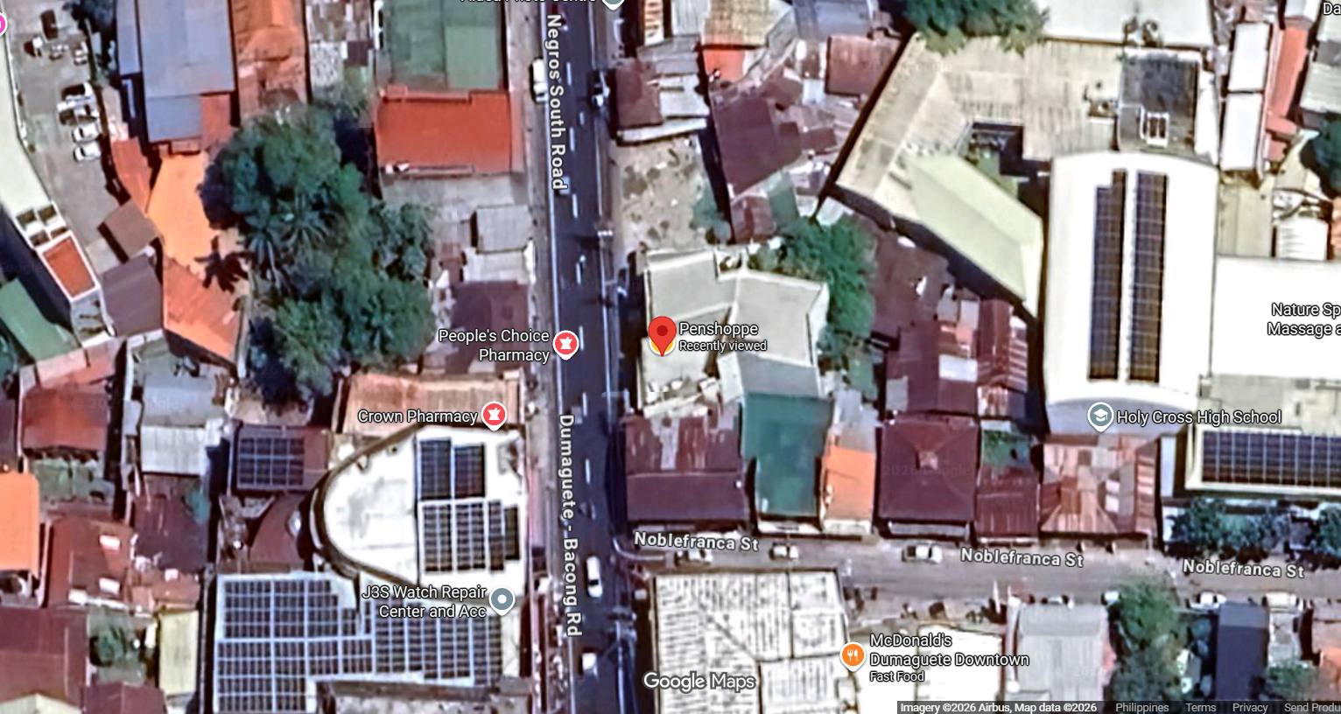

Figure 3. Location of Kaye’s Hair Salon and Spa through Google Map
Population of the Respondents
The study involved a total of thirty (30) respondents who participated in the evaluation of the Web-Based Appointment System for Kaye’s Hair Salon and Spa. The respondents were composed of ten (10) IT experts and twenty (20) end users, including salon management and customers. The IT experts were included to provide a technical assessment of the system, while the end users were selected because they represent the intended users and direct beneficiaries of the proposed web-based appointment system.
The selection of respondents was based on their relevance to the study. The salon management personnel evaluated the system from an operational perspective, particularly in terms of appointment monitoring, service coordination, and record management. The customers, on the other hand, assessed the system based on their experience in booking appointments, viewing schedules, accessing appointment information, and using the system interface. This ensured that the evaluation reflected both management needs and customer experience.
Two (2) structured evaluation instruments were used to gather feedback from the respondents. The IT experts evaluated the system based on the eight ISO 25010 software quality characteristics: functional suitability, performance efficiency, compatibility, usability, reliability, security, maintainability, and portability. The end users evaluated the system based on selected ISO 25010 characteristics, specifically functional suitability, performance efficiency, and usability. This approach allowed the researchers to obtain both technical and user-centered feedback regarding the system’s quality, performance, usability, and suitability for the appointment management needs of Kaye’s Hair Salon and Spa.
Research Instrument
The researchers used structured survey questionnaires as the primary instruments for evaluating the Web-Based Appointment System for Kaye’s Hair Salon and Spa. Two sets of questionnaires were prepared to match the type of respondents involved in the study. The End User Questionnaire was administered to twenty (20) end users composed of salon management and customers, and it focused on selected ISO 25010 software quality characteristics, namely functional suitability, performance efficiency, and usability.
The IT Expert Questionnaire was administered to ten (10) IT experts to assess the system from a technical perspective. This instrument covered the eight ISO 25010 software quality characteristics: functional suitability, performance efficiency, compatibility, usability, reliability, security, maintainability, and portability. Both questionnaires used a Likert four-point rating scale, with 4 as the highest rating and 1 as the lowest rating. The weighted mean was used to summarize and interpret the respondents’ evaluation of the system.

Table 1. Four-Point Likert Scale Used in the Research Instrument
Range of Scale (1-4) | Functional Suitability
1 | Poorly Functional
2 | Moderately Functional
3 | Functional
4 | Very Functional

Table 2. Structure of End-user Survey (Customer and Salon Management
Part | Content | No. of Items | Description
Part I | Respondent’s Profile | 3 | Name, age, and address
Part II – A | Functional Suitability | 3 | Completeness, correctness and appropriateness of system functions.
Part II – B | Performance Efficiency | 3 | Time and behavior, resource utilization, and capacity .
Part II – C | Usability | 3 | Appropriateness, learnability, operability, error protection, interface aesthetics and accessibility
Part III | Feedback and Suggestions | 3 | Helpful features, problems encountered
Total |  | 12

Table 3. Structure of IT Expert Questionnaires
Part | Content | No. of Items | Description
Part I | Respondent’s Profile | 4 | Name, age, specialization/expertise and affiliated institution/company
Part II-A | Functional Suitability | 3 | Completeness, correctness and appropriateness of system function
Part II-B | Performance Efficiency | 3 | Time behavior, resource utilization, and capacity
Part II-C | Compatibility | 2 | Co-Existence and interoperability
Part III | Feedback and Suggestions | 3 | Helpful features, problems encountered and suggested improvements
Part II-D | Usability | 6 | Appropriateness, learnability, operability, error proctection,interface aesthetics and accessibility.
Part II-E | Reliability | 4 | Maturity, availability, fault tolerance and recoverability
Part II-F | Security | 5 | Confidentiality, integrity, non-repudiation, accountability, and authenticity
Part II-G | Maintainability | 5 | Modularity, reusability, analyzability, modifiability and testability
Part II-H | Portability | 3 | Adaptability, install ability, and replace ability
Part III | Feedback and suggestions | 3 | Helpful features, problems encountered and suggested improvements.
Total |  | 38

Organizational Structure
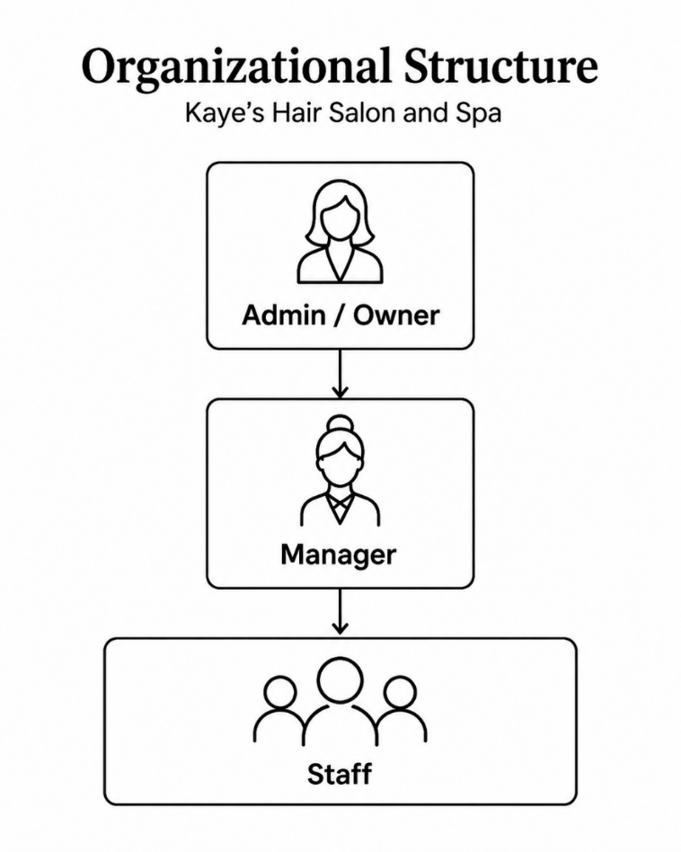
The organizational structure of Kaye’s Hair Salon and Spa is composed of three main levels: the Admin/Owner, Manager, and Staff. The Admin/Owner serves as the highest authority and is responsible for overseeing the overall business operations, managing system access, monitoring reports, and making major decisions for the salon. The Manager assists the owner by supervising daily salon activities, monitoring appointments, managing customer transactions, and ensuring that services are properly handled. The Staff are responsible for providing salon services, assisting customers, and supporting the daily operations of the salon. This structure shows a clear flow of authority and responsibility, helping the salon maintain organized management and smooth service delivery.

Figure 4. Organizational Structure
Requirements Analysis/Specification
The Data Flow Diagram illustrates how information moves within the Web-Based Appointment System for Kaye’s Hair Salon and Spa, showing the interaction between the customer, admin, manager, notification service, system processes, and database records. It presents how customers register or log in, select services, choose a preferred appointment date and time, submit booking details, upload payment receipts, and provide ratings and feedback for the stylist or service. The diagram also shows how customers receive verification results, booking confirmations, payment updates, and email notifications from the system.
The admin manages the service and schedule records, including service details, prices, categories, schedule updates, and slot settings. The admin is also responsible for approving or rejecting appointments, updating appointment statuses, verifying payments, and requesting operational reports. Meanwhile, the manager accesses the report generation process to request and receive summary reports for monitoring salon performance and appointment activities.
The diagram emphasizes the centralized handling of important records, such as customer records, service and schedule records, appointment records, payment and receipt records, feedback records, and report records. Overall, the Data Flow Diagram shows that the system is designed to organize appointment transactions, reduce manual scheduling errors, prevent booking conflicts, support proper payment verification, improve customer communication, and provide accurate reports for better salon management.

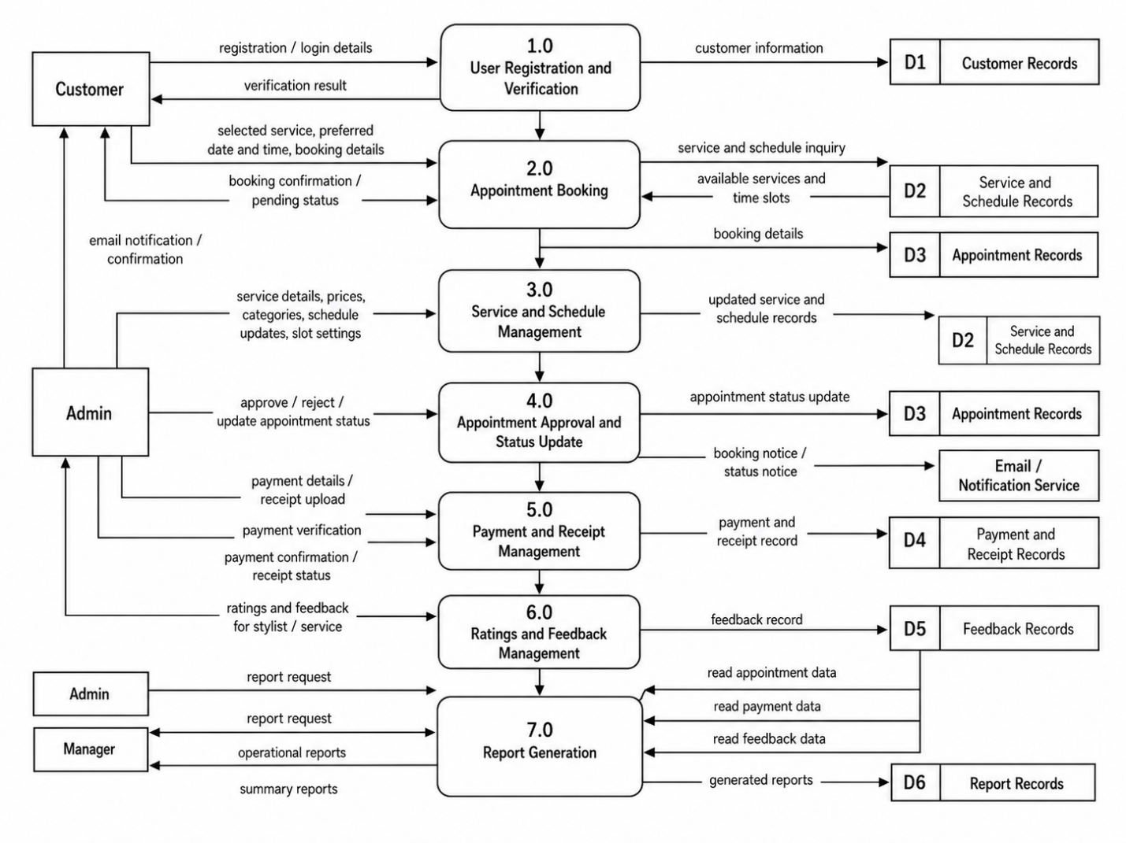
Figure 5. Data Flow Diagram

Fishbone Diagram
The Fishbone Diagram presents the major causes affecting the appointment scheduling and management process of Kaye’s Hair Salon and Spa. It shows that the existing manual process may lead to problems caused by people, process/method, records/data, communication, schedule/availability, and technology/system. These include human errors in booking, missed or forgotten appointments, slow manual confirmation, informal rescheduling or cancellation, handwritten logbook records, scattered customer information, delayed customer confirmation, miscommunication through calls and text messages, limited visibility of available time slots, difficulty managing unavailable days, and the absence of a centralized digital platform. These issues may result in booking conflicts, unclear appointment status updates, difficulty retrieving appointment history, and inefficient monitoring of salon operations. Overall, the fishbone diagram emphasizes the need for a Web-Based Appointment System for Kaye’s Hair Salon and Spa to centralize appointment records, improve communication, support online booking, monitor schedules more effectively, and reduce errors in the salon’s daily operations.

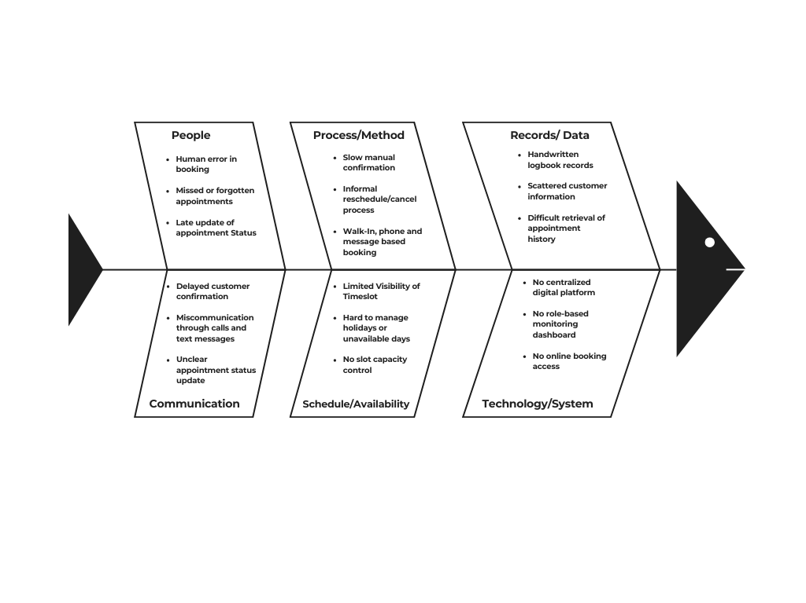
Functional Decomposition Diagram
Figure 6. Fishbone Diagram

Functional Decomposition Diagram presents the major components of the Web-Based Appointment System for Kaye’s Hair Salon and Spa by breaking the system into smaller and more manageable functions. It shows that the system is composed of role-based authentication, appointment booking, service management, customer booking management, notification and confirmation, ratings and feedback, sales and revenue monitoring, and admin dashboard. These modules represent the important functions needed to support the salon’s operations, such as admin and manager login, customer OTP verification, service selection, schedule checking, appointment submission, service updating, booking tracking, customer notifications, feedback submission, revenue monitoring, and report viewing.
The diagram shows how each function contributes to the complete operation of the proposed system. By organizing the system into clear modules, the functional decomposition diagram demonstrates how the web-based appointment system can simplify booking transactions, improve service and schedule management, support customer communication, monitor salon performance, and provide organized records for decision-making. This structure helps ensure that the system is easier to understand, develop, and maintain while addressing the salon’s need for a more efficient appointment management process.

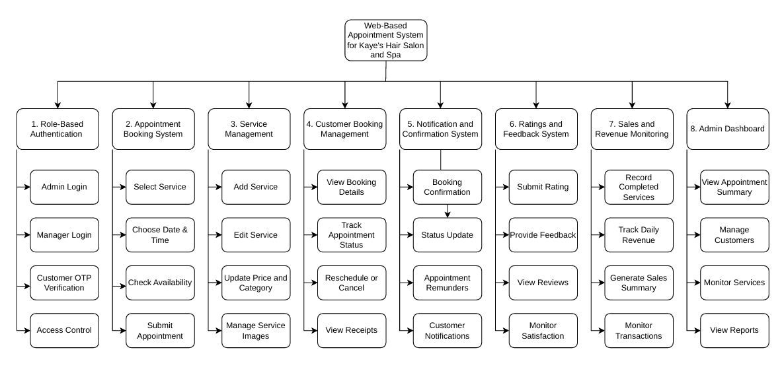
Technical Feasibility
Figure 7. Functional Decomposition Diagram

The technical requirement of Web-Based Appointment System for Kaye’s Hair Salon and Spa was assessed based on the compatibility of the required hardware, software, and supporting technologies, as well as the relevance of the selected development tools to the objectives of the study. The system is considered technically feasible because it can be developed and operated using available and commonly used technologies. Since the system is web-based, it can be accessed through desktop computers, laptops, tablets, and smartphones with a stable internet connection. Users do not need to install a separate application because the system can run through modern web browsers such as Google Chrome, Microsoft Edge, Mozilla Firefox, and Safari.
In terms of software compatibility, the system can operate on common operating systems such as Windows, Android, iOS, and macOS. The proposed backend technology, Laravel, is compatible with standard web hosting environments that support PHP and database connectivity. React is suitable for creating a responsive and user-friendly interface for customers, managers, and administrators. MySQL is also appropriate for storing and managing structured records such as customer information, appointment details, service records, payment transactions, feedback, and notifications. Email services may also be integrated to support OTP verification, booking confirmations, and appointment reminders.
The selected technologies are relevant to the needs of Kaye’s Hair Salon and Spa because they directly support the major functions of the proposed system. Laravel can handle authentication, role-based access, appointment management, payment records, and database transactions. React can provide an accessible and responsive interface for online booking, appointment monitoring, and administrative functions. MySQL can centralize important records, making it easier to retrieve, update, and manage salon information compared to manual logbooks and scattered message-based records. Overall, the system is technically feasible because the required technologies are available, compatible with common devices and platforms, and aligned with the purpose of improving appointment scheduling, record management, and salon operational monitoring.
Area of  Compatibility | Requirement | Compatibility  Assessment
Hardware | Desktop, laptop, tablet, or smartphone | Compatible with common internet-enabled devices
Operating System | Windows, Android, iOS, macOS | Compatible because the system runs through a browser
Browser | Chrome, Edge, Firefox, Safari | Compatible with modern web browsers
Backend | Laravel and PHP-supported server | Compatible with standard web hosting environments
Frontend | React-based user interface | Compatible with responsive web design
Database | MySQL database server | Compatible for structured data storage and retrieval
Internet Connection | Stable internet access | Required for online booking and system access
Email/Notification Service | SMTP or email service provider | Compatible for OTP, confirmations, and reminders
Table 4. Technical Feasibility
Schedule Feasibility
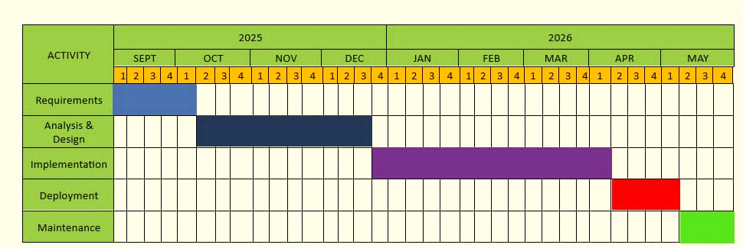
Figure 8 presents the Gantt chart used to show the development schedule of the developed system. The project timeline was divided into major activities, including requirements gathering, analysis and design, implementation, deployment, and maintenance. The requirements phase was conducted in September 2025 to identify the salon’s current appointment process, operational problems, and system needs. This was followed by the analysis and design phase from October to December 2025, where the system structure, interface, database, and workflow were planned. The implementation phase was carried out from January to March 2026, covering the actual development and integration of the system features. Deployment was scheduled in April 2026, while maintenance was allotted in May 2026 to ensure that the system remained functional, updated, and ready for further improvement.
Figure 8. Gantt Chart

Economic Feasibility
The economic feasibility of the proposed Web-Based Appointment System for Kaye’s Hair Salon and Spa was assessed by comparing the expected development, implementation, and maintenance costs with the benefits that the system can provide to the salon. The system is considered economically feasible because it uses cost-effective and accessible technologies such as Laravel, React, and MySQL. Since the project is developed for academic purposes, the expected expenses are limited to basic resources such as internet connection, hosting, domain registration, email service, system maintenance, and user training. It also does not require expensive equipment because it can be accessed using existing devices such as desktop computers, laptops, tablets, and smartphones.
In terms of cost and benefit analysis, the expected costs are reasonable compared to the operational advantages of the system. These benefits include faster appointment processing, reduced booking conflicts, organized customer records, improved payment and receipt monitoring, easier service management, better sales tracking, and improved communication with customers. The system can also help lessen manual work, paper-based records, scheduling errors, missed appointments, and delayed confirmations.
Overall, the proposed system is economically feasible because its expected benefits outweigh the required costs. Through improved efficiency, better customer service, and more organized salon operations, the cost of implementing and maintaining the system can be recovered over time through regular business operations and improved service delivery.

Requirements Modeling
In this section, the requirements modeling of the developed Web-Based Appointment System for Kaye’s Hair Salon and Spa is presented through the Input–Process–Output (IPO) model, with additional performance and control components. This model shows the major data, procedures, results, system quality expectations, and safeguards involved in the operation of the system.
Input
The input component includes the data and resources needed by the system to perform its functions. These include customer information, appointment details, service information, payment details, feedback and ratings, holiday schedules, system requirements, and the hardware, software, and internet resources used in the system. These inputs serve as the foundation for processing appointment transactions and managing salon records.
Process
The process component describes how the system transforms the inputs into useful results. This includes requirements analysis, system design, development, appointment booking, schedule availability checking, payment verification, record management, testing, deployment, and maintenance. Through these processes, the system supports organized booking, service coordination, payment monitoring, and administrative management.

Output
The output component refers to the results produced by the system. These include the developed Web-Based Appointment System, organized appointment scheduling, centralized customer records, payment monitoring, receipts, appointment confirmations, notifications, feedback records, and dashboard reports. These outputs help improve the efficiency, accuracy, and reliability of salon operations.
Performance
The performance component focuses on how efficiently and reliably the system operates. The system is expected to provide fast response time, accurate appointment processing, real-time schedule checking, reduced booking conflicts, reliable data storage, and accessibility through common devices such as computers, laptops, tablets, and smartphones.
Control
The control component refers to the security and validation measures implemented in the system. These include role-based access control, email OTP verification, login and session security, input validation, payment proof verification, customer data protection, and backup of important records. These controls help maintain data accuracy, protect customer information, and ensure secure system operations.

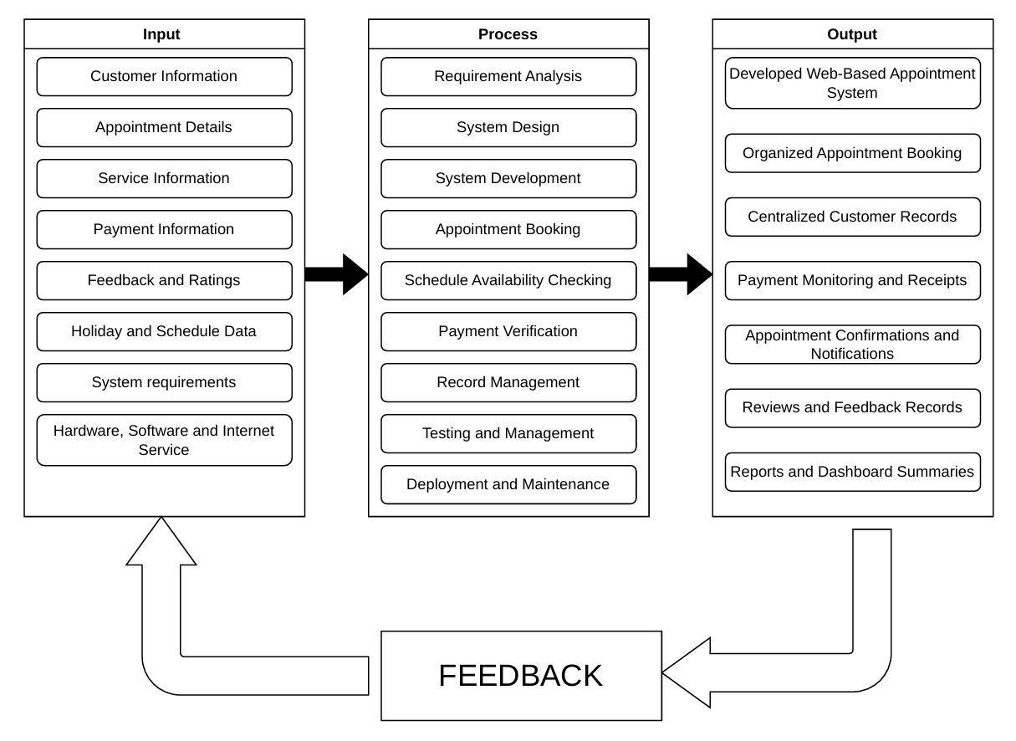
Figure 9. IPO Diagram

Data and Process Modeling
Data and process modeling help explain how information moves within the Web-Based Appointment System for Kaye’s Hair Salon and Spa and how each user interacts with the system. Through the context diagram and data flow diagram, the researchers were able to present the system’s main external users, processes, data inputs, and outputs in a clearer and more organized way. The context diagram provides the overall view of the system by showing the interaction between the customer, admin, manager, and email or notification service. Customers provide OTP verification, appointment details, payment information or receipt uploads, and ratings and feedback, while the system returns booking confirmations, appointment status updates, payment updates, reminders, and notifications. The admin manages service and schedule information, appointment approval, and payment verification, while the manager receives dashboard summaries, booking overviews, and operational reports. The data flow diagram further shows how customer records, service and schedule records, appointment records, payment and receipt records, feedback records, and report records are processed and stored. Overall, these modeling diagrams serve as a guide in developing the system by showing how the proposed web-based appointment system can centralize salon records, improve communication, reduce manual booking errors, monitor schedules more efficiently, and support better appointment management for Kaye’s Hair Salon and Spa.
Context Diagram
Context Diagram illustrates the overall interaction between the Web-Based Appointment System for Kaye’s Hair Salon and Spa and its external entities, including the customer, admin, manager, and email/notification service. The diagram shows that customers can submit OTP verification, appointment details, payment information or receipt uploads, and ratings and feedback, while receiving booking confirmations, appointment status updates, payment updates, and notifications from the system. The admin manages service and schedule information, approves appointments, and verifies payments, while the system provides booking records, payment records, feedback records, and operational reports for monitoring. The manager can request reports and monitoring information and receive summary reports, dashboard summaries, and booking and service overviews. The email/notification service supports the system by sending confirmation messages, reminders, and status notifications and returning delivery status. Overall, the context diagram shows how the system centralizes appointment transactions, improves communication, supports role-based access, and helps manage salon operations more efficiently.

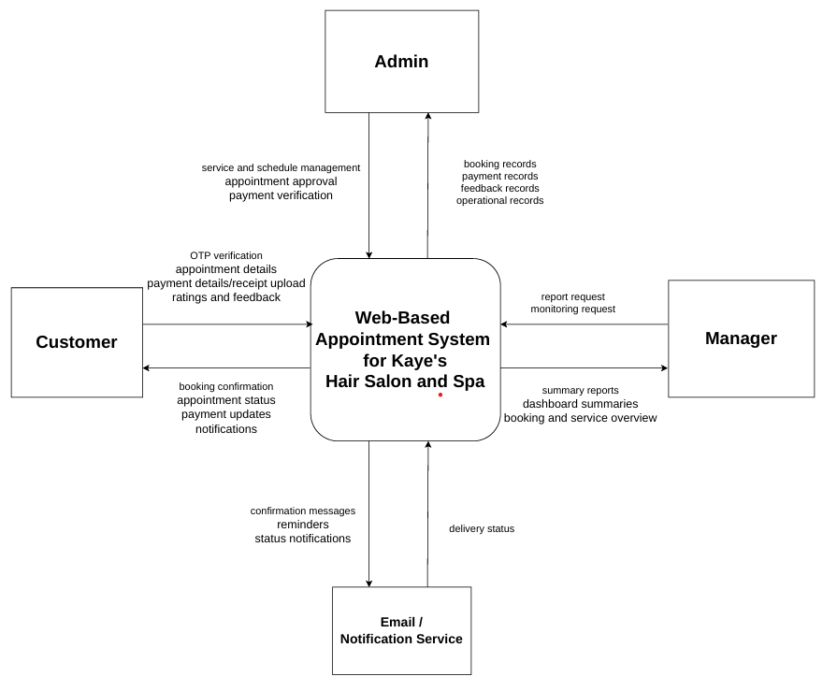

Figure 10. Context Diagram

Data Flow Diagram
The Data Flow Diagram illustrates how information moves within the Web-Based Appointment System for Kaye’s Hair Salon and Spa, showing the interaction between the customer, admin, manager, notification service, system processes, and database records. It presents how customers register or log in, select services, choose a preferred appointment date and time, submit booking details, upload payment receipts, and provide ratings and feedback for the stylist or service. The diagram also shows how customers receive verification results, booking confirmations, payment updates, and email notifications from the system.
The admin manages the service and schedule records, including service details, prices, categories, schedule updates, and slot settings. The admin is also responsible for approving or rejecting appointments, updating appointment statuses, verifying payments, and requesting operational reports. Meanwhile, the manager accesses the report generation process to request and receive summary reports for monitoring salon performance and appointment activities.
The diagram emphasizes the centralized handling of important records, such as customer records, service and schedule records, appointment records, payment and receipt records, feedback records, and report records. Overall, the Data Flow Diagram shows that the system is designed to organize appointment transactions, reduce manual scheduling errors, prevent booking conflicts, support proper payment verification, improve customer communication, and provide accurate reports for better salon management.



Figure 11. Data Flow Diagram

Object Modeling
Object modeling was used to present the interaction between the users and the developed Web-Based Appointment System for Kaye’s Hair Salon and Spa. In this study, the use case diagram identifies the major actors of the system, namely the Customer, Admin, and Manager, and shows the functions that each actor can perform within the system. The diagram helps describe the scope of user interaction and clarifies how the system supports appointment booking, appointment monitoring, service management, payment verification, customer management, feedback handling, notification access, and report viewing.
The Customer interacts with the system by viewing salon services, booking appointments, selecting the preferred date and time, providing customer information, choosing a payment method, uploading proof of payment, viewing appointment details, receiving notifications, viewing receipts, and submitting ratings and feedback. The Admin has wider system access and is responsible for managing appointments, customers, services, holidays, payment verification, reviews, notifications, reports, and other system records. The Manager, on the other hand, mainly monitors salon operations by viewing the dashboard, checking appointment records, monitoring customer bookings, viewing services, holidays, reviews, notifications, and reports.
Figure 6 presents the functional boundaries of the developed system and shows how each user role contributes to the appointment management process. It also emphasizes the separation of access among the Customer, Admin, and Manager, which supports organized system operation and controlled user access.
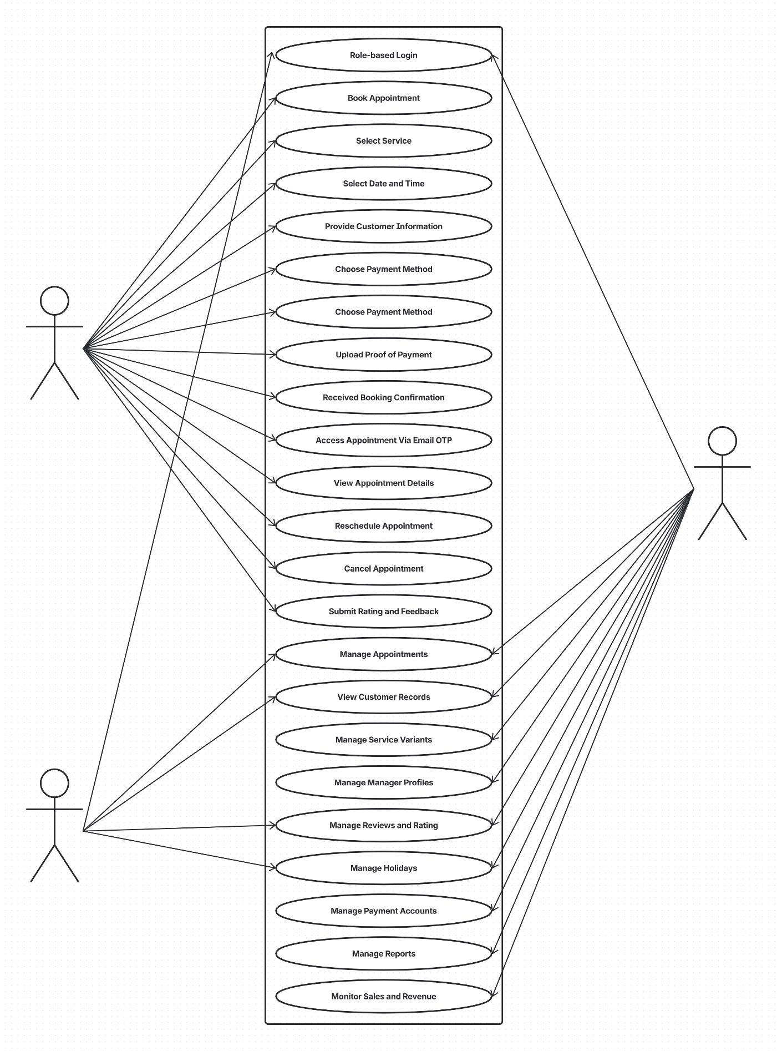
CUSTOMER
MANAGER
ADMIN
Figure 11. Use Case Diagram

Requirements and Documentation
The requirements documentation presents the documented requirements and implemented features of the developed Web-Based Appointment System for Kaye’s Hair Salon and Spa. It provides an overview of the major system functions, including appointment booking, customer record management, service management, holiday scheduling, payment monitoring, ratings and feedback, role-based access, notifications, and report generation. It also shows how the Customer, Admin, and Manager modules support organized salon workflows, reduce booking conflicts, improve record handling, and provide a more efficient and user-friendly appointment management process.
User-Interface Design and Reports
The user interface design and reports component describes the visual layout, navigation structure, interactive elements, and reporting features of the developed system. It includes menus, buttons, forms, search functions, dashboards, and system-generated summaries that help Customers, Admin, and Manager access information clearly and efficiently. The reports present important data such as appointment records, customer information, service details, payment and sales records, reviews, and dashboard summaries, which support monitoring and decision-making in salon operations.
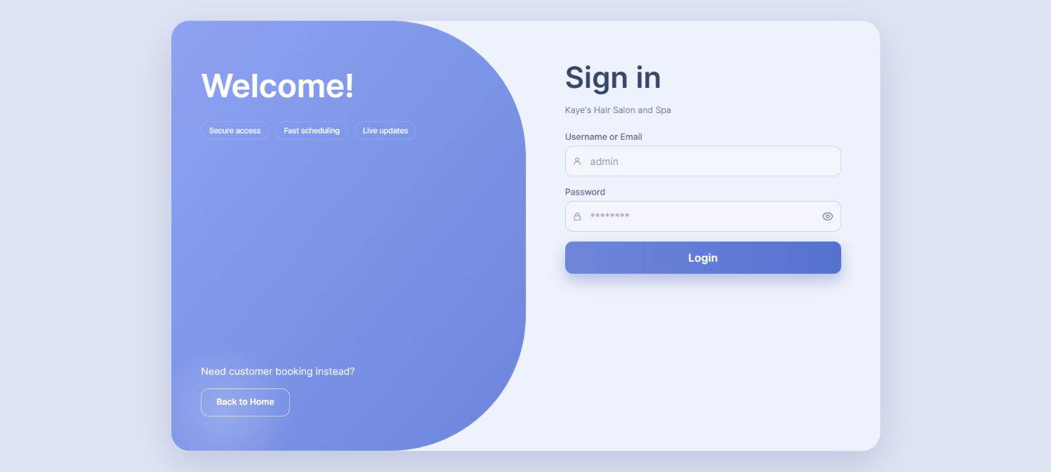
Login Page for Admin and Manager
The login page provides authorized Admin and Manager users with secure access to the management side of the system.

Figure 1. Login Page

Figure 1 shows the login page for the Admin and Manager of the developed Web-Based Appointment System for Kaye’s Hair Salon and Spa. The page provides a clean and organized sign-in interface where authorized users enter their username and password to access the management side of the system. This supports the system’s role-based access control, which separates administrative and managerial functions from customer-facing features. The interface also includes a password visibility option, a login button, and a back-to-home button to support ease of use and smooth navigation. This page serves as the entry point for authorized users who manage appointments, services, customer records, reports, and other salon operations
Admin Dashboard
The Admin Dashboard provides an overview of the salon’s main records and operational status.
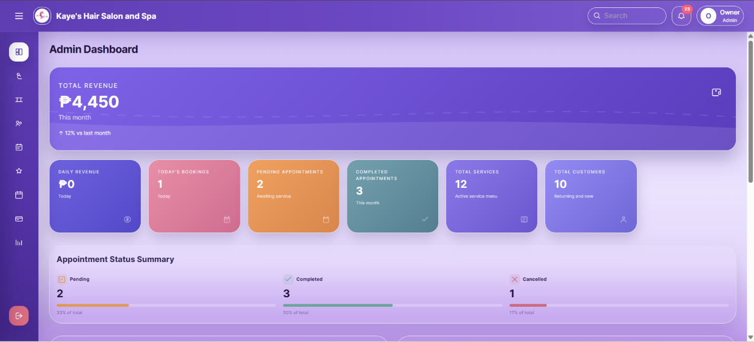
Figure 2. Admin Dashboard

Figure 2 shows the Admin Dashboard of the developed Web-Based Appointment System for Kaye’s Hair Salon and Spa. The dashboard presents key salon records such as total revenue, daily revenue, today’s bookings, pending appointments, completed appointments, total services, total customers, and appointment status summary. This interface helps the Admin monitor overall salon operations, track appointment activities, review service and customer data, and support better decision-making through organized dashboard summaries. This is aligned with the system’s purpose of improving appointment monitoring, service management, payment tracking, and operational reporting.
Customer Management
The Customer Management page allows the Admin to view and monitor customer records, appointment history, and customer-related transaction details .

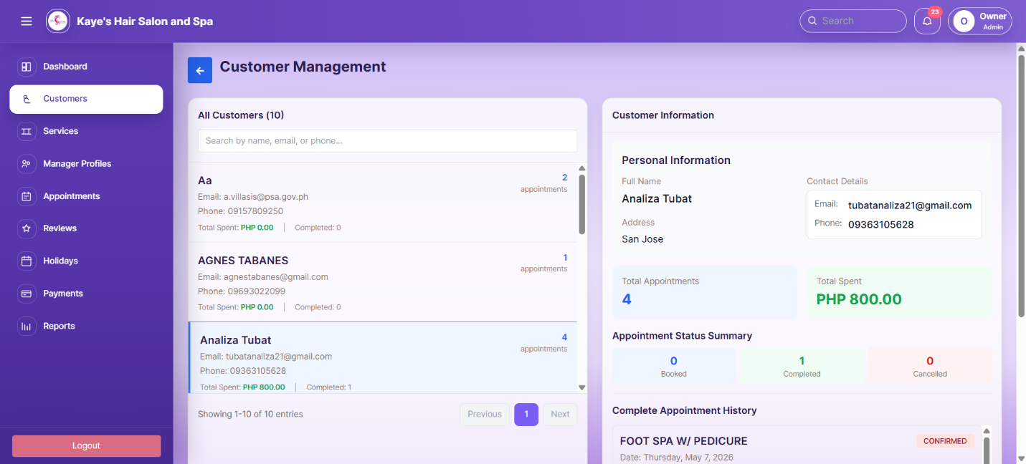
Figure 3. Customer Management

Figure 3 shows the Customer Management page of the developed system. This interface displays the list of customers together with their contact details, appointment count, total spending, and appointment status summary. It allows the Admin to search customer records, view customer information, and monitor completed or cancelled appointments. Through this page, the Admin can manage customer-related records in an organized manner, supporting faster record retrieval, better appointment monitoring, and improved customer management for salon operations.

Manage Services
The Customer Management page allows the Admin to view and monitor customer records, appointment history, and customer-related transaction details .
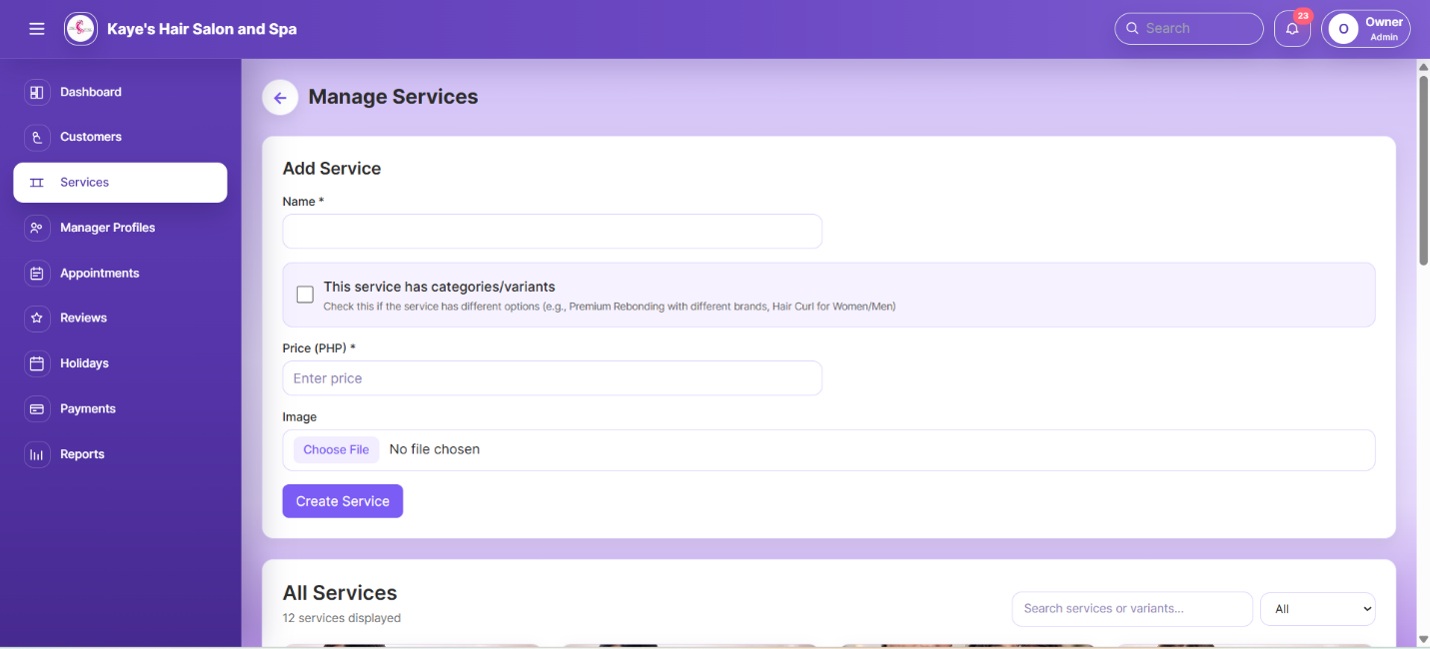
Figure 4. Manage Services

Figure 4 shows the service management interface. It allows the Admin to add service records by entering the service name, price, image, and category or variant option when applicable. The page also displays the list of existing services with search and filter functions for easier record management. This helps ensure that customers can view accurate and updated service information during the booking process.
Manager Profiles
The Manager Profiles page allows the Admin to create and maintain manager account records.
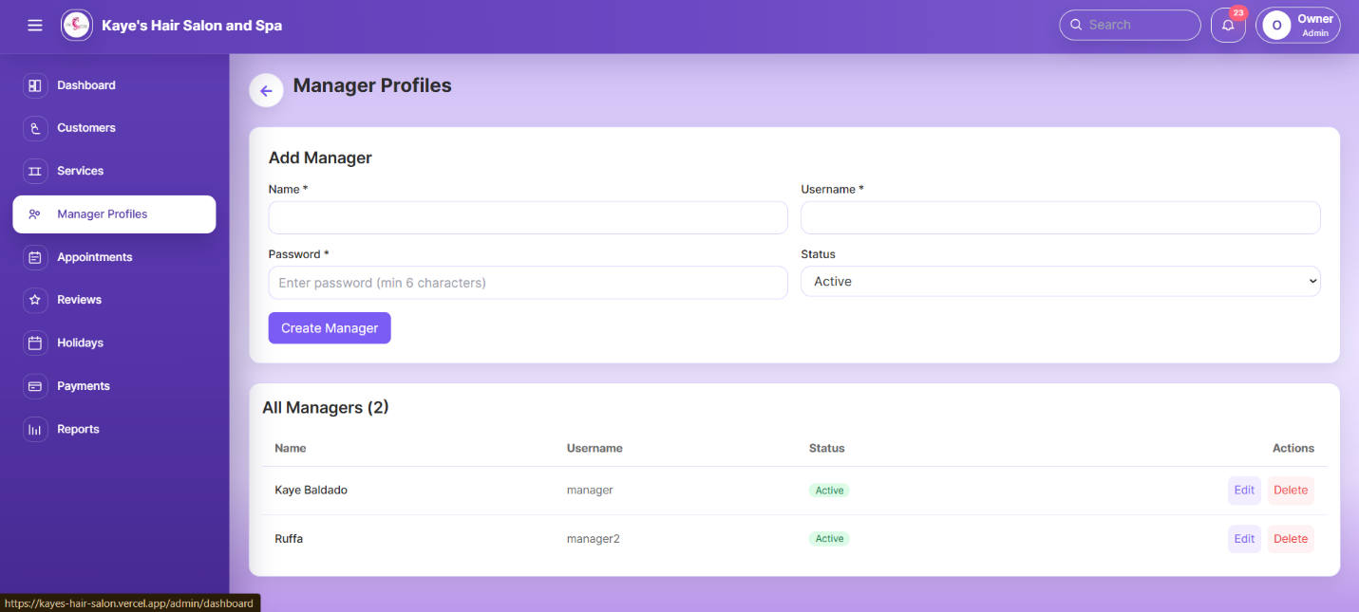
Figure 5. Manager Profiles

Figure 5 shows the manager account management interface. It provides fields for adding a manager’s name, username, password, and account status. Existing manager accounts are displayed in a table with available actions for editing or deleting records when necessary. This page helps the Admin control managerial access and keep user accounts organized within the system.

Appointment Management
The Appointment Management page allows the Admin to monitor, filter, and manage customer bookings.
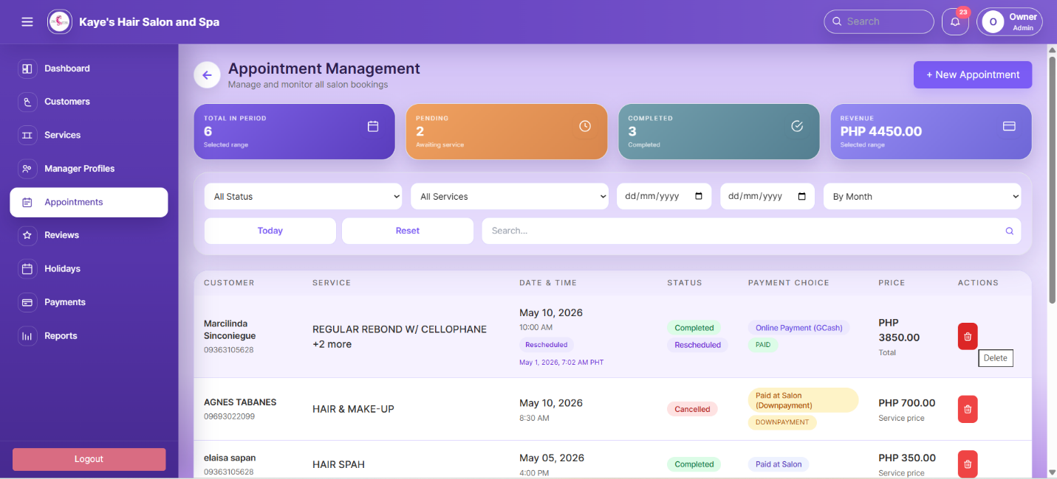
Figure 6. Appointment Management

Figure 6 shows the appointment management interface. It displays appointment summaries such as total appointments within the selected period, pending appointments, completed appointments, and revenue. The page also includes filter options for status, service, date range, and month to help the Admin search appointment records more efficiently. Appointment details such as customer name, selected service, date and time, status, payment choice, price, and available actions are shown in a table. This page supports organized appointment monitoring and helps the Admin track booking progress, payment status, and completed transactions.
Customer Ratings
The Customer Ratings page allows the Admin to review and monitor customer feedback after completed appointments.
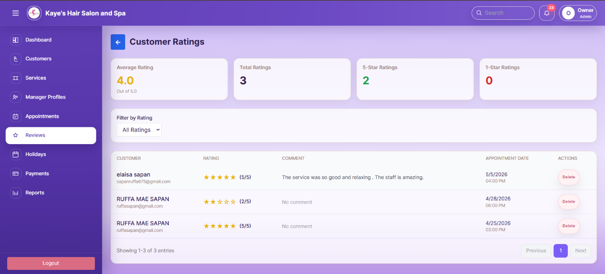
Figure 7. Customer Ratings

Figure 7 shows the customer ratings interface. It displays rating summaries such as average rating, total ratings, 5-star ratings, and 1-star ratings. The page also includes a filter option for sorting reviews based on rating level. Customer feedback is shown in a table with the customer name, rating, comment, appointment date, and available action. This page helps the Admin evaluate customer satisfaction, identify service quality concerns, and use feedback as a basis for improving salon operations.

Holidays
The Holidays page allows the Admin to manage closed dates and special occasions that affect appointment availability.
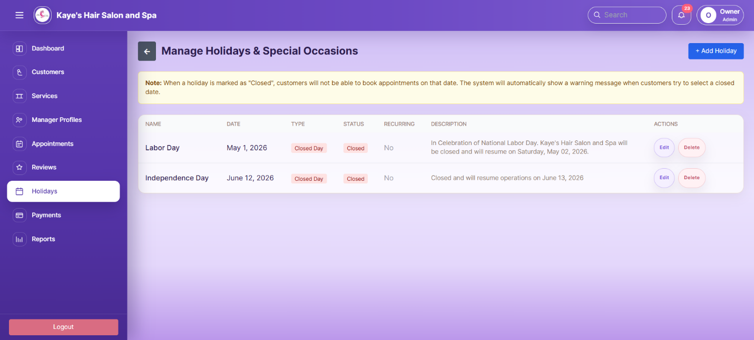
Figure 8. Holidays
Figure 8 shows the holiday management interface. It displays holiday records with details such as name, date, type, status, recurring option, description, and available actions. The page also allows the Admin to add, edit, or delete holiday entries when necessary. When a holiday is marked as closed, customers cannot book appointments on that date, helping the system prevent invalid bookings and maintain accurate schedule availability.

Payment Accounts
The Payment Accounts page allows the Admin to manage the payment details shown to customers during the booking process.
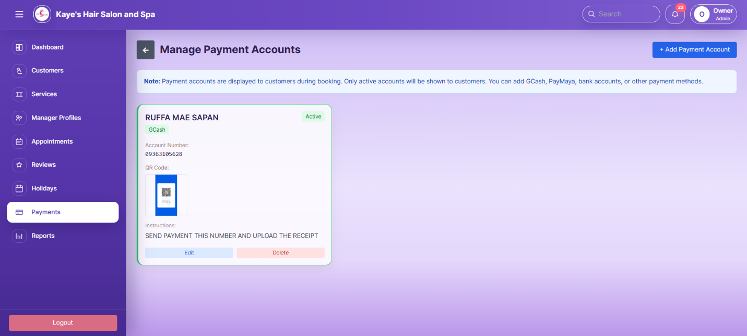
Figure 9. Payment Accounts
Figure 9 shows the payment account management interface. It displays the available payment account, including the account name, payment method, account number, QR code, instructions, and account status. The page also provides options to add, edit, or delete payment accounts when needed. This helps ensure that customers receive accurate payment information and can properly submit their payment or proof of payment for verification.

Reports
The Reports page allows the Admin to monitor sales, payments, appointment status, and service performance.
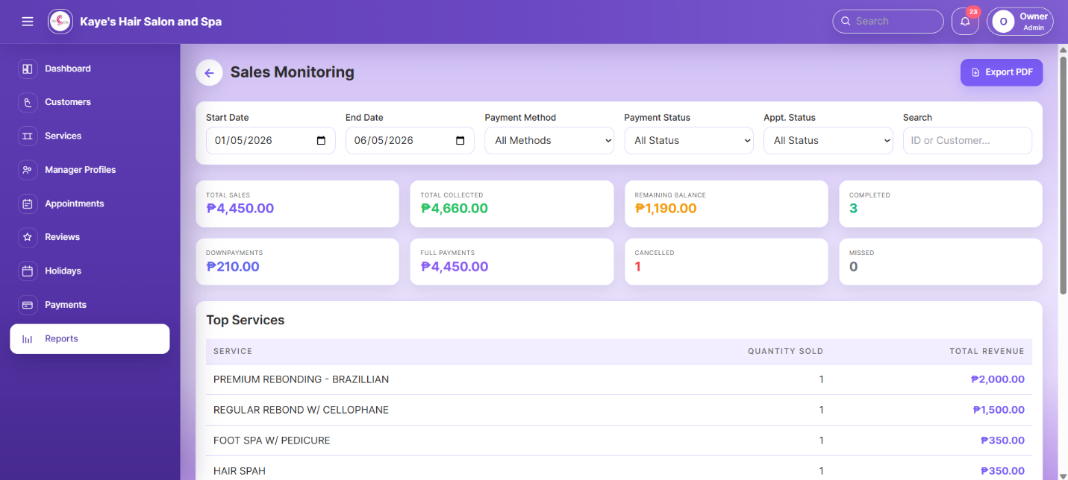
Figure 10. Reports
Figure 10 shows the reports and sales monitoring interface. It provides filter options for date range, payment method, payment status, appointment status, and customer search. The page displays important summaries such as total sales, total collected amount, remaining balance, completed appointments, downpayments, full payments, cancelled appointments, and missed appointments. It also presents top services with their quantity sold and total revenue. This page helps the Admin review salon performance, track income, and support decision-making through organized report summaries.

Manager Dashboard
The Manager Dashboard provides a summary of appointment activities and key operational records for monitoring daily salon operations.
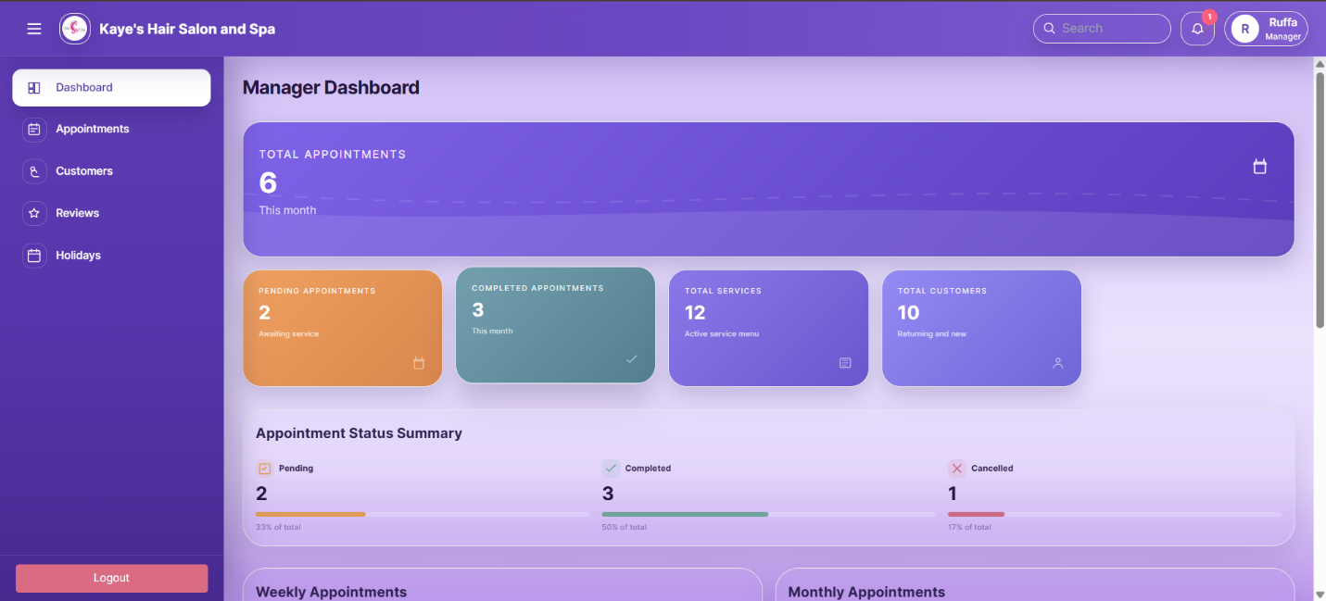
Figure 11. Manager Dashboard
Figure 11 shows the Manager Dashboard. It displays important summaries such as total appointments, pending appointments, completed appointments, total services, total customers, and appointment status summary. This page allows the Manager to monitor booking progress, review appointment status, and oversee customer and service records in a clear dashboard format. It supports the manager’s role in daily appointment monitoring and salon operation supervision while maintaining access only to authorized functions.

Manager Appointment Management
The Manager Appointment Management page allows the Manager to monitor customer bookings and review appointment-related records.
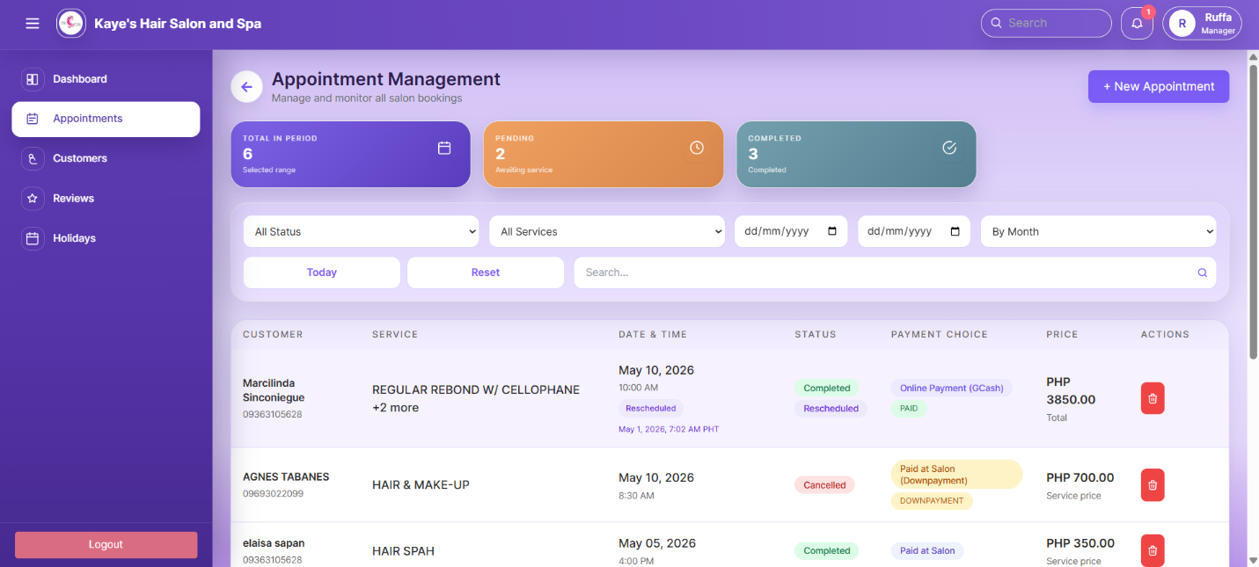

Figure 12. Manager Appointment Management
Figure 12 shows the appointment management interface for the Manager. It displays appointment summaries such as total appointments, pending appointments, and completed appointments. The page also includes filters for appointment status, service type, date range, and month, allowing the Manager to search and review records more efficiently. Appointment details such as customer name, selected service, date and time, status, payment choice, and price are presented in a table. This page supports the Manager in monitoring daily bookings, tracking appointment progress, and assisting in organized salon operation supervision.

Manager Customer Management
The Manager Customer Management page allows the Manager to view customer records and review appointment-related information for monitoring purposes.

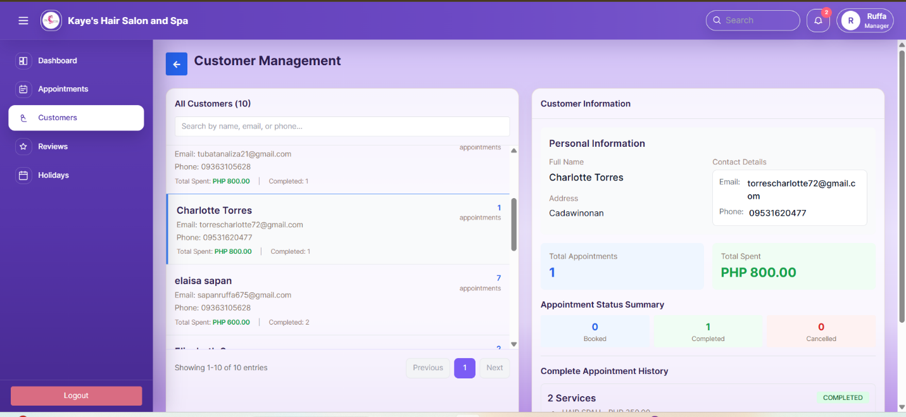
Figure 13. Manager Customer Management
Figure 13 shows the customer management interface for the Manager. It displays the list of customers with their contact details, appointment count, total spending, and completed appointment records. The selected customer’s information is shown on the right side, including personal details, appointment status summary, and appointment history. This page helps the Manager review customer booking activity, monitor completed appointments, and access customer-related records in an organized manner.

Manager Reviews Management
The Manager Reviews Management page allows the Manager to view customer ratings and feedback for service monitoring.
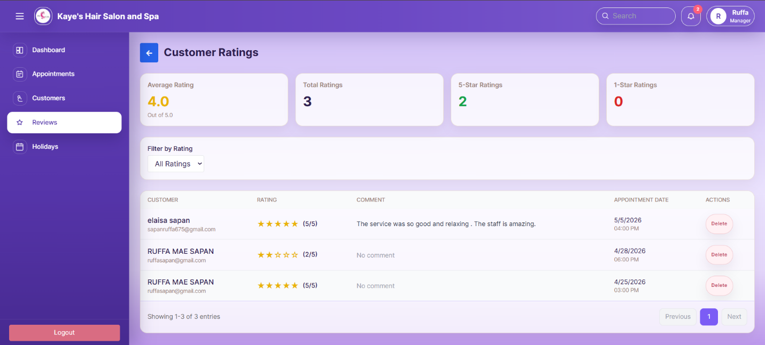

Figure 13. Manager Reviews Management
Figure 13 shows the reviews management interface for the Manager. It displays rating summaries such as average rating, total ratings, 5-star ratings, and 1-star ratings. The page also includes a rating filter and a table that shows the customer name, rating, comment, appointment date, and available action. This page helps the Manager monitor customer satisfaction, review service feedback, and identify areas that may need improvement in salon operations.
The Manager Holidays Management page allows the Manager to view and monitor closed dates and special occasions that affect appointment availability.

Manager Holidays Management
The Manager Holidays Management page allows the Manager to view and monitor closed dates and special occasions that affect appointment availability.

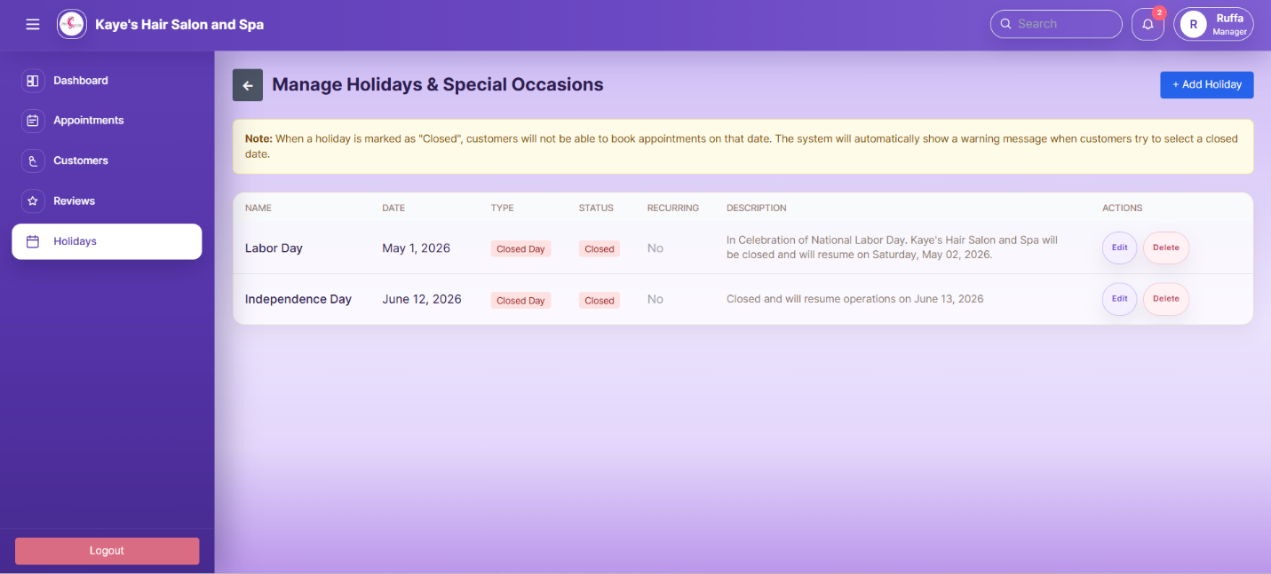
Figure 14. Manager Holidays Management
Figure 13 shows the holidays management interface for the Manager. It displays holiday records with details such as name, date, type, status, recurring option, description, and available actions. The page also includes a notice informing users that customers cannot book appointments on dates marked as closed. This helps the Manager monitor unavailable schedules and ensure that appointment bookings follow the salon’s operating calendar.

Customer Landing Page
The Customer Landing Page provides customers with direct access to the main booking features and salon information.
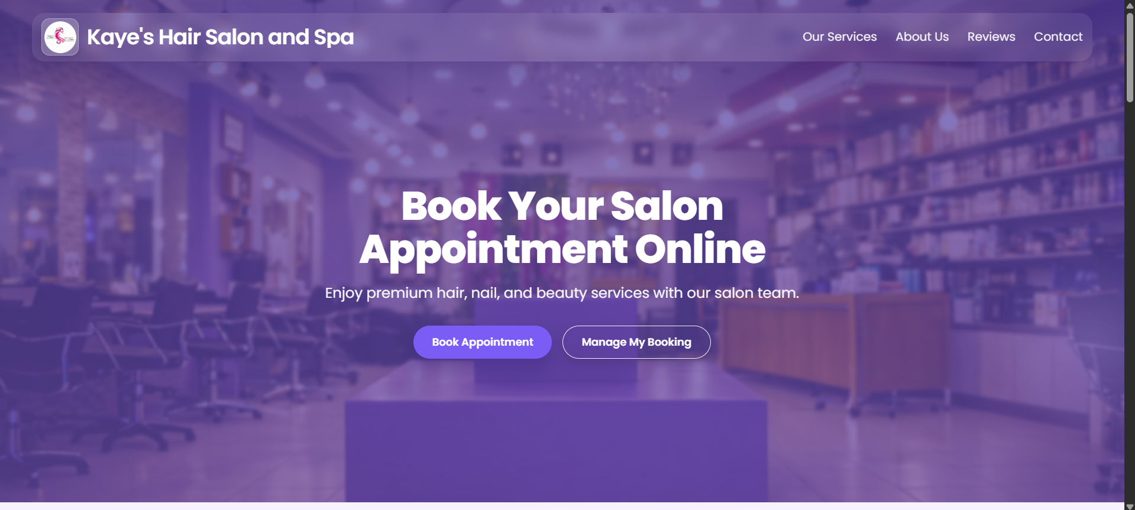

Figure 14. Customer Landing Page
Figure 14 shows the customer landing page of the system. It displays the salon name, navigation links, and a hero section that encourages customers to book an appointment online. The page includes buttons for Book Appointment and Manage My Booking, allowing customers to start a new booking or access an existing appointment. This page serves as the customer’s main entry point for viewing services, checking salon information, and managing appointment-related transactions.

User Guide in Landing Page
The user guide section helps customers understand the appointment booking process through clear step-by-step instructions.
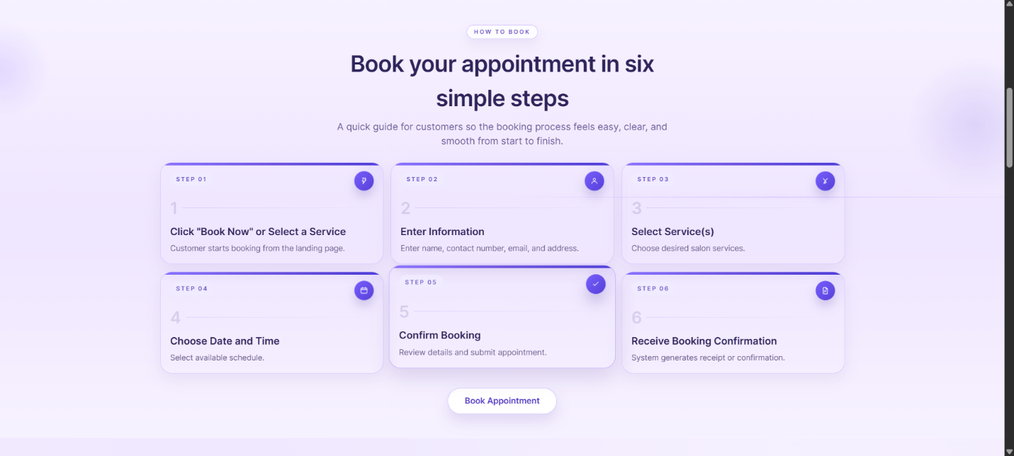

Figure 15. User Guide
Figure 15 shows the user guide section on the landing page. It presents the booking process in six simple steps: clicking Book Now or selecting a service, entering customer information, selecting service or services, choosing the appointment date and time, confirming the booking, and receiving booking confirmation. This section guides customers before they start the transaction, making the booking process easier to follow and more user-friendly.

Salon Services in Landing Page
The services section allows customers to view the salon’s available services before booking an appointment.
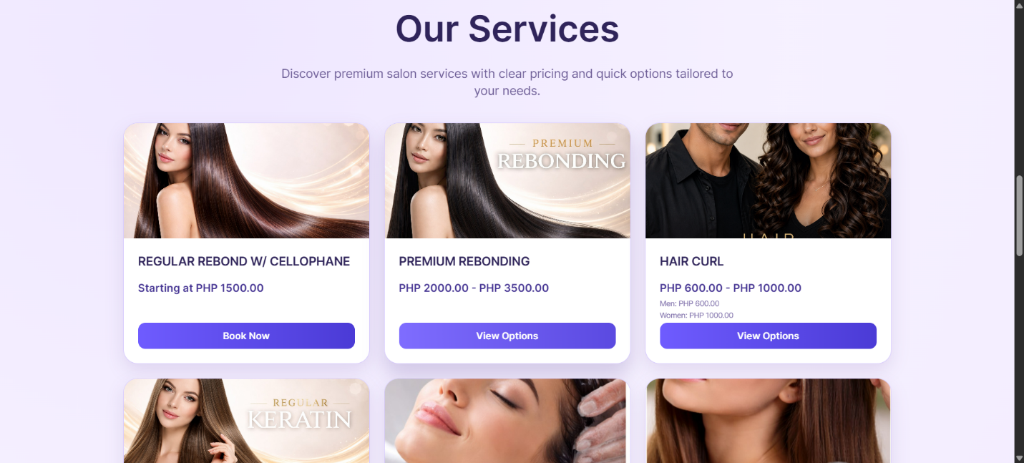

Figure 16. Salon Services in Landing Page
Figure 16 shows the salon services section displayed on the customer landing page. It presents service cards with images, service names, prices, and action buttons such as Book Now or View Options. This section helps customers compare available services and proceed directly to the booking process after selecting their preferred salon service.

Customer Reviews in Landing Page
The customer reviews section allows visitors to view feedback from previous clients and learn more about the salon’s service experience.

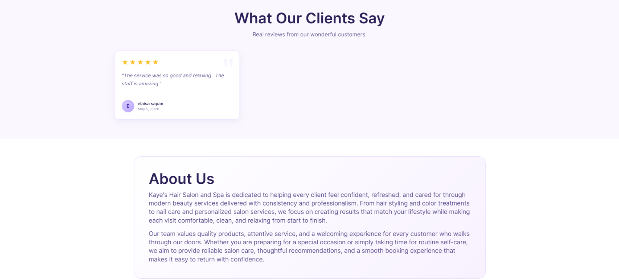
Figure 17. Customer Reviews in Landing Page
Figure 17 shows the customer reviews section displayed on the landing page. It presents customer feedback, star ratings, and brief comments that reflect client satisfaction with the salon services. The page also includes an About Us section, which provides a short description of the salon and its commitment to quality service. This section helps build customer trust and supports the system’s goal of improving customer engagement and service transparency.
The Customer Email Verification page allows customers to verify their email before continuing with the appointment booking process.

Customer Email Verification
The Customer Email Verification page allows customers to verify their email before continuing with the appointment booking process.

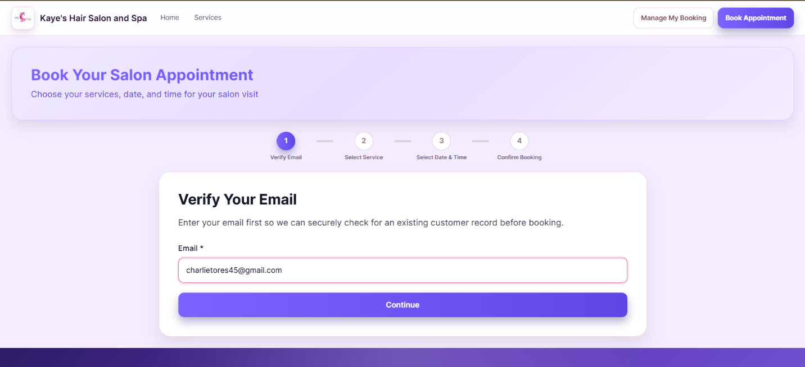
Figure 18. Customer Email Verification
Figure 18 presents the email verification step in the customer booking process. The page requires the customer to enter an email address so the system can check for an existing customer record and continue the appointment transaction securely. This step supports organized customer record management and helps ensure that booking details are connected to the correct customer information before selecting services, date, time, and final booking confirmation.

Sign Up
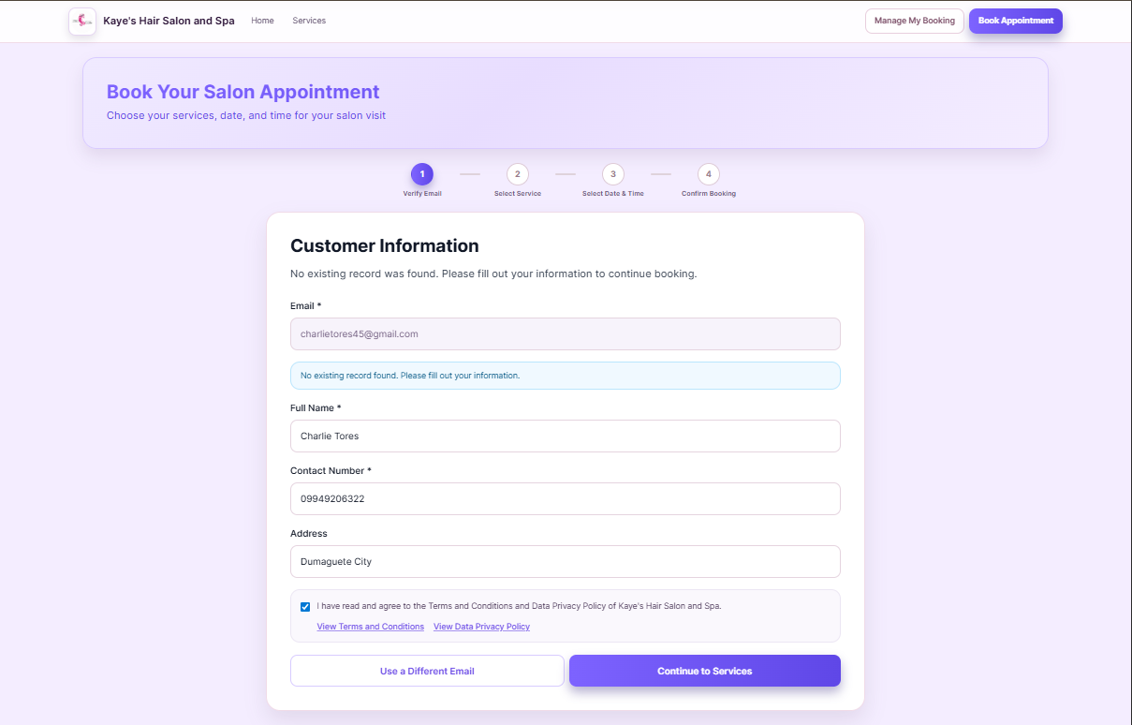
The Sign Up page allows new customers to provide their personal details before continuing with the appointment booking process.

Figure 19. Sign Up
Figure 19 shows the customer information form used when no existing customer record is found through email verification. The page collects the customer’s email, full name, contact number, and address to create or update the booking record. It also includes an agreement checkbox for the Terms and Conditions and Data Privacy Policy before the customer can proceed to service selection. This step supports accurate customer record management and ensures that appointment details are connected to the correct customer information.

Select Services
The Select Services page allows customers to choose one or more salon services before selecting an appointment date and time.
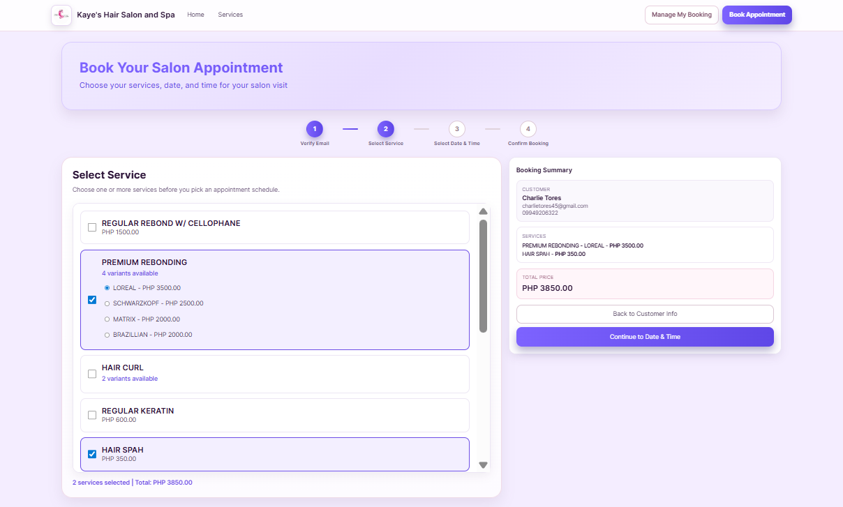
Figure 20. Select Services
Figure 20 shows the service selection step in the customer booking process. It displays the available salon services, including service variants and prices when applicable. Customers can select their preferred services, while the booking summary on the side shows the selected service, customer details, and total amount. This page helps customers review their chosen services before proceeding to the schedule selection step.
.
Select Date and Time
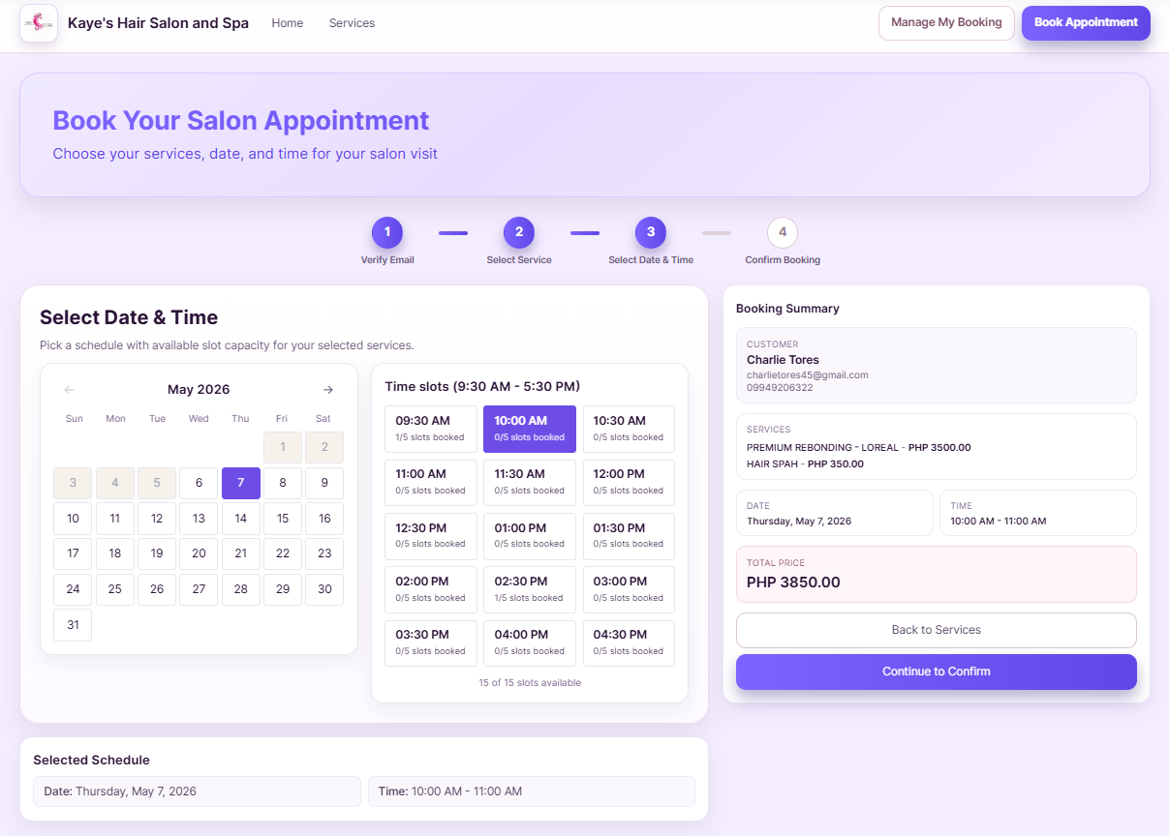
The Select Date and Time page allows customers to choose an available appointment schedule after selecting their preferred salon services.
Figure 21. Select Date and Time
Figure 21 shows the schedule selection step in the booking process. It displays a calendar, available time slots, and a booking summary that includes the customer details, selected services, date, time, and total price. The page helps customers choose a valid schedule while allowing the system to monitor slot availability and prevent booking conflicts. After selecting the preferred date and time, the customer can proceed to the booking confirmation step.

Payment Process
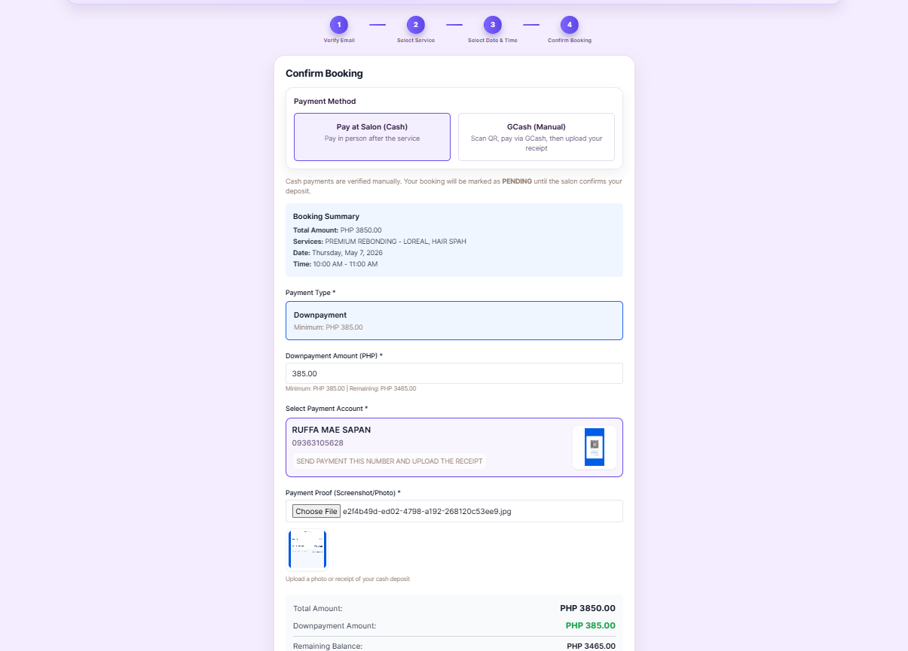
The Payment Process page allows customers to review their booking details and choose a payment option before final confirmation.
Figure 22. Payment Process
Figure 22 shows the payment step of the booking process. It presents the available payment methods, such as Pay at Salon and GCash, together with the booking summary, selected services, appointment schedule, payment type, downpayment amount, proof of payment upload, total amount, and remaining balance. This page helps customers confirm their payment details before submitting the booking, while also supporting payment monitoring and receipt verification on the management side.
Appointment Receipt
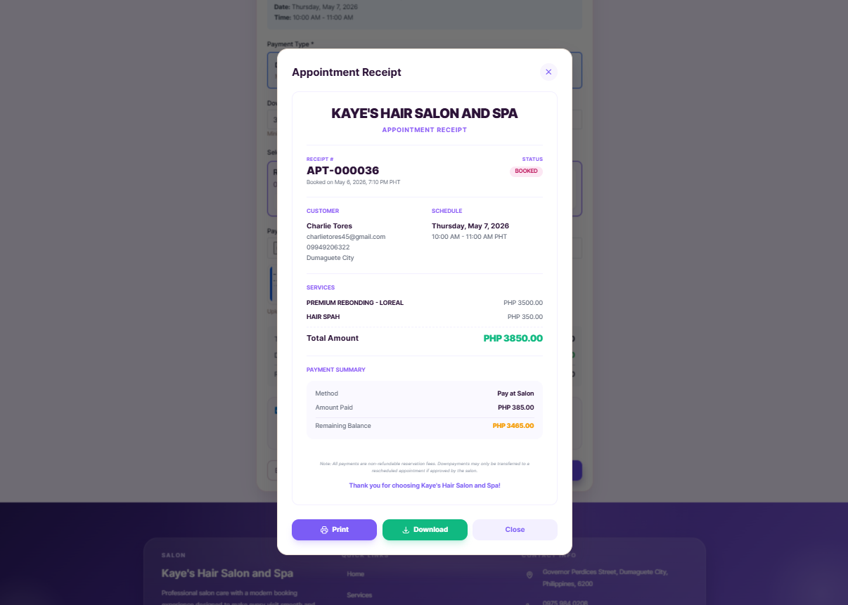
The Appointment Receipt page provides customers with a formal summary of their confirmed booking and payment details.
Figure 23. Appointment Receipt
Figure 23 shows the appointment receipt generated after the booking process. It displays important information such as the receipt number, booking status, customer details, appointment schedule, selected services, total amount, payment method, amount paid, and remaining balance. The receipt also includes options to print, download, or close the receipt. This feature helps customers keep a record of their appointment while supporting clear payment monitoring and transaction documentation.
Customer Dashboard
The Customer Dashboard allows registered customers to view and manage their appointment records, including booking status, selected services, schedule, and payment details.

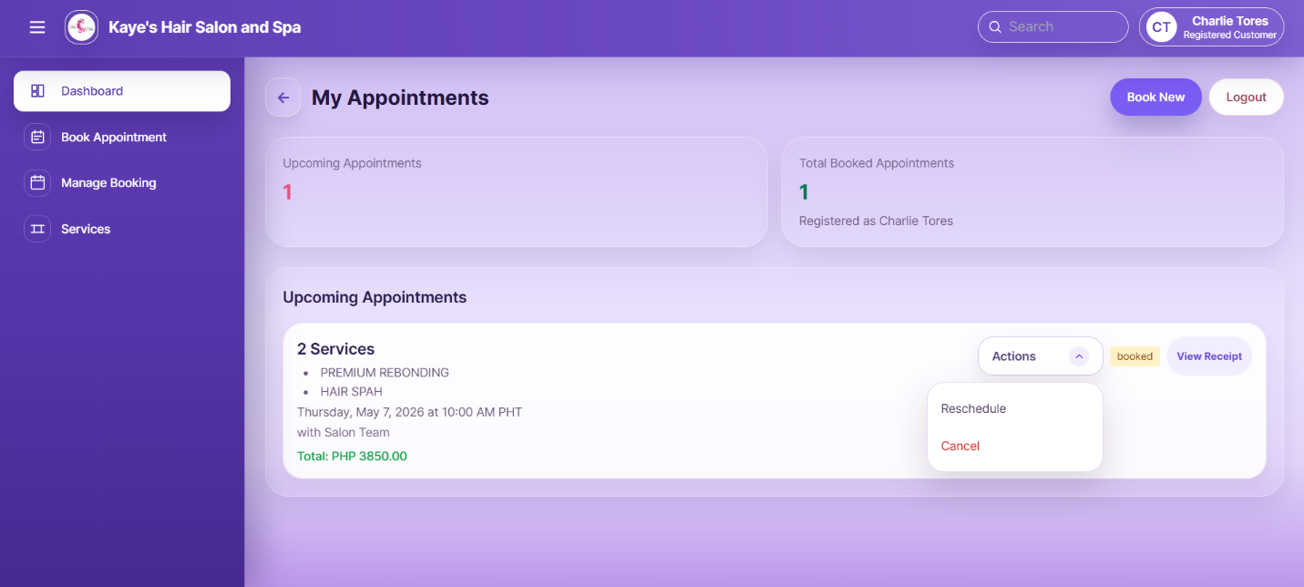
Figure 24. Customer Dashboard
Figure 24 shows the customer dashboard or My Appointments page. It displays the customer’s upcoming appointments, total booked appointments, selected services, appointment date and time, booking status, and total payment amount. The page also provides action options such as viewing the receipt, rescheduling, or cancelling an appointment when allowed. This interface helps customers monitor their bookings and review important appointment and payment information in one organized page.
Appointment Reschedule
The Appointment Reschedule page allows customers to choose a new available date and time for an existing appointment.
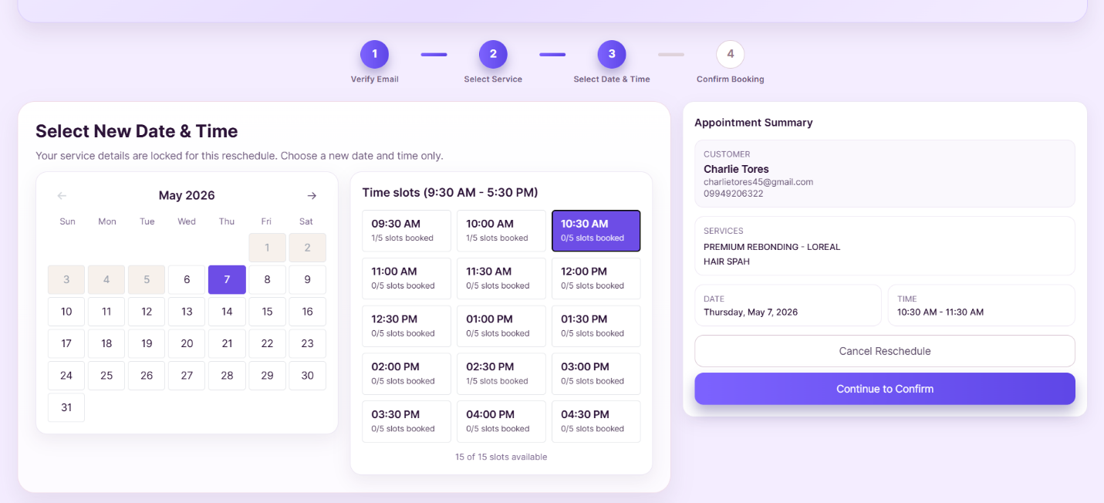
Figure 24. Appointment Reschedule
Figure 24 shows the rescheduling interface for customer appointments. It displays a calendar, available time slots, and an appointment summary containing the customer details, selected services, current date, and selected new time. The page allows customers to update their schedule while still following the system’s availability checking and slot control. It also provides options to continue with the reschedule confirmation or cancel the rescheduling process.

Confirm Reschedule
The Confirm Reschedule page allows customers to review the updated appointment details before finalizing the rescheduling request.
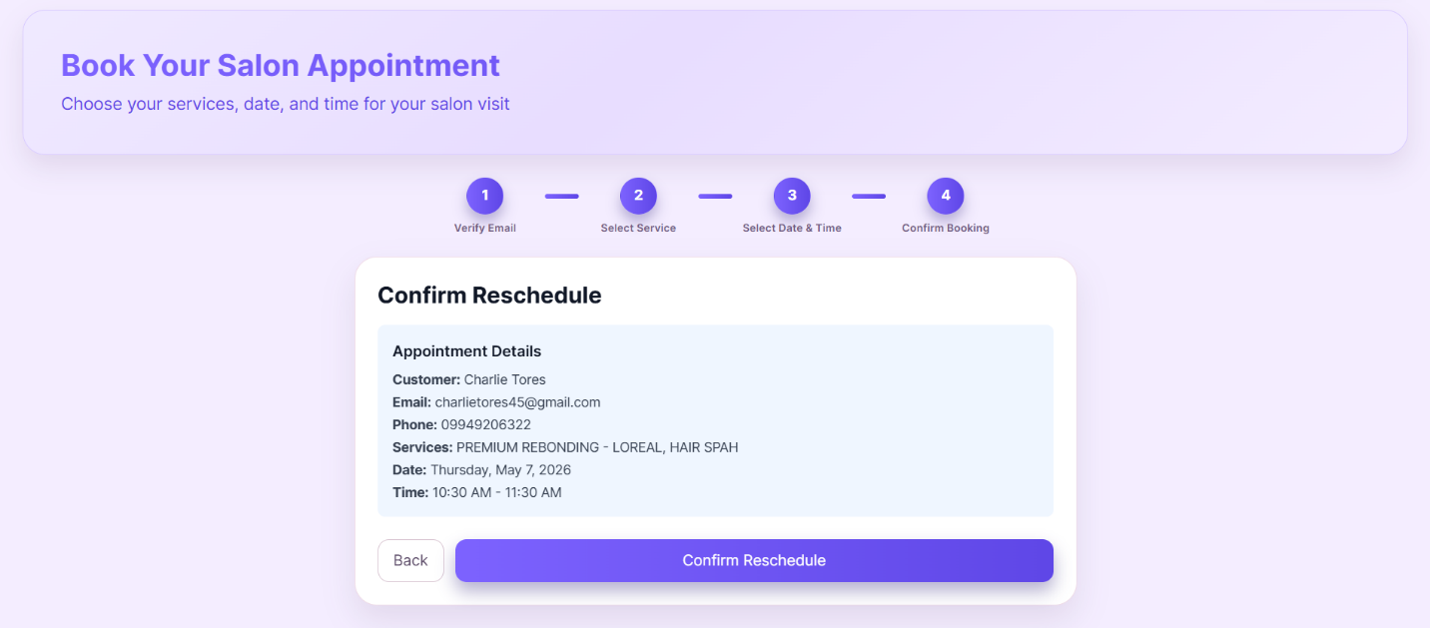
Figure 25. Confirm Reschedule
Figure 25 shows the confirmation page for rescheduling an appointment. It displays the customer’s name, email, contact number, selected services, new appointment date, and updated time. This page allows the customer to verify the changes before submitting the reschedule request. The Confirm Reschedule button completes the process, while the Back button allows the customer to return and make changes if needed.
Reschedule Receipt
The Reschedule Receipt provides customers with confirmation that their appointment schedule has been successfully updated.
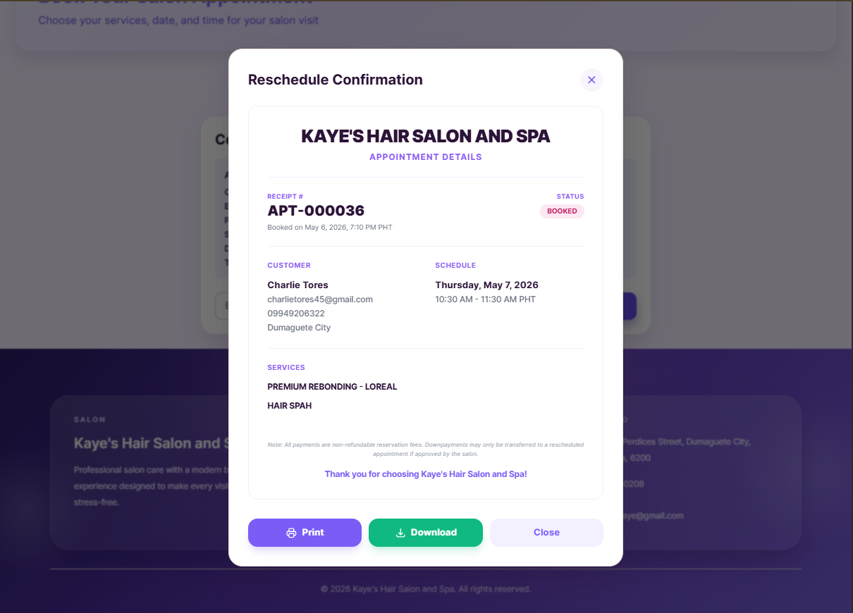
Figure 26. Reschedule Receipt
Figure 26 shows the reschedule confirmation receipt. It displays the receipt number, booking status, customer details, updated appointment schedule, and selected services. The page also includes options to print, download, or close the receipt, allowing customers to keep a copy of their updated appointment details. This feature supports clear transaction documentation and helps ensure that customers have proof of their rescheduled booking.
Booking Management
The Booking Management page allows customers to securely access their existing appointment records through email OTP verification.
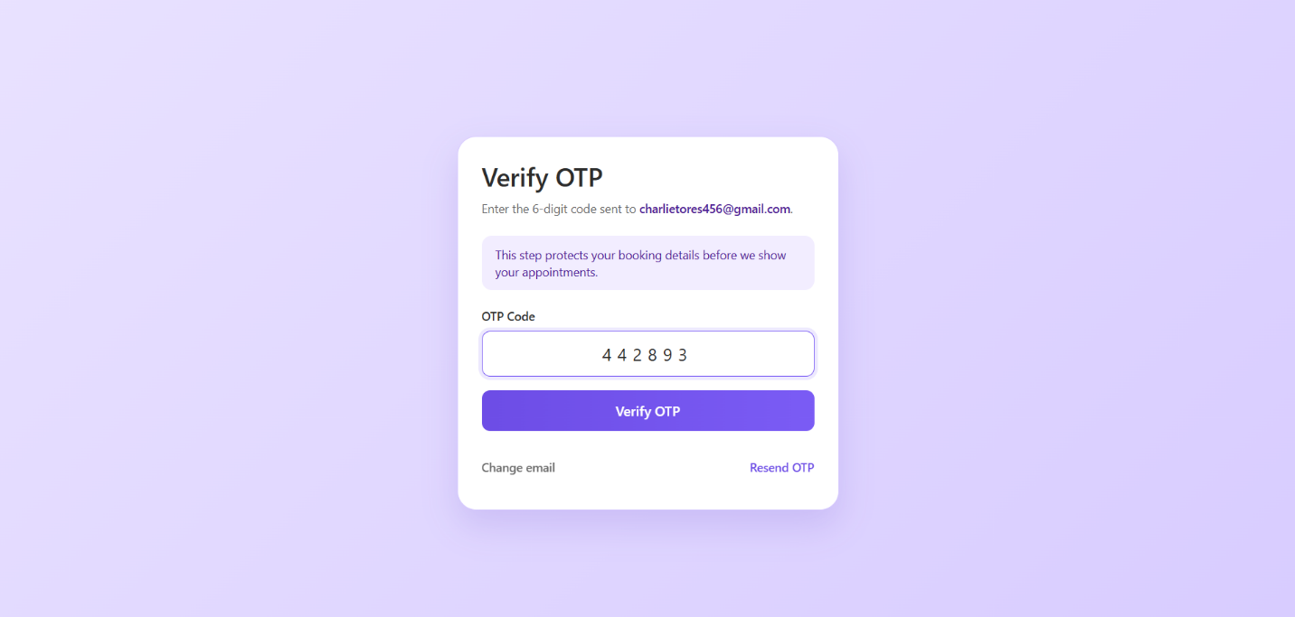

Figure 27. Email OTP Verification for Booking Management
Figure 27 shows the OTP verification page used for managing customer bookings. The customer enters the six-digit code sent to their registered email before viewing appointment details. This step protects booking information by ensuring that only the verified customer can access, reschedule, cancel, or review their appointment record. The page also includes options to change the email or resend the OTP when needed, supporting both security and ease of use.

Data Design
The Entity Relationship Diagram (ERD) presents the database structure of the developed system and shows how the main records are connected to support salon appointment management. The database includes important tables such as appointments, customers, admins, managers, services, service_variants, appointment_services, payment_accounts, sales, ratings, notifications, and holidays. These tables help organize customer information, booking records, selected services, payment details, feedback, and schedule-related data in one centralized database.
The appointments table serves as the core record of the system because it stores the main booking details, including customer information, appointment date and time, payment status, booking status, rescheduling details, and other appointment-related information. Service records are supported by the services, service_variants, and appointment_services tables, allowing customers to select one or more salon services during booking. Payment and sales monitoring are handled through the payment_accounts and sales tables, which support payment details, receipts, transaction records, and revenue monitoring.The database also supports security, access control, and operational monitoring through related tables. The admins and managers tables separate management access, while the customers and customer_otps tables support customer identification and email-based verification. The appointment_ratings, customer_ratings, notifications, and holidays tables help manage customer feedback, system updates, and unavailable booking
Development and Testing
This section presents the development and testing specifications of the developed Web-Based Appointment System for Kaye’s Hair Salon and Spa. It includes the software requirements, hardware requirements, programming environment, compatibility requirements, and testing activities used to ensure that the system operates properly. The system was developed using Laravel for the backend, React for the frontend, and MySQL for the database, with major functions such as appointment booking, service management, customer booking management, sales and revenue monitoring, ratings and feedback, role-based authentication, and notification and confirmation features.
Software Specification
The software specification identifies the required platforms, tools, and applications needed to develop and operate the system. Since the system is web-based, users are not required to install a separate application. Customers, Admin, and Manager can access the system through modern web browsers using an internet-enabled device.
Table 10. Software Requirements for Development and Management Use
Software Specification | Minimum Requirement | Recommended Requirement
Operating System | Windows 10 | Windows 11
Web Browser | Chrome, Edge, Firefox, or Safari | Latest browser version
Backend Framework | Laravel-supported environment | Latest stable Laravel-supported environment
Frontend Framework | React-supported environment | Latest stable React-supported environment
Database | MySQL-supported database server | MySQL 8.0 or higher
Code Editor | Visual Studio Code or similar editor | Latest stable version
Web Server | Apache/XAMPP or hosting server | PHP-supported hosting server
Email Service | SMTP-supported email service | SMTP service for OTP and notifications
Internet Connection | Stable internet connection | Stable broadband connection

Table 10 presents the software requirements for developing and managing the system. Laravel was used to handle backend processes such as authentication, role-based access, appointment records, payment monitoring, and database transactions. React was used to provide a responsive and user-friendly interface, while MySQL served as the centralized database for storing customer records, appointment details, service information, payment records, feedback, holidays, and notifications. Email service support was also included for OTP verification, booking confirmations, and appointment-related messages.
Table 11. Software Requirements for Customer Access
Software Specification | Minimum Requirement | Recommended Requirement
Device Operating System | Android, iOS, Windows, or macOS | Updated Android, iOS, Windows, or macOS
Web Browser | Chrome, Safari, Edge, or Firefox | Latest browser version
Internet Connection | Stable mobile data or Wi-Fi | Stable broadband or strong mobile data connection
Email Access | Active email account | Active email account with OTP access
File Upload Support | Browser with upload support | Updated browser for payment proof upload

Table 11 shows the software requirements for customer access. Customers can use smartphones, tablets, laptops, or desktop computers to view services, book appointments, verify email OTP, choose payment options, upload proof of payment, view receipts, reschedule or cancel bookings, and submit ratings and feedback.
Hardware Specification
The hardware specification describes the physical device requirements needed to run the system smoothly. Since the system is web-based, it can operate on commonly available devices and does not require expensive or specialized equipment.
Table 12. Hardware Requirements for Laptop/Desktop
Hardware Specification | Minimum Requirement | Recommended Requirement
Processor | Intel Core i3 or equivalent | Intel Core i5 / Ryzen 5 or higher
Memory (RAM) | 4GB RAM | 8GB RAM or higher
Storage | 128GB HDD/SSD | 256GB SSD or higher
Display | 14-inch screen | 15-inch screen or larger
Network | Wi-Fi or LAN connection | Stable broadband connection
Table 12 presents the hardware requirements for Admin and Manager access, as well as system development and testing. A basic laptop or desktop computer is sufficient for managing appointments, services, customers, holidays, payment records, reviews, and reports. Higher specifications are recommended for smoother multitasking, faster loading, and more efficient monitoring.
Table 13. Hardware Requirements for Smartphone/Tablet
Hardware Specification | Minimum Requirement | Recommended Requirement
Processor | Quad-core processor | Octa-core processor
Memory (RAM) | 3GB RAM | 4GB RAM or higher
Storage | 32GB | 64GB or higher
Display | 5.5-inch screen | 6-inch screen or larger
Network | Mobile data or Wi-Fi | Stable Wi-Fi or strong mobile data
Table 13 shows the hardware requirements for customers using smartphones or tablets. These specifications allow customers to access the booking page, select services, verify email OTP, upload payment proof, view appointment receipts, and manage bookings. A larger display and stable internet connection are recommended to provide a better user experience.
Programming Environment
The programming environment used in the development of the Web-based Appointment System for Kaye’s Hair Salon and Spa consisted of a combination of frontend, backend, database, and development tools that supported the creation, testing, and deployment of the system. These technologies were selected to ensure that the system would be responsive, secure, maintainable, and capable of handling the required functions for customers, managers, and the admin/owner.
Web Front End
This section discusses the technologies used in developing the web front end of the proposed system.
React.js
React.js serves as the primary architectural framework for the system’s user interface. Developed as a declarative and component-based JavaScript library, React.js allowed the researchers to build a sophisticated Single Page Application (SPA). In this system, React.js manages the complex state of the appointment booking process, ensuring that service selections, and time slots are updated instantaneously. By utilizing a virtual Document Object Model (DOM), React.js optimizes rendering performance, providing customers with a fluid and seamless experience that mimics a native desktop application.
Tailwind CSS
Tailwind CSS was used to design the user interface of the system. It is a utility-first CSS framework that allowed the researchers to create a responsive, clean, and visually consistent layout. Tailwind CSS was especially useful in making the system adaptable to different screen sizes, including mobile devices, tablets, and desktop computers.
Web Back End
This section discusses the programming languages and frameworks used in developing the web back end of the proposed system.
Laravel
Laravel is the robust PHP framework utilized to develop the server-side logic and API of the system. It was chosen for its advanced features, such as the Eloquent Object-Relational Mapper (ORM), which simplifies database interactions, and its built-in security protocols including CSRF protection and encrypted session management. Within the context of the salon system, Laravel acts as the central coordinator—processing booking requests, calculating 10% mandatory deposits, and managing role-based access for Admins and Managers. Its modular structure ensures that the backend remains organized and easily maintainable as the salon's requirements evolve.
JavaScript
JavaScript is the fundamental programming language used to implement the system’s dynamic behavior. On the client side, JavaScript facilitates asynchronous communication with the Laravel backend, allowing users to submit forms, verify OTPs (One-Time Passwords), and upload payment receipts without the need for traditional page refreshes. Its versatility enables the researchers to create highly interactive elements, such as real-time search filters for services and automated calculation of remaining balances, significantly improving the overall responsiveness and usability of the platform.
PHP
PHP (Hypertext Preprocessor) is the core server-side scripting language that powers the Laravel framework. It is responsible for executing the business logic of the salon system on the server. PHP handles the heavy lifting of the application, such as processing payment logic, communicating with the MySQL database, and generating automated email notifications for confirmed or rescheduled appointments. Its deep integration with various web servers and its ability to handle complex data structures make it an indispensable variable in the system's backend development.
MySQL
MySQL is the relational database management system used to store and organize the salon's critical information. It manages structured data across multiple tables, including users, appointments, services, and payments. For Kaye's Hair Salon and Spa, MySQL ensures data integrity and consistency, allowing for reliable tracking of customer booking histories and financial records. The researchers utilized MySQL’s indexing capabilities to ensure that even as the database grows, queries for available time slots and daily sales reports remain efficient and high-performing.
Deployment Diagram

Test Plan
The test plan presents the major system functions that were checked to determine whether the developed system performed according to its intended requirements. The testing focused on the main modules used by the Customer, Admin, and Manager, including appointment booking, email OTP verification, service selection, schedule checking, payment handling, record management, reports, and role-based access. This process helped verify that the system could support the salon’s operational needs and reduce common issues such as booking conflicts, incomplete records, and unauthorized access.
Table 24. Test Plan
Module / Feature | Test Scenario | Expected Result
Admin and Manager Login | Enter valid username and password. | User is redirected to the correct dashboard based on role.
Role-Based Access | Login as Admin and Manager separately. | Admin can access full management features, while Manager can access only authorized functions.
Customer Email Verification | Enter customer email and request OTP. | System sends OTP and allows customer verification.
Customer Information Form | Submit complete customer details. | Customer record is saved and user proceeds to service selection.
Service Selection | Select one or more salon services. | Selected services appear in the booking summary with correct amount.
Schedule Selection | Select available appointment date and time. | System accepts available schedule and prevents invalid or unavailable slots.
Payment Process | Choose Pay at Salon or GCash and submit required payment details. | Payment information is saved and included in the booking record.
Appointment Receipt | Complete the booking process. | System generates a receipt with customer, schedule, service, and payment details.
Manage Booking | Access appointment through email OTP. | Customer can view appointment details and available actions.
Reschedule Appointment | Select a new available date and time. | Appointment schedule is updated after confirmation.
Appointment Management | Admin updates appointment status. | Status changes are saved and reflected in the appointment records.
Service Management | Admin adds, edits, or deletes a service. | Service list is updated and displayed correctly on the customer side.
Holiday Management | Add a closed date or holiday. | Customers cannot book appointments on marked closed dates.
Payment Account Management | Add or update payment account details. | Payment instructions and QR code are displayed correctly during booking.
Ratings and Feedback | Customer submits rating after completed appointment. | Feedback is saved and displayed in the reviews management page.
Reports | Filter appointment and sales records. | System displays correct report summaries based on selected filters.

Test Data
The test data presents the sample information used to check whether the system could process records accurately. These data were used to test customer booking, service selection, schedule availability, payment handling, OTP verification, appointment updates, ratings, and report generation. The use of test data helped confirm that the system could store, retrieve, update, and display records properly across its major modules.
Table 24. Test Data
Test Area | Sample Test Data | Purpose
Customer Information | Name: Ruffa Mae Sapan  Email: ruffasapan@gmail.com  Contact No.: 09363105628 | To test customer record creation and email verification.
Email OTP Verification | OTP Code: 125676 | To test secure customer access for booking management.
Selected Services | SEMIDILINO, FOOT SPA W/ PEDICURE | To test multiple-service selection during booking.
Appointment Schedule | Date: May 06, 2026  Time: 2:30 PM | To test schedule selection and availability checking.
Payment Method | GCash / Full Payment | To test payment option selection.
Payment Proof | Sample image file: payment-proof.jpg | To test payment proof upload for online payment.
Appointment Status | Pending, Confirmed, Completed, | To test appointment status updates.
Holiday Record | Holiday Name: Labor Day;  Date: May 01, 2026;  Status: Closed | To test blocked dates and unavailable schedule control.
Rating and Feedback | Rating: 3 stars | To test customer feedback submission.
Report Filter | Date Range: May 1–31, 2026;  Payment Status: Paid | To test report filtering and sales summary generation.
The test data presents the sample information used to check whether the system could process records accurately. These data were used to test customer booking, service selection, schedule availability, payment handling, OTP verification, appointment updates, ratings, and report generation. The use of test data helped confirm that the system could store, retrieve, update, and display records properly across its major modules.
Implementation Results
This section presents the implementation results of the developed Web-Based Appointment System for Kaye’s Hair Salon and Spa, focusing on the testing activities and survey evaluation conducted after development. The system was tested based on its major functions, including appointment booking, email-based OTP verification, service selection, schedule checking, payment handling, receipt generation, ratings and feedback, role-based access, notifications, and reports. The system was developed using Laravel for the backend, React for the frontend, and MySQL for the database, supporting centralized records and web-based access for customers, admin, and manager.
Unit Testing
Unit testing was conducted to check each system module individually before connecting it to the full workflow. The tested modules included customer email verification, appointment booking, service selection, date and time selection, payment process, receipt generation, customer dashboard, rescheduling, ratings and feedback, admin login, manager login, service management, customer management, holiday management, payment account management, and reports. This testing confirmed that the major functions were able to perform their intended tasks before proceeding to integration.
Integration Testing
Integration testing focused on verifying whether the system components worked together properly. The interaction between the React interface, Laravel backend, MySQL database, and email service was checked through major user transactions such as booking an appointment, sending and verifying OTP, selecting services, choosing payment options, uploading proof of payment, generating receipts, updating appointment status, and displaying reports. The results showed that the system components were able to exchange and update information correctly across customer, admin, and manager modules.
Compatibility Testing
Compatibility testing was conducted to determine whether the system could function across common devices and browsers. Since the system is web-based, it was tested using desktops, laptops, tablets, and smartphones through browsers such as Chrome, Edge, Firefox, and Safari. The testing confirmed that customers could access the booking pages, verify email OTP, upload payment proof, view receipts, and manage appointments, while the admin and manager could access their dashboards and monitoring pages. This supports the system’s objective of providing accessible appointment services through internet-enabled devices.
Performance Testing
Performance testing measured the system’s ability to respond efficiently during normal use. Functions such as loading services, checking schedules, processing bookings, sending OTP, uploading payment proof, generating receipts, filtering appointment records, and viewing dashboard summaries were observed. The survey results also supported this finding, as the end users rated Performance Efficiency with an overall mean of 3.80, interpreted as Very Efficient, while the IT experts rated it 3.60, also interpreted as Very Efficient.
Load Testing
Load testing was conducted to observe how the system performed when multiple records and repeated user actions were processed. The testing included scenarios such as customers viewing services, booking appointments, checking schedules, submitting payment details, and accessing appointment records. On the management side, appointment records, customer records, services, ratings, holidays, and reports were reviewed while system transactions were being processed. The system remained stable under expected salon usage and was able to support the daily operations required by the salon.
Results and Survey-Based Observations
This section presents the evaluation results of the Web-Based Appointment System for Kaye’s Hair Salon and Spa based on the responses of two groups of respondents: twenty (20) end users composed of fifteen (15) customers and five (5) salon management personnel, and ten (10) IT experts. The questionnaire for the end users focused on the ISO/IEC 25010 software quality characteristics of functional suitability, performance efficiency, and usability, while the questionnaire for the IT experts covered functional suitability, performance efficiency, compatibility, usability, reliability, security, maintainability, and portability. The weighted mean and verbal interpretation were used to determine the level of acceptability and quality of the developed system..
End User Evaluation Results
Table 10. Summary of End User Evaluation (n = 20)
ISO Characteristic | Overall Mean | Verbal Description
Functional Suitability | 3.73 | Very Functional
Performance Efficiency | 3.80 | Very Efficient
Usability | 3.66 | Very Usable
Grand Mean | 3.73 | Highly Acceptable
Rating Indices Verbal Equivalent Rating Indices Verbal Equivalent
1.00 – 1.75 Poor 1.00 – 1.75 Poorly (ISO Characteristic)
1.76 – 2.50 Needs Improvement 1.76 – 2.50 Moderately (ISO Characteristic)
2.51 – 3.25 Satisfactory 2.51 – 3.25 (ISO Characteristic)
3.26 – 4.00 Excellent 3.26 – 4.00 Very (ISO Characteristic)

Table 10 summarizes the evaluation of the system by the end users. Performance Efficiency obtained the highest overall mean of 3.80, which shows that the system was viewed as fast and efficient during use. Usability received the lowest overall mean of 3.66, but it still falls within the highest interpretation range. The general mean of 3.73 indicates that the system was highly acceptable to the end users.
Table 11. End User Evaluation by Respondent Role
Respondent Role | Functional Suitability | Performance Efficiency | Usability | General  Mean
Customers | 3.64 | 3.78 | 3.63 | 3.68
Salon Management | 4.00 | 3.87 | 3.68 | 3.85
Rating Indices Verbal Equivalent Rating Indices Verbal Equivalent
1.00 – 1.75 Poor 1.00 – 1.75 Poorly (ISO Characteristic)
1.76 – 2.50 Needs Improvement 1.76 – 2.50 Moderately (ISO Characteristic)
2.51 – 3.25 Satisfactory 2.51 – 3.25 (ISO Characteristic)
3.26 – 4.00 Excellent 3.26 – 4.00 Very (ISO Characteristic)
Table 11 presents the role-based evaluation of the system by customers and salon management. Salon Management obtained a higher general mean of 3.85, suggesting that the system strongly supports management-related tasks such as appointment monitoring, customer record access, and service coordination. Customers obtained a general mean of 3.68, which still reflects a highly positive evaluation of the booking process, schedule selection, payment options, receipt viewing, and booking management features.
End User Evaluation Results
Table 12. Summary of IT Expert Evaluation
ISO Characteristic | Overall Mean | Verbal Description
Functional Suitability | 3.50 | Very Functional
Performance Efficiency | 3.60 | Very Efficient
Compatibility | 3.40 | Very Compatible
Usability | 3.50 | Very Usable
Reliability | 3.38 | Very Reliable
Security | 3.34 | Very Secure
Maintainability | 3.36 | Very Maintainable
Portability | 3.43 | Very Portable
Grand Mean | 3.44 | Highly Acceptable
Rating Indices Verbal Equivalent Rating Indices Verbal Equivalent
1.00 – 1.75 Poor 1.00 – 1.75 Poorly (ISO Characteristic)
1.76 – 2.50 Needs Improvement 1.76 – 2.50 Moderately (ISO Characteristic)
2.51 – 3.25 Satisfactory 2.51 – 3.25 (ISO Characteristic)
3.26 – 4.00 Excellent 3.26 – 4.00 Very (ISO Characteristic)

Table 12 summarizes the IT expert evaluation of the system based on the eight ISO 25010 characteristics. Performance Efficiency obtained the highest mean of 3.60, showing that the system was technically assessed as efficient in handling its main functions. Security received the lowest mean of 3.34, but it is still interpreted as Very Secure. The general mean of 3.44 indicates that the system was highly acceptable from the perspective of IT experts.
The survey results show that the system received positive evaluations from both end users and IT experts. End users gave a general mean of 3.73, interpreted as Highly Acceptable, with Performance Efficiency receiving the highest rating. The role-based summary also shows that both customers and salon management gave favorable evaluations, with salon management rating the system slightly higher because of its usefulness in monitoring appointments, records, and services. IT experts gave a general mean of 3.44, also interpreted as Highly Acceptable, confirming that the system met the expected software quality characteristics in terms of functionality, efficiency, usability, reliability, security, maintainability, compatibility, and portability.
CHAPTER V
RECOMMENDATIONS

APPENDICES

Appendix A
Transmittal Letter
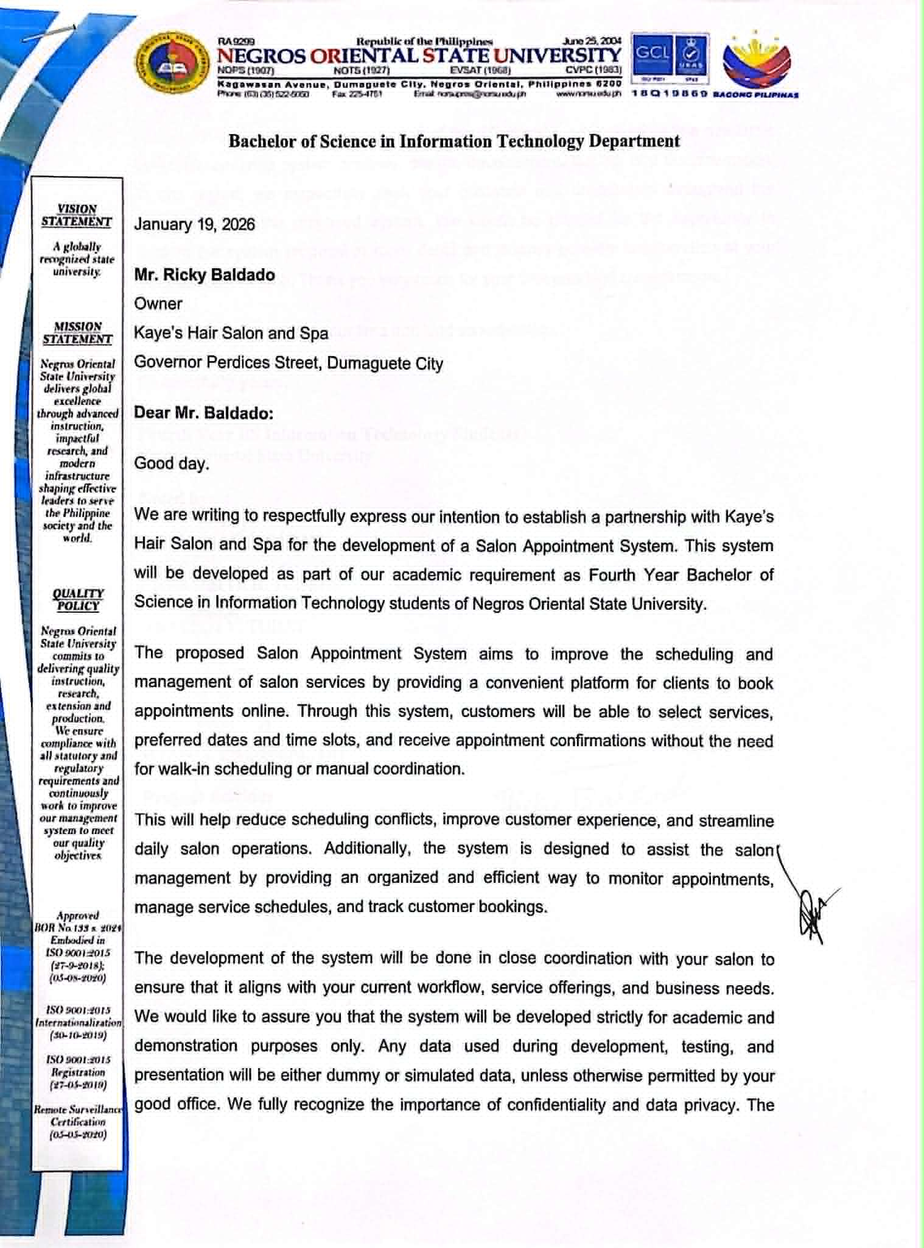



Appendix B Testing Instruments for End User
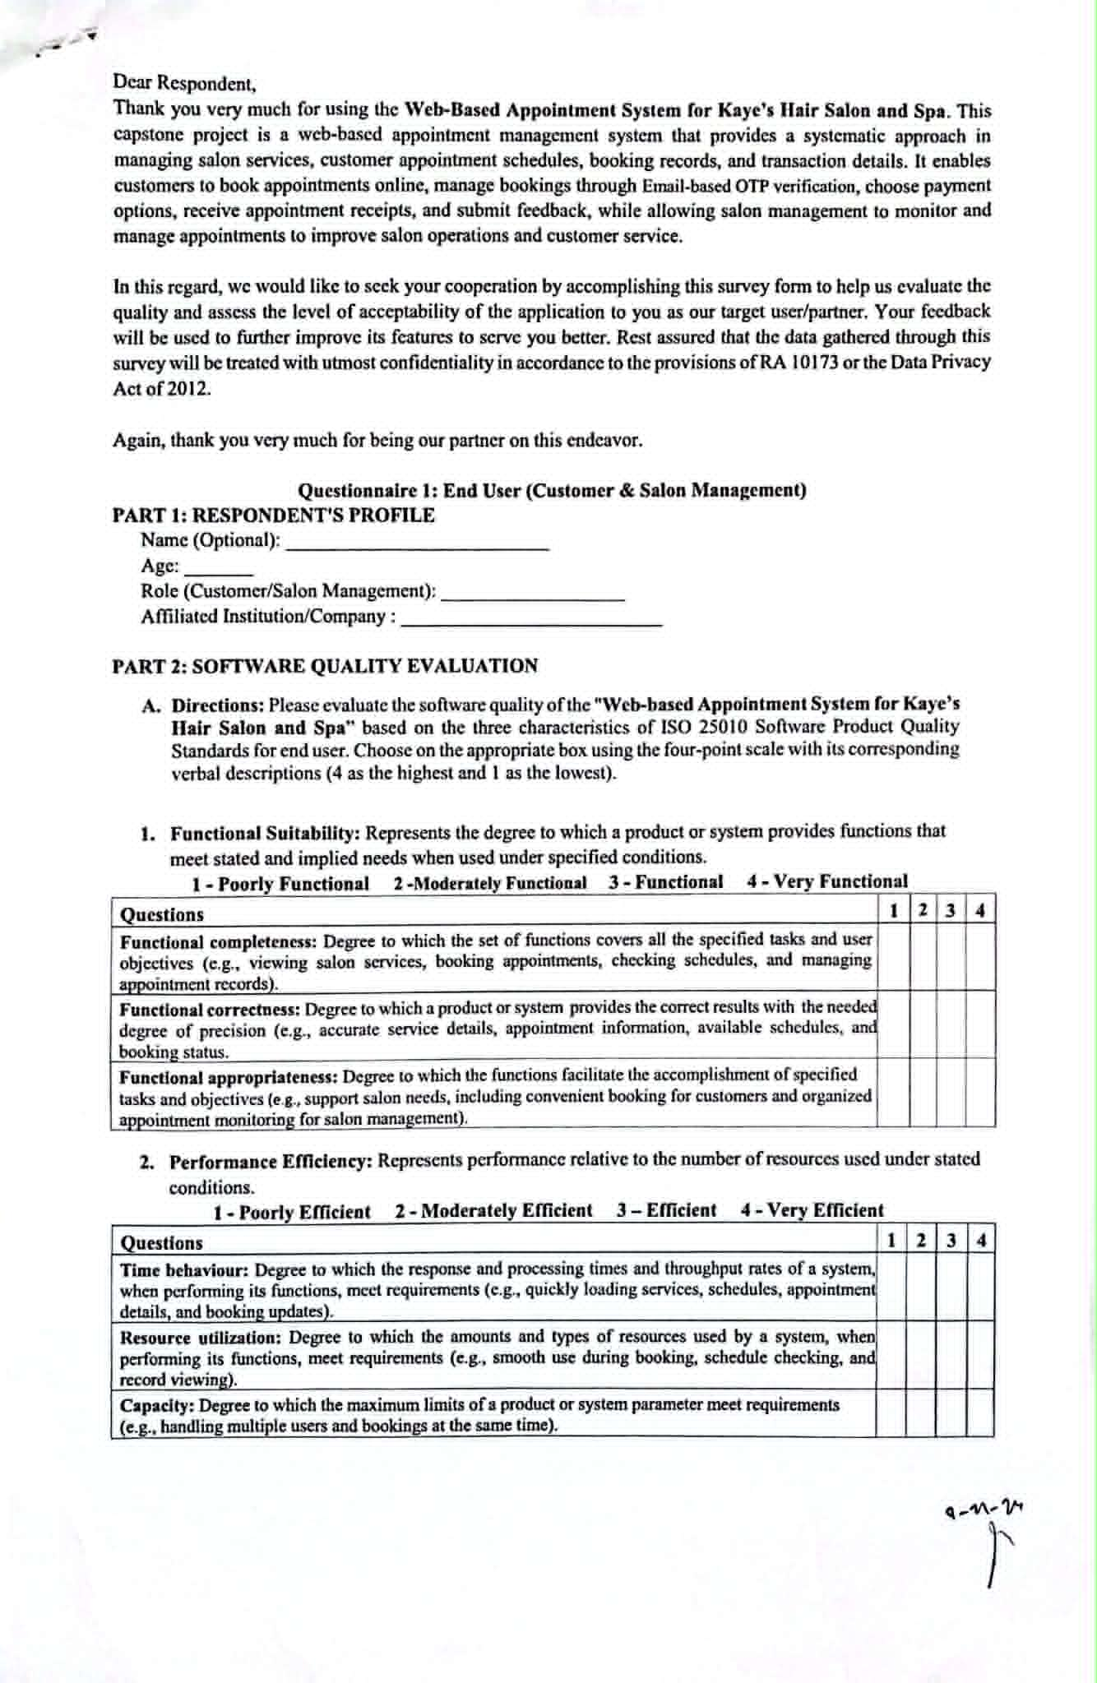
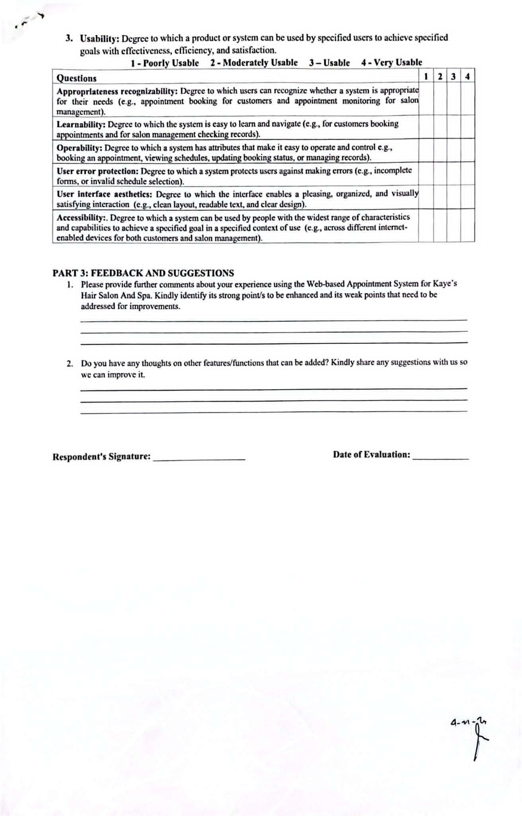
Appendix C
Testing Instruments for IT Experts
