Michigan State University
Pavement Research Center of Excellence

Evaluation of MDOT’s Methodologies for both Quantifying
Pavement Distress and Modeling Pavement Performance for Life-
Cycle Cost and Remaining Service Life Estimation Purposes

Supplementary Document V3.0

User manual for the PDSComp V0.1 Software

Michigan State University
Department of Civil and Environmental Engineering
428 S. Shaw Lane, 3546 Engineering Building, East Lansing, MI 48824

Muhammed Emin Kutay, PhD, PE (PI)
Professor
Michigan State University
kutay@egr.msu.edu

June 1, 2025

Table of Contents
INTRODUCTION 3
PD/AD (Pre-2019 )Data Tab 3
SDS (Post-2020) Data Tab 10

INTRODUCTION
This document is a user’s manual for the PDSComp software written in JAVA. This software loads the MDOT’s PMS data (that are in the form of ‘csv’ files) and processes them to compute the Pavement Distress Score (PDS).
The GUI codes are in the following JAVA files:
- MyLauncher.java
- MainApplication.java
- MainController.java
Compiled version of the GUI is located in the following folder:
- './PDSComp/target/’
In this folder, there is a file “run.bat”, which is an executable file and it can be executed by simply double clicking in Windows. For Mac, type the following: “./run.sh”
Once executed, the GUI shown in Figure 1 will appear.

PD/AD (Pre-2019 )Data Tab
First tab ‘PD/AD (Pre-2019) Data’ in the figure is for processing data collected before 2019.
First step is to click “Select PD/AD” button. Once clicked, this will allow you to select multiple csv files. These are the ‘Tfiles’ shown in Figure 2, which includes the PD/AD data collected before 2019.
Next step is to click “Select Pavement List” button shown in Figure 3. Once clicked, you’ll be asked to select a pavement list that should be in csv format. There are two pavement lists, one for Flexible pavements and one for Rigid pavements. Snapshots of the Flexible and Rigid pavement lists are shown in Figure 5 and Figure 6, respectively. The most important columns are:
- CS
- BMP
- EMP
- DIR
- SURFACE
All the columns above must exist and they should not be blank. Otherwise the program will give error.
Then click the “Compute PDS: Pavement List” button (Figure 4). The program will convert all the PD/AD data to SDS equivalent and compute the PDS values for each section in the pavement list. A snapshot of the command prompt while the code is running is shown in Figure 7. The outputs of the program is shown in Figure 8 where separate csv files are generated for each year of PD/AD data and one COMBINED csv file is generated by stacking all the yearly csv files.

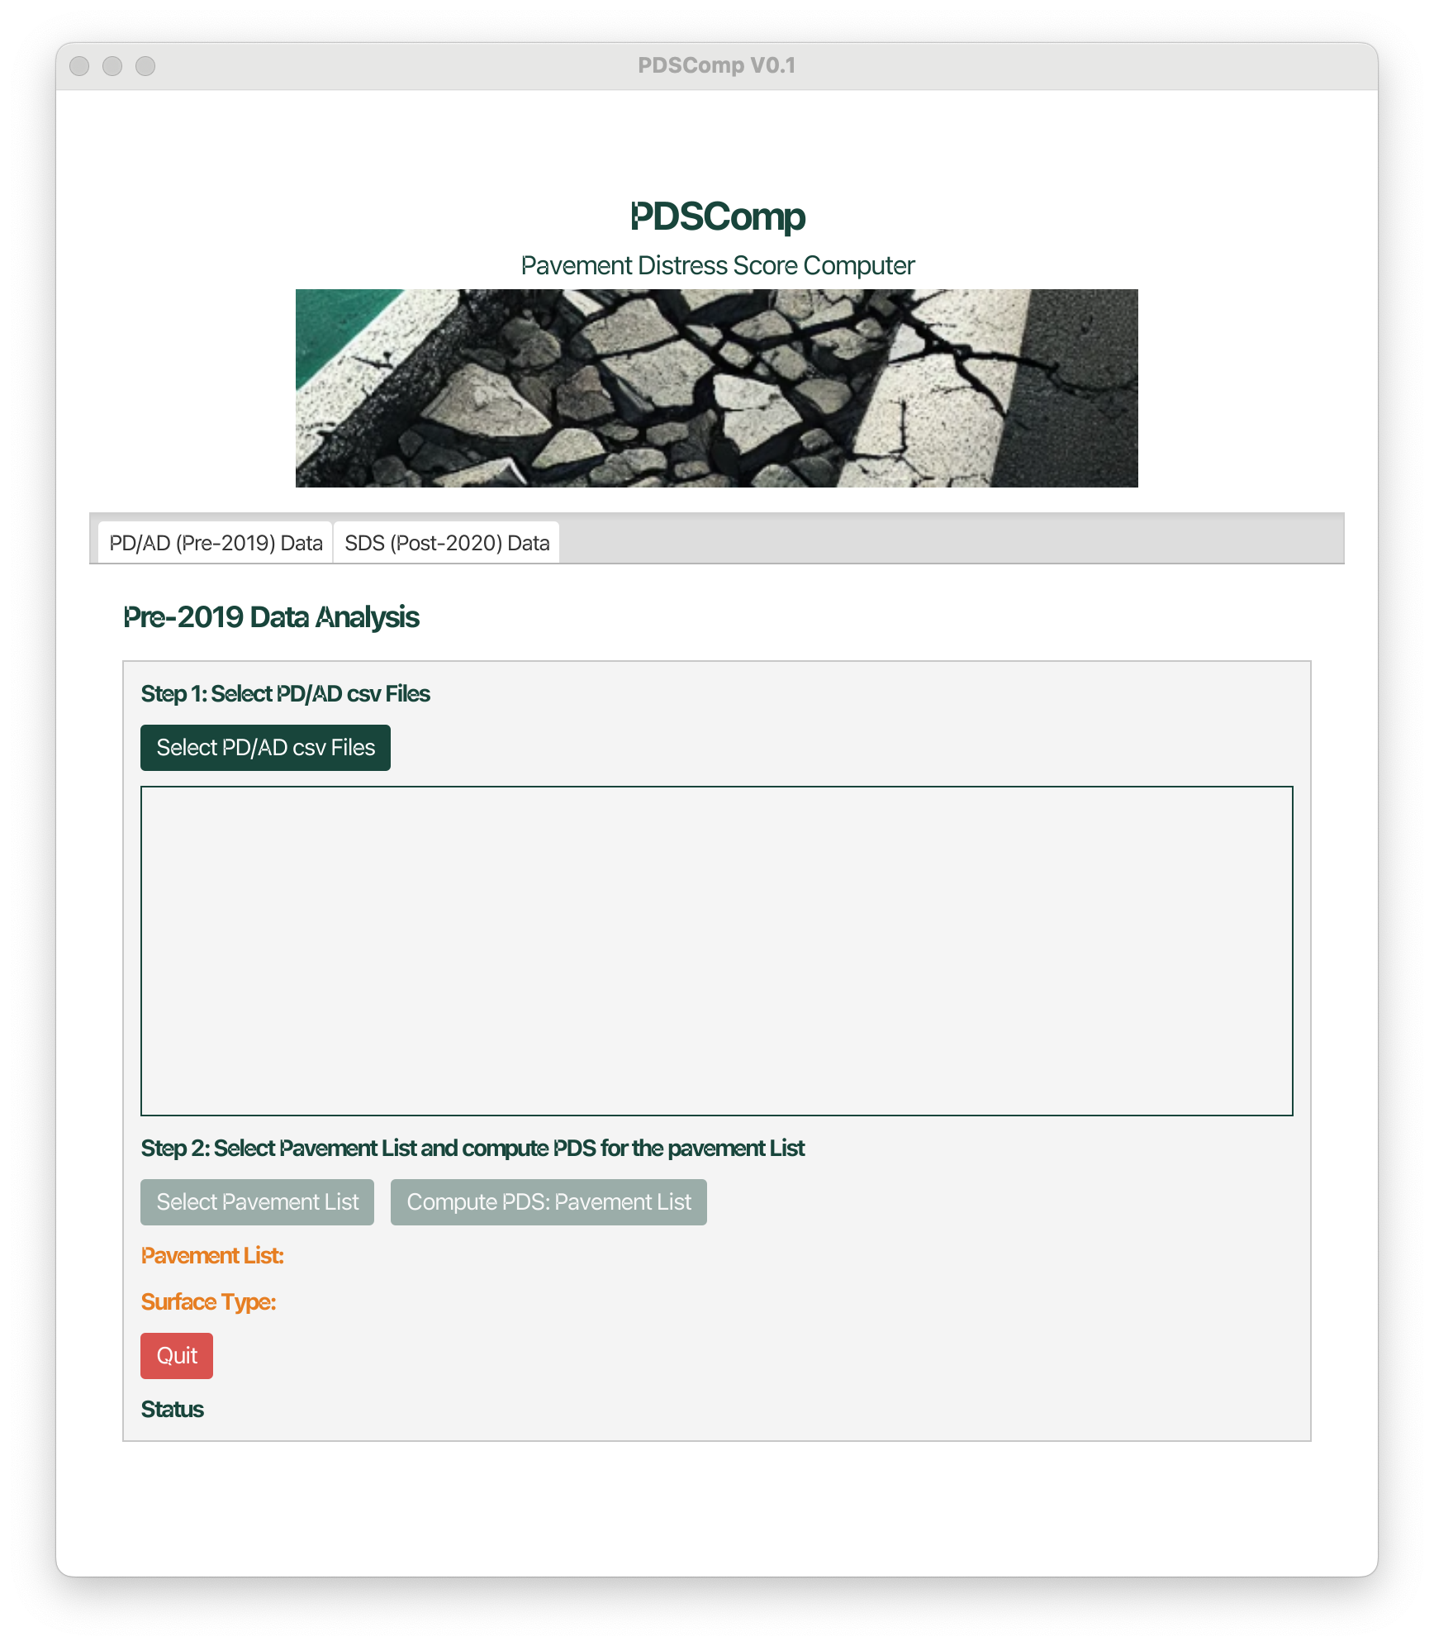
Figure 1 A screenshot of the GUI
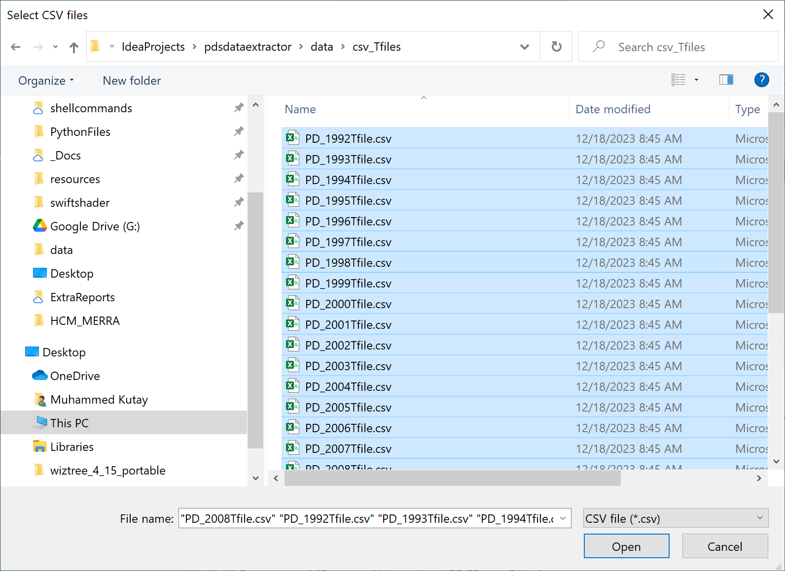
Figure 2 A screenshot of the list of the “Tfiles”, which are the main PMS files

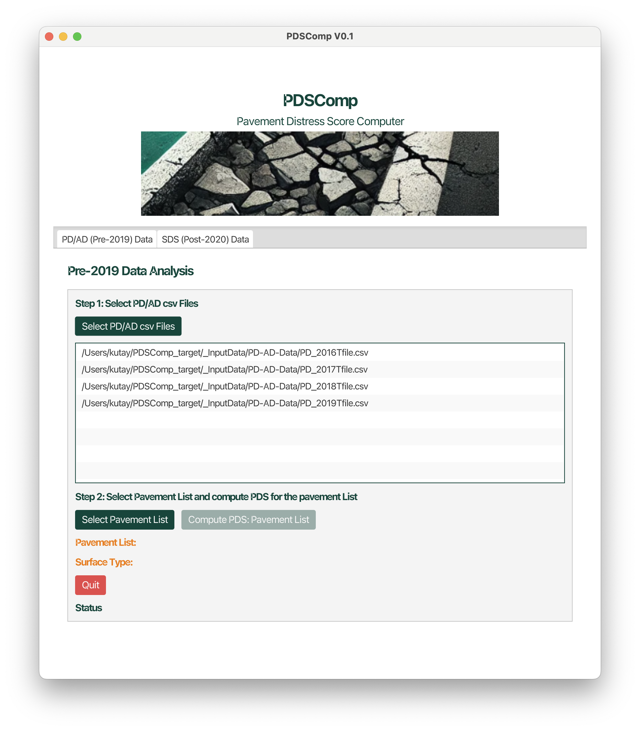
Figure 3 After selection of PD/AD files.
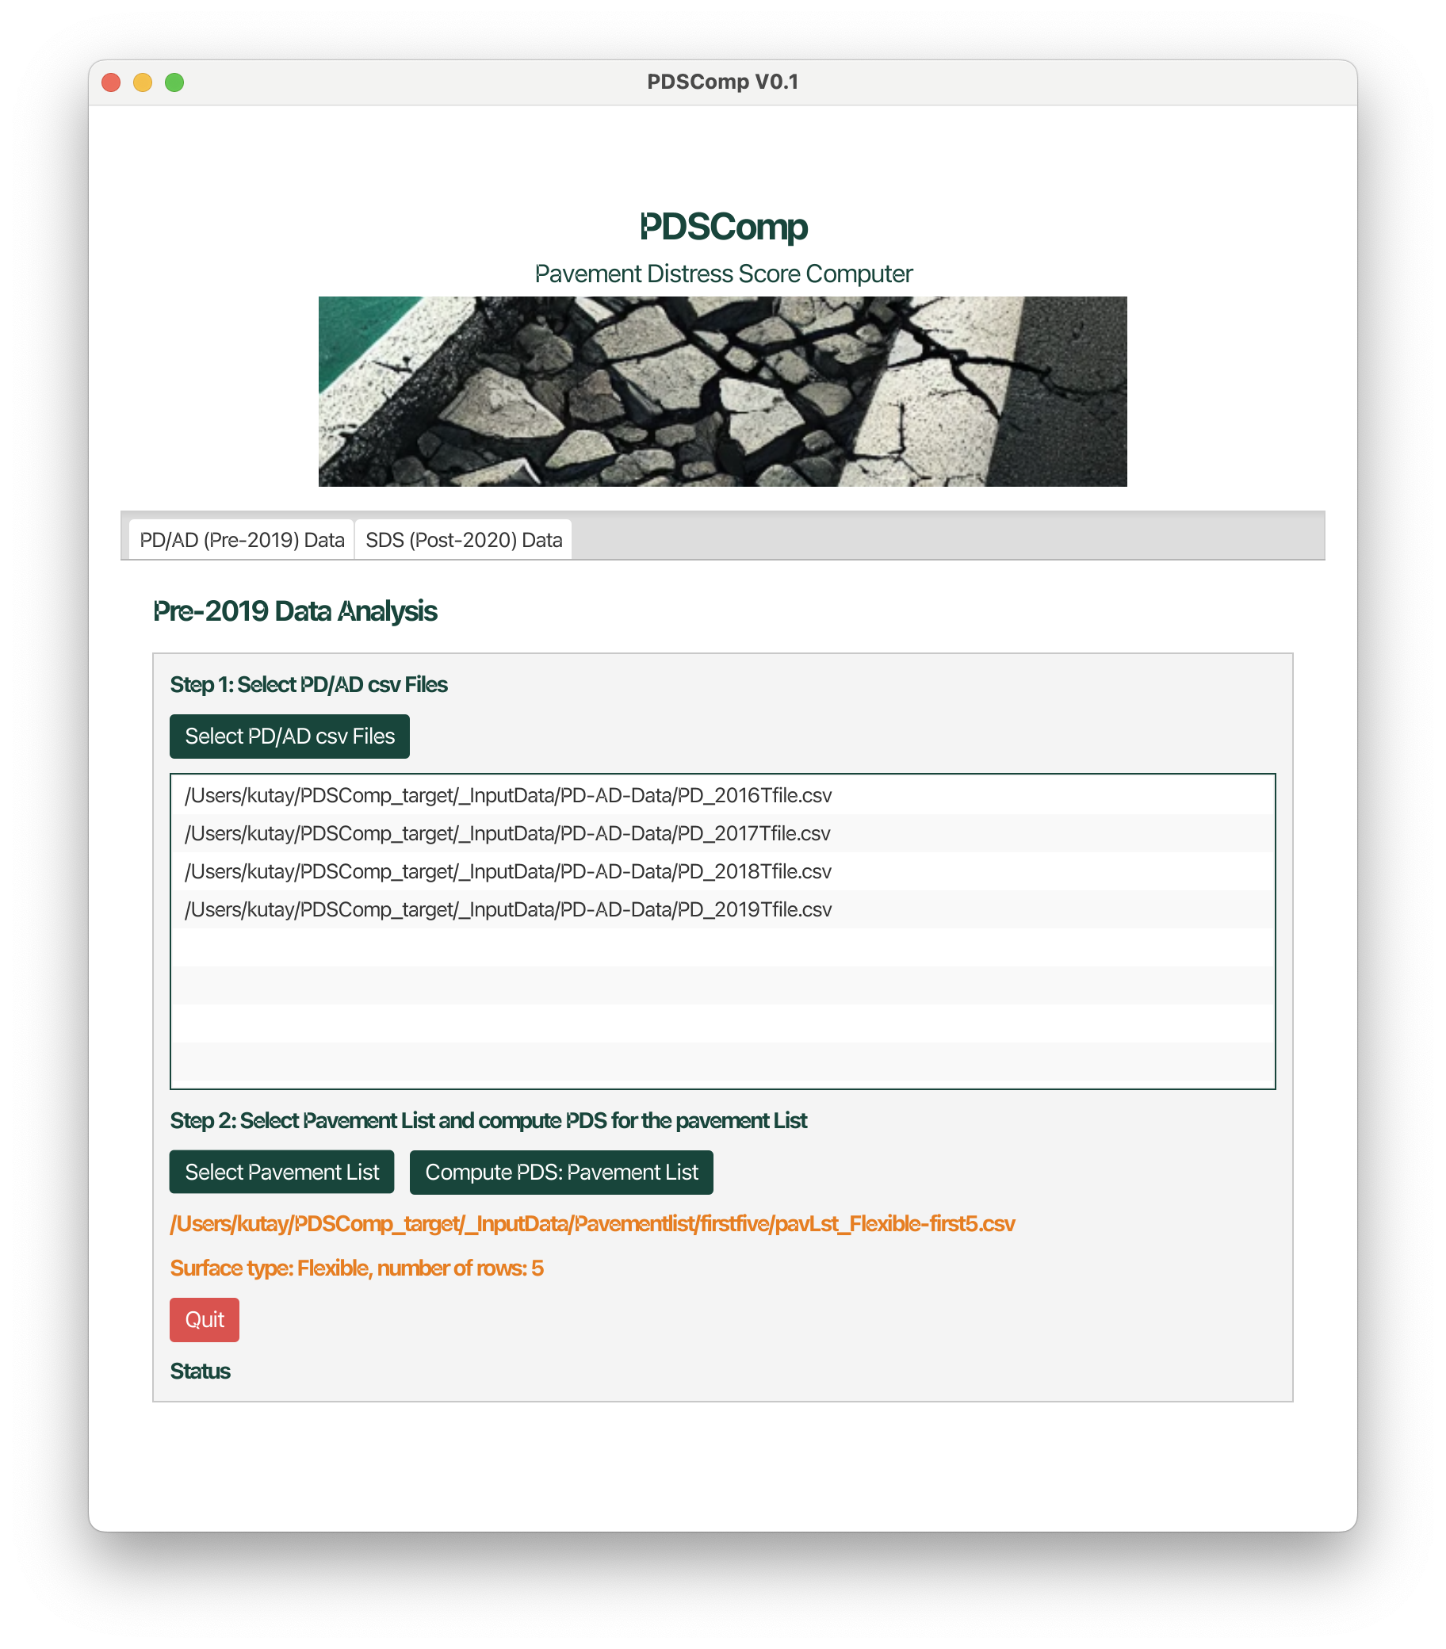
Figure 4 After selection of Pavement List

Finally, clicking “Process Files” will process all the files. A screenshot of the GUI and the command prompt while the program is running is shown in Figure 7. The outputs will be saved in the same folder where the input pavement list is located (see Figure 8).
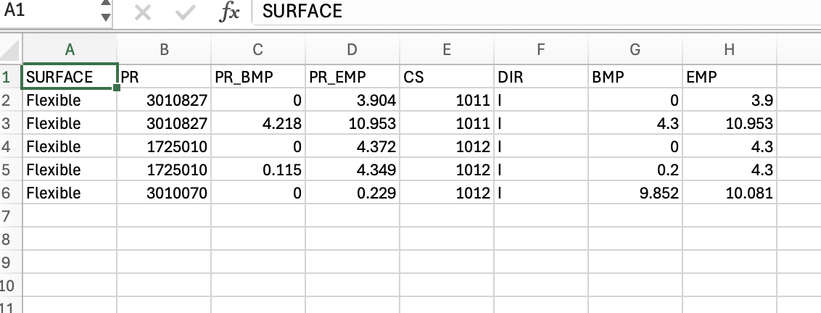
Figure 5 A screenshot of the Flexible pavement list

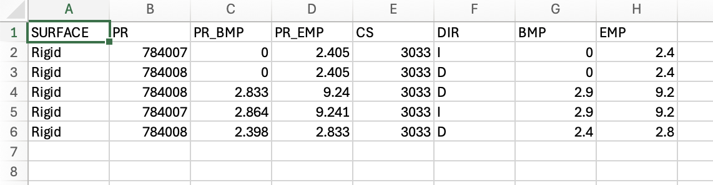
Figure 6 A screenshot of the Rigid pavement list

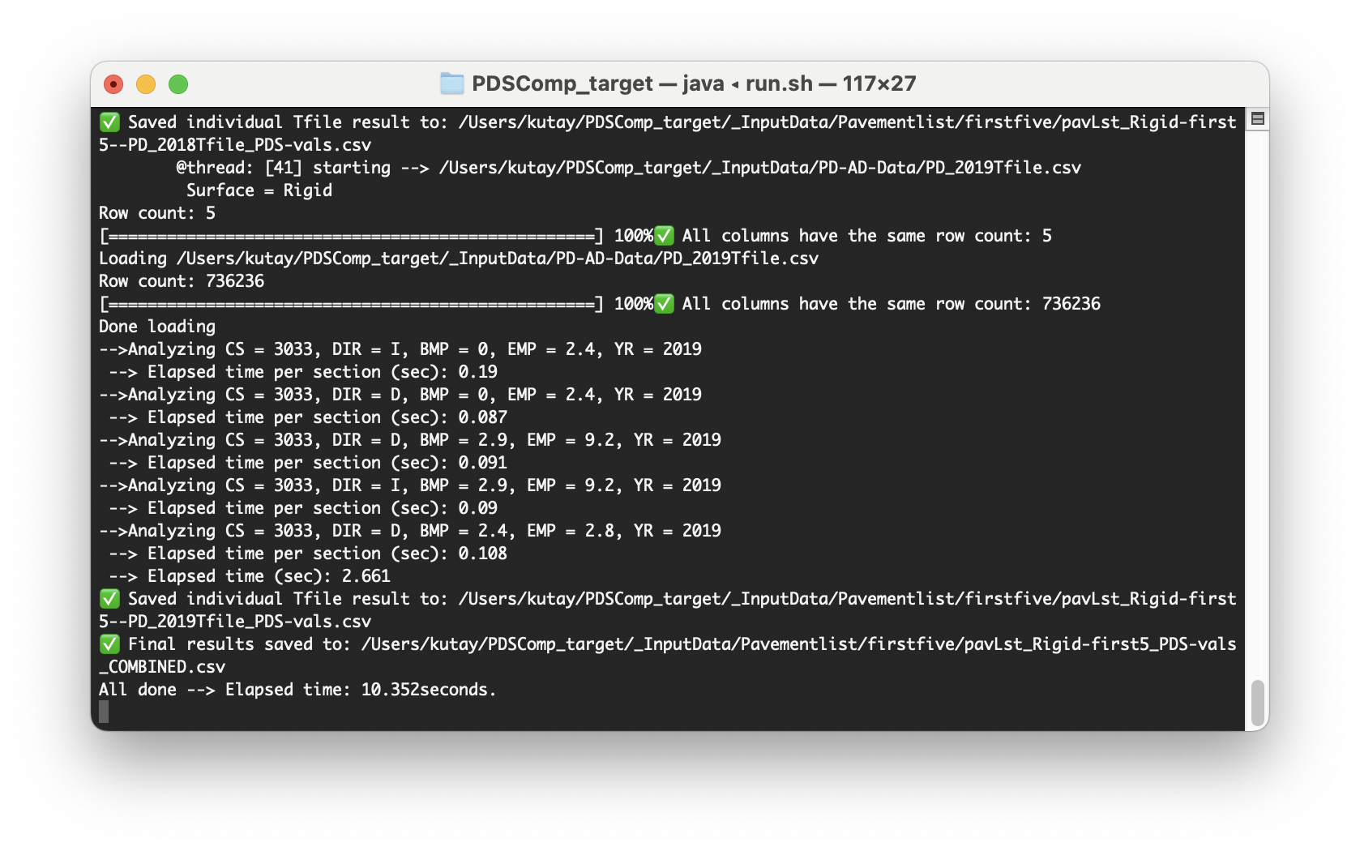
Figure 7 A screenshot of the command prompt while the program is running.

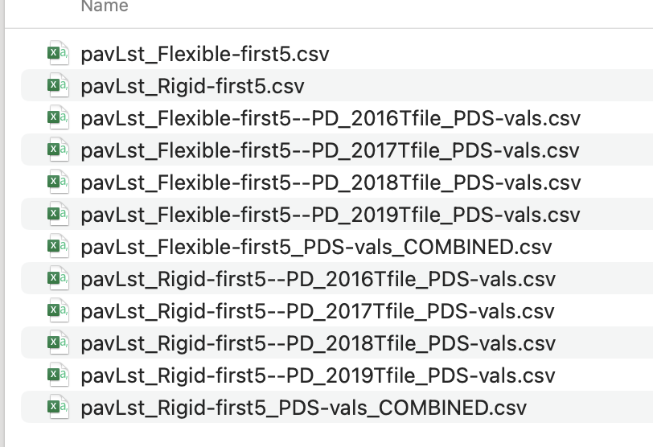
Figure 8 A screenshot of the outputs.

SDS (Post-2020) Data Tab
Whenthe user clicks the SDS (Post-2020) Data tab, the GUI in Figure 9 becomes visible. Here. First user clicks the ‘Select SDS csv files’ button. Once user selects the SDS data, next step is computation of PDS values for every row of the SDS data in the list. A screenshot of the SDS (Post-2020) Data tab after cliking the Select SDS csv files button is shown in Figure 10. At this point, user clicks the ‘Compute PDS: all rows’ button to compute the PDS values for every 0.1 mile or 0.01 mile section that is in the SDS csv files selected.
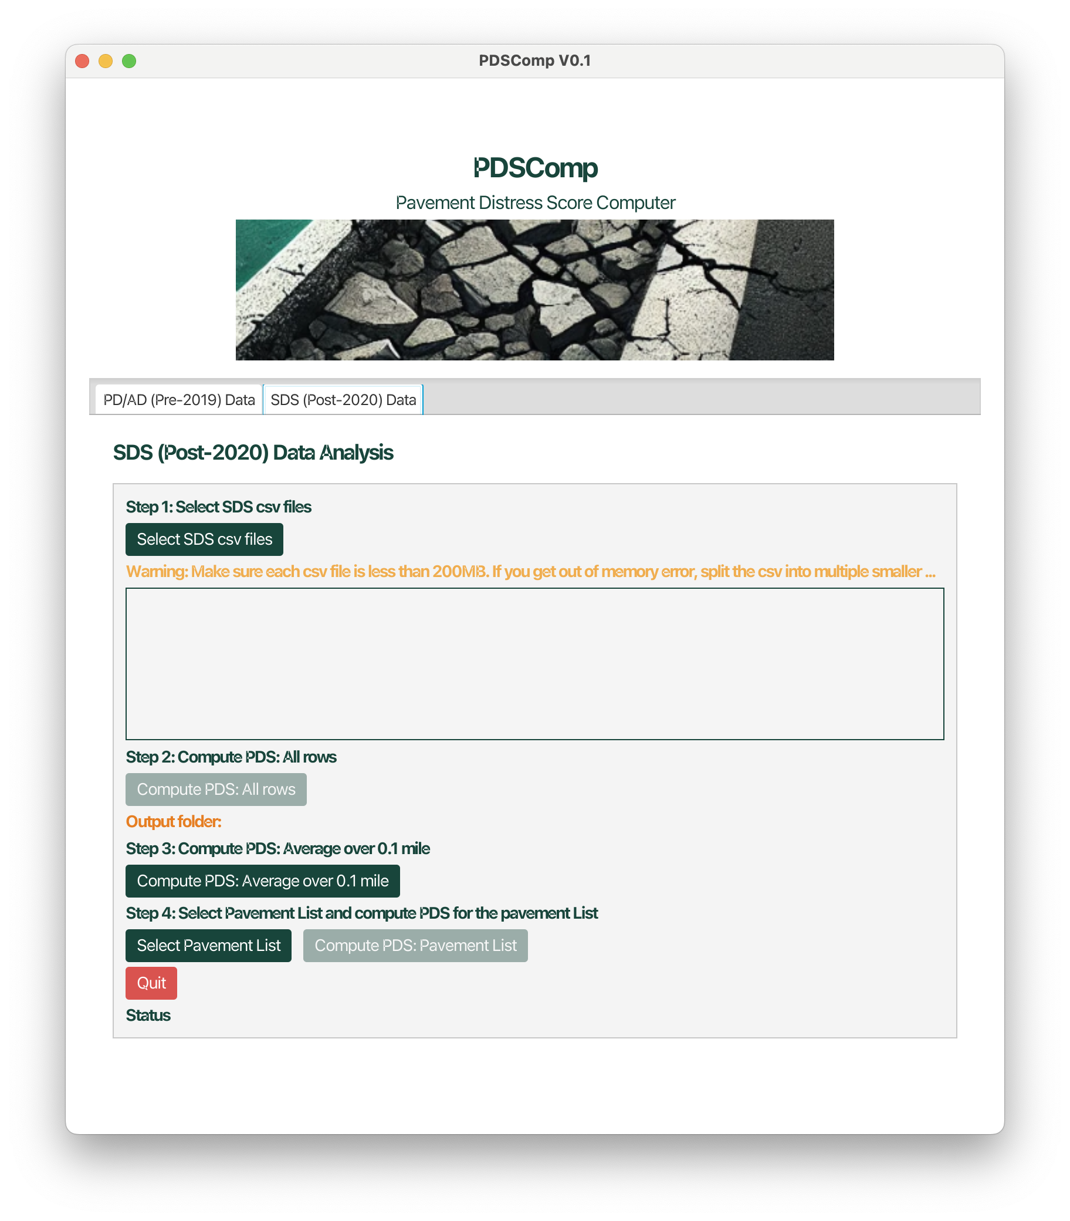
Figure 9 A screenshot of the SDS (Post-2020) Data Tab.

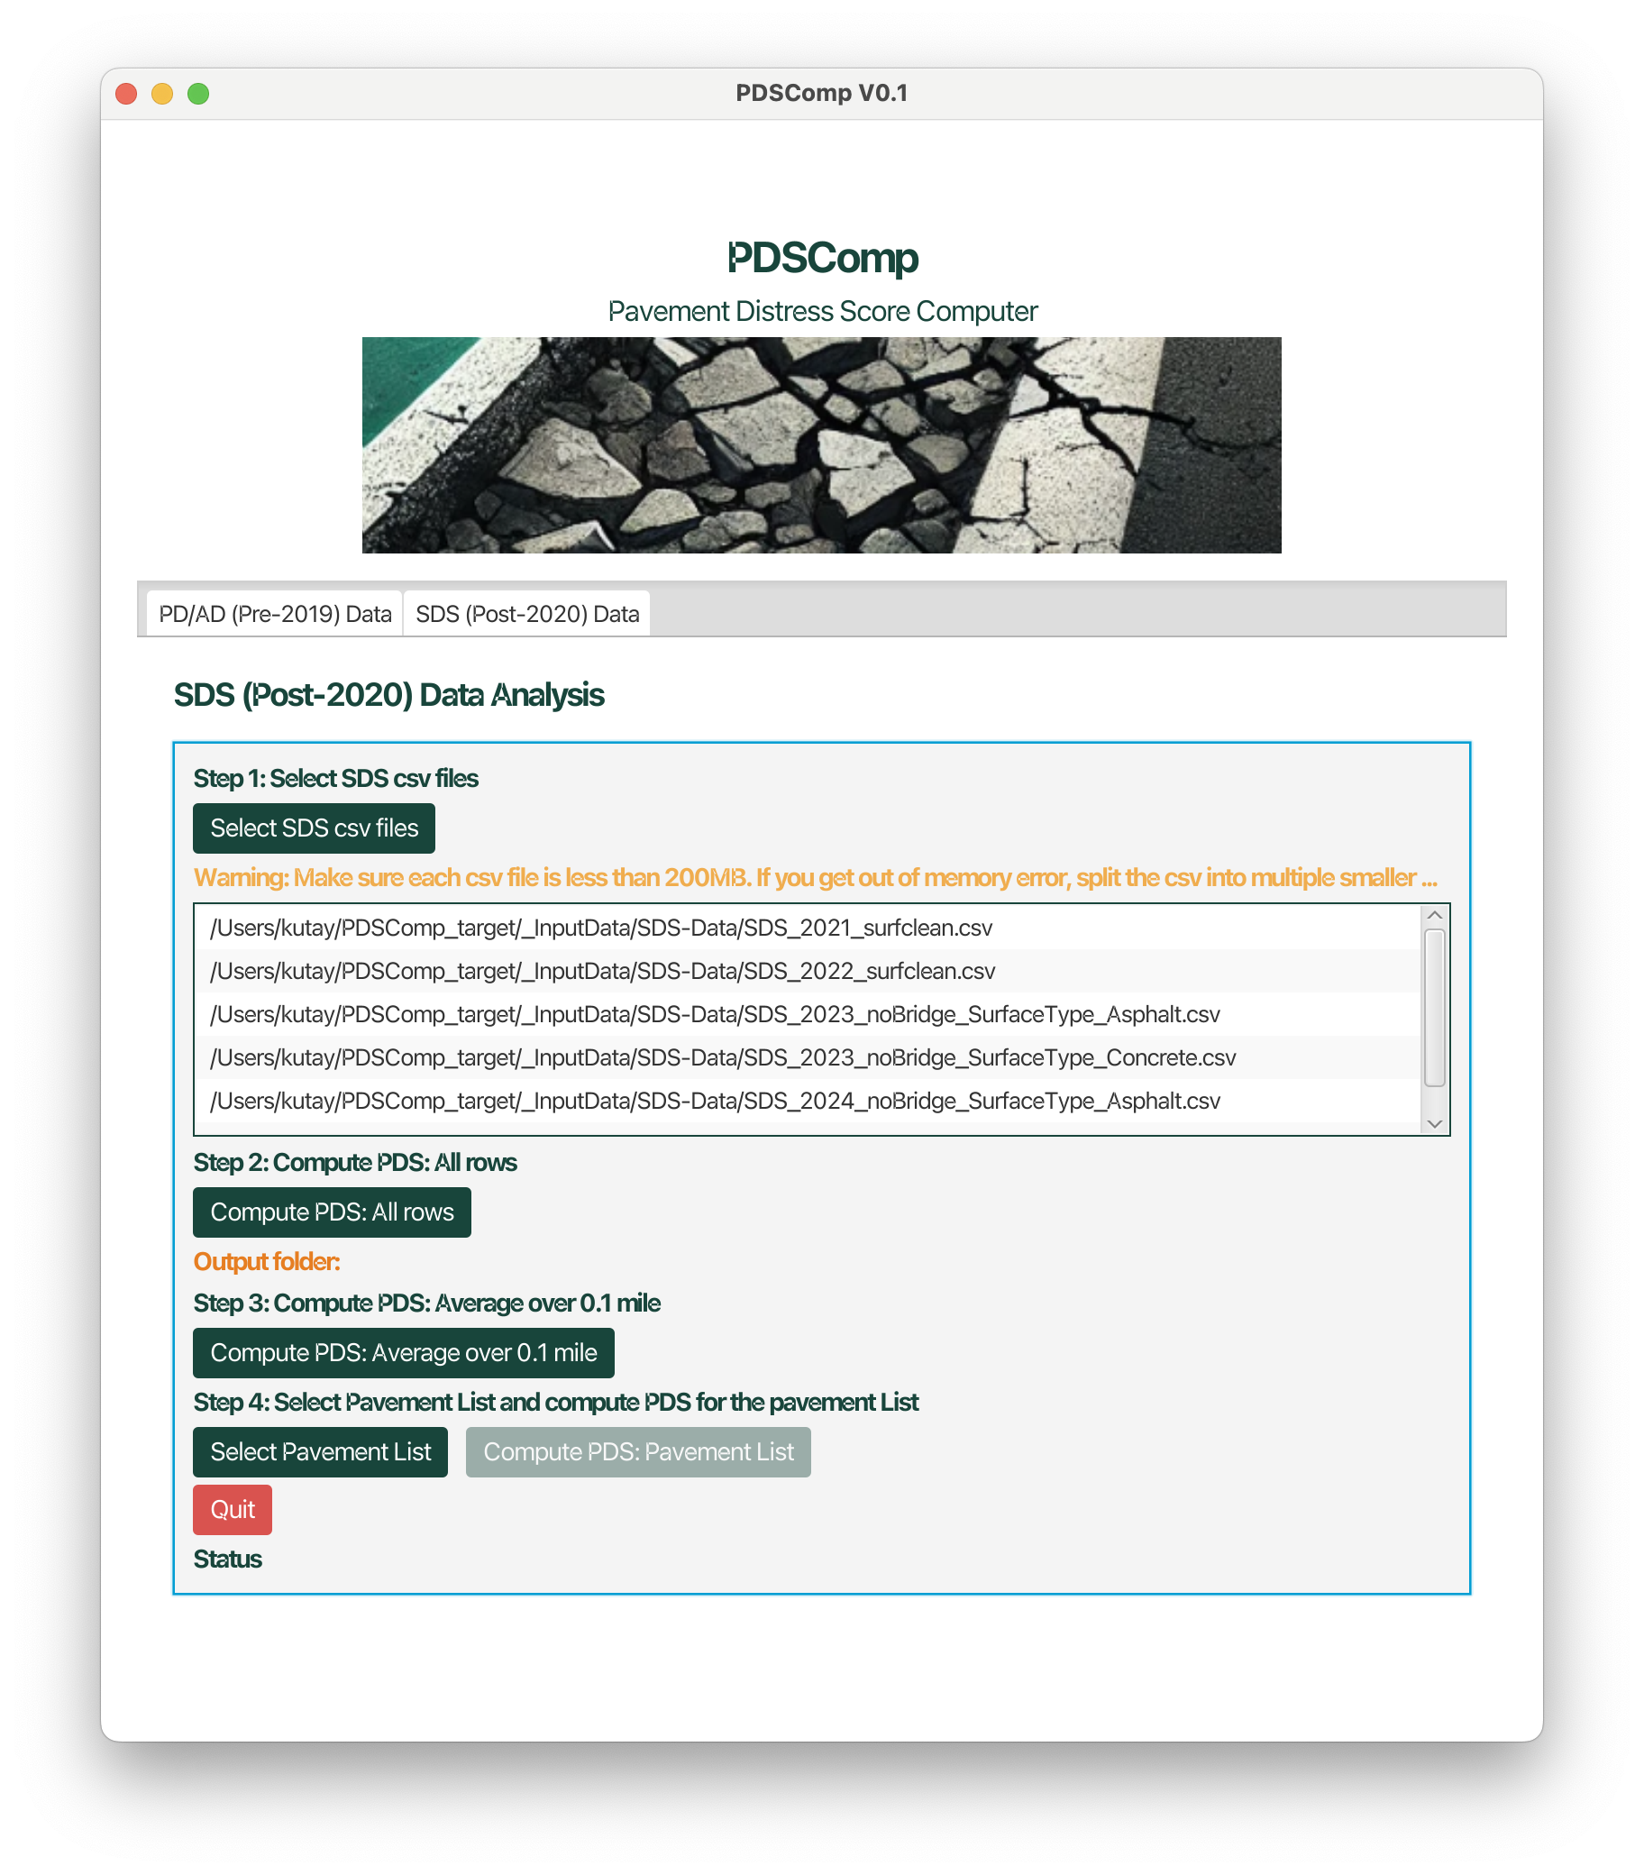
Figure 10 A screenshot of the SDS (Post-2020) Data tab after cliking the Select SDS csv files button.

Next step is to compute average 0.1 mile segment PDS data from the 0.01 mile data. This is done by clicking the ‘Compute PDS:Average over 0.1 mile’ button. This step is not necessary for the years where the original SDS data is already in 0.1 mile increments.
Finally next step is to compute the PDS values for the selected pavement sections. User clicks the ‘Select Pavement List’ button and selects the files shown in Figure 5 and Figure 6. The most important columns are:
- PR
- PR_BMP
- PR_EMP
- SURFACE
All other columns can be empty because at this point only these are used.
Finally, user clicks Copute PDS: Pavement List button to compute the average PDS values over the given BMP/EMP ranges in the pavement list.

