**GRAPHICAL USER INTERFACE DESIGN**

**User Interface/Report Number: Login for Customers, Couriers, Restaurant Owners and Admins**

**Related Use-Case: 8, 9, 10, 11**

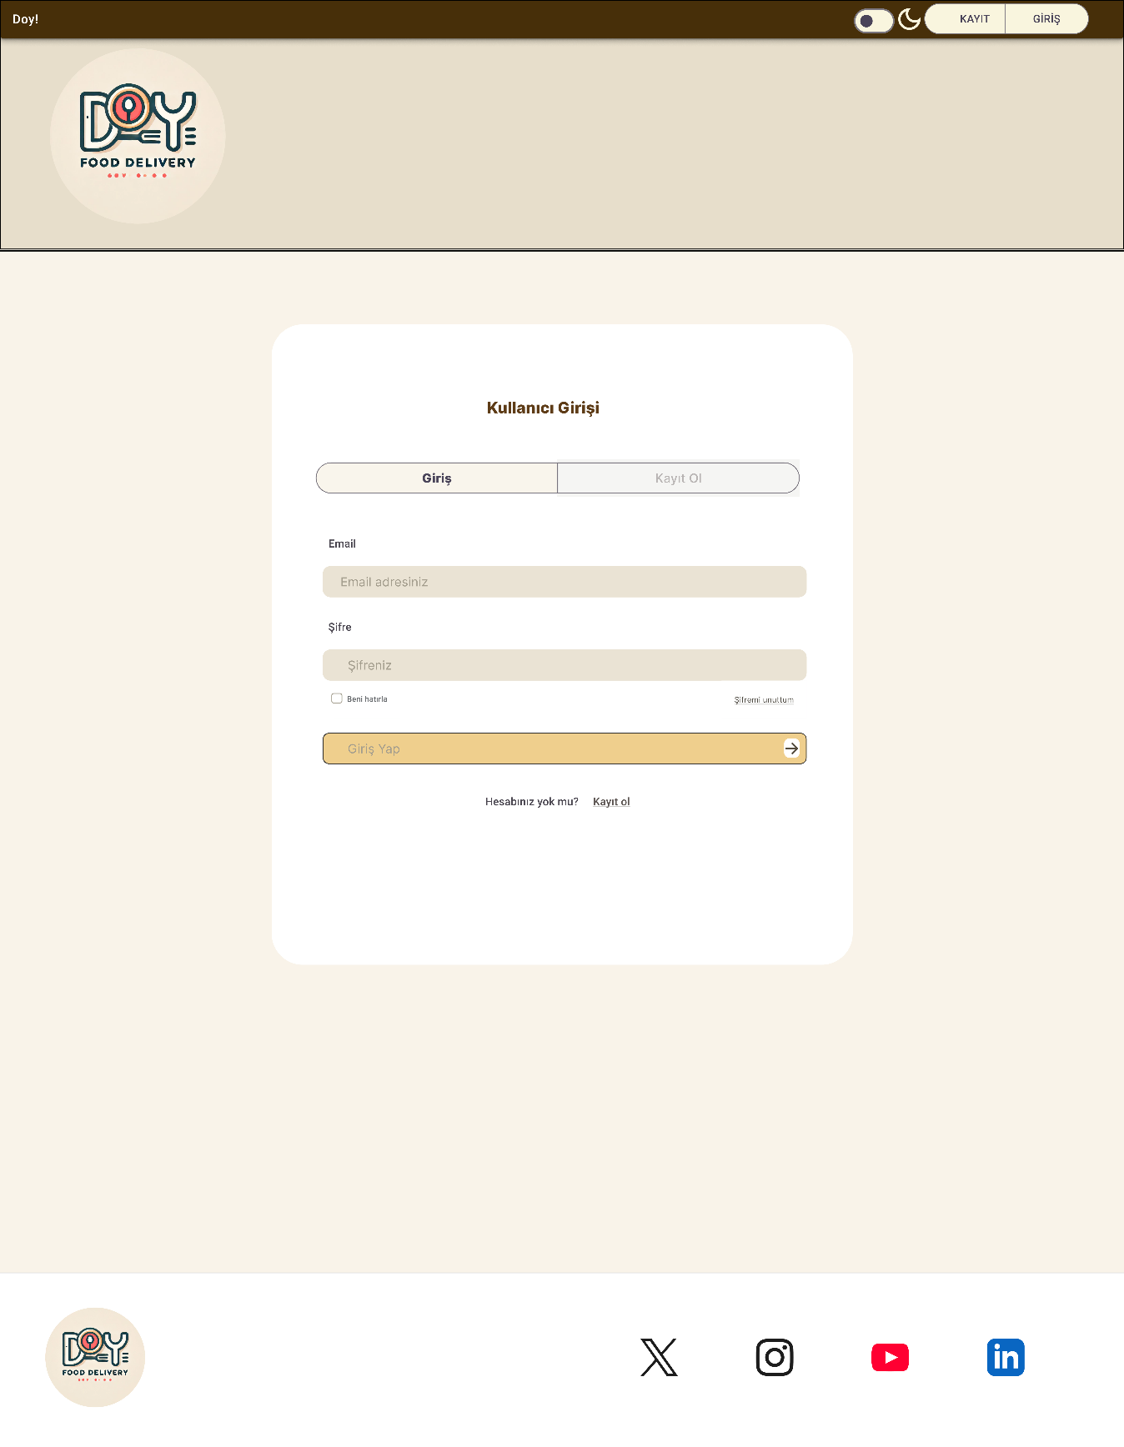

**User Interface/Report Number: Registration for Customers, Couriers and Restaurant Owners**

**Related Use-Case: 29, 30, 31**

**User Interface/Report Number: Main Page, Browse Restaurants Page, Restaurant Page and Order Page for Customers**

**Related Use-Case: 1,2,3,4,5,6,7**



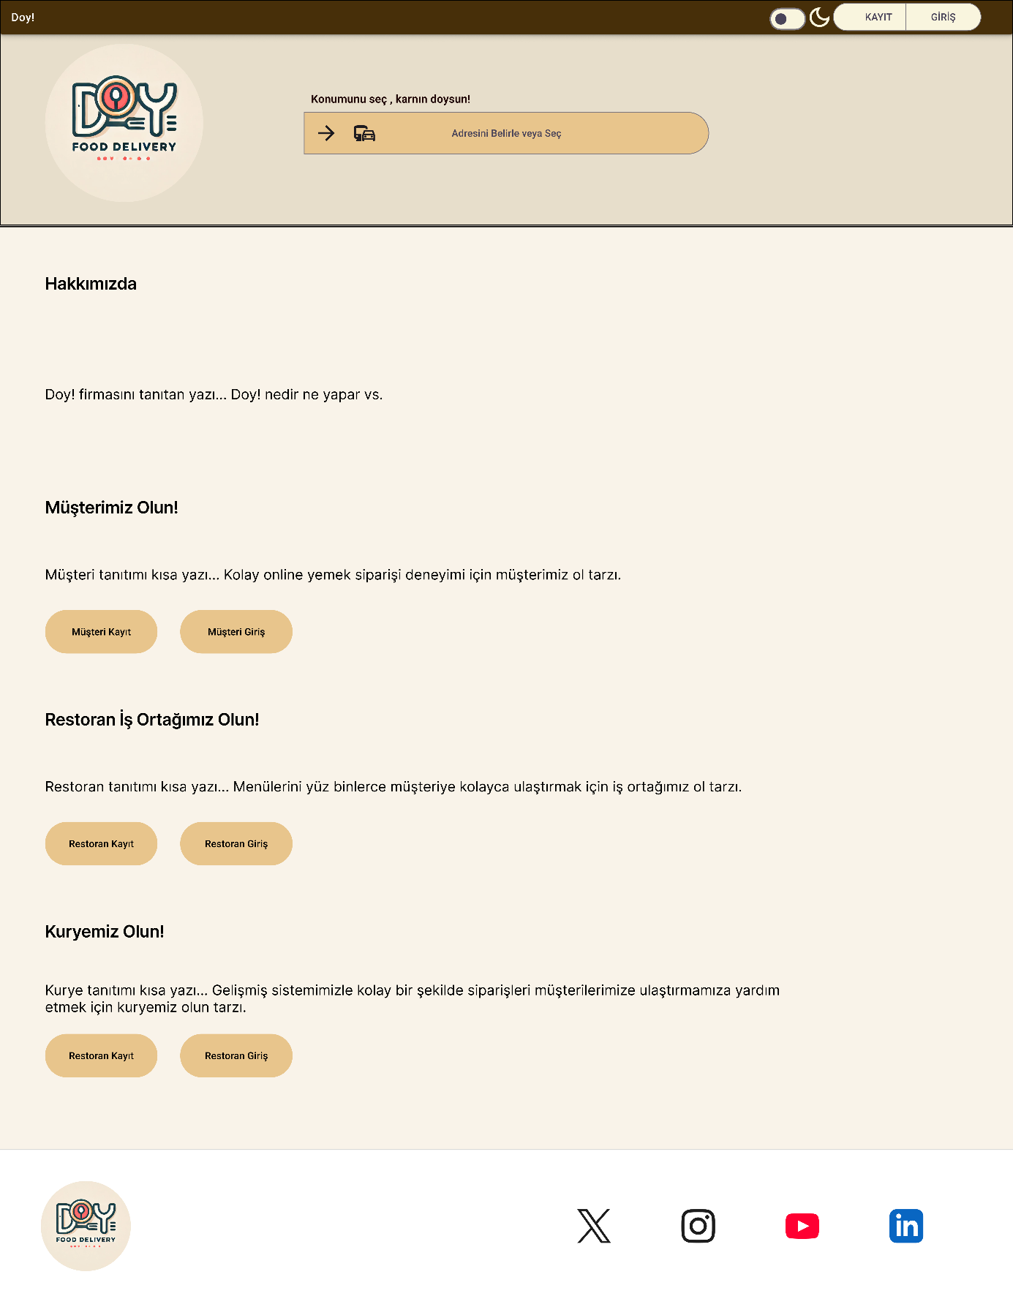

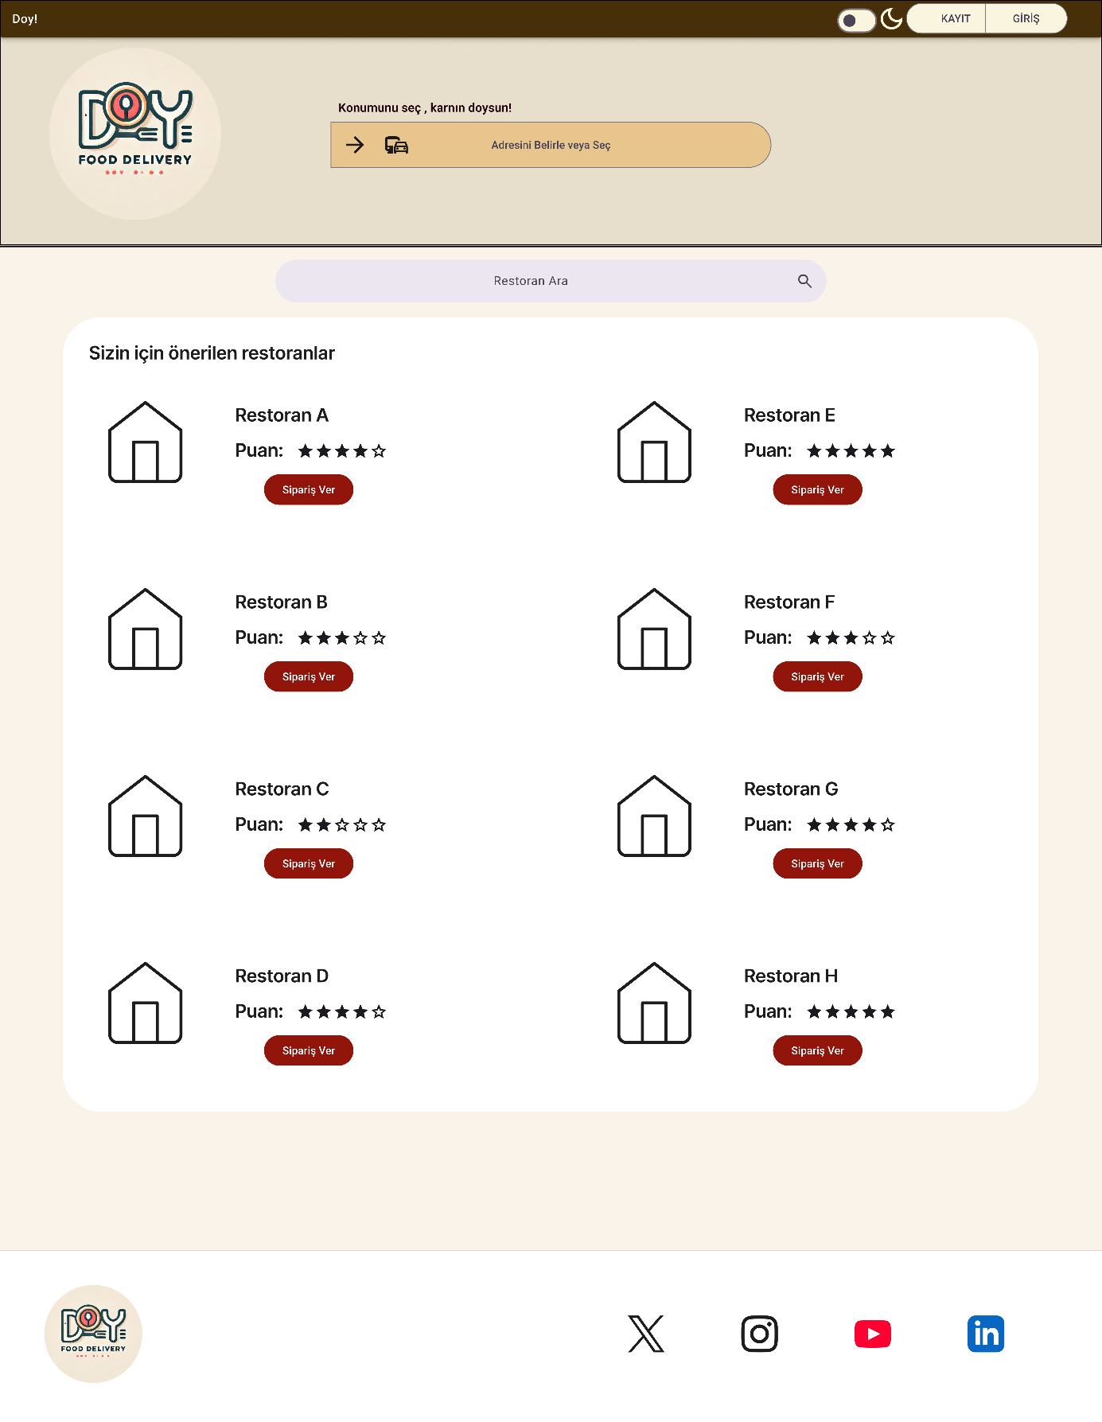

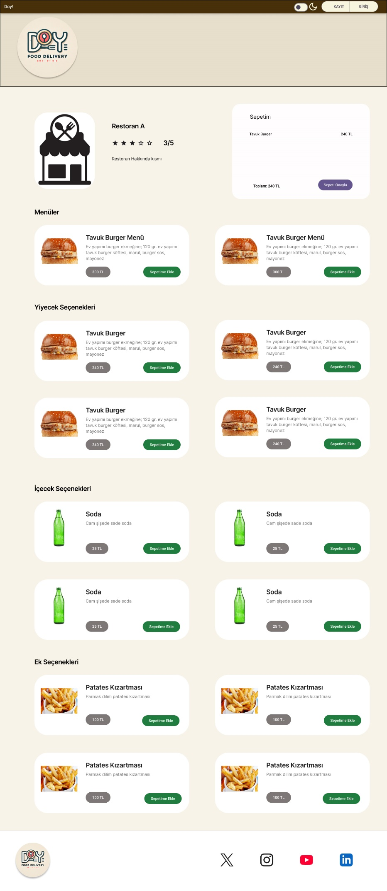

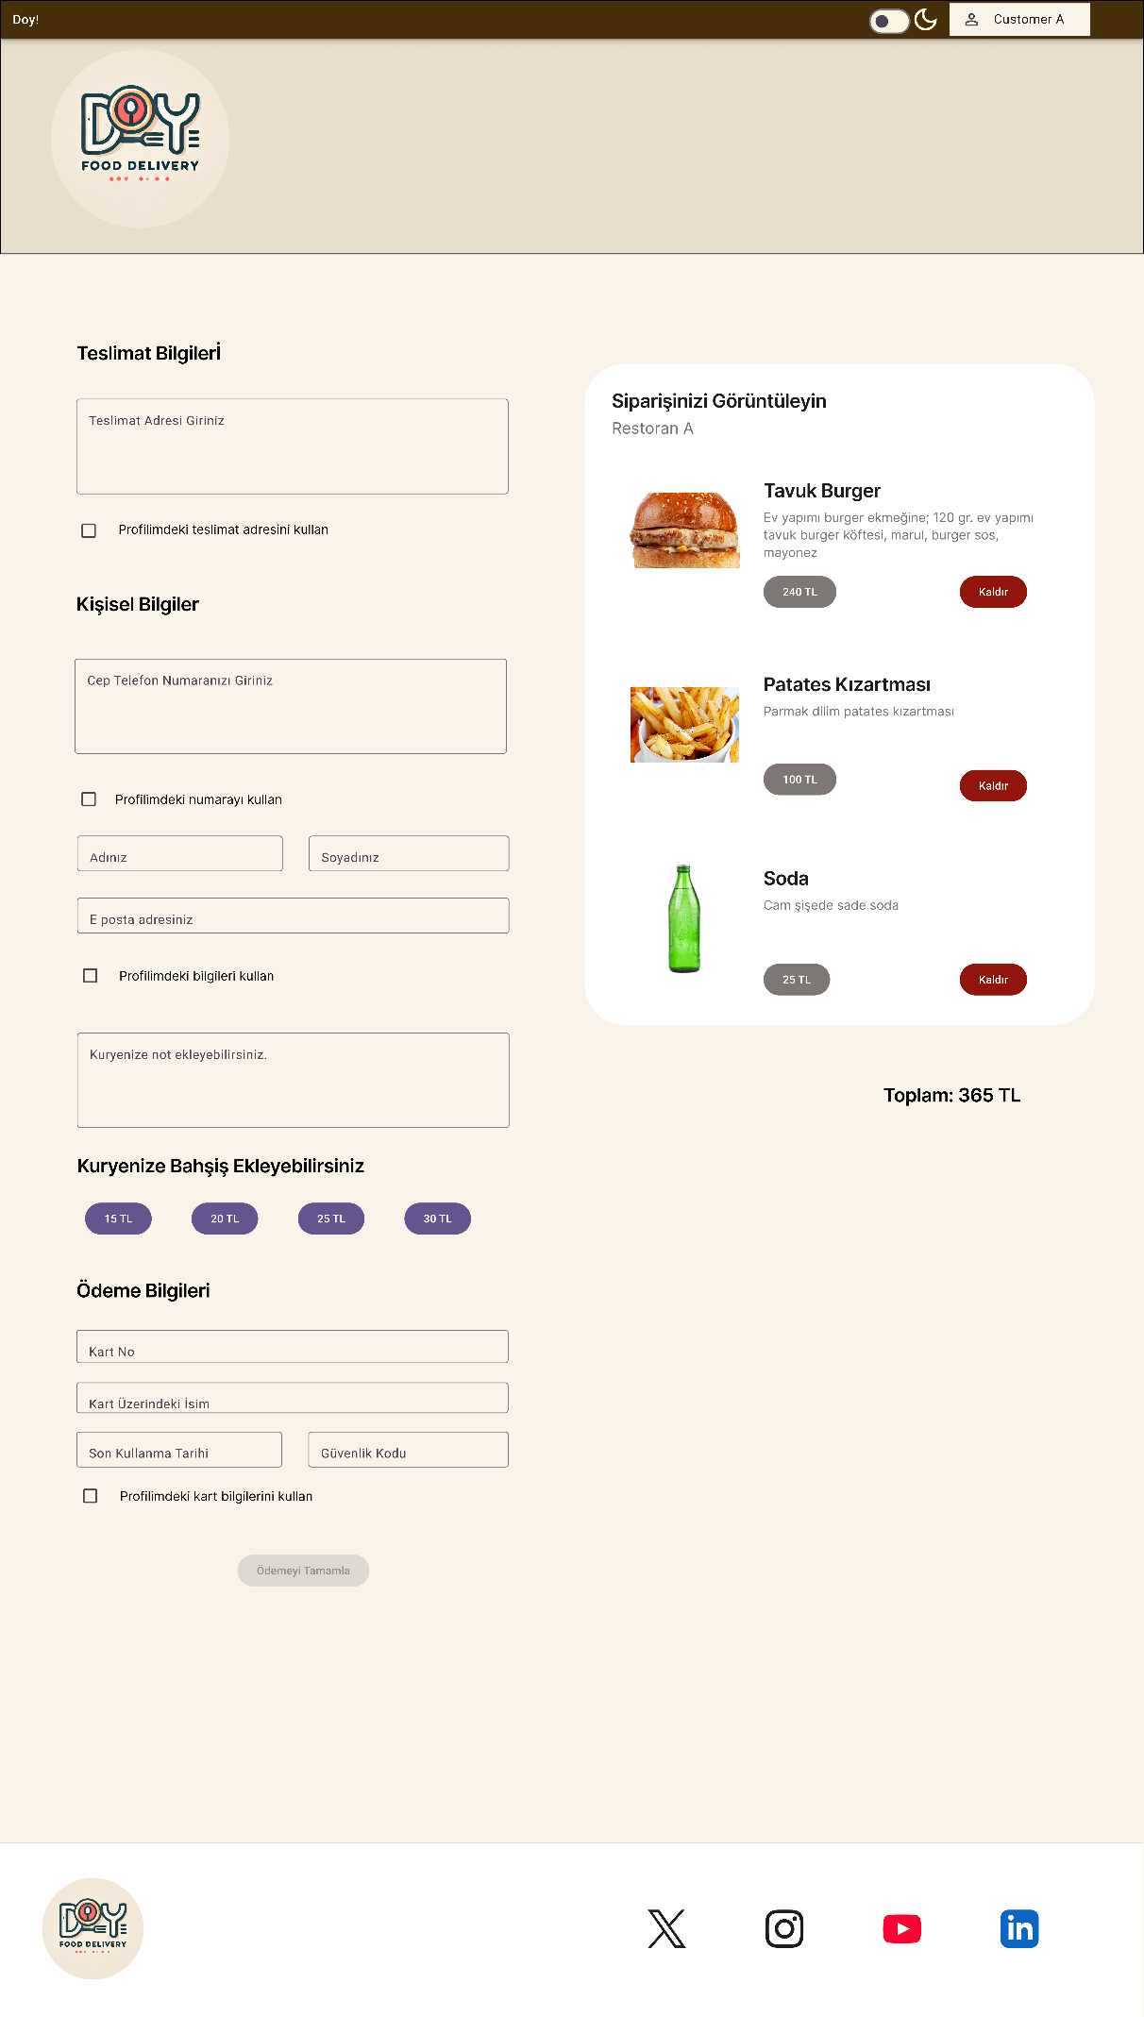

**User Interface/Report Number: Edit Restaurant, See/Assign Orders Page for Restaurant Owners**

**Related Use-Case: 17,18,19,20,21,22**

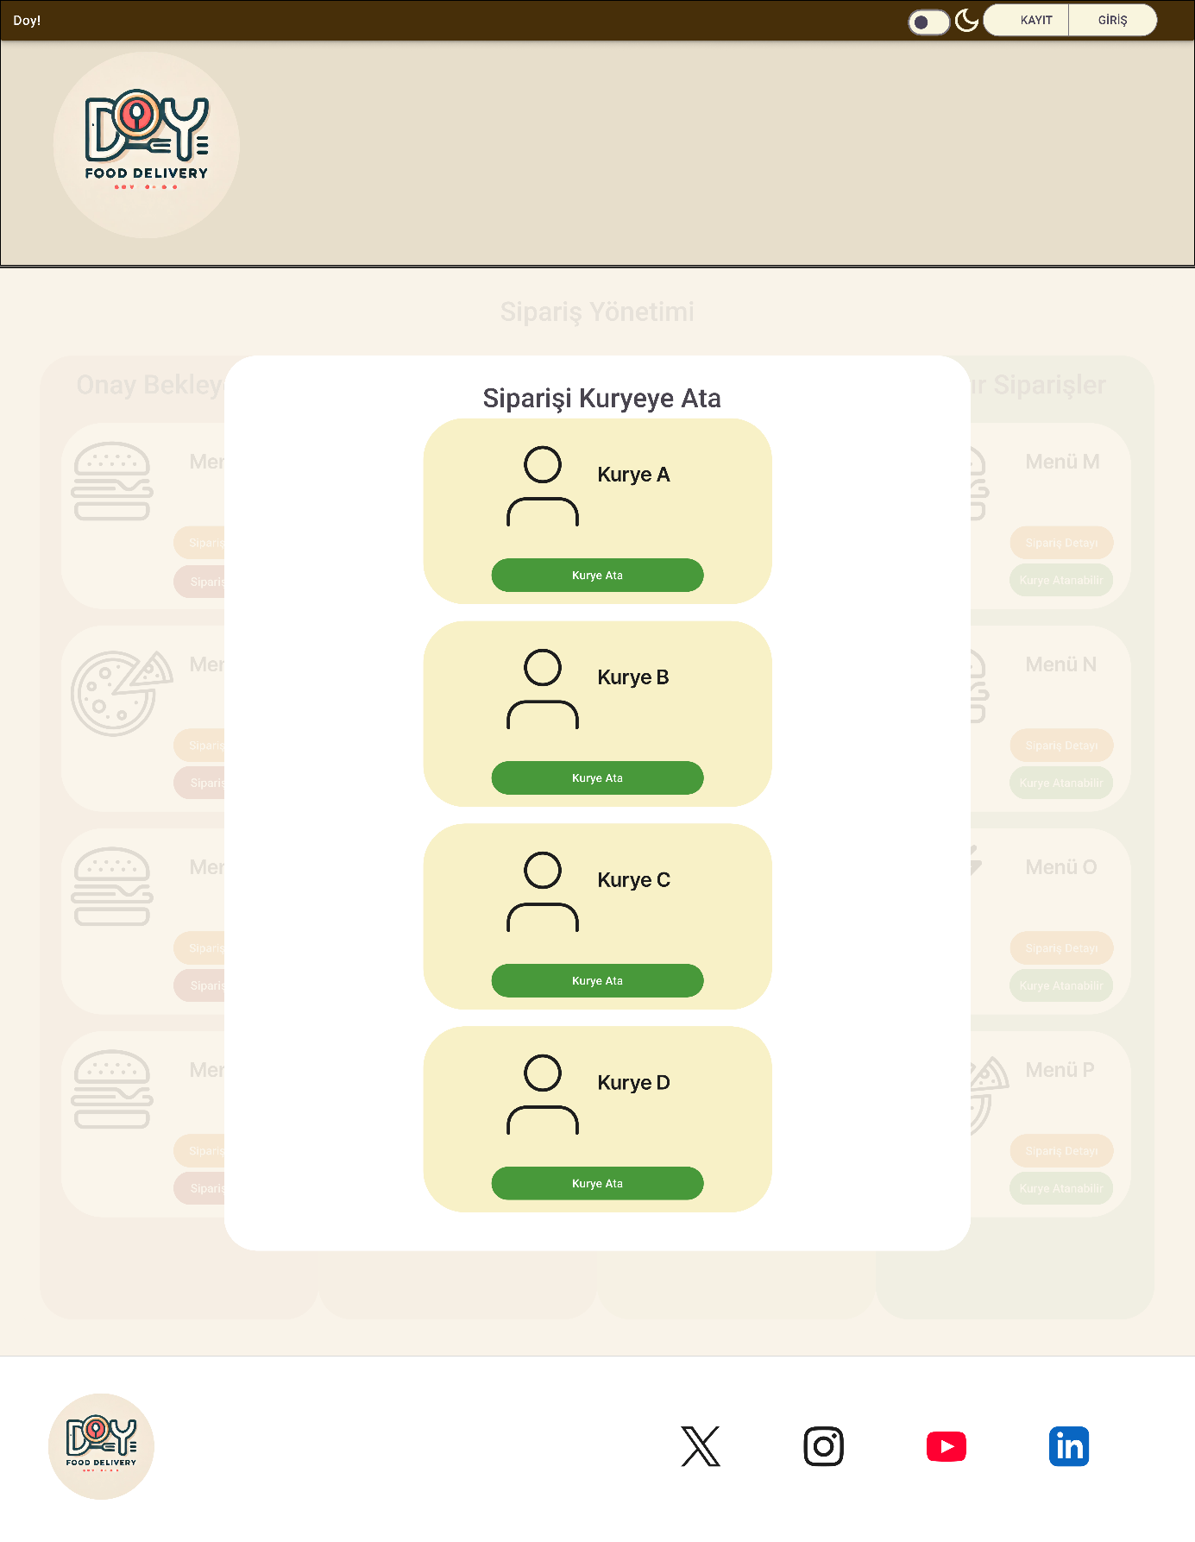

**User Interface/Report Number: See Assigned Orders Page for Couriers**

**Related Use-Case: 25,26,27**

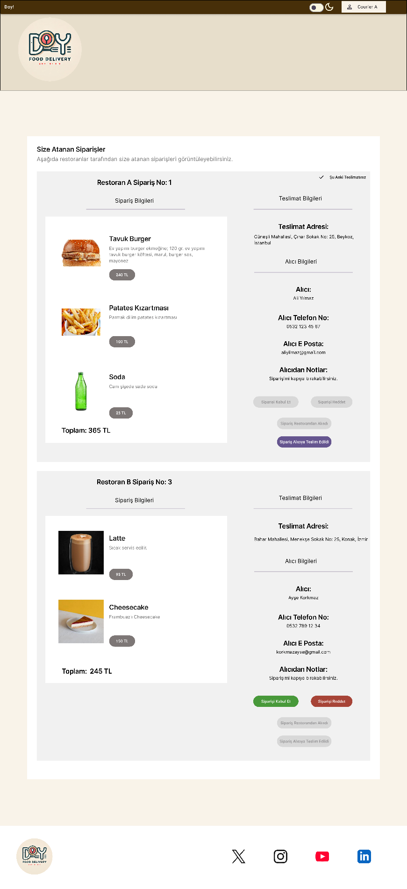

**User Interface/Report Number: User Management Pages for Admins**

**Related Use-Case: 12,13,14,15,16**



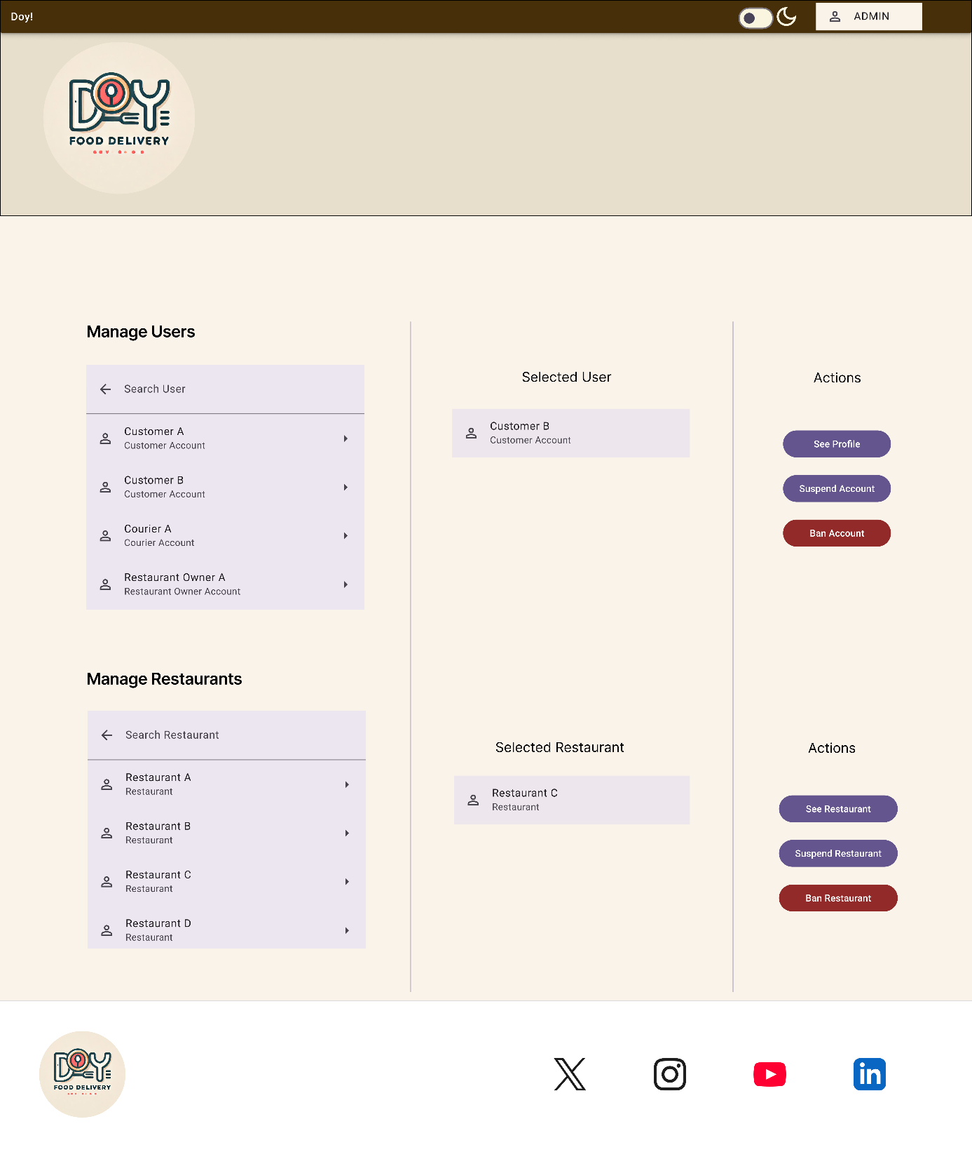

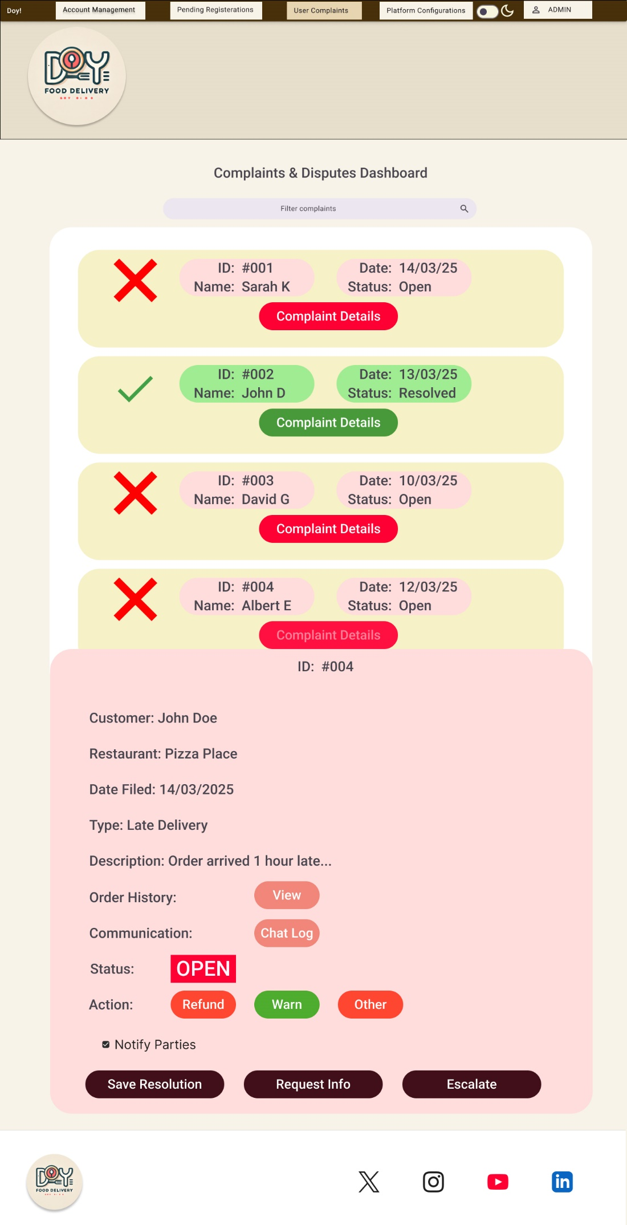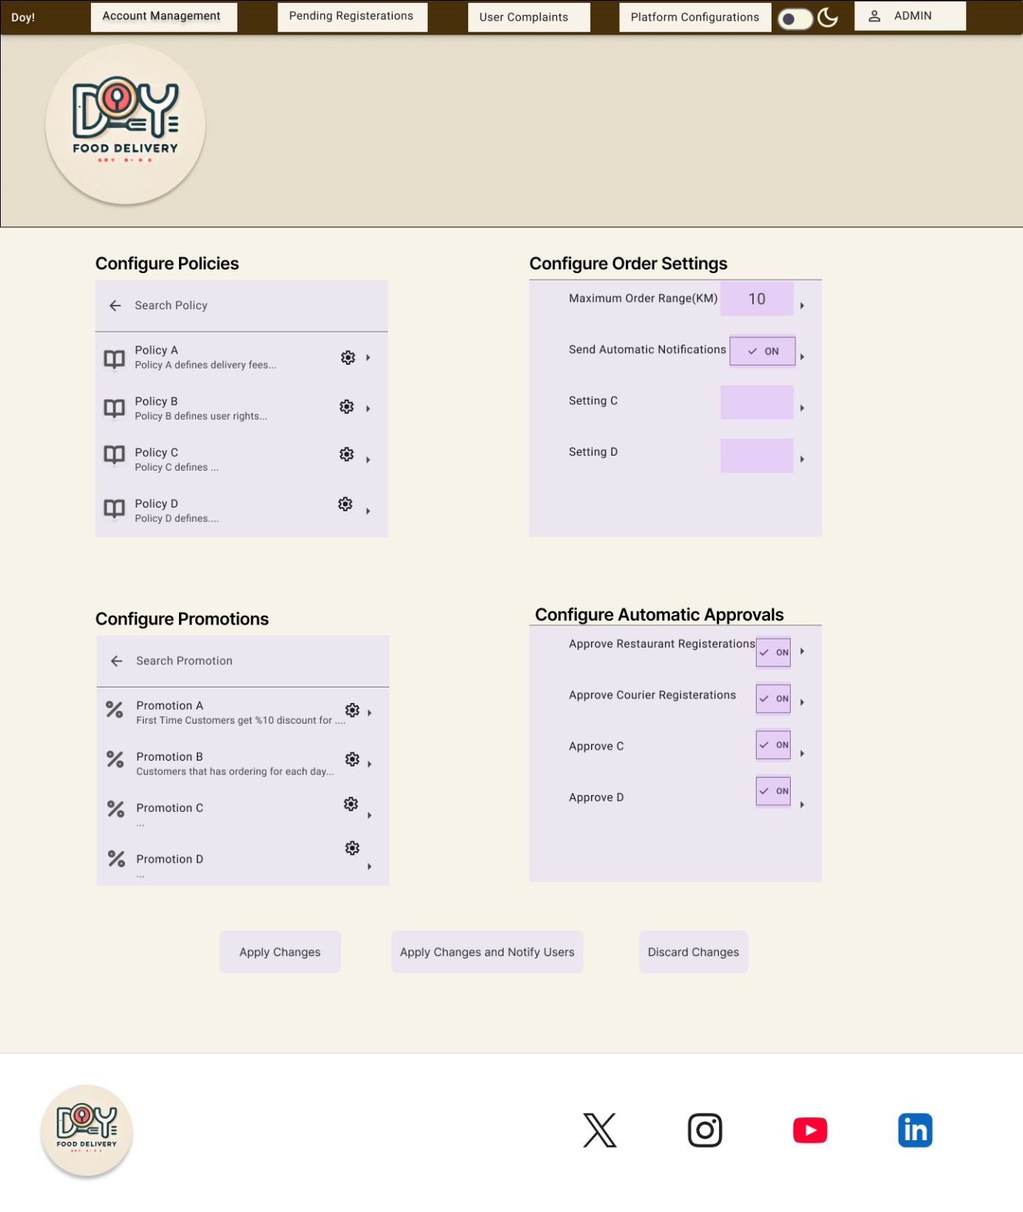

**User Interface/Report Number: Profile Pages for Customers, Couriers and Restaurant Owners**

**Related Use-Case: 24,28**

