- Title should be memo architect not memo worlbench also it should be header style
- When starting the memo background should be in center, vs select a view to get started
- Text on left too small model elements is too small
  - It should use a file explorer find of interface as its not clear if elements under it can be expanded
  - Folder/container should be clearly separate from elements
  - I should be able to create subfolder under element type and move elements under it
- Text is too light hard to ready and small
- Clicking on item should show expanded property page not on the side, the side property is appropriate in diagram/view mode
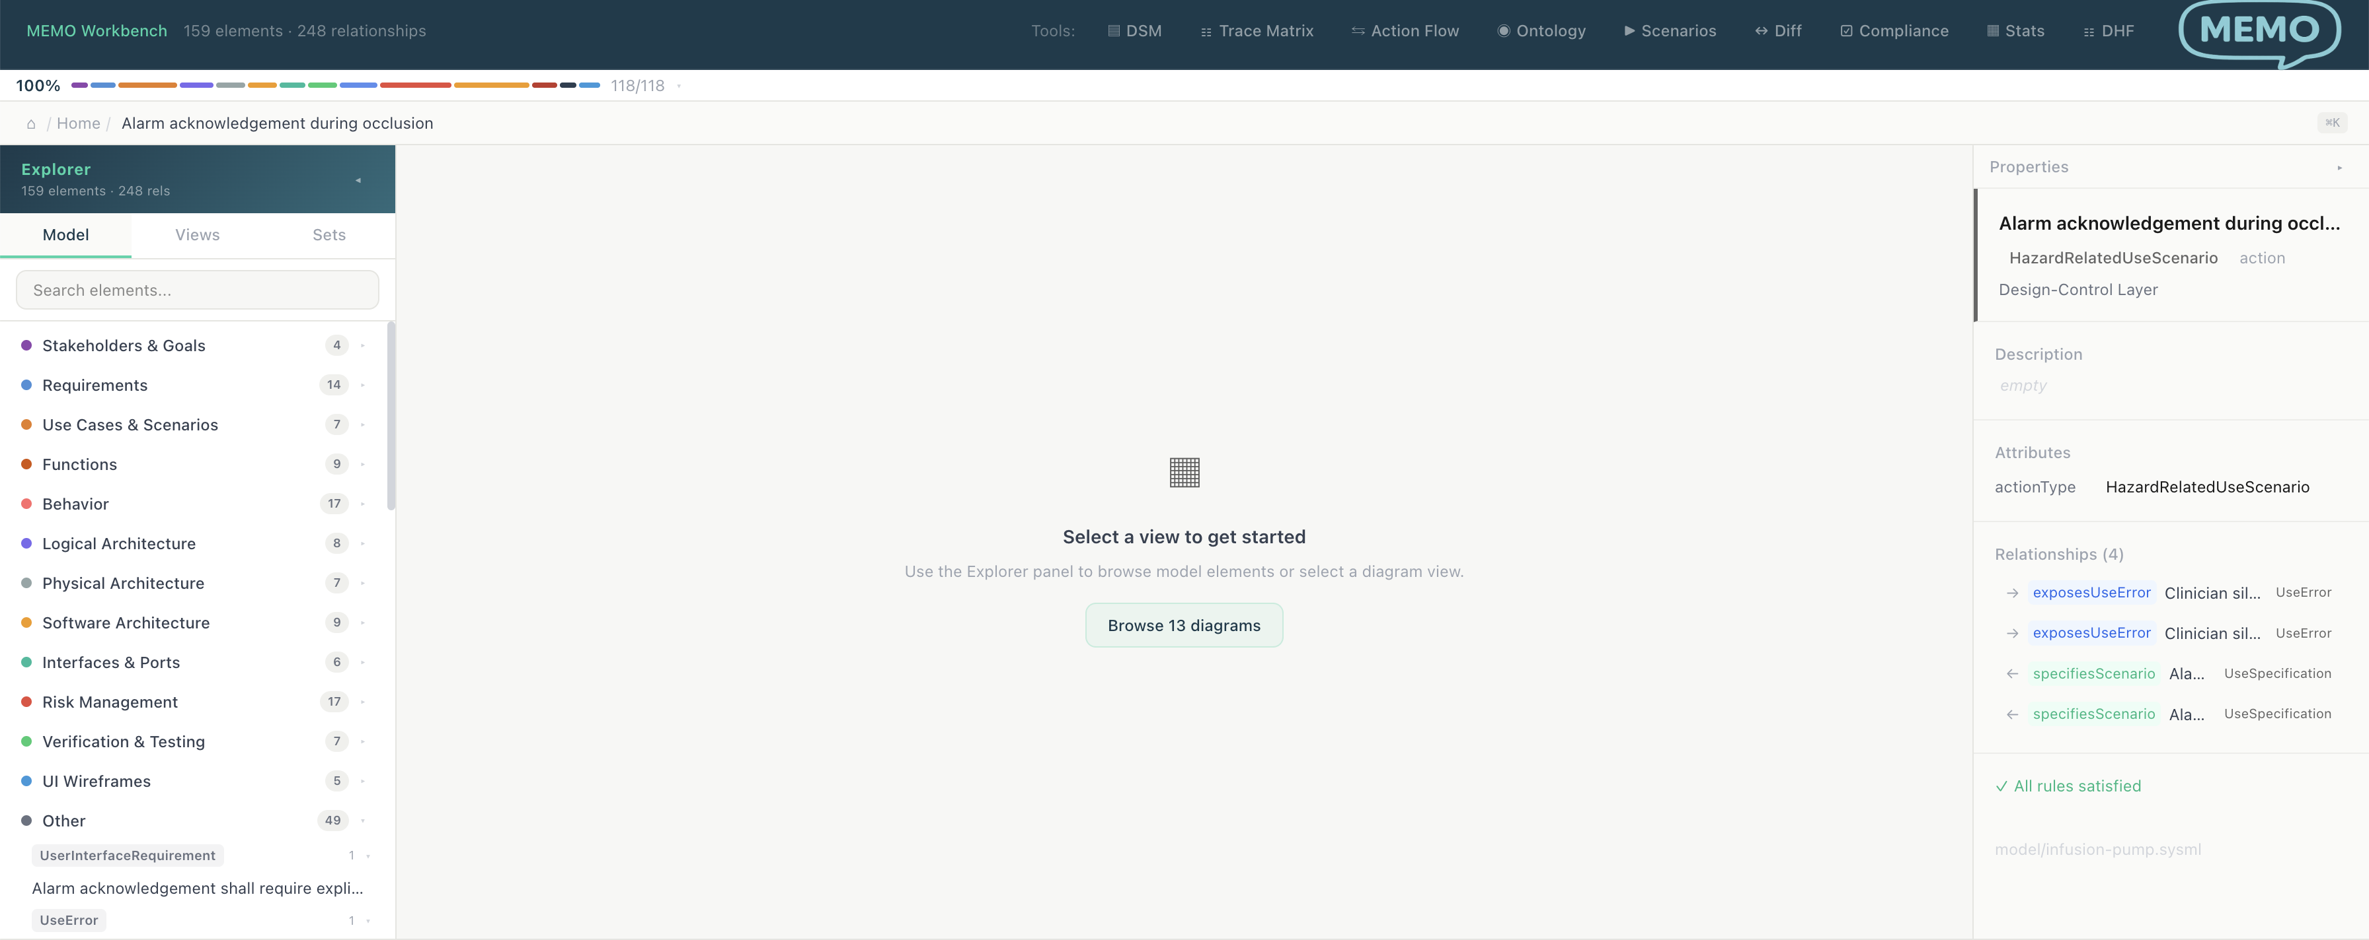
- If this is to help quick browse it should be clickable
  - 
- The elements in others are too granular, these should be attribues not types, e.g. PromaryOperatingFunction should be function and primary function can be attribute if it’s a list or we can also use labels.
- The bottom bar and are can be like vscode hw it shows compile erros, it can be used for other thing and minimized, the bar should be bottom of screen
- In Views, auto should be a folder and it should have auto generated diagrams under it. The current Full model overview is unusable, the diagrams should be consuble and not dump of model.
  - 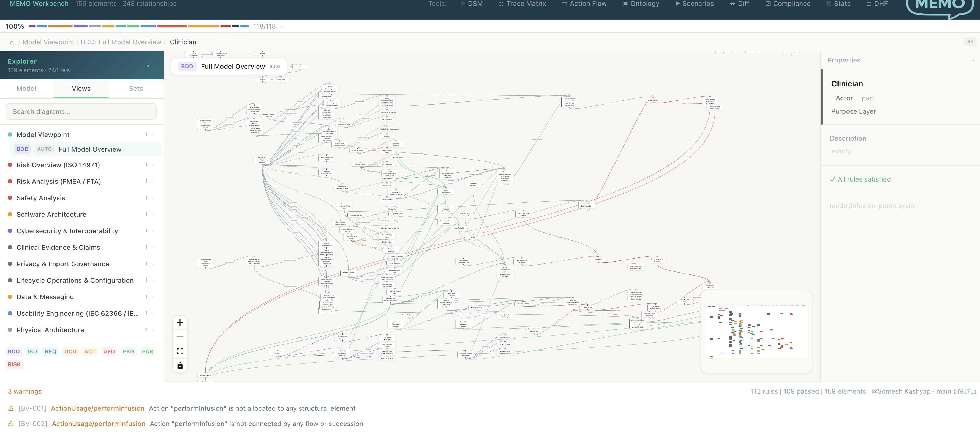
- In diagram there should be example of user diagrams. Use should able to add diagrams (sysmlv2) the diagram an switch between visual or edit mode or side by side, sysmlv2 should be redered
- Sets are poorly defined what are they ? Instead of them there should be scenarios editor
- Actionflow is now is not a separate item, its is a specific diagram, so doesn’t belong on top
- DHF should also be explored type
- There should be templete editor as well
- The DHF dashboard should be homepage fo dhf tab
- How does model diff work ?
- Ontology viewer should have list or element in diagram type group by type and also relationships visually

