## Background

The Kariba Dam, located in the Kariba Gorge of the Zambezi river basin between Zambia and Zimbabwe, impounds the 185 cubic kilometres Lake Kariba which is the world's largest man-made lake and reservoir by volume, lying nearly 1300 kilometres upstream from the Indian Ocean, along the border between Zambia and Zimbabwe.

It is a amazing and beautiful existence. however, It is warned by Institute of Risk Management of South Africa that the dam faces a dire need for repairing. The way to solve the problems of Kariba Dam can be simply divided into three categories: repairing dams, rebuilding dams and removing dams and replacing it with a series of dams. Three options feasible for us to address is quite different for the fact that their impacts on the ecology, economics and other aspects varies.

Generally, The Zambezi River can be separated into three sub-sections according to its different physical and biological characteristics: the [Lower Zambezi](http://www.tothevictoriafalls.com/vfpages/zambezi/lowerzambezi.html), the [Middle Zambezi](http://www.tothevictoriafalls.com/vfpages/zambezi/middlezambezi.html), and the [Upper Zambezi](http://www.tothevictoriafalls.com/vfpages/zambezi/upperzambezi.html). The [Middle Zambezi](http://www.tothevictoriafalls.com/vfpages/zambezi/middlezambezi.html), where the Kariba Dam lies, is 600 miles long in low-lying country, and is divided from the Victoria Falls to the Lake Cahora Bassa. An overview of the Zambezi River generated from the Zambezi River Authority is as follows:

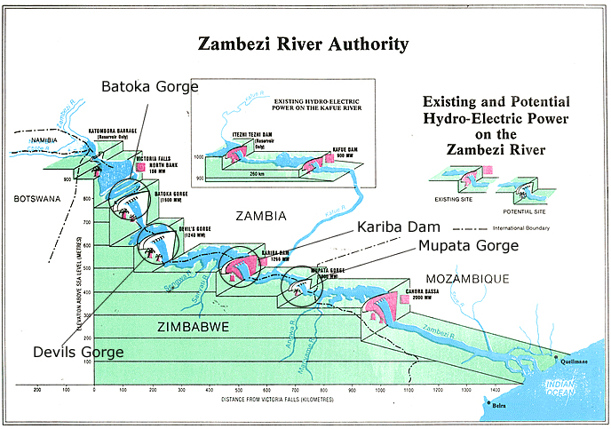

Figure 2-1 An overview of the Zambezi River generated from the Zambezi River Authority[http://www.tothevictoriafalls.com/vfpages/zambezi.html]

As shown in Fig. 2-1, hydro-electric dam facilities are also proposed to build along the [Middle Zambezi](http://www.tothevictoriafalls.com/vfpages/zambezi/middlezambezi.html) in addition to the existing dams. This official report indicates the reliability of the dam construction from the Victoria Falls to the Lake Cahora Bassa.

## Our work

We evaluated three possible solutions to the current Kariba Dam problem and discussed in detail the advantages and disadvantages of each option. To remove the existing dam and create a new series of dams, we developed a model to determine the best choice of the number and placement of the new dams along the Zambezi River. Then, a discrete dynamic programming model of series dams is established, which provides detailed guidance for the action ought to be taken to minimize negative influences under different geographical, climatic and environmental conditions.

We generate the elevation map of the whole Kariba River. Combining the map with the potential dam sites ZAR proposed, we select the feasible range of Kariba River for the construction of the dam. Since not all the locations of a river are suitable for the construction of a dam, we first use the topography information to establish a rule to select the feasible dam site, and then we use the established rules to select the feasible address of the dam. At last, we establish a general optimization model for the selection of the optimal combination of dams, and then a local optimal solution using Hybrid PSO Algorithm. On the basis of this, in order to adjust the parallel-dam system to adapt to the dynamic changes of various environments, we establish a discrete dynamic programming model, and use the Progress Optimality Algorithm to relieve the computational complexity of the model.

We simulate the whole calculation process via computer. The number and the placement of dams selected by our site selection model has a high average safety level and competitive total construction costs. On the basis of the dynamic control model, we design the optimization strategy to adapt to the extreme conditions and local adverse conditions, and the algorithm we use can quickly converge to a local optimal solution that is good enough for scheduling. In order to accelerate the convergence rate of the algorithm, we discretize the height of the dam according to a certain interval to make it an integer variable. Thus, we choose the discrete height interval of the dam for sensitivity analysis. And the results show that our model is very robust. Also, in the sensitivity analysis of the risk assessment method, we find the possible problems and point out the corresponding solutions.