## The derivation of the cost of a dam

In order to calculate the cost of each dam, we use the following formula

$$Cost=k*l^{α}h^{β}$$

Using the data in table.xx and using the least squares method, we calculate the value of each parameter as:

$α=1.27274$, $β=1.71658$, $k=0.0000356525$

So we obtain the final cost formula as follow:

$$Cost=0.0000356525*l^{1.27274}h^{1.71658}$$

Using this coefficient to verify the original data, we can find that the relative error is within 5% for the four groups of dams, and it can calculate the true price of the dam in a certain extent.

|  |  |  |  |  |  |
| --- | --- | --- | --- | --- | --- |
| Name | $h$/m | $l$/m | Real Cost/million dollar | Anticipated Cost/million dollar | Percentage of error |
| Hoover Dam | 221.4 | 379 | 700 | 723.973 | -3.425% |
| Deriner Dam | 249 | 720 | 2000 | 2004.52 | -0.226% |
| Glen Canyon Dam | 220 | 480 | 997 | 967.34 | 2.975% |
| Kariba Dam | 128 | 579 | 480 | 484.693 | -0.978% |

#### Analysis of the characteristics of the cost function

The graph of the proposed formula when $l∈(200,1250)$, $h∈(20,250)$ is shown below:

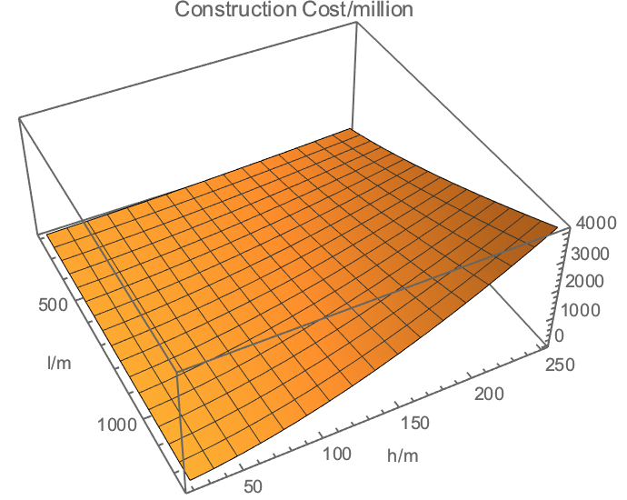

It can be seen that the increase in the cost of dam construction is relatively gentle when both $h$ and $l$ are small, and when both $h$ and $l$ are not too small, the cost will increase sharply as both increase. The reason is that with the increase of $h$, the scale of the dam will increase sharply, and thus the cost of management, construction and planning will also increase sharply. Thus, this formula can reflect the cost of the dam to a certain extent, possessing a certain degree of reference.