## sensitivity analysis

In the above discussion, we set that the height of the dam is discretized by 5 meters to simplify the model and speed up the process of searching for the optimal point. Thus, we need to analyze the variation trend of the optimal cost when the interval varies to avoid large variations in the solution of convergence due to the high degree of discretization of the dam. We take the 10 sites as an example. When the discrete interval changes from 2 to 20, the effect on the optimization target is shown in Fig.

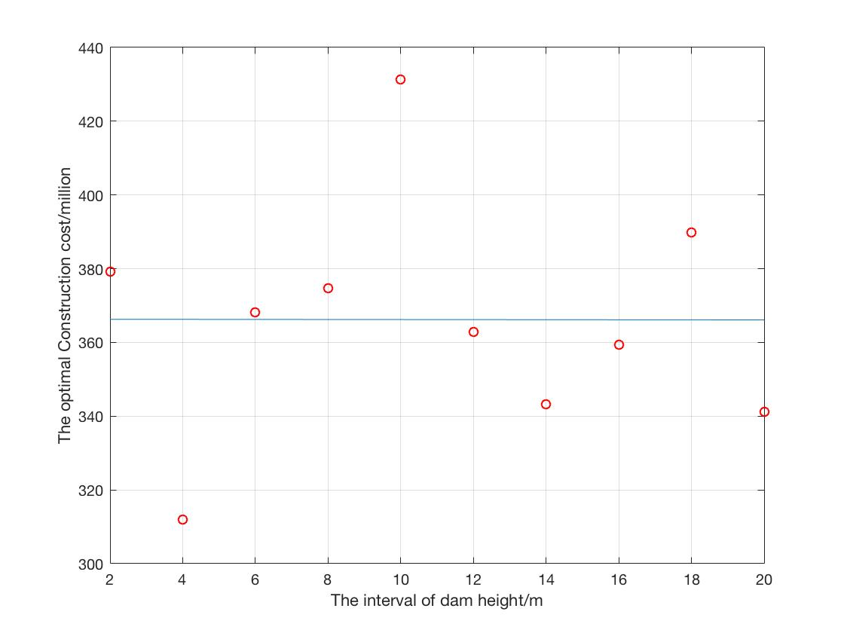 After the first-order polynomial fitting with matlab, it can be seen that the model is very robust. After fixing the number of iterations and the number of particles, there is no significant relationship with the optimal value of the obtained objective function and the discrete interval. When the discretization guarantees the convergence rate and the speed of convergence, the discretization has little adverse effect on the convergence of the function value.