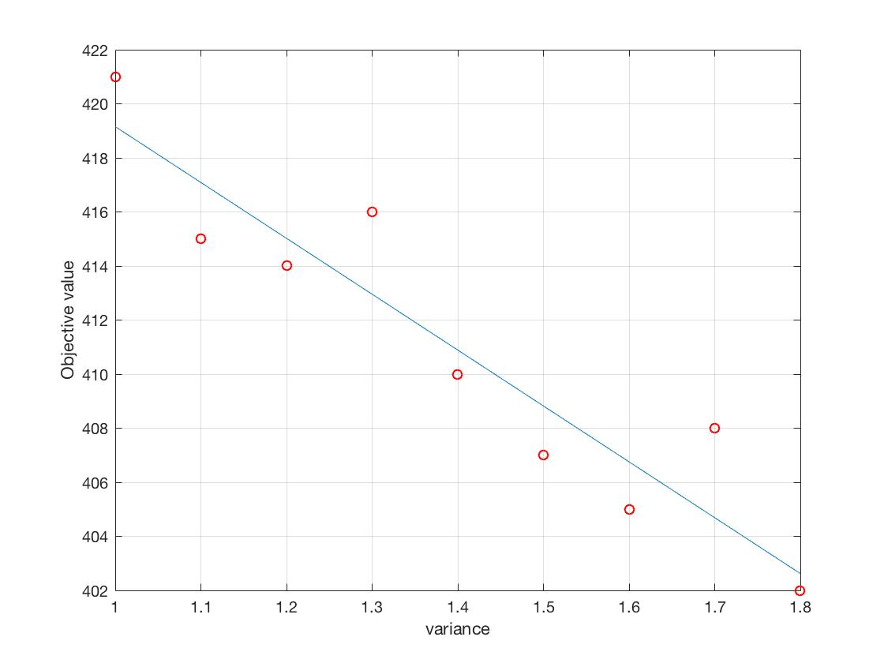

When we change the boundary between the normal state and the slight alert state from 1 to 1.8 times, we can get the corresponding optimal objective function value in Fig xx. As we can see, with the increase of the threshold, the value of the objective function will decrease , Which is due to the fact that with the rise of the limit, the dam lying in normal state will increase, thus contributing the decrease of the objective function. Thus, The effect of each boundary on the model results is relatively large. We need to refer to as much data as possible to get more accurate model results when determining the state boundaries.