# PC^2 Guide

## Pre-Requisites :-

LAN connection between PCs

GNU g++ compiler

Installing GNU g++ compiler:

First check if the PC already g++ compiler installed in it by using command

**“g++ -v “** on command prompt. It will tell the version of install g++ compiler in the system. Otherwise it will give error like “*g++ is not any external or internal command*”.

If g++ is not present then download and install the latest version of ***MinGw*** form internet. Once the installer is downloaded, run it and you will see a window like the image shown below. Now right click on all packets names as “**mingw32-gcc-g++”** and click on **Mark For Installaton.**

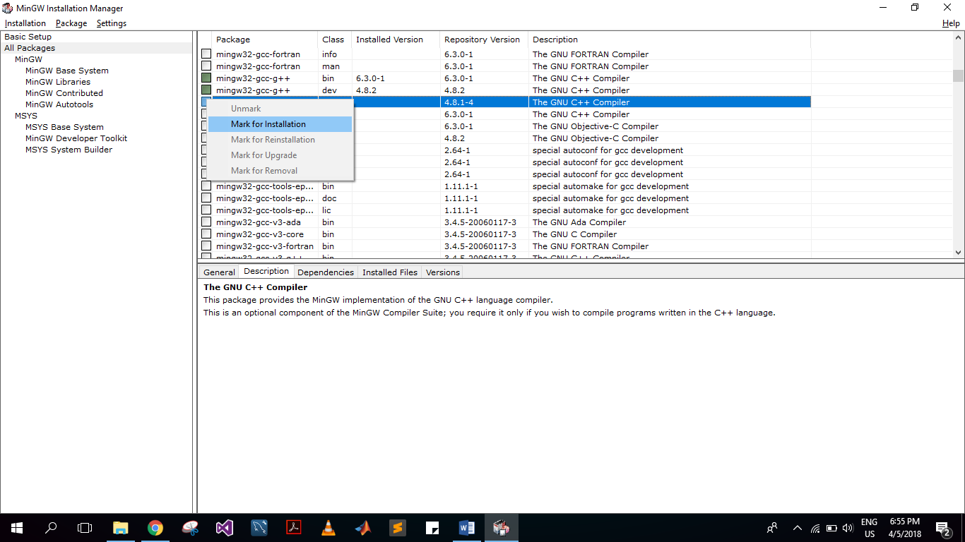

After this go to **Installation->Apply Changes** a dialog box will appear click on **Apply** button .

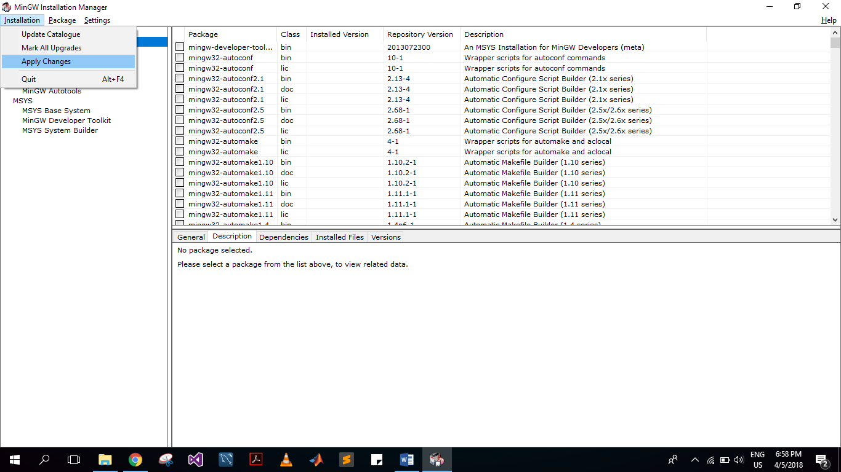

Once the installation complete Goto “**C:\MinGW\bin**” (Or wherever you installed the MinGw) copy this path and go to **“Control Panel->System and Security->System**”

Click on **Advanced System Settings** from left window. A dialog box will appear the click on E**nvironment Vriables**  as shown in image

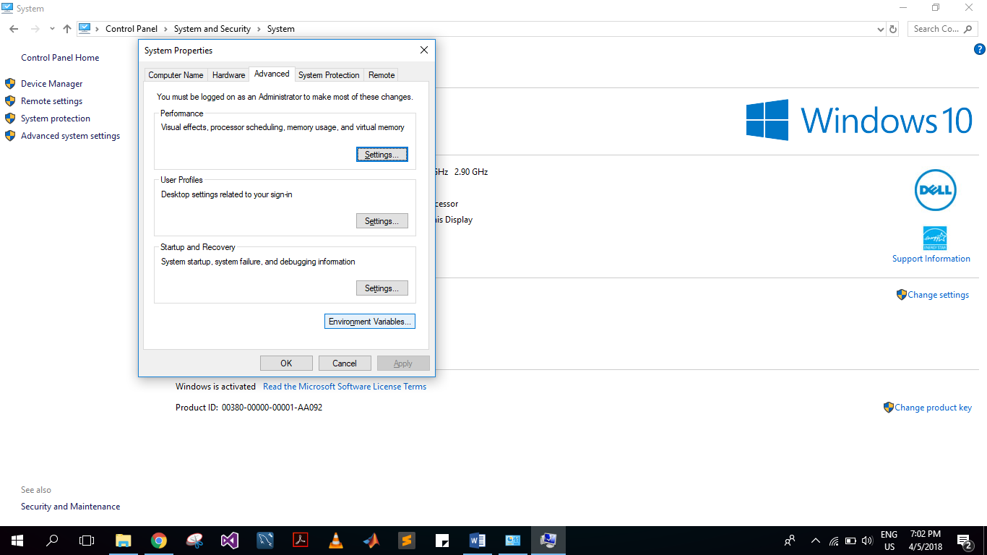

Find “**Path**” in System variable and add the copied directory-path into system path variables as shown below

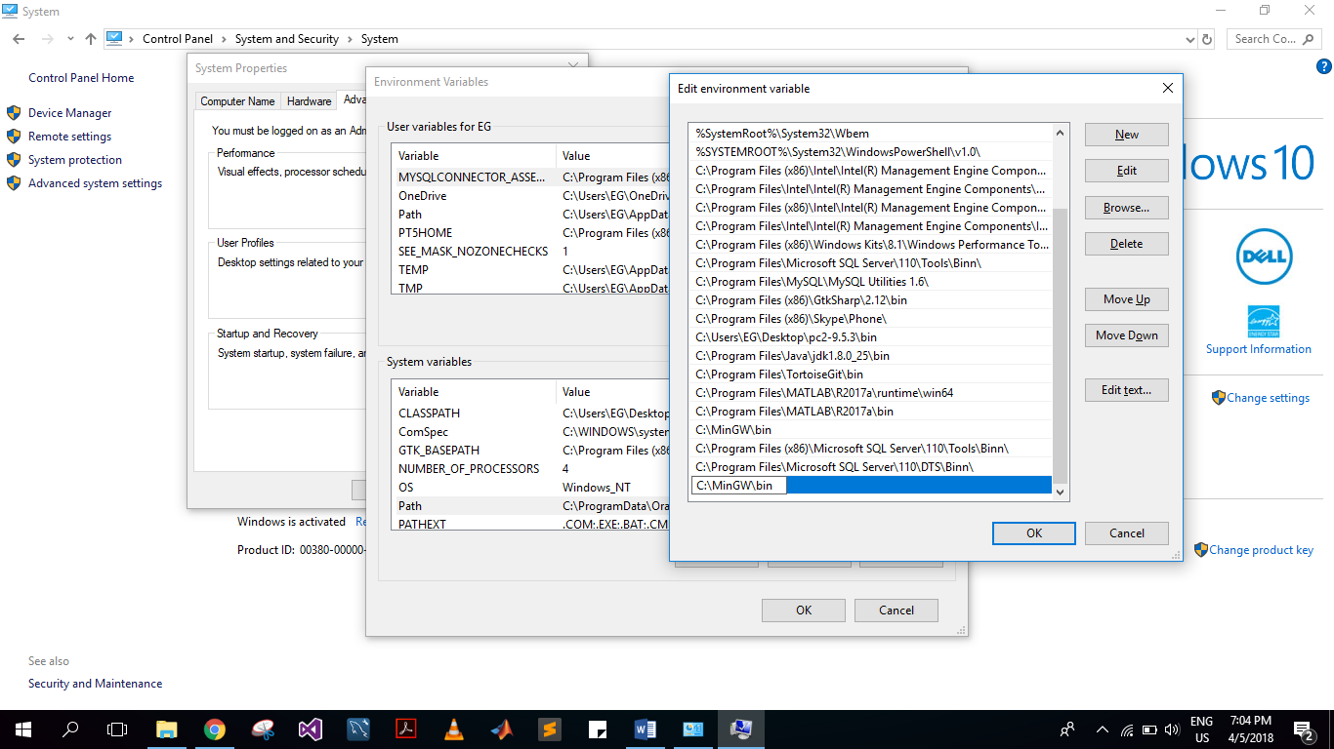

Click **OK .** Now verify installation via command “**g++ -v** ” in command prompt.

# Setting up PC^2

* Download the latest PC2 version from [*https://pc2.ecs.csus.edu*](https://pc2.ecs.csus.edu)also download the PC^2 admin guide form [*https://pc2.ecs.csus.edu/pc2docs.html*](https://pc2.ecs.csus.edu/pc2docs.html)
* After downloading it copy the **pc2-9.5.3** ( or any lates version name) in each PC on the LAN.
* Now open “**C:\pc2-9.5.3\bin**” and give this directory path to **System Path variables** like you did for gnu g++ compiler
* Repeat this step on each PC on the Network



* Go to C:\pc2-9.5.3\bin Folder and look for **pc2v9.ini** file and open it

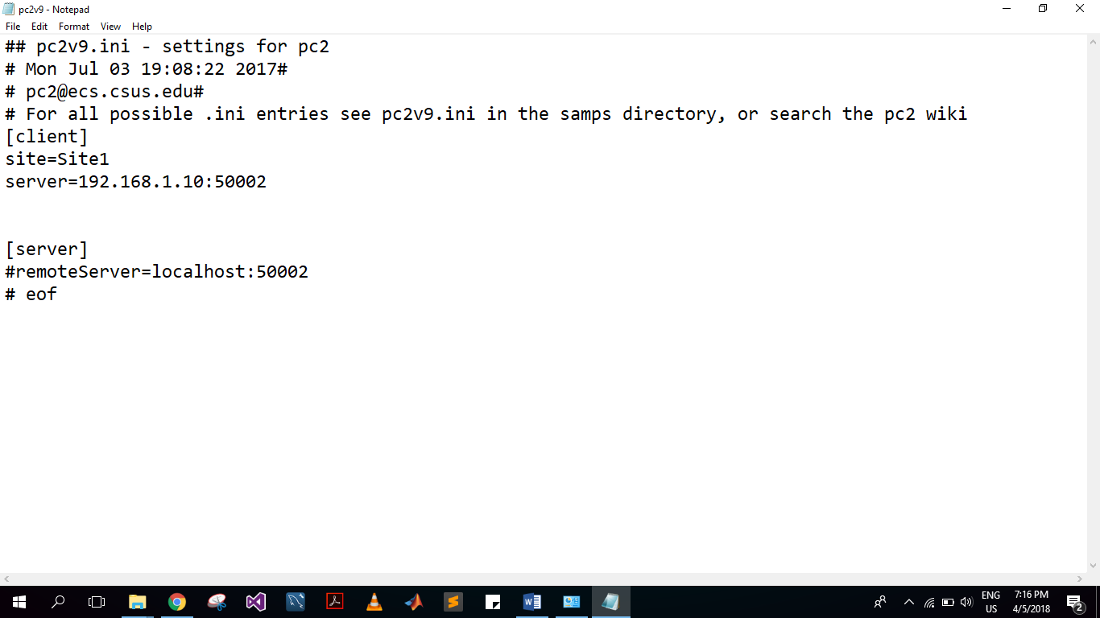

* Choose a PC in LAN for server. Give its IP address in this file **server=”*your select PC Ip*”:50002**
* For Example : In the image shown above I have set the IP as *192.168.1.10* as it was the IP address of my selected server PC.
* Now copy paste this edited file in all PCs in **C:\pc2-9.5.3\bin**

# Starting Server

* Open the file **pc2server** and login using default credentials

UserName = site1

Password = site1

* From here You can set the contest time here and start/stop the contest

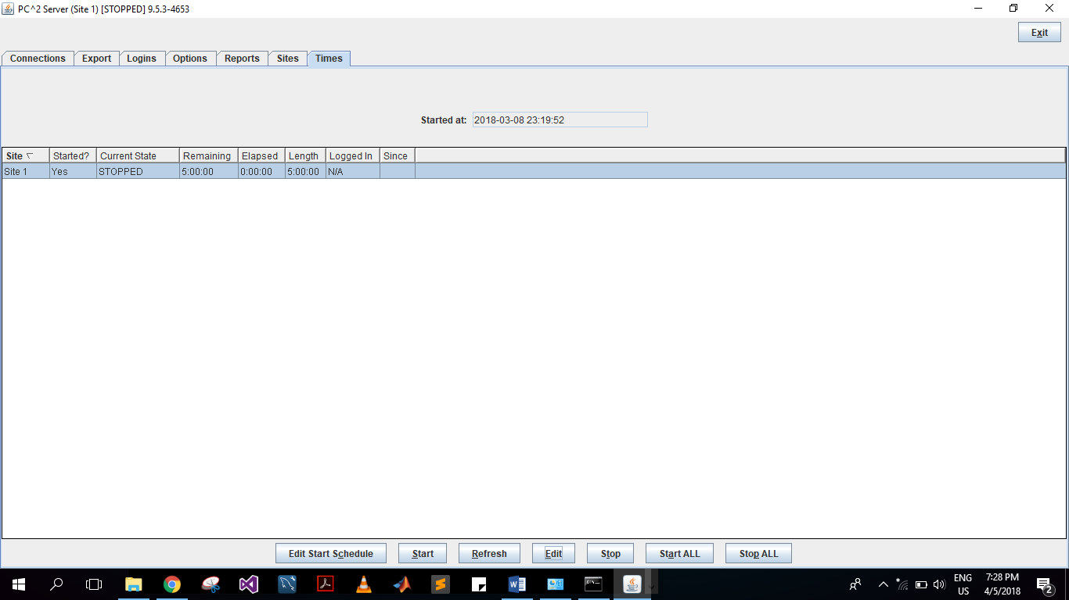

# Configuring Contest via Admin