**User Management System**

This is a very simple user management system.

**Task 1: Marks: 5**

Design the following screen: This should be the first screen to display

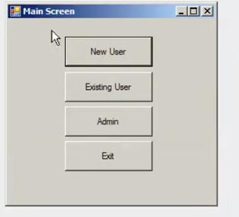

**Task 2: Marks: 30**

Consider the **MAIN SCREEN**

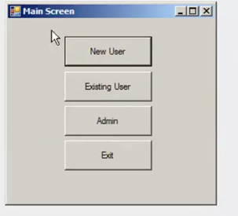

If user press the **NEW USER** button then following screen must be displayed.

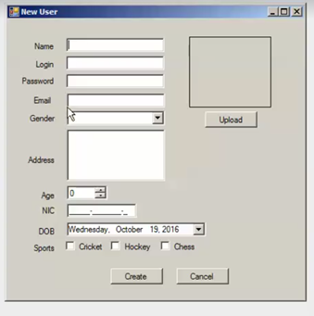

This screen must be opened up. User have to fill in all fields and upload a picture as well. You have to put validations on all fields and none of the fields or the image box must be left emptied. You can use to display a **MESSAGE BOX** in case user press **CREATE** without filling in all the fields. Moreover if a user already exits with same Login or Email, the user account should not be created and must be displayed a message that “User Already Exist”.

**Note**: all these entries are to be made in dbo.Users in database (look at end of assignment).

Next when user have entered all fields and press **CREATE** you are to close this screen and open up the following screen.

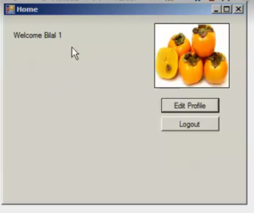

Here if the user clicks on the **LOGOUT** button simply close this screen and return to **MAIN SCREEN**.

However if user press the **EDIT PROFILE** Button then following Screen must be displayed:

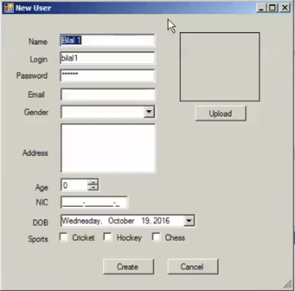

Here if user clicks **CANCEL** no changes are made to the profile else if create is clicked then update all the fields for which values were provided.

Pressing either the button must also close this window and get back the **HOME SCREEN.**

**Task3: Marks: 25**

Consider the **MAIN SCREEN** again:



Now if user press the **EXISTING USER** button following **LOGIN SCREEN** must be shown.

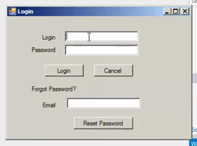

Now if user Presses **CANCEL** get back to **MAIN SCREEN**.

If User Press **LOGIN** then first validate all fields. Then check for a matching Login and password. If no match found then display **Error Message** else go to **HOME SCREEN** which is described in task2.

If user presses **RESET PASSWORD** then if email address exists, a code will be sent on that email else display Error Message.

Next a reset password screen would be shown where user will enter that code in "Reset Password" Field.

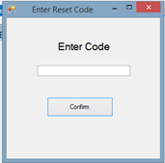

If correct code is entered, user will see password field, user will provide new password in the field and will click on update, then password in dbo.Users against that user will be updated.

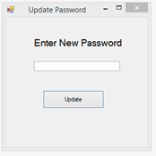

User will be than redirected to HOME screen.

**Task 4: Marks: 40**

Consider the **MAIN SCREEN** again:



Now if the user presses **ADMIN** then following screen must be displayed:

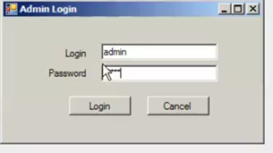

If user press **CANCEL** get back to **MAIN SCREEN**. Else if user press **LOGIN** Validate then look for a matching record in the dbo.Admin (for details look at the end of assignment). If Admin does not exist then display Error Message. Else following screen must be displayed:

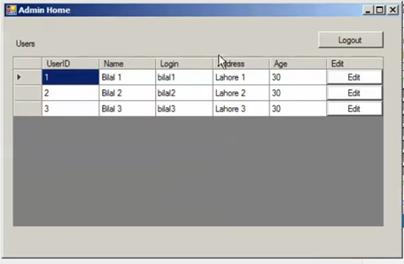

This screen shows all records from the dbo.Users. If the admin clicks **LOGOUT** then go back to **MAIN SCREEN**. However if user presses the edit button for any record then following screen must be opened where admin can change that record:

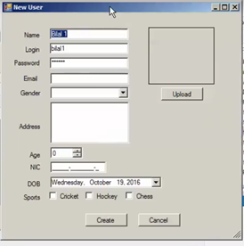

This screen looks like the New User Screen before but in the case when opened by Admin all the fields must be filled out with values from the record from dbo.Users.

In this case if Admin press **CANCEL** then close Screen and get back to Admin **HOME SCREEN**. Else make the required changes in dbo.Users and return to Admin **HOME SCREEN**. (perform all validations on data being entered)

**Instructions**:

The name of your database must be **Assignment4**. You are to create the following two tables in your database:

**dbo.Users** having following structure:

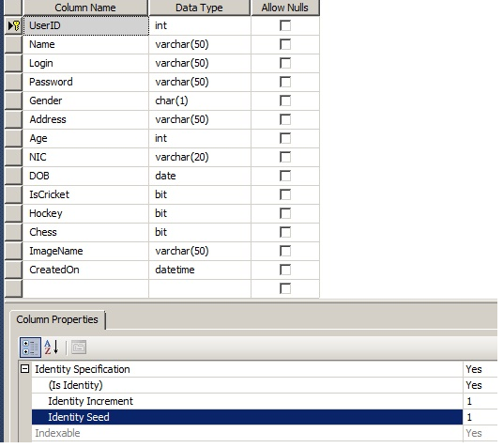

**dbo.Admin** having following structure:

