Customer Relationship Management (CRM)

AN INTRODUCTION OF CRM

What is CRM?
Customer relationship management (CRM) can mean different things to different people. Kay Mandati, Relationship Manager for BMW North America, states:

“CRM is…a long-term commitment, best when initiated in a well-defined
scope and with clear objectives, and then slowly grown and expanded
as successes and failures are realized.”

Inherent in her definition is that CRM is a process that requires clear objectives and commitment. Joe Rapolla, the CRM manager for Venvidi Universal Music Group, was in charge of getting the group’s eight divisions to share information. He feels that

“CRM is not a tool or a technology; it is a business practice that utilizes
technology and requires organizational evolution.”

Thus, CRM is a strategy companies can use to effectively use technology to provide a unified view of each customer which allows them to create loyalty and reduce organizational costs. To better understand what something truly is, it is often useful to know what it is not; in the case of CRM, it is not to be mistaken for a database marketing system. Such systems can be extremely useful to companies to better know their customers, yet CRM goes beyond the scope of this system—it touches on every department of a company to provide a single view of the customer.

CRM is also not just a software package. It includes the use of software, but having the right package installed does not mean that a company will have a true CRM system. CRM, finally, is neither a pure marketing strategy nor a pure IT strategy; it is a business strategy which utilizes both marketing and IT to achieve its end.

Why CRM?
CRM is attractive to companies because it promises, if done properly, to aid in retaining customers and building loyalty. This is important in today’s competitive, global economy as a customer can shop anywhere for anything. There are higher costs associated with going out and seeking new customers as opposed to selling more to the customers one already has—some estimates show the cost ratio can be as much as five to one for new customers to existing customers.
An example of these higher costs is seen in industrial sales where it generally takes 8 to 10 calls to get a new customer rather than 2 to 3 calls to service an existing customer. The costs for marketing to Web customers are $34 for a new one and $6.80 for an existing one. To be more cost effective, it is worthwhile for a company to sell more to customers it already has through cross-selling and up-selling than to constantly seek new customers. CRM, when implemented correctly, allows a company to do just that.

CRM Vendors—the “Big Guys”
Several of the dominant vendors kept popping up in research for this paper; according to AMR Research, the big vendors in CRM currently are Siebel Systems, PeopleSoft, Oracle, Nortel Networks (Clarify), SalesLogix, and E.piphany.

HOW DOES CRM WORK?

Multi-Channel Principle
Understanding CRM might be more complex than it seems at first sight. To better understand, one can look at a bank as an example. Today, any bank customer willing to communicate with his/her bank has the opportunity to do so through a multitude of channels: phone, ATM, teller, personal banker, etc … (See Fig.1).
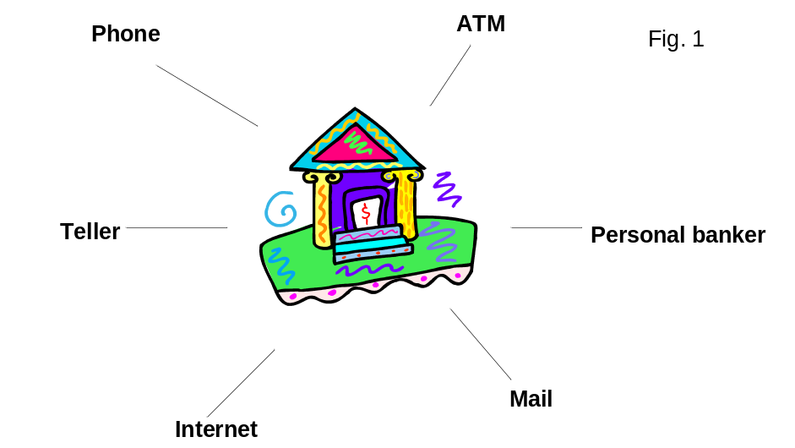

From an end user perspective, being able to use these channels is a given and should be as simple as it is effective. Now, suppose that the same bank, which has millions of customers generating billions of transactions each week, wants to build a unique image of each of its customers with the purpose of offering each of them the right financial services at the right time and the right place. How would CRM help them do that?

End to End CRM Infrastructure
Here is a hint. In CRM theory, each time a customer interacts with any of a company’s touch points, the information that is collected (quantitative, qualitative, and behavioral) is sent to the company’s systems databases (See Fig. 2).

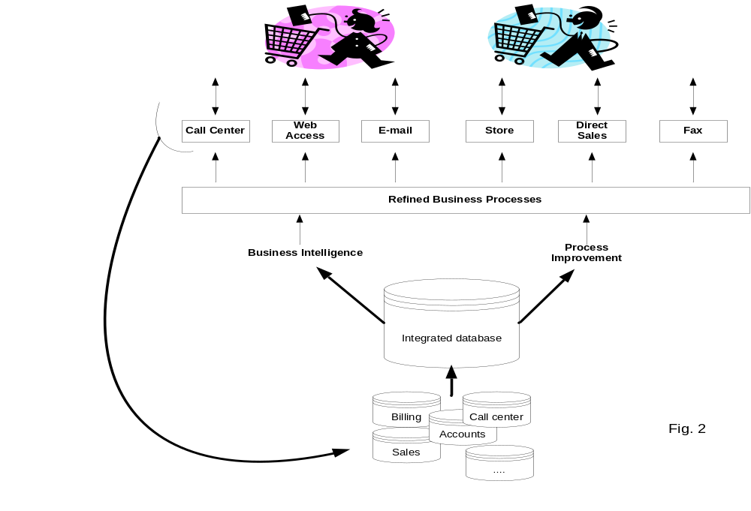

This information is then aggregated into a single CRM data warehouse where it is cleaned, analyzed, refined, and made ready for immediate or future one-to-one interaction with the customer. Amazon is a good example of CRM. When Amazon customers look for items on Amazon.com, they are systematically suggested additional offers based on their current choices.

Scope of CRM
When implementing a CRM process, companies can go different avenues and implement different CRM modules. There are typically four families of CRM initiatives: Sales Force Automation (SFA), Marketing Automation (EMA), Call Center, and Analytics/Data mining. Implementing a single CRM module can be very complex and demanding; it is very uncommon to find companies that tackle more than one or two modules at the same time.

Sales Automation
“Sales automation streamlines the sales process and helps salespeople and their supervisors manage both customers and the sales cycle through such applications as contact managers, opportunity or pipeline managers, configurations, and order entry.” SFA is considered the “grand father” of CRM because most customer-orientated software initiatives start in the sales departments. SFA implementations range from simple contact management packages (such as Outlook) to more comprehensive solutions such as account management, opportunity management, etc …
Beyond leveraging sales teams’ efforts toward higher sales revenues and customer retention, SFA systems are praised for their synchronization capabilities that allow sales department employees to share real-time customer data wherever they are and regardless of the number of sales people inputting information in the systems.

Marketing Automation:
“Marketing automation is a set of applications that help marketers manage and simplify the marketing process. Applications include campaign management; email marketing, database marketing and data marts, and marketing encyclopedias”
Traditional marketing campaigns are sequential. Marketing departments prepare the campaign, launch it through the company’s communication channels, and wait for the end of the campaign to analyze the results and prepare the next campaign from the feedback collected from the previous campaign (See Fig. 3).
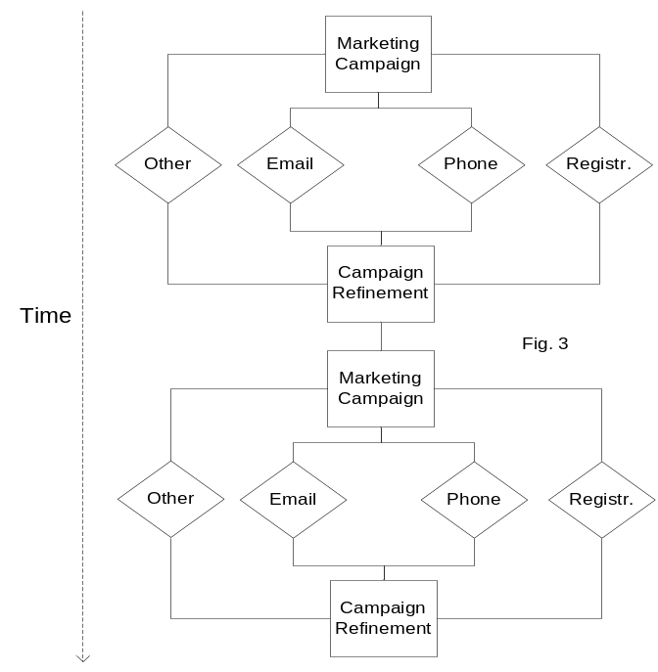

Marketing Automation (EMA) is meant to allow marketing departments to run more efficient campaigns. Instead of waiting for extensive periods of time before launching new campaigns (sometimes several months), EMA software tools allow a company to run permanent and “self feeding” marketing initiatives (See Fig. 4) [9]

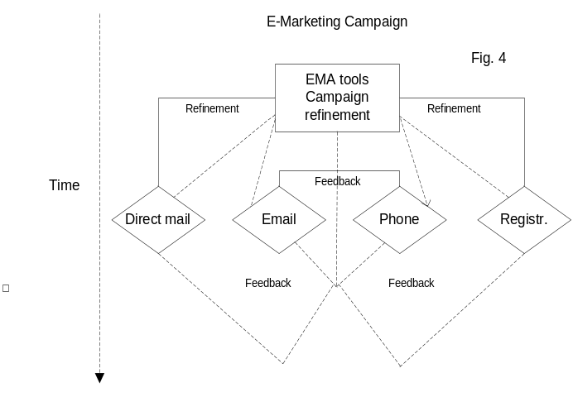

Rather than being stored for further analysis, customer feedback is immediately used to refine an ongoing campaign, making it both more effective and less resource consuming.

Calls Centers
“Call centers are the primary conduits between consumers and corporations. Customer Service is the primary business process for creating customer loyalty, promoting customer retention, and ultimately increasing customer value while reducing cost of sales.”
Long gone is the time when customers only interacted face-to-face with a customer service representative. We are living in the 1-800 era. Call centers have three major purposes: to reduce costs by limiting (costly) human interaction, to provide consistent service levels, and to collect customer feedback on products and services. Most systems also come with agent scheduling and call volume forecast capabilities.

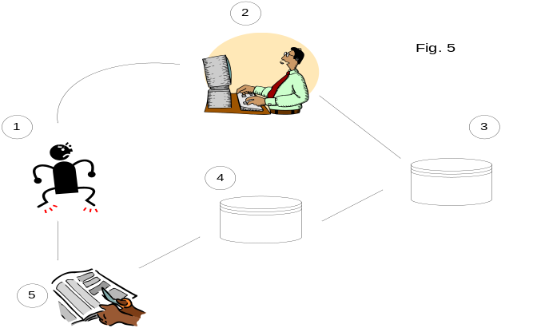Here is an example of how a typical Call Center works (See Fig. 5). [9]

Customer A calls to complain about a product or a service (1). The call center will first pull up this customer’s account from his phone number, name, or account number (2)-(3) or any other way. The system will then determine what the issue is and communicate with the central system to determine the best options to address the issue (4) based on the customer’s profile (at this point, the customer may or may not talk to a live person). In this example, customer A is finally offered a coupon towards a next purchase (5).

Analytics/Data Mining
“Analytics covers the process of extrapolating true business intelligence from disparate customer data sources in order to segment, analyze, and serve the consumer in the most efficient manner possible. Additionally, analytics is also getting predictive, empowering businesses to identify how a customer is likely to respond to different sales and marketing campaigns.”
We are touching on here what is probably the most important challenge of a CRM program: how do we get a “single version of the customer truth?”. A CRM program could consist of the implementation of multiple modules. If these modules do not communicate with one another, they will provide only snapshots of customer information, leading to a CRM “stovepipes” situation (See Fig. 6). [9]
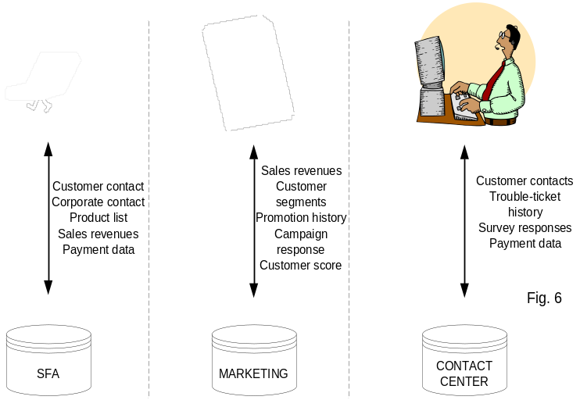

A CLOSER LOOK AT CRM IN A CALL CENTER ENVIRONMENT: NEXSTAR FINANCIAL CORPORATION

An experienced mortgage management team and the investment firm Kohlberg Kravis Roberts and Co. founded Nexstar Financial Corporation in 1999. The strategic vision of Nexstar was to completely redefine the mortgage loan process (i.e. application, underwriting, closing, loan servicing set-up) by more quickly and accurately delivering the service to its clients and the customers of those clients. The streamlining of this complex process would be enabled mostly by their highly capable and highly customized web-based system, which was created by Eotek, a fully owned subsidiary of Nexstar.

The Business Case for CRM
Similar to traditional mortgage companies, Nexstar does operate as a direct lender. However, this is not the strategic focus of the company. Nexstar’s direct business was primarily demand-driven. On the other hand, the strategic positioning of the company is that of a mortgage processing outsourcer. With over 90% of its business coming from the BPO line, Nexstar has developed a diversified portfolio of clients, from large national lenders, such as Washington Mutual, to smaller credit unions and community banks. This business model has allowed them to flatten the volatility of demand associated with the mortgage industry. As mortgage rates increase, demand slows and traditional mortgage companies are forced to downsize. As part of the downsizing, many companies look to outsource their mortgage operations to BPOs, such as Nexstar, as a cost saving measure. This difference in market positioning among traditional companies and Nexstar is directly correlated to their varying use of CRM.

At this time, traditional mortgages companies are less focused on CRM initiatives because the market is so volatile, thus making large-scale IT projects unattractive. Most use standardized software or ASPs that only enable them to provide a minimal amount of customer service and customer convenience. While traditional companies may be less focused on improving customer service, Nexstar’s business model necessitates the use of a more enabling CRM project. Poor customer service may cause a traditional company to lose that customer for life. However, if Nexstar provides inferior customer service, they could potentially lose an entire client. Plus, why would potential clients outsource their business to Nexstar if they can perform the same level of customer service in house? Therefore, their absolute dependence on extremely high customer service levels drove Nexstar to implement a customized CRM system in their call center.

