Linux Shell Assignment Solutions
Name: _Aariz______________
Date: __06/08/26__________________

1. Creating and Renaming Files/Directories
- Create a directory named test_dir
Command:
mkdir test_dir
Explanation: Creates a new directory named test_dir.
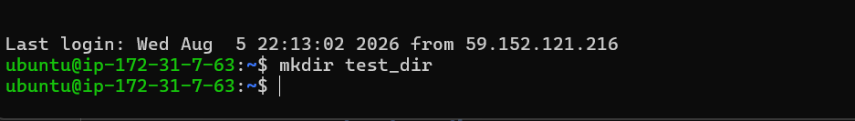
- Create an empty file inside test_dir
Command:
touch test_dir/example.txt
Explanation: Creates an empty file named example.txt inside test_dir.
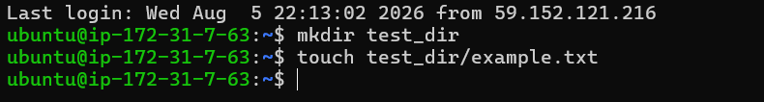
- Rename example.txt to renamed_example.txt
Command:
mv test_dir/example.txt test_dir/renamed_example.txt
Explanation: Renames the file while keeping it in the same directory.
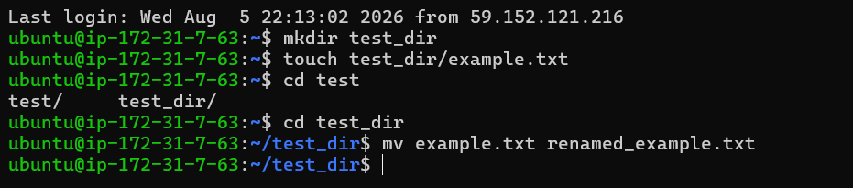

2. Viewing File Contents
- Display the contents of /etc/passwd
Command:
cat /etc/passwd
Explanation: Prints the complete contents of the file.
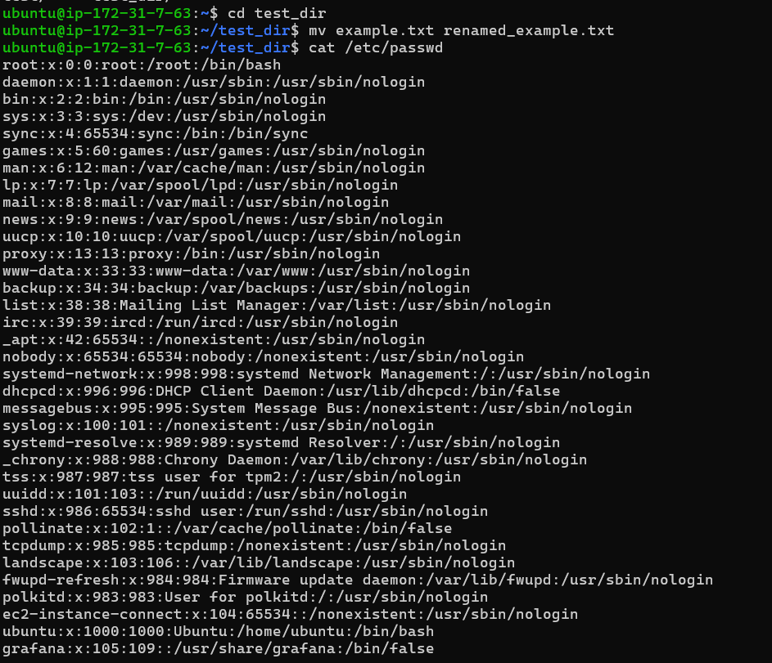

- Display only the first 5 lines
Command:
head -n 5 /etc/passwd
Explanation: Shows the first five lines of the file.
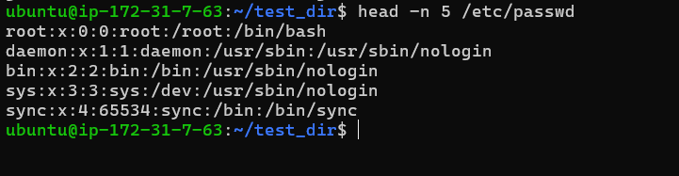
- Display only the last 5 lines
Command:
tail -n 5 /etc/passwd
Explanation: Shows the last five lines of the file.
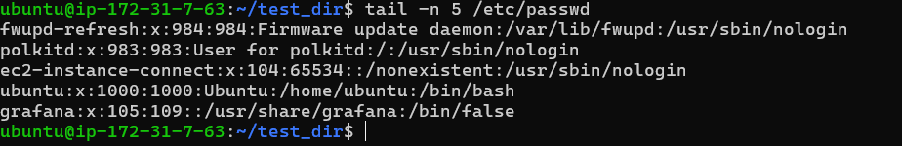

3. Searching for Patterns
- Find all lines containing 'root'
Command:
grep 'root' /etc/passwd
Explanation: Searches the file and displays every line containing the word 'root'.

4. Zipping and Unzipping
- Compress test_dir into test_dir.zip
Command:
zip -r test_dir.zip test_dir
Explanation: Creates a ZIP archive of the directory.
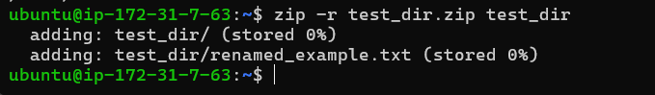
- Extract test_dir.zip into unzipped_dir
Command:
unzip test_dir.zip -d unzipped_dir
Explanation: Extracts the ZIP archive into the specified directory.
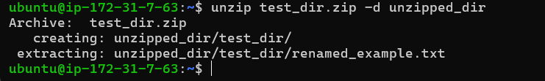

5. Downloading Files
- Download a file using wget
Command:
wget https://github.com/iam-veeramalla/sandbox/blob/main/log/dummylog01122022.log
Explanation: Downloads the file from the given URL into the current directory. This is the demo log file.
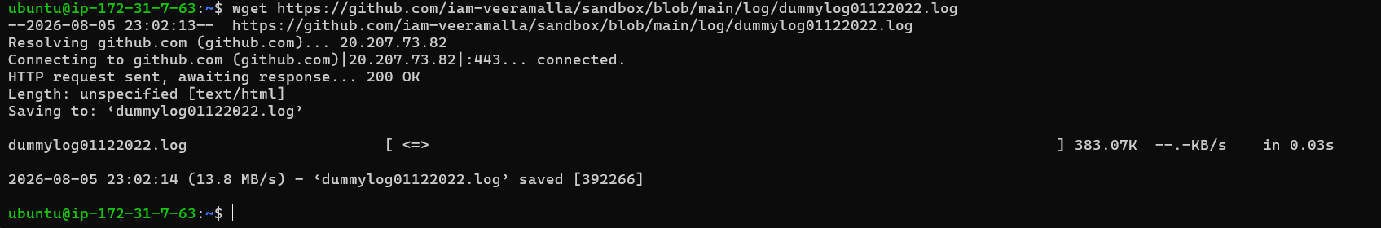

6. Changing Permissions
- Create secure.txt
Command:
touch secure.txt
Explanation: Creates an empty file.
- Make the file read-only for everyone
Command:
chmod 444 secure.txt
Explanation: Sets read-only permission for owner, group, and others (r--r--r--).
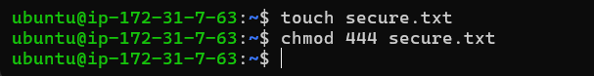

7. Working with Environment Variables
- Create an environment variable
Command:
export MY_VAR='Hello, Linux!'
Explanation: Creates an environment variable named MY_VAR with the specified value for the current shell session.
- Verify the variable (optional)
Command:
echo $MY_VAR
Explanation: Displays the value stored in the environment variable.
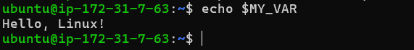

GitHub Repository Link
https://github.com/memonaariz/1st-assignment/upload/main

