Software Design Document
AI CyberShield: Explainable AI-Based Phishing URL Detection



Submitted by
Muhammad Shahzad (F25BINFT7M04007)
BS Information Technology (BSIT), Academic Year 2026–2027

Submitted to
Dr. Salman Latif

Department of Information Technology
Faculty of Computing
The Islamia University of Bahawalpur
Summary
This Software Design Document (SDD) describes how AI CyberShield will be designed to satisfy the requirements defined in the Software Requirements Specification (SRS). AI CyberShield is a web-based application that classifies a submitted URL as likely phishing or likely legitimate using supervised machine learning and explains the main factors behind each prediction. The design described here is proposed: no implementation exists yet, and all component names, interfaces and file layouts are planned rather than reported.
The architecture separates an offline training and evaluation pipeline from an online inference application. The offline pipeline prepares the public PhiUSIIL dataset (primary candidate), deduplicates and splits it before any fitting, trains and compares Logistic Regression, Random Forest and XGBoost, selects the final model on measured validation results, evaluates it once on a held-out test set and writes versioned model artefacts and an evaluation report. The online application is a React.js and Tailwind CSS single-page interface that calls a stateless Python FastAPI service. For each request the service validates the URL, extracts features from the URL text through a module shared with the training pipeline, computes a phishing probability, derives a risk level and rule-based indicators, and computes SHAP feature attributions.
Key design considerations are safety (submitted URLs are processed only as text and are never opened, fetched, resolved, redirected to, rendered or executed), consistency between training and inference features, leakage-aware evaluation, privacy through data minimisation (no database and no storage of submitted URLs in the minimum viable product), and honest communication of limitations: predictions are advisory, false positives and false negatives are possible, and explanations describe model behaviour rather than proving malicious intent. The interface consists of an Analyse URL page with an integrated result and explanation view, a Model Evaluation page and an About & Limitations page.
Table of Contents
1. Application Architecture 4
1.1. System Architecture Diagram 4
1.2. Component Responsibilities 5
1.3. Inference Pipeline and Data Flow 6
1.4. Training and Evaluation Pipeline 8
1.5. Feature Extraction Design 9
1.6. API Design 10
1.7. Sequence Diagram 12
1.8. Class Diagram 13
1.9. Explainability Design 15
1.10. Security and Safety Design 15
1.11. Proposed Directory Structure 16
1.12. Coding Conventions 16
1.13. Requirements Traceability 17
2. Data Model Schema 18
2.1. Persistence Decision 18
2.2. Persisted Artefacts and Data Files 19
2.3. Entity Descriptions 20
2.4. Optional Analysis History 21
2.5. Data Retention and Privacy 21
3. User Interface 22
3.1. Design Philosophy 22
3.2. Colour Scheme and Typography 22
3.3. Responsive Behaviour 22
3.4. Screen 1: Analyse URL 23
3.5. Screen 2: Prediction Result and Explanation 24
3.6. Screen 3: Model Evaluation 26
3.7. Screen 4: About and Limitations 26
3.8. Accessibility and Interaction States 27

- Application Architecture
AI CyberShield uses a layered client–server architecture with three tiers: a presentation tier (React single-page application in the browser), an application tier (stateless FastAPI service) and an artefact tier (versioned model files produced offline). A separate offline pipeline produces the artefacts. The design does not follow a full MVC framework; instead, the backend is organised into thin API routers (the controllers), a service layer that implements the analysis logic, and Pydantic schemas that define the data exchanged with the client. Every element described in this section is proposed and will be confirmed or revised during implementation.
  - System Architecture Diagram
Figure 1 shows the proposed architecture. The arrows between the browser and the API represent HTTPS requests carrying JSON. The artefact store is read at start-up only; the offline pipeline writes it.
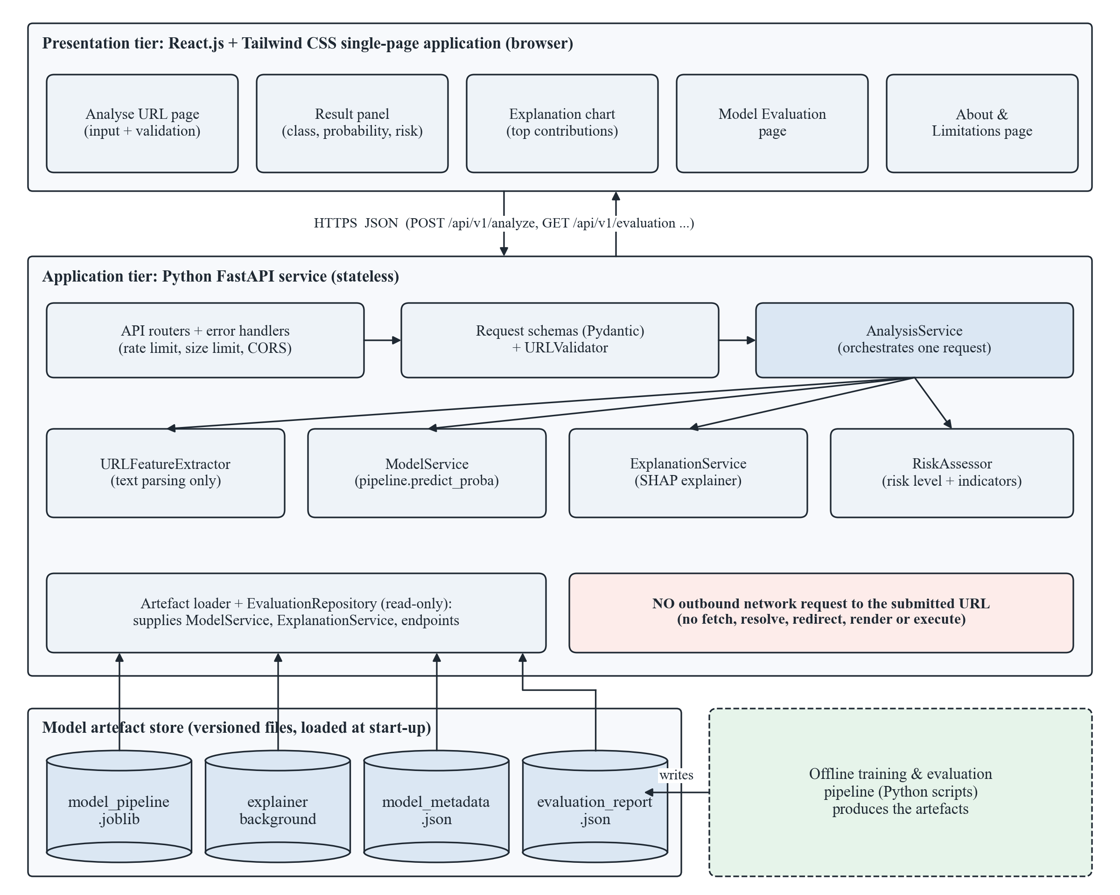
Figure 1: Proposed system architecture of AI CyberShield
  - Component Responsibilities
Table 1 lists each component, its responsibility and the SRS requirements it realises.
Table 1: Component responsibilities and requirement mapping
Component | Responsibility | SRS requirements
Frontend: Analyse URL page (React, Tailwind CSS) | URL input, client-side checks (empty, length), Analyse button, loading state, inline error messages. | FR001, FR007
Frontend: Result panel and explanation chart | Display class, probability, risk level, indicators, top-k contributions, advisory and interpretation notices; render the URL as defanged plain text. | FR005, FR006, FR009
Frontend: Model Evaluation and About pages | Display the evaluation report and limitations served by the API. | FR008
API routers (api/routes_*.py) | Map HTTP endpoints to services; enforce request size limit, rate limit and CORS; convert exceptions into structured errors. | FR001, FR007, NFR003
Schemas (api/schemas.py, Pydantic) | Define request and response models so that every response has a fixed, documented structure. | FR001, FR005–FR008
URLValidator (cybershield/validation.py) | Apply the validation rules of FR002 and return a ValidatedURL or raise a URLValidationError with an error code. | FR002, FR009
URLFeatureExtractor (cybershield/features.py) | Parse the URL string and compute the feature vector; shared by training and inference; no network access. | FR003, FR009
ModelService | Load the serialised scikit-learn pipeline and metadata at start-up; return the phishing probability and class using the stored threshold. | FR004
ExplanationService | Build the SHAP explainer at start-up; return top-k signed contributions for a feature vector. | FR006
RiskAssessor | Map the probability to a risk level and derive rule-based risk indicators from URL components. | FR005
AnalysisService | Orchestrate one analysis request: validate, extract, predict, explain, assess, assemble the response. | FR001–FR006, FR009
EvaluationRepository | Read the evaluation report and model metadata files and serve them read-only. | FR008
Offline pipeline (ml/src/*.py) | Data preparation, deduplication, splitting, training, tuning, selection, evaluation, explanation analysis and artefact export. | FR008, NFR010, NFR011

  - Inference Pipeline and Data Flow
Figure 2 shows the data flow for one analysis request, from URL entry to the rendered result. The submitted URL is treated as a character string throughout: it is parsed with standard library functions (urllib.parse) and is never used as the target of a network operation.
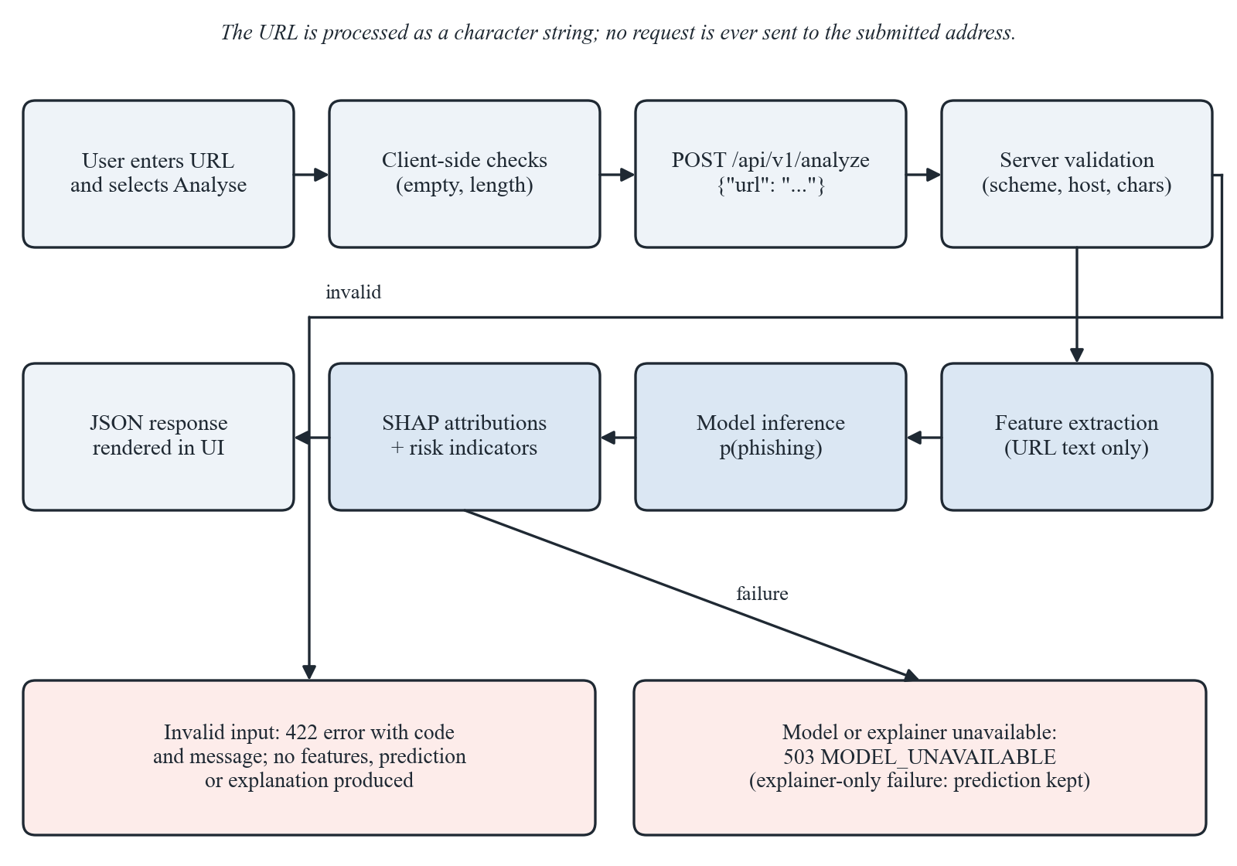
Figure 2: Inference pipeline and data flow for one URL
- The user enters a URL and selects Analyse. The frontend trims whitespace, checks that the value is not empty and not longer than 2048 characters, disables the button and shows the loading state.
- The frontend sends POST /api/v1/analyze with {"url": "..."}.
- The router checks the body size and rate limit, and Pydantic checks that url is a string.
- URLValidator applies the FR002 rules; on failure the router returns a 422 error and processing stops.
- URLFeatureExtractor computes the feature vector in the order recorded in the model metadata.
- ModelService returns the phishing probability; the class is Likely phishing if the probability is at least the stored decision threshold.
- ExplanationService returns the top-k contributions; RiskAssessor returns the risk level and indicators.
- AnalysisService assembles the AnalyzeResponse (including the advisory notice and processing time) and the frontend renders it.

  - Training and Evaluation Pipeline
Figure 3 shows the offline pipeline. Its central rule is that the held-out test partition is never used for fitting preprocessing, selecting features, tuning hyperparameters or choosing the decision threshold.
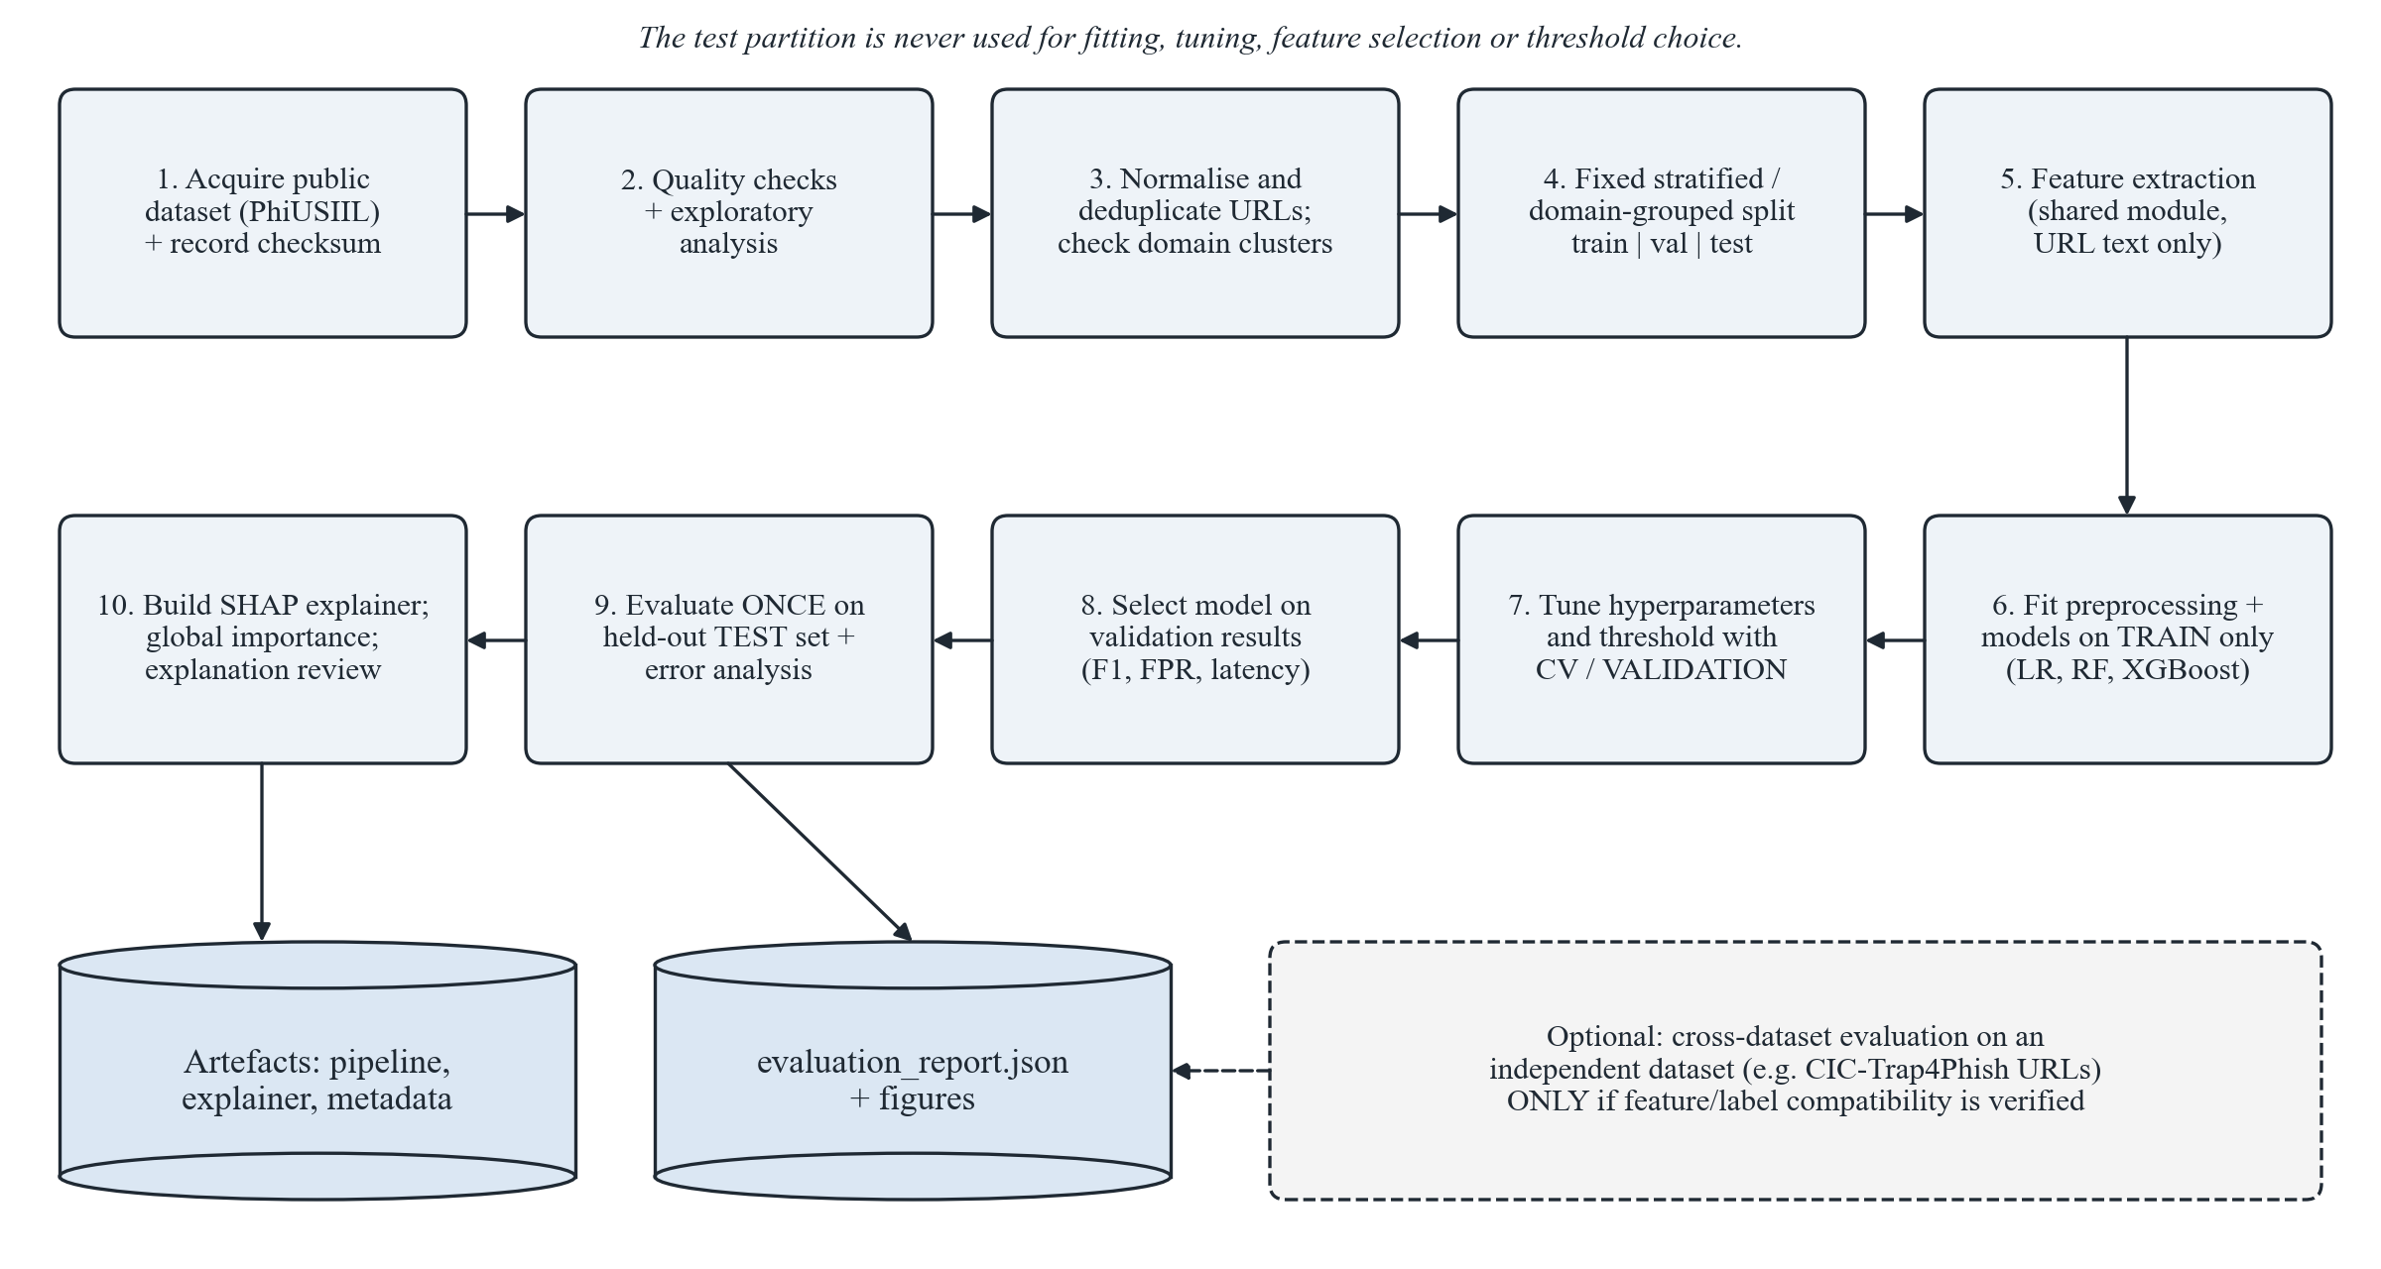
Figure 3: Offline training and evaluation pipeline
Table 2: Design decisions in the offline pipeline
Stage | Design decision
Data acquisition | Download the PhiUSIIL dataset (primary candidate) and record its source URL, licence (CC BY 4.0) and SHA-256 checksum. Map labels explicitly (the dataset documents 1 = legitimate, 0 = phishing) to the project convention 1 = phishing.
Quality checks | Check missing values, malformed URLs, label consistency and class balance; compare URL formatting (scheme, www. prefix, trailing slash, length) by class to detect collection artefacts.
Deduplication | Normalise URLs consistently (lower-case scheme and host, remove default ports and trailing slashes) and drop exact duplicates before splitting; report how many were removed.
Splitting | Stratified 70/15/15 train/validation/test split (provisional); if many URLs share a registered domain, use a domain-grouped split so that no domain appears in more than one partition. Save split indices and the random seed.
Feature extraction | Use only the project’s URL-text features computed by cybershield/features.py; do not use page-content or externally derived columns supplied with the dataset.
Training | Fit scikit-learn Pipeline objects (scaling for Logistic Regression; none required for trees) on the training split only.
Tuning and threshold | Use stratified cross-validation on the training split or the validation split for hyperparameter search (e.g. randomised search with a fixed budget) and for decision-threshold selection.
Model selection | Choose the model on validation F1-score and false-positive rate, then inference time and explanation practicality; prefer the simpler model when results are comparable. Record the rationale.
Final evaluation | Evaluate the selected model once on the test split: precision, recall, F1-score, false-positive rate, confusion matrix and inference time; perform error analysis of false positives and false negatives.
Cross-dataset evaluation | Only if an independent dataset (e.g. the URL-string component of CIC-Trap4Phish 2025) has verified licence, mappable labels and URLs processable by the same extractor; remove URLs overlapping with the training data first. Otherwise document why it was not feasible.
Artefact export | Write model_pipeline.joblib, the explainer background sample, model_metadata.json and evaluation_report.json with versions and checksums.

  - Feature Extraction Design
Table 3 lists the candidate URL features. All are computed from the URL string without network access. The final feature set will be fixed after dataset verification and a leakage review; for example, scheme-related features will be retained only if exploratory analysis shows they are not merely artefacts of how the dataset was collected.
Table 3: Candidate URL features (to be finalised)
ID | Feature | Definition (computed on the URL text)
F01 | url_length | Number of characters in the full URL.
F02 | host_length | Number of characters in the hostname.
F03 | path_length / query_length | Characters in the path and in the query string.
F04 | num_dots, num_hyphens | Counts of ‘.’ and ‘-’ in the hostname.
F05 | num_digits, digit_ratio | Count of digits in the URL and their proportion of all characters.
F06 | num_special_chars | Count of characters such as @ ? = & % _ ~ + in the URL.
F07 | has_at_symbol | 1 if ‘@’ appears in the URL, else 0.
F08 | host_is_ip | 1 if the hostname is an IPv4 or IPv6 literal, else 0.
F09 | num_subdomains | Number of labels before the registered domain (using a bundled public-suffix list; no look-up).
F10 | tld_length | Length of the top-level domain.
F11 | is_https | 1 if the scheme is https (subject to artefact review).
F12 | has_port | 1 if an explicit port is present.
F13 | double_slash_in_path | 1 if ‘//’ occurs after the scheme separator.
F14 | host_entropy | Shannon entropy of the hostname characters.
F15 | has_punycode | 1 if any hostname label starts with ‘xn--’.
F16 | num_path_segments | Number of non-empty path segments.
F17 | keyword_count | Occurrences of a fixed, documented word list (e.g. login, verify, account, update, secure).
F18 | is_shortener | 1 if the registered domain is in a bundled, versioned list of URL-shortening services.

  - API Design
The backend exposes a versioned REST API under /api/v1. All responses are JSON; all errors use one structure. Table 4 lists the endpoints, which match the SRS.
Table 4: API endpoints
Method | Endpoint | Purpose | SRS
POST | /api/v1/analyze | Validate a URL, extract features, classify it, and return the prediction, risk level, risk indicators and explanation. | FR001–FR007, FR009
GET | /api/v1/evaluation | Return the evaluation summary produced by the offline pipeline (metrics, confusion matrix, model comparison, global importance, limitations). | FR008
GET | /api/v1/model | Return metadata of the deployed model (name, version, feature-extractor version, decision threshold, risk thresholds, dataset name). | FR005, FR008
GET | /api/v1/health | Report service status and whether model and explainer artefacts are loaded. | NFR002

Request: POST /api/v1/analyze
{
"url": "https://example.com/account/verify"
}

Successful response (200) – structure only; values shown are placeholders
{
"request_id": "<uuid>",
"url_display": "hxxps://example[.]com/account/verify",
"scheme_added": false,
"prediction": "phishing | legitimate",
"label": "Likely phishing | Likely legitimate",
"probability_phishing": "<float 0-1>",
"decision_threshold": "<float from model metadata>",
"risk_level": "low | medium | high",
"risk_indicators": [
{"code": "MANY_SUBDOMAINS", "message": "<text>", "severity": "info | warning"}
],
"explanation": {
"available": true,
"method": "SHAP TreeExplainer",
"base_value": "<float>",
"contributions": [
{"feature": "num_subdomains", "description": "<text>", "value": "<number>",
"contribution": "<signed float>", "direction": "phishing | legitimate"}
]
},
"model": {"name": "<selected model>", "version": "<semver>"},
"disclaimer": "Advisory prediction. False positives and false negatives are possible.",
"processing_ms": "<integer>"
}

Error response (all endpoints)
{
"error": {"code": "UNSUPPORTED_SCHEME",
"message": "Only web addresses starting with http:// or https:// can be analysed."},
"request_id": "<uuid>"
}

GET /api/v1/evaluation returns the content of evaluation_report.json (Section 2); GET /api/v1/model returns the public subset of model_metadata.json; GET /api/v1/health returns {"status": "ok" | "degraded", "model_loaded": bool, "explainer_loaded": bool, "model_version": str}. Table 5 lists the error codes, which are identical to Table 5 of the SRS.
Table 5: API error codes
Error code | HTTP | Raised when
EMPTY_INPUT | 422 | The submitted value is empty or contains only whitespace.
URL_TOO_LONG | 422 | The URL exceeds 2048 characters.
UNSUPPORTED_SCHEME | 422 | The scheme is not http or https (e.g. javascript:, data:, file:, ftp:).
INVALID_URL_FORMAT | 422 | No valid host, embedded whitespace or control characters, or the value cannot be parsed as a URL.
INVALID_REQUEST | 422 | The JSON body is malformed or the url field is missing or not a string.
PAYLOAD_TOO_LARGE | 413 | The request body exceeds 8 KB.
RATE_LIMITED | 429 | The client exceeded the configured request rate.
EVALUATION_NOT_AVAILABLE | 404 | No evaluation report has been generated yet.
MODEL_UNAVAILABLE | 503 | Model or explainer artefacts are not loaded.
INTERNAL_ERROR | 500 | Any unexpected server error (details are logged, not returned).

Error handling design: URLValidator raises URLValidationError(code); a global FastAPI exception handler converts it, Pydantic validation errors (INVALID_REQUEST), size and rate-limit violations, and unexpected exceptions into the error structure. Unexpected exceptions are logged with the request ID but without the submitted URL, and the client receives only INTERNAL_ERROR. If the explainer fails for one request, the prediction is still returned with explanation.available = false.
  - Sequence Diagram
Figure 4 shows the interaction between the frontend and backend components for a successful analysis, and the alternative path when validation fails.
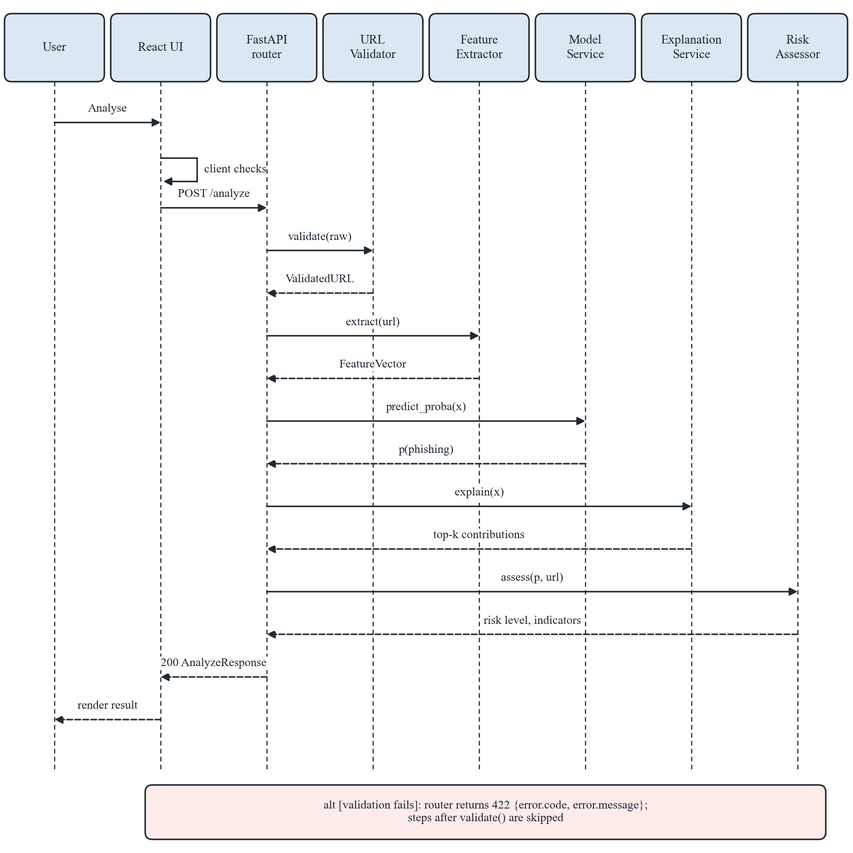
Figure 4: Sequence diagram for POST /api/v1/analyze
  - Class Diagram
Figure 5 shows the proposed backend classes. The service classes are created once at start-up and injected into the routers using FastAPI dependencies; they hold no per-user state, which keeps the API stateless.
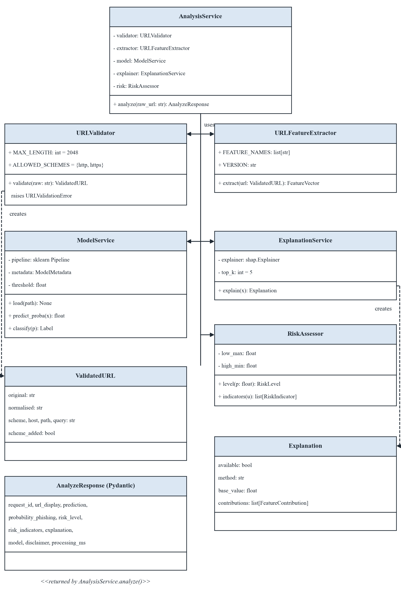
Figure 5: Proposed backend class diagram
  - Explainability Design
- For Random Forest and XGBoost, shap.TreeExplainer is used; for Logistic Regression, shap.LinearExplainer (or standardised coefficients) is used. The explainer is created once at start-up with a fixed background sample drawn from the training split and stored as an artefact.
- Attributions are computed on the model’s probability (or log-odds) output for the phishing class; the chosen output space is recorded in the metadata and stated on the evaluation page.
- The top k = 5 (provisional) features by absolute contribution are returned, each with a plain-language description taken from a feature dictionary in features.py.
- Global importance (mean absolute SHAP values on the test split) is computed offline and stored in the evaluation report; it is also reviewed for features that may reflect dataset artefacts.
- If SHAP proves too slow for interactive use (see NFR001), the fallback is caching the explainer, reducing the background sample, or using a model-appropriate alternative; the change will be documented.

  - Security and Safety Design
- No outbound access: the analysis path imports no HTTP client; parsing uses urllib.parse and ipaddress only. An automated test replaces socket.socket with a function that raises an error and asserts that analysis still succeeds.
- Input limits: URL length ≤ 2048 characters, request body ≤ 8 KB, and a per-client rate limit (proposed: 30 requests per minute).
- Output safety: the frontend renders the URL and all API text through React’s default escaping, never uses dangerouslySetInnerHTML, and shows the defanged form of the URL.
- CORS and headers: CORS allows only the frontend origin; the API sets X-Content-Type-Options: nosniff.
- Artefact integrity: the service verifies artefact checksums from the metadata before loading the serialised model, and loads only artefacts produced by the project’s own pipeline.
- Logging: logs contain request ID, timestamp, endpoint, status code, error code and latency, but never the submitted URL.

  - Proposed Directory Structure
The repository (https://github.com/memonaarshad786/ai-cybershield) will be organised as follows. The shared cybershield package keeps validation and feature extraction identical for training and inference.
ai-cybershield/
|-- README.md project proposal
|-- docs/ SRS.docx, SDD.docx
|-- cybershield/ shared package (training + inference)
| |-- validation.py URLValidator, ValidatedURL
| `-- features.py URLFeatureExtractor, feature dictionary
|-- backend/
| |-- app/
| | |-- main.py app factory, start-up loading, middleware
| | |-- config.py settings from environment variables
| | |-- api/ routes_analyze.py, routes_meta.py,
| | | schemas.py, errors.py
| | `-- services/ analysis.py, model.py, explanation.py,
| | risk.py, evaluation.py
| |-- tests/ test_validation.py, test_features.py,
| | test_api.py, test_no_network.py
| `-- requirements.txt
|-- ml/
| |-- configs/train.yaml seeds, split ratios, search spaces
| |-- src/ prepare_data.py, split.py, train.py,
| | evaluate.py, explain_global.py
| |-- notebooks/ exploratory analysis only
| |-- data/ raw/, interim/, splits/ (not committed)
| `-- reports/ evaluation_report.json, figures/
|-- artifacts/ model_pipeline.joblib, model_metadata.json,
| explainer_background.npy
`-- frontend/
|-- src/api/client.js
|-- src/pages/ AnalysePage, EvaluationPage, AboutPage
|-- src/components/ UrlForm, ResultCard, RiskIndicators,
| ExplanationChart, SafetyNotice, ErrorMessage
|-- tests/
`-- package.json

  - Coding Conventions
Table 6: Coding conventions
Area | Convention
Python style | PEP 8, enforced with Ruff and formatted with Black; type hints on public functions; docstrings for modules and public classes.
Naming | snake_case for Python functions, variables and feature names; PascalCase for classes and React components; UPPER_SNAKE_CASE for constants and error codes.
JavaScript/React | Functional components with hooks; ESLint and Prettier; one component per file; API calls only through src/api/client.js.
Configuration | Thresholds, limits, paths and allowed origins read from environment variables or YAML; no secrets or data files committed.
Reproducibility | Fixed random seeds; pinned dependency versions; dataset checksum and library versions recorded in model metadata.
Testing | Pytest for Python modules and API (FastAPI TestClient); frontend component tests for form validation and result rendering; tests run before each merge to the main branch.
Version control | Feature branches and descriptive commit messages; large data and model files excluded via .gitignore.

  - Requirements Traceability
Table 7: Traceability from SRS functional requirements to design elements
SRS requirement | Design elements (this document)
FR001 URL Submission | UrlForm component; POST /api/v1/analyze; AnalyzeRequest schema
FR002 URL Format Validation | URLValidator; client-side checks in UrlForm; error codes (Table 5)
FR003 URL Feature Extraction | URLFeatureExtractor in the shared package; feature table (Table 3)
FR004 Classification | ModelService; model_pipeline.joblib; decision threshold in model_metadata.json
FR005 Results and Risk Indicators | RiskAssessor; ResultCard and RiskIndicators components
FR006 Explainable AI Output | ExplanationService; ExplanationChart component
FR007 Error Handling | Exception handlers; error structure; ErrorMessage component
FR008 Model Evaluation Reporting | Offline pipeline; evaluation_report.json; GET /api/v1/evaluation; EvaluationPage
FR009 Safe Processing | Security and safety design; no-network test; defanged plain-text display

- Data Model Schema
  - Persistence Decision
The minimum viable product does not require a database. Each prediction is computed from the submitted URL and the loaded model within a single request, no user accounts exist, and the privacy requirements (NFR005) prohibit storing submitted URLs on the server. PostgreSQL, listed in the proposal as optional, is therefore not used. The persistent data of the system consists of versioned files produced by the offline pipeline, while the data exchanged at run time is transient. Figure 6 shows the resulting logical data model.
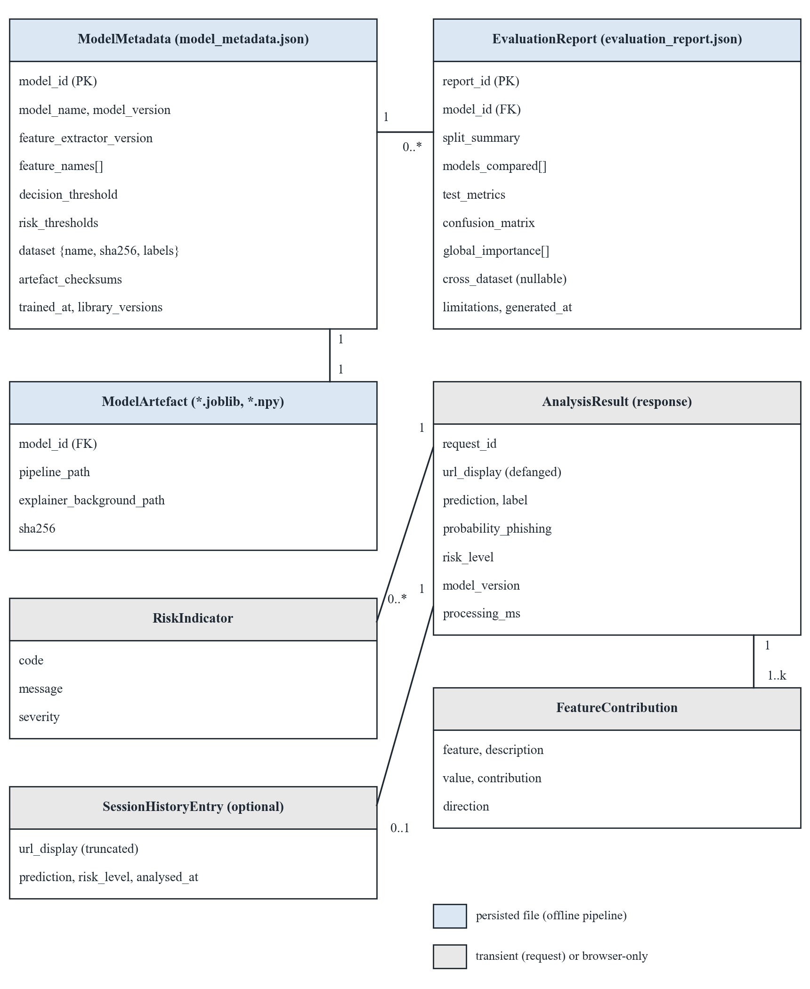
Figure 6: Logical data model: persisted artefact files and transient run-time entities
  - Persisted Artefacts and Data Files
Table 8: Persisted files
File | Producer / consumer | Content
ml/data/raw/PhiUSIIL_Phishing_URL_Dataset.csv | Downloaded manually / prepare_data.py | Public dataset; not committed; checksum recorded.
ml/data/splits/*.parquet + split_indices.json | split.py / train.py, evaluate.py | Deduplicated records and fixed partition indices with the random seed.
artifacts/model_pipeline.joblib | train.py / ModelService | Fitted scikit-learn pipeline (preprocessing + selected classifier).
artifacts/explainer_background.npy | train.py / ExplanationService | Background sample from the training split used by the SHAP explainer.
artifacts/model_metadata.json | train.py / ModelService, GET /api/v1/model | Model identity, versions, feature order, thresholds, dataset checksum, artefact checksums.
ml/reports/evaluation_report.json (+ figures) | evaluate.py / GET /api/v1/evaluation | Split summary, validation comparison, test metrics, confusion matrix, latency, global importance, cross-dataset section, limitations.

  - Entity Descriptions
ModelMetadata (artifacts/model_metadata.json)
Table 9: ModelMetadata fields
Field | Type | Description
model_id | string (PK) | Unique identifier, e.g. derived from name, version and training timestamp.
model_name / model_version | string | Selected algorithm and semantic version of the deployed model.
feature_extractor_version | string | Version of cybershield/features.py; must match the running code.
feature_names | array of string | Ordered list of features expected by the pipeline.
decision_threshold | number | Threshold chosen on validation data.
risk_thresholds | object {low_max, high_min} | Probability limits for Low/Medium/High (provisional 0.30/0.70).
dataset | object {name, source_url, sha256, label_mapping} | Training data provenance and label convention.
artefact_checksums | object | SHA-256 of pipeline and background files.
trained_at, library_versions, random_seed | string / object / integer | Reproducibility information.

EvaluationReport (ml/reports/evaluation_report.json)
Table 10: EvaluationReport fields
Field | Type | Description
report_id | string (PK) | Identifier of the report.
model_id | string (FK → ModelMetadata) | Model version that the report describes.
split_summary | object | Record counts per partition, duplicates removed, split strategy.
models_compared | array of object | Validation precision, recall, F1, FPR and latency for each candidate model.
test_metrics | object | Held-out precision, recall, F1-score, FPR, inference time (mean, p95).
confusion_matrix | object {tn, fp, fn, tp} | Counts on the test split.
global_importance | array of {feature, mean_abs_shap} | Global attribution ranking.
cross_dataset | object or null | Metrics on a compatible independent dataset, or null with a reason string.
limitations, generated_at | array of string / datetime | Documented limitations and generation time.

Transient run-time entities
AnalysisResult (returned by POST /api/v1/analyze) contains the fields shown in Section 1.6 and is discarded after the response is sent. Each AnalysisResult contains one to k FeatureContribution records (feature, description, value, contribution, direction) and zero or more RiskIndicator records (code, message, severity). These entities exist only in memory and in the HTTP response.
  - Optional Analysis History
If time permits, a session-only history may be added. In that case a SessionHistoryEntry (truncated defanged URL, prediction, risk level, analysed_at) is stored only in the browser’s sessionStorage, limited to the 10 most recent entries, cleared when the tab is closed, and removable with a Clear history control. The server stores nothing. Server-side history with PostgreSQL would require a separate privacy review and supervisor approval and is not part of this design.
  - Data Retention and Privacy
- Submitted URLs are held in memory only for the duration of a request and are not logged or persisted on the server.
- Datasets are used under their published licences (PhiUSIIL: CC BY 4.0) with attribution; raw dataset files are not redistributed in the repository.
- Model artefacts and the evaluation report contain aggregated statistics and model parameters, not user data.

- User Interface
  - Design Philosophy
The interface is focused on a single task: checking one URL safely and understanding the result. It follows a calm, professional security-tool style with generous spacing, a clear visual hierarchy and no decorative elements that distract from the result. Every result is accompanied by its limitations. Colour is never the only carrier of meaning: classes and risk levels always appear as text, and icons support but do not replace labels. The interface is designed mobile-first with Tailwind CSS utility classes and scales up to desktop layouts.
  - Colour Scheme and Typography
Table 11: Proposed colour scheme and typography
Element | Proposed value | Use
Primary | Navy #1E3A5F | Header bar, primary buttons, links.
Background / surface | #F7F9FC / #FFFFFF | Page background and cards.
Text | #1F2933 (body), #6B7280 (secondary) | Body text and hints.
Phishing / high risk | Red #C0392B on #FDECEA | Likely phishing badge, high-risk level, contributions towards phishing.
Legitimate / low risk | Green #2E7D32 on #E6F4EA | Likely legitimate badge, low-risk level, contributions towards legitimate.
Medium risk / notices | Amber #B7791F on #FFF8E6 | Medium risk level, safety and limitation notices.
Typography | Inter or system sans-serif; 16 px base; 1.5 line height; monospace for URLs | Readable text; URLs shown in a monospace font to make look-alike characters easier to notice.

All text and colour combinations are to be checked against the WCAG 2.1 AA contrast ratio during implementation (NFR006).
  - Responsive Behaviour
The layout adapts to three breakpoints; Figure 7 shows the mobile layout of the input and result screens.
- Mobile (360–767 px): single column; navigation collapses into a menu button; result sections stack vertically; the risk-indicator list is collapsible.
- Tablet (768–1023 px): single column with wider cards; explanation chart uses full width.
- Desktop (≥ 1024 px): content limited to about 1100 px width; result summary and risk indicators appear side by side above the explanation chart.

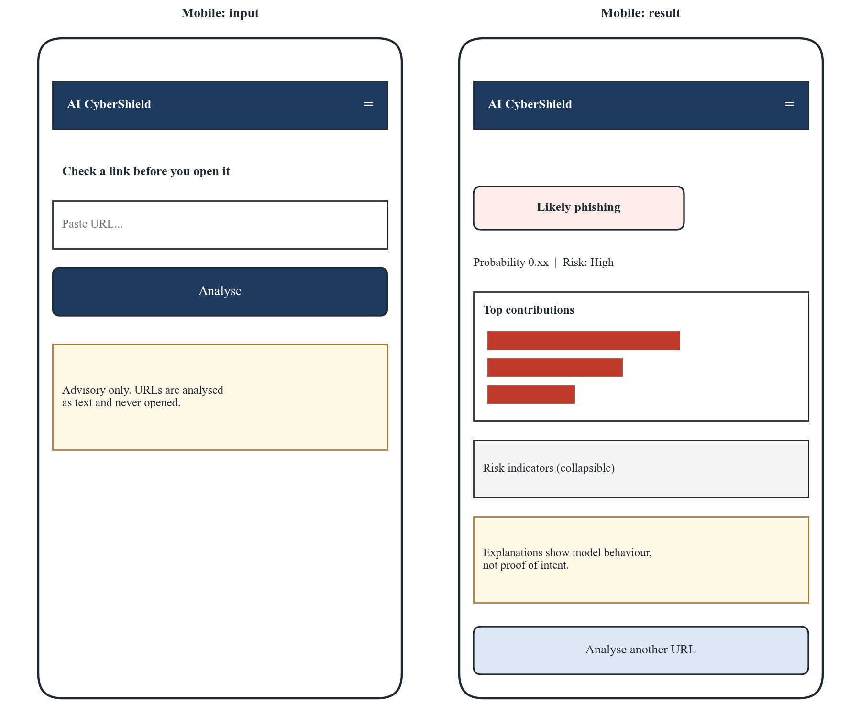
Figure 7: Mobile layout of the input and result screens (wireframe)
  - Screen 1: Analyse URL
The home screen (Figure 8) lets the user submit a URL. Numbers in the wireframe correspond to Table 12.
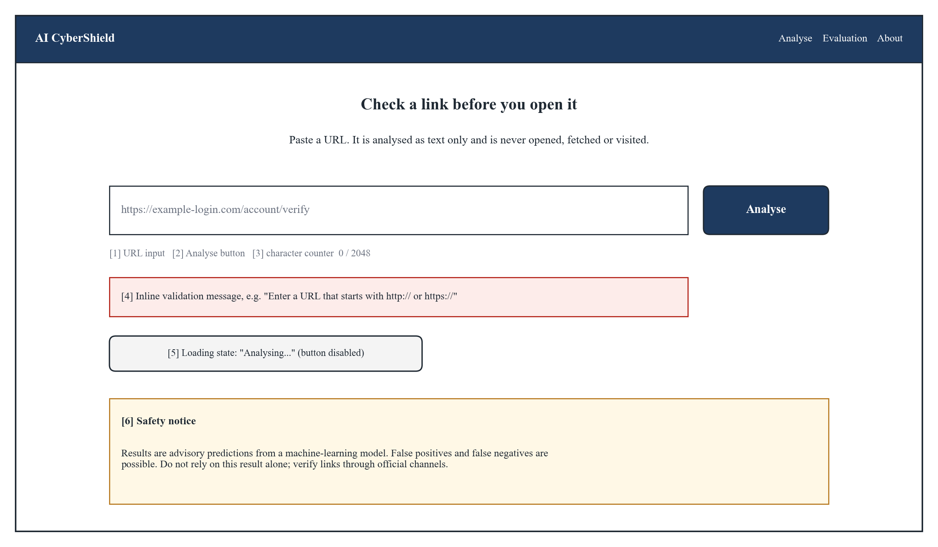
Figure 8: Analyse URL screen (wireframe)
Table 12: Controls of the Analyse URL screen
# | Control | Purpose | Valid input | Behaviour
1 | URL input field (text, monospace) | Enter the URL to analyse. | 1–2048 characters; http/https or no scheme. | Enter key submits; whitespace trimmed; value kept after errors; never rendered as a link.
2 | Analyse button | Submit the URL (FR001). | Enabled when the field is not empty. | Disabled and labelled “Analysing…” during a request; prevents duplicate submission.
3 | Character counter | Show length against the limit. | – | Turns amber near and red above the limit.
4 | Inline validation message | Explain why input was rejected (FR007). | – | Shows the message for the returned error code (Table 5); linked to the field for screen readers.
5 | Loading indicator | Show that analysis is in progress. | – | Appears immediately after submission; replaced by the result or an error.
6 | Safety notice | State that analysis is text-only and advisory. | – | Always visible on this screen.

  - Screen 2: Prediction Result and Explanation
After a successful analysis, the result view (Figure 9) appears below the form on the same page, so the user can analyse another URL without navigating away.
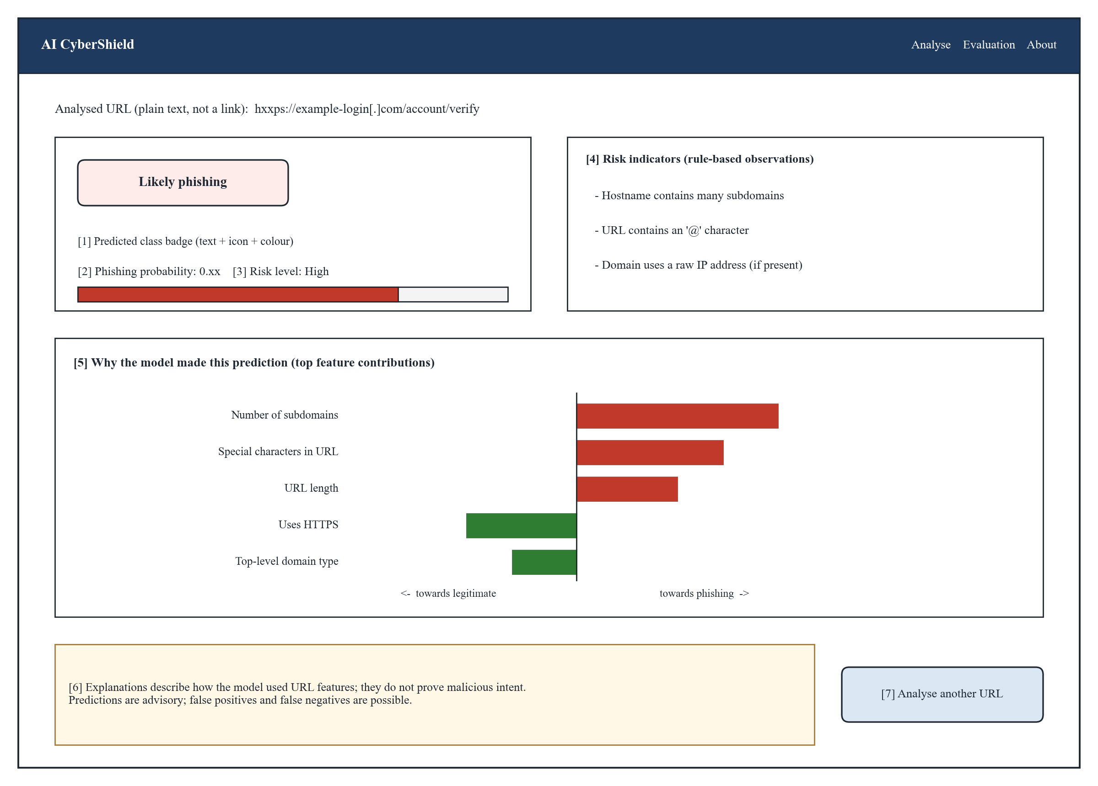
Figure 9: Prediction result and explanation view (wireframe)
Table 13: Elements of the result and explanation view
# | Element | Purpose | Behaviour
– | Analysed URL | Confirm which URL was analysed. | Defanged plain text in monospace (e.g. hxxps://example[.]com); never a hyperlink; long URLs wrap.
1 | Predicted class badge | Show Likely phishing / Likely legitimate (FR004). | Text, icon and colour together.
2 | Phishing probability | Show the model’s probability. | Shown with two decimals and a horizontal bar; label clarifies it is a model estimate.
3 | Risk level | Show Low / Medium / High (FR005). | Derived from thresholds in model metadata; tooltip explains the bands.
4 | Risk indicators | List rule-based observations (FR005). | Each as a short sentence; if none apply, states that no specific indicator was found without implying safety.
5 | Explanation chart | Show top-k feature contributions (FR006). | Horizontal diverging bars (towards phishing to the right, towards legitimate to the left); hover/focus shows value and description; text alternative provided as a list.
6 | Interpretation and advisory notice | Communicate limits of the result. | Always shown with the result.
7 | Analyse another URL | Start again. | Clears the form and result and focuses the input field.

  - Screen 3: Model Evaluation
The Model Evaluation page (Figure 10) presents the report produced by the offline pipeline (FR008). All values are loaded from GET /api/v1/evaluation; the wireframe shows placeholders only and no results are implied.
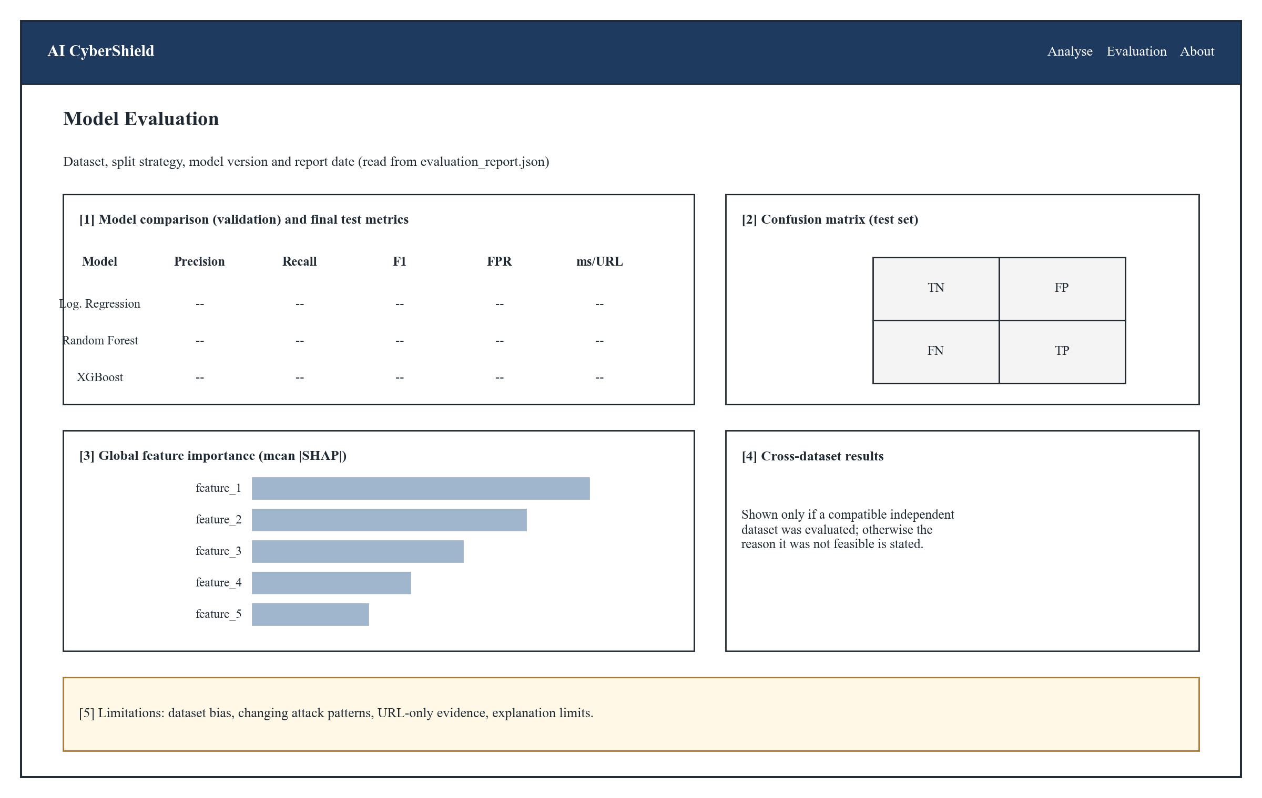
Figure 10: Model Evaluation screen (wireframe)
Table 14: Elements of the Model Evaluation screen
# | Element | Behaviour
1 | Model comparison and test metrics table | Validation results for each candidate model and the held-out test results of the selected model.
2 | Confusion matrix | TN, FP, FN and TP counts on the test split with row and column labels.
3 | Global feature importance | Mean absolute SHAP values with feature descriptions.
4 | Cross-dataset results | Shown only if evaluated; otherwise the reason it was not feasible.
5 | Limitations | Dataset bias, changing attack patterns, URL-only evidence and explanation limits.
– | Unavailable state | If the API returns EVALUATION_NOT_AVAILABLE, a notice replaces the content.

  - Screen 4: About and Limitations
A short static page explains what the system does, how the URL is processed (text only, never opened), what the probability and risk levels mean, what explanations can and cannot show, that false positives and false negatives are possible, which datasets are used with attribution, and that the tool is an academic prototype that does not replace established security controls. It contains no input controls.
  - Accessibility and Interaction States
- All controls are reachable and operable with the keyboard, with visible focus outlines.
- Form errors and results are announced to screen readers using ARIA live regions.
- Charts have text alternatives (the same contributions as a list).
- Every asynchronous action has explicit loading, success, error and service-unavailable states.

