Software Requirement Specifications
AI CyberShield: Explainable AI-Based Phishing URL Detection



Submitted by
Muhammad Shahzad (F25BINFT7M04007)
BS Information Technology (BSIT), Academic Year 2026–2027

Submitted to
Dr. Salman Latif

Department of Information Technology
Faculty of Computing
The Islamia University of Bahawalpur
Meeting Details
Sr No | Details | Date | Supervisor Signature
Summary
This Software Requirements Specification (SRS) defines the requirements of AI CyberShield, a web-based application that estimates whether a submitted URL is likely to be a phishing URL and explains the main factors behind each estimate. Phishing links remain a common route for credential theft and fraud, and newly created malicious addresses are often absent from blocklists when they are first used. Supervised machine-learning classifiers trained on lexical and structural URL characteristics can assess previously unseen URLs, but their predictions are usually opaque and their reported performance can be inflated by duplicate data or dataset-specific artefacts.
The proposed system accepts a single URL, validates it, extracts features from the URL text only, classifies it with a model selected from Logistic Regression, Random Forest and XGBoost on the basis of measured validation results, and presents the predicted class, a phishing probability, a risk level, rule-based risk indicators and a feature-level explanation produced with SHAP. A separate page presents the model evaluation report generated by an offline, leakage-aware training pipeline that uses the public PhiUSIIL Phishing URL Dataset as its primary candidate dataset.
The document specifies nine functional requirements (FR001–FR009), the non-functional requirements for performance, reliability, security, privacy, usability, maintainability, compatibility and reproducibility, and five use cases with activity diagrams. The intended users are students, general web users and reviewers who want an advisory second opinion on a link. The system never opens, fetches, resolves, redirects to, renders or executes a submitted URL, and its predictions are advisory: false positives and false negatives are possible, and explanations describe model behaviour rather than proving malicious intent. Email, QR-code, browser-extension and document analysis are future extensions and are outside the committed scope.
Table of Contents
1. Introduction 5
1.1. Purpose 5
1.2. Scope 5
1.3. Product Perspective 6
1.4. User Characteristics 7
1.5. Similar apps and systems/Literature Review 8
1.6. Proposed Technologies 9
2. Requirements 11
2.1. Functional Requirements 11
2.1.1. URL Submission 11
2.1.2. URL Format Validation 12
2.1.3. URL Feature Extraction 12
2.1.4. Phishing versus Legitimate Classification 13
2.1.5. Prediction Results and Risk Indicators 13
2.1.6. Explainable AI Output 14
2.1.7. Error Handling and Invalid Inputs 15
2.1.8. Model Evaluation Reporting 15
2.1.9. Safe Processing of Submitted URLs 16
2.2. Non-Functional Requirements 17
3. Use Cases and Flow of Processes 19
3.1. Use Case 1: Analyse URL 19
3.2. Use Case 2: View Prediction Result 22
3.3. Use Case 3: View Prediction Explanation 24
3.4. Use Case 4: Handle Invalid Input 26
3.5. Use Case 5: View Model Evaluation Report 28
4. References 30

- Introduction
AI CyberShield is a Final Year Project in the Department of Information Technology, The Islamia University of Bahawalpur. It is not developed for a specific client organisation; it is an academic prototype addressing a general cybersecurity need. Phishing attacks commonly persuade a user to visit a deceptive web address that imitates a trusted service. AI CyberShield helps a user assess such an address before opening it, by applying a trained machine-learning model to characteristics of the URL string and by explaining which characteristics influenced the result. The project proposal (README.md in the project repository) describes the research aim, objectives, methodology and timeline; this SRS refines that proposal into verifiable software requirements.
  - Purpose
The purpose of this SRS is to define, in a precise and testable form, what the AI CyberShield system must do and the quality constraints it must satisfy. It serves as the agreed basis for design (documented separately in the Software Design Document), implementation, testing and supervisor evaluation. The goals of the system are to:
- allow a user to submit a single URL and receive an advisory classification of likely phishing or likely legitimate together with a phishing probability and a risk level;
- explain each prediction by showing the URL features that contributed most strongly towards each class;
- process every submitted URL safely as untrusted text, without any network access to the submitted destination;
- present a model evaluation report produced by a reproducible, leakage-aware training pipeline, including cross-dataset results only where dataset compatibility permits; and
- communicate the limitations of the predictions and explanations clearly to users.

  - Scope
The core system detects potentially phishing URLs using supervised machine learning, provides explanations for its predictions and displays the results in a web interface. The boundaries of the minimum viable product (MVP) are summarised in Table 1.
Table 1: Scope of the minimum viable product
In scope (committed) | Out of scope (future extensions, not guaranteed)
Single-URL submission through a web dashboard | Email content or header analysis
Server-side URL validation and safe handling of untrusted input | QR-code decoding and analysis
URL feature extraction from the URL string only (no network access) | Static analysis of PDF or Office documents
Classification using a model selected from Logistic Regression, Random Forest and XGBoost | Browser extension integration
Phishing probability, risk level and rule-based risk indicators | Batch or bulk URL analysis
Per-prediction SHAP explanations (or a documented model-appropriate alternative) | User accounts, authentication and administration modules
Model evaluation report page (metrics, confusion matrix, model comparison, global importance) | Fetching page content, WHOIS, DNS, certificate or reputation look-ups
Offline training and evaluation pipeline using public datasets | Server-side persistent storage of submitted URLs
Cross-dataset evaluation, only if feature and label compatibility is verified | Real-time protection or automatic blocking of links

An optional, privacy-conscious analysis history may be added if time permits. If implemented, it will be kept only in the user’s browser session storage and will not be part of the committed scope.
  - Product Perspective
AI CyberShield is a new, self-contained system composed of an offline training pipeline and an online web application. The online application follows a client–server architecture in which the browser communicates with a stateless REST API over HTTPS using JSON. The relationship between the components is as follows:
- React.js frontend (with Tailwind CSS): provides the Analyse URL page, the result panel, the explanation chart, the Model Evaluation page and the About & Limitations page. It performs basic client-side checks for usability, but the backend remains the authority for validation.
- FastAPI backend: exposes the endpoints POST /api/v1/analyze, GET /api/v1/evaluation, GET /api/v1/model and GET /api/v1/health; validates requests, orchestrates analysis and returns structured responses and errors.
- Feature-extraction module: a Python module that parses the URL string and computes numerical features. The same module is used by the offline pipeline and by the backend so that training and inference use identical feature definitions.
- Trained model: a serialised scikit-learn pipeline (preprocessing plus classifier) produced by the offline pipeline and loaded once when the backend starts.
- Explainability module: computes SHAP attributions for each prediction (TreeSHAP for tree ensembles; a linear or model-agnostic explainer for Logistic Regression).
- Results dashboard: displays the predicted class, probability, risk level, risk indicators, explanation and the advisory notice returned by the backend.
- Offline training and evaluation pipeline: prepares the public dataset, trains and compares candidate models, selects the final model on validation results, evaluates it once on the held-out test set and writes the model artefacts and the evaluation report that the backend serves.

The system does not depend on any external web service at prediction time and makes no outbound request to the submitted URL.
  - User Characteristics
The system has a single human role, the User, because all functions are available without authentication and no administrative workflow exists in the MVP. Typical users are described in Table 2.
Table 2: Intended user groups
User group | Characteristics | Main needs
Students and general web users | Basic computer and web-browsing skills; no machine-learning or security expertise assumed. | Quick, understandable assessment of a suspicious link; clear warnings and limitations.
Users reviewing phishing predictions (e.g. supervisor, examiners, security-aware users) | Some familiarity with phishing indicators; interested in why a result was produced. | Probability, risk indicators, feature-level explanations and access to the evaluation report.
Project developer (offline only) | Runs the training pipeline from the command line; not a role in the web application. | Reproducible training, evaluation and artefact generation.

Users are assumed to use a modern desktop or mobile web browser. No personal account, login or administrator role is required or provided.
  - Similar apps and systems/Literature Review
Blocklist-based services. Widely used protections such as Google Safe Browsing [19] warn users about URLs that have already been identified as dangerous. Such services are effective for known threats but cannot, by design, recognise a newly created malicious URL that has not yet been reported. AI CyberShield is not a replacement for these services; it is a complementary, explanation-oriented academic prototype.
Machine-learning URL classifiers. Detecting phishing URLs with machine learning is an established research area. Sahingoz et al. [5] built a large URL dataset and evaluated several classifiers on features extracted from URLs, showing that URL-based features alone can support effective classification. Mohammad, Thabtah and McCluskey [4] proposed a set of phishing website features that underpins the UCI Phishing Websites dataset [3]; that dataset contains engineered features, several of which depend on page content or third-party information, and does not include raw URLs. Prasad and Chandra [1] introduced the PhiUSIIL framework, based on a similarity index and incremental learning, together with a large public dataset [2] of legitimate and phishing URLs that includes raw URL strings and both URL-derived and page-derived features.
Generalisation and evaluation pitfalls. High within-dataset accuracy does not guarantee good performance on data from other sources. Rashid et al. [6] studied the generalisation of phishing URL detectors across datasets and investigated unsupervised domain adaptation to reduce performance loss under distribution shift. Arp et al. [11] identified recurring pitfalls in machine learning for security, including sampling bias, data snooping and spurious correlations, while Kaufman et al. [12] and Kapoor and Narayanan [13] described how data leakage leads to over-optimistic and irreproducible results. CIC-Trap4Phish 2025 [7] is a recent multi-format dataset whose URL-string component may serve as an independent test source, subject to verification of licence, labels and compatibility.
Explainable AI. SHAP, proposed by Lundberg and Lee [8], attributes a prediction to input features using Shapley values; TreeSHAP [9] computes these values efficiently for tree ensembles, and LIME [10] is an alternative local-surrogate method. The NIST AI Risk Management Framework [17] lists explainability, validity and transparency among the characteristics of trustworthy AI systems.
Table 3 distinguishes what is already established from what this project contributes. Phishing detection with machine learning and SHAP are not new inventions of this project.
Table 3: Established knowledge versus the proposed contribution
Established in prior work | Contribution of this project (applied)
ML classifiers can detect phishing URLs on benchmark datasets [1], [5]. | A reproducible comparison of Logistic Regression, Random Forest and XGBoost under one documented, leakage-controlled protocol using URL-only features.
Results may not transfer to other data sources [6]. | Cross-dataset evaluation of the selected model, only where feature and label compatibility is verified.
SHAP and similar methods attribute predictions to features [8]–[10]. | User-facing explanations presented with explicit limitations, and use of global attributions to look for dataset artefacts.
Leakage and sampling bias inflate reported performance [11]–[13]. | Deduplication, domain-aware splitting, train-only fitting of preprocessing and one-time test-set use, all documented.
Blocklists protect against known URLs [19]. | Safe, text-only analysis of unseen URLs with advisory output; no automatic browsing of submitted addresses.

  - Proposed Technologies
The proposed technology stack is shown in Table 4. All components are free and open source. Exact versions will be pinned in dependency files during implementation.
Table 4: Proposed technologies
Layer | Technology | Purpose in AI CyberShield
Frontend | React.js, Tailwind CSS | Single-page dashboard: URL form, result panel, explanation chart, evaluation and limitations pages; responsive utility-first styling.
Backend API | Python, FastAPI (with Pydantic) | REST endpoints, request/response schemas, validation, error handling and automatic OpenAPI documentation.
Machine learning | Scikit-learn, XGBoost | Preprocessing pipelines, Logistic Regression, Random Forest, cross-validation and metrics [16]; gradient-boosted trees [15].
Explainability | SHAP | Local and global feature attributions [8], [9]; a model-appropriate alternative will be documented if SHAP proves impractical.
Data processing | Pandas, NumPy | Loading, cleaning, deduplicating and transforming dataset records and feature matrices.
Visualisation | Matplotlib (reports); a React charting component in the UI | Evaluation figures (confusion matrix, precision–recall curves, SHAP summaries) and the per-prediction contribution chart.
Version control | Git, GitHub | Source control and history of code and documents (repository: https://github.com/memonaarshad786/ai-cybershield).
Testing | Pytest, FastAPI TestClient, a React testing tool (e.g. Vitest with React Testing Library) | Unit, API and component tests, including a test that no network access occurs during analysis.
Database (optional) | PostgreSQL – not used in the MVP | Not required, because predictions are computed per request and no server-side history is kept. It would be introduced only if server-side history is approved later.

- Requirements
AI CyberShield provides one main workflow and one supporting workflow. In the main workflow, the user submits a URL, the system validates it, extracts URL features, classifies the URL, computes an explanation and displays the result with risk indicators and an advisory notice. Invalid input or service problems are reported through clear error messages. In the supporting workflow, the user opens the Model Evaluation page to read the evaluation report generated by the offline pipeline. Safe processing of untrusted input applies to every function.
  - Functional Requirements
The functional requirements are listed below in the university’s standard format. Each requirement has a unique identifier (FR001–FR009) that is referenced by the use cases in Section 3 and by the design components in the SDD. Values marked provisional will be confirmed during implementation.
    - URL Submission
- Name: URL Submission
- ID: FR001
- Purpose: Allow the user to submit exactly one URL for analysis through the web dashboard.
- User(s): User
- Input:
  - URL: a text value typed or pasted into the URL input field.
  - Analyse action: selection of the Analyse button or pressing Enter in the input field.
- Output: The URL is sent to the backend as POST /api/v1/analyze with body {"url": "<text>"}; a loading state is shown and the Analyse button is disabled until a response or error is received.
- Acceptance criteria:
  - Only one request is in progress per form at a time; repeated clicks do not send duplicate requests.
  - Leading and trailing whitespace is removed before submission.
  - The interface never renders the submitted value as a clickable link.

    - URL Format Validation
- Name: URL Format Validation
- ID: FR002
- Purpose: Ensure that only well-formed web URLs are analysed, so that the feature extractor receives valid input and unsafe schemes are rejected.
- User(s): User (indirectly); performed by the system
- Input:
  - URL: the submitted text value.
- Output: Either a validated URL (original text, normalised form and parsed components) passed to FR003, or a validation error passed to FR007.
- Acceptance criteria:
  - Empty or whitespace-only input is rejected with EMPTY_INPUT.
  - Input longer than 2048 characters is rejected with URL_TOO_LONG.
  - Schemes other than http and https (e.g. javascript:, data:, file:, ftp:) are rejected with UNSUPPORTED_SCHEME.
  - Input without a scheme is parsed as http:// + input; the response records that a scheme was added (provisional rule, to be confirmed against the dataset’s URL format).
  - Input with no valid host, embedded whitespace, or control characters is rejected with INVALID_URL_FORMAT.
  - Validation is enforced on the server even if the browser performs the same checks.

    - URL Feature Extraction
- Name: URL Feature Extraction
- ID: FR003
- Purpose: Convert a validated URL into the numerical feature vector expected by the trained model, using the URL text only.
- User(s): System
- Input:
  - Validated URL: output of FR002.
- Output: A feature vector whose feature names and order exactly match those recorded in the model metadata.
- Acceptance criteria:
  - Features are computed from the URL string by parsing only; no DNS lookup, HTTP request, redirect or page download is performed.
  - The same feature-extraction module and version are used for training and inference; a version mismatch prevents the service from starting.
  - Identical input always produces an identical feature vector (deterministic).
  - The final feature set is fixed after dataset verification and leakage review; candidate features are documented in the SDD.

    - Phishing versus Legitimate Classification
- Name: Phishing versus Legitimate Classification
- ID: FR004
- Purpose: Estimate the probability that the URL is a phishing URL and assign a predicted class.
- User(s): System
- Input:
  - Feature vector: output of FR003.
  - Decision threshold: the value selected on validation data and stored in the model metadata (provisional default 0.50).
- Output: Phishing probability between 0 and 1 and a predicted class: Likely phishing if probability ≥ threshold, otherwise Likely legitimate.
- Acceptance criteria:
  - The deployed model is the one selected on measured validation results (not assumed accuracy) and recorded in the model metadata.
  - The model and threshold are loaded once at start-up from versioned artefacts.
  - The response includes the model name and version used for the prediction.

    - Prediction Results and Risk Indicators
- Name: Prediction Results and Risk Indicators
- ID: FR005
- Purpose: Present the classification in an understandable form with a risk level and human-readable risk indicators.
- User(s): User
- Input:
  - Prediction: output of FR004.
  - Parsed URL components: output of FR002.
  - Risk thresholds: stored in the model metadata (provisional: Low < 0.30 ≤ Medium < 0.70 ≤ High).
- Output: A result panel showing the URL as non-clickable plain text, the predicted class, the phishing probability, the risk level, a list of rule-based risk indicators (e.g. “hostname contains an IP address”) and an advisory notice.
- Acceptance criteria:
  - The class is shown with text and an icon, not colour alone.
  - Risk indicators are derived from documented rules on URL components and are labelled as observations, not proof.
  - Every result includes the notice that predictions are advisory and that false positives and false negatives are possible.

    - Explainable AI Output
- Name: Explainable AI Output
- ID: FR006
- Purpose: Show which URL features most influenced the individual prediction.
- User(s): User
- Input:
  - Feature vector and model: outputs of FR003 and FR004.
  - Top-k setting: number of features to display (provisional k = 5).
- Output: The top-k feature contributions, each with feature name, plain-language description, feature value, signed contribution and direction (towards phishing or towards legitimate), displayed as a chart with an interpretation notice.
- Acceptance criteria:
  - Attributions are computed with SHAP (TreeSHAP for tree models) or a documented alternative, using the same model instance that produced the prediction.
  - The interface states that explanations describe model behaviour and do not prove intent or causality.
  - If the explanation cannot be computed, the prediction is still shown with a notice that the explanation is unavailable.

    - Error Handling and Invalid Inputs
- Name: Error Handling and Invalid Inputs
- ID: FR007
- Purpose: Report validation failures and service problems clearly and safely without exposing internal details.
- User(s): User
- Input:
  - Error condition: a validation failure (FR002), malformed request, oversized request, rate-limit violation, unavailable model or unexpected server error.
- Output: A structured JSON error {"error": {"code", "message"}} with the appropriate HTTP status code (see Table 5), displayed as a plain-language message next to the input field or as a page-level alert.
- Acceptance criteria:
  - No prediction, feature vector or explanation is returned for invalid input.
  - Error messages never include stack traces, file paths or other internal details.
  - The user’s input remains in the field after a validation error so that it can be corrected.

    - Model Evaluation Reporting
- Name: Model Evaluation Reporting
- ID: FR008
- Purpose: Make the measured performance and limitations of the deployed model transparent to users.
- User(s): User
- Input:
  - Evaluation report: a JSON report and figures generated by the offline pipeline for the deployed model version.
- Output: A Model Evaluation page showing dataset and split summary, validation comparison of the candidate models, held-out test precision, recall, F1-score, false-positive rate, confusion matrix, inference time, global feature importance, cross-dataset results where feasible, and limitations.
- Acceptance criteria:
  - All values are read from the generated report; none are hard-coded in the interface.
  - If no report exists, the page shows that the evaluation is not yet available (EVALUATION_NOT_AVAILABLE).
  - Cross-dataset results are shown only if compatibility was verified; otherwise the reason is stated.

    - Safe Processing of Submitted URLs
- Name: Safe Processing of Submitted URLs
- ID: FR009
- Purpose: Guarantee that analysing a URL cannot cause the system or the user to visit or execute the submitted destination.
- User(s): System (protects the User)
- Input:
  - Submitted URL: any value received by the analyze endpoint.
- Output: Analysis performed on the URL as a character string only.
- Acceptance criteria:
  - The backend never opens, fetches, resolves, redirects to, renders or executes a submitted URL; an automated test fails if any network call is attempted during analysis.
  - The frontend displays submitted URLs as escaped plain text (in a defanged form such as hxxps://example[.]com) and never as hyperlinks or embedded content.
  - Submitted URLs are not written to server logs or persistent storage.

Table 5 lists the error codes used by FR002 and FR007. The same codes are used in the API design in the SDD.
Table 5: Error codes and user messages
Error code | HTTP status | Condition | Message shown to the user
EMPTY_INPUT | 422 | The submitted value is empty or contains only whitespace. | Please enter a URL to analyse.
URL_TOO_LONG | 422 | The URL exceeds 2048 characters. | This URL is longer than 2048 characters and cannot be analysed.
UNSUPPORTED_SCHEME | 422 | The scheme is not http or https (e.g. javascript:, data:, file:, ftp:). | Only web addresses starting with http:// or https:// can be analysed.
INVALID_URL_FORMAT | 422 | No valid host, embedded whitespace or control characters, or the value cannot be parsed as a URL. | This does not look like a valid web address. Check it and try again.
INVALID_REQUEST | 422 | The JSON body is malformed or the url field is missing or not a string. | The request could not be processed. Please try again.
PAYLOAD_TOO_LARGE | 413 | The request body exceeds 8 KB. | The request is too large.
RATE_LIMITED | 429 | The client exceeded the configured request rate. | Too many requests. Please wait a moment and try again.
EVALUATION_NOT_AVAILABLE | 404 | No evaluation report has been generated yet. | The evaluation report is not available yet.
MODEL_UNAVAILABLE | 503 | Model or explainer artefacts are not loaded. | The analysis service is temporarily unavailable.
INTERNAL_ERROR | 500 | Any unexpected server error (details are logged, not returned). | Something went wrong. Please try again later.

  - Non-Functional Requirements
Table 6 specifies the non-functional requirements. Numerical targets are proposed and unverified; they will be measured during implementation and testing, and any change will be documented in the final report.
Table 6: Non-functional requirements
ID | Category | Requirement | Verification
NFR001 | Performance | For a single URL, the analyze endpoint should return a prediction with explanation within 2 s for at least 95% of requests on the documented development machine (proposed target). | Timed API test over a sample of test URLs; report mean and 95th percentile.
NFR002 | Reliability | The service shall not crash on any input; every failure shall produce a structured error (FR007). The service shall start only if model, explainer and metadata load successfully, and /api/v1/health shall report their status. | Malformed-input and fault-injection API tests; start-up test with a missing artefact.
NFR003 | Security | All input shall be treated as untrusted: URL length ≤ 2048 characters, request body ≤ 8 KB, basic per-client rate limiting (proposed: 30 requests per minute), CORS restricted to the frontend origin, and no use of raw HTML rendering of user input [18]. | API tests for limits and rate limiting; code review for unsafe rendering.
NFR004 | Safety | No outbound network request shall be made to a submitted URL during analysis (FR009). | Automated test that blocks sockets during analysis; code review.
NFR005 | Privacy and data minimisation | Submitted URLs shall not be stored server-side or logged; logs record only request ID, time, status code, error code and latency. Any optional history shall stay in browser session storage. | Log inspection during tests; review of storage code.
NFR006 | Usability | A first-time user shall be able to analyse a URL in no more than three interactions (open page, paste, analyse). Messages shall be in plain language; the interface shall be keyboard-operable and aim for WCAG 2.1 AA colour contrast. | Task walkthrough with at least three users; contrast check.
NFR007 | Explainability | Every successful prediction shall include an explanation or an explicit notice that it is unavailable, plus the advisory and interpretation notices. | API and UI tests.
NFR008 | Maintainability | Code shall be modular (validation, features, model, explanation, risk, API, UI), follow PEP 8 and ESLint rules, and core Python modules shall have automated tests (proposed: ≥ 80% line coverage). | Linters in CI or pre-commit; coverage report.
NFR009 | Compatibility | The frontend shall work on current versions of Chrome, Edge and Firefox at viewport widths from 360 px to 1920 px; the backend shall run on Windows and Linux with Python 3.11 or later (to be fixed at implementation). | Manual cross-browser and responsive checks.
NFR010 | Reproducibility of ML experiments | Training shall be re-runnable from the repository with pinned dependencies, fixed random seeds, recorded dataset checksum, saved split indices and a configuration file; model metadata shall record versions and thresholds. | Re-run the pipeline and compare metadata and metrics.
NFR011 | Evaluation integrity | Preprocessing, feature selection, tuning and threshold selection shall use training/validation data only; the test set shall be used once; no results shall be invented or selectively reported. | Pipeline code review; evaluation report audit trail.
NFR012 | Portability and cost | The system shall run locally with free and open-source software and require no paid service or GPU. | Fresh installation following the README.

- Use Cases and Flow of Processes
The use cases below formalise the process flow defined by the functional requirements. Figure 1 shows the system-level use case diagram. There is one primary actor, the User. UC004 extends UC001 when input is invalid, UC001 includes the display of the result (UC002), and viewing the explanation (UC003) optionally extends viewing the result.
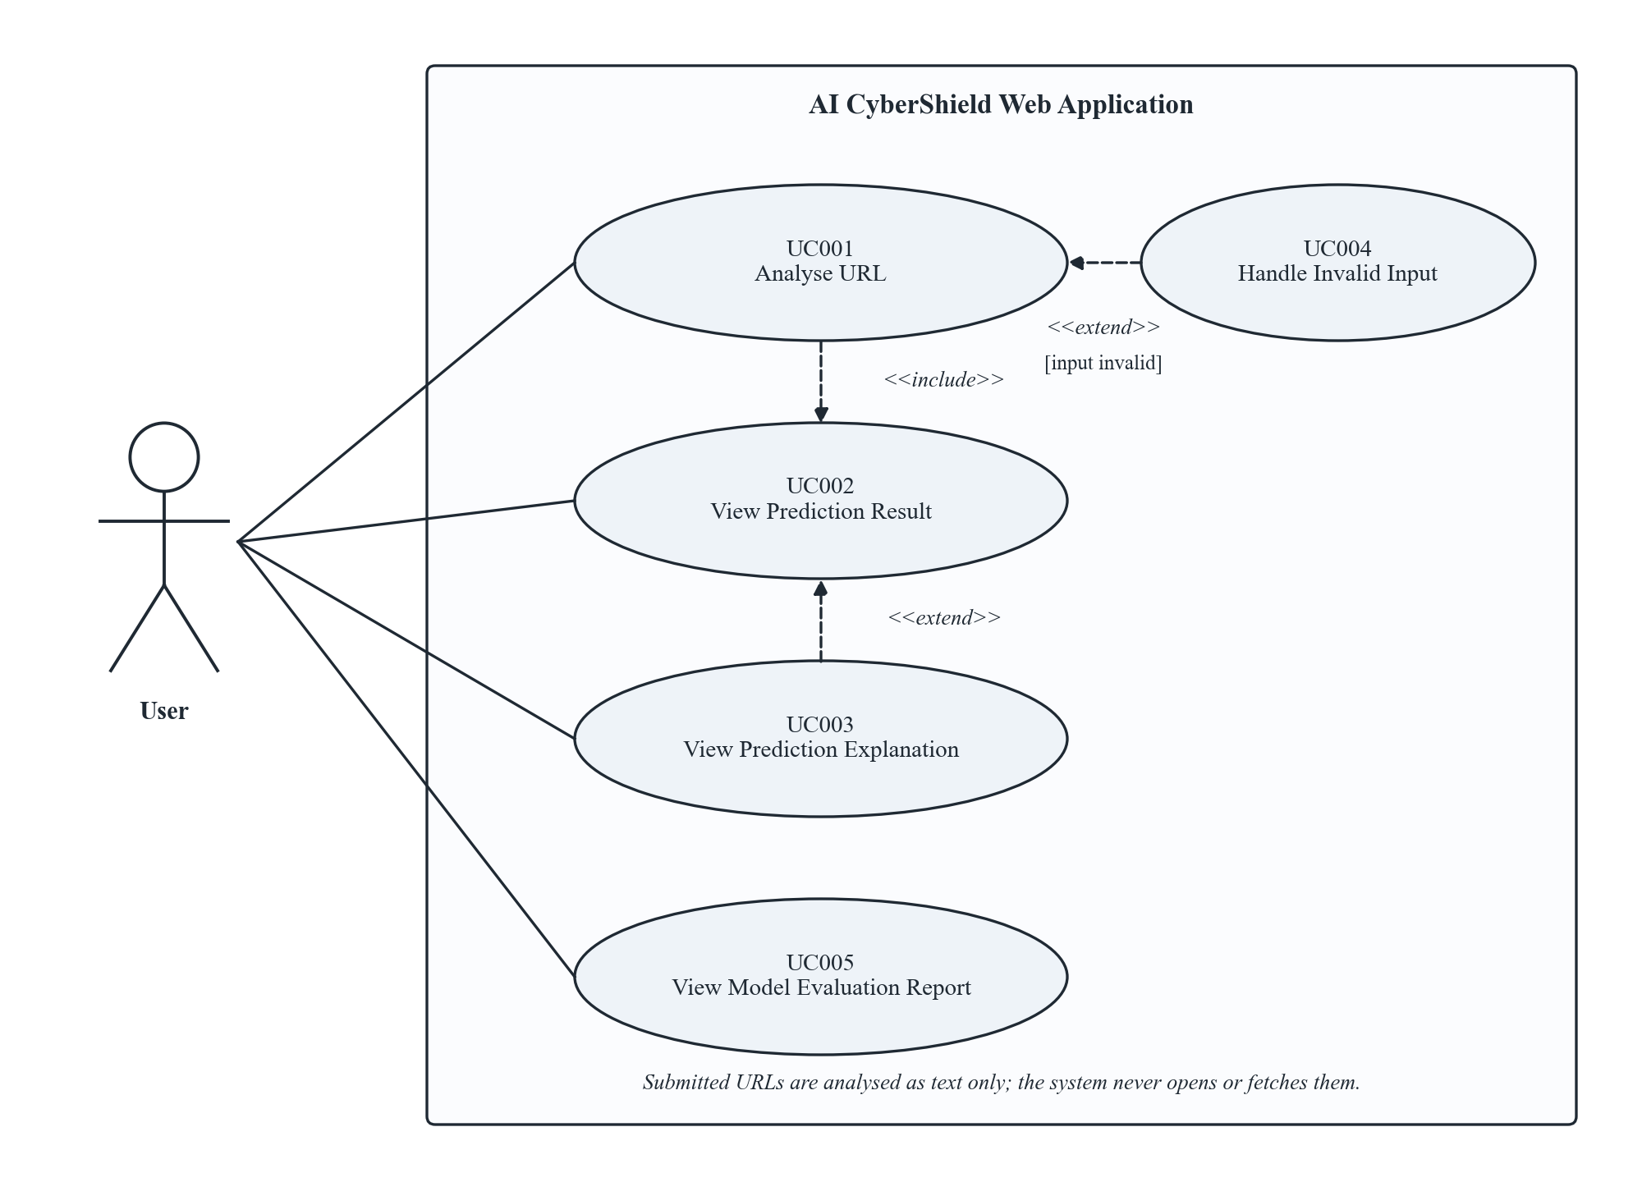
Figure 1: System Level Use Case Diagram
  - Use Case 1: Analyse URL
ID | UC001
Name | Analyse URL
Description | The user submits a single URL and the system analyses it as text, producing a prediction and explanation.
Requirement(s) | FR001, FR002, FR003, FR004, FR009
Actor(s) | User
Precondition | The web application and backend are running and the model artefacts are loaded.
Postcondition | A prediction, risk level, risk indicators and explanation are returned and displayed (UC002); no network request has been made to the submitted URL.
Basic Flow | Basic Flow  - User opens the Analyse URL page.  - User enters or pastes a URL and selects Analyse.  - System trims whitespace, shows the loading state and sends the request.  - System validates the URL (FR002).  - System extracts features from the URL text (FR003).  - System computes the phishing probability and predicted class (FR004).  - System computes the feature attributions (FR006) and risk indicators (FR005).  - System returns the result and the interface displays it (UC002).  Alternative Flow  - At step 2, the user presses Enter instead of selecting Analyse; the flow continues at step 3.  - At step 4, the URL has no scheme; the system analyses it as http:// + input and indicates that a scheme was added.  Exceptions  - Validation fails at step 4: UC004 is performed and no prediction is produced.  - Model or explainer not loaded: MODEL_UNAVAILABLE (503) is shown.  - Rate limit exceeded: RATE_LIMITED (429) is shown.  - Unexpected server error: INTERNAL_ERROR (500) is shown without internal details.

Diagrams
Figure 2 shows the activity diagram of UC001 with swimlanes for the User and the system.
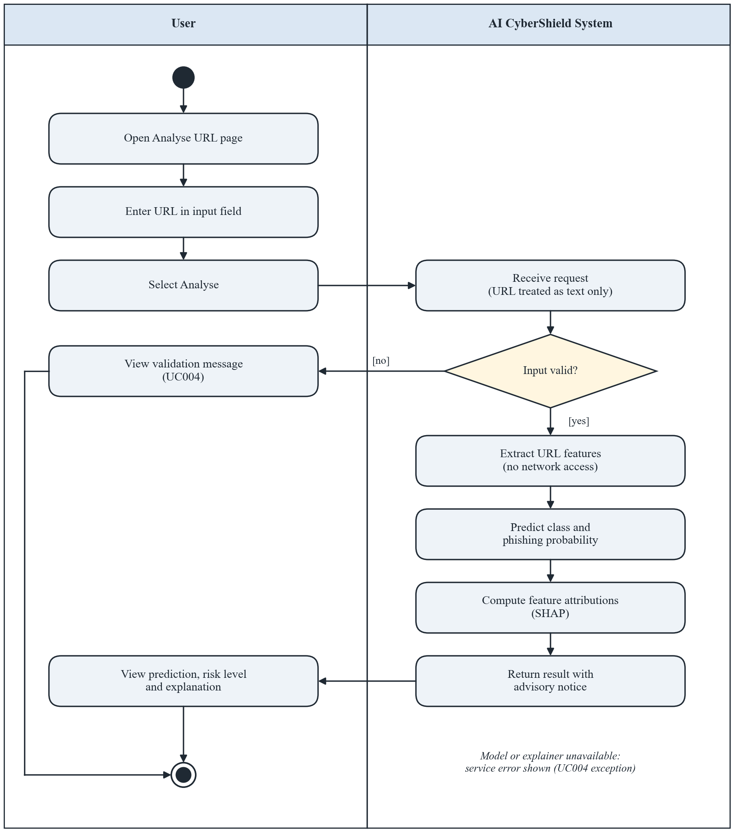
Figure 2: Activity Diagram of UC001 – Analyse URL
  - Use Case 2: View Prediction Result
ID | UC002
Name | View Prediction Result
Description | The user reads the predicted class, phishing probability, risk level, risk indicators and advisory notice for the analysed URL.
Requirement(s) | FR005, FR009
Actor(s) | User
Precondition | UC001 has completed successfully.
Postcondition | The user has been shown the result together with the advisory notice; the URL is displayed only as non-clickable plain text.
Basic Flow | Basic Flow  - System maps the probability to a risk level using the configured thresholds.  - System derives rule-based risk indicators from the URL components.  - System renders the result panel: URL (defanged plain text), class badge, probability, risk level, indicators and advisory notice.  - User reads the result.  Alternative Flow  - User expands the explanation section: UC003 is performed.  - User selects Analyse another URL: the form is cleared and UC001 can start again.  Exceptions  - No rule-based indicator applies: the panel states that no specific indicators were found, without implying the URL is safe.

Diagrams
Figure 3 shows the activity diagram of UC002 with swimlanes for the User and the system.
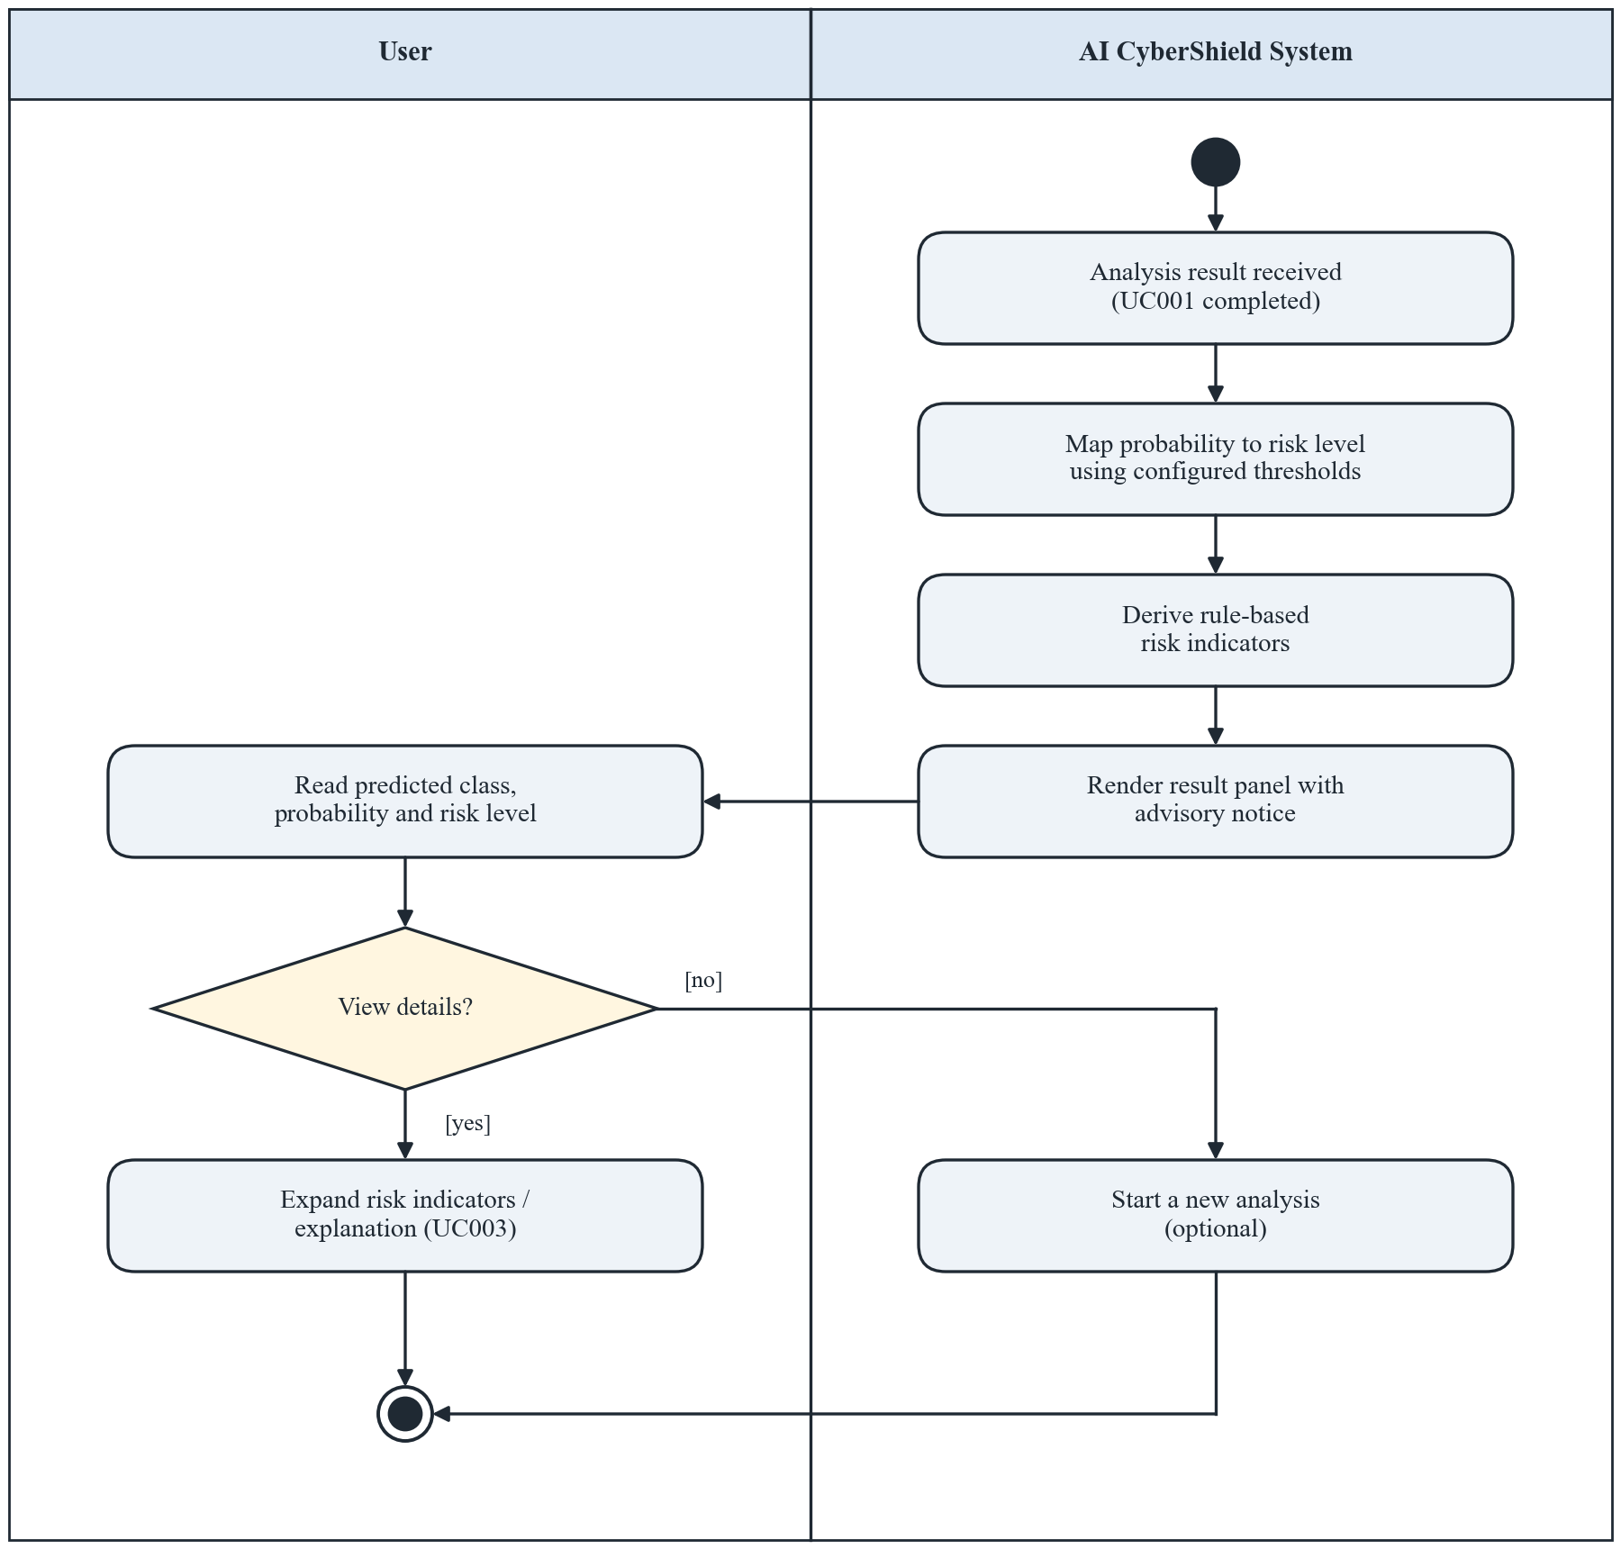
Figure 3: Activity Diagram of UC002 – View Prediction Result
  - Use Case 3: View Prediction Explanation
ID | UC003
Name | View Prediction Explanation
Description | The user views the features that contributed most to the individual prediction and the interpretation notice.
Requirement(s) | FR006
Actor(s) | User
Precondition | A prediction result is displayed (UC002).
Postcondition | The top-k feature contributions and the interpretation notice are displayed.
Basic Flow | Basic Flow  - User opens the explanation section of the result.  - System retrieves the attributions returned with the prediction.  - System ranks features by absolute contribution and selects the top k.  - System shows each feature with its description, value, contribution and direction in a chart.  - System shows the notice that explanations describe model behaviour and do not prove intent.  Alternative Flow  - User hovers over or focuses a bar to read the exact contribution value and description.  Exceptions  - Explanation could not be computed: the prediction remains visible and a notice states that the explanation is unavailable.

Diagrams
Figure 4 shows the activity diagram of UC003 with swimlanes for the User and the system.
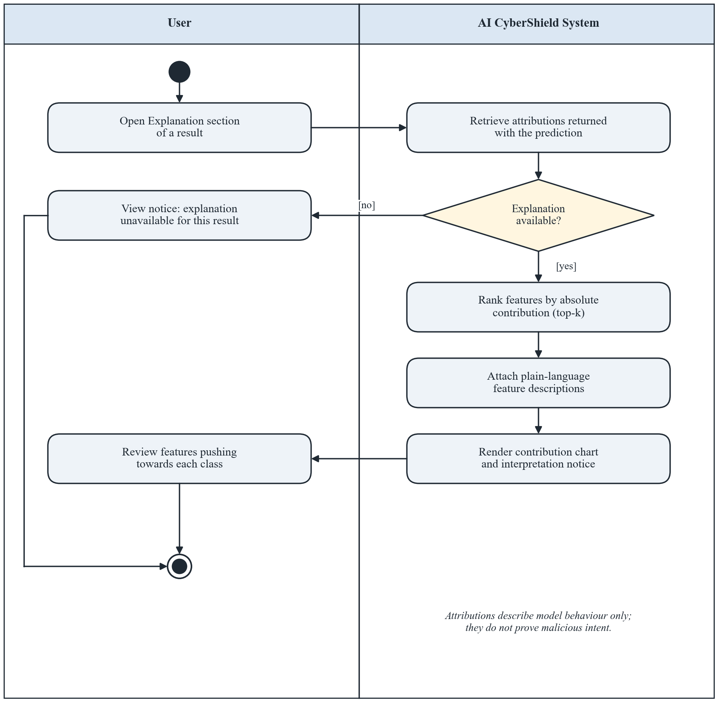
Figure 4: Activity Diagram of UC003 – View Prediction Explanation
  - Use Case 4: Handle Invalid Input
ID | UC004
Name | Handle Invalid Input
Description | The system rejects invalid input and tells the user how to correct it.
Requirement(s) | FR002, FR007
Actor(s) | User
Precondition | The user has submitted a value through UC001.
Postcondition | A specific error message is displayed; no features, prediction or explanation are produced; the input remains editable.
Basic Flow | Basic Flow  - System applies the validation rules (FR002).  - A rule is violated; system selects the matching error code (Table 5).  - System returns a 422 response with code and message.  - Interface shows the message next to the input field.  - User corrects the URL and resubmits (UC001).  Alternative Flow  - Client-side check detects empty or over-long input before sending; the same message is shown without a request.  - User decides not to correct the input and leaves the page.  Exceptions  - Malformed JSON or missing field: INVALID_REQUEST (422).  - Request body larger than 8 KB: PAYLOAD_TOO_LARGE (413).

Diagrams
Figure 5 shows the activity diagram of UC004 with swimlanes for the User and the system.
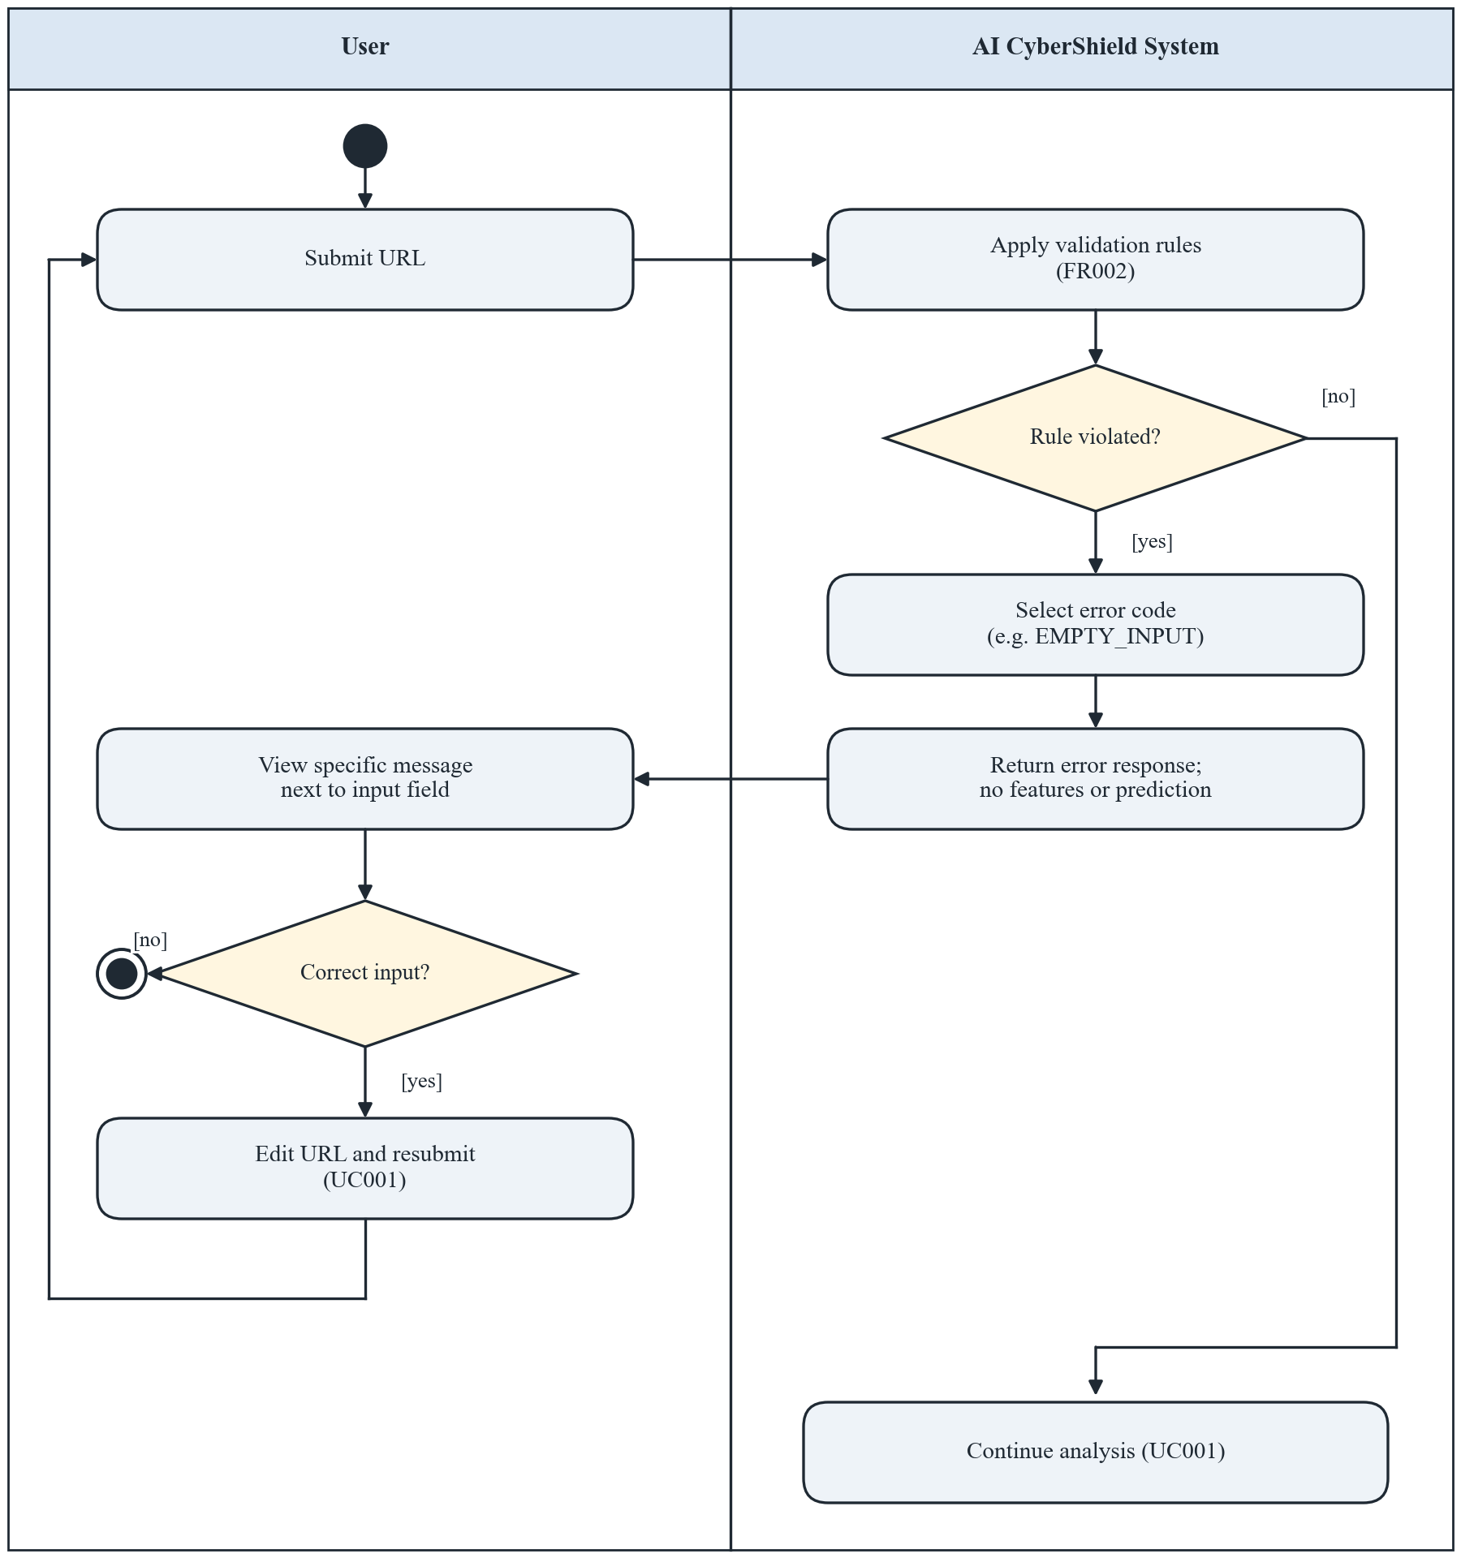
Figure 5: Activity Diagram of UC004 – Handle Invalid Input
  - Use Case 5: View Model Evaluation Report
ID | UC005
Name | View Model Evaluation Report
Description | The user reviews the measured performance, model comparison, global feature importance and limitations of the deployed model.
Requirement(s) | FR008
Actor(s) | User
Precondition | The web application is running.
Postcondition | The evaluation report for the deployed model version is displayed, or a notice that it is not yet available.
Basic Flow | Basic Flow  - User opens the Model Evaluation page.  - System requests GET /api/v1/evaluation.  - System displays dataset and split summary, validation comparison of candidate models and held-out test metrics.  - System displays the confusion matrix, inference time, global feature importance and limitations.  - System displays cross-dataset results if they were produced.  Alternative Flow  - Cross-dataset evaluation was not feasible: the page states the reason instead of showing results.  Exceptions  - No report has been generated: EVALUATION_NOT_AVAILABLE (404) notice is shown.  - Service error: INTERNAL_ERROR (500) notice is shown.

Diagrams
Figure 6 shows the activity diagram of UC005 with swimlanes for the User and the system.
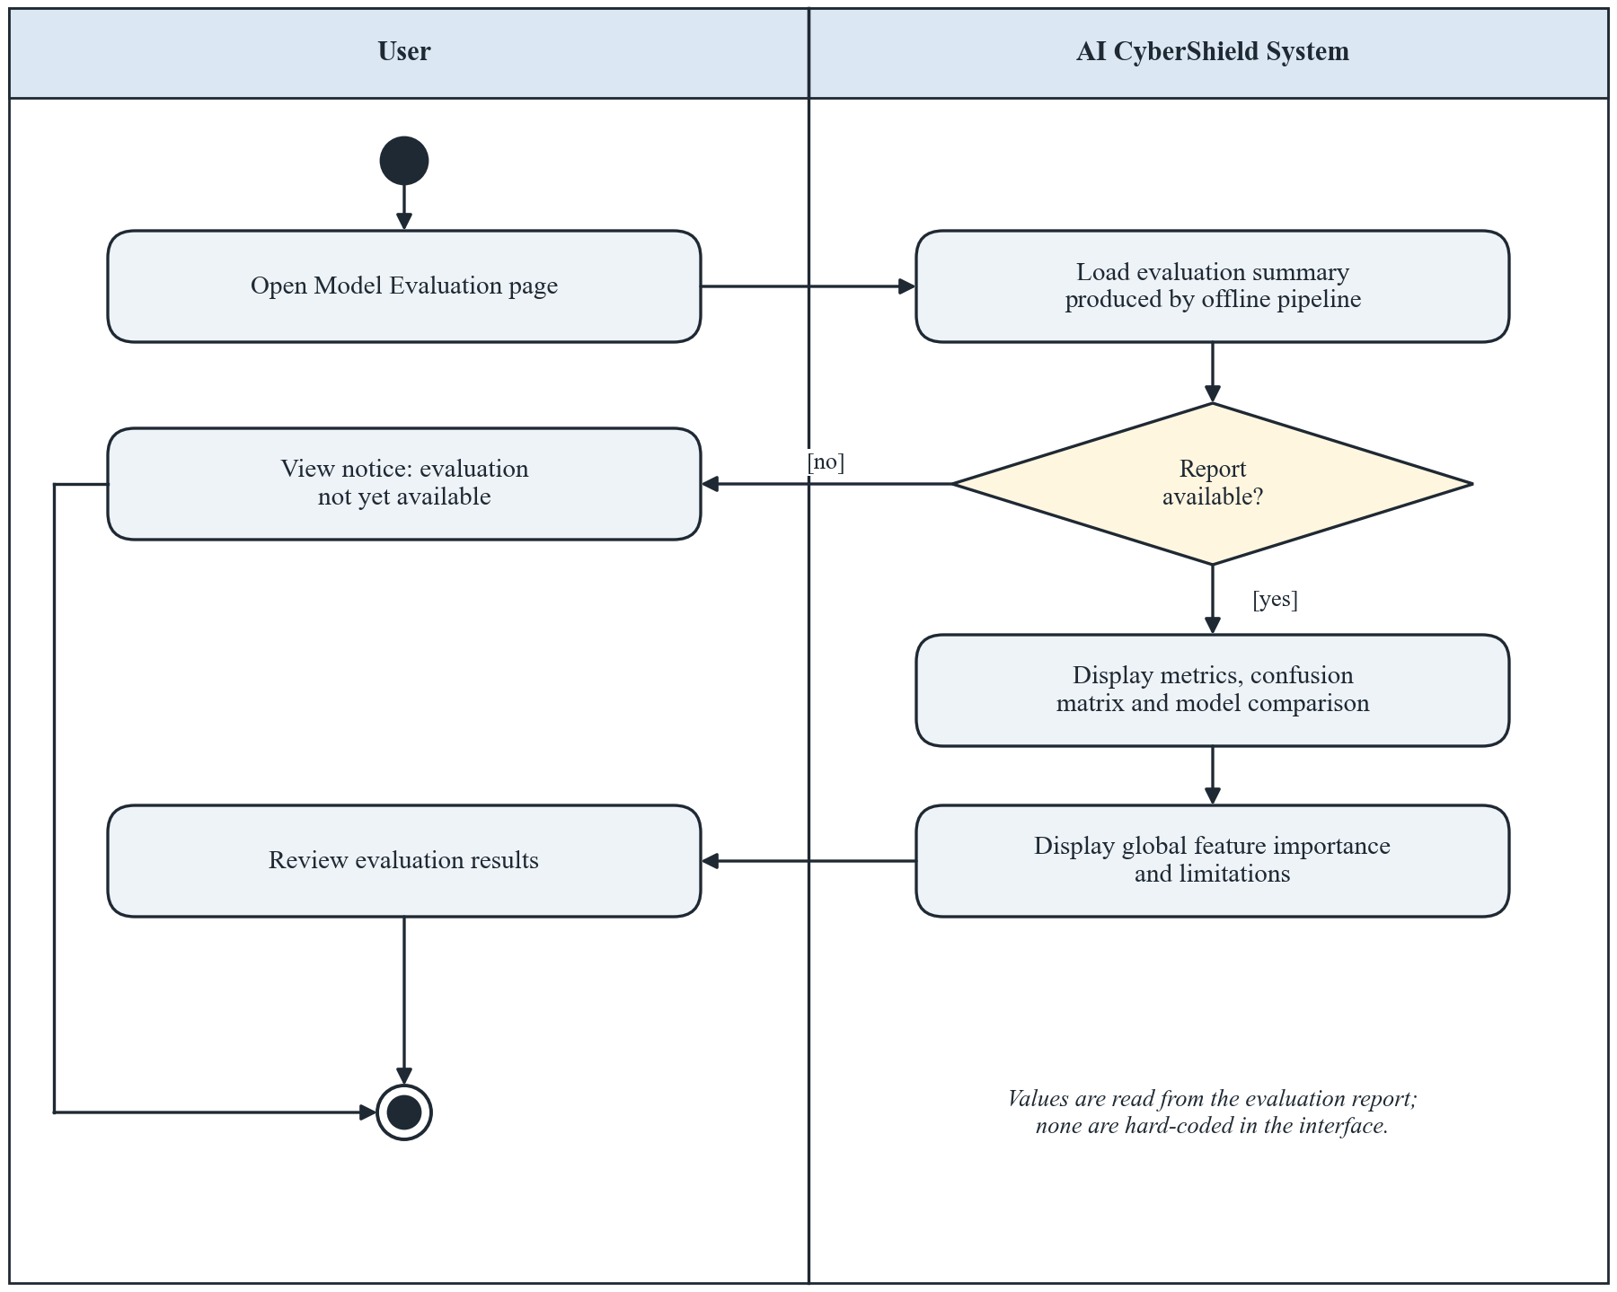
Figure 6: Activity Diagram of UC005 – View Model Evaluation Report
- References
[1] A. Prasad and S. Chandra, “PhiUSIIL: A diverse security profile empowered phishing URL detection framework based on similarity index and incremental learning,” Computers & Security, vol. 136, Art. no. 103545, Jan. 2024, doi: 10.1016/j.cose.2023.103545.
[2] A. Prasad and S. Chandra, “PhiUSIIL Phishing URL Dataset,” UCI Machine Learning Repository, 2024. [Online]. Available: https://archive.ics.uci.edu/dataset/967/phiusiil+phishing+url+dataset
[3] R. Mohammad and L. McCluskey, “Phishing Websites,” UCI Machine Learning Repository, 2015, doi: 10.24432/C51W2X.
[4] R. Mohammad, F. Thabtah, and L. McCluskey, “An assessment of features related to phishing websites using an automated technique,” in Proc. Int. Conf. Internet Technology and Secured Transactions (ICITST), London, U.K., 2012. (Page range and DOI to be verified.)
[5] O. K. Sahingoz, E. Buber, O. Demir, and B. Diri, “Machine learning based phishing detection from URLs,” Expert Systems with Applications, vol. 117, pp. 345–357, Mar. 2019, doi: 10.1016/j.eswa.2018.09.029.
[6] F. Rashid, B. Doyle, S. C. Han, and S. Seneviratne, “Phishing URL detection generalisation using Unsupervised Domain Adaptation,” Computer Networks, vol. 245, Art. no. 110398, May 2024, doi: 10.1016/j.comnet.2024.110398.
[7] F. Nejati, M. Rabbani, M. Eskandarian, M. Mirani, G. Piya, I. Opushnyev, A. A. Ghorbani, and S. Dadkhah, “CIC-Trap4Phish: A unified multi-format dataset for phishing and quishing attachment detection,” arXiv preprint arXiv:2602.09015, Feb. 2026. Dataset: https://www.unb.ca/cic/datasets/trap4phish2025.html
[8] S. M. Lundberg and S.-I. Lee, “A unified approach to interpreting model predictions,” in Advances in Neural Information Processing Systems 30 (NeurIPS 2017), 2017. [Online]. Available: https://papers.nips.cc/paper/2017/hash/8a20a8621978632d76c43dfd28b67767-Abstract.html
[9] S. M. Lundberg, G. Erion, H. Chen, A. DeGrave, J. M. Prutkin, B. Nair, R. Katz, J. Himmelfarb, N. Bansal, and S.-I. Lee, “From local explanations to global understanding with explainable AI for trees,” Nature Machine Intelligence, vol. 2, no. 1, pp. 56–67, 2020, doi: 10.1038/s42256-019-0138-9.
[10] M. T. Ribeiro, S. Singh, and C. Guestrin, “‘Why should I trust you?’: Explaining the predictions of any classifier,” in Proc. 22nd ACM SIGKDD Int. Conf. Knowledge Discovery and Data Mining, 2016, pp. 1135–1144, doi: 10.1145/2939672.2939778.
[11] D. Arp, E. Quiring, F. Pendlebury, A. Warnecke, F. Pierazzi, C. Wressnegger, L. Cavallaro, and K. Rieck, “Dos and don’ts of machine learning in computer security,” in Proc. 31st USENIX Security Symp., 2022, pp. 3971–3988. [Online]. Available: https://www.usenix.org/conference/usenixsecurity22/presentation/arp
[12] S. Kaufman, S. Rosset, C. Perlich, and O. Stitelman, “Leakage in data mining: Formulation, detection, and avoidance,” ACM Trans. Knowledge Discovery from Data, vol. 6, no. 4, pp. 1–21, Dec. 2012, doi: 10.1145/2382577.2382579.
[13] S. Kapoor and A. Narayanan, “Leakage and the reproducibility crisis in machine-learning-based science,” Patterns, vol. 4, no. 9, Art. no. 100804, Sep. 2023, doi: 10.1016/j.patter.2023.100804.
[14] L. Breiman, “Random forests,” Machine Learning, vol. 45, no. 1, pp. 5–32, 2001, doi: 10.1023/A:1010933404324.
[15] T. Chen and C. Guestrin, “XGBoost: A scalable tree boosting system,” in Proc. 22nd ACM SIGKDD Int. Conf. Knowledge Discovery and Data Mining, 2016, pp. 785–794, doi: 10.1145/2939672.2939785.
[16] F. Pedregosa et al., “Scikit-learn: Machine learning in Python,” J. Machine Learning Research, vol. 12, pp. 2825–2830, 2011. [Online]. Available: https://jmlr.org/papers/v12/pedregosa11a.html
[17] National Institute of Standards and Technology, “Artificial Intelligence Risk Management Framework (AI RMF 1.0),” NIST AI 100-1, Jan. 2023, doi: 10.6028/NIST.AI.100-1.
[18] OWASP Foundation, “Input Validation Cheat Sheet,” OWASP Cheat Sheet Series. [Online]. Available: https://cheatsheetseries.owasp.org/cheatsheets/Input_Validation_Cheat_Sheet.html
[19] Google, “Google Safe Browsing.” [Online]. Available: https://safebrowsing.google.com/
Note: bibliographic details of [1], [5], [6], [12] and [13] were checked against Crossref metadata, and dataset details against the official UCI and UNB pages, in October 2026. Reference [7] is a preprint, and [4] requires verification of its page range and DOI.

