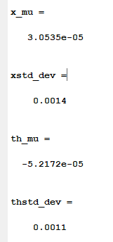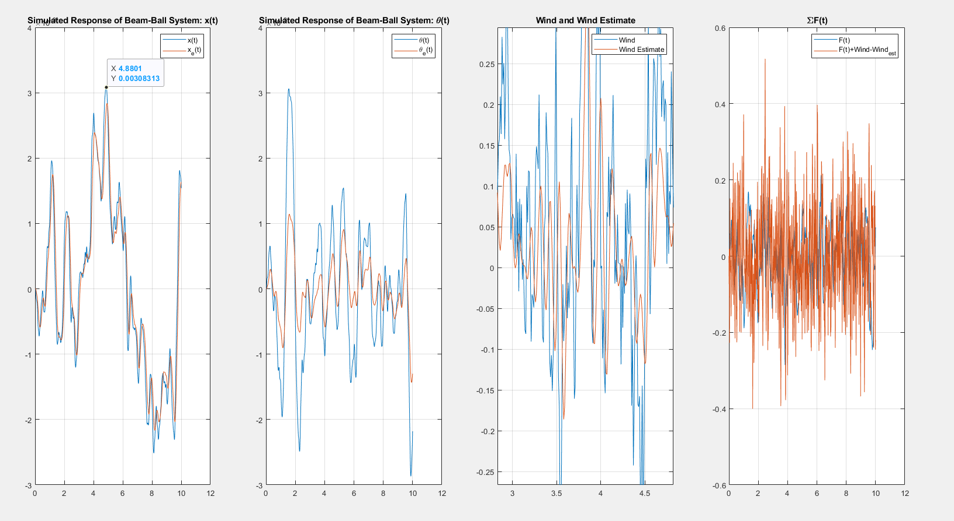

**% Gantry system**

**% System**

**mgc = 1; ml = 4; L = 1;**

**[A,B] = linearizedGantry(mgc,ml,L);**

**C = [1 0 0 0];**

**% Wind noise**

**Aw = [-5 0; 1 -5];**

**Bw = [1;0];**

**Cw = [100,-450];**

**Dw = 0;**

**mu = 0; sig = 1;**

**% Augmented system**

**Aaug = [A, B*Cw; zeros(2,4), Aw]; Baug = [B;zeros(2,1)];**

**Caug = [C, zeros(1,2)];**

**Haug = lqr(Aaug',Caug',diag([1,1,1,1,1e3,1e3]),0.01)'**

**% return**

**% Feedback gains**

**% Here, I used pole-placement to set des_poles = [-2,-3,-4,-5]**

**Kx = [12.2449 -9.7551 15.7143 1.7143];**

**Kr = 12.2449;**

**% Observer gains**

**% Here I used pole-placement to set the observer poles at [-5,-6,-7,-8]**

**des_obs_poles = [-5,-6,-7,-8,-9];**

**H = [26; -5.3061; 202; -209.6429];**

**% Initial conditions**

**X = zeros(4,1); Xe = zeros(4,1); Xw = zeros(2,1); Wind = 0; Xaug = zeros(6,1); Xaug_e = zeros(6,1);**

**dX = zeros(4,1); dXe = zeros(4,1); dXw = zeros(2,1); dXaug_e = zeros(6,1);**

**% Simulation setup**

**Ref = 0;**

**t = 0; dt = 100e-6; Tend = 10;**

**N = (Tend / dt) + 1;**

**% DATA = zeros(N,8); % x, th, xe, the, w, F+we**

**DATA = zeros(N,8); % x, th, xe, the, w, we, F, F+w-we**

**i=1;**

**tic**

**while(t < Tend)**

**% U = Kr*Ref - Kx*X;**

**% Uw = normrnd(mu,sig);**

**% Wind = Cw*Xw;**

**%**

**% dX = GantryDynamics(X,U + Wind, mgc,ml,L);**

**% dXe = A*Xe + B*U + H*C*(X - Xe);**

**% dXw = Aw*Xw + Bw*Uw;**

**U = Kr*Ref - Kx*X;**

**Uw = normrnd(mu,sig);**

**Wind = Cw*Xw;**

**Wind_est = Cw*Xaug_e([5:6]);**

**dX = GantryDynamics(X,U + Wind - Wind_est, mgc,ml,L);**

**dXe = A*Xe + B*U + H*C*(X - Xe);**

**dXw = Aw*Xw + Bw*Uw;**

**dXaug_e = Aaug*Xaug_e + Baug*U + Haug*Caug*(Xaug - Xaug_e);**

**X = X + dX * dt;**

**Xe = Xe + dXe * dt;**

**Xw = Xw + dXw * dt;**

**Xaug = [X;Xw];**

**Xaug_e = Xaug_e + dXaug_e * dt;**

**t = t + dt;**

**% DATA(i,:) = [X(1), X(2), Xe(1), -Xe(2), U, U+Wind];**

**DATA(i,:) = [X(1), X(2), Xe(1), -Xe(2), Wind,Wind_est, U, U+Wind-Wind_est];**

**i = i+1;**

**end**

**toc**

**kk = 1e2;**

**t = [1:length(DATA)]' * dt;**

**DATAds = downsample(DATA,kk);**

**tds = downsample(t,kk);**

**subplot(1,4,1);**

**plot(tds, DATAds(:,[1,3]));**

**grid on;**

**legend('x(t)','x_e(t)');**

**title('Simulated Response of Beam-Ball System: x(t)');**

**x_mu = mean(DATAds(:,1))**

**xstd_dev = std(DATAds(:,1))**

**subplot(1,4,2);**

**plot(tds, DATAds(:,[2,4]));**

**grid on;**

**legend('\theta(t)','\theta_e(t)');**

**title('Simulated Response of Beam-Ball System: \theta(t)');**

**th_mu = mean(DATAds(:,2))**

**thstd_dev = std(DATAds(:,2))**

**subplot(1,4,3);**

**plot(tds,DATAds(:,[5:6]));**

**grid on;**

**legend('Wind','Wind Estimate');**

**title('Wind and Wind Estimate');**

**subplot(1,4,4);**

**plot(tds,DATAds(:,[7:8]));**

**grid on;**

**legend('F(t)','F(t)+Wind-Wind_{est}');**

**title('\SigmaF(t)');**