TechPup Product Blueprint & App Architecture
Design Date: 2026-06-22 | Document Type: Core Product Architecture Document

1. App Navigation & Tab Bar Structure
The TechPup interface is anchored by a persistent 6-tab navigation structure, supplemented by a comprehensive global top bar for contextual switching and utility tracking.
Global Bars
- Top Bar: Displays the current dog's name, a small avatar head photo, and a quick-switch dropdown menu for multi-dog management (supporting unlimited dog profiles under a single account).
- Status Icons: Real-time hardware indicators displaying collar connection status, battery percentage, and GPS status / fence boundary indicators.
- Notification Bell: Centralized hub for training reminders, health alerts, and goal / badge unlocks.
Tab Bar Layout
# | Tab | Name | Primary Purpose
1 | Home | 🐾 Core Gamified Screen & Avatar Hub
2 | Activity | 🏃 Detailed Walk, Step, and Play Tracking
3 | Health | ❤️ RER, Weight, and Vet Diagnostics Dashboard
4 | Training | 🎓 Smart Collar Controls & Behavior Lessons
5 | Safety / Map | 📍 GPS Real-Time Tracking & Geofencing
6 | More / Profile | ☰ Account, Collar Settings, and Cosmetic Shop

2. Tab Specifications
Tab 1 — Home: Dog Avatar Hub (Core Gamified Screen)
The main operational screen transforms real-world collar metrics into a live virtual representation of the dog's well-being. The avatar never experiences a 'game over' or death sequence; poor data translates strictly to non-punitive distressed moods and proactive clinical nudges.
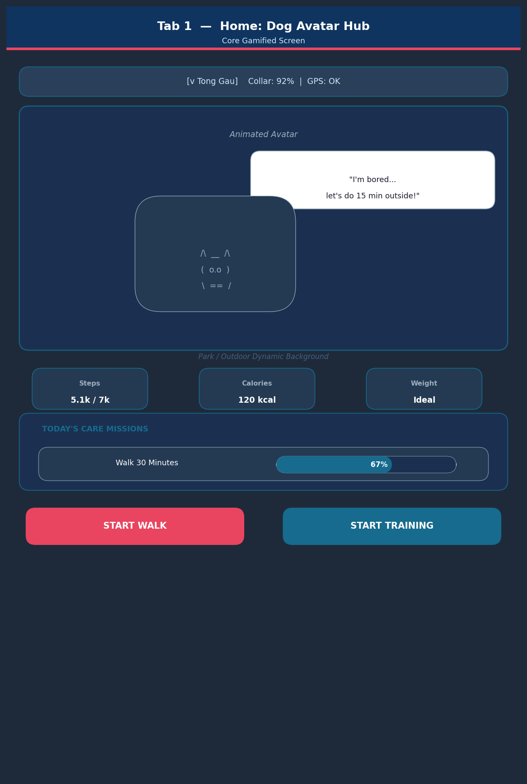

Core Logic Engine (AI Mood Score): Calculates a dynamic server-side wellness score (0 to 100) by processing active steps vs. daily goal, calories burned vs. RER, weight stability trends, and real-time barking frequency against established baselines.
Avatar Mood States
Mood | Trigger Condition
Thriving | All metrics optimal.
Happy | Activity goal achieved, weight within range, minimal bark occurrences.
Bored | Low activity metrics, zero play events registered.
Sleepy | High daytime activity logged, matching resting windows / night cycles.
Sluggish | Weight above target profile paired with low physical movement.
Stressed | Elevated bark detection tracking steadily above historical baselines.

- Dynamic Backgrounds: Automatically transitions between Park (active walking), Couch / Home (extended rest), and Night mode (late-hour inactivity).
- Quick Stats Chips: Tap-sensitive data capsules: Steps Today, Calories Burned, RER Completion %, and Weight Status.
- Mood Explanation Panel: Comic-book style speech bubble with contextual, slightly playful text.
- Daily Care Missions: Horizontal task cards adjusted per lifecycle profile. Completing a mission awards immediate PupCoins and XP.
Primary Action Buttons
- Start Walk: Triggers native collar GPS tracking, opens Activity tab.
- Start Training: Launches active lesson portal in Training tab.
- Hug / Reward: Celebration animation + minor XP boost. Purely gamified.
Tab 2 — Activity: Walks, Steps, Adventure
Provides analytical visualization of movement metrics recorded across daily, weekly, and monthly intervals.
Activity Summary Cards
- Steps: Current count vs. target with trend arrows vs. 7-day average.
- Distance & Duration: Cumulative kilometers and total active minutes.
- Play Time: Auto-tracked via pattern recognition or logged manually.
- Sleep Quality: Total overnight duration parsed into 'Good', 'Light', or 'Restless' profiles.
- Daily Adventure Ring: Circular performance ring (smartwatch-style); inner avatar silhouette runs when active, rests when goal hit.
- Sessions Timeline: Chronological log (e.g. 08:10 – Morning Walk – 1.6 km – 22 min – 65 kcal). Each entry opens its map trace in Safety tab.
- Quest Path: Multi-step chain: Walk 10 min -> Play fetch -> 5-min training -> Day Badge + bulk XP.
- Manual Controls: Start Walk to initialize collar GPS. Log Play to classify play type retroactively.
Tab 3 — Health: RER, Weight, Diagnostics
A simplified health interface engineered for clinical scanning and medical history retention.
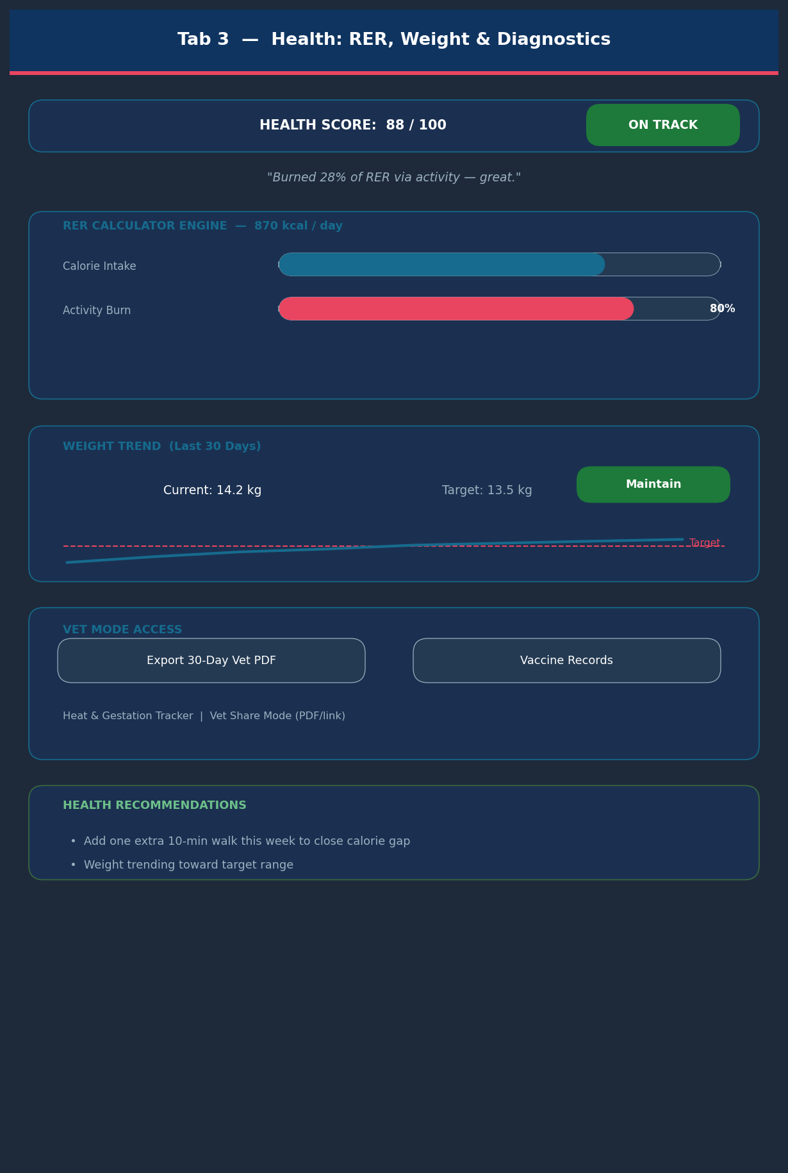

- Top Health Summary: 0-100 score with status tags: 'On Track', 'Needs more movement', 'Check with vet'.
- RER & Calories Panel: Algorithmic basal energy calculator (breed, age, weight). Side-by-side graph: nutritional intake vs. calorie burn.
- Weight & Body Condition: 30-day regression trend line vs. target range. Milestone badges as weight converges.
- Health Recommendations: Algorithmic flags: e.g. 'Add one extra 10-min walk this week'.
Special Clinical Tools
- Heat & Gestation Tracker: Calendar interface with forecasted heat cycles and pregnancy countdowns.
- Vaccine Log & Planner: Digital ledger with immunization schedules and automated appointment alerts.
- Vet Share Mode: One-click 30-day PDF export or view-only hyperlink for the attending vet.
Tab 4 — Training: Guided Lessons & Live Collar Control
Behavioral Modification Programs
- Target Tracks: Anti-barking, No jumping, Loose leash walking, Recall, Calm at door / visitors.
- Difficulty Stratification: Beginner / Intermediate / Advanced tiers over set calendar periods (e.g. 7-day plan).
Interactive Lesson Layout (per step)
- Observe trigger event: wait for bark.
- Execute hardware command: press 'Gentle Vibration' once.
- Deliver verbal cue: say 'Quiet' calmly.
- Reinforce positive response: reward with a treat when barking stops.
- Adaptive Feedback Loop: Post-lesson modal: 'How did it go?' — dynamically scales next difficulty. Awards Training XP and 'Good Student' badge on completion.
Hardware Interface — Live Control Tab
- Real-Time Execution Panel: Active only when collar is connected to the device.
- Acoustic & Haptic Control: Dual adjustable sliders for frequency and vibration duration. Safety limits prevent over-stimulation.
- One-Touch Presets: Instant buttons: Attention cue, Stop barking cue, Recall cue.
- Historical Log & Analytics: Daily behavioral log + long-term bark frequency chart (e.g. 'Barks down 25% since last week').
Tab 5 — Safety & Location: GPS, Geofence, Lost Mode
- Vector Mapping Viewport: Full-width map with dog icon over precise coordinates. Green = Safe Zone, Red = Out of Zone.
- Telemetry Overlay: Last ping, speed, mobility state, collar battery — shown on avatar tap.
- Virtual Fence Engine: Multi-boundary polygon / radius tool. Toggle push alerts per zone boundary crossing.
Lost Mode Protocol
- Forces LED array to maximum brightness.
- Emits acoustic beacon pulses at safe intervals.
- Scales GPS polling to maximum frequency; locks 'Last seen here' pin.
- Activates passive NFC chip so any phone can tap collar and view owner emergency contacts.
Tab 6 — More / Profile: Account, Settings, Shop
- Owner Account Core: Display names, district, email/Apple/Google auth, notification preferences.
- Dog Identity Profile: Name, breed, DOB, sex, photo, allergies, prescriptions, vet clinic. Includes NFC rescue card editor.
- Collar Configuration Engine: Haptic intensity, acoustic frequency ranges, LED color schemes.
Accessibility Mode — Hearing-Impaired Dogs
Replaces acoustic alerts with distinct haptic vibration patterns:
Pattern | Morse Code | Meaning
Alpha | ( . . . ) | "Come here" command
Beta | ( - - - ) | "Food time" indication
Gamma | ( - . - ) | "Walk time" notification
Delta | ( . . . - - - . . . ) | "Good job" validation

- Data Sharing & Permissions: Invitation framework granting full admin collar control or view-only access to family members or medical practitioners.

3. Game Mechanics & Economy Design
TechPup employs a strict 'Reverse Tamagotchi' design philosophy. The game engine never penalizes or kills the pet avatar; game states are derived entirely from physical hardware readings rather than artificial app-side timers.
Dual Reward Windows
To establish sustainable, non-fatiguing daily habits, missions are allocated into two discrete operational windows:
- Morning Window 06:00 – 12:00: Focuses on early-day activation tracking.
- Evening Window 17:00 – 22:00: Focuses on decompression or secondary walk loops.
Full Day Bonus: Completing missions in both windows on the same calendar day unlocks a cumulative +5 PupCoin bonus.
Earning Engine: Coins & XP Matrix
Action / Source | PupCoins | XP | Rule / Constraint
Morning Mission Complete | Mood-Based (2–20) | Wellness Score / 10 | Window expires at 12:00
Evening Mission Complete | Mood-Based (2–20) | Wellness Score / 10 | Window expires at 22:00
Both Windows Completed | +5 Bonus | — | Awarded on double completion
Passive Tick: Happy Mood | 3–5 Coins | — | Every 2 hrs; yields on app open
Passive Tick: Thriving Mood | 2x Happy (6–10) | — | Every 2 hrs; yields on app open
Day 7 Login Streak | +100 Coins | +20 XP | 7 consecutive app opens
Day 30 Login Streak | +500 Coins | +50 XP | Exclusive badge + cosmetic unlock
Social: Friends | +50 Coins | +5 XP | Requires reciprocal verification
Social: Love | +250 Coins | +20 XP | Triggers firework animation on both screens
Training Lesson Complete | +10 Coins | +15 XP | Validated post-lesson evaluation

Mission Payout by Mood State
Avatar Mood | PupCoins | XP
Thriving | 20 Coins | 2.0 XP
Happy | 10 Coins | 1.0 XP
Content | 8 Coins | 0.8 XP
Bored / Tired / Anxious | 5 Coins | 0.5 XP
Uneasy / Overtired | 2–3 Coins | 0.2–0.3 XP
Concerned / Distressed | 0 Coins | 0.0 XP — halts all passive coin accumulation

The Reward Floor Rule: When a dog's biometric data triggers a 'concerned' or 'distressed' health flag, all payouts drop to 0 and passive accumulation halts. Veterinary alerts take absolute priority over virtual rewards.
Progression & Retention Systems
- XP Architecture: Flat progression: 50 XP per level. Permanent — never regresses. Leveling unlocks quest variants and seasonal event access, not cosmetics.
- Mission Streak: Consecutive days with at least one completed mission. Resets to 1 (not 0) on a miss.
- Login Streak: Consecutive days the app is opened, independent of mission performance.
- Cosmetic Shop: All items (outfits, accessories, backgrounds) purchasable with PupCoins only. Zero level locks. Inventory rotates weekly.
- Avatar Evolutions: Long-term consistency unlocks richer animation loops and movement variations.
Retention Anti-Decay Framework
- Level-Gated Quest Variants: Level milestones unlock breed-tailored quest variants (e.g. Level 5 Shiba Inu unlocks 'Advanced Scent-Trail' brain-drain quests).
- Seasonal Events: Time-bound themed events ('HK Lunar New Year Walk Week', 'Summer Hydration Challenge') replace standard missions with high-value event goals.
- Breed Expansion Packs: Each new breed adds unique avatar art, breed-specific badges, and tailored quest copy.

4. Social Features & In-Person Interactivity
TechPup encourages real-world community building through peer-to-peer validation loops and breed-specific performance tracking.
Local Socialization Engine — Mutual Verification Flow
Real-world meetups use hardware verification to prevent solo farming. Both owners must open their interfaces simultaneously and scan the on-screen Dog Profile QR Code or perform an NFC tap.
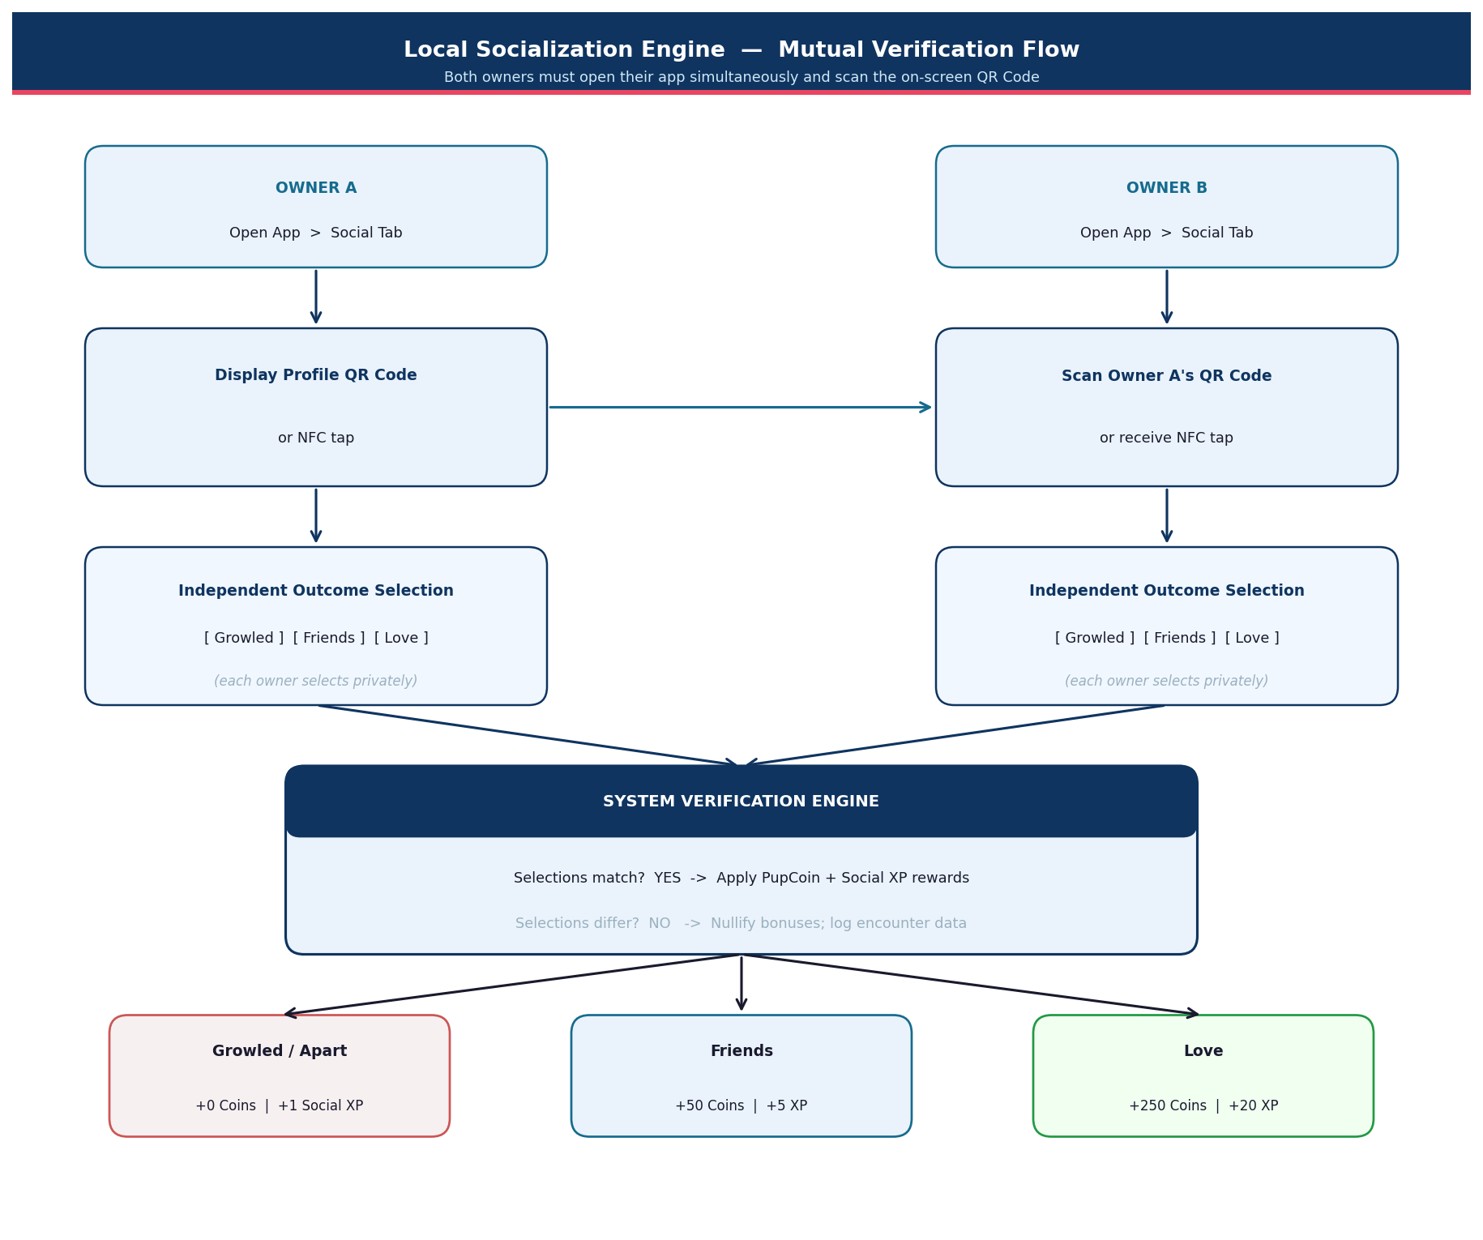

Social Outcome Rewards
Outcome | Icon | PupCoins | XP | Extra Effect
Growled / Went separate ways | 🐾 | 0 | +1 Social Skills XP | Encounter logged
Friends | 🐕 | +50 | +5 XP | Added to friend list
Love | ❤️ | +250 | +20 XP | Fireworks animation on both screens

- Mutual Consensus Rule: Both owners must independently select the same outcome. Mismatches withhold bonuses but preserve encounter history.
- Exclusivity of Love: The 'Love' status is exclusive — only one dog may hold this tier at a time. A new Love moves the previous dog to Friends.
- Friend Profiles: Friend profiles show only the virtual avatar's current mood — no raw biometric data exposed. Friends can exchange one 'Paw' reaction per day (+2 PupCoins to recipient).
Breed Leaderboards
Weekly Top-10 ranking per breed by accumulated Wellness Score. Dogs compete only within their own breed to keep competition balanced (e.g. Poodles vs. Poodles).

5. Core User System Flows
Onboarding & Identity Registration
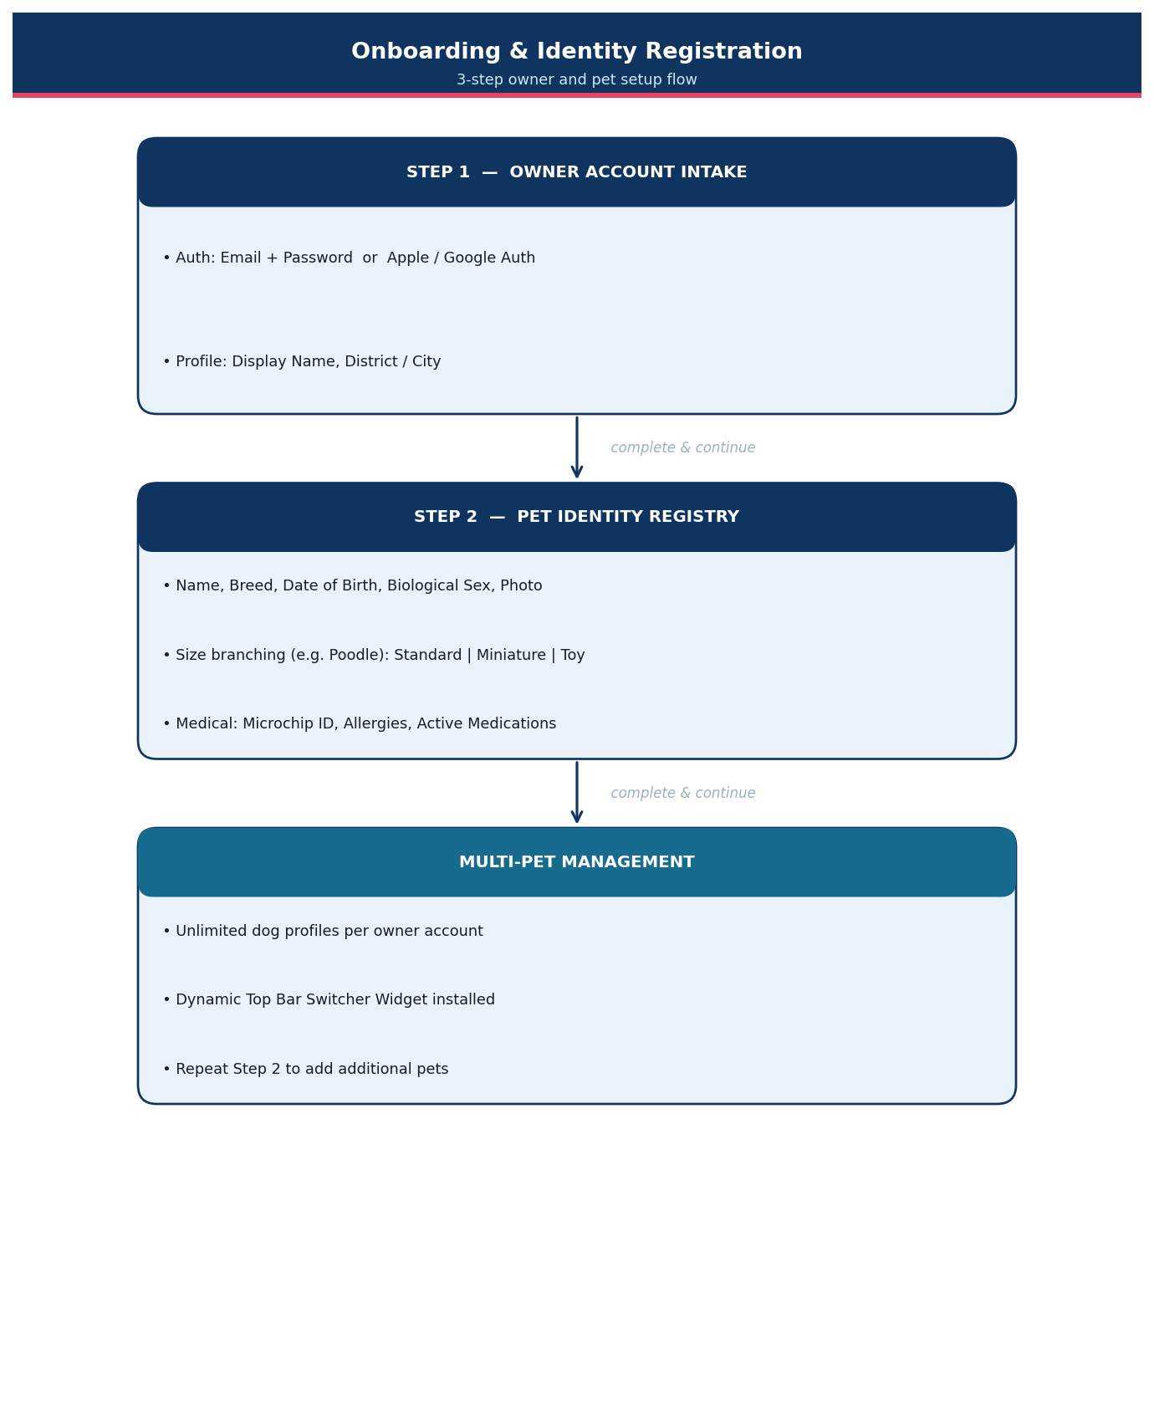

6. Comprehensive Systems Mapping
The complete architectural relationship between hardware data, app systems, and game loops:
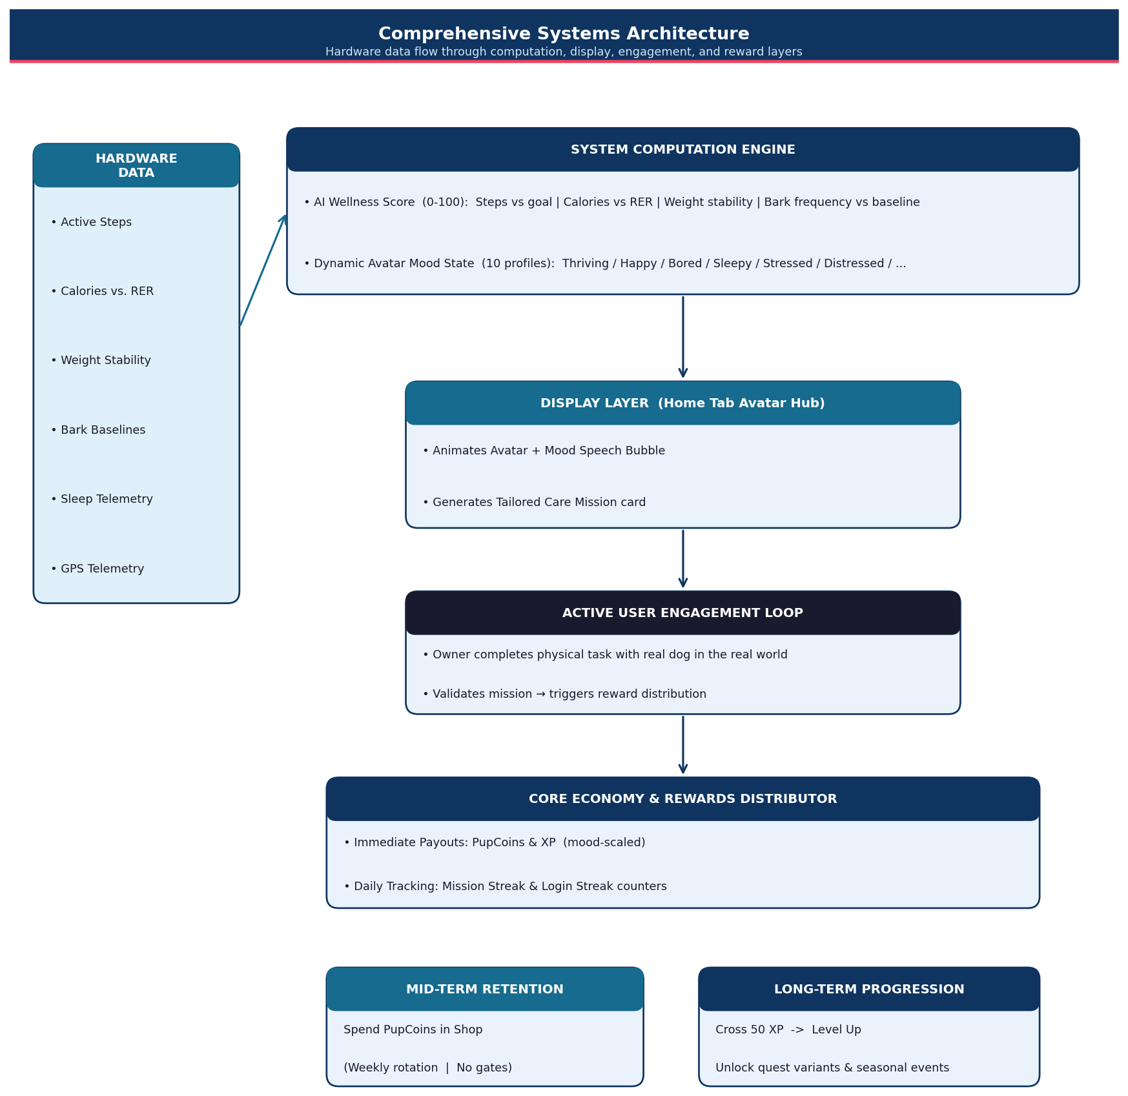

7. HK Breed Market — Popularity & TechPup Coverage
The chart below ranks the top 10 dog breeds in Hong Kong by estimated owner share (2025–2026). Navy bars are breeds already supported in TechPup v1; grey bars are v2+ expansion targets.
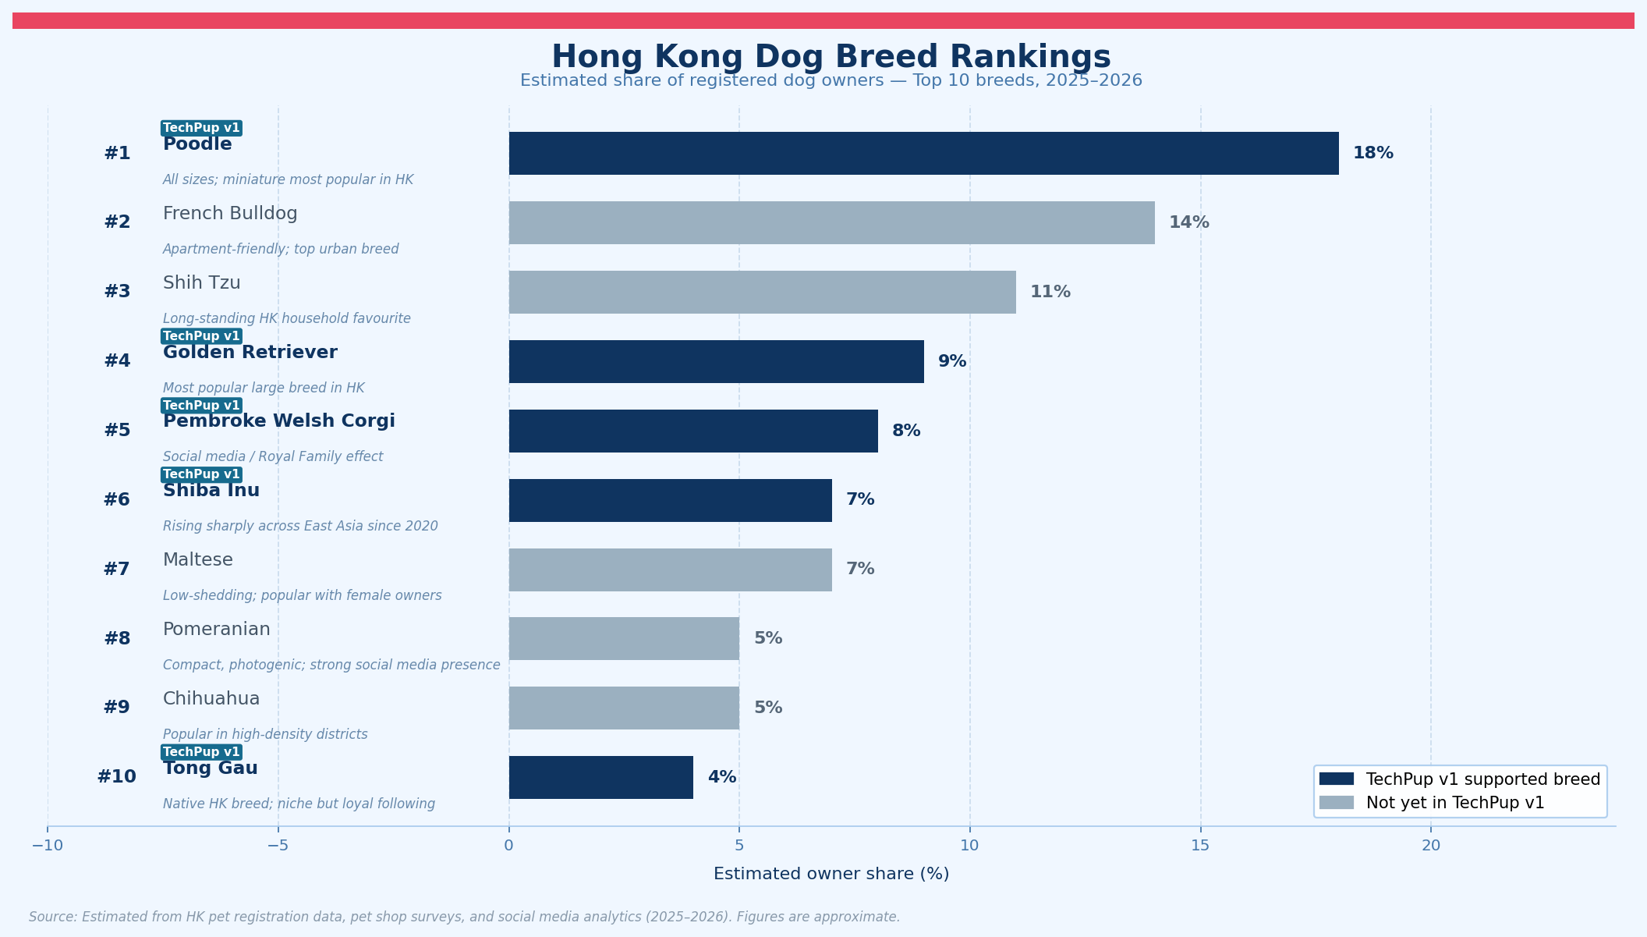
TechPup v1 covers 5 of the top 10 breeds (Poodle #1, Golden Retriever #4, Corgi #5, Shiba Inu #6, Tong Gau #10), representing an estimated 46% of HK dog owners combined.
Priority Expansion Targets (v2+)
Breed | Current Rank | Est. Owner Share | Priority Reason
French Bulldog | #2 | 14% | Largest unserved segment; apartment-friendly profile fits HK market
Shih Tzu | #3 | 11% | Long-standing HK favourite; strong female owner overlap
Maltese | #7 | 7% | Low-shedding appeal; popular with the 62% female owner base
Pomeranian | #8 | 5% | High social media engagement — natural fit for follower system
Chihuahua | #9 | 5% | Popular in high-density districts; lower activity baseline needed

8. Social Competition System — Owner vs Owner Rankings
The individual game loop (mood → mission → coins → level) drives daily habit. Competition adds a second pull: other people's dogs make yours feel slow. A leaderboard seen once a week is enough to push a skipped evening mission into a completed one.
Design Rules
- No punishment: Rankings show top dogs only — no public shame ladder for low performers.
- Opt-in only: Dog profiles are private by default. Owners opt in explicitly.
- Breed-fair by default: Dogs compete within their own breed on activity-based metrics.
- Multiple axes: One dog can be #1 in Likes but #12 in Level — every owner has a lane.
Dog Public Profile — Data Exposure Rules
Field | Visible to followers | Notes
Dog name + breed | Yes
Avatar (current mood) | Yes | Updates daily — no raw biometric data
Level | Yes | Computed from cumulative XP
Weekly Wellness Score | Yes | Breed-normalised 0–100
Follower count | Yes
Weekly Paws received | Yes
Mission streak | Yes
Badges earned | Yes
Raw health data (HR, weight, sleep) | Never | Always private — never exposed publicly

Four Competition Axes
Axis | What it measures | Reset cycle | Scope
Level | Total XP earned since registration | Never — permanent | Global + same breed filter
Weekly Wellness Score | Average daily wellness score over past 7 days | Every Monday 00:00 | Same breed only
Followers | Total follower count | Never — permanent | Global
Weekly Paws (Likes) | Paw reactions received from followers in 7 days | Every Monday 00:00 | Global

Leaderboard UI Structure
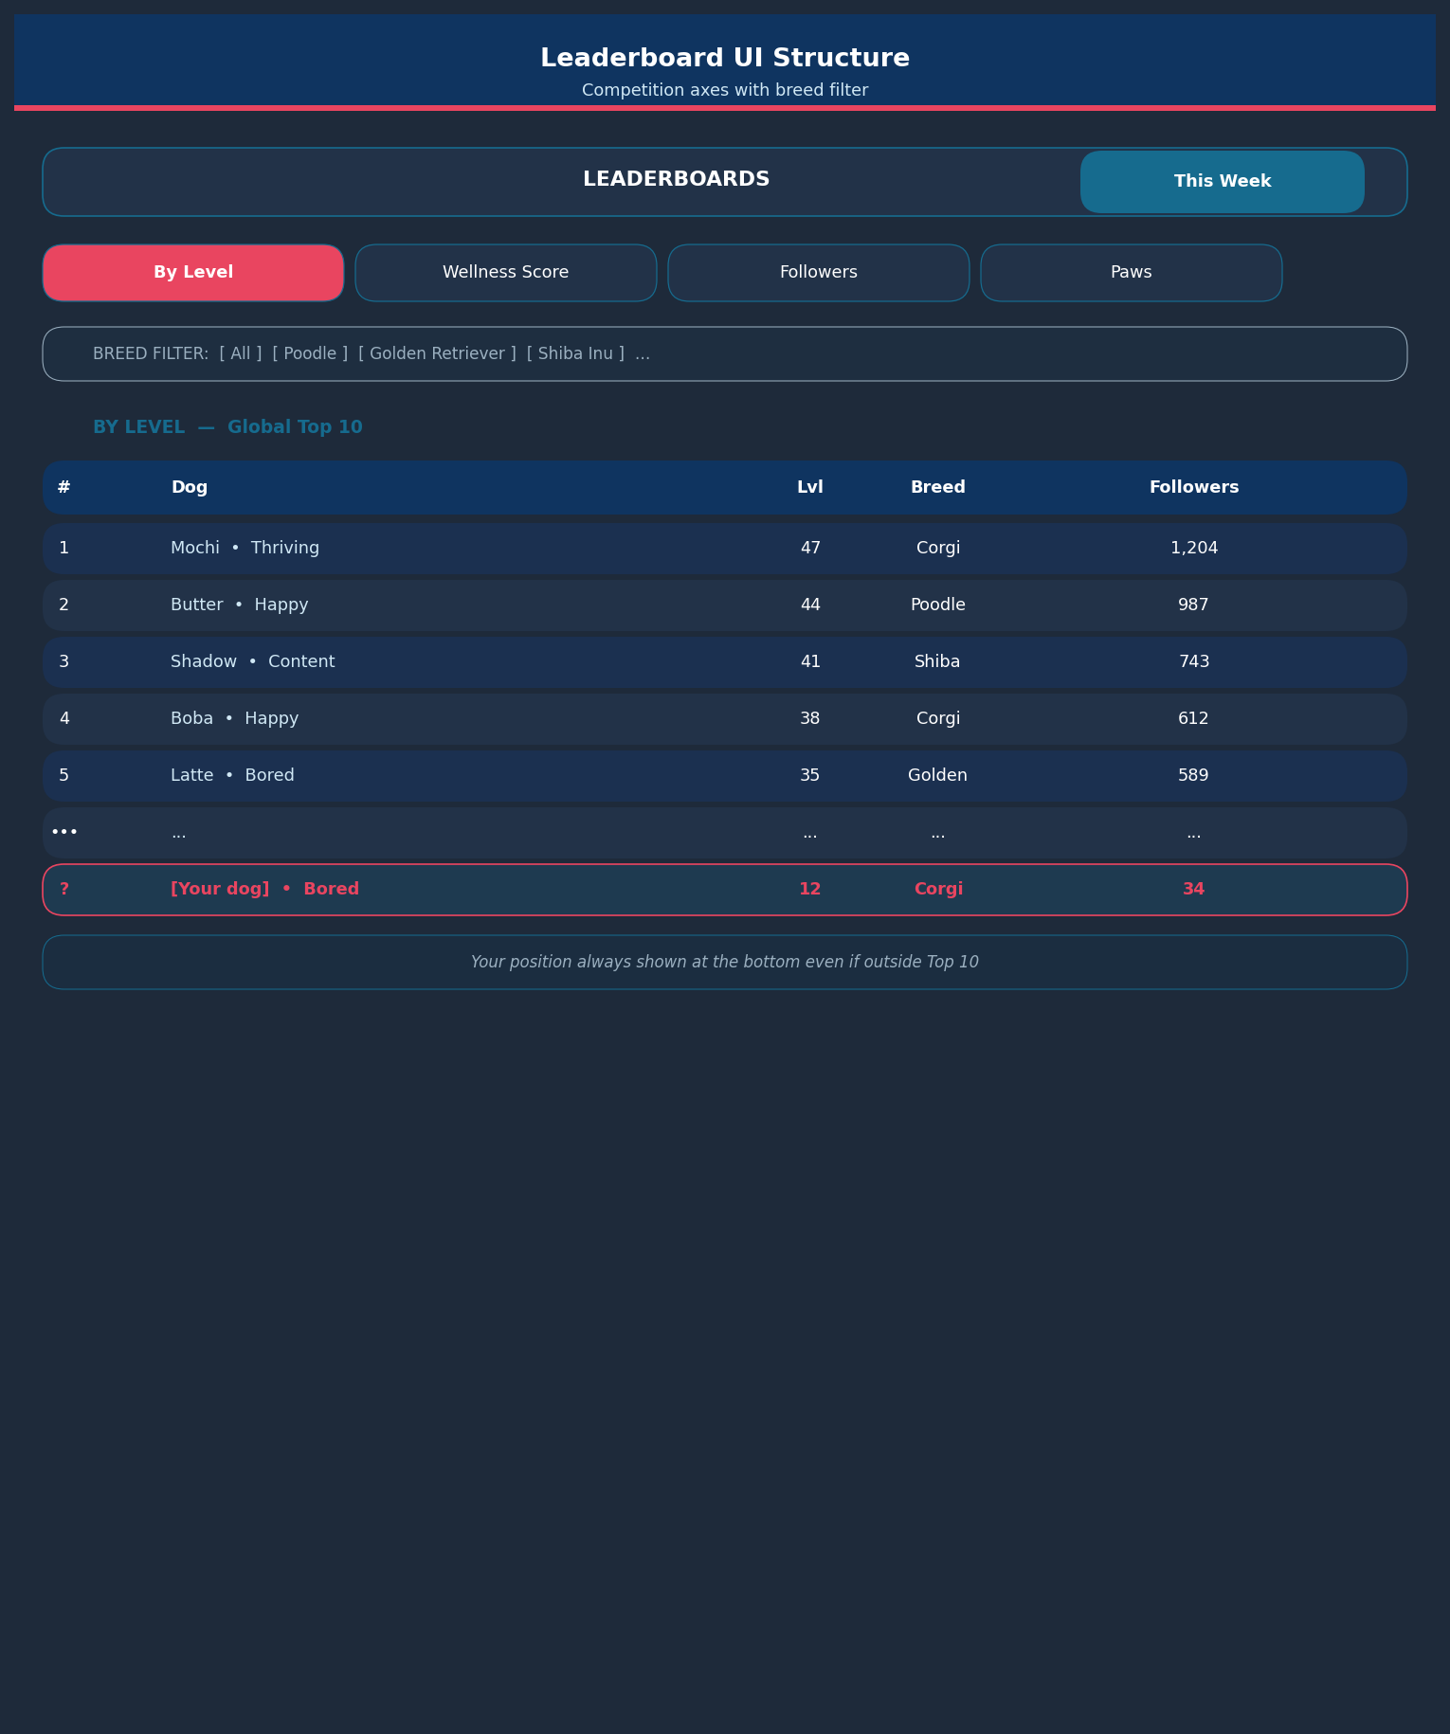

Your position is always shown at the bottom of any leaderboard, even if outside the top 10.
Paw Reactions — Likes System
Rule | Detail
How to send | Tap the Paw icon on any public dog's daily update card
Daily limit | 5 Paws per user per day — hard server-side cap
Reward to recipient | +2 PupCoins per Paw received
Weekly Paws leaderboard | Top 10 most-Pawed dogs this week, globally
Milestone badge | 'Fan Favourite' — awarded at 100 Paws received in a single week

What triggers a daily update card (the thing followers can Paw)
- Avatar mood change on morning collar sync
- Mission completed (morning or evening window)
- Badge unlocked
- Level-up
- New 'Love' social meeting recorded
Follower System
Action / Event | Behaviour
Follow a dog | Tap Follow on any public profile
Unfollow | Tap again; no notification sent to the followed owner
Follower feed | Home tab 'Community' section shows today's updates from followed dogs
10 followers reached | 'Rising Star' badge unlocked on dog profile
100 followers reached | 'Local Legend' badge unlocked on dog profile
500 followers reached | 'HK Icon' badge unlocked on dog profile
Follower leaderboard | Global Top 10 most-followed dogs — never resets

Competition Loop Diagram
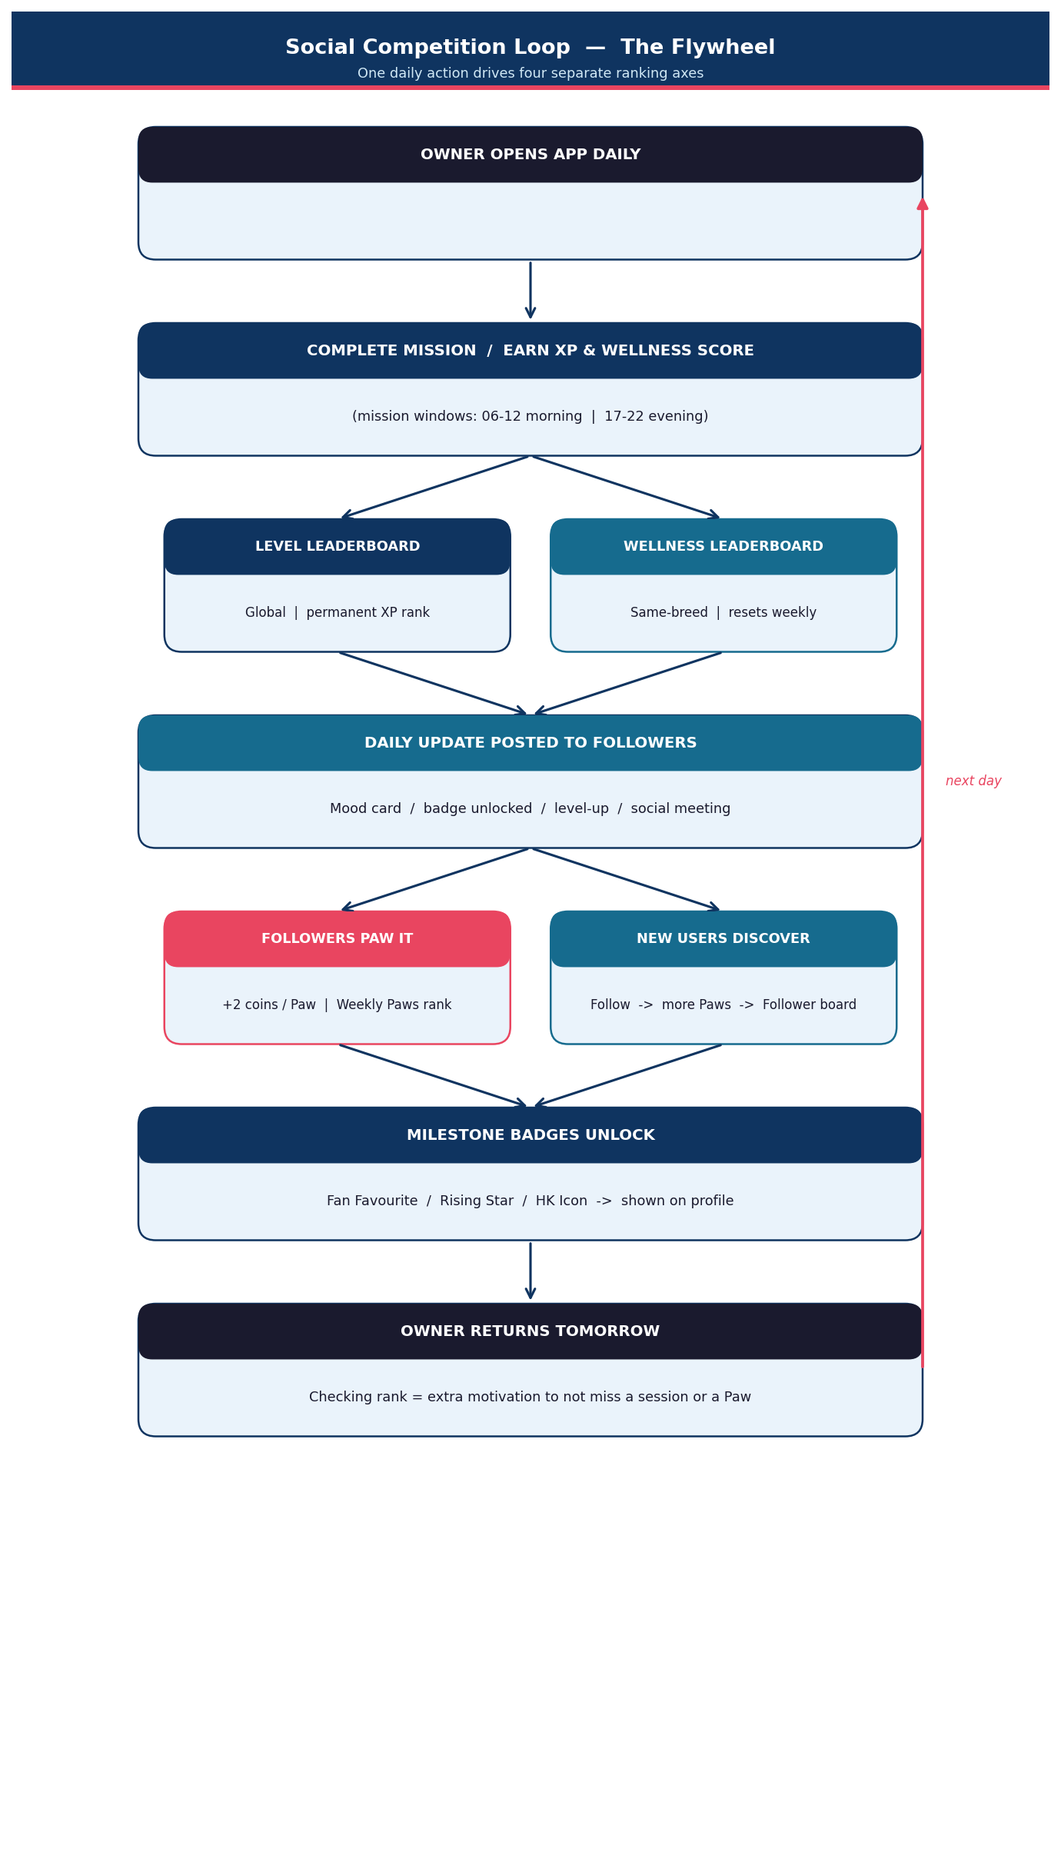

Competition Badges
Badge | Icon | Trigger
Top of the Pack | medal | Reach #1 on any leaderboard for 1 full week
Rising Star | star | Hit 10 followers
Local Legend | stars | Hit 100 followers
HK Icon | trophy | Hit 500 followers
Fan Favourite | paw | Receive 100 Paws in a single week
Level King | crown | Reach top 3 on Level leaderboard (any breed filter)
Wellness Champion | fire | #1 Wellness Score in your breed for 2 consecutive weeks

Anti-Gaming Rules
Risk | Rule
Fake follower rings | Follow requires a registered account; accounts with 0 dogs cannot follow
Paw farming with alt accounts | 5 Paws per user per day, hard server-side limit
Solo social meeting XP farm | Both owners must verify the same interaction outcome
Level sandbagging | Level is cumulative only — no reset, no manipulation possible
Wellness score manipulation | Score is computed server-side from collar data; no manual override

Social flywheel summary: Daily missions build Level and Wellness Score -> scores post as daily update cards -> followers Paw those cards -> Paw count builds a second leaderboard axis -> milestone badges attract more followers -> more followers increase the social pull to open the app daily. One daily action drives four separate ranking axes simultaneously.

