1. **What is the difference between JDK, JRE, and JVM?**

JVM

JVM is an acronym for Java Virtual Machine; it is an abstract machine which provides the runtime environment in which Java bytecode can be executed. It is a specification which specifies the working of Java Virtual Machine. Its implementation has been provided by Oracle and other companies. Its implementation is known as JRE.

JVMs are available for many hardware and software platforms (so JVM is platform dependent). It is a runtime instance which is created when we run the Java class. There are three notions of **the** JVM: specification, implementation, and instance.

JRE

JRE stands for Java Runtime Environment. It is the implementation of JVM. The Java Runtime Environment is a set of software tools which are used for developing Java applications. It is used to provide the runtime environment. It is the implementation of JVM. It physically exists. It contains a set of libraries + other files that JVM uses at runtime.

JDK

JDK is an acronym for Java Development Kit. It is a software development environment which is used to develop Java applications and applets. It physically exists. It contains JRE + development tools. JDK is an implementation of any one of the below given Java Platforms released by Oracle Corporation:

* Standard Edition Java Platform
* Enterprise Edition Java Platform
* Micro Edition Java Platform

JDK, JRE and JVM?

• Java Virtual Machine: JVM is an abstract machine. It actually runs by Java code. Most people know Java with this slogan "Write once and run everywhere' This slogan is because of JVM.

• Java Runtime Environment: JRE is what we need to run a Java program and contains set of libraries and other files that JVM uses at run time. JRE = JVM + Library Classes

• Java Development Kit: JDK is what we need to compile Java source code and contains JRE, development tools. JDK = JRE + Development tools

1. **What are the various access specifiers (aka access modifiers) in Java?**

In Java, access specifiers are the keywords which are used to define the access scope of the method, class, or a variable. In Java, there are four access specifiers given below.

* **Public** The classes, methods, or variables which are defined as public, can be accessed by any class or method.
* **Protected** Protected can be accessed by the class of the same package, or by the sub-class of this class, or within the same class.
* **Default** Default are accessible within the package only. By default, all the classes, methods, and variables are of default scope.
* **Private** The private class, methods, or variables defined as private can be accessed within the class only.

### What is the purpose of static methods and variables?

The methods or variables defined as static are shared among all the objects of the class. The static members belong to the class itself, not to any single object. As a result, we do not need to create an object to access those static variables or methods. It can be done directly through the class name. Therefore, static is used in the case, where we need to define variables or methods which are common to all the objects of the class or perform any action that does not rely on an object (i.e. utility methods)

For example, In the class simulating the collection of the students in a college, the name of the college is the common attribute to all the students. Therefore, the college name will be defined as **static**.

### Can we override the static methods?

No, we can't override static methods. If a static method is created with a similar method signature as a method being passed down by inheritance this will be method hiding, not overriding.

### What is the static block?

The static block is a code block that allows only static members. This block is always executed once and before anything else. This block is run whenever that specific class is loaded for the first time. This block is commonly used to initialize static variables.

### What is the difference between static (class) method and instance method?

|  |  |
| --- | --- |
| Static | Instance |
| Uses keyword static | No extra keywords |
| Can be called by the class name so an object does not need to be created to use it | Must make an object to use the method |
| Can be used in other static context: methods, blocks, etc.. | All static and non-static fields can be used in the instance methods. |
| Ex: public static int cube (int n) {return n* n * n;} | Ex: public void msg() {…} |

### Why is the main method static?

Because an object is not required to call static methods. If we make the main method non-static, the JVM will have to create an object first and then call main() method which will lead to the extra memory allocation. The main method being static also allows us to call other static variable or methods.

### Can we execute a program without main() method?

Yes, one of the ways to execute the program without the main method is using static block. Also, in testing we use other approaches such as the Test annotations to run our code.

### What is an object?

The Object is the real-time entity having some state and behavior. In Java, an Object is an instance of the class which has the instance variables as the properties and the methods as the behaviors. The object of a class can be created by using the **new** keyword.

* What if the static modifier is removed from the signature of the main method?

Program compiles. However, at runtime, it throws an error "NoSuchMethodError."

### Object vs Class

Class is a blueprint or template which you can create as many objects as you like.

* + The blueprint will define the information (instance variables) or actions (methods) that an object would have

Object is an instance of a class

Class is declared using class key word, Object is created through new keyword mainly.

### What is the difference between stack and heap?

Both are used for memory but have different purposes

Stack: Stores primitives, method calls, and references

Heap: Stores the objects themselves. The String pool is also in the heap

### Can we overload the constructors?

Yes, the constructors can be overloaded by changing the number of parameters or by changing the data type of the parameters.

### Can we make constructors static?

As we know that the static members (method, block, or variable) belongs to the class, not the object. Since Constructors are invoked only when the object is created, there is no sense to make the constructors static. However, if you try to do so, the compiler will show the compiler error.

### What is the method?

A definition of actions that are executed whenever called. Methods allow these actions/statement to be created once and called any number of times. This makes the code reusable.

### Difference between a Constructor and a Method?

* Constructor does not have a return type and constructor’s name must be same as the class name.
* Constructor is called automatically when a new object is created. Constructor is invoked implicitly.
* The Java compiler provides a default constructor if we do not have any constructor.
* Constructors are not inherited by child classes
* Method have a return and the method’s name may or not be same as the class name o Methods is invoked explicitly.
* Method is not provided by compiler in any case.
* Methods are inherited by child classes.

### What is immutable?

* After object creation, the object cannot be altered/changed. If the object needs to be changed a new object must be made.

### What is Array?

* + An array is a data structure that holds a fixed number of values of a single type (primate and objects). The length of an array is established when the array is created. After creation, its length is fixed.
  + Each item in an array is called an element, and each element is accessed by its numerical index. The index numbers begin with 0. The last index of any given array would always be the length - 1
  + **Advantage of Java Array** 
    - Code Optimization: It makes the code optimized, we can retrieve or sort the data easily.
    - Random access: We can get any data located at any index position.
* **Disadvantage of Java Array**
* Size Limit: We can store only fixed size of elements in the array. It does not grow its size at runtime. To solve this problem, collection framework is used in java.

### Array vs ArrayList

Array is a part of core Java programming and ArrayList is part of collection framework.

• Major difference is that Array is a fixed length data structure, so we can’t change length, but ArrayList is re-sizeable.

• The other major one is that Array can contain both primitive and object elements, but ArrayList can only contain only objects. It cannot contain primitive types.

### What are Wrapper classes?

Wrapper classes are object representations of primitive datatypes. These classes are needed to be able to store primitive like data in collections such as ArrayList. These wrapper classes also have useful utility methods.

### Important String Methods?

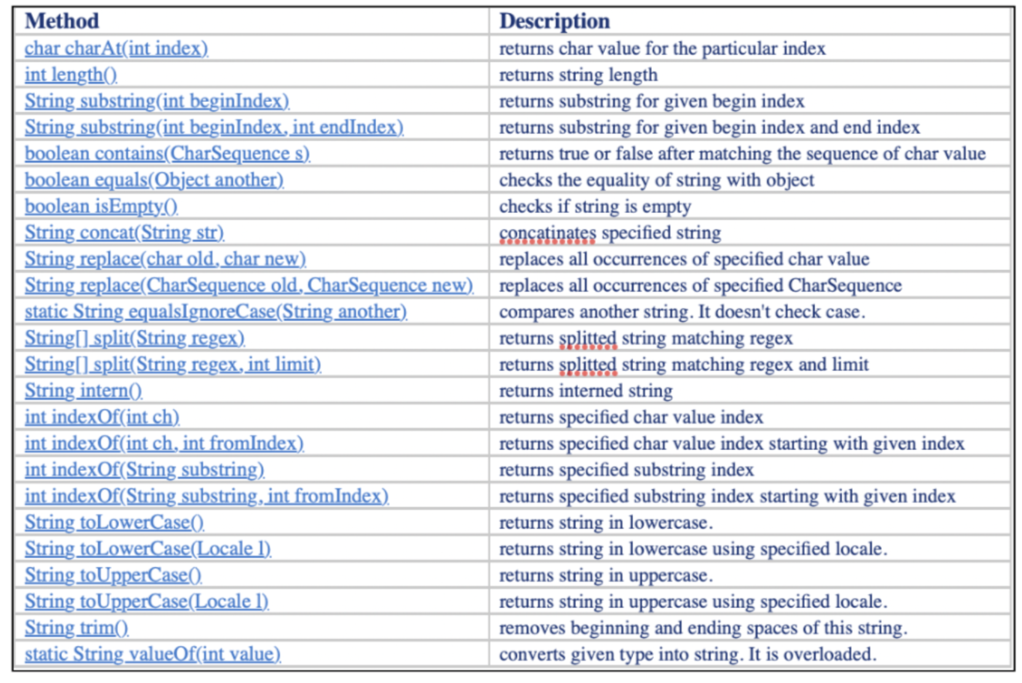

### Do you know typecasting? What is casting?

* + Auto-boxing is a process that will convert(cast) a primate datatype to an object wrapper class object automatically.



* + Un-boxing is a process when the wrapper class object is converted(cast) to a private datatype automatically.

Assigning a value of one type to a variable of another type is known as Type Casting.

### Other types of questions asked:

* Share the screen with a code. Find what is wrong in the code or how would you refactor it.
* What would you rate your Java experience out of 10?
* What is your Java level? Do you use it in terms of testing only or in terms of development as well?
* Data types and differences?