Milestone 01: Kubernetes Installation and Setup
• Install a local Kubernetes cluster using Minikube
• Validate the cluster: You can validate the cluster by checking the available nodes of the cluster
The deliverable of this milestone is to provide the screenshots of the terminal and dashboard,
which shows the installation and running of Minikube
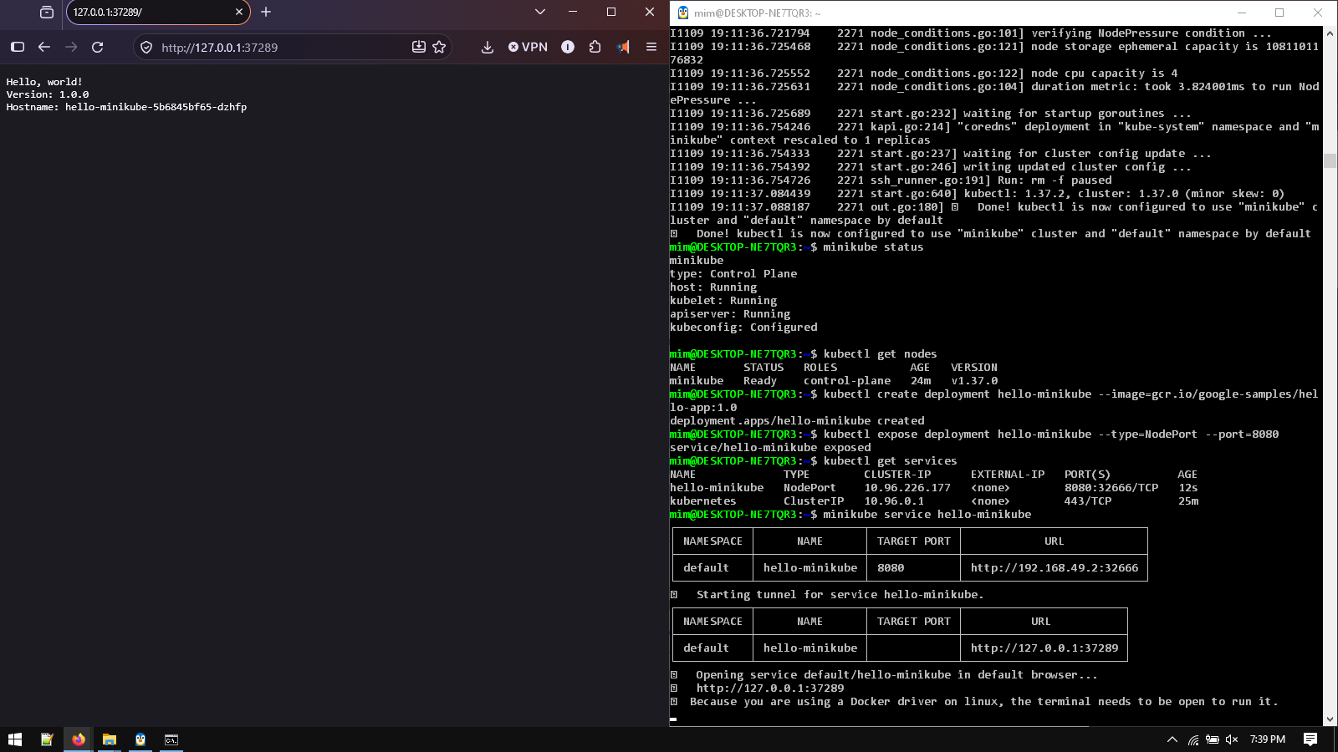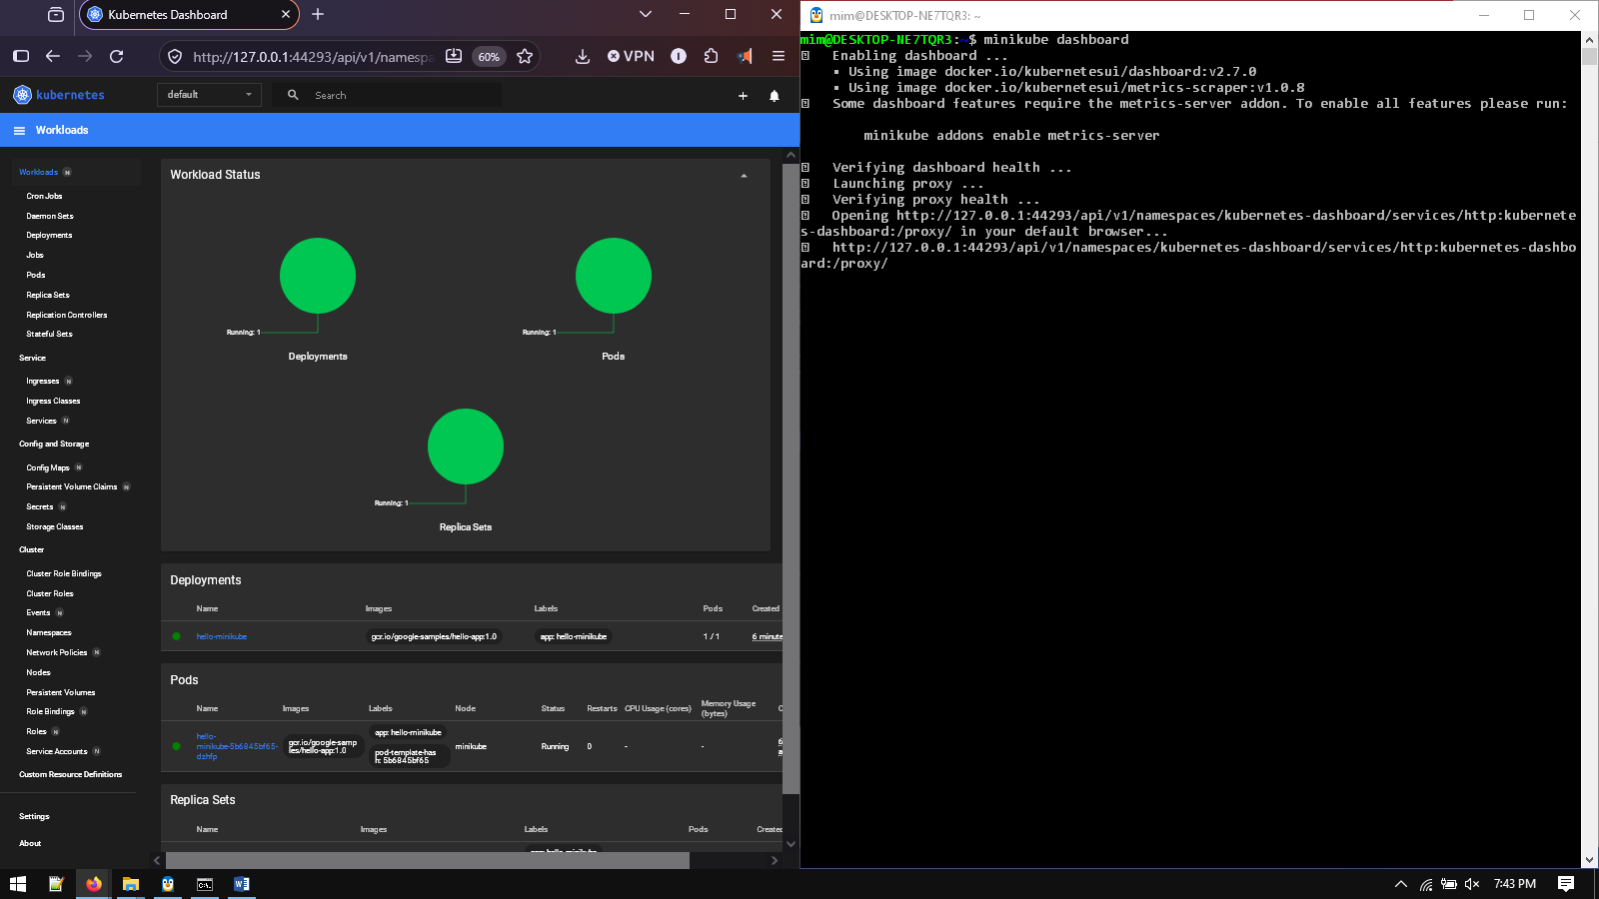
Milestone 02: Deploying and Managing Applications
1. Use the pucitcloudnet/fft [1] docker image as a sample application for deployment. The following
images contain an application code and Apache server configuration. Figure 1 shows the output of the
application available in the pucitcloudnet/fft docker image.
2. Create Kubernetes deployment manifests: Write YAML files that define the desired state of your
application, including the container image, ports, and other necessary configurations.
3. Deploy the application: Use the kubectl command to deploy your application to the Kubernetes cluster.
4. Verify the application: Confirm that your application is running correctly by checking the pod status
and accessing the deployed service.
The deliverable of this milestone is to provide the screenshots of the terminal, Minikube dash-
board and deployed application accessing from the browser
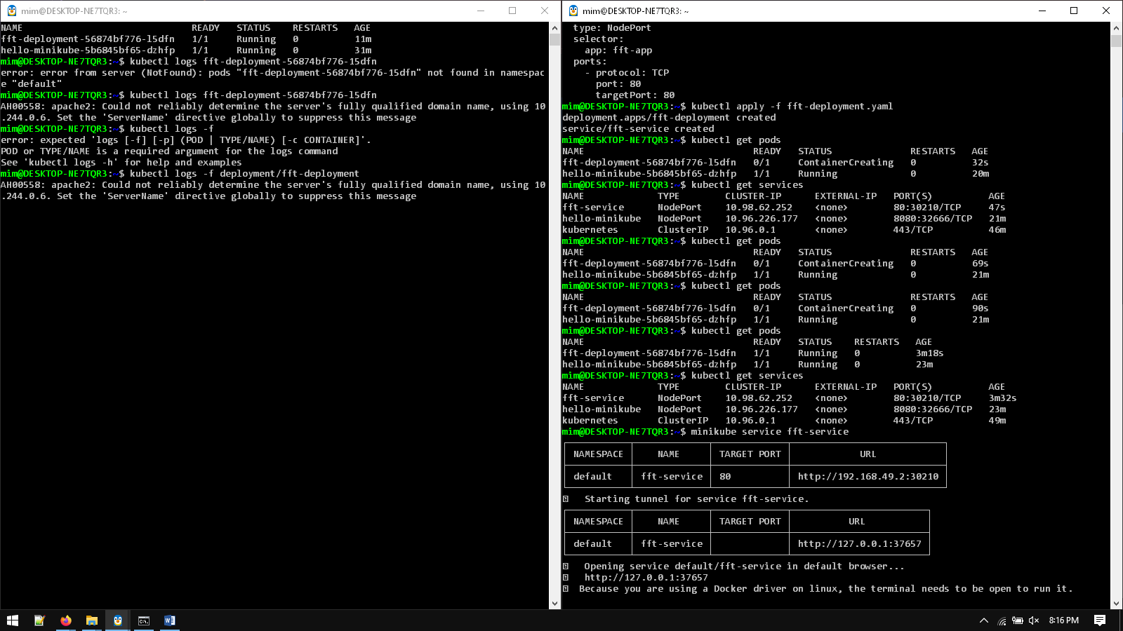
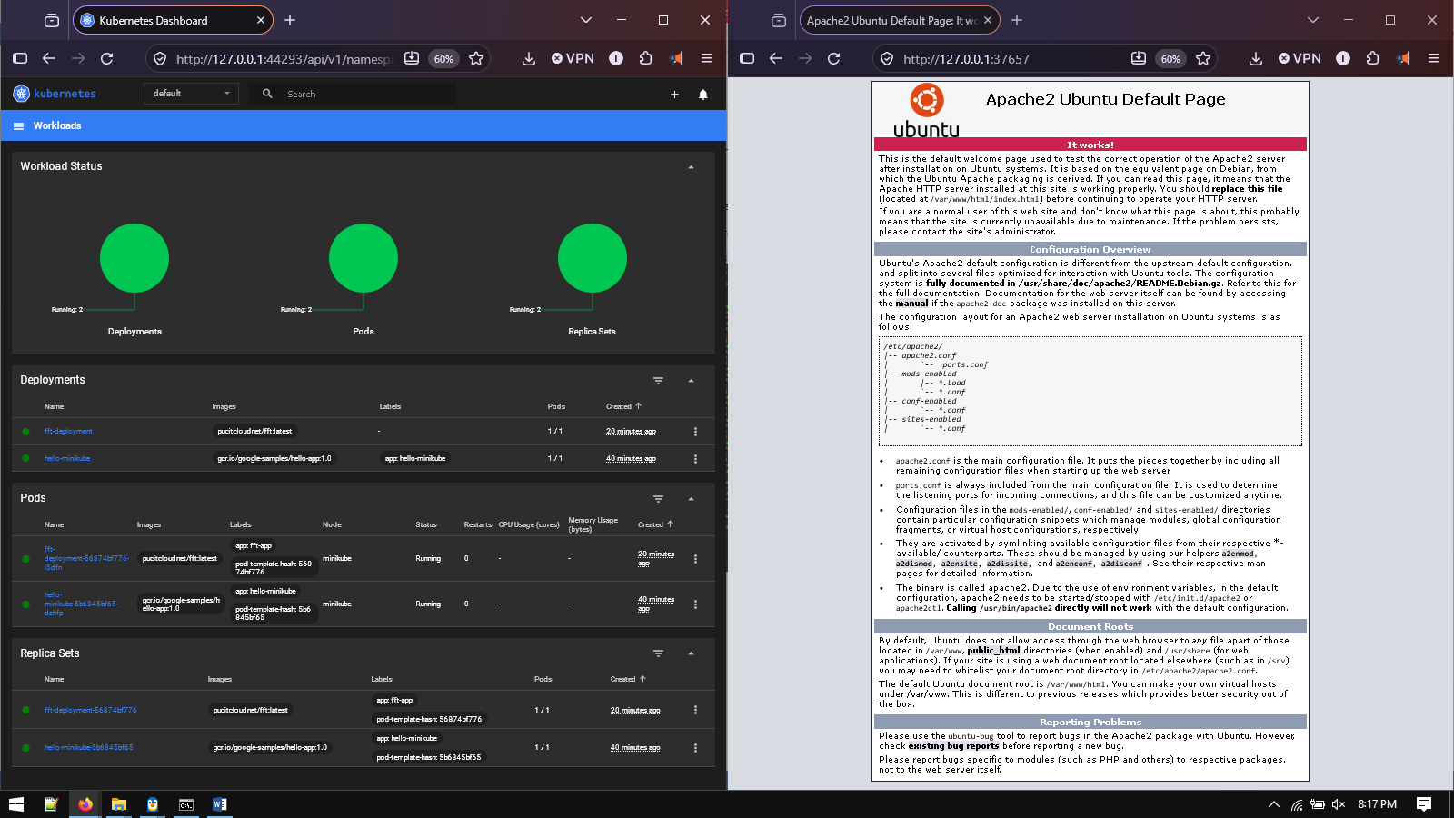

Milestone 03: Scaling and Load Balancing
• Configure horizontal pod autoscaling (HPA): Write an HPA manifest that defines the scaling rules
based on CPU or custom metrics.
• Test the autoscaling behavior: Generate load on your application using HTTPerf [2] to trigger scaling
and observe the increase or decrease in the number of pod replicas.
• Implement service and load balancing: Create a Kubernetes Service and expose it using a LoadBalancer
to distribute traffic to your application.
The deliverable of this milestone is to provide the screenshots of the terminal, Minikube
dashboard, deployed services, and httperf script output

At MAX =5 Replicas
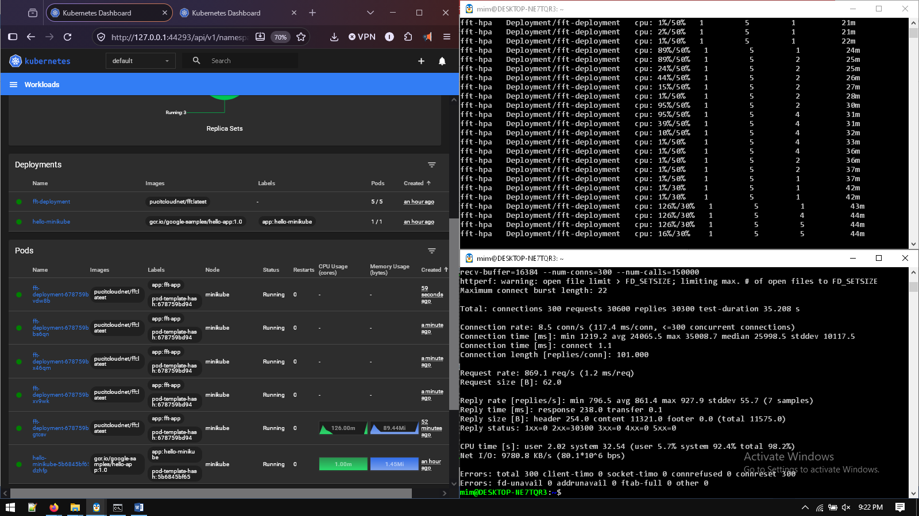

Cooldown to MIN = 1 Replicas
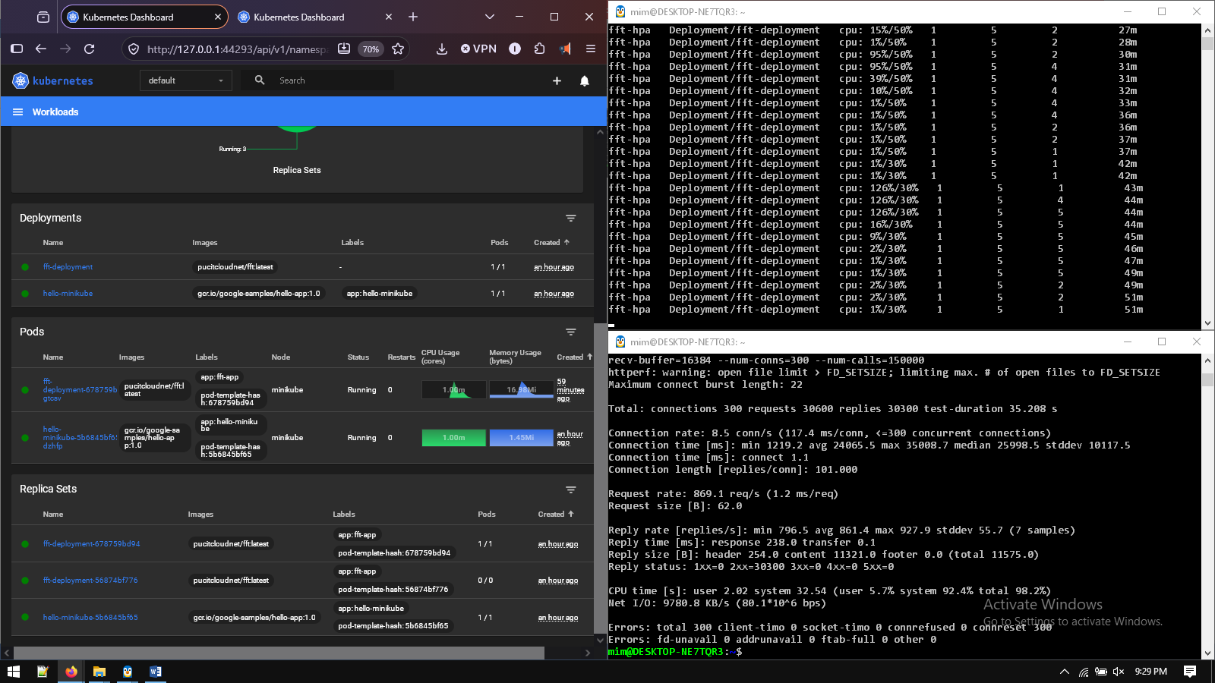

FFT Values UI


