CPU Inference Benchmarking Results Summary
Matrix multiplication Paged KV cache IMBPS
Deveshi Singh October 2026
Main conclusion CPU inference performance depended on how work was grouped and how data was traversed. No single loop order or cache threshold predicted the fastest implementation. The strongest results came from reducing dispatch and allocation overhead, matching traversal to physical storage, and enabling IMBPS only when the active MLP workload was large enough.

Results at a glance
Benchmark | Observed result | Practical interpretation
Batched matrix multiplication | BMM remained faster after the nominal working set exceeded cache. | Dispatches, temporary allocations and copies still mattered.
Optimized GEMM loop orders | Six loop orders were usually within about 2 percent once they shared the same tiled SIMD microkernel. | Microkernel quality mattered more than the outer loop order.
Paged KV cache | Matched layout and traversal won; the preferred layout changed with physical block locality. | Choose layout using the expected fragmentation pattern.
IMBPS | Prefill gains were reproduced approximately. Decode shaped MLPs benefited only at high active row counts. | Select K empirically and bypass IMBPS for small decode workloads.

What changed across the experiments
- First, batched execution removed repeated framework dispatches and temporary result copies.
- Next, KV experiments separated physical layout from traversal order and exposed a fragmentation dependent crossover.
- Finally, IMBPS split the MLP expansion dimension to improve cache locality, but the best split still depended on kernel overhead and workload size.

Matrix multiplication findings

Batched execution remained faster
A loop of individual matrix multiplications performed the same useful FLOPs as one batched matrix multiplication, but it issued one operation per batch item, created temporary outputs, allocated a final stacked tensor and copied each temporary into it. Those costs remained visible even after the matrices exceeded the nominal cache capacity.
Implementation | Execution and memory behavior
Looped MM | Multiple aten::mm dispatches plus temporary C tensors and a final stacked C tensor
Batched MM | One aten::bmm dispatch and one final C allocation

The shared microkernel reduced loop order differences
Cache tiling plus SIMD register blocking was about 3.1 times faster than tiled-only multiplication in the earlier Apple ARM experiment. Once all six outer loop orders used that same microkernel, their geometric-mean performance was generally within about 2 percent of the best. The initial kij and ikj advantage was therefore workload-specific rather than universal.

Paged KV cache findings
The KV experiments separated physical storage from traversal. Matching the traversal order to the physical layout consistently improved locality. Which matching layout was best depended on whether the physical block table contained long contiguous runs or highly fragmented blocks.
Block table locality | Preferred organization | Observed result
Contiguous runs of at least 8 blocks | HBND with head-first traversal | At run length 512, HBND/BHND was 0.937 times
Run length 4 | No clear winner | Effective tie
Runs of 1 or 2 blocks | BHND with block-first traversal | At run length 1, HBND/BHND was 1.059 times

A separate BF16 decode sweep found a repeatable region for block-major storage with block-first traversal. It won 39 of 48 MHA workloads with a median speedup of about 1.17 times, mainly at 40 to 72 MiB of logical K plus V traffic per call. The baseline had no repeatable wins in that region.

IMBPS prefill reproduction
IMBPS partitions the OPT-30B MLP expansion dimension and processes one block at a time. The reproduction used one EPYC 9654 socket with 96 physical cores and 384 MiB aggregate L3. The measured speedups were close to the paper, although K=8 slightly outperformed K=4 at the larger batches.
Batch | Paper K=4 | Measured K=4 | Fastest tested K
16 | 1.21 times | 1.160 times | K=4 at 1.160 times
32 | 1.25 times | 1.184 times | K=8 at 1.185 times
64 | 1.23 times | 1.206 times | K=8 at 1.213 times

Cache fit did not guarantee speedup
For B=16 and sequence length 256, Equation 13 selected K=2 as the smallest power-of-two split whose modeled 364 MiB working set fit within 384 MiB L3. K=2 was statistically indistinguishable from TPP, and every larger split was slower. Cache residency alone was therefore not sufficient to predict runtime.
Backend | K | Modeled working set | Median time | Speedup over TPP
TPP | 1 | 672 MiB | 292.02 ms | 1.000 times
IMBPS | 2 | 364 MiB | 292.40 ms | 0.998 times CI 0.978 to 1.046
IMBPS | 4 | 210 MiB | 454.19 ms | 0.645 times
IMBPS | 8 | 133 MiB | 330.55 ms | 0.883 times
IMBPS | 16 | 94.5 MiB | 358.31 ms | 0.818 times
IMBPS | 32 | 75.25 MiB | 613.19 ms | 0.478 times

The equation predicted locality better than runtime
At sequence lengths 1024 and 1408, the Equation 13 candidate uniquely minimized L3 misses and DRAM traffic and maximized hit rate and measured arithmetic intensity. The next larger split had the lowest profiled runtime. This supports using the equation as a starting point followed by a small empirical search.
Sequence | Equation K | Best locality | Lowest profiled time
1024 | 16 | K=16 | K=32
1408 | 32 | K=32 | K=64

Decode shaped MLP pilot
The current extension evaluates the standalone OPT-30B MLP with one token per sequence. Active rows M represent the live decode batch; for speculative verification, the same M can represent batch multiplied by verified draft tokens. The pilot does not include attention, KV-cache access, proposal generation or token acceptance.
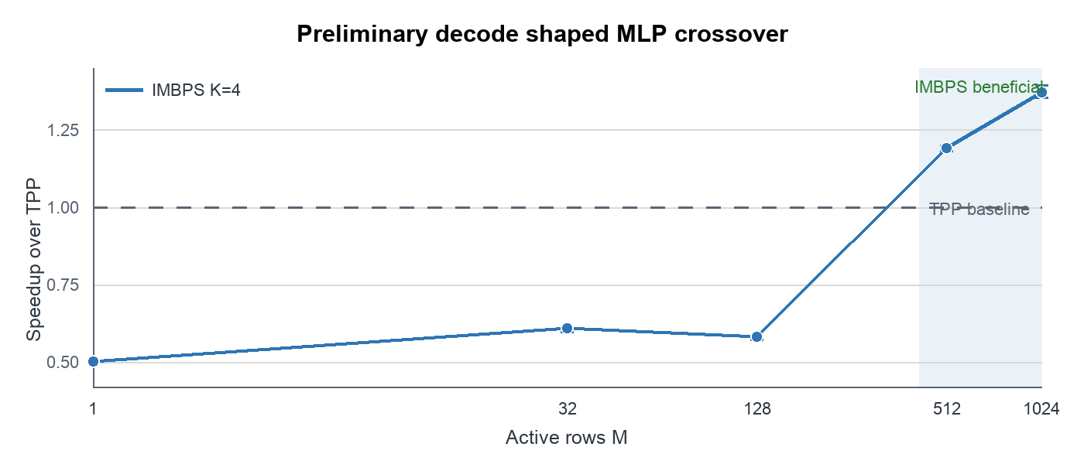
Figure 1 K=4 became beneficial between 128 and 512 active rows
Active rows | TPP | Best IMBPS K | IMBPS time | Paired speedup
1 | 1.711 ms | 4 | 3.419 ms | 0.501 times
32 | 3.591 ms | 4 | 5.936 ms | 0.609 times
128 | 8.236 ms | 4 | 14.201 ms | 0.581 times
512 | 39.001 ms | 4 | 32.727 ms | 1.192 times CI 1.182 to 1.198
1024 | 80.062 ms | 4 | 58.420 ms | 1.370 times CI 1.353 to 1.394

The pilot supports a conditional policy: use TPP for small active-row counts and consider IMBPS for highly batched decode or speculative verification. The full timing matrix is needed to locate the crossover more precisely. Counter evidence and end-to-end accepted-token throughput remain open.

Experimental conditions
Item | Earlier prefill experiments | Decode pilot
Processor placement | EPYC 9654 socket 0 96 cores 12 CCDs | Same
Cache model | 384 MiB aggregate L3 | 96 MiB aggregate private L2
Model operator | OPT-30B MLP BF16 ReLU bias | Same
Software | PACE 1.0.0 PyTorch 2.7.0 CPU | Same
Memory settings | THP madvise no tcmalloc preload | THP always tcmalloc 2.18.1
Scheduling | Exclusive Slurm allocation one NUMA node | Same
Status | Completed timing and historical uProf mechanism runs | Preliminary three-round timing pilot

What is established and what remains open
- Established Batched dispatch reduces framework and allocation overhead beyond what a cache-size-only hypothesis predicts.
- Established KV layout should match traversal, and fragmentation changes the preferred layout.
- Established IMBPS reproduced substantial OPT-30B prefill gains on mn01, although the optimal K differed from the paper at larger batches.
- Preliminary Standalone decode-shaped MLPs benefited at 512 and 1024 active rows but regressed at 128 rows and below.
- Not yet established End-to-end decode or speculative-decode throughput, because attention, KV-cache work and acceptance behavior were excluded.
- Not yet established Parallel per-CCD IMBPS. Job 9300 only varied complete-CCD thread groups; it did not execute independent per-CCD splits.

Next experiments
Priority | Experiment | Decision it will support
1 | Complete the full decode timing matrix over M=1 to 1024 and K=2 to 32 | Choose a reliable active-row crossover and split policy
2 | Add fixed-trace end-to-end normal and speculative decode | Test accepted-token throughput with attention and KV cache included
3 | Implement parallel IMBPS with one worker group per CCD | Compare global splitting with CCD-local cache ownership and scaling
4 | Repeat cache and traffic counters when amd_uncore access returns | Confirm whether L2 and DRAM traffic explain the decode crossover

Evidence
- Table II timing summary
- Cache fit control
- Equation 13 uProf summary
- Decode pilot summary
- Decode experimental plan

