Student Data Serverless App – Project Documentation

# Project Overview

This is a fully serverless web application hosted on AWS, designed to store and retrieve student information. It leverages Amazon S3 for static website hosting, AWS Lambda for business logic, Amazon DynamoDB as the NoSQL database, and Amazon API Gateway to expose RESTful APIs.

# Architecture Components

Amazon S3: Hosts a static website with HTML, CSS, and JavaScript  
Amazon API Gateway: Exposes REST API endpoints (GET and POST)  
AWS Lambda:  
 - getstudent: Retrieves all student records  
 - insertstudentData: Adds new student records  
Amazon DynamoDB: Stores student data (table: studentData)  
IAM Role: Assumed by both Lambda functions to access DynamoDB

# IAM Role

Purpose: Allows Lambda functions to read/write to DynamoDB.

Permissions:

{  
 "Effect": "Allow",  
 "Action": [  
 "dynamodb:GetItem",  
 "dynamodb:PutItem",  
 "dynamodb:Scan"  
 ],  
 "Resource": "arn:aws:dynamodb:us-east-2:<your-account-id>:table/studentData"  
}

# DynamoDB Table

Table Name: studentData

Partition Key: studentid (String)

Other Configurations: Default

# Lambda Functions

## 1. getstudent – Python 3.12

Purpose: Retrieves all records from the table

import json  
import boto3  
  
def lambda_handler(event, context):  
 dynamodb = boto3.resource('dynamodb', region_name='us-east-2')  
 table = dynamodb.Table('studentData')  
  
 response = table.scan()  
 data = response['Items']  
  
 while 'LastEvaluatedKey' in response:  
 response = table.scan(ExclusiveStartKey=response['LastEvaluatedKey'])  
 data.extend(response['Items'])  
  
 return data

## 2. insertstudentData – Python 3.12

Purpose: Adds new student records

import json  
import boto3  
  
dynamodb = boto3.resource('dynamodb')  
table = dynamodb.Table('studentData')  
  
def lambda_handler(event, context):  
 student_id = event['studentid']  
 name = event['name']  
 student_class = event['class']  
 age = event['age']  
   
 response = table.put_item(  
 Item={  
 'studentid': student_id,  
 'name': name,  
 'class': student_class,  
 'age': age  
 }  
 )  
   
 return {  
 'statusCode': 200,  
 'body': json.dumps('Student data saved successfully!')  
 }

# API Gateway

API Name: student

Type: Edge-optimized

Methods:  
 - GET: Triggers getstudent  
 - POST: Triggers insertstudentData

CORS: Enabled for both GET and POST methods

# S3 Static Website Hosting

Use: Hosts the frontend (HTML/JS)  
Steps:  
- Enable static website hosting  
- Paste API Gateway invoke URL in the JS code  
- Allow public access  
- Attach an inline policy to allow S3 access  
- JS code uses fetch() or axios to call the REST API

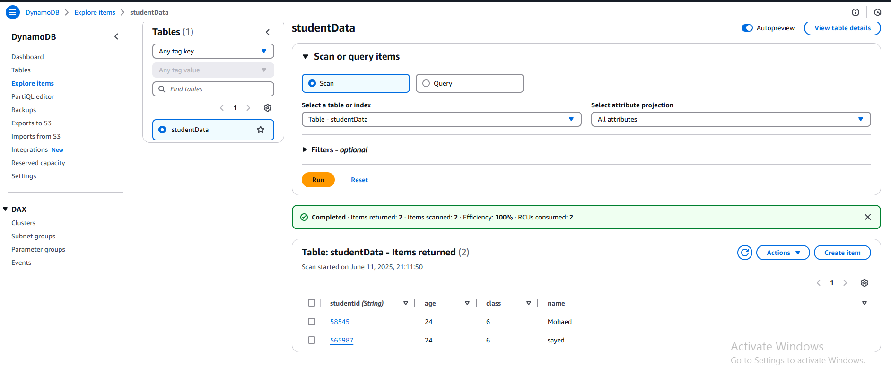

# Future Improvements

- Enable Cross-Origin Resource Sharing (CORS) across multiple regions  
- Expand into a broader ISAAC-based distributed architecture  
- Add authentication using Amazon Cognito  
- Logging/Monitoring using CloudWatch