**D4 Dotfiles Manual**

**[I]Shortcuts :**

Setting $MOD = Windows key

(1) MOD +

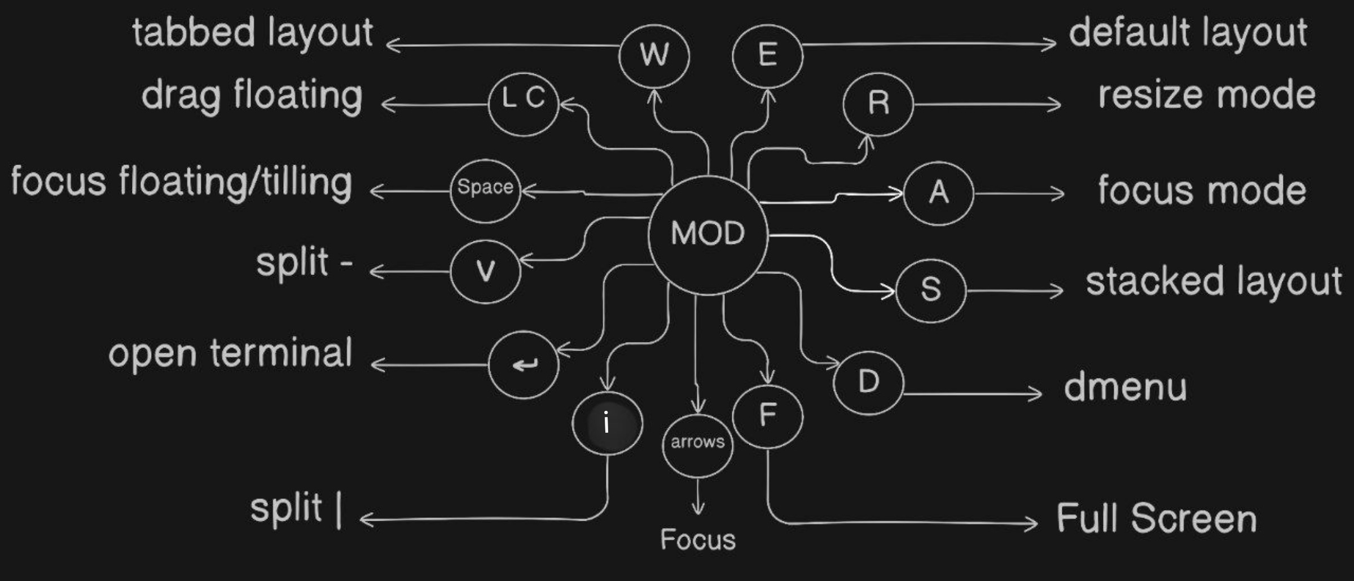

(2) MOD + Shift +

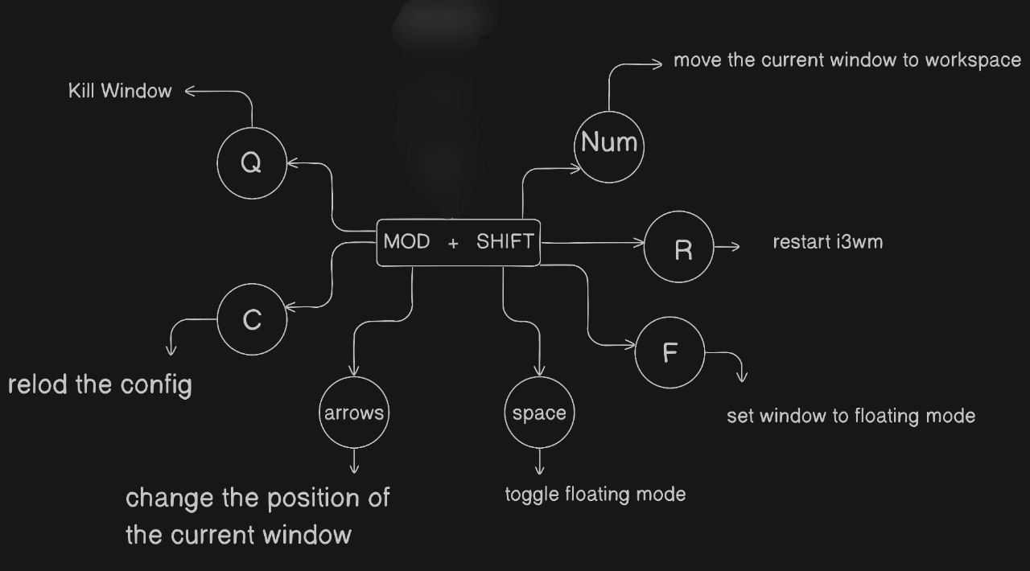

(3) Custom Shortcuts :

MOD + CTRL + z => File Manager

MOD + CTRL + c => Brave

MOD + CTRL + v => Vscode

MOD + CTRL + m => mousepad

MOD + CTRL + a => anyType

MOD + CTRL + g => Chatgpt

MOD + CTRL + w => Whatsapp

MOD + CTRL + t => Telegram

Print => screenshot the entire Frame

Mod + Print => select to screenshot

MOD + CTRL + up =>> gaps inner current plus 5

MOD + CTRL + down =>> gaps inner current minus 5

MOD + CTRL + left =>> gaps outer current plus 5

MOD + CTRL + right =>> gaps outer current minus 5

MOD + CTRL + = =>> increase the volume by 5%

MOD + CTRL + - =>> decrease the volume by 5%

MOD + CTRL + ] =>> increase the brightness by 5%

MOD + CTRL + [ =>> decrease the brightness by 5%

ALTS =>> switch language (En - Ar)

MOD + CTRL + Q =>> Power menu