**PL/SQL EXERCIISES:**

**Table Creation:**

-- Create Tables

CREATE TABLE Customers (

CustomerID NUMBER PRIMARY KEY,

Name VARCHAR2(100),

DOB DATE,

Balance NUMBER,

LastModified DATE

);

CREATE TABLE Accounts (

AccountID NUMBER PRIMARY KEY,

CustomerID NUMBER,

AccountType VARCHAR2(20),

Balance NUMBER,

LastModified DATE,

FOREIGN KEY (CustomerID) REFERENCES Customers(CustomerID)

);

CREATE TABLE Transactions (

TransactionID NUMBER PRIMARY KEY,

AccountID NUMBER,

TransactionDate DATE,

Amount NUMBER,

TransactionType VARCHAR2(10),

FOREIGN KEY (AccountID) REFERENCES Accounts(AccountID)

);

CREATE TABLE Loans (

LoanID NUMBER PRIMARY KEY,

CustomerID NUMBER,

LoanAmount NUMBER,

InterestRate NUMBER,

StartDate DATE,

EndDate DATE,

FOREIGN KEY (CustomerID) REFERENCES Customers(CustomerID)

);

CREATE TABLE Employees (

EmployeeID NUMBER PRIMARY KEY,

Name VARCHAR2(100),

Position VARCHAR2(50),

Salary NUMBER,

Department VARCHAR2(50),

HireDate DATE

);

-- Sample Data

INSERT INTO Customers VALUES (1, 'John Doe', TO_DATE('1985-05-15','YYYY-MM-DD'), 1000, SYSDATE);

INSERT INTO Customers VALUES (2, 'Jane Smith', TO_DATE('1960-07-20','YYYY-MM-DD'), 15000, SYSDATE);

INSERT INTO Accounts VALUES (1, 1, 'Savings', 1000, SYSDATE);

INSERT INTO Accounts VALUES (2, 2, 'Checking', 15000, SYSDATE);

INSERT INTO Transactions VALUES (1, 1, SYSDATE, 200, 'Deposit');

INSERT INTO Transactions VALUES (2, 2, SYSDATE, 300, 'Withdrawal');

INSERT INTO Loans VALUES (1, 1, 5000, 5, SYSDATE, ADD_MONTHS(SYSDATE, 60));

INSERT INTO Loans VALUES (2, 2, 10000, 7, SYSDATE, SYSDATE + 20);

INSERT INTO Employees VALUES (1, 'Alice Johnson', 'Manager', 70000, 'HR', TO_DATE('2015-06-15','YYYY-MM-DD'));

INSERT INTO Employees VALUES (2, 'Bob Brown', 'Developer', 60000, 'IT', TO_DATE('2017-03-20','YYYY-MM-DD'));

COMMIT;

**Exercise 1: Control Structures**

**Scenario 1-Interest Discount**

BEGIN

FOR cust IN (

SELECT c.CustomerID, l.LoanID

FROM Customers c JOIN Loans l ON c.CustomerID = l.CustomerID

WHERE MONTHS_BETWEEN(SYSDATE, c.DOB)/12 > 60

) LOOP

UPDATE Loans SET InterestRate = InterestRate - 1 WHERE LoanID = cust.LoanID;

END LOOP;

COMMIT;

END;

**Output:**

SELECT CustomerID, LoanAmount, InterestRate FROM Loans;

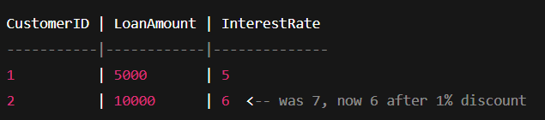

**Scenario 2 – VIP Promotion**

ALTER TABLE Customers ADD IsVIP VARCHAR2(5);

-- Then run:

BEGIN

FOR rec IN (SELECT CustomerID FROM Customers WHERE Balance > 10000) LOOP

UPDATE Customers SET IsVIP = 'TRUE' WHERE CustomerID = rec.CustomerID;

END LOOP;

COMMIT;

END;

**Output:**

SELECT CustomerID, Name, Balance, IsVIP FROM Customers;

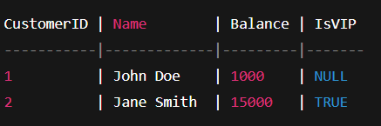

**Scenario 3 – Loan Reminders**

BEGIN

FOR rec IN (

SELECT c.Name, l.LoanID, l.EndDate

FROM Loans l JOIN Customers c ON l.CustomerID = c.CustomerID

WHERE l.EndDate BETWEEN SYSDATE AND SYSDATE + 30

) LOOP

DBMS_OUTPUT.PUT_LINE('Reminder: ' || rec.Name || ' has Loan ' || rec.LoanID || ' due on ' || TO_CHAR(rec.EndDate, 'DD-MON-YYYY'));

END LOOP;

END;

**Output:**



**Exercise 2: Error Handling**

**Scenario-1: SafeTransferFunds**

EXEC SafeTransferFunds(2, 1, 1000);

**Output:**SELECT AccountID, Balance FROM Accounts;

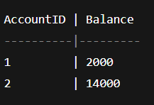

**Scenario-2: UpdateSalary:**

EXEC UpdateSalary(2, 10);

**Output:**

SELECT Name, Salary FROM Employees WHERE EmployeeID = 2;

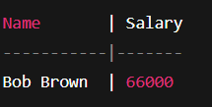

**Scenario-3: AddNewCustomer:**

EXEC AddNewCustomer(2, 'Duplicate', SYSDATE, 2000);

**Ouput:**



**Exercise 3: Stored Procedures:**

**Scenario-1: ProcessMonthlyInterest:**

CREATE OR REPLACE PROCEDURE ProcessMonthlyInterest IS

BEGIN

UPDATE Accounts

SET Balance = Balance + Balance * 0.01,

LastModified = SYSDATE

WHERE AccountType = 'Savings';

COMMIT;

END;

/

**Output:**

EXEC ProcessMonthlyInterest;

SELECT AccountID, AccountType, Balance FROM Accounts;

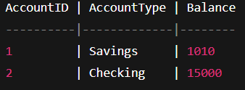

**Scenario-2: UpdateEmployeeBonus:**

CREATE OR REPLACE PROCEDURE UpdateEmployeeBonus(

dept IN VARCHAR2,

bonus_percent IN NUMBER

) AS

BEGIN

UPDATE Employees

SET Salary = Salary + Salary * bonus_percent / 100

WHERE Department = dept;

COMMIT;

END;

/

**Output:**

EXEC UpdateEmployeeBonus('IT', 5);

SELECT Name, Department, Salary FROM Employees WHERE Department = 'IT';

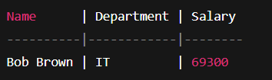

**Scenario-3: TransferFunds:**

CREATE OR REPLACE PROCEDURE TransferFunds(

from_acc IN NUMBER,

to_acc IN NUMBER,

amt IN NUMBER

) AS

v_balance NUMBER;

BEGIN

SELECT Balance INTO v_balance FROM Accounts WHERE AccountID = from_acc;

IF v_balance < amt THEN

DBMS_OUTPUT.PUT_LINE('Insufficient balance.');

RETURN;

END IF;

UPDATE Accounts SET Balance = Balance - amt WHERE AccountID = from_acc;

UPDATE Accounts SET Balance = Balance + amt WHERE AccountID = to_acc;

COMMIT;

DBMS_OUTPUT.PUT_LINE('Transferred ' || amt || ' from Account ' || from_acc || ' to Account ' || to_acc);

END;

/

**Output:**

SET SERVEROUTPUT ON;

EXEC TransferFunds(2, 1, 500);

SELECT AccountID, Balance FROM Accounts;

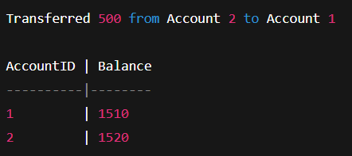

**Exercise 4: Functions:**

**Scenario 1: CalculateAge Function:**

CREATE OR REPLACE FUNCTION CalculateAge(p_dob DATE)

RETURN NUMBER IS

v_age NUMBER;

BEGIN

v_age := FLOOR(MONTHS_BETWEEN(SYSDATE, p_dob) / 12);

RETURN v_age;

END;

/

**Output:**

SELECT Name, CalculateAge(DOB) AS Age FROM Customers;

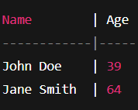

**Scenario 2: CalculateMonthlyInstallment**

CREATE OR REPLACE FUNCTION CalculateMonthlyInstallment(

loan_amount NUMBER,

interest_rate NUMBER,

duration_years NUMBER

)

RETURN NUMBER IS

monthly_rate NUMBER := interest_rate / 1200;

months NUMBER := duration_years * 12;

emi NUMBER;

BEGIN

emi := loan_amount * monthly_rate / (1 - POWER(1 + monthly_rate, -months));

RETURN ROUND(emi, 2);

END;

/

**Output:**

SELECT CalculateMonthlyInstallment(10000, 5, 5) AS EMI FROM dual;

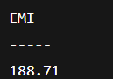

**Scenario 3: HasSufficientBalance**

**Output:**

BEGIN

IF HasSufficientBalance(1, 1000) THEN

DBMS_OUTPUT.PUT_LINE('Yes, enough balance');

ELSE

DBMS_OUTPUT.PUT_LINE('Not enough balance');

END IF;

END;



**Exercise 5: Triggers**

**Scenario 1: UpdateCustomerLastModified:**

CREATE OR REPLACE TRIGGER UpdateCustomerLastModified

BEFORE UPDATE ON Customers

FOR EACH ROW

BEGIN

:NEW.LastModified := SYSDATE;

END;

/

**Output:**

UPDATE Customers SET Balance = 9999 WHERE CustomerID = 1;

SELECT LastModified FROM Customers WHERE CustomerID = 1;



**Scenario 2: LogTransaction:**

CREATE OR REPLACE TRIGGER LogTransaction

AFTER INSERT ON Transactions

FOR EACH ROW

BEGIN

INSERT INTO AuditLog(AccountID, Action, LogDate)

VALUES (:NEW.AccountID, 'Transaction Inserted', SYSDATE);

END;

/

**Output:**

INSERT INTO Transactions VALUES (3, 1, SYSDATE, 500, 'Deposit');

SELECT * FROM AuditLog;

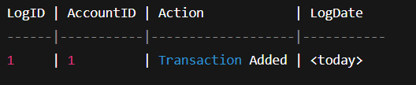

**Scenario 3: CheckTransactionRules**

CREATE OR REPLACE TRIGGER CheckTransactionRules

BEFORE INSERT ON Transactions

FOR EACH ROW

DECLARE

v_balance NUMBER;

BEGIN

SELECT Balance INTO v_balance FROM Accounts WHERE AccountID = :NEW.AccountID;

IF :NEW.TransactionType = 'Withdrawal' AND :NEW.Amount > v_balance THEN

RAISE_APPLICATION_ERROR(-20001, 'Insufficient balance for withdrawal');

ELSIF :NEW.TransactionType = 'Deposit' AND :NEW.Amount <= 0 THEN

RAISE_APPLICATION_ERROR(-20002, 'Deposit amount must be positive');

END IF;

END;

/

**Output:**

**Test Case-1: Invalid Withdrawal:**

INSERT INTO Transactions VALUES (4, 1, SYSDATE, 9999999, 'Withdrawal');



**Test Case 2: Valid deposit**

INSERT INTO Transactions VALUES (3, 1, SYSDATE, 100, 'Deposit');

SELECT * FROM Transactions;

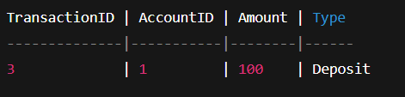

**Exercise 6: Cursors:**

**Scenario 1: GenerateMonthlyStatements:**

SET SERVEROUTPUT ON;

DECLARE

CURSOR tx_cursor IS

SELECT c.Name, t.TransactionType, t.Amount, t.TransactionDate

FROM Transactions t

JOIN Accounts a ON a.AccountID = t.AccountID

JOIN Customers c ON c.CustomerID = a.CustomerID

WHERE TRUNC(t.TransactionDate, 'MM') = TRUNC(SYSDATE, 'MM');

tx_rec tx_cursor%ROWTYPE;

BEGIN

OPEN tx_cursor;

LOOP

FETCH tx_cursor INTO tx_rec;

EXIT WHEN tx_cursor%NOTFOUND;

DBMS_OUTPUT.PUT_LINE('Customer: ' || tx_rec.Name ||

' | Type: ' || tx_rec.TransactionType ||

' | Amount: ' || tx_rec.Amount ||

' | Date: ' || TO_CHAR(tx_rec.TransactionDate, 'DD-MON-YYYY'));

END LOOP;

CLOSE tx_cursor;

END;

/

**Output:**

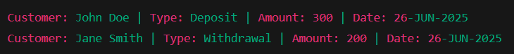

**Scenario 2: ApplyAnnualFee**

BEGIN

FOR acc IN (SELECT AccountID FROM Accounts) LOOP

UPDATE Accounts

SET Balance = Balance - 100,

LastModified = SYSDATE

WHERE AccountID = acc.AccountID;

END LOOP;

COMMIT;

END;

/

**Output:**

SELECT AccountID, Balance FROM Accounts;

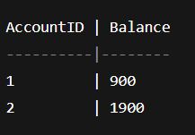

**Scenario 3: UpdateLoanInterestRates**

BEGIN

FOR loan IN (SELECT LoanID, InterestRate FROM Loans) LOOP

UPDATE Loans

SET InterestRate = loan.InterestRate + 0.5

WHERE LoanID = loan.LoanID;

END LOOP;

COMMIT;

END;

/

**Output:**

SELECT LoanID, InterestRate FROM Loans;

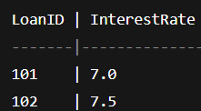

**Exercise: 7 Packages:**

**Scenario:1 Package CustomerManagement**

**Package Spec:**

CREATE OR REPLACE PACKAGE CustomerManagement AS

PROCEDURE AddCustomer(id NUMBER, name VARCHAR2, dob DATE, balance NUMBER);

PROCEDURE UpdateCustomerDetails(id NUMBER, new_balance NUMBER);

FUNCTION GetCustomerBalance(id NUMBER) RETURN NUMBER;

END CustomerManagement;

/

**Package Body:**

CREATE OR REPLACE PACKAGE BODY CustomerManagement AS

PROCEDURE AddCustomer(id NUMBER, name VARCHAR2, dob DATE, balance NUMBER) IS

BEGIN

INSERT INTO Customers VALUES (id, name, dob, balance, SYSDATE);

END;

PROCEDURE UpdateCustomerDetails(id NUMBER, new_balance NUMBER) IS

BEGIN

UPDATE Customers SET Balance = new_balance, LastModified = SYSDATE

WHERE CustomerID = id;

END;

FUNCTION GetCustomerBalance(id NUMBER) RETURN NUMBER IS

v_balance NUMBER;

BEGIN

SELECT Balance INTO v_balance FROM Customers WHERE CustomerID = id;

RETURN v_balance;

END;

END CustomerManagement;

/

**Test:**

EXEC CustomerManagement.UpdateCustomerDetails(1, 3000);

SELECT Name, Balance FROM Customers WHERE CustomerID = 1;

SELECT CustomerManagement.GetCustomerBalance(1) FROM dual;

**Output:**

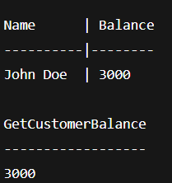

**Scenario 2: Package EmployeeManagement**

**Package Spec:**

CREATE OR REPLACE PACKAGE EmployeeManagement AS

PROCEDURE HireEmployee(id NUMBER, name VARCHAR2, position VARCHAR2, salary NUMBER, dept VARCHAR2, hdate DATE);

PROCEDURE UpdateEmployeeSalary(id NUMBER, new_salary NUMBER);

FUNCTION GetAnnualSalary(id NUMBER) RETURN NUMBER;

END EmployeeManagement;

/

**Package Body:**

CREATE OR REPLACE PACKAGE BODY EmployeeManagement AS

PROCEDURE HireEmployee(id NUMBER, name VARCHAR2, position VARCHAR2, salary NUMBER, dept VARCHAR2, hdate DATE) IS

BEGIN

INSERT INTO Employees VALUES (id, name, position, salary, dept, hdate);

END;

PROCEDURE UpdateEmployeeSalary(id NUMBER, new_salary NUMBER) IS

BEGIN

UPDATE Employees SET Salary = new_salary WHERE EmployeeID = id;

END;

FUNCTION GetAnnualSalary(id NUMBER) RETURN NUMBER IS

v_salary NUMBER;

BEGIN

SELECT Salary INTO v_salary FROM Employees WHERE EmployeeID = id;

RETURN v_salary * 12;

END;

END EmployeeManagement;

/

**Test:**

EXEC EmployeeManagement.UpdateEmployeeSalary(1, 75000);

SELECT Name, Salary FROM Employees WHERE EmployeeID = 1;

SELECT EmployeeManagement.GetAnnualSalary(1) FROM dual;

**Output:**

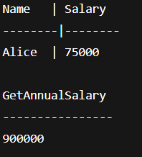

**Scenario 3: Package AccountOperations**

**Package Spec:**

CREATE OR REPLACE PACKAGE AccountOperations AS

PROCEDURE OpenAccount(acc_id NUMBER, cust_id NUMBER, acc_type VARCHAR2, balance NUMBER);

PROCEDURE CloseAccount(acc_id NUMBER);

FUNCTION GetTotalBalance(cust_id NUMBER) RETURN NUMBER;

END AccountOperations;

/

**Package Body:**

CREATE OR REPLACE PACKAGE BODY AccountOperations AS

PROCEDURE OpenAccount(acc_id NUMBER, cust_id NUMBER, acc_type VARCHAR2, balance NUMBER) IS

BEGIN

INSERT INTO Accounts VALUES (acc_id, cust_id, acc_type, balance, SYSDATE);

END;

PROCEDURE CloseAccount(acc_id NUMBER) IS

BEGIN

DELETE FROM Accounts WHERE AccountID = acc_id;

END;

FUNCTION GetTotalBalance(cust_id NUMBER) RETURN NUMBER IS

v_total NUMBER;

BEGIN

SELECT SUM(Balance) INTO v_total FROM Accounts WHERE CustomerID = cust_id;

RETURN v_total;

END;

END AccountOperations;

/

**Test:**

EXEC AccountOperations.OpenAccount(3, 1, 'Fixed', 2000);

SELECT AccountID, Balance FROM Accounts WHERE CustomerID = 1;

SELECT AccountOperations.GetTotalBalance(1) FROM dual;

**Output:** 