**Logging using SLF4J**

**Exercise 1: Logging Error Messages and Warning Levels**

**pom.xml**

<project xmlns="http://maven.apache.org/POM/4.0.0"

xmlns:xsi="http://www.w3.org/2001/XMLSchema-instance"

xsi:schemaLocation="http://maven.apache.org/POM/4.0.0

http://maven.apache.org/xsd/maven-4.0.0.xsd">

<modelVersion>4.0.0</modelVersion>

<groupId>com.slf4jdemo</groupId>

<artifactId>slf4jdemo</artifactId>

<version>0.0.1-SNAPSHOT</version>

<dependencies>

<!-- SLF4J API -->

<dependency>

<groupId>org.slf4j</groupId>

<artifactId>slf4j-api</artifactId>

<version>2.0.13</version>

</dependency>

<!-- Simple logger implementation -->

<dependency>

<groupId>org.slf4j</groupId>

<artifactId>slf4j-simple</artifactId>

<version>2.0.13</version>

</dependency>

</dependencies>

</project>

**LoggerDemo.java**

package com.slf4jdemo.log;

import org.slf4j.Logger;

import org.slf4j.LoggerFactory;

public class LoggerDemo {

private static final Logger ***logger*** = LoggerFactory.*getLogger*(LoggerDemo.class);

public static void main(String[] args) {

***logger***.info("This is an INFO message");

***logger***.warn("This is a WARN message");

***logger***.error("This is an ERROR message");

***logger***.debug("This is a DEBUG message");

}

}

**Output:**

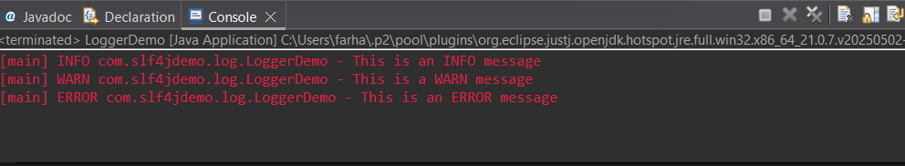

**Exercise 2: Parameterized Logging**

**pom.xml**

<project xmlns="http://maven.apache.org/POM/4.0.0"

xmlns:xsi="http://www.w3.org/2001/XMLSchema-instance"

xsi:schemaLocation="http://maven.apache.org/POM/4.0.0

http://maven.apache.org/xsd/maven-4.0.0.xsd">

<modelVersion>4.0.0</modelVersion>

<groupId>com.slf4jdemo</groupId>

<artifactId>parameter-logging-demo</artifactId>

<version>1.0-SNAPSHOT</version>

<properties>

<maven.compiler.source>1.8</maven.compiler.source>

<maven.compiler.target>1.8</maven.compiler.target>

</properties>

<dependencies>

<!-- SLF4J API -->

<dependency>

<groupId>org.slf4j</groupId>

<artifactId>slf4j-api</artifactId>

<version>1.7.30</version>

</dependency>

<!-- Logback Classic (SLF4J implementation) -->

<dependency>

<groupId>ch.qos.logback</groupId>

<artifactId>logback-classic</artifactId>

<version>1.2.3</version>

</dependency>

</dependencies>

</project>

**ParameterizedLoggerDemo.java**

package com.slf4jdemo.parameter;

import org.slf4j.Logger;

import org.slf4j.LoggerFactory;

public class ParameterizedLoggerDemo {

private static final Logger ***logger*** = LoggerFactory.*getLogger*(ParameterizedLoggerDemo.class);

public static void main(String[] args) {

String username = "john_doe";

int userId = 42;

***logger***.info("User {} has logged in with ID {}", username, userId);

***logger***.warn("User {} has attempted to access a restricted area", username);

***logger***.error("User {} encountered an error with code {}", username, 500);

}

}

**Output:**

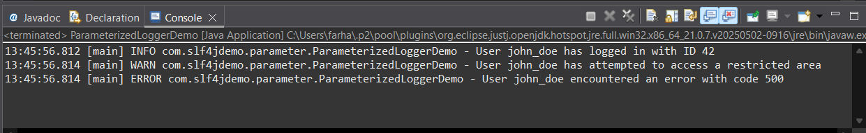

**Exercise 3: Using Different Appenders**

**pom.xml**

<project xmlns="http://maven.apache.org/POM/4.0.0"

xmlns:xsi="http://www.w3.org/2001/XMLSchema-instance"

xsi:schemaLocation="http://maven.apache.org/POM/4.0.0

http://maven.apache.org/xsd/maven-4.0.0.xsd">

<modelVersion>4.0.0</modelVersion>

<groupId>com.slf4jdemo</groupId>

<artifactId>parameter-logging-demo</artifactId>

<version>1.0-SNAPSHOT</version>

<properties>

<maven.compiler.source>1.8</maven.compiler.source>

<maven.compiler.target>1.8</maven.compiler.target>

</properties>

<dependencies>

<!-- SLF4J API -->

<dependency>

<groupId>org.slf4j</groupId>

<artifactId>slf4j-api</artifactId>

<version>1.7.30</version>

</dependency>

<!-- Logback Classic (SLF4J implementation) -->

<dependency>

<groupId>ch.qos.logback</groupId>

<artifactId>logback-classic</artifactId>

<version>1.2.3</version>

</dependency>

</dependencies>

</project>

**logback.xml**

<configuration>

<appender name="console" class="ch.qos.logback.core.ConsoleAppender">

<encoder>

<pattern>%d{HH:mm:ss.SSS} [%thread] %-5level %logger{36} - %msg%n</pattern>

</encoder>

</appender>

<appender name="file" class="ch.qos.logback.core.FileAppender">

<file>app.log</file>

<encoder>

<pattern>%d{HH:mm:ss.SSS} [%thread] %-5level %logger{36} - %msg%n</pattern>

</encoder>

</appender>

<root level="debug">

<appender-ref ref="console" />

<appender-ref ref="file" />

</root>

</configuration>

**AppendersLoggerDemo.java**

package com.slf4jdemo.appenders;

import org.slf4j.Logger;

import org.slf4j.LoggerFactory;

public class AppendersLoggerDemo {

private static final Logger ***logger*** = LoggerFactory.*getLogger*(AppendersLoggerDemo.class);

public static void main(String[] args) {

***logger***.debug("Debug message - used for debugging during development.");

***logger***.info("Info message - application started.");

***logger***.warn("Warning message - something might be wrong.");

***logger***.error("Error message - something went wrong!");

}

}

**Output:**

