**Spring Core Maven**

**Exercise 1: Configuring a Basic Spring Application**

**pom.xml**

<project xmlns="http://maven.apache.org/POM/4.0.0"

xmlns:xsi="http://www.w3.org/2001/XMLSchema-instance"

xsi:schemaLocation="http://maven.apache.org/POM/4.0.0

http://maven.apache.org/xsd/maven-4.0.0.xsd">

<modelVersion>4.0.0</modelVersion>

<groupId>com.library</groupId>

<artifactId>LibraryManagement</artifactId>

<version>1.0-SNAPSHOT</version>

<dependencies>

<!-- Spring Core -->

<dependency>

<groupId>org.springframework</groupId>

<artifactId>spring-context</artifactId>

<version>5.3.36</version>

</dependency>

</dependencies>

</project>

**applicationContext.xml**

<?xml version="1.0" encoding="UTF-8"?>

<beans xmlns="http://www.springframework.org/schema/beans"

xmlns:xsi="http://www.w3.org/2001/XMLSchema-instance"

xsi:schemaLocation="http://www.springframework.org/schema/beans

http://www.springframework.org/schema/beans/spring-beans.xsd">

<bean id="bookRepository" class="com.library.repository.BookRepository"/>

<bean id="bookService" class="com.library.service.BookService"/>

</beans>

**BookService.java**

package com.library.service;

public class BookService {

public void addBook() {

System.***out***.println("BookService: Adding a book...");

}

}

**BookRepository.java**

package com.library.repository;

public class BookRepository {

public void saveBook() {

System.***out***.println("BookRepository: Saving the book...");

}

}

**LibraryManagementApplication.java**

package com.library;

import org.springframework.context.ApplicationContext;

import org.springframework.context.support.ClassPathXmlApplicationContext;

import com.library.service.BookService;

public class LibraryManagementApplication {

public static void main(String[] args) {

ApplicationContext context =

new ClassPathXmlApplicationContext("applicationContext.xml");

BookService service = context.getBean("bookService", BookService.class);

service.addBook();

}

}

**Output:**

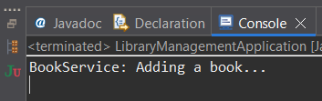

**Exercise 2: Implementing Dependency Injection**

**applicationContext.xml**

<?xml version="1.0" encoding="UTF-8"?>

<beans xmlns="http://www.springframework.org/schema/beans"

xmlns:xsi="http://www.w3.org/2001/XMLSchema-instance"

xsi:schemaLocation="http://www.springframework.org/schema/beans

http://www.springframework.org/schema/beans/spring-beans.xsd">

<!-- Repository Bean -->

<bean id="bookRepository" class="com.library.repository.BookRepository"/>

<!-- Service Bean with dependency injection -->

<bean id="bookService" class="com.library.service.BookService">

<property name="bookRepository" ref="bookRepository"/>

</bean>

</beans>

**BookService.java**

package com.library.service;

import com.library.repository.BookRepository;

public class BookService {

private BookRepository bookRepository;

// Setter for DI

public void setBookRepository(BookRepository bookRepository) {

this.bookRepository = bookRepository;

}

public void addBook() {

System.out.println("BookService: Adding a book...");

bookRepository.save(); // Delegates to repository

}

}

**BookRepository.java**

package com.library.repository;

public class BookRepository {

public void save() {

System.out.println("BookRepository: Saving the book to the database...");

}

}

**LibraryManagementApplication.java**

package com.library;

import org.springframework.context.ApplicationContext;

import org.springframework.context.support.ClassPathXmlApplicationContext;

import com.library.service.BookService;

public class LibraryManagementApplication {

public static void main(String[] args) {

ApplicationContext context = new ClassPathXmlApplicationContext("applicationContext.xml");

BookService service = context.getBean("bookService", BookService.class);

service.addBook();

}

}

**Output:**

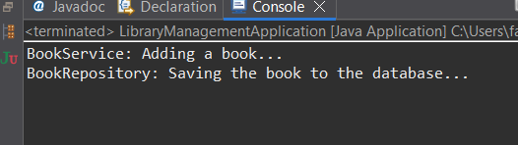

**Exercise 3: Implementing Logging with Spring AOP**

**applicationContext.xml**

<?xml version="1.0" encoding="UTF-8"?>

<beans xmlns="http://www.springframework.org/schema/beans"

xmlns:xsi="http://www.w3.org/2001/XMLSchema-instance"

xmlns:aop="http://www.springframework.org/schema/aop"

xsi:schemaLocation="

http://www.springframework.org/schema/beans

http://www.springframework.org/schema/beans/spring-beans.xsd

http://www.springframework.org/schema/aop

http://www.springframework.org/schema/aop/spring-aop.xsd">

<!-- Enable AOP -->

<aop:aspectj-autoproxy/>

<!-- Repository Bean -->

<bean id="bookRepository" class="com.library.repository.BookRepository"/>

<!-- Service Bean -->

<bean id="bookService" class="com.library.service.BookService">

<property name="bookRepository" ref="bookRepository"/>

</bean>

<!-- Logging Aspect Bean -->

<bean id="loggingAspect" class="com.library.aspect.LoggingAspect"/>

</beans>

**pom.xml**

<project xmlns="http://maven.apache.org/POM/4.0.0"

xmlns:xsi="http://www.w3.org/2001/XMLSchema-instance"

xsi:schemaLocation="http://maven.apache.org/POM/4.0.0

http://maven.apache.org/xsd/maven-4.0.0.xsd">

<modelVersion>4.0.0</modelVersion>

<groupId>com.library</groupId>

<artifactId>LibraryManagement</artifactId>

<version>1.0-SNAPSHOT</version>

<dependencies>

<!-- Spring Core -->

<dependency>

<groupId>org.springframework</groupId>

<artifactId>spring-context</artifactId>

<version>5.3.36</version>

</dependency>

<!-- Spring AOP -->

<dependency>

<groupId>org.springframework</groupId>

<artifactId>spring-aspects</artifactId>

<version>5.3.34</version> <!-- Match this with your Spring version -->

</dependency>

</dependencies>

</project>

**LoggingAspect.java**

package com.library.aspect;

import org.aspectj.lang.ProceedingJoinPoint;

import org.aspectj.lang.annotation.Around;

import org.aspectj.lang.annotation.Aspect;

*@Aspect*

public class LoggingAspect {

*@Around*("execution(* com.library.service.*.*(..))")

public Object logExecutionTime(ProceedingJoinPoint joinPoint) throws Throwable {

long start = System.*currentTimeMillis*();

Object result = joinPoint.proceed(); // Proceed to the actual method

long end = System.*currentTimeMillis*();

String methodName = joinPoint.getSignature().toShortString();

System.***out***.println(methodName + " executed in " + (end - start) + " ms");

return result;

}

}

**Ouput:**

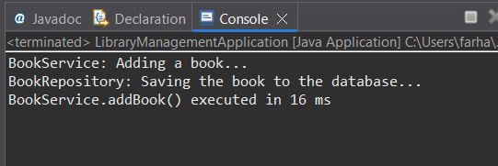

**Exercise 4: Creating and Configuring a Maven Project**

**pom.xml**

<project xmlns="http://maven.apache.org/POM/4.0.0"

xmlns:xsi="http://www.w3.org/2001/XMLSchema-instance"

xsi:schemaLocation="http://maven.apache.org/POM/4.0.0

http://maven.apache.org/xsd/maven-4.0.0.xsd">

<modelVersion>4.0.0</modelVersion>

<groupId>com.library</groupId>

<artifactId>LibraryManagement</artifactId>

<version>1.0-SNAPSHOT</version>

<packaging>jar</packaging>

<name>LibraryManagement</name>

<properties>

<java.version>1.8</java.version>

<spring.version>5.3.34</spring.version>

</properties>

<dependencies>

<!-- Spring Context -->

<dependency>

<groupId>org.springframework</groupId>

<artifactId>spring-context</artifactId>

<version>${spring.version}</version>

</dependency>

<!-- Spring AOP -->

<dependency>

<groupId>org.springframework</groupId>

<artifactId>spring-aspects</artifactId>

<version>${spring.version}</version>

</dependency>

<!-- Spring Web MVC -->

<dependency>

<groupId>org.springframework</groupId>

<artifactId>spring-webmvc</artifactId>

<version>${spring.version}</version>

</dependency>

<!-- JUnit for testing -->

<dependency>

<groupId>junit</groupId>

<artifactId>junit</artifactId>

<version>4.13.2</version>

<scope>test</scope>

</dependency>

</dependencies>

<build>

<plugins>

<!-- Maven Compiler Plugin -->

<plugin>

<groupId>org.apache.maven.plugins</groupId>

<artifactId>maven-compiler-plugin</artifactId>

<version>3.8.1</version>

<configuration>

<source>${java.version}</source>

<target>${java.version}</target>

</configuration>

</plugin>

</plugins>

</build>

</project>

**Exercise 5: Configuring the Spring IoC Container**

**applicationContext.xml**

<?xml version="1.0" encoding="UTF-8"?>

<beans xmlns="http://www.springframework.org/schema/beans"

xmlns:xsi="http://www.w3.org/2001/XMLSchema-instance"

xsi:schemaLocation="

http://www.springframework.org/schema/beans

http://www.springframework.org/schema/beans/spring-beans.xsd">

<!-- BookRepository Bean -->

<bean id="bookRepository" class="com.library.repository.BookRepository" />

<!-- BookService Bean with Setter Injection -->

<bean id="bookService" class="com.library.service.BookService">

<property name="bookRepository" ref="bookRepository" />

</bean>

</beans>

**BookService.java**

package com.library.service;

import com.library.repository.BookRepository;

public class BookService {

private BookRepository bookRepository;

// Setter for DI

public void setBookRepository(BookRepository bookRepository) {

this.bookRepository = bookRepository;

}

public void addBook() {

System.out.println("BookService: Adding a book...");

bookRepository.save();

}

}

**BookRepository.java**

package com.library.repository;

public class BookRepository {

public void save() {

System.out.println("BookRepository: Saving a book...");

}

}

**LibraryManagementApplication.java**

package com.library;

import org.springframework.context.ApplicationContext;

import org.springframework.context.support.ClassPathXmlApplicationContext;

import com.library.service.BookService;

public class LibraryManagementApplication {

public static void main(String[] args) {

ApplicationContext context = new ClassPathXmlApplicationContext("applicationContext.xml");

BookService bookService = context.getBean("bookService", BookService.class);

bookService.addBook();

}

}

**Output:**

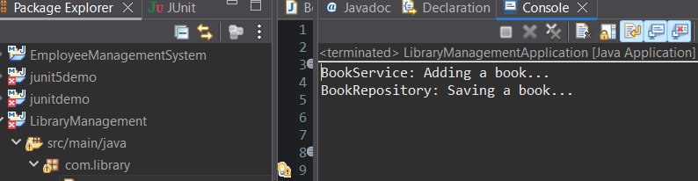

**Exercise 6: Configuring Beans with Annotations**

**applicationContext.xml**

<?xml version="1.0" encoding="UTF-8"?>

<beans xmlns="http://www.springframework.org/schema/beans"

xmlns:xsi="http://www.w3.org/2001/XMLSchema-instance"

xmlns:context="http://www.springframework.org/schema/context"

xsi:schemaLocation="

http://www.springframework.org/schema/beans

http://www.springframework.org/schema/beans/spring-beans.xsd

http://www.springframework.org/schema/context

http://www.springframework.org/schema/context/spring-context.xsd">

<!-- Enable annotation-based configuration -->

<context:component-scan base-package="com.library" />

</beans>

**BookService.java**

package com.library.service;

import com.library.repository.BookRepository;

import org.springframework.beans.factory.annotation.Autowired;

import org.springframework.stereotype.Service;

@Service

public class BookService {

private BookRepository bookRepository;

@Autowired

public void setBookRepository(BookRepository bookRepository) {

this.bookRepository = bookRepository;

}

public void addBook() {

System.out.println("BookService: Adding a book...");

bookRepository.save();

}

}

**BookRepository.java**

package com.library.repository;

import org.springframework.stereotype.Repository;

@Repository

public class BookRepository {

public void save() {

System.out.println("BookRepository: Saving a book...");

}

}

**LibraryManagementApplication.java**

package com.library;

import org.springframework.context.ApplicationContext;

import org.springframework.context.support.ClassPathXmlApplicationContext;

import com.library.service.BookService;

public class LibraryManagementApplication {

public static void main(String[] args) {

ApplicationContext context = new ClassPathXmlApplicationContext("applicationContext.xml");

BookService bookService = context.getBean("bookService", BookService.class);

bookService.addBook();

}

}

**Output:**

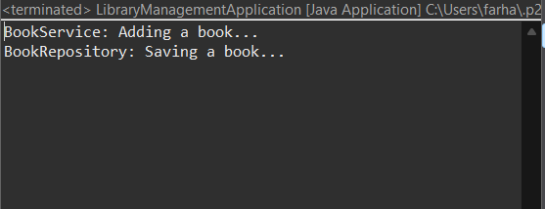

**Exercise 7: Implementing Constructor and Setter Injection**

**BookService.java**

package com.library.service;

import com.library.repository.BookRepository;

public class BookService {

private BookRepository bookRepository;

// Constructor for constructor injection

public BookService(BookRepository bookRepository) {

this.bookRepository = bookRepository;

System.out.println("BookService: Constructor injection used.");

}

// Setter for setter injection

public void setBookRepository(BookRepository bookRepository) {

this.bookRepository = bookRepository;

System.out.println("BookService: Setter injection used.");

}

public void addBook() {

System.out.println("BookService: Adding a book...");

bookRepository.save();

}

}

**applicationContext.xml**

<?xml version="1.0" encoding="UTF-8"?>

<beans xmlns="http://www.springframework.org/schema/beans"

xmlns:xsi="http://www.w3.org/2001/XMLSchema-instance"

xsi:schemaLocation="

http://www.springframework.org/schema/beans

http://www.springframework.org/schema/beans/spring-beans.xsd">

<!-- BookRepository Bean -->

<bean id="bookRepository" class="com.library.repository.BookRepository" />

<!-- BookService Bean with constructor and setter injection -->

<bean id="bookService" class="com.library.service.BookService">

<!-- Constructor Injection -->

<constructor-arg ref="bookRepository" />

<!-- Setter Injection -->

<property name="bookRepository" ref="bookRepository" />

</bean>

</beans>

**LibraryManagementApplication.java**

package com.library;

import org.springframework.context.ApplicationContext;

import org.springframework.context.support.ClassPathXmlApplicationContext;

import com.library.service.BookService;

public class LibraryManagementApplication {

public static void main(String[] args) {

ApplicationContext context = new ClassPathXmlApplicationContext("applicationContext.xml");

BookService bookService = context.getBean("bookService", BookService.class);

bookService.addBook();

}

}

**Output:**

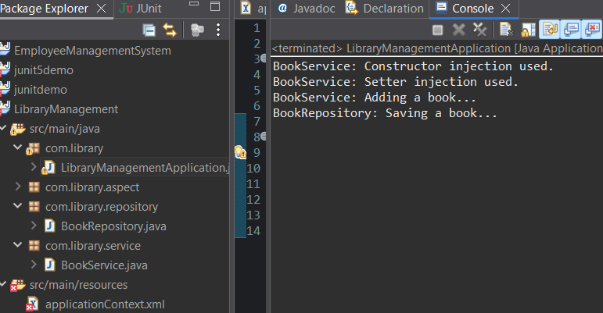

**Exercise 8: Implementing Basic AOP with Spring**

**applicationContext.xml**

<?xml version="1.0" encoding="UTF-8"?>

<beans xmlns="http://www.springframework.org/schema/beans"

xmlns:xsi="http://www.w3.org/2001/XMLSchema-instance"

xsi:schemaLocation="

http://www.springframework.org/schema/beans

http://www.springframework.org/schema/beans/spring-beans.xsd">

<!-- Repository Bean -->

<bean id="bookRepository" class="com.library.repository.BookRepository" />

<!-- BookService with constructor and setter injection -->

<bean id="bookService" class="com.library.service.BookService">

<!-- Constructor injection -->

<constructor-arg ref="bookRepository" />

<!-- Setter injection (redundant for demo, but included per your exercise) -->

<property name="bookRepository" ref="bookRepository" />

</bean>

</beans>

**BookService.java**

package com.library.service;

import com.library.repository.BookRepository;

public class BookService {

private BookRepository bookRepository;

// ✅ Constructor Injection

public BookService(BookRepository bookRepository) {

this.bookRepository = bookRepository;

System.out.println("Constructor injection: BookRepository injected");

}

// ✅ Default Constructor (required for setter injection or XML <bean> without constructor-arg)

public BookService() {

System.out.println("Default constructor called");

}

// ✅ Setter Injection

public void setBookRepository(BookRepository bookRepository) {

this.bookRepository = bookRepository;

System.out.println("Setter injection: BookRepository injected");

}

public void addBook() {

System.out.println("BookService: Adding book...");

bookRepository.save();

}

}

**BookRepository.java**

package com.library.repository;

public class BookRepository {

public void save() {

System.out.println("BookRepository: Saving book...");

}

}

**LibraryManagementApplication.java**

package com.library;

import org.springframework.context.ApplicationContext;

import org.springframework.context.support.ClassPathXmlApplicationContext;

import com.library.service.BookService;

public class LibraryManagementApplication {

public static void main(String[] args) {

ApplicationContext context = new ClassPathXmlApplicationContext("applicationContext.xml");

BookService bookService = context.getBean("bookService", BookService.class);

bookService.addBook();

}

}

**Output:**

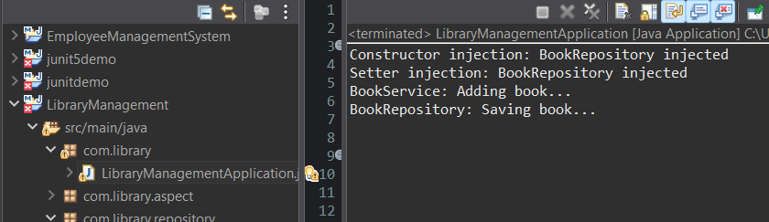

**Exercise 8: Implementing Basic AOP with Spring**

**LoggingAspect.java**

package com.library.aspect;

import org.aspectj.lang.JoinPoint;

public class LoggingAspect {

// Before Advice

public void beforeAdvice(JoinPoint joinPoint) {

System.out.println("LOG: Before method " + joinPoint.getSignature().getName());

}

// After Advice

public void afterAdvice(JoinPoint joinPoint) {

System.out.println("LOG: After method " + joinPoint.getSignature().getName());

}

}

**applicationContext.xml**

<?xml version="1.0" encoding="UTF-8"?>

<beans xmlns="http://www.springframework.org/schema/beans"

xmlns:aop="http://www.springframework.org/schema/aop"

xmlns:xsi="http://www.w3.org/2001/XMLSchema-instance"

xsi:schemaLocation="

http://www.springframework.org/schema/beans

http://www.springframework.org/schema/beans/spring-beans.xsd

http://www.springframework.org/schema/aop

http://www.springframework.org/schema/aop/spring-aop.xsd">

<!-- Enable AOP -->

<aop:aspectj-autoproxy />

<!-- Repository Bean -->

<bean id="bookRepository" class="com.library.repository.BookRepository" />

<!-- Service Bean -->

<bean id="bookService" class="com.library.service.BookService">

<constructor-arg ref="bookRepository" />

<property name="bookRepository" ref="bookRepository" />

</bean>

<!-- Aspect Bean -->

<bean id="loggingAspect" class="com.library.aspect.LoggingAspect" />

<!-- AOP Configuration -->

<aop:config>

<aop:aspect ref="loggingAspect">

<!-- Pointcut for all methods in BookService -->

<aop:pointcut id="bookServiceMethods"

expression="execution(* com.library.service.BookService.*(..))" />

<!-- Before advice -->

<aop:before method="beforeAdvice" pointcut-ref="bookServiceMethods" />

<!-- After advice -->

<aop:after method="afterAdvice" pointcut-ref="bookServiceMethods" />

</aop:aspect>

</aop:config>

</beans>

**LibraryManagementApplication.java**

package com.library;

import org.springframework.context.ApplicationContext;

import org.springframework.context.support.ClassPathXmlApplicationContext;

import com.library.service.BookService;

public class LibraryManagementApplication {

public static void main(String[] args) {

ApplicationContext context = new ClassPathXmlApplicationContext("applicationContext.xml");

BookService bookService = context.getBean("bookService", BookService.class);

bookService.addBook(); // AOP will trigger here

}

}

**Output:**

