**Hands on 1 Create a Spring Web Project using Maven**

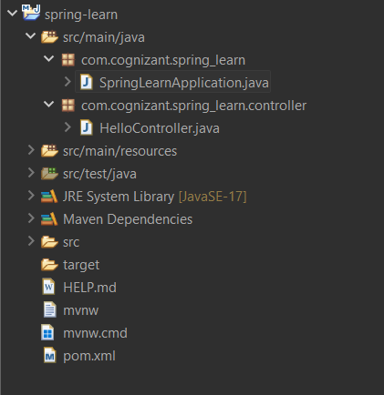

**SpringLearnApplication.java**

package com.cognizant.spring_learn;

import org.springframework.boot.SpringApplication;

import org.springframework.boot.autoconfigure.SpringBootApplication;

*@SpringBootApplication*

public class SpringLearnApplication {

public static void main(String[] args) {

SpringApplication.*run*(SpringLearnApplication.class, args);

}

}

**HelloController.java**

package com.cognizant.spring_learn.controller;

import org.springframework.web.bind.annotation.GetMapping;

import org.springframework.web.bind.annotation.RestController;

*@RestController*

public class HelloController {

*@GetMapping*("/")

public String hello() {

return "Spring Boot is working!";

}

}

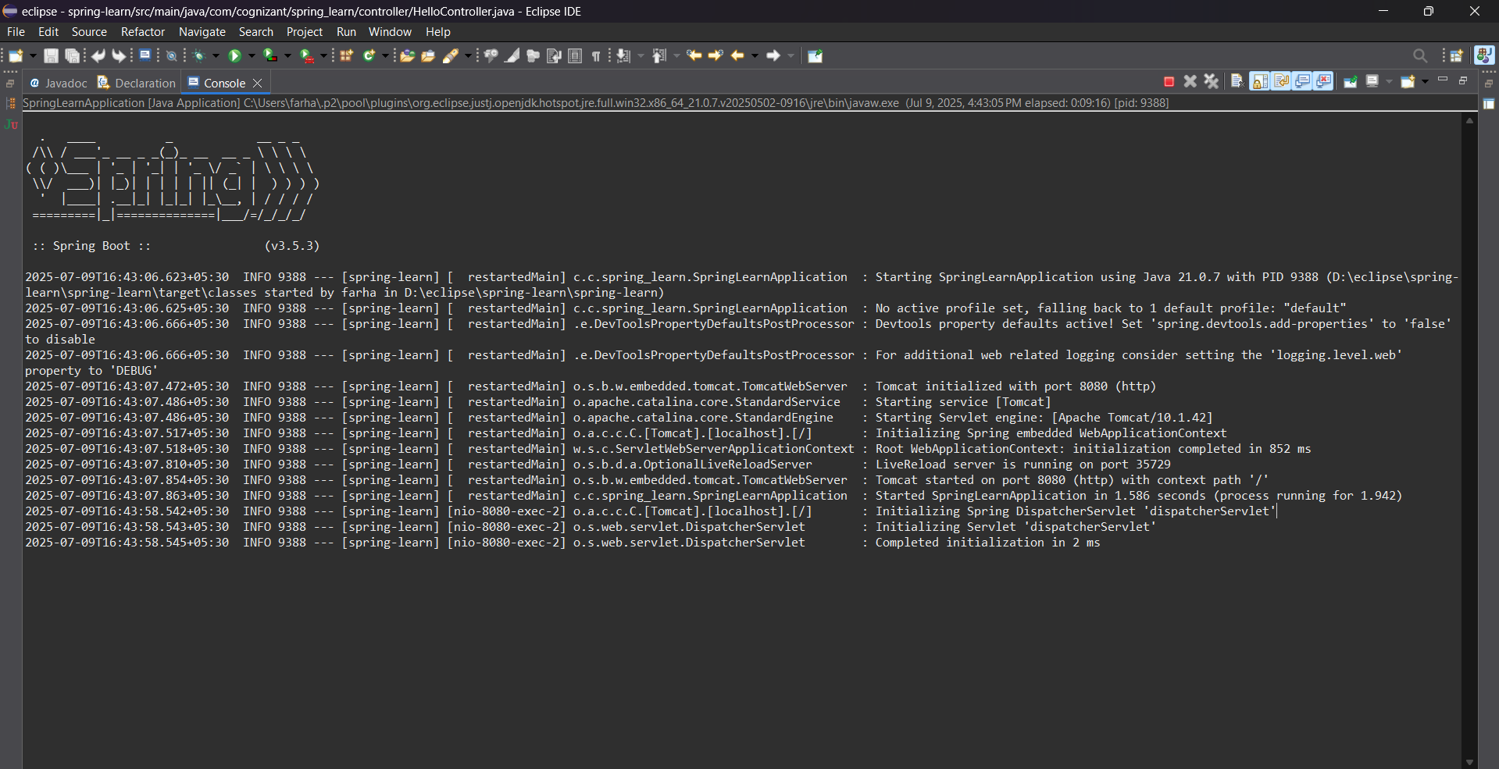**Output**

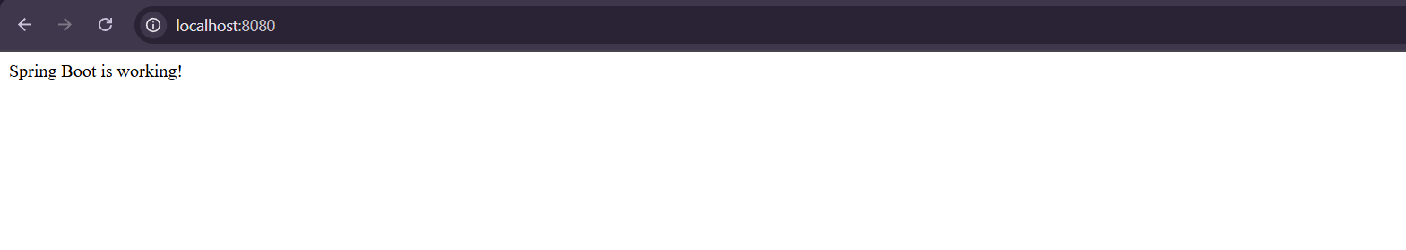

**Hands on 2 Spring Core – Load SimpleDateFormat from Spring Configuration XML**

**SpringLearningApplication.java**

package com.cognizant.spring_learn;

import java.text.SimpleDateFormat;

import java.util.Date;

import org.springframework.context.ApplicationContext;

import org.springframework.context.support.ClassPathXmlApplicationContext;

import org.springframework.boot.SpringApplication;

import org.springframework.boot.autoconfigure.SpringBootApplication;

*@SpringBootApplication*

public class SpringLearnApplication {

public static void main(String[] args) {

SpringApplication.*run*(SpringLearnApplication.class, args);

*displayDate*();

}

public static void displayDate() {

ApplicationContext context = new ClassPathXmlApplicationContext("date-format.xml");

SimpleDateFormat format = context.getBean("dateFormat", SimpleDateFormat.class);

try {

Date date = format.parse("31/12/2018");

System.***out***.println("Parsed Date: " + date);

} catch (Exception e) {

e.printStackTrace();

}

}

}

**date-format.xml**

<?xml version="1.0" encoding="UTF-8"?>

<beans xmlns="http://www.springframework.org/schema/beans"

xmlns:xsi="http://www.w3.org/2001/XMLSchema-instance"

xsi:schemaLocation="http://www.springframework.org/schema/beans

http://www.springframework.org/schema/beans/spring-beans.xsd">

<bean id="dateFormat" class="java.text.SimpleDateFormat">

<constructor-arg value="dd/MM/yyyy" />

</bean>

</beans>

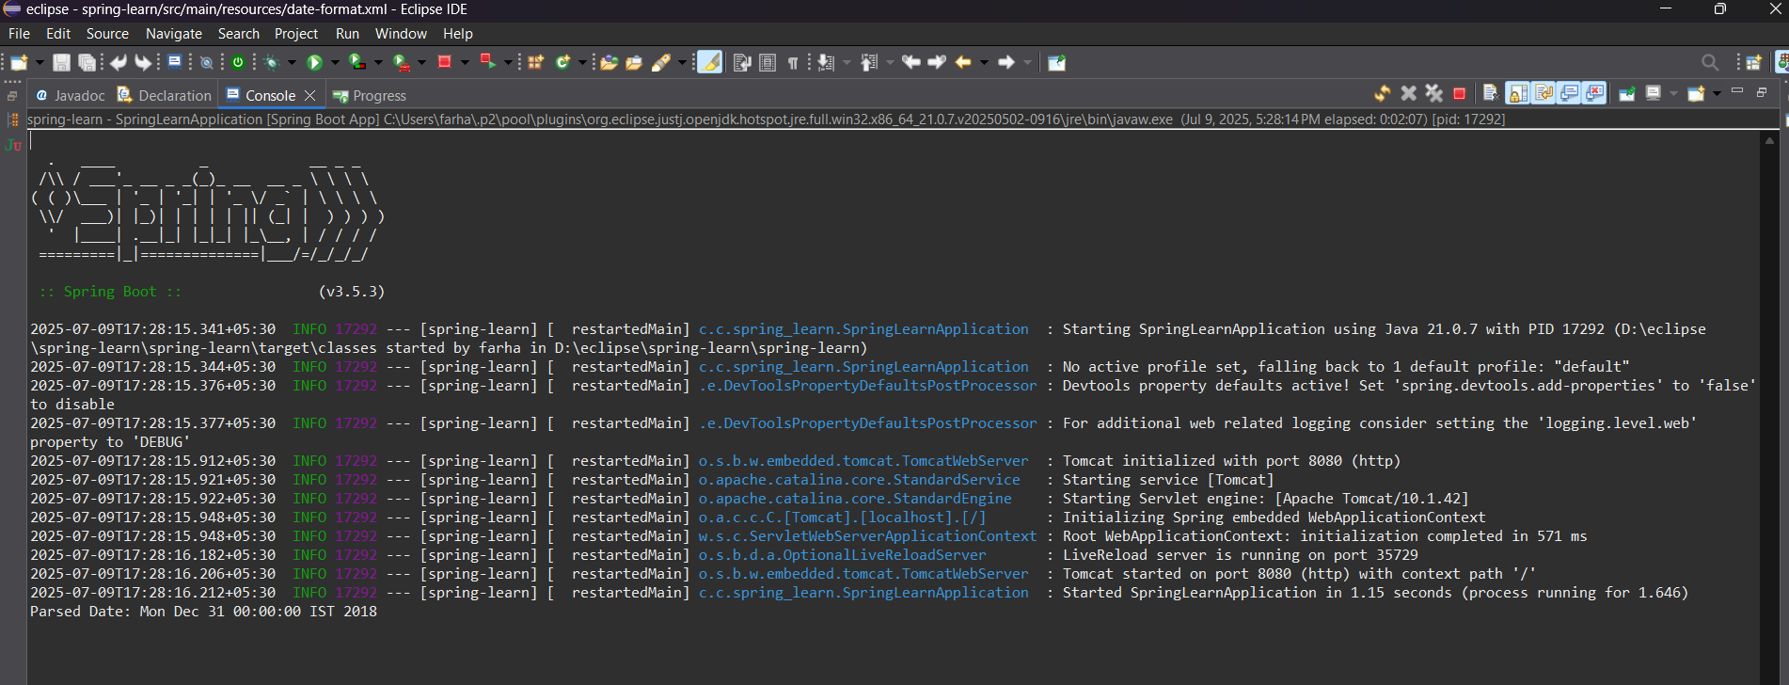**Output:**

**Hands on 3 Spring Core - Incorporate Logging**

**SpringLearningApplication.java**

package com.cognizant.spring_learn;

import java.text.ParseException;

import java.text.SimpleDateFormat;

import java.util.Date;

import org.slf4j.Logger;

import org.slf4j.LoggerFactory;

import org.springframework.boot.SpringApplication;

import org.springframework.boot.autoconfigure.SpringBootApplication;

import org.springframework.context.ApplicationContext;

import org.springframework.context.support.ClassPathXmlApplicationContext;

*@SpringBootApplication*

public class SpringLearnApplication {

private static final Logger ***LOGGER*** = LoggerFactory.*getLogger*(SpringLearnApplication.class);

public static void main(String[] args) throws ParseException {

***LOGGER***.info("START");

SpringApplication.*run*(SpringLearnApplication.class, args);

*displayDate*();

***LOGGER***.info("END");

}

public static void displayDate() throws ParseException {

***LOGGER***.info("START");

ApplicationContext context = new ClassPathXmlApplicationContext("date-format.xml");

SimpleDateFormat format = context.getBean("dateFormat", SimpleDateFormat.class);

Date date = format.parse("31/12/2018");

***LOGGER***.debug("Parsed Date: {}", date);

***LOGGER***.info("END");

}

}

**application.properties**

spring.application.name=spring-learn

logging.level.org.springframework=info

logging.level.com.cognizant.springlearn=debug

logging.pattern.console=%d{yyMMdd}|%d{HH:mm:ss.SSS}|%-20.20thread|%5p|%-25.25logger**{25}**|%25M|%m%n

**Output:**

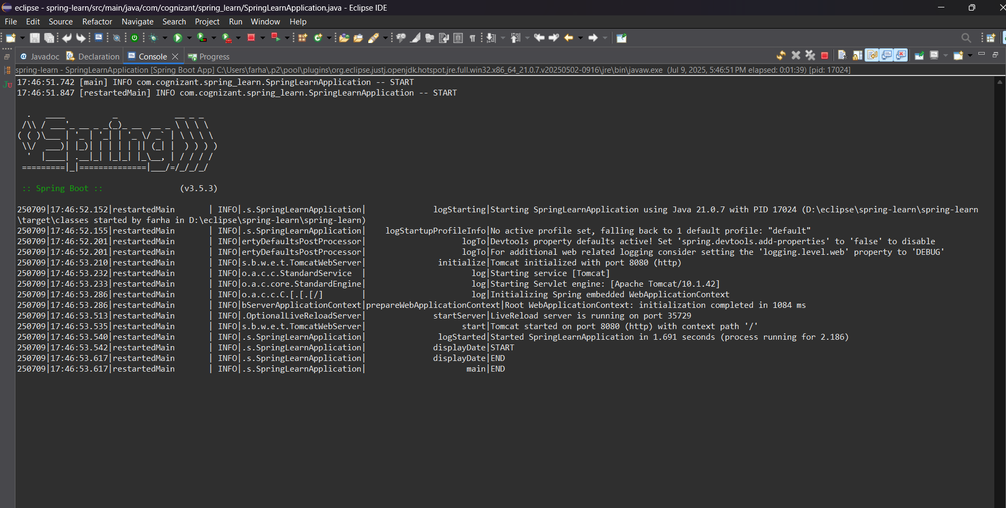

**Hands on 4 Spring Core – Load Country from Spring Configuration XML**

**SpringLearnApplication.java**

package com.cognizant.spring_learn;

import com.cognizant.spring_learn.Country;

import org.slf4j.Logger;

import org.slf4j.LoggerFactory;

import org.springframework.context.ApplicationContext;

import org.springframework.context.support.ClassPathXmlApplicationContext;

import org.springframework.boot.SpringApplication;

import org.springframework.boot.autoconfigure.SpringBootApplication;

*@SpringBootApplication*

public class SpringLearnApplication {

private static final Logger ***LOGGER*** = LoggerFactory.*getLogger*(SpringLearnApplication.class);

public static void main(String[] args) {

SpringApplication.*run*(SpringLearnApplication.class, args);

*displayCountry*();

}

public static void displayCountry() {

ApplicationContext context = new ClassPathXmlApplicationContext("country.xml");

Country country = context.getBean("country", Country.class);

***LOGGER***.debug("Country : {}", country.toString());

}

}

**Country.java**

package com.cognizant.spring_learn;

import org.slf4j.Logger;

import org.slf4j.LoggerFactory;

public class Country {

private static final Logger ***LOGGER*** = LoggerFactory.*getLogger*(Country.class);

private String code;

private String name;

public Country() {

***LOGGER***.debug("Inside Country Constructor.");

}

public String getCode() {

***LOGGER***.debug("Getting country code: {}", code);

return code;

}

public void setCode(String code) {

***LOGGER***.debug("Setting country code: {}", code);

this.code = code;

}

public String getName() {

***LOGGER***.debug("Getting country name: {}", name);

return name;

}

public void setName(String name) {

***LOGGER***.debug("Setting country name: {}", name);

this.name = name;

}

*@Override*

public String toString() {

return "Country [code=" + code + ", name=" + name + "]";

}

}

**country.xml**

<?xml version="1.0" encoding="UTF-8"?>

<beans xmlns="http://www.springframework.org/schema/beans"

xmlns:xsi="http://www.w3.org/2001/XMLSchema-instance"

xsi:schemaLocation="http://www.springframework.org/schema/beans

https://www.springframework.org/schema/beans/spring-beans.xsd">

<bean id="country" class="com.cognizant.spring_learn.Country">

<property name="code" value="IN"/>

<property name="name" value="India"/>

</bean>

</beans>

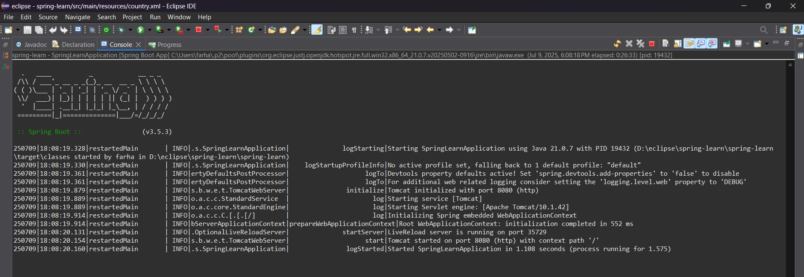**Output:**

**Hands on 5 Spring Core – Demonstration of Singleton Scope and Prototype Scope**

**SpringLearningApplication.java**

package com.cognizant.spring_learn;

import org.springframework.context.ApplicationContext;

import org.springframework.context.support.ClassPathXmlApplicationContext;

public class SpringLearnApplication {

public static void main(String[] args) {

*displayCountry*();

}

public static void displayCountry() {

ApplicationContext context = new ClassPathXmlApplicationContext("country.xml");

Country country = context.getBean("country", Country.class);

Country anotherCountry = context.getBean("country", Country.class);

System.***out***.println("Country Bean 1: " + country);

System.***out***.println("Country Bean 2: " + anotherCountry);

System.***out***.println("Are both beans same? " + (country == anotherCountry));

}

}

**Country.java**

package com.cognizant.spring_learn;

import org.slf4j.Logger;

import org.slf4j.LoggerFactory;

public class Country {

private static final Logger ***LOGGER*** = LoggerFactory.*getLogger*(Country.class);

private String code;

private String name;

public Country() {

***LOGGER***.debug("Inside Country Constructor.");

}

public String getCode() {

***LOGGER***.debug("Getting country code: {}", code);

return code;

}

public void setCode(String code) {

***LOGGER***.debug("Setting country code: {}", code);

this.code = code;

}

public String getName() {

***LOGGER***.debug("Getting country name: {}", name);

return name;

}

public void setName(String name) {

***LOGGER***.debug("Setting country name: {}", name);

this.name = name;

}

*@Override*

public String toString() {

return "Country [code=" + code + ", name=" + name + "]";

}

}

**country.xml**

<?xml version="1.0" encoding="UTF-8"?>

<beans xmlns="http://www.springframework.org/schema/beans"

xmlns:xsi="http://www.w3.org/2001/XMLSchema-instance"

xsi:schemaLocation="http://www.springframework.org/schema/beans

http://www.springframework.org/schema/beans/spring-beans.xsd">

<bean id="country" class="com.cognizant.spring_learn.Country">

<property name="code" value="IN"/>

<property name="name" value="India"/>

</bean>

</beans>

**Output:**

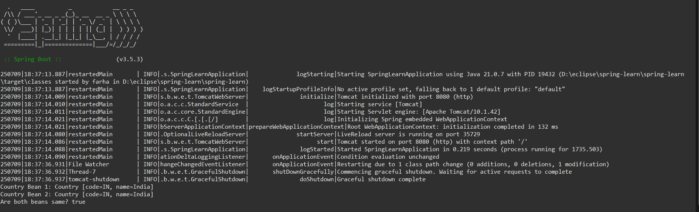

**Hands on 6 Spring Core – Load list of countries from Spring Configuration XML**

**Country.java**

package com.cognizant.spring_learn;

import org.slf4j.Logger;

import org.slf4j.LoggerFactory;

public class Country {

private static final Logger ***LOGGER*** = LoggerFactory.*getLogger*(Country.class);

private String code;

private String name;

public Country() {

***LOGGER***.debug("Inside Country Constructor.");

}

public String getCode() {

***LOGGER***.debug("Getting country code: {}", code);

return code;

}

public void setCode(String code) {

***LOGGER***.debug("Setting country code: {}", code);

this.code = code;

}

public String getName() {

***LOGGER***.debug("Getting country name: {}", name);

return name;

}

public void setName(String name) {

***LOGGER***.debug("Setting country name: {}", name);

this.name = name;

}

*@Override*

public String toString() {

return "Country [code=" + code + ", name=" + name + "]";

}

}

**country.xml**

<?xml version="1.0" encoding="UTF-8"?>

<beans xmlns="http://www.springframework.org/schema/beans"

xmlns:xsi="http://www.w3.org/2001/XMLSchema-instance"

xsi:schemaLocation="http://www.springframework.org/schema/beans

http://www.springframework.org/schema/beans/spring-beans.xsd">

<bean id="in" class="com.cognizant.spring_learn.Country">

<property name="code" value="IN"/>

<property name="name" value="India"/>

</bean>

<bean id="us" class="com.cognizant.spring_learn.Country">

<property name="code" value="US"/>

<property name="name" value="United States"/>

</bean>

<bean id="de" class="com.cognizant.spring_learn.Country">

<property name="code" value="DE"/>

<property name="name" value="Germany"/>

</bean>

<bean id="jp" class="com.cognizant.spring_learn.Country">

<property name="code" value="JP"/>

<property name="name" value="Japan"/>

</bean>

<bean id="countryList" class="java.util.ArrayList">

<constructor-arg>

<list>

<ref bean="in"/>

<ref bean="us"/>

<ref bean="de"/>

<ref bean="jp"/>

</list>

</constructor-arg>

</bean>

</beans>

**SpringLearningApplication.java**

package com.cognizant.spring_learn;

import java.util.List;

import org.slf4j.Logger;

import org.slf4j.LoggerFactory;

import org.springframework.context.ApplicationContext;

import org.springframework.context.support.ClassPathXmlApplicationContext;

public class SpringLearnApplication {

private static final Logger LOGGER = LoggerFactory.getLogger(SpringLearnApplication.class);

public static void main(String[] args) {

displayCountries();

}

public static void displayCountries() {

LOGGER.debug("START");

ApplicationContext context = new ClassPathXmlApplicationContext("country.xml");

List<Country> countryList = context.getBean("countryList", List.class);

LOGGER.debug("Country List: {}", countryList);

LOGGER.debug("END");

}

}

**Output:**

