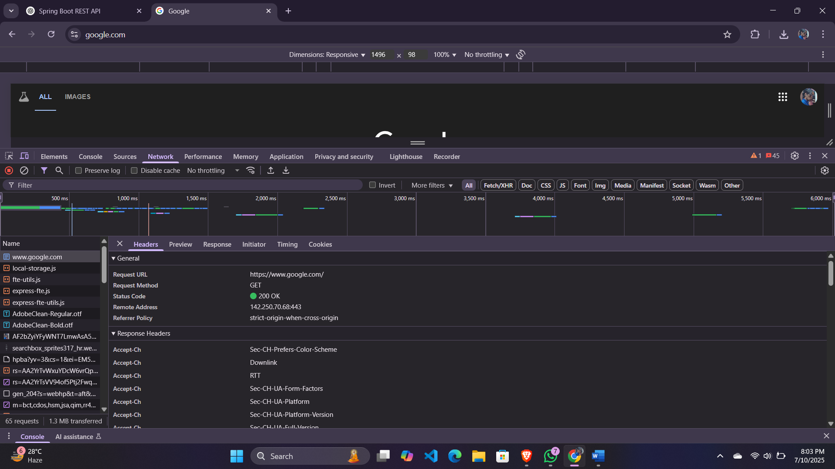**HTTP Request Response**

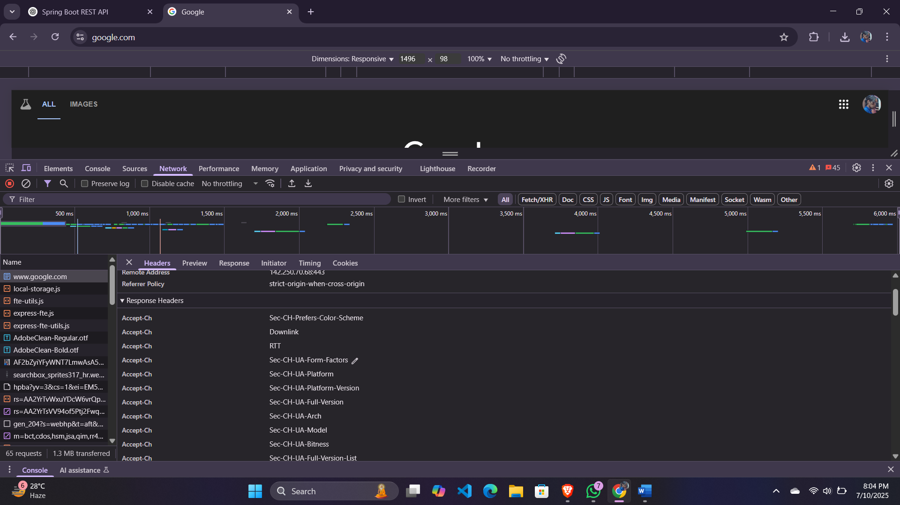

**Hello World RESTful Web Service**

**SpringLearnApplication.java**

package com.cognizant.spring_learn;

import org.springframework.boot.SpringApplication;

import org.springframework.boot.autoconfigure.SpringBootApplication;

@SpringBootApplication

public class SpringLearnApplication {

public static void main(String[] args) {

SpringApplication.run(SpringLearnApplication.class, args);

}

}

**HelloController.java**

package com.cognizant.spring_learn.controller;

import org.slf4j.Logger;

import org.slf4j.LoggerFactory;

import org.springframework.web.bind.annotation.GetMapping;

import org.springframework.web.bind.annotation.RestController;

@RestController

public class HelloController {

private static final Logger LOGGER = LoggerFactory.getLogger(HelloController.class);

@GetMapping("/hello")

public String sayHello() {

LOGGER.info("START - sayHello()");

LOGGER.info("END - sayHello()");

return "Hello World!!";

}

}

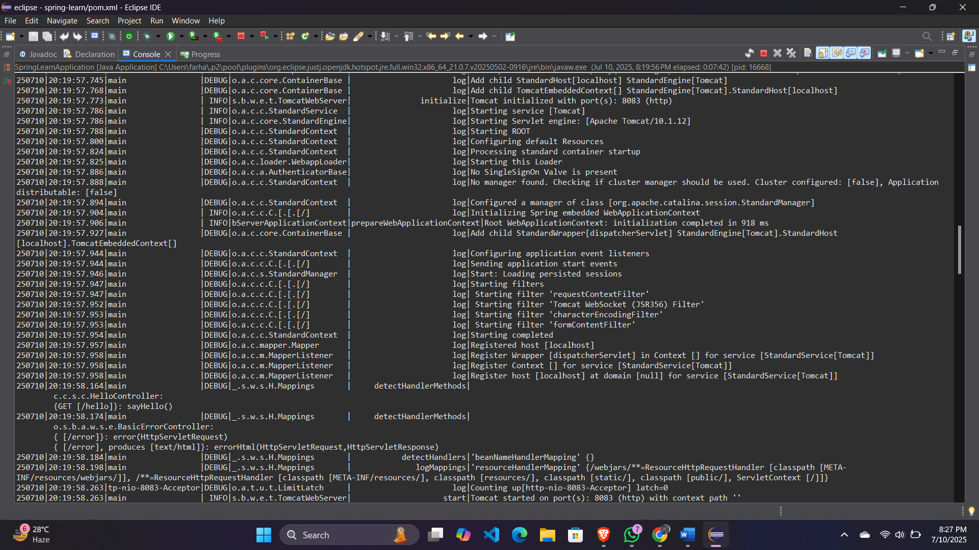**Output:**

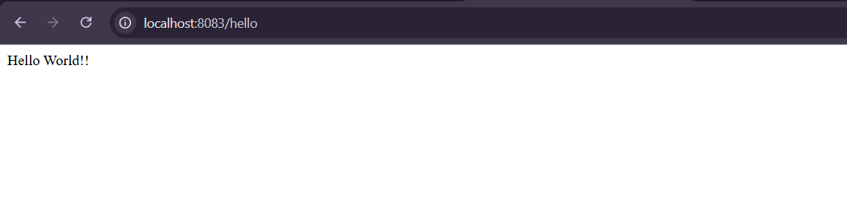

**REST - Country Web Service**

**CountryController.java**

package com.cognizant.spring_learn.controller;

import com.cognizant.spring_learn.Country;

import org.slf4j.Logger;

import org.slf4j.LoggerFactory;

import org.springframework.context.support.ClassPathXmlApplicationContext;

import org.springframework.web.bind.annotation.RequestMapping;

import org.springframework.web.bind.annotation.RestController;

@RestController

public class CountryController {

private static final Logger LOGGER = LoggerFactory.getLogger(CountryController.class);

@RequestMapping("/country")

public Country getCountryIndia() {

LOGGER.info("START - getCountryIndia()");

ClassPathXmlApplicationContext context = new ClassPathXmlApplicationContext("country.xml");

Country in = (Country) context.getBean("country");

LOGGER.info("END - getCountryIndia()");

return in;

}

}

**country.xml**

<?xml version="1.0" encoding="UTF-8"?>

<beans xmlns="http://www.springframework.org/schema/beans"

xmlns:xsi="http://www.w3.org/2001/XMLSchema-instance"

xsi:schemaLocation="http://www.springframework.org/schema/beans

http://www.springframework.org/schema/beans/spring-beans.xsd">

<bean id="country" class="com.cognizant.spring_learn.model.Country">

<property name="code" value="IN"/>

<property name="name" value="India"/>

</bean>

</beans>

**Country.java**

package com.cognizant.spring.model;

public class Country {

private String code;

private String name;

public Country() {}

public Country(String code, String name) {

this.code = code;

this.name = name;

}

public String getCode() { return code; }

public void setCode(String code) { this.code = code; }

public String getName() { return name; }

public void setName(String name) { this.name = name; }

}

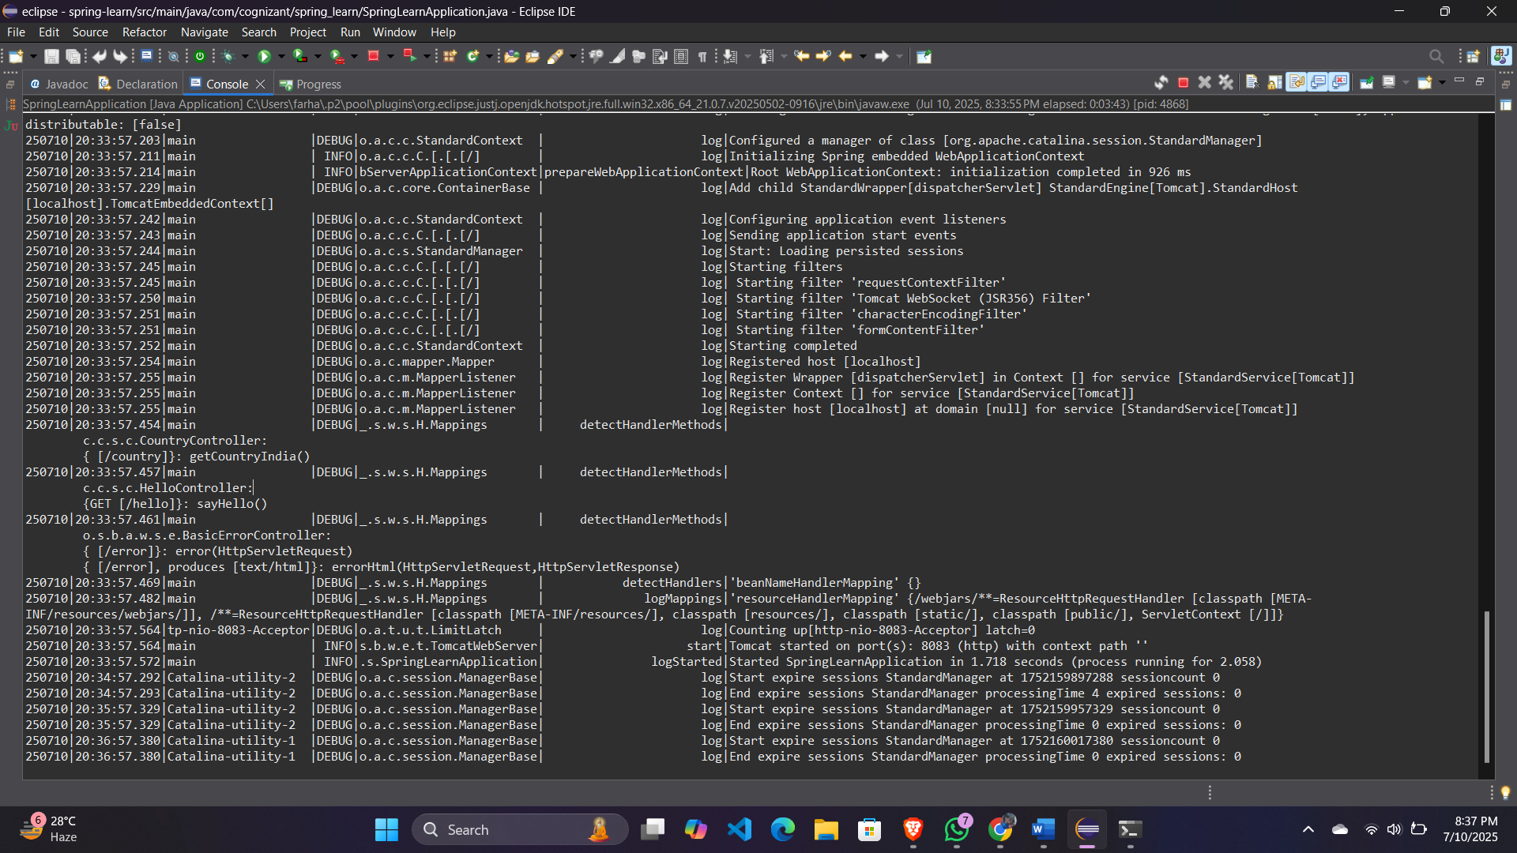**Output:**

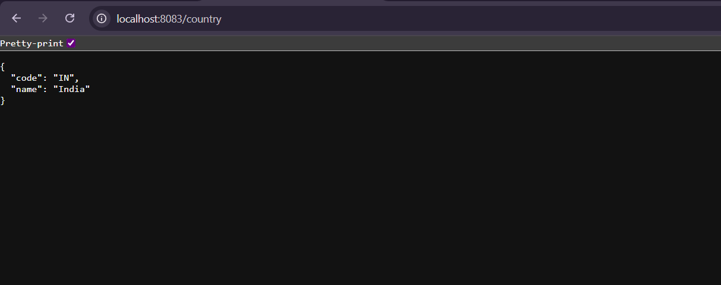

**REST - Get all countries**

**CountryController.java**

package com.cognizant.spring_learn.controller;

import com.cognizant.spring_learn.Country;

import org.slf4j.Logger;

import org.slf4j.LoggerFactory;

import org.springframework.context.support.ClassPathXmlApplicationContext;

import org.springframework.web.bind.annotation.GetMapping;

import org.springframework.web.bind.annotation.RequestMapping;

import org.springframework.web.bind.annotation.RestController;

import java.util.List;

@RestController

public class CountryController {

private static final Logger LOGGER = LoggerFactory.getLogger(CountryController.class);

@RequestMapping("/country")

public Country getCountryIndia() {

LOGGER.info("START - getCountryIndia()");

ClassPathXmlApplicationContext context = new ClassPathXmlApplicationContext("country.xml");

Country in = (Country) context.getBean("country");

LOGGER.info("END - getCountryIndia()");

return in;

}

@GetMapping("/countries")

public List<Country> getAllCountries() {

LOGGER.info("START - getAllCountries()");

ClassPathXmlApplicationContext context = new ClassPathXmlApplicationContext("country.xml");

List<Country> list = (List<Country>) context.getBean("countryList");

LOGGER.info("END - getAllCountries()");

return list;

}

}

**country.xml**

<?xml version="1.0" encoding="UTF-8"?>

<beans xmlns="http://www.springframework.org/schema/beans"

xmlns:xsi="http://www.w3.org/2001/XMLSchema-instance"

xsi:schemaLocation="http://www.springframework.org/schema/beans

http://www.springframework.org/schema/beans/spring-beans.xsd">

<bean id="country" class="com.cognizant.spring_learn.Country">

<property name="code" value="IN"/>

<property name="name" value="India"/>

</bean>

<bean id="countryList" class="java.util.ArrayList">

<constructor-arg>

<list>

<ref bean="country"/>

<bean class="com.cognizant.spring_learn.Country">

<property name="code" value="US"/>

<property name="name" value="United States"/>

</bean>

<bean class="com.cognizant.spring_learn.Country">

<property name="code" value="JP"/>

<property name="name" value="Japan"/>

</bean>

<bean class="com.cognizant.spring_learn.Country">

<property name="code" value="DE"/>

<property name="name" value="Germany"/>

</bean>

</list>

</constructor-arg>

</bean>

</beans>

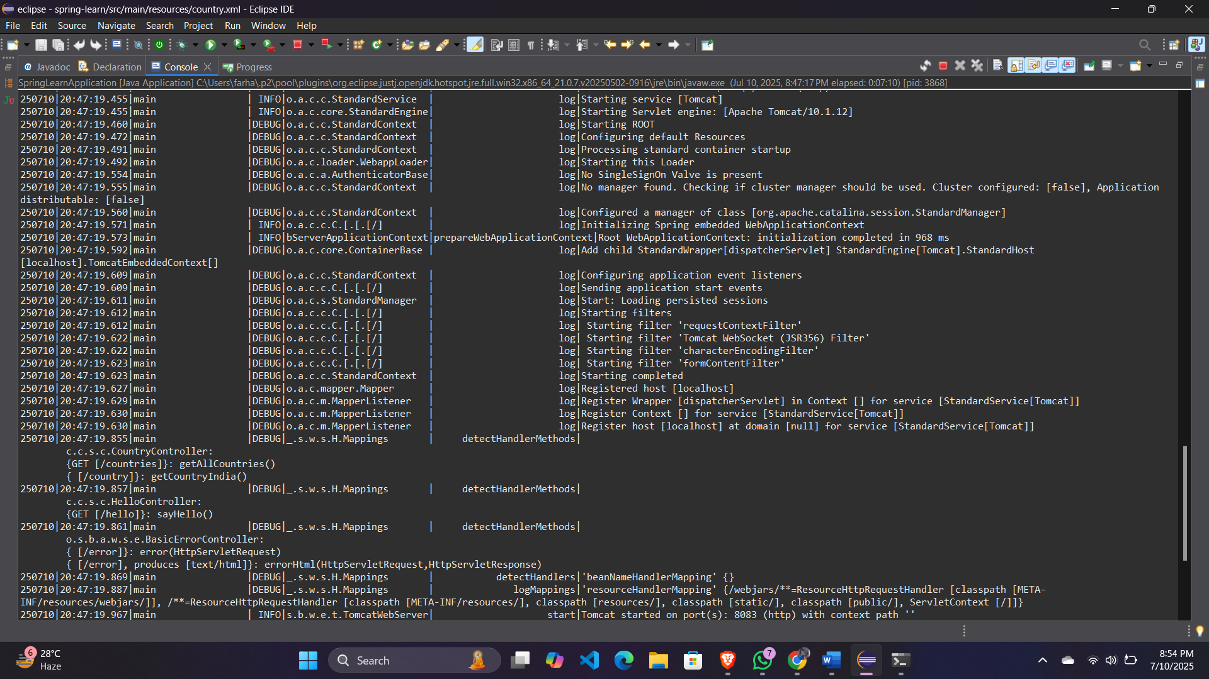**Output:**

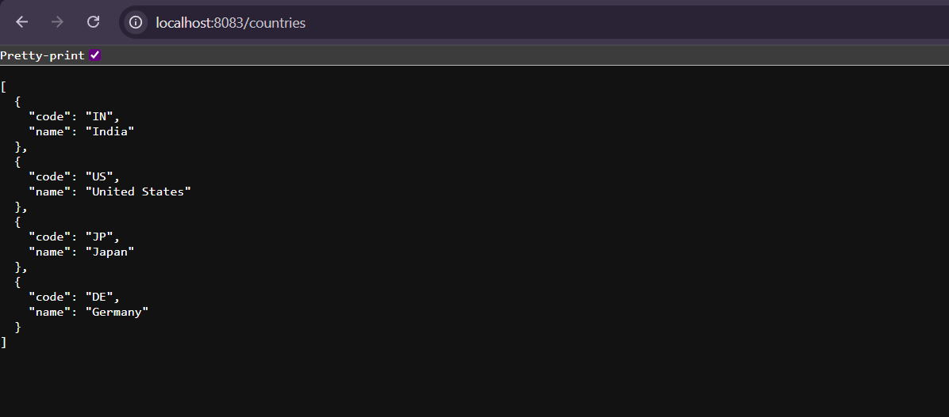

**REST - Get country based on country code**

**CountryService.java**

package com.cognizant.spring_learn.service;

import com.cognizant.spring_learn.Country;

import com.cognizant.spring_learn.service.exception.CountryNotFoundException;

import org.springframework.context.support.ClassPathXmlApplicationContext;

import org.springframework.stereotype.Service;

import java.util.List;

@Service

public class CountryService {

public Country getCountry(String code) throws CountryNotFoundException {

ClassPathXmlApplicationContext context = new ClassPathXmlApplicationContext("country.xml");

List<Country> countries = (List<Country>) context.getBean("countryList");

// Lambda to find country (case insensitive)

return countries.stream()

.filter(c -> c.getCode().equalsIgnoreCase(code))

.findFirst()

.orElseThrow(() -> new CountryNotFoundException("Country with code " + code + " not found"));

}

}

**CountryNotFoundException.java**

package com.cognizant.spring_learn.service.exception;

import org.springframework.http.HttpStatus;

import org.springframework.web.bind.annotation.ResponseStatus;

@ResponseStatus(value = HttpStatus.NOT_FOUND, reason = "Country Not Found")

public class CountryNotFoundException extends Exception {

public CountryNotFoundException(String message) {

super(message);

}

}

**CountryController.java**

@GetMapping("/countries/{code}")

public Country getCountry(@PathVariable String code) throws CountryNotFoundException {

LOGGER.info("START - getCountry()");

Country country = countryService.getCountry(code);

LOGGER.info("END - getCountry()");

return country;

}

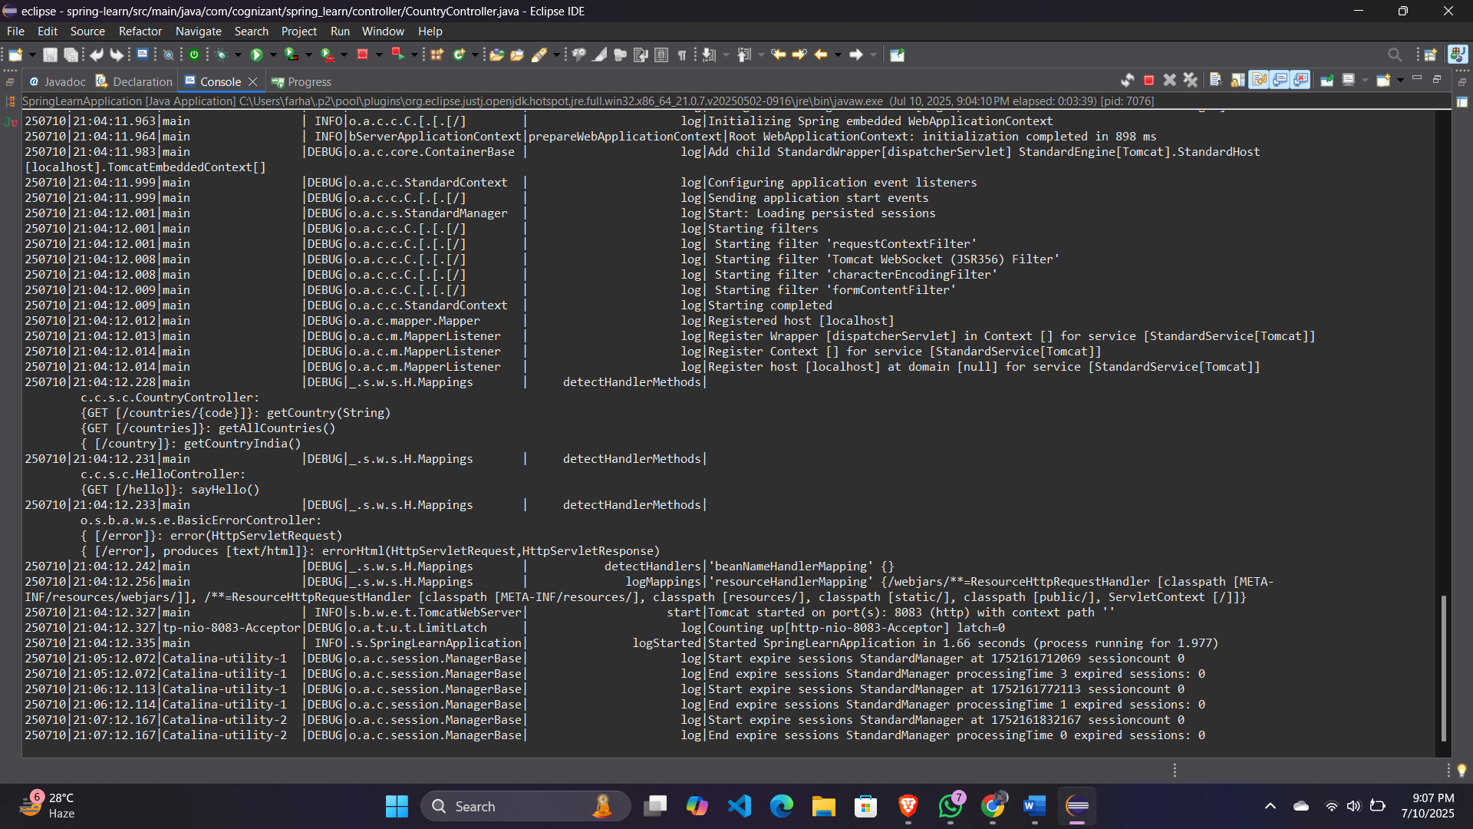**Output:**

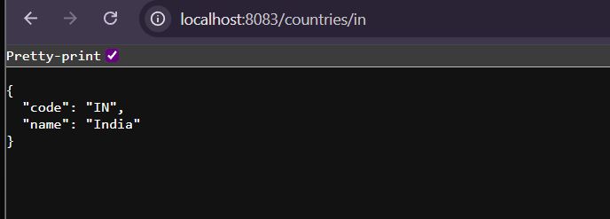

**MockMVC - Test get country service**

package com.cognizant.spring_learn;

import com.cognizant.spring_learn.controller.CountryController;

import org.junit.jupiter.api.Test;

import org.springframework.beans.factory.annotation.Autowired;

import org.springframework.boot.test.autoconfigure.web.servlet.AutoConfigureMockMvc;

import org.springframework.boot.test.context.SpringBootTest;

import org.springframework.test.web.servlet.MockMvc;

import org.springframework.test.web.servlet.ResultActions;

import static org.junit.jupiter.api.Assertions.assertNotNull;

import static org.springframework.test.web.servlet.request.MockMvcRequestBuilders.get;

import static org.springframework.test.web.servlet.result.MockMvcResultMatchers.status;

import static org.springframework.test.web.servlet.result.MockMvcResultMatchers.jsonPath;

@SpringBootTest

@AutoConfigureMockMvc

public class SpringLearnApplicationTests {

@Autowired

private CountryController countryController;

@Autowired

private MockMvc mvc;

@Test

public void contextLoads() {

assertNotNull(countryController);

}

@Test

public void testGetCountry() throws Exception {

ResultActions actions = mvc.perform(get("/country"));

actions.andExpect(status().isOk());

actions.andExpect(jsonPath("$.code").exists());

actions.andExpect(jsonPath("$.code").value("IN"));

actions.andExpect(jsonPath("$.name").exists());

actions.andExpect(jsonPath("$.name").value("India"));

}

}

**Output:**



**MockMVC - Test get country service for exceptional scenario**

**CountryNotFoundException.java**

package com.cognizant.spring_learn.service.exception;

import org.springframework.http.HttpStatus;

import org.springframework.web.bind.annotation.ResponseStatus;

@ResponseStatus(value = HttpStatus.NOT_FOUND, reason = "Country Not Found")

public class CountryNotFoundException extends Exception {

public CountryNotFoundException(String message) {

super(message);

}

}

**CountryService.java**

package com.cognizant.spring_learn.service;

import com.cognizant.spring_learn.Country;

import com.cognizant.spring_learn.service.exception.CountryNotFoundException;

import org.springframework.context.support.ClassPathXmlApplicationContext;

import org.springframework.stereotype.Service;

import java.util.List;

@Service

public class CountryService {

public Country getCountry(String code) throws CountryNotFoundException {

ClassPathXmlApplicationContext context = new ClassPathXmlApplicationContext("country.xml");

List<Country> countries = (List<Country>) context.getBean("countryList");

return countries.stream()

.filter(c -> c.getCode().equalsIgnoreCase(code))

.findFirst()

.orElseThrow(() -> new CountryNotFoundException("Country with code " + code + " not found"));

}

}

**CountryController.java**

package com.cognizant.spring_learn.controller;

import com.cognizant.spring_learn.Country;

import com.cognizant.spring_learn.service.CountryService;

import com.cognizant.spring_learn.service.exception.CountryNotFoundException;

import org.slf4j.Logger;

import org.slf4j.LoggerFactory;

import org.springframework.beans.factory.annotation.Autowired;

import org.springframework.context.support.ClassPathXmlApplicationContext;

import org.springframework.web.bind.annotation.*;

import java.util.List;

@RestController

public class CountryController {

private static final Logger LOGGER = LoggerFactory.getLogger(CountryController.class);

@Autowired

private CountryService countryService;

@RequestMapping("/country")

public Country getCountryIndia() {

LOGGER.info("START - getCountryIndia()");

ClassPathXmlApplicationContext context = new ClassPathXmlApplicationContext("country.xml");

Country in = (Country) context.getBean("country");

LOGGER.info("END - getCountryIndia()");

return in;

}

@GetMapping("/countries")

public List<Country> getAllCountries() {

LOGGER.info("START - getAllCountries()");

ClassPathXmlApplicationContext context = new ClassPathXmlApplicationContext("country.xml");

List<Country> list = (List<Country>) context.getBean("countryList");

LOGGER.info("END - getAllCountries()");

return list;

}

@GetMapping("/countries/{code}")

public Country getCountry(@PathVariable String code) throws CountryNotFoundException {

LOGGER.info("START - getCountry()");

Country country = countryService.getCountry(code);

LOGGER.info("END - getCountry()");

return country;

}

}

**SpringLearnApplicationTests.java**

package com.cognizant.spring_learn;

import com.cognizant.spring_learn.controller.CountryController;

import org.junit.jupiter.api.Test;

import org.springframework.beans.factory.annotation.Autowired;

import org.springframework.boot.test.autoconfigure.web.servlet.AutoConfigureMockMvc;

import org.springframework.boot.test.context.SpringBootTest;

import org.springframework.test.web.servlet.MockMvc;

import org.springframework.test.web.servlet.ResultActions;

import static org.junit.jupiter.api.Assertions.assertNotNull;

import static org.springframework.test.web.servlet.request.MockMvcRequestBuilders.get;

import static org.springframework.test.web.servlet.result.MockMvcResultMatchers.status;

import static org.springframework.test.web.servlet.result.MockMvcResultMatchers.jsonPath;

@SpringBootTest

@AutoConfigureMockMvc

public class SpringLearnApplicationTests {

@Autowired

private CountryController countryController;

@Autowired

private MockMvc mvc;

@Test

public void contextLoads() {

assertNotNull(countryController);

}

@Test

public void testGetCountry() throws Exception {

ResultActions actions = mvc.perform(get("/country"));

actions.andExpect(status().isOk());

actions.andExpect(jsonPath("$.code").exists());

actions.andExpect(jsonPath("$.code").value("IN"));

actions.andExpect(jsonPath("$.name").exists());

actions.andExpect(jsonPath("$.name").value("India"));

}

@Test

public void testGetCountryByCode() throws Exception {

mvc.perform(get("/countries/in"))

.andExpect(status().isOk())

.andExpect(jsonPath("$.code").value("IN"))

.andExpect(jsonPath("$.name").value("India"));

}

@Test

public void testGetCountryException() throws Exception {

mvc.perform(get("/countries/xyz"))

.andExpect(status().isNotFound())

.andExpect(status().reason("Country Not Found"));

}

}