**ReactJS-HOL**

**Create a new React Application with the name “myfirstreact”, Run the application to print “welcome to the first session of React” as heading of that page.**

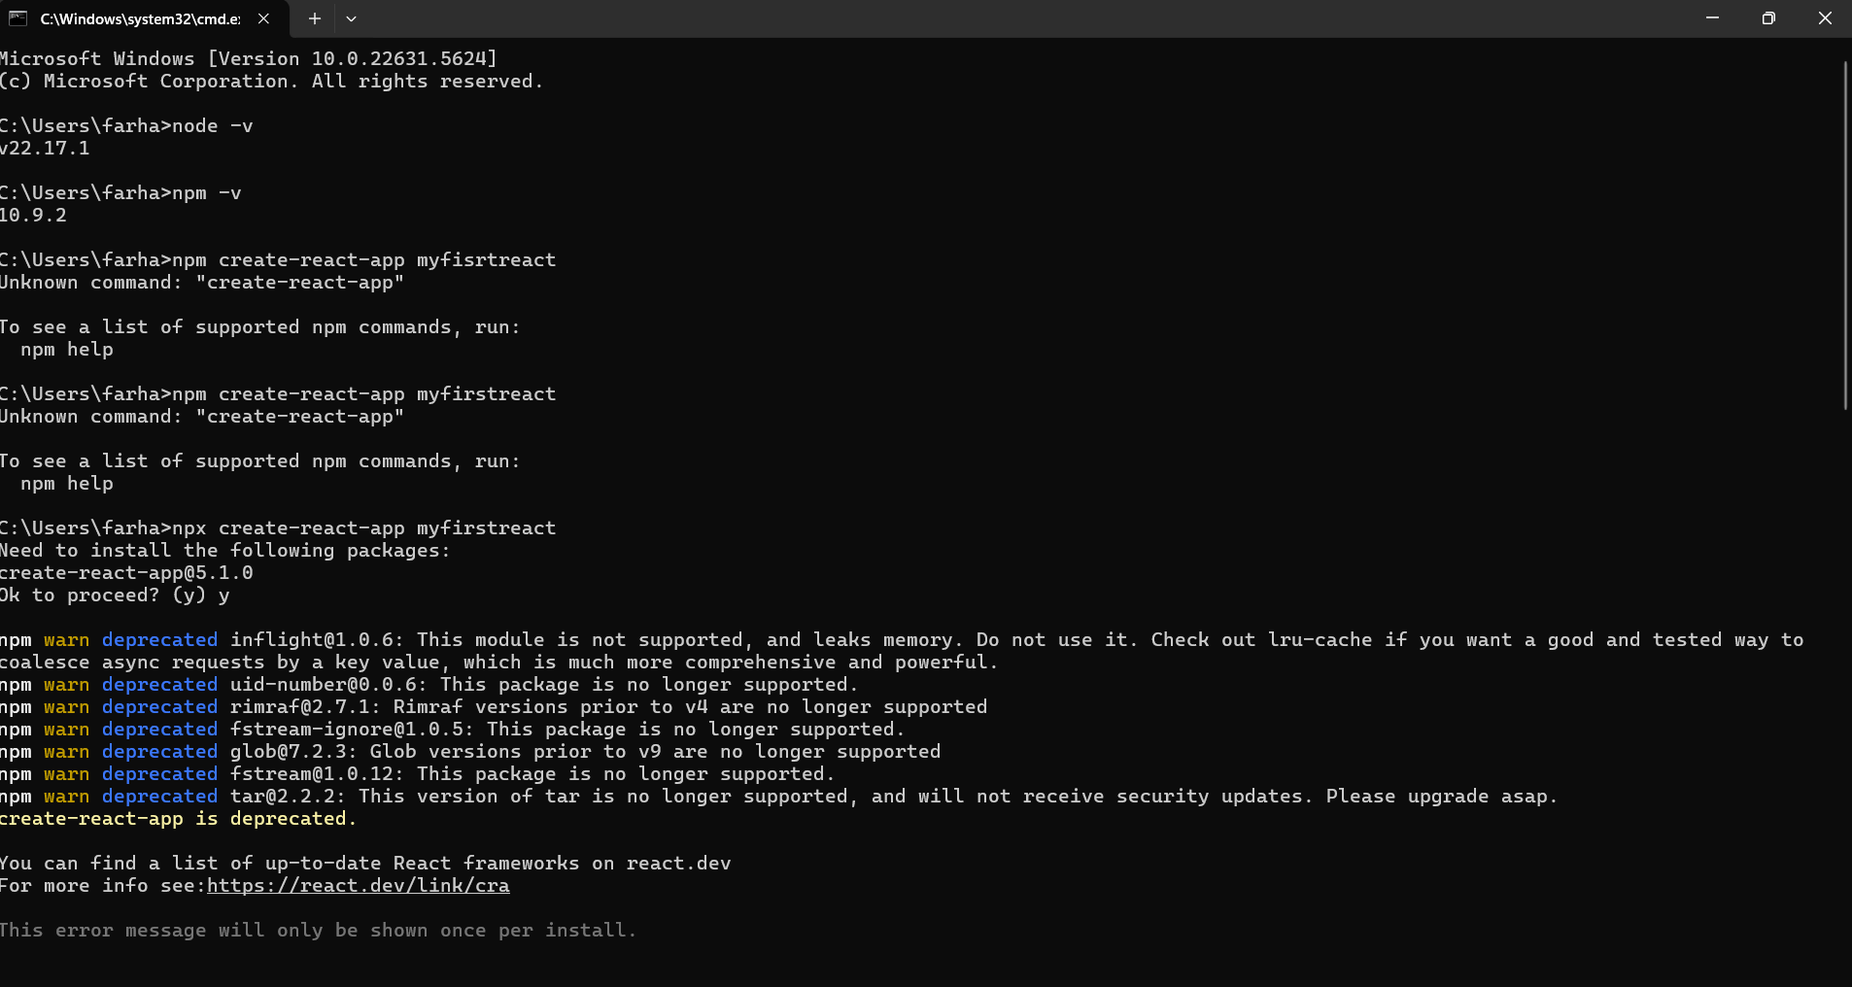

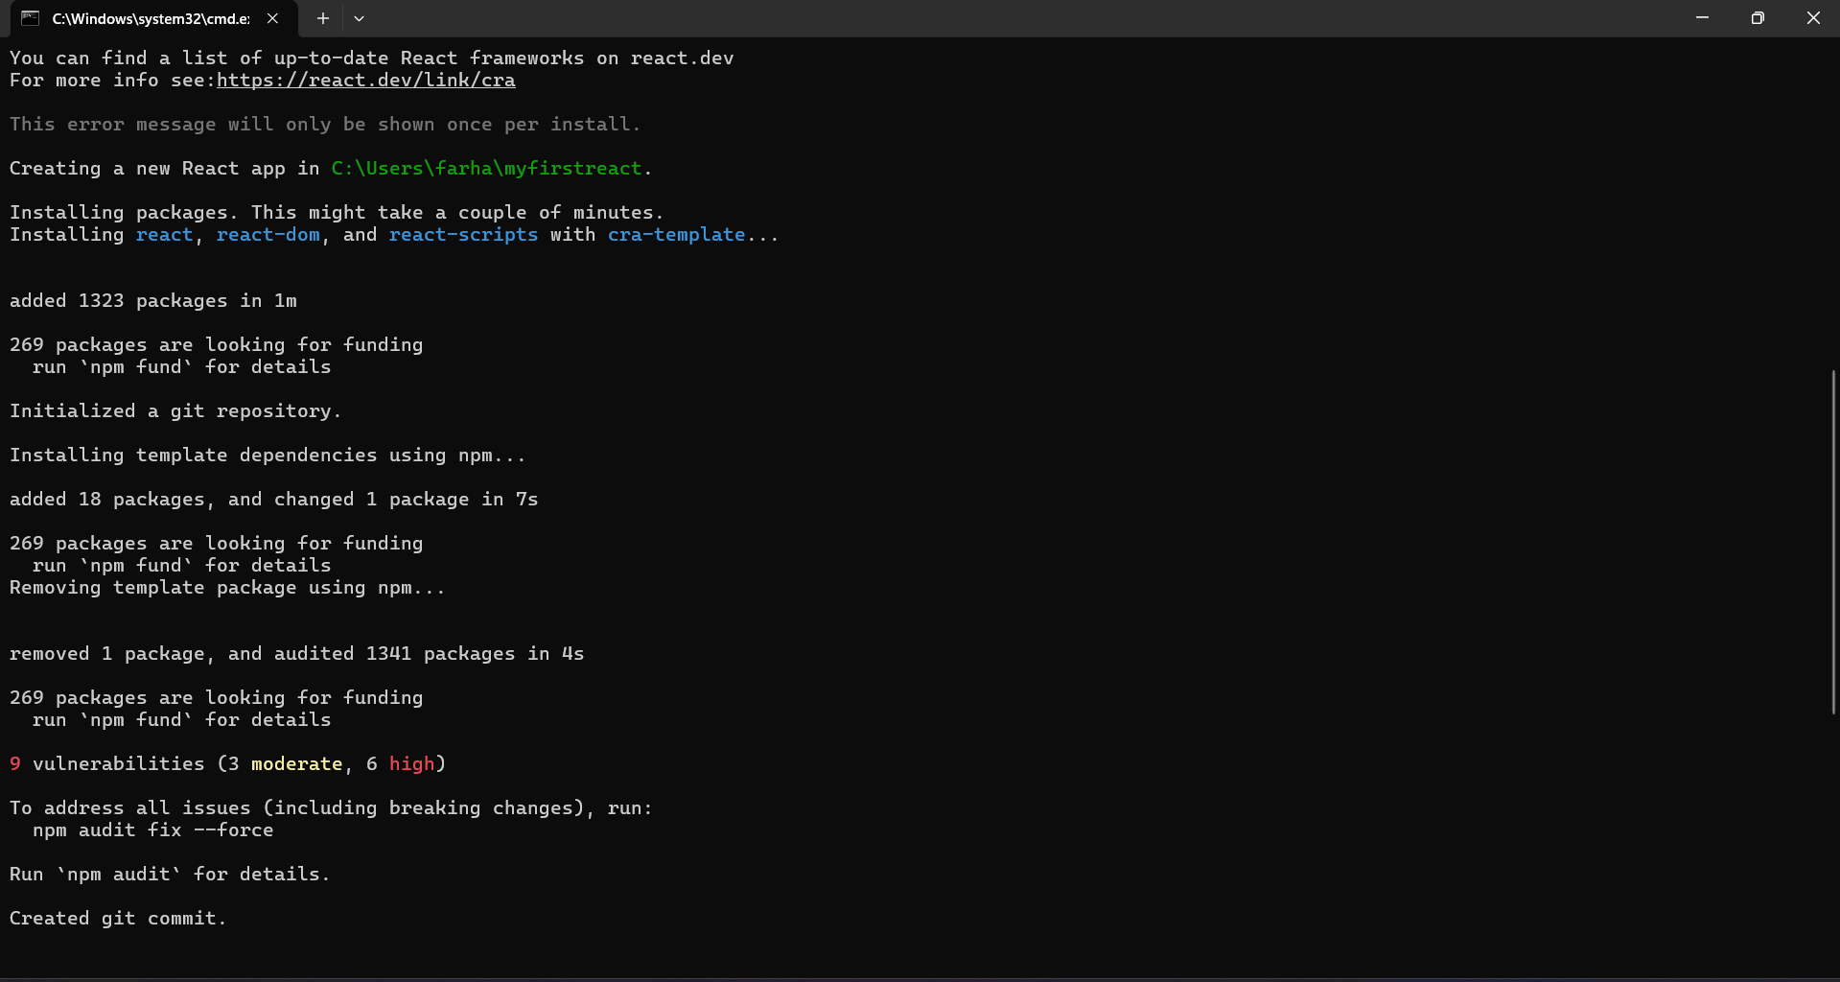

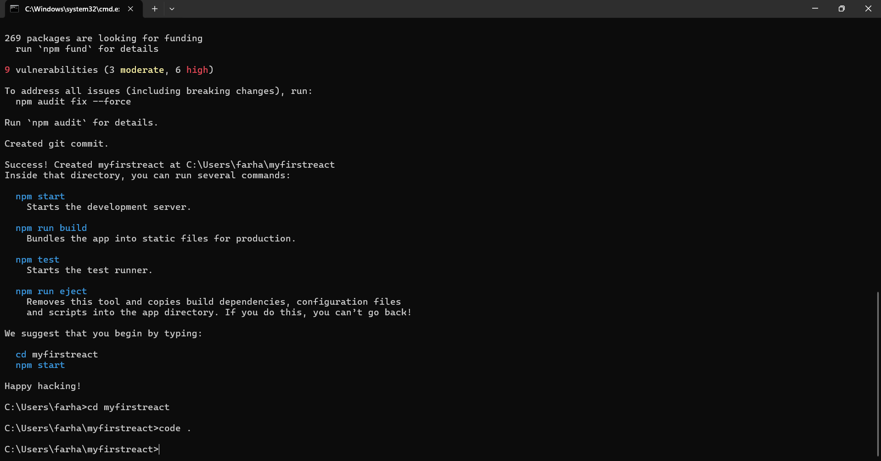

App.js

function App(){

  return(

    <div>

      <h1>Welcome to the first session of react</h1>

    </div>

  );

}

export default App;

**Output:**



