**My Academy team at Cognizant want to create a dashboard containing the details of ongoing and completed cohorts. A react application is created which displays the detail of the cohorts using react component. You are assigned the task of styling these react components.**

**CohortDetails.js**

import React from 'react';

import styles from './CohortDetails.module.css';

function CohortDetails({ cohort }) {

  const headingStyle = {

    color: cohort.status.toLowerCase() === 'ongoing' ? 'green' : 'blue'

  };

  return (

    <div className={styles.box}>

      <h3 style={headingStyle}>{cohort.name}</h3>

      <dl>

        <dt>Status:</dt>

        <dd>{cohort.status}</dd>

        <dt>Start Date:</dt>

        <dd>{cohort.startDate}</dd>

        <dt>End Date:</dt>

        <dd>{cohort.endDate}</dd>

      </dl>

    </div>

  );

}

export default CohortDetails;

**CohortDetails.module.css**

.box {

  width: 300px;

  display: inline-block;

  margin: 10px;

  padding: 10px 20px;

  border: 1px solid black;

  border-radius: 10px;

}

dt {

  font-weight: 500;

}

**App.js**

import React from 'react';

import CohortDetails from './components/CohortDetails';

function App() {

  const cohorts = [

    {

      name: 'Java Full Stack - Batch 1',

      status: 'Ongoing',

      startDate: '2025-06-10',

      endDate: '2025-12-10'

    },

    {

      name: 'React Bootcamp - Batch 2',

      status: 'Completed',

      startDate: '2025-01-05',

      endDate: '2025-06-01'

    }

  ];

  return (

    <div>

      {cohorts.map((cohort, index) => (

        <CohortDetails key={index} cohort={cohort} />

      ))}

    </div>

  );

}

export default App;

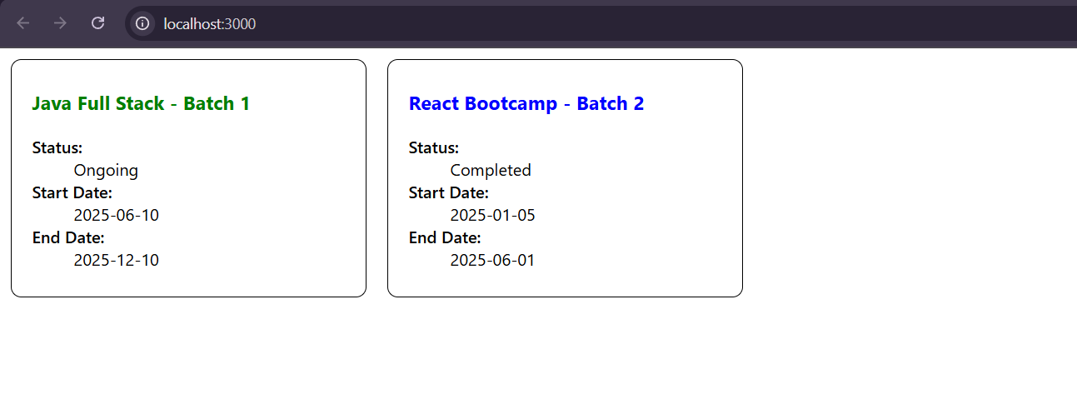**Output:**