**Create a React Application named “cricketapp” with the following components:**

**1. ListofPlayers • Declare an array with 11 players and store details of their names and scores using the map feature of ES6 • Filter the players with scores below 70 using arrow functions of ES6.**

**2. IndianPlayers a. Display the Odd Team Player and Even Team players using the Destructuring features of ES6 b. Declare two arrays T20players and RanjiTrophy players and merge the two arrays and display them using the Merge feature of ES6**

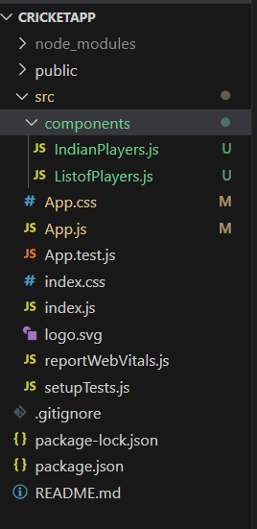

**IndianPlayers.js**

// src/components/IndianPlayers.js

import React from 'react';

const IndianPlayers = () => {

  const oddPlayers = ['Sachin', 'Virat3', 'Yuvraj5'];

  const evenPlayers = ['Dhoni2', 'Rohit4', 'Rahul6'];

  // Destructuring examples

  const [first, third, fifth] = oddPlayers;

  const [second, fourth, sixth] = evenPlayers;

  const T20Players = ['Mr. First Player', 'Mr. Second Player'];

  const RanjiPlayers = ['Mr. Third Player', 'Mr. Fourth Player', 'Mr. Fifth Player'];

  const mergedPlayers = [...T20Players, ...RanjiPlayers];

  return (

    <div>

      <h2>Odd Players</h2>

      <ul>

        <li>First: {first}</li>

        <li>Third: {third}</li>

        <li>Fifth: {fifth}</li>

      </ul>

      <h2>Even Players</h2>

      <ul>

        <li>Second: {second}</li>

        <li>Fourth: {fourth}</li>

        <li>Sixth: {sixth}</li>

      </ul>

      <h2>List of Indian Players Merged:</h2>

      <ul>

        {mergedPlayers.map((player, index) => (

          <li key={index}>{player}</li>

        ))}

      </ul>

    </div>

  );

};

export default IndianPlayers;

**ListofPlayers.js**

// src/components/ListofPlayers.js

import React from 'react';

const ListofPlayers = () => {

  const players = [

    { name: 'Mr. Jack', score: 50 },

    { name: 'Mr. Michael', score: 70 },

    { name: 'Mr. John', score: 40 },

    { name: 'Mr. Alvin', score: 61 },

    { name: 'Mr. Elizabeth', score: 61 },

    { name: 'Mr. Jacob', score: 61 },

    { name: 'Mr. David', score: 64 },

    { name: 'Mr. Rahul', score: 75 },

    { name: 'Mr. Ranjiv', score: 54 },

    { name: 'Mr. Smith', score: 61 },

    { name: 'Mr. Rohit', score: 30 }

  ];

  const filteredPlayers = players.filter(player => player.score < 70);

  return (

    <div>

      <h2>List of Players</h2>

      <ul>

        {players.map((player, index) => (

          <li key={index}>{player.name} {player.score}</li>

        ))}

      </ul>

      <h3>List of Players having Scores Less than 70</h3>

      <ul>

        {filteredPlayers.map((player, index) => (

          <li key={index}>{player.name} {player.score}</li>

        ))}

      </ul>

    </div>

  );

};

export default ListofPlayers;

**App.js**

// src/App.js

import React from 'react';

import './App.css';

import ListofPlayers from './components/ListofPlayers';

import IndianPlayers from './components/IndianPlayers';

function App() {

  const flag = true; // Set to false to switch view

  return (

    <div className="App">

      <h1>Cricket App</h1>

      {flag ? <ListofPlayers /> : <IndianPlayers />}

    </div>

  );

}

export default App;

**Output:**

**When flag=true**

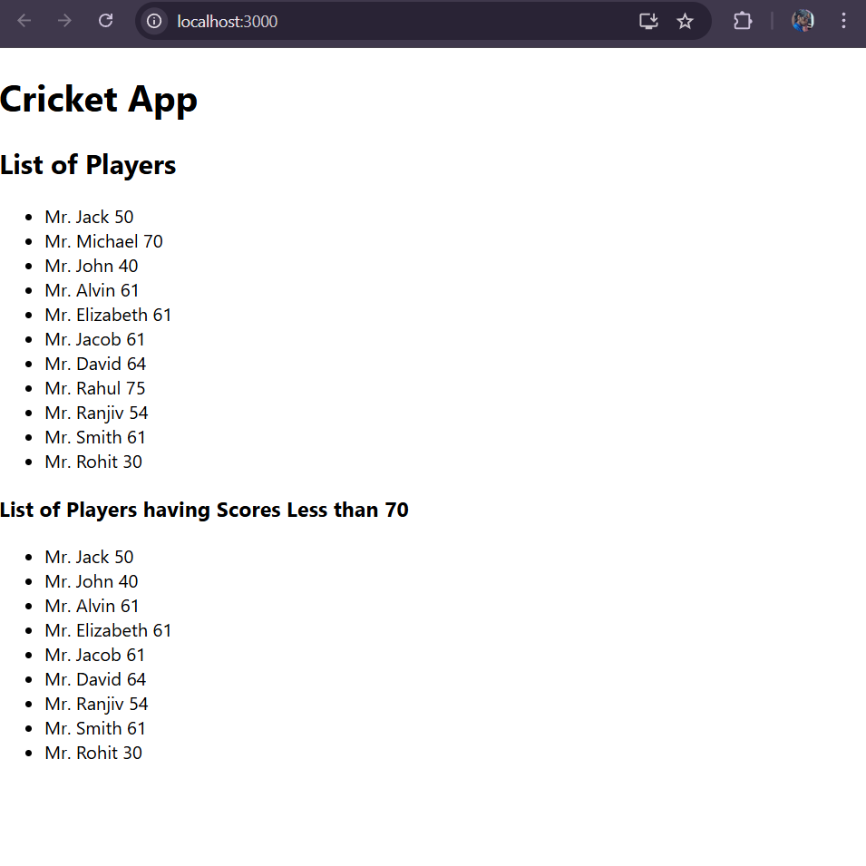

**When flag=-false**

