1. Technologies Used: Mean Stack

- Frontend

AngularJS, HTML5, CSS3, Responsive UI

- Backend

MongoDB, NodeJS(Express Framework)

2. Admin Panel

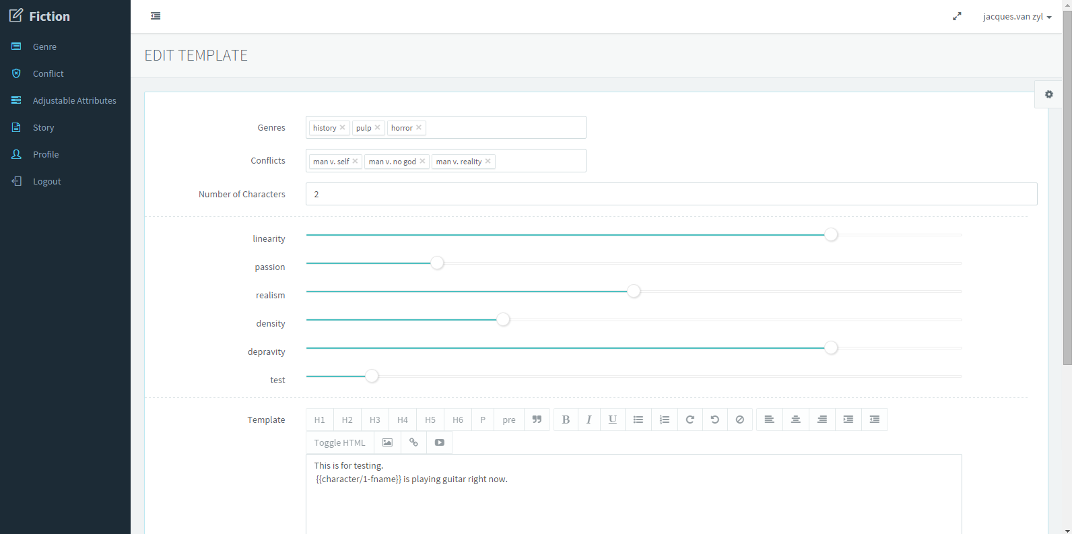

- Genre Tab - add/edit/delete genres.

- Conflict Tab - add/edit/delete conflicts.

- Adjustable Attributes - add/edit/delete adjustable attributes(Displayed as slider in UI)

\* adjustable attributes can have a value range of 0 - 10.

Default value is 5.

- Story

Add/Edit/Delete templates that are used to generate fictions.

Markup Language:

{{character/X-name}}

X is the no. of character.

"name" means the full name of the character.

eg. {{character/1-name}}

In generation process, it will be replaced by the full name of 1st character (Paul Smith).

{{character/X-fname}}

{{character/X-lname}}

3. Frontend UI

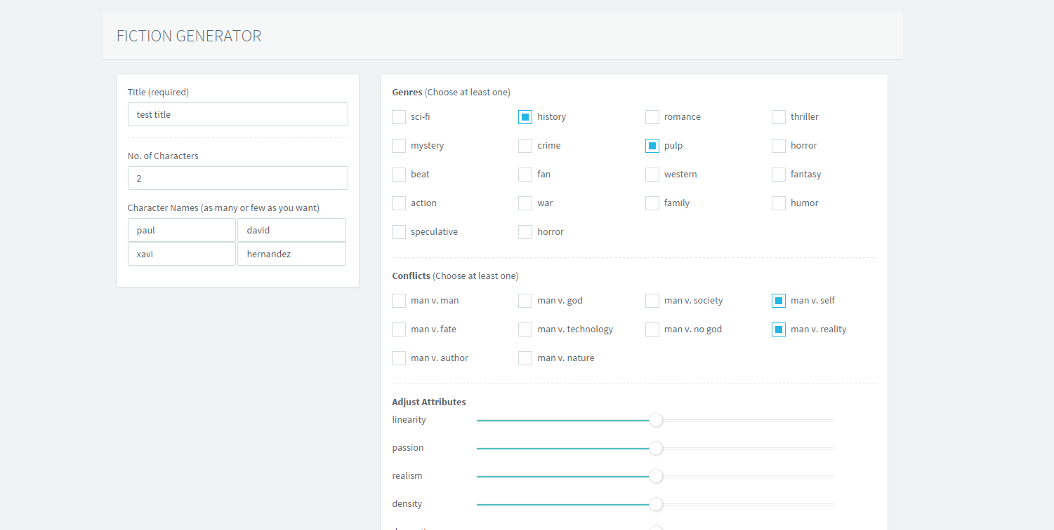

It has various options that are used to generate fictions.

After successful generation, it can print the generated fiction into PDF format.