# Overview!

This is the Guide of how to use the Logger Module , first of all this module was developed using Singletone pattern , so it is one object through the whole app.

# Supported Languages

* Swift 5

# Interface

The module have one interface with only two methods these are your entry points for the framework

* Log
* Fetch

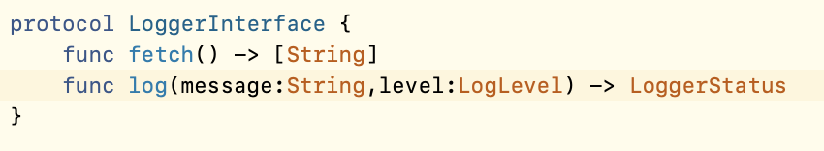

# Logger Status

Is your Guide for the result you receive from the log function it has three result types each one indicates for a specific state

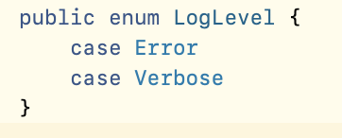

# Limitations

- The Logger Framework receives up to 5k logs through the session

- The Logger Framework receives a message up to 1k characters if it received more than that it will shrank the message by taking the first 1K and adding three dots at the end

- The Logger Framework clears the data on starting a new session .