**Stock Price Prediction**

**510621205028:R.Menaga**

**Phase 2 Submission Document**



**INTRODUCTION:**

* In recent years, the financial industry has witnessed a surge in the adoption of artificial intelligence and deep learning techniques to enhance decision-making processes, particularly in the domain of stock price prediction.
* Deep learning, a subset of machine learning, has proven to be exceptionally effective in handling complex and non-linear data patterns, making it a promising approach for forecasting stock prices.
* This research aims to explore the application of deep learning techniques, particularly recurrent neural networks (RNNs) and convolutional neural networks (CNNs), in predicting stock prices.
* RNNs excel at capturing sequential dependencies in time-series data, which is crucial in modeling stock price movements over time. CNNs, with their ability to extract hierarchical features, can be employed to analyse various technical indicators and sentiment data.
* Briefly introduce the real estate market and the importance of accurate Stock price prediction.
* Emphasize the need for  more advanced deep learning techniques like CNN-LSTM or attention mechanisms for improved accuracy in predicting stock prices.

**Content for Project Phase 2 :**

Consider exploring more advanced deep learning techniques like CNN-LSTM or attention mechanisms for improved accuracy in predicting stock prices.

**Data Source:**

A good data source for stock price prediction using deep learning should be Accurate, Complete, Covering the geographic area of interest, Accessible.

**Dataset Link:** [**https://www.kaggle.com/datasets/prasoonkottarathil/microsoft-lifetime-stocks-dataset**](https://www.kaggle.com/datasets/prasoonkottarathil/microsoft-lifetime-stocks-dataset)

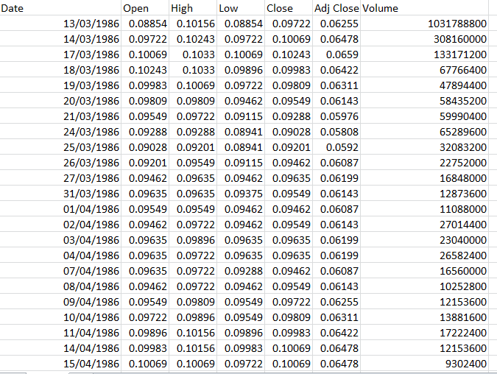

**Data Collection and Preprocessing:**

* Data Preparation: Gathering historical stock price data, economic indicators, news sentiment scores, and other relevant features for model training and testing.
* Model Architecture: Designing and implementing deep learning models, including RNNs and CNNs, to learn and predict stock price movements.

**Exploratory Data Analysis (EDA):**

* EDA provides valuable insights into the data, and the visualizations help to communicate these insights effectively.
* By performing EDA, we can identify trends, patterns, and relationships that may not be immediately apparent from the data.
* This knowledge can then be used to inform further analysis and decision-making.

**Feature Engineering:**

* Create new features or transform existing ones to capture valuable information.
* Utilize domain knowledge to engineer features that may impact stock prices, such as proximity to schools, transportation, or crime rates.
* Explain the process of creating new features or transforming existing ones.
* Showcase domain-specific feature engineering, such as proximity scores or composite indicators.
* Emphasize the impact of engineered features on model performance.

**Advanced Regression Techniques:**

1. **Convolutional Neural Networks (CNNs):** Can take technical indicators' 2-D images as inputs and predict the stock price.
2. **Long Short Term Memory Networks (LSTMs):** Models are extremely powerful time-series models. They can predict an arbitrary number of steps into the future.
3. **Recurrent Neural Networks (RNNs):** is used on time-series data of the stocks.
4. **Generative Adversarial Networks (GANs):**Used for image and video generation, and even for style transfer.
5. **Radial Basis Function Networks (RBFNs):** A particular type of Artificial Neural Network used for function approximation problems.
6. **Self-Supervised learning:** Learning from unlabelled data using pretext tasks, e.g., contrastive learning.

**Model Evaluation and Selection:**

* Split the dataset into training and testing sets.
* Evaluate models using appropriate metrics
* Use cross-validation techniques to tune hyperparameters and ensure model stability.
* Compare the results with traditionalConvolutional Neural Networks to highlight improvements.
* Select the best-performing model for further analysis.

**Model Interpretability:**

* Explain how to interpret feature importance from attention mechanisms for improved accuracy in predicting stock prices.
* Discuss the insights gained from feature importance analysis and their relevance to stock price prediction.
* Interpret feature importance from ensemble models advanced deep learning techniques like CNN-LSTM or attention mechanisms for improved accuracy in predicting stock prices.

.**Deployment and Prediction:**

* Deploy the chosen regression model to predict house prices.
* Develop a user-friendly interface for users to input property features and receive price predictions.

**Program:**

**Stock Price Prediction**

import numpy as np  
import pandas as pd  
import matplotlib.pyplot as plt  
import seaborn as sb  
  
from sklearn.model_selection import train_test_split  
from sklearn.preprocessing import StandardScaler  
from sklearn.linear_model import LogisticRegression  
from sklearn.svm import SVC  
from xgboost import XGBClassifier  
from sklearn import metrics  
  
import warnings  
warnings.filterwarnings('ignore')

**In[1]:**

import numpy as np

import matplotlib.pyplot as plt

import pandas as pd

dataset_train = pd.read_csv('D:\data\msft.csv')

print('shape is = {}'.format(dataset_train.shape))

print(dataset_train.head())

**Out[1]:**

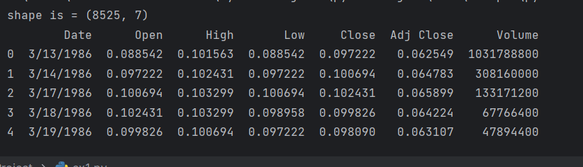

**In[2]:**

Print(df.shape)

**Out[2]:**

(8525, 7)

**In[3]:**

Print(df.describe())

**Out[3]:**

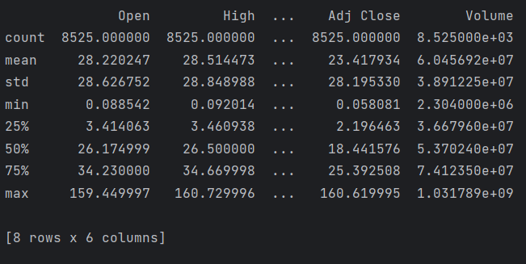

**In[4]:**

df = pd.read_csv('D:\data\msft.csv')  
print(df.head())  
plt.figure(figsize=(15,5))  
plt.plot(df['Close'])  
plt.title('Stock price prediction ', fontsize=15)  
plt.ylabel('Stock')  
plt.show()

**Out[4]:**

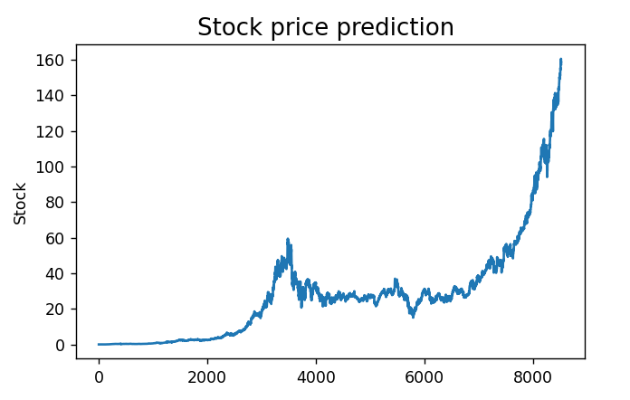

**In[5]:**

df = pd.read_csv('D:\data\msft.csv')  
print(df.head())  
features = ['Open', 'High', 'Low', 'Close', 'Volume']  
plt.subplots(figsize=(20,10))  
for i, col in enumerate(features):  
 plt.subplot(2,3,i+1)  
 sb.distplot(df[col])  
plt.show()

**Out[5]:**

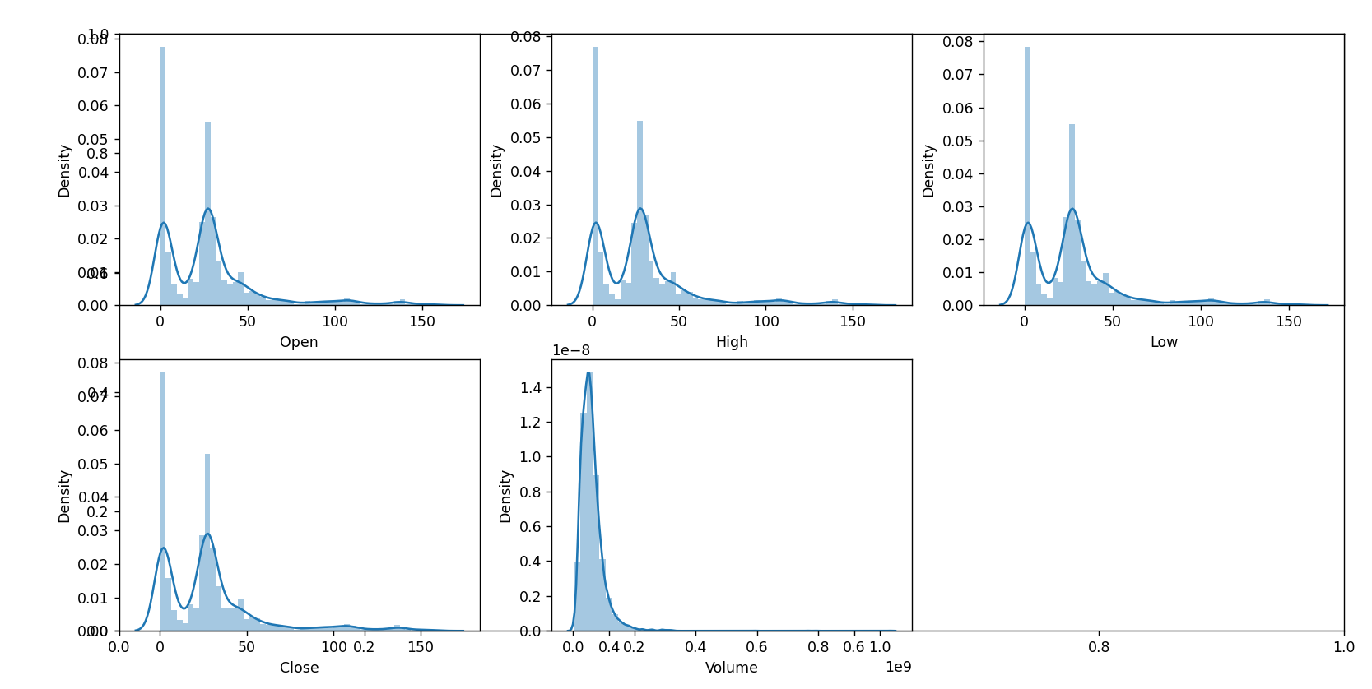

**In[6]:**

df = pd.read_csv('D:\data\msft.csv')  
df.head()  
features = ['Open', 'High', 'Low', 'Close', 'Volume']  
plt.subplots(figsize=(20,10))  
for i, col in enumerate(features):  
 plt.subplot(2,3,i+1)  
 sb.boxplot(df[col])  
plt.show()

**Out[6]:**

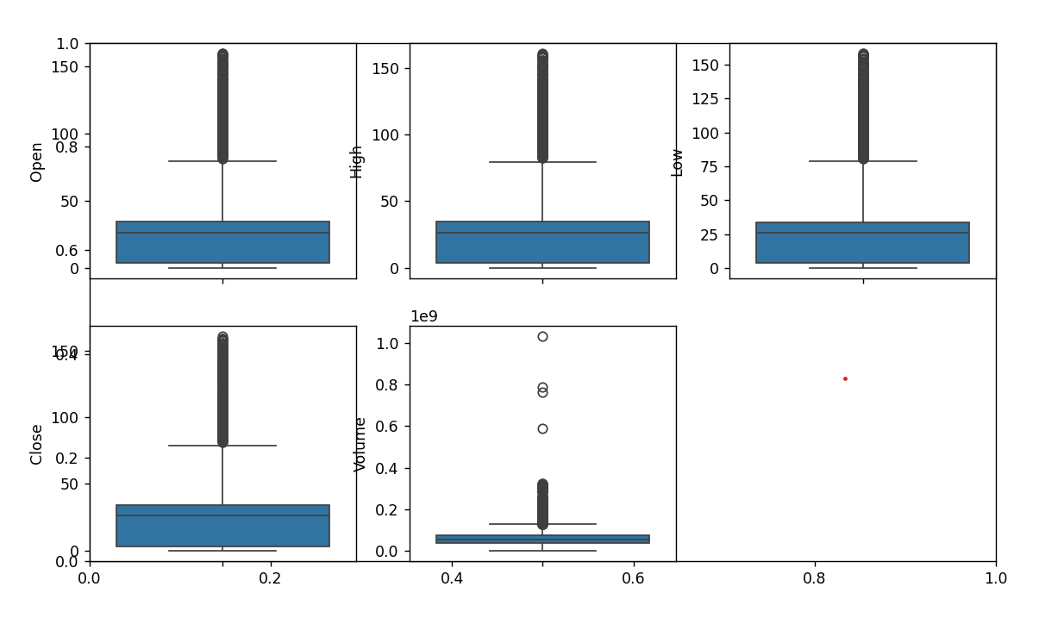

**In[7]:**

df = pd.read_csv('D:\data\msft.csv')  
splitted = df['Date'].str.split('/', expand=True)  
df['day'] = splitted[1].astype('int')  
df['month'] = splitted[0].astype('int')  
df['year'] = splitted[2].astype('int')  
print(df.head())

**Out[7]:**

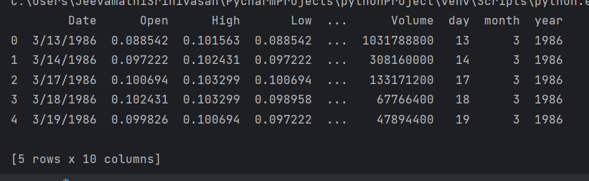

**In[8]:**

data_grouped = df.groupby('year').mean()  
plt.subplots(figsize=(20,10))  
for i, col in enumerate(['Open', 'High', 'Low', 'Close']):  
 plt.subplot(2,2,i+1)  
 data_grouped[col].plot.bar()  
plt.show()

**Out[8]:**

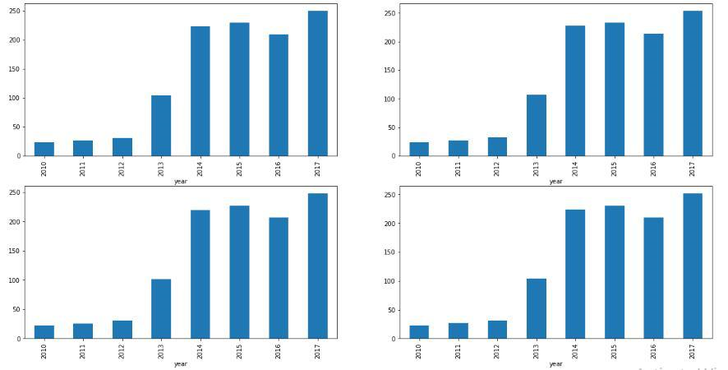

**In[9]:**

df['is_quarter_end'] = np.where(df['month']%3==0,1,0)

df.head()

**Out[9]:**

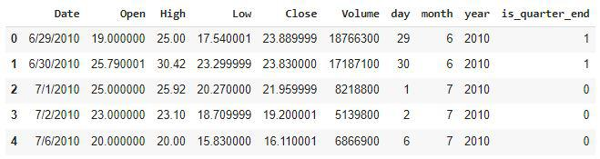

**In[10]:**

df.groupby('is_quarter_end').mean()

**Out[10]:**

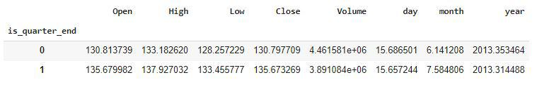

**In[11]:**

df = pd.read_csv('D:\data\msft.csv')  
print(df.head())  
df['open-close'] = df['Open'] - df['Close']  
df['low-high'] = df['Low'] - df['High']  
df['target'] = np.where(df['Close'].shift(-1) > df['Close'], 1, 0)  
plt.pie(df['target'].value_counts().values,  
 labels=[0, 1], autopct='%1.1f%%')  
plt.show()

**Out[11]:**

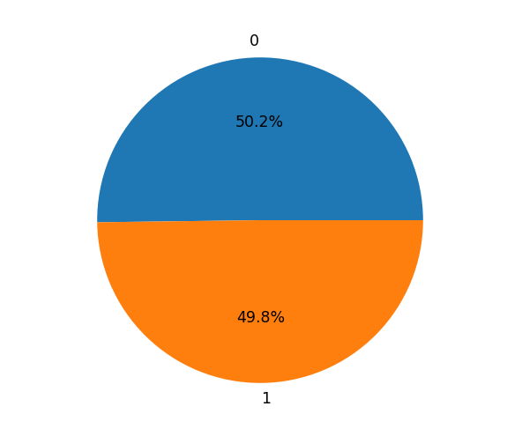

**In[12]:**

plt.figure(figsize=(10, 10))

sb.heatmap(df.corr() > 0.9, annot=True, cbar=False)

plt.show()

**Out[12]:**

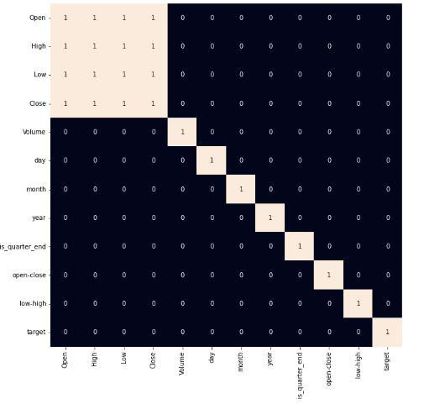

**In[13]:**

models = [LogisticRegression(), SVC(

  kernel='poly', probability=True), XGBClassifier()]

for i in range(3):

  models[i].fit(X_train, Y_train)

  print(f'{models[i]} : ')

  print('Training Accuracy : ', metrics.roc_auc_score(

    Y_train, models[i].predict_proba(X_train)[:,1]))

  print('Validation Accuracy : ', metrics.roc_auc_score(

    Y_valid, models[i].predict_proba(X_valid)[:,1]))

  print()

**Out[13]:**

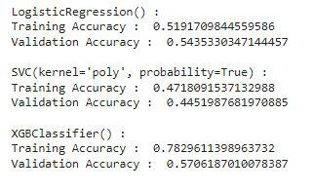

**In[14]:**

metrics.plot_confusion_matrix(models[0], X_valid, Y_valid)

plt.show()

**Out[14]:**

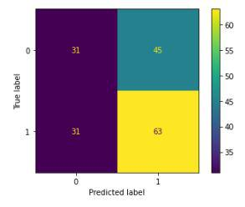

**In[15]:**

features = df[['open-close', 'low-high', 'is_quarter_end']]

target = df['target']

scaler = StandardScaler()

features = scaler.fit_transform(features)

X_train, X_valid, Y_train, Y_valid = train_test_split(

    features, target, test_size=0.1, random_state=2022)

print(X_train.shape, X_valid.shape)

**Out[15]:**

(1522, 3) (170, 3)

**Conclusion and Future Work (Phase 2):**

**Project Conclusion:**

* In the Phase 2 conclusion, we will summarize the key findings and insights from the advanced regression techniques. We will reiterate the impact of these techniques on improving the accuracy and robustness of stock price predictions.
* Future Work: We will discuss potential avenues for future work, such as incorporating additional data sources exploring deep learning models for prediction, or expanding the project into a web application with more features and interactivity