
Beaconhouse National University
Software Requirements Specification
VC Analytical Dashboard
Version 2.0
17 July 2026

Document Control

Approvals
Role | Name | Signature / Date
Sponsor (Vice Chancellor)
Project Lead
Technical Reviewer

Table of Contents
Document Control 2
Revision History 2
Approvals 2
Table of Contents 3
1. Problem Statement 6
1.1 Purpose 6
1.2 System Scope and Limitations 6
1.3 System Objectives 7
1.4 Scope Exclusions 7
2. The Modules 7
2.1 The Module Overview 8
2.2 Rules that Apply to Every Module 8
2.3 Roles 9
3. Functional Requirements 9
3.1 Module 1 — DC Cases (Discipline Cases) 9
3.1.1 Data Model 9
3.1.2 Functional Requirements 10
3.2 Module 2 — Scholarships 10
3.2.1 Data Model 10
3.2.2 Functional Requirements 10
3.3 Module 3 — Admissions / Applications 11
3.3.1 Data Model 11
3.3.2 Functional Requirements 11
3.4 Module 4 — Hostel Accommodation 11
3.4.1 Data Model 11
3.4.2 Functional Requirements 12
3.5 Module 5 — Enrolled Students 12
3.5.1 Data Model 12
3.5.2 Functional Requirements 12
3.6 Module 6 — Faculty 13
3.6.1 Data Model 13
3.6.2 Functional Requirements 13
3.7 Module 7 — Staff 13
3.7.1 Data Model 13
3.7.2 Functional Requirements 13
3.8 Module 8 — Classes 14
3.8.1 Data Model 14
3.8.2 Functional Requirements 14
3.9 Module 9 — Student Performance 14
3.9.1 Data Model 14
3.9.2 Business Rules 15
3.9.3 Functional Requirements 15
3.10 Module 10 — E-Portal Cases 15
3.10.1 Data Model 15
3.10.2 Business Rules 15
3.10.3 Functional Requirements 15
3.11 Module 11 — Grants 16
3.11.1 Data Model 16
3.11.2 Business Rules 16
3.11.3 Functional Requirements 16
3.12 Module 12 — Research, Partnerships & ORIP 16
3.12.1 Data Model 17
3.12.2 Functional Requirements 17
3.13 Module 13 — Rankings, Quality & Compliance 17
3.13.1 Data Model 17
3.13.2 Functional Requirements 18
3.14 Module 14 — Student Life, Careers & Alumni 18
3.14.1 Data Model 18
3.14.2 Functional Requirements 19
3.15 Module 15 — Campus Operations & Sustainability 19
3.15.1 Data Model 19
3.15.2 Functional Requirements 20
3.16 Cross-Module Filtering and Drill-Down 20
3.17 Business Rule Evaluation 20
4. Non-Functional Requirements 21
5. Data Model 22
5.1 The Core Reporting Model 22
5.2 Filters and Drill-Down Records 22
5.3 Business Rule Flags and Alerts 22
5.4 What the Model Encodes, and Why 23
6. Dashboard Workflows 23
6.1 VC Login and Module Navigation 23
6.2 Applying Filters and Drilling Down 25
6.3 E-Portal Case Auto-Escalation (BR-EP-01) 26
6.4 Grant End-Date Flagging (BR-GRT-01) 26
6.5 CGPA Division Classification (BR-PERF-01) 27
6.6 Transition from Dummy Data to Live Integration 28
7. Implementation Status 29
7.1 Current Status 29
7.2 What a First Prototype Should Demonstrate 30
7.3 Access 30
8. Business Rules Summary 30
9. Visualization Summary 30
10. Open Questions and Resolved Decisions 31
10.1 Resolved Decisions 31
10.2 Items Still to Confirm 32

1. Problem Statement

1.1 Purpose
Beaconhouse National University's Vice Chancellor currently has to request figures from separate offices Student Affairs, the Registrar, Admissions, HR, Research, Quality Assurance, Facilities, and others to answer basic questions: how many discipline cases are open, how many students hold a scholarship, whether a grant is about to lapse, how a school's students are performing. Each office holds its own numbers in its own format, refreshed on its own schedule, and none of them are cross-checked against one another. By the time a figure reaches the VC's desk it may already be a week or a month old, and there is nowhere the VC can go to see the whole institution at once.
The VC Analytical Dashboard puts those figures in a single, read-only interface. It does not change how any department does its work, and it does not become the system of record for discipline cases, scholarships, admissions, or anything else — those systems keep their own data and their own rules. What the dashboard adds is a consistent, always-available summary layer on top: summarized metrics, visual charts, and drill-downs, built first as a working demonstration against a seeded sample data set, and designed so that data set can be replaced module by module with live data once the University is ready. This document is the authoritative reference for the design, development, testing, and stakeholder sign-off of that first phase.

1.2 System Objectives
The VC Analytical Dashboard will hold a single, consistent summary of the University's institutional data, present it visually, and let the VC move from a summary figure to the record behind it without asking another office to do it. Specifically, it must:
- Present a summary view of all eleven institutional modules on their own tabs, without becoming the system of record for any of them.
- Render each module's key figures as visual cards and charts pie, bar, donut, gauge, line, and funnel rather than raw transactional tables.
- Let the VC filter and drill down from any summary figure to the underlying record list, through a consistent, reusable filter panel applied across modules.
- Apply defined business rules consistently auto-escalating aged e-Portal cases, flagging grants nearing their end date, and classifying students into CGPA divisions rather than leaving these judgment calls to individual staff.
- Run, in this phase, against a seeded sample data set that stands in for the University's live systems, structured so each module's data source can be replaced independently later, without a redesign.
- Keep the Finance module out of scope until a separate decision is made to include it.

1.3 Scope Exclusions
- The dashboard is used by the Vice Chancellor only, in this phase. There is no multi-user access or permission tiering yet, and no student- or department-facing interface.
- The dashboard does not create, edit, or delete records in any source system; it is read-only throughout, in every module.
- The Finance module is explicitly excluded from this phase.
- The dashboard is not the source of truth for any figure it shows. In this phase it reads from a seeded sample data set standing in for the University's own systems (SIS, HR, e-Portal, and others); once live integration begins it still holds no independent copy of that data.

2. The Modules
This section summarizes the eleven institutional modules the dashboard covers. Modules 1–11 were captured directly from stakeholder requirements gathering. It is provided so the development team has one place to see what the system as a whole is meant to summarize before the detailed requirements in Section 3.

2.1 The Module Overview
Module | What It Tracks | Primary Business Rule
DC Cases | Discipline cases raised against students for code-of-conduct violations. | —
Scholarships | A rollup of scholarships awarded, sourced from the Scholarship Management System. | —
Admissions / Applications | The applicant pool, by program, semester, and outcome. | —
Hostel Accommodation | On- and off-campus hostel occupancy against capacity. | —
Enrolled Students | University-wide enrollment, by school, program, and semester. | —
Faculty | Faculty headcount by school and employment type. | —
Staff | Staff headcount by department. | —
Classes | Scheduled classes and attendance, by school. | —
Student Performance | CGPA distribution across the student body. | BR-PERF-01
E-Portal Cases | Support / service cases raised through the e-Portal. | BR-EP-01
Grants | Grant status and timeline, university-wide. | BR-GRT-01

2.2 Rules that Apply to Every Module
- Every module is read-only; nothing on the dashboard writes back to a source system (see Section 1.4).
- Every module's default view is unfiltered; no date range is pre-applied to any trend view (confirmed with stakeholder).
- Filters are drawn from a shared panel appropriate to that module — school, program, semester, date range, plus module-specific filters — and stay applied when the VC drills down to a record list (see Section 3.16 and Figure 2).
- Every chart segment or summary figure that can be broken down further is clickable and opens the corresponding record list, carrying the active filters through.
- Modules 12 through 15 were added to this SRS from the VC Executive Dashboard blueprint after Modules 1–11 were captured from direct stakeholder requirements gathering; Finance, also described in that blueprint, remains explicitly out of scope (see Section 1.4).

2.3 Roles
User Class | Characteristics
Vice Chancellor (sole user) | Executive user. Consumes summarized, visual information; performs read-only drill-downs and filtering; does not create, edit, or delete records. Expects fast load and clear visualizations rather than transactional detail.
Administrator (future) | Not part of this phase. Noted so the design does not preclude adding data-management and multi-user roles later.

2.4 The Module Categories
The dashboard's module tabs group into six institutional categories. The categories let the VC and the development team read the modules as coherent areas of the University rather than a flat list, and they set the order in which the tabs are arranged. Finance is named for completeness but stays out of scope this phase (see Section 1.4).
Category | Modules
Academics | Scholarships · Admissions / Applications · Enrolled Students · Classes · Student Performance · Student Life
Employees | Faculty · Staff
Operations | Hostel Accommodation
Conduct & Support | DC Cases · E-Portal Cases
Research | Grants · Research, Partnerships & ORIP
Finance | Placeholder — out of scope this phase (Section 1.4)
To be categorised ‡ | Rankings, Quality & Compliance (Section 3.13)

Coverage notes.
† Student Life appears in this grouping and in the Table of Contents (Module 14, Student Life, Careers & Alumni) but does not yet have a specification in Section 3; it is carried here as a placeholder, like Finance, pending its write-up. Campus Operations & Sustainability (Module 15 in the Table of Contents) is in the same position and, once specified, most naturally sits under Operations.
‡ Rankings, Quality & Compliance is specified in Section 3.13 but was not part of the category list provided, so it is held under “To be categorised” until a category is confirmed — its integrity-case content could sit under Conduct & Support and its accreditation and QA content under a quality grouping.
Count and cross-references. The body currently specifies thirteen module sections (3.1–3.13), while several passages and the Table of Contents still refer to “fifteen modules” and to Sections 3.16–3.17 (now 3.14–3.15). These should be reconciled in a future revision.

2.5 The University → School → Programme Hierarchy
Every count, chart, and drill-down in the dashboard follows one consistent hierarchy, from the whole institution down to a single programme:
University-wide → School → Programme
The default view of any figure is University-wide: the dashboard answers the question for BNU as a whole first — how many students are enrolled, how many cases are open, how much has been disbursed. From there the VC narrows to a single School, and then to a single Programme within that school, without switching tabs or losing the figure they started from.
This ordering is the same everywhere. It is the order of the shared filter panel (School, then Programme, per FR-NAV-02), the order in which drill-downs open (FR-NAV-05), and the way every breakdown chart is grouped — for example, Enrolled Students is shown university-wide, then by school, then by programme (FR-ENR-01 to FR-ENR-03). Modules whose records are not owned by a school — Staff, organised by department — keep the same University-wide → group → item direction with their own top level in place of School. See Figure 7.
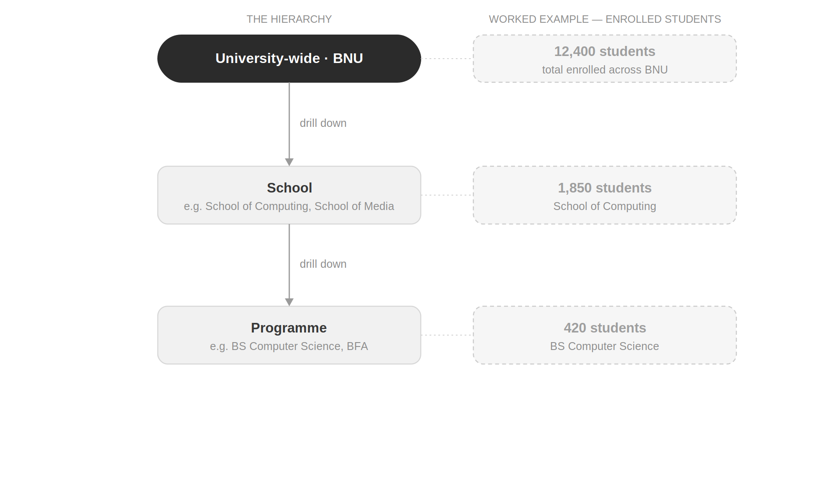
Figure 7. The University → School → Programme drill-down hierarchy, shown with a worked example (Enrolled Students).

3. Functional Requirements
This section specifies the fifteen modules. Each module lists its data model (assumed fields), any business rules, and the functional requirements that realize the required views, drill-downs, and filters. Requirement IDs are stable and may be referenced by test cases. Sections 3.16 and 3.17 then collect the requirements that cut across every module rather than belonging to one of them.

3.1 Module 1 — DC Cases (Discipline Cases)
Definition. Cases raised against a student for violating the University code of conduct.

3.1.1 Data Model
The fields below are the working data set for this module. They are drawn from the requirements gathering session and are marked assumed pending confirmation against the eventual source schema.
Data Field | Description
Case ID | Unique identifier for the discipline case.
Student ID / Name | The student the case is raised against.
School / Program | The student's school and program.
Date Raised | The date the case was opened.
Violation Type | Category of code-of-conduct violation.
Status | Case status, e.g. Pending or Resolved.

3.1.2 Functional Requirements
Req. ID | Requirement | Priority
FR-DC-01 | Display the total count of discipline cases. | High
FR-DC-02 | Show a Pending vs Resolved split as a pie or bar chart. | High
FR-DC-03 | Provide filters by school, program, and date range. | High
FR-DC-04 | Allow drill-down from Pending to the list / count of cases awaiting action. | Medium
Drill-down. Clicking the “Pending” segment displays the list and count of cases awaiting action.
Filters. School, program, date range.

3.2 Module 2 — Scholarships
Definition. A VC-level rollup of the scholarships awarded through the Scholarship Management System. This module summarizes outcomes only — the rules for how a scholarship is defined, awarded, merged against the 100% ceiling, and retained live in the Scholarship Management System and its own SRS, not here.

3.2.1 Data Model
The fields below are the working data set for this module. They are drawn from the requirements gathering session and are marked assumed pending confirmation against the eventual source schema.
Data Field | Description
Scholarship Type / Name | The scholarship being awarded.
Awarding Criteria | Eligibility / criteria for the award.
Number of Recipients | Count of students awarded this scholarship.
Amount per Award | Value granted per recipient.
Total Disbursed | Aggregate amount disbursed for the scholarship.
School / Program of Recipient | Where the recipients are enrolled.

3.2.2 Functional Requirements
Req. ID | Requirement | Priority
FR-SCH-01 | List / tabulate the active scholarship types. | High
FR-SCH-02 | Show the percentage of the student body on scholarship as a gauge or donut chart. | High
FR-SCH-03 | Display total amount disbursed as a summary card (or map-based view, per sketch). | Medium
FR-SCH-04 | Provide filters by school, program, and scholarship type. | High
Filters. School, program, scholarship type.

3.3 Module 3 — Admissions / Applications

3.3.1 Data Model
The fields below are the working data set for this module. They are drawn from the requirements gathering session and are marked assumed pending confirmation against the eventual source schema.
Data Field | Description
Application ID | Unique identifier for the application.
Program Applied To | The program the applicant applied for.
Semester / Year | Intake the application belongs to.
Status | Received, Admitted, or Rejected.

3.3.2 Functional Requirements
Req. ID | Requirement | Priority
FR-ADM-01 | Display the current application pool count. | High
FR-ADM-02 | Show a 5-year trend line of applications received. | High
FR-ADM-03 | Compare Received vs Admitted as a bar or funnel chart. | High
FR-ADM-04 | Provide filters by program, semester, and year range. | High
Filters. Program, semester, year range.

3.4 Module 4 — Hostel Accommodation

3.4.1 Data Model
The fields below are the working data set for this module. They are drawn from the requirements gathering session and are marked assumed pending confirmation against the eventual source schema.
Data Field | Description
Hostel Type | On-campus or Off-campus (Bedian, Safari and BNU Hostel).
Hostel Name | The specific hostel.
Student ID | The residing student.
Occupancy Status | Whether a place is occupied.
Capacity | Total capacity of the hostel.

3.4.2 Functional Requirements
Req. ID | Requirement | Priority
FR-HST-01 | Show the On-campus vs Off-campus occupancy split. | High
FR-HST-02 | Show occupancy against capacity. | High
FR-HST-03 | Provide a list of residing students per hostel. | Medium
FR-HST-04 | Provide a filter by hostel type. | Medium
Filters. Hostel type.

3.5 Module 5 — Enrolled Students

3.5.1 Data Model
The fields below are the working data set for this module. They are drawn from the requirements gathering session and are marked assumed pending confirmation against the eventual source schema.
Data Field | Description
Student ID | Unique identifier for the student.
School | The student's school.
Program | The student's program.
Semester | Fall or Spring.
Enrollment Status | Current enrollment state.

3.5.2 Functional Requirements
Req. ID | Requirement | Priority
FR-ENR-01 | Display total enrolled students university-wide. | High
FR-ENR-02 | Show a breakdown of enrollment by school. | High
FR-ENR-03 | Show a breakdown of enrollment by program. | High
FR-ENR-04 | Show a semester-over-semester comparison (Fall vs Spring trend). | Medium

3.6 Module 6 — Faculty

3.6.1 Data Model
The fields below are the working data set for this module. They are drawn from the requirements gathering session and are marked assumed pending confirmation against the eventual source schema.
Data Field | Description
Faculty ID | Unique identifier for the faculty member.
Name | Faculty member's name.
School | The school the faculty member belongs to.
Employment Type | Full-Time or Visiting.

3.6.2 Functional Requirements
Req. ID | Requirement | Priority
FR-FAC-01 | Show faculty count by school as a bar chart. | High
FR-FAC-02 | Show the Full-Time vs Visiting split per school. | High

3.7 Module 7 — Staff

3.7.1 Data Model
The fields below are the working data set for this module. They are drawn from the requirements gathering session and are marked assumed pending confirmation against the eventual source schema.
Data Field | Description
Staff ID | Unique identifier for the staff member.
Department | The department the staff member belongs to.
Designation | The staff member's designation.

3.7.2 Functional Requirements
Req. ID | Requirement | Priority
FR-STF-01 | Show staff count by department. | High
FR-STF-02 | Provide a filter by department. | Medium
Filters. Department.

3.8 Module 8 — Classes

3.8.1 Data Model
The fields below are the working data set for this module. They are drawn from the requirements gathering session and are marked assumed pending confirmation against the eventual source schema.
Data Field | Description
Class ID | Unique identifier for the class.
School | The school running the class.
Scheduled Date / Time | When the class is scheduled.
Attendance Status | Attended or Not Attended.

3.8.2 Functional Requirements
Req. ID | Requirement | Priority
FR-CLS-01 | Show Scheduled vs Not Attended counts per school. | High
FR-CLS-02 | Provide filters by school and date range. | Medium
Filters. School, date range.

3.9 Module 9 — Student Performance

3.9.1 Data Model
The fields below are the working data set for this module. They are drawn from the requirements gathering session and are marked assumed pending confirmation against the eventual source schema.
Data Field | Description
Student ID | Unique identifier for the student.
School | The student's school.
Program | The student's program.
CGPA | Cumulative Grade Point Average.

3.9.2 Business Rules
BR-PERF-01. CGPA divisions — Division 1: 2.00–2.99; Division 2: 3.00–3.49; Division 3 (Top performers): 3.50–4.00. See Figure 5 for how a student's CGPA is classified.

3.9.3 Functional Requirements
Req. ID | Requirement | Priority
FR-PERF-01 | Show the count / percentage of students per CGPA division. | High
FR-PERF-02 | Break the divisions down by school and program. | High
FR-PERF-03 | Provide filters by school and program. | High
Filters. School, program.

3.10 Module 10 — E-Portal Cases

3.10.1 Data Model
The fields below are the working data set for this module. They are drawn from the requirements gathering session and are marked assumed pending confirmation against the eventual source schema.
Data Field | Description
Case ID | Unique identifier for the e-Portal case.
Date Raised | When the case was raised.
Category | The case category.
Status | In-Process or Escalated.
Days Open | Number of days the case has been open.

3.10.2 Business Rules
BR-EP-01. A case is auto-escalated if it remains unresolved for more than 7 days. See Figure 3 for the full escalation flow.

3.10.3 Functional Requirements
Req. ID | Requirement | Priority
FR-EP-01 | Show In-Process vs Escalated counts. | High
FR-EP-02 | Provide a list of escalated cases. | High
FR-EP-03 | Apply the auto-escalation rule (BR-EP-01) when deriving status. | High
FR-EP-04 | Provide filters by category and date range. | Medium
Filters. Category, date range.

3.11 Module 11 — Grants

3.11.1 Data Model
The fields below are the working data set for this module. They are drawn from the requirements gathering session and are marked assumed pending confirmation against the eventual source schema.
Data Field | Description
Grant ID | Unique identifier for the grant.
Title | The grant title.
Department / School | The owning department or school.
Status | Completed or Underway.
Start Date | Grant start date.
End Date | Grant end date.

3.11.2 Business Rules
BR-GRT-01. A grant is flagged if its end date falls within 6 months of the current date. See Figure 4 for the flagging flow.

3.11.3 Functional Requirements
Req. ID | Requirement | Priority
FR-GRT-01 | Show Completed vs Underway counts. | High
FR-GRT-02 | List grants ending within 6 months, highlighted / flagged (BR-GRT-01). | High
FR-GRT-03 | Provide filters by department and status. | Medium
Filters. Department, status.

3.15 Business Rule Evaluation
The three business rules defined in Sections 3.9–3.11 are collected here because they share the same mechanism: a condition evaluated against source data that changes the status or classification the dashboard displays, without any staff action. Figures 3 through 5 set out each rule's flow in full.
Req. ID | Requirement | Priority
FR-RULE-01 | Re-evaluate BR-EP-01 (e-Portal auto-escalation) against each open case's Days Open, and reflect the result in the case's Status without staff action. | High
FR-RULE-02 | Re-evaluate BR-GRT-01 (grant flagging) against each Underway grant's End Date, and reflect the result in the flagged list without staff action. | High
FR-RULE-03 | Apply BR-PERF-01 (CGPA division) to classify every student's current CGPA into Division 1, 2, or 3 for the Student Performance module. | High

4. Non-Functional Requirements
The following non-functional requirements are drafted from the requirements prompt and are marked for confirmation where the prompt itself flagged them as draft.
ID | Category | Requirement
NFR-01 | Usability | Provide single-screen or tabbed navigation across the fifteen modules, with a consistent, reusable filter panel (school / program / semester / date range). Each module is on its own separate tab (confirmed).
NFR-02 | Performance | Load module data without noticeable lag even as the sample data set scales up for demonstration purposes.
NFR-03 | Security | For this phase, authentication may be simple (single VC login). It must be hardened when real data and multi-user access are introduced; access control is designed in, not retrofitted.
NFR-04 | Data Privacy | Although data is dummy now, the design anticipates real student / staff PII later. Access controls must not be an afterthought; PII in transit must be encrypted.
NFR-05 | Scalability | The chosen technology stack must be scalable — a stated stakeholder priority.
NFR-06 | Data Layer Compatibility | Compatibility with Oracle Database is preferred (a plus point).
NFR-07 | Maintainability | Modules should be independently maintainable so a later live-integration phase can replace the dummy data source per module without redesign (see Figure 6).
NFR-08 | Availability | The dashboard should be available whenever the VC needs it; formal uptime targets are deferred until live integration, when the underlying source systems' own availability becomes a factor.
NFR-09 | Accessibility | Charts and summary cards should remain legible at standard browser zoom levels and via keyboard navigation; a full accessibility audit is deferred to design.

5. Data Model
The dashboard is a reporting layer, not a system of record, so its data model is deliberately conceptual rather than a schema to be implemented directly: it describes the shapes of information every module shares, so that a later live-integration phase can map each module's real source fields onto the same structure without redesigning the dashboard around them.

5.1 The Core Reporting Model
Every module reduces to the same two kinds of object. A Metric is a countable or summable figure a case count, a CGPA, a disbursed amount, a utilization percentage that a chart or summary card renders. A Dimension is a way of slicing that metric school, program, semester, date range, status, category, or a module-specific value such as hostel type or utility type. Every chart in Sections 3.1–3.15 is a Metric rendered against one or more Dimensions, and every filter in Section 3.16 is a Dimension the VC can constrain before the Metric is computed.

5.2 Filters and Drill-Down Records
A Filter Selection holds the Dimension values the VC has currently applied on a module's tab — empty by default, per FR-NAV-03. A Drill-Down Record is the underlying row (a single case, student, grant, or similar) that a Metric was aggregated from; clicking a chart segment resolves the current Filter Selection plus the clicked segment into the matching set of Drill-Down Records, per FR-NAV-05.

5.3 Business Rule Flags and Alerts
Where a module carries a business rule (Section 3.17), the model adds one more concept: a Rule Flag, computed from a source record's own fields rather than stored independently — an e-Portal case's Days Open determines its Escalated flag (BR-EP-01), a grant's End Date determines its flagged status (BR-GRT-01), and a student's CGPA determines their division (BR-PERF-01). Because a Rule Flag is derived rather than stored, it is always re-evaluated against current data rather than fixed at the moment a record was created; Figures 3 through 5 show this in full.

5.4 What the Model Encodes, and Why
This structure exists so that the fifteen modules in Section 3, despite covering very different subject matter, behave the same way to the VC: the same filter mechanism, the same drill-down mechanism, and the same treatment of a business rule as something computed rather than manually set. It also exists so that Phase 2 (Figure 6) can replace a module's dummy Metric and Dimension source, one module at a time, without changing how the dashboard presents or filters that module.

6. Dashboard Workflows
This section sets out, as flowcharts, the workflows a VC or the system itself follows when using the dashboard. Sections 6.1 and 6.2 describe how the VC moves through the interface; Sections 6.3 through 6.5 describe how each business rule from Section 3.17 is evaluated; Section 6.6 describes how this phase's dummy data is intended to be replaced by live data in a future phase.

6.1 VC Login and Module Navigation
The VC authenticates once, lands on a default module tab, and moves between the fifteen tabs described in Section 3. Each tab loads that module's summary cards and charts before any filtering happens.
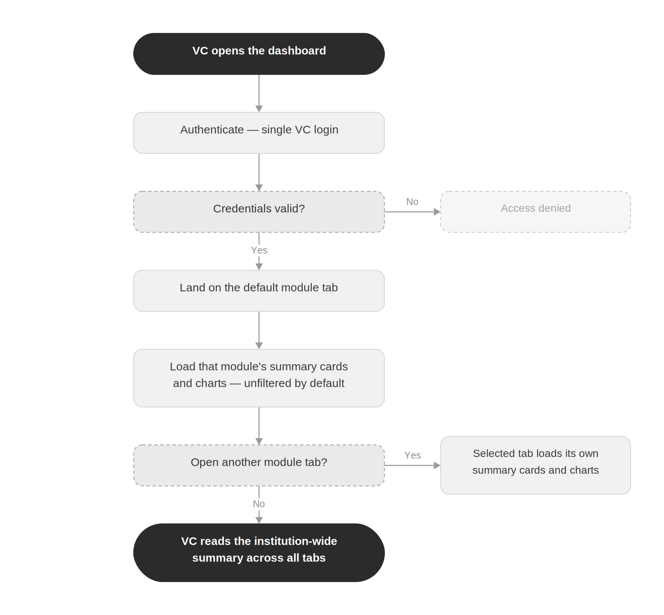
Figure 1. VC login and module navigation flow.

6.2 Applying Filters and Drilling Down
This is the flow behind FR-NAV-02 through FR-NAV-05 in Section 3.16: setting a filter re-queries the current module's data, and clicking a chart segment opens the matching drill-down list without losing the filters already applied.
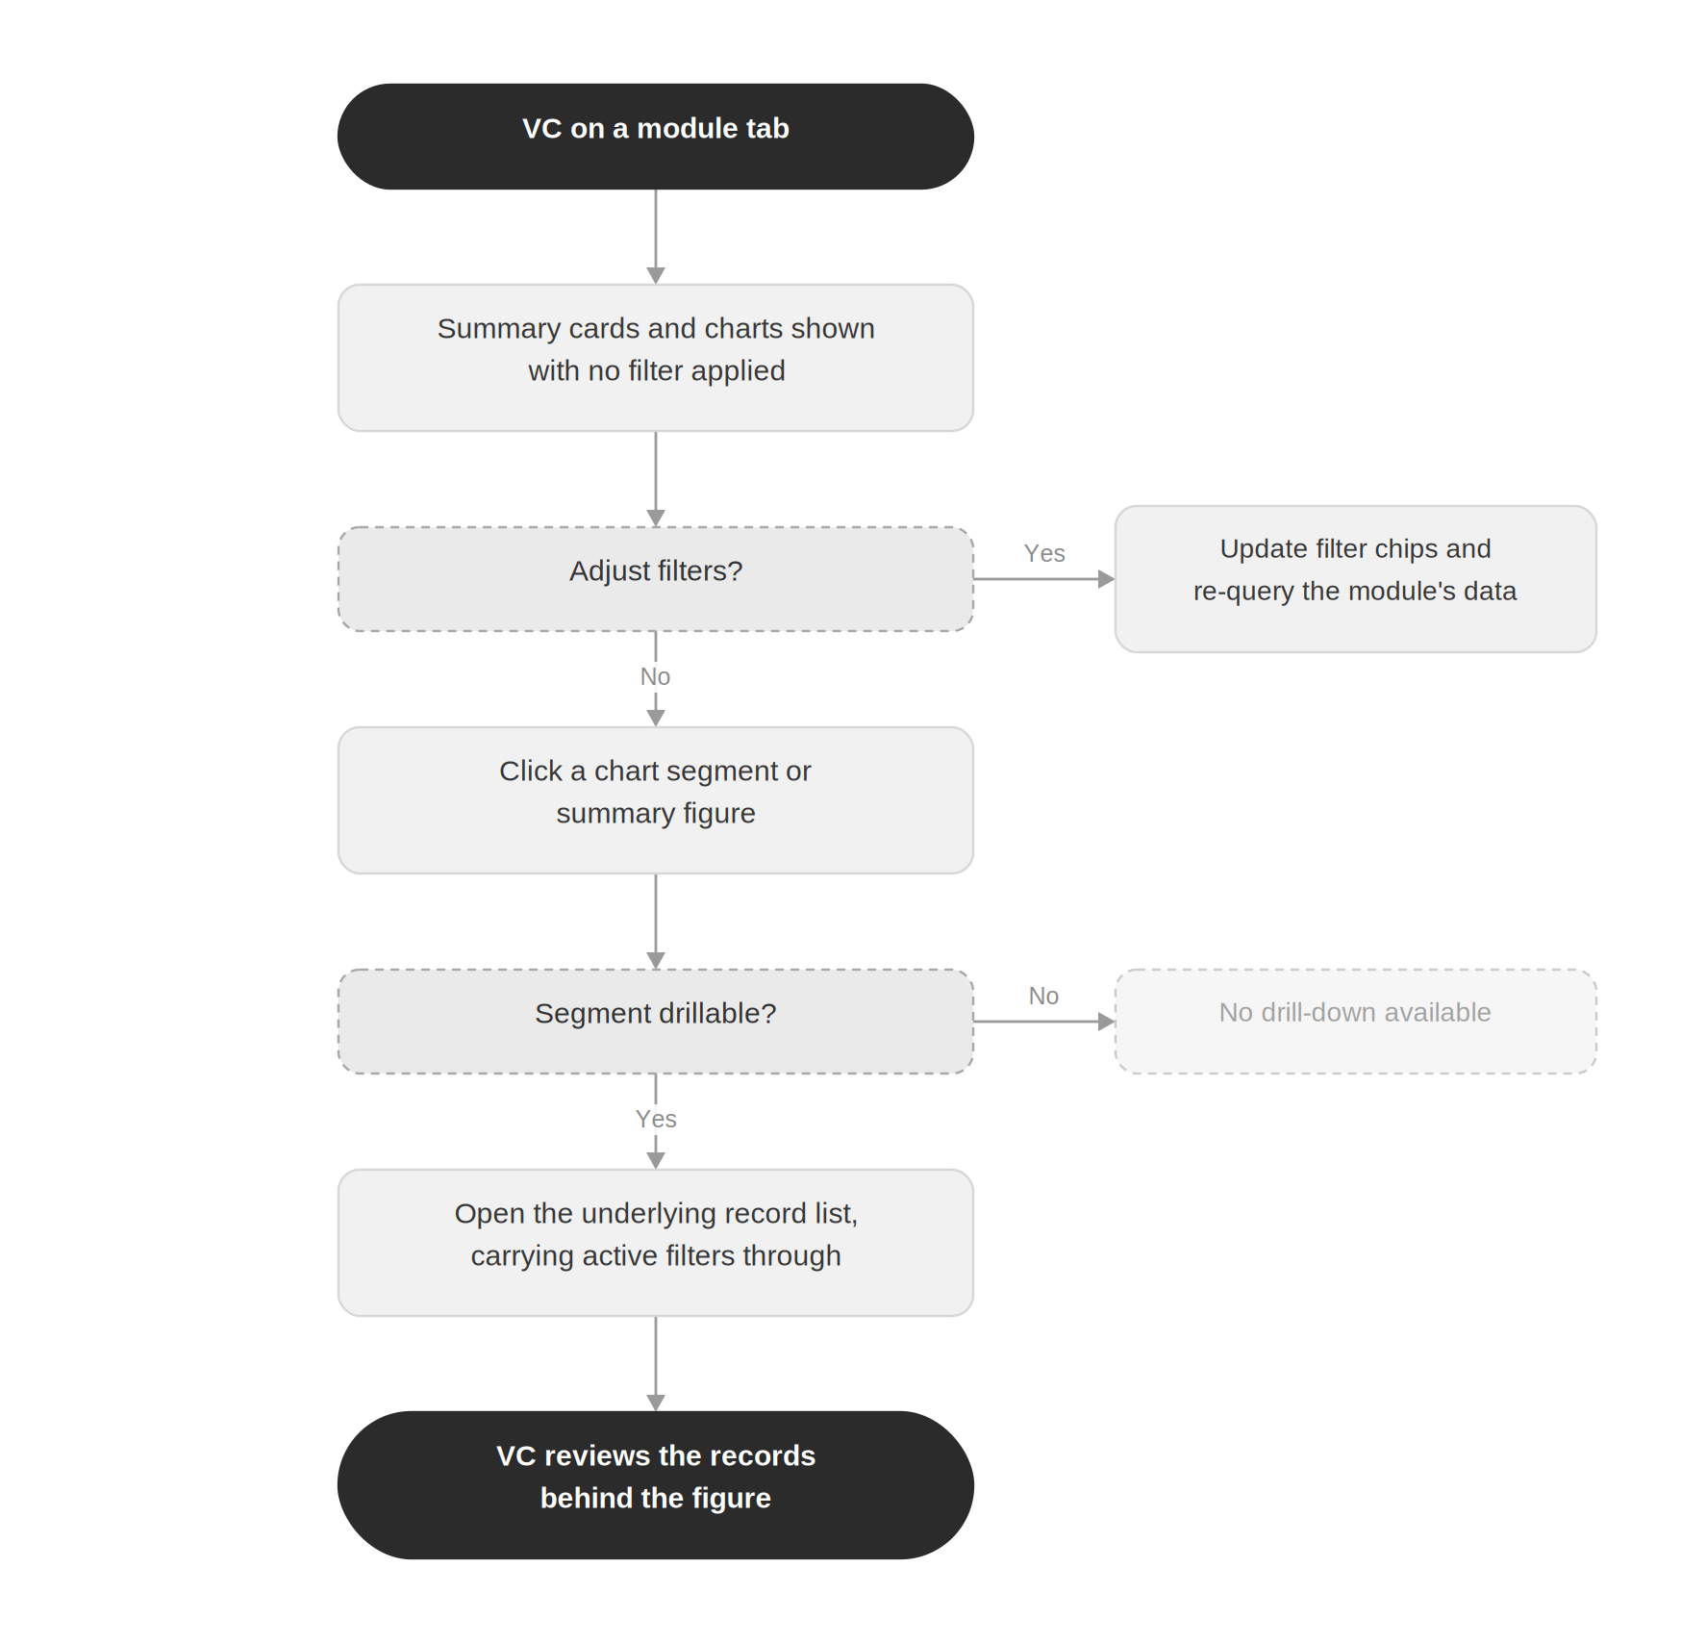
Figure 2. Filter and drill-down interaction flow.

6.3 E-Portal Case Auto-Escalation (BR-EP-01)
This flow realizes FR-EP-03 and FR-RULE-01: an e-Portal case's status changes from In-Process to Escalated purely as a function of how long it has been open, re-checked daily rather than decided by a staff member.
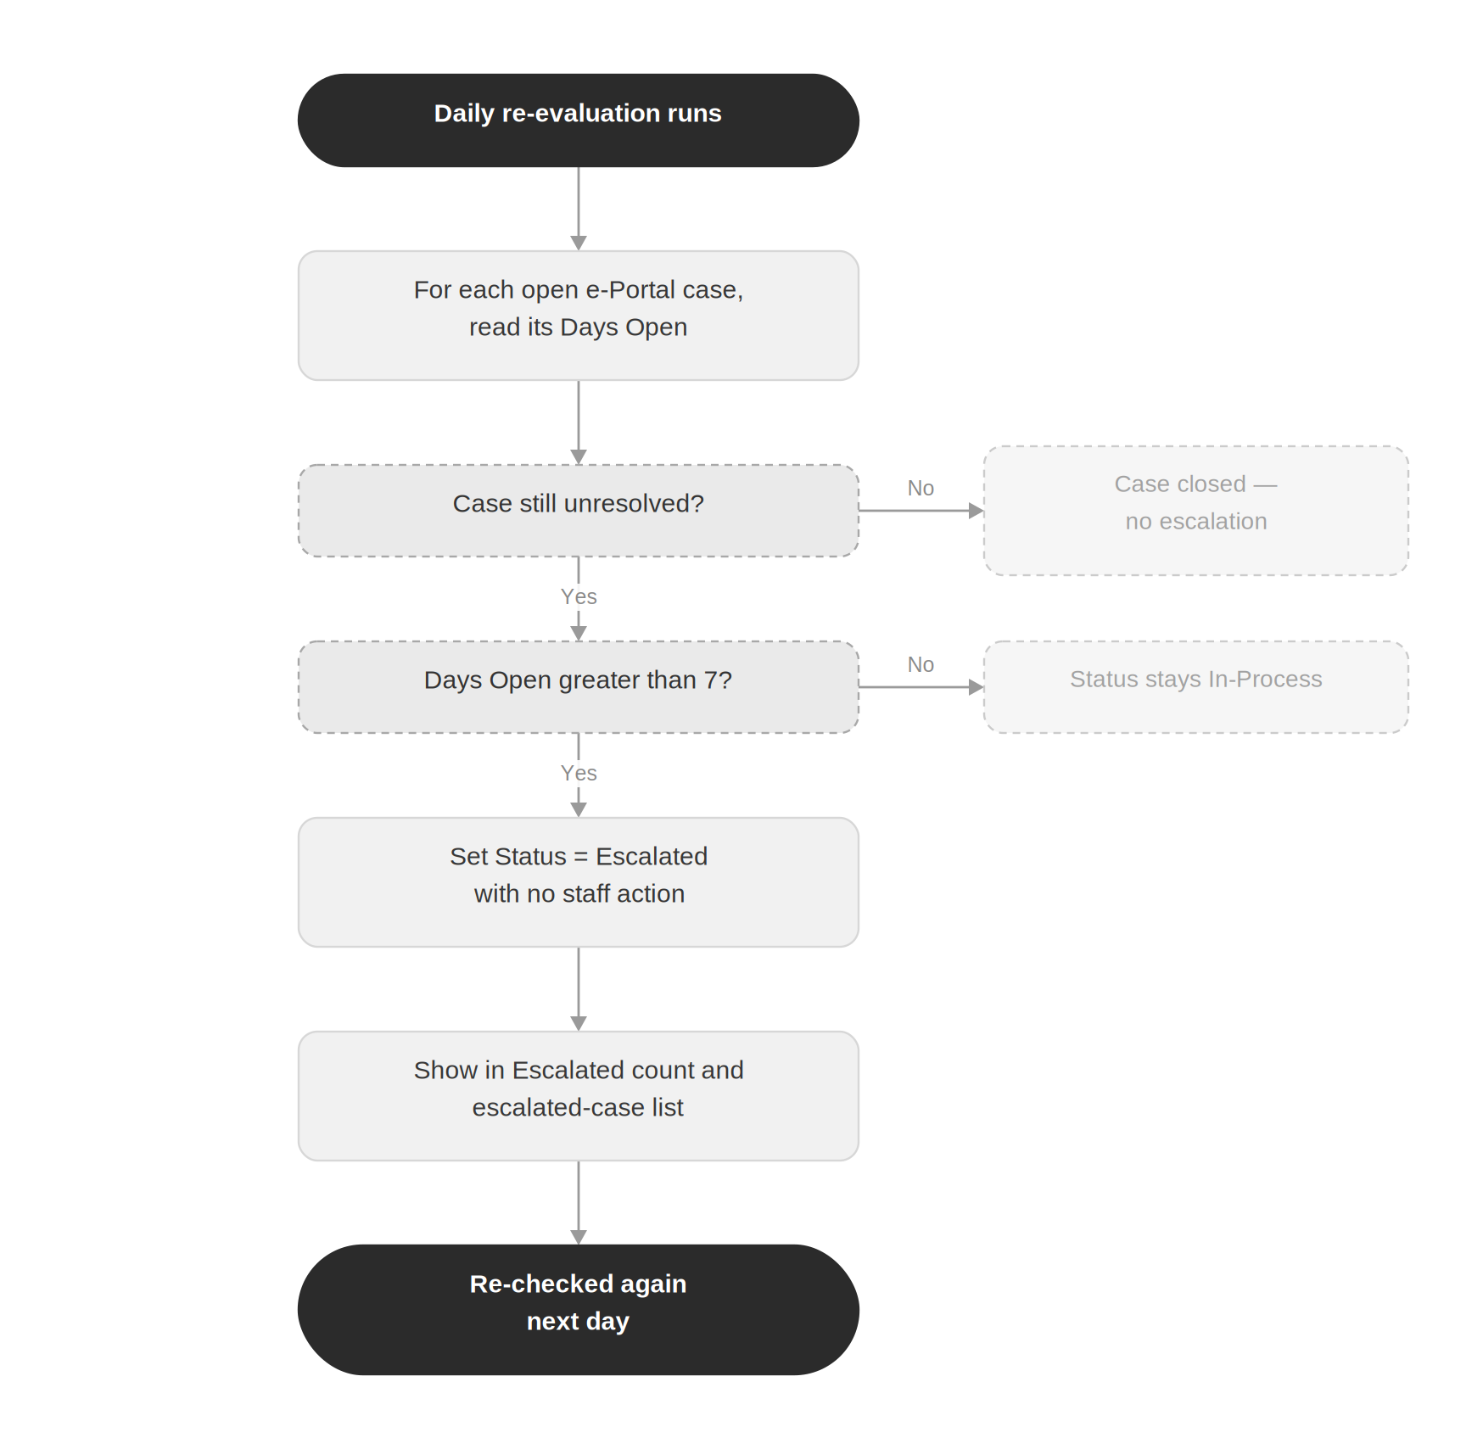
Figure 3. E-Portal case auto-escalation flow, BR-EP-01.

6.4 Grant End-Date Flagging (BR-GRT-01)
This flow realizes FR-GRT-02 and FR-RULE-02: an Underway grant is flagged the moment its End Date falls within six months of the current date, and stays flagged — and re-evaluated — until it closes.
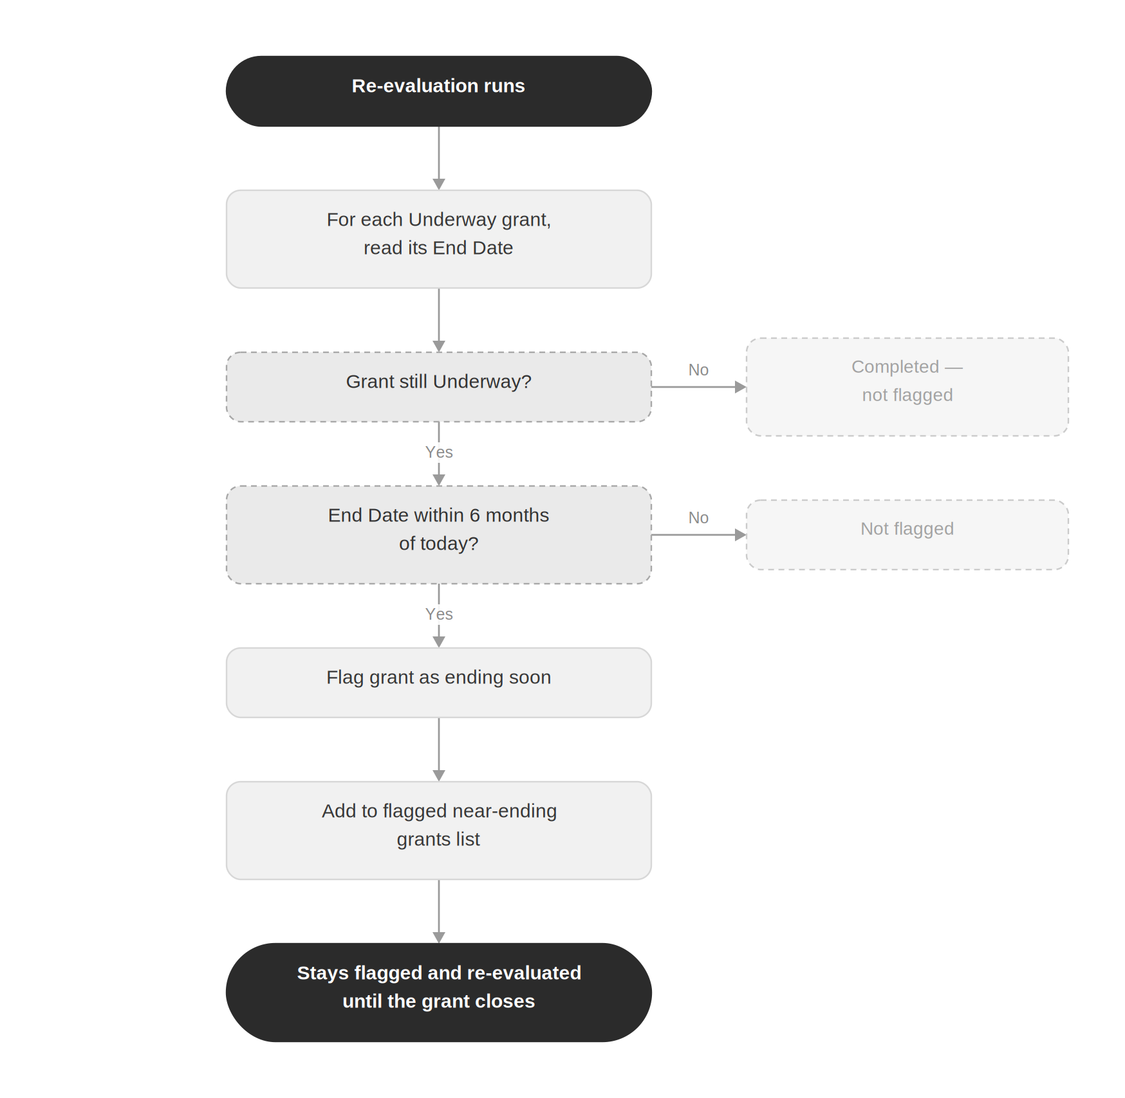
Figure 4. Grant end-date flagging flow, BR-GRT-01.

6.5 CGPA Division Classification (BR-PERF-01)
This flow realizes FR-PERF-01, FR-PERF-02, and FR-RULE-03: a student's current CGPA places them into exactly one of three divisions, which is what the Student Performance module counts and breaks down by school and program.
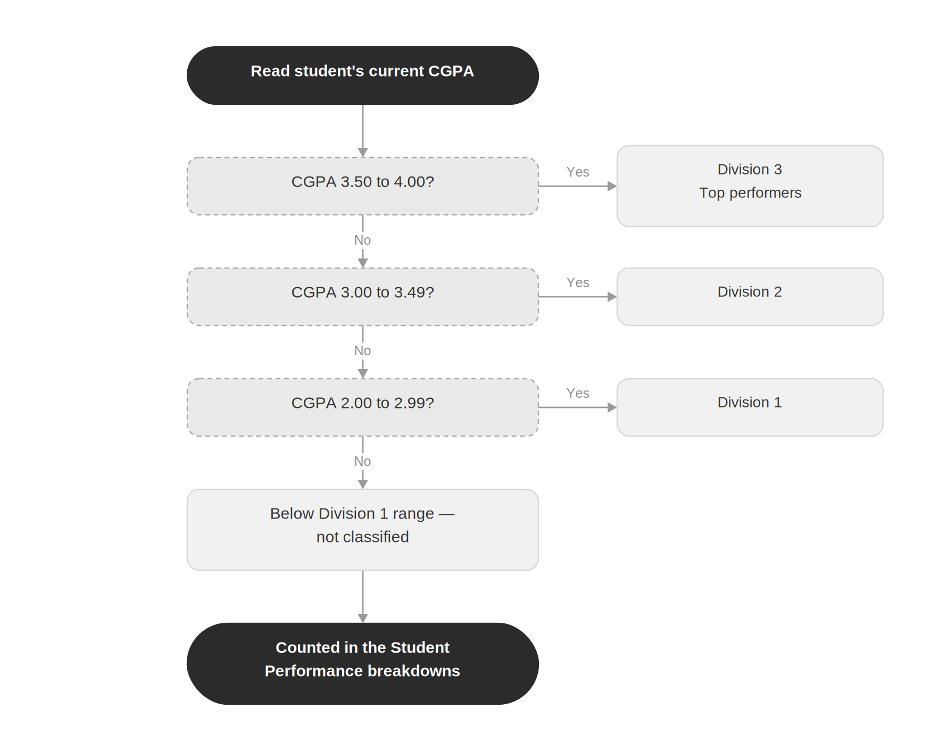
Figure 5. CGPA division classification flow, BR-PERF-01.

6.6 Transition from Dummy Data to Live Integration
This flow is forward-looking: it shows how the module-by-module maintainability required by NFR-07 is meant to play out once live integration is approved, without changing the dashboard's read-only behavior or its user interface.
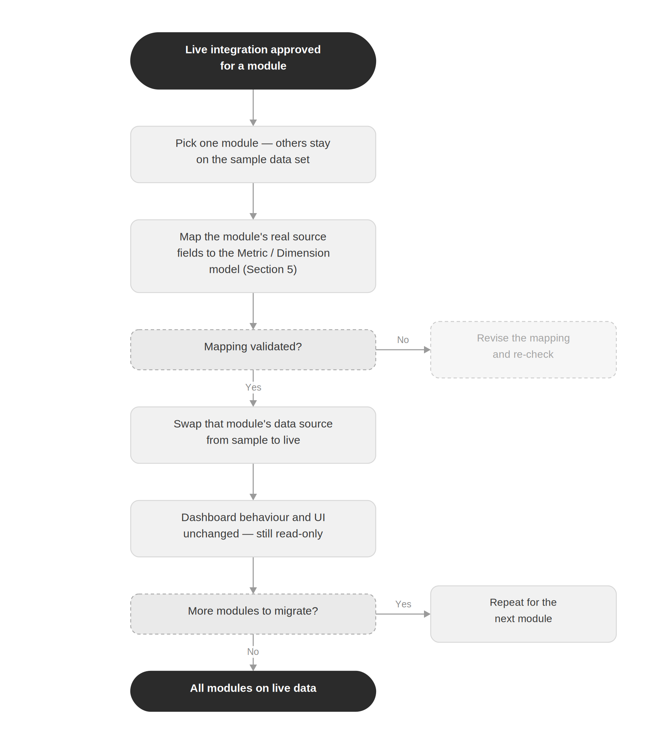
Figure 6. Transition from dummy data to live integration, by module.

7. Implementation Status
Unlike the Scholarship Management System, no working prototype of the VC Analytical Dashboard has been built yet. This section records that status plainly, rather than presenting screenshots that do not exist, and sets out what a first prototype would need to demonstrate against the requirements in Sections 3 through 6.

7.1 Current Status
As of this version, the VC Analytical Dashboard exists only as this specification. No screens, sample data set, or deployed environment have been built. Where a future prototype differs from a requirement in Sections 3 to 6, the requirement governs, as it would for any prototype built against this document.

7.2 What a First Prototype Should Demonstrate
- Tabbed navigation across all eleven modules (Section 3), each loading its own summary cards and charts (Figure 1).
- The reusable filter panel and drill-down mechanism working on at least one module end to end, with filters carried through to the drill-down list (Figure 2).
- The three business rules e-Portal auto-escalation, grant flagging, and CGPA division — computed from sample data rather than hand-set (Figures 3–5).
- A seeded sample data set standing in for live SIS, HR, and e-Portal data, structured so a single module's source could plausibly be swapped later without touching the others (Figure 6, Section 5).

7.3 Access
Once a prototype exists, its live URL, source location, and version date should be recorded here, in the same form used by the Scholarship Management System SRS, so this document stays the authoritative reference for what any given prototype build is meant to show.

8. Business Rules Summary
For convenience, the business rules embedded in the modules above are collected here.
Rule ID | Module | Rule
BR-PERF-01 | Student Performance | CGPA divisions Division 1: 2.00–2.99; Division 2: 3.00–3.49; Division 3 (Top performers): 3.50–4.00 (Figure 5).
BR-EP-01 | E-Portal Cases | A case is auto-escalated if it remains unresolved for more than 7 days (Figure 3).
BR-GRT-01 | Grants | A grant is flagged if its end date falls within 6 months of the current date (Figure 4).

9. Visualization Summary
A quick reference to the intended visual treatment per module, to guide chart selection during design.
Module | Intended Visuals
DC Cases | Total count card; Pending vs Resolved pie/bar; drill-down list.
Scholarships | Active-types table; % on scholarship gauge/donut; total-disbursed card (or map).
Admissions / Applications | Pool count card; 5-year trend line; Received vs Admitted bar/funnel.
Hostel Accommodation | On- vs Off-campus split; occupancy vs capacity; per-hostel resident list.
Enrolled Students | Total card; by-school and by-program breakdowns; Fall vs Spring trend.
Faculty | Count-by-school bar; Full-Time vs Visiting split per school.
Staff | Count-by-department; department filter.
Classes | Scheduled vs Not Attended per school.
Student Performance | Per-division counts / percentages; school & program breakdowns.
E-Portal Cases | In-Process vs Escalated counts; escalated-case list.
Grants | Completed vs Underway counts; flagged near-ending grants list.

10. Open Questions and Resolved Decisions

10.1 Resolved Decisions
The following were raised as open questions during requirements capture and have been answered by the stakeholder:
Question | Decision
Module layout — separate page/tab vs single scrollable dashboard? | Separate tab per module.
Date-range defaults for trend views? | No default date range.
Preferred tech stack? | Development team's choice, but it must be scalable and secure (priority). Oracle DB compatibility is a plus.
Finance module? | Explicitly out of scope.
Financial Health module from the VC Executive Dashboard blueprint — include? | Not included — Finance stays out of scope per the decision above.

10.2 Items Still to Confirm
- Platform reach — browser-only, or also mobile / tablet responsive?
- Refresh / sync frequency — not a requirement while data is dummy; to be defined when live integration begins (see Figure 6).
- Assumed data fields — every field marked assumed throughout Section 3 needs confirmation against the eventual source schema.
- Scholarship “total disbursed” view — confirm whether this is a summary card or the map-based treatment from the sketch (FR-SCH-03).
- First prototype timeline — no target date is set for the work described in Section 7.2.
End of Software Requirements Specification — VC Analytical Dashboard, v2.0

