INTRODUCTION TO DATA MANAGEMENT
PROJECT REPORT
(Project Semester January-April 2025)

INTERACTIVE EXCEL DASHBOARD: COVID 19 MORTALITY RATES

Submitted by

Namit Pareek

Registration No: 12321081

Programme and Section: KM005, Btech (CSE)
Course Code: INT 217

Under the Guidance of

Baljinder Kaur (UID 27952)

Discipline of CSE/IT

Lovely School of Computer Science and Engineering

Lovely Professional University, Phagwara

CERTIFICATE

This is to certify that Namit Pareek bearing Registration no. 12321081 has completed INT 217 project titled, “INTERACTIVE EXCEL DASHBOARD: COVID 19 MORTALITY RATES” under my guidance and supervision. To the best of my knowledge, the present work is the result of his/her original development, effort and study.

Signature and Name of the Supervisor
Baljinder Kaur
Designation of the Supervisor
School of Computer Science and Engineering
Lovely Professional University
Phagwara, Punjab.

Date: 13/04/2025

DECLARATION

I, Namit Pareek, student of Btech under CSE/IT Discipline at, Lovely Professional University, Punjab, hereby declare that all the information furnished in this project report is based on my own intensive work and is genuine.

Date: 13-04-2025 Signature: 
Registration No: 12321081 Namit Pareek

ACKNOWLEDGEMENT

I would like to express my sincere gratitude to my mentor Ms. Baljinder Kaur (UID: 27952) for her valuable guidance throughout this project. I also thank Lovely Professional University for providing the necessary resources and support.

Table of Contents

- Introduction
- Source of Dataset
- Data Preprocessing
- Analysis on dataset (for each analysis)
- Introduction
- General Description
- Specific Requirements, functions and formulas
- Analysis results
- Visualization
- Conclusion
- Future Scope
- References
- Relevant links

INTRODUCTION

This project presents an exploratory data analysis (EDA) on a provisional COVID-19 mortality dataset. The dataset comprises official records detailing death counts by sex, age group, state, and year across the United States.

The primary objective of this analysis is to uncover meaningful patterns, trends, and insights related to the demographic and temporal impact of the pandemic. By leveraging Excel-based analytical and visualization tools, the project assesses how factors such as age, sex, state, and time frame correlate with reported COVID-19 fatalities.

In addition to visual exploration, interactive dashboards and slicers were incorporated to enhance user-driven investigation. This project not only emphasizes a data-informed understanding of the pandemic’s toll but also showcases how visual storytelling can bring clarity to complex public health data.

Source of Dataset

The dataset used for this project is publicly available on Data.gov, under the Health and Human Services category. It contains structured records compiled by official agencies to document provisional counts of COVID-19-related deaths in the United States, segmented by demographic and geographic factors.

As an open government dataset, it serves as a credible and authoritative source for analyzing the public health impact of the COVID-19 pandemic across time, age groups, sex, and regions.

About the Dataset: The dataset includes multiple attributes that capture the demographic and temporal distribution of COVID-19 deaths. Each record represents an aggregated death count associated with a specific demographic group and time frame. Key columns include:
- Sex: Indicates the gender of the individuals (Male, Female, All Sexes).
- Age Group: Categorizes individuals into predefined age brackets (e.g., 55–64 years, 85 years and over).
- State: The U.S. state where the deaths were reported.
- Year: The year in which the deaths occurred (e.g., 2020, 2021, 2022).
- Month: The month of the year the deaths were recorded.
- COVID-19 Deaths: Number of reported deaths attributed to COVID-19.
- Pneumonia and Influenza Deaths: Comparative death counts from related respiratory illnesses.
- Total Deaths: Aggregated deaths from all listed causes.
This structured combination of categorical, numerical, temporal, and regional features makes the dataset well-suited for interactive visualizations and exploratory insights into the pandemic’s progression and demographic impact.

Data Preprocessing

Data Cleaning and Preprocessing
The initial phase involved a thorough examination of the dataset to identify inconsistencies, formatting issues, and missing values. Since the data spanned multiple years and demographic categories, careful attention was given to the integrity and uniformity of the records. Key cleaning steps included:
Replacing incomplete or ambiguous entries (e.g., blank or malformed year and state names) with standardized values or the statistical mode.
Stripping extra spaces and applying consistent casing to string fields like state_name and age_group.
Converting string-based null representations (e.g., "NA", "null", or empty strings) into actual missing values and handling them accordingly.
Removing or imputing rows with incomplete information where appropriate to maintain dataset reliability.
These steps ensured the data was clean, consistent, and ready for meaningful visual exploration without distortion from data quality issues.

Exploratory Analysis and Visualization
Once the dataset was cleaned, an in-depth exploratory analysis was conducted using Excel dashboards and pivot charts. Key aspects of the analysis included:
- Demographic Patterns: Analysed death distributions by sex and age groups to understand the relative impact on different population segments.
- State-wise Trends: Used interactive bar charts and slicers to explore how different states were affected over the years.
- Yearly and Monthly Progression: Visualized how COVID-19 deaths fluctuated across years, identifying peak periods and declining trends.
- Comparative Insights: Evaluated COVID-19 deaths alongside related causes such as pneumonia and influenza to understand overlapping or compounding effects.
- Interactivity and Usability: Enabled user-driven filtering and exploration through slicers, enhancing the accessibility of insights.
This phase uncovered crucial temporal and geographic trends, offering a clearer picture of how different demographics and states were impacted throughout the pandemic.

Analysis on Dataset

Analysis 1: Year-wise COVID-19 Death Distribution

1. General Description
This analysis examined the monthly progression of COVID-19-related deaths from 2020 to 2023 across the United States. By visualizing the percentage of deaths by month for each year, the analysis aimed to highlight shifts in mortality patterns and identify critical periods of heightened fatality. The visualization provided a comparative view of how death trends evolved over the four-year span.

2. Specific Requirements
The goal was to compare the intensity and consistency of deaths year over year, identify peak periods within each year, and determine whether overall mortality was stabilizing. The inclusion of data from 2020 through 2023 enabled insights into the initial outbreak, peak severity, and subsequent recovery or ongoing challenges.

3. Analysis Results
In 2020, deaths began at 0% and gradually increased, peaking mid-year before declining. The year 2021 exhibited the steepest rise early in the year, reaching over 90% by April, maintaining high levels through the rest of the year—marking it as the deadliest year. In contrast, 2022 and 2023 remained consistently high throughout, with values nearing or at 100% in most months, but without the sharp mid-year fluctuations seen in 2021 and 2020. This suggests a levelling off mortality, potentially due to stabilized healthcare responses, public adaptation, or other mitigating factors.

4. Visualization
A multi-line chart displayed month-wise death percentages for each year from 2020 to 2023. The interactive nature of the chart allowed users to hover and isolate each year's trend, making it easier to distinguish the early spike of 2021, the steady rates of 2022 and 2023, and the more dynamic pattern of 2020. This easily illustrated the elaboration of the epidemic’s impact across time
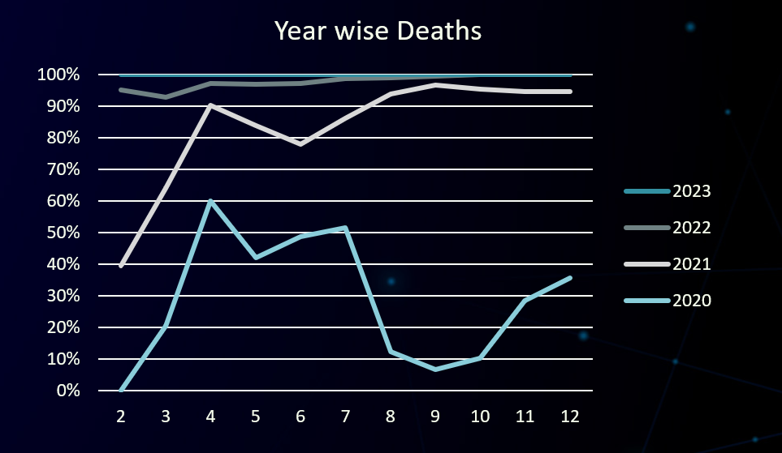

Analysis 2: Age and Sex to Death Ratio

1. General Description
This analysis explored the relationship between age, sex, and COVID-19-related deaths. By visualizing mortality counts across different age brackets and separating them by gender (male, female) along with total deaths (all sexes), it aimed to identify the most affected demographics and uncover any gender disparities in fatality trends.

2. Specific Requirements
The objective was to determine which age groups experienced the highest number of deaths and whether there were notable differences between male and female mortality. This demographic breakdown provided valuable insights for targeted healthcare strategies and public health communication.

3. Analysis Results
The data revealed that individuals aged 30–39 years and 25–34 years accounted for the highest number of COVID-19-related deaths, with both males and females contributing significantly, though males slightly outnumbered females in most categories. The 18–29 and 15–24 age groups also showed considerable death counts, while younger groups—especially those under 5 years—recorded minimal deaths. The “All Sexes” bars further reinforced the trend, emphasizing that the burden of mortality was heaviest among young-to-middle-aged adults rather than the very young.

4. Visualization
A horizontal bar chart was used to display the death counts across age groups and by gender. The use of distinct colors for males, females, and total deaths enabled easy comparison. This format clearly highlighted the concentration of fatalities in specific age ranges, revealing both the proportional gender differences and the overall distribution of COVID-19’s impact by age.

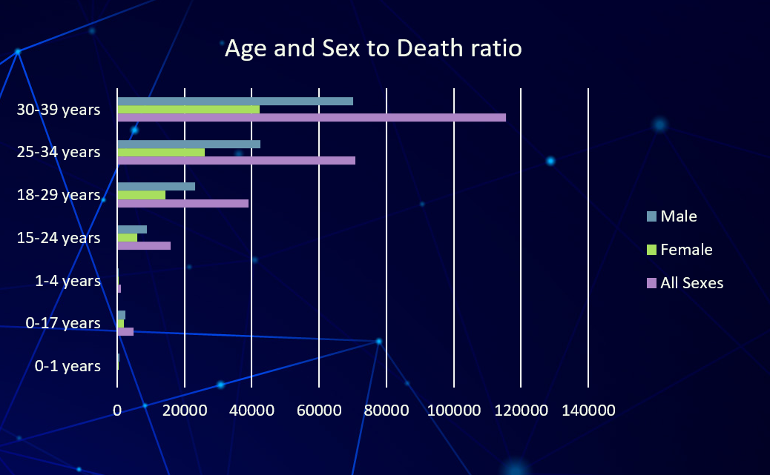

Analysis 3: State-wise COVID-19 Death Distribution

1. General Description
This analysis focused on the geographic distribution of COVID-19-related deaths across selected U.S. states. By visualizing the contribution of each state to the overall death toll, the analysis aimed to highlight regional disparities and identify states that bore the highest burden during the pandemic.

2. Specific Requirements
The objective was to determine which states reported the highest number of deaths, assess their proportional contribution to national mortality, and uncover any significant contrasts between heavily and lightly impacted states. This geographical breakdown helped assess localized severity and the effectiveness of regional health policies.

3. Analysis Results
The pie chart revealed that California overwhelmingly accounted for the largest share of COVID-19 deaths among the listed states, dominating the chart with a substantial margin. Other states such as Michigan, Texas, and New York also showed notable death counts, though far less than California. States like Hawaii, Colorado, and Washington had comparatively smaller shares, indicating a relatively lower impact. This distribution underscores the critical situation in high-population states and suggests variations in exposure, healthcare infrastructure, and policy implementation.

4. Visualization
A pie chart was employed to display state-wise death proportions, with each state represented by a unique color. This visual format made it easy to identify California’s dominant contribution and allowed for quick comparative assessment of other states. The chart provided an effective overview of regional disparities in mortality throughout the pandemic.

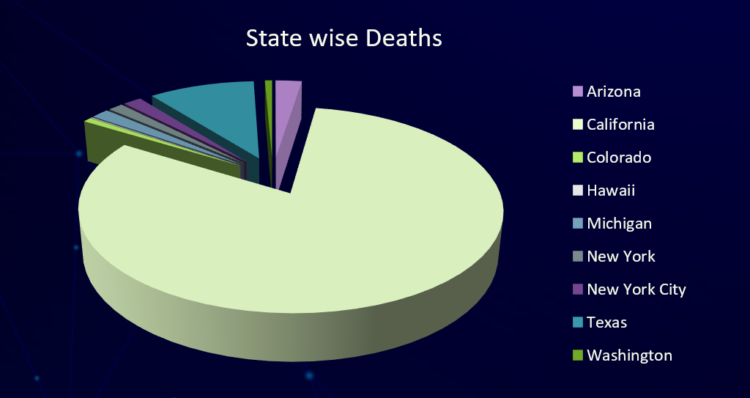

Analysis 4: Age-wise COVID-19 Death Distribution Across Years

1. General Description
This analysis aimed to examine how COVID-19-related deaths varied across different age groups over time. By visualizing annual death counts segmented by age from 2020 to 2023, the study explored the evolving vulnerability of age brackets and the pandemic’s shifting demographic impact.

2. Specific Requirements
The goal was to compare death counts across age categories for each year, identify the most affected age groups, and detect any significant trends such as shifts in peak mortality from older to younger populations or vice versa. This helped assess age-specific risk and guide age-targeted public health interventions.

3. Analysis Results
The bar chart revealed that the 30–39 years and 25–34 years age groups experienced the highest number of deaths throughout the timeline, especially during 2020 and 2021. Deaths in these age categories declined significantly in 2022 and even more sharply in 2023. Across all age groups, there was a noticeable decline in death tolls from 2021 onward, suggesting improvements in medical interventions, vaccination coverage, or reduced virus severity. Younger age groups (0–1 years, 0–17 years, and 1–4 years) consistently exhibited the lowest death counts throughout all years.

4. Visualization
A clustered bar chart was used to present yearly death counts for each age group, with distinct colors representing each year from 2020 to 2023. This layout enabled clear year-over-year comparisons and illustrated the sharp contrast in death trends between age brackets and over time. The visual effectively emphasized the declining trend in mortality among all age groups by 2023.
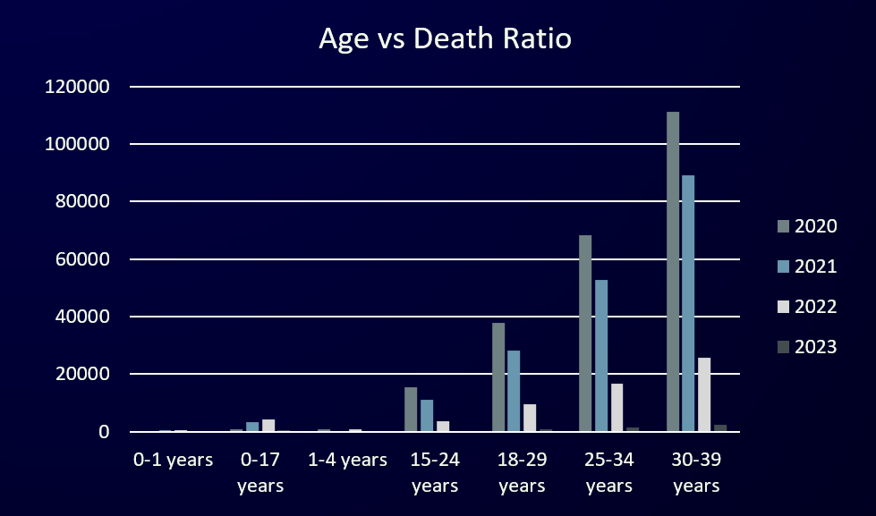

Analysis 5: Death Comparison by Cause – COVID-19, Influenza, and Pneumonia

1. General Description
This analysis focused on comparing total deaths caused by three major respiratory illnesses: COVID-19, Influenza, and Pneumonia. The intent was to gauge the relative lethality of each disease over a specific period by directly visualizing their cumulative death tolls.

2. Specific Requirements
The aim was to determine which disease contributed the most to overall mortality and how the burden of COVID-19 compares to more historically common illnesses like influenza and pneumonia. This supports prioritizing public health efforts and resource allocation.

3. Analysis Results
The 3D bar chart illustrated that Pneumonia and COVID-19 were nearly equal in death toll, with both diseases accounting for just over 30 million deaths each. In contrast, Influenza accounted for a significantly lower number of deaths—just a small fraction compared to the other two. This highlights the severe mortality impact of pneumonia and COVID- 19 relative to influenza.

4. Visualization
A 3D vertical bar chart was used to contrast the total death counts across the three diseases. The design effectively highlighted the magnitude difference, with each disease represented in a unique color. This visual made it immediately clear that COVID-19 and pneumonia posed substantially greater mortality threats than influenza during the analyzed timeframe.

Conclusion

This project centered around a comprehensive exploratory data analysis (EDA) of COVID-19-related deaths in the United States, with the core objective of uncovering demographic, geographic, and temporal trends that shaped the impact of the pandemic. By analyzing patterns across age groups, sexes, states, and years, the dashboard delivers an interactive view of mortality insights that can inform both policy and public awareness.

• Age group analysis highlighted that senior populations—especially those aged 75 and above—were the most vulnerable throughout the pandemic.
• Sex-wise comparisons revealed a consistently higher death toll among males, aligning with international findings.
• Year-on-year trends exposed significant spikes in mortality in 2021, offering insight into wave severity and healthcare response.
• State-level breakdowns enabled granular visibility into regional patterns and progress over time.
• User-friendly visuals brought clarity to complex data, fostering interactive exploration for deeper understanding.

The project not only showcases the strength of structured data analysis and visualization but also emphasizes how publicly available health datasets can be transformed into meaningful, accessible insights. From a broader lens, it reflects the value of data-driven storytelling in addressing real-world challenges and enhancing public health communication.

Future Scope
This project sets the stage for several meaningful extensions and analytical advancements in public health data monitoring:
- Predictive Modelling: Develop time-series forecasting models using historical death data to anticipate future surges or declines, aiding in proactive healthcare planning and resource allocation.
- Interactive Dashboards: Enhance the current Excel dashboard by integrating tools like Power BI or Tableau for dynamic filtering, drill-down capabilities, and real-time updates tailored to policymakers or researchers.
- Geo-Spatial Analysis: Leverage geographic mapping libraries to build heatmaps or choropleth maps showing state-wise or county-level COVID-19 death concentrations for micro-trend detection.
- Demographic Deep Dives: Incorporate more granular demographic data (e.g., ethnicity, occupation, pre-existing conditions) to analyze how specific populations were disproportionately affected.
- Anomaly Detection: Use machine learning models to automatically flag unexpected spikes in death rates, enabling timely investigations or interventions.
- Public Health Integration: Merge this dataset with vaccination rates, hospital capacity, or case counts to create a multi-dimensional view of the pandemic’s impact.
- Policy Impact Analysis: Study the correlation between policy changes (e.g., lockdowns, mask mandates) and death rates across states to assess the effectiveness of interventions.
- Longitudinal Studies: Continue tracking post-pandemic data to assess recovery trends, long-term mortality shifts, or emerging public health risks.

References
- CDC, “Provisional COVID-19 Death Counts by Sex, Age, and State,” National Center for Health Statistics, [Online]. Available: https://data.cdc.gov
- Microsoft Corporation, “Overview of Excel for Windows”, Microsoft Support, [Online]. Available: https://support.microsoft.com/en-us/excel
- Microsoft Learn, “Create and use a Dashboard in Excel”, [Online]. Available: https://learn.microsoft.com/en-us/training/modules/create-dashboards-excel/
- Microsoft Corporation, “PivotTables and PivotCharts in Excel”, Microsoft Support, [Online]. Available: https://support.microsoft.com/en-us/office/pivottable-overview-00aaf32e-3d8e-4f1c-8552-1c45baf7b551
- Microsoft Excel Team, “Formulas and Functions in Excel”, [Online]. Available: https://support.microsoft.com/en-us/excel-formulas-functions

Relevant links
- Dataset Link: https: https://catalog.data.gov/dataset/provisional-covid-19-death-counts-by-sex-age-and-state
- LinkedIn Post link: https://www.linkedin.com/posts/namit-pareek-ab2705291_eda-dataanalysis-excel-activity-7316406928539013120-ASd9

