STUDENT ADMISSION PORTAL
Laboratory Practical Record / Course Project Report
Subject: Web Technology
Course Outcomes Evaluated: CO3 (8 Marks), CO4 (16 Marks), CO5 (16 Marks)
Total Marks Assigned: 40 / 40 Marks
Student Name: __________________________________________________
Register Number: __________________________________________________
Degree & Branch: Bachelor of Engineering (B.E.)
Department: Computer Science and Engineering
College Name: __________________________________________________
Academic Year: __________________________________________________

Question 1: CO3 — Registration Form & Client-Side Validation (8 Marks)
Aim: To design, develop, and verify an interactive, responsive student admission registration form using semantic HTML5 markup, CSS3 layout, real-time JavaScript validation with password entropy tracking, drag-and-drop avatar handling, and secure asynchronous persistence to MySQL.
1. PHP, Servlet WEB-INF Files and Other Files (.html, .css, .js)
Files used for CO3 (Client-Side Registration):
• registration/index.html – Semantic HTML5 registration form with floating labels
• registration/css/style.css – Responsive CSS3 layout, validation highlight classes
• registration/js/validation.js – JavaScript validation, password entropy tracker, AJAX submit
• registration/register.php – Server endpoint: BCrypt hashing, PDO insertion, file upload
registration/index.html (Key Excerpt)
<!DOCTYPE html>
<html lang="en">
<head>
<meta charset="UTF-8">
<meta name="viewport" content="width=device-width, initial-scale=1.0">
<title>Student Admission Registration Portal</title>
<link rel="stylesheet" href="css/style.css">
</head>
<body>
<!-- Registration Form -->
<form id="registrationForm" method="POST" action="register.php"
enctype="multipart/form-data" novalidate>

<!-- Full Name input with live validation -->
<input type="text" id="studentName" name="name" class="form-control"
placeholder="e.g. Aarav Sharma" required autocomplete="name">
<span class="field-error" id="nameError"></span>

<!-- Roll Number -->
<input type="text" id="rollNumber" name="roll_number" class="form-control"
placeholder="e.g. CS2026-105" required>
<span class="field-error" id="rollError"></span>

<!-- Email -->
<input type="email" id="email" name="email" class="form-control"
placeholder="student@example.edu" required>
<span class="field-error" id="emailError"></span>

<!-- Password with 5-rule strength meter -->
<input type="password" id="password" name="password" class="form-control" required>
<div class="strength-bar-fill" id="strengthFill"></div>

<!-- Submit via AJAX -->
<button type="submit" id="submitBtn">Submit Application</button>
</form>
</body>
</html>
registration/js/validation.js (Key Excerpt)
/**
* Student Admission Portal - Client-Side Form Validation
* CO3: HTML, CSS, JavaScript Validation
*/
document.addEventListener('DOMContentLoaded', () => {
const form = document.getElementById('registrationForm');
const nameInput = document.getElementById('studentName');
const emailInput = document.getElementById('email');
const passwordInput= document.getElementById('password');

// 1. Validate student name using regex
function validateName() {
const val = nameInput.value.trim();
if (!val) { setError(nameInput, 'Student name is required.'); return false; }
if (!/^[a-zA-Z\s.'-]+$/.test(val)) {
setError(nameInput, 'Name can only contain letters and spaces.');
return false;
}
setSuccess(nameInput); return true;
}

// 2. Password entropy tracker — checks 5 rules
passwordInput.addEventListener('input', () => {
const val = passwordInput.value;
let score = 0;
if (val.length >= 8) score++; // length
if (/[A-Z]/.test(val)) score++; // uppercase
if (/[a-z]/.test(val)) score++; // lowercase
if (/[0-9]/.test(val)) score++; // digit
if (/[^A-Za-z0-9]/.test(val)) score++; // special
// Update the strength bar width (20% per rule met)
strengthFill.style.width = (score * 20) + '%';
});

// 3. AJAX form submission — no page reload
form.addEventListener('submit', async (e) => {
e.preventDefault();
if (!validateAll()) return;
const resp = await fetch('register.php', { method: 'POST',
body: new FormData(form) });
const data = await resp.json();
if (data.status === 'success') showSuccessScreen(data);
else showErrors(data.errors);
});
});
registration/register.php (Key Excerpt)
<?php
/** Server-side registration endpoint: validates, hashes password, inserts into DB */
header('Content-Type: application/json; charset=utf-8');
require_once __DIR__ . '/../php-admin/config/database.php';

if ($_SERVER['REQUEST_METHOD'] !== 'POST') { http_response_code(405); exit; }

$name = trim($_POST['name'] ?? '');
$rollNumber = trim($_POST['roll_number'] ?? '');
$email = trim($_POST['email'] ?? '');
$password = $_POST['password'] ?? '';

// Server-side regex validation (mirrors JS rules)
if (!preg_match("/^[a-zA-Z\s.'-]+$/", $name))
$errors['name'] = 'Name contains invalid characters.';
if (!preg_match('/^[A-Za-z0-9-_]{3,20}$/', $rollNumber))
$errors['roll_number'] = 'Invalid roll number format.';
if (!filter_var($email, FILTER_VALIDATE_EMAIL))
$errors['email'] = 'Invalid email address.';

// BCrypt password hashing (cost factor 10)
$passwordHash = password_hash($password, PASSWORD_BCRYPT);

// PDO prepared statement — prevents SQL injection
$pdo = getDbConnection();
$stmt = $pdo->prepare(
"INSERT INTO students (roll_number, name, email, course, password_hash)
VALUES (:roll, :name, :email, :course, :hash)"
);
$stmt->execute([':roll'=>$rollNumber,':name'=>$name,
':email'=>$email,':course'=>$course,':hash'=>$passwordHash]);

echo json_encode(['status'=>'success','message'=>'Registration successful.']);
?>
2. DB Schema Script
The shared database schema (student_portal) is used across CO3, CO4, and CO5. Relevant table for CO3 is the students table where registration records are persisted.
-- STUDENT ADMISSION PORTAL - SHARED DATABASE SCHEMA
-- Compatible with MySQL 8.0+ and MariaDB 10.4+ (XAMPP)

CREATE DATABASE IF NOT EXISTS `student_portal`
CHARACTER SET utf8mb4 COLLATE utf8mb4_unicode_ci;
USE `student_portal`;

-- Table: students (used by CO3 registration endpoint)
CREATE TABLE `students` (
`id` INT AUTO_INCREMENT PRIMARY KEY,
`roll_number` VARCHAR(30) NOT NULL UNIQUE,
`name` VARCHAR(100) NOT NULL,
`email` VARCHAR(100) NOT NULL UNIQUE,
`course` VARCHAR(80) NOT NULL,
`password_hash` VARCHAR(255) NOT NULL, -- BCrypt $2y$ hash
`profile_image` VARCHAR(255) DEFAULT NULL,
`status` ENUM('Pending','Approved','Rejected') NOT NULL DEFAULT 'Approved',
`registration_date` TIMESTAMP DEFAULT CURRENT_TIMESTAMP,
`updated_at` TIMESTAMP DEFAULT CURRENT_TIMESTAMP ON UPDATE CURRENT_TIMESTAMP,
INDEX `idx_roll_number` (`roll_number`),
INDEX `idx_student_email` (`email`)
) ENGINE=InnoDB DEFAULT CHARSET=utf8mb4 COLLATE=utf8mb4_unicode_ci;
3. Screenshots of Output in Browser
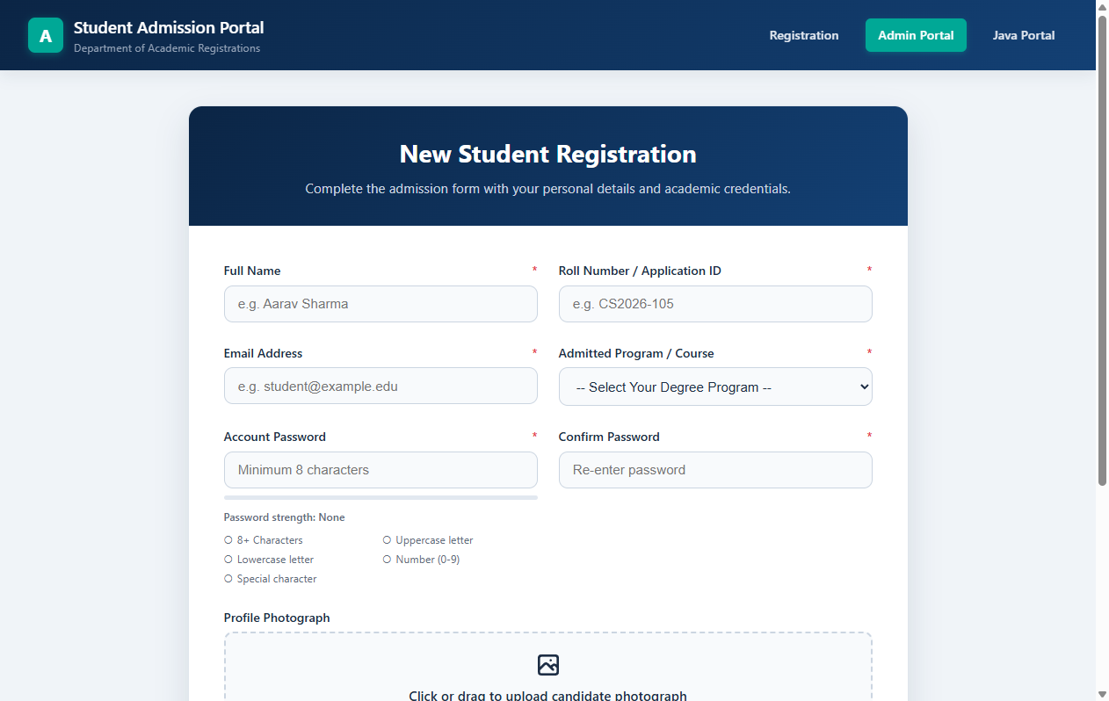
Figure 1: Main Student Admission Registration Form
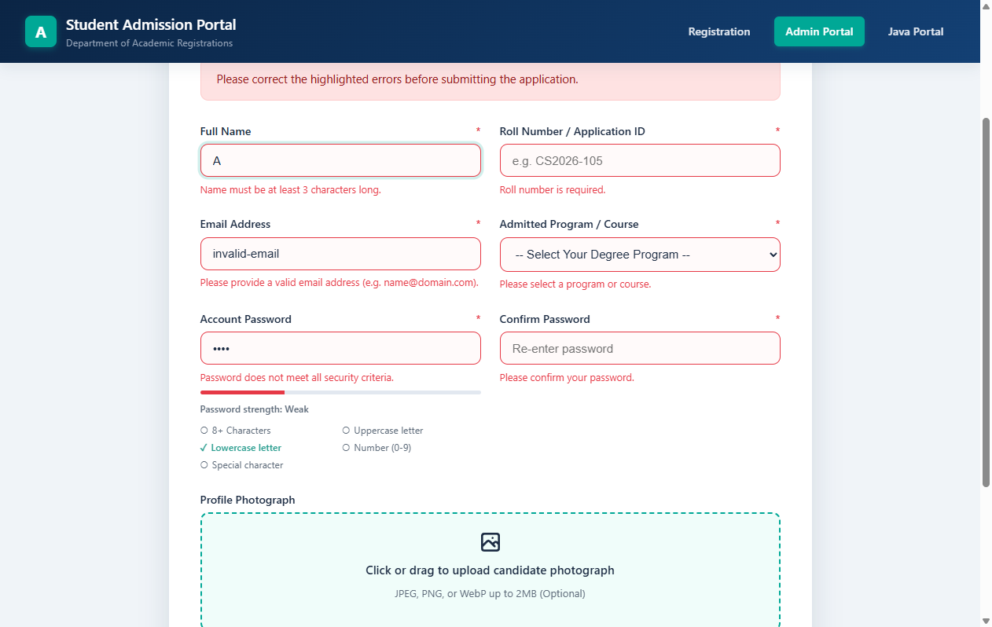
Figure 2: Live Validation Errors and Password Strength Meter
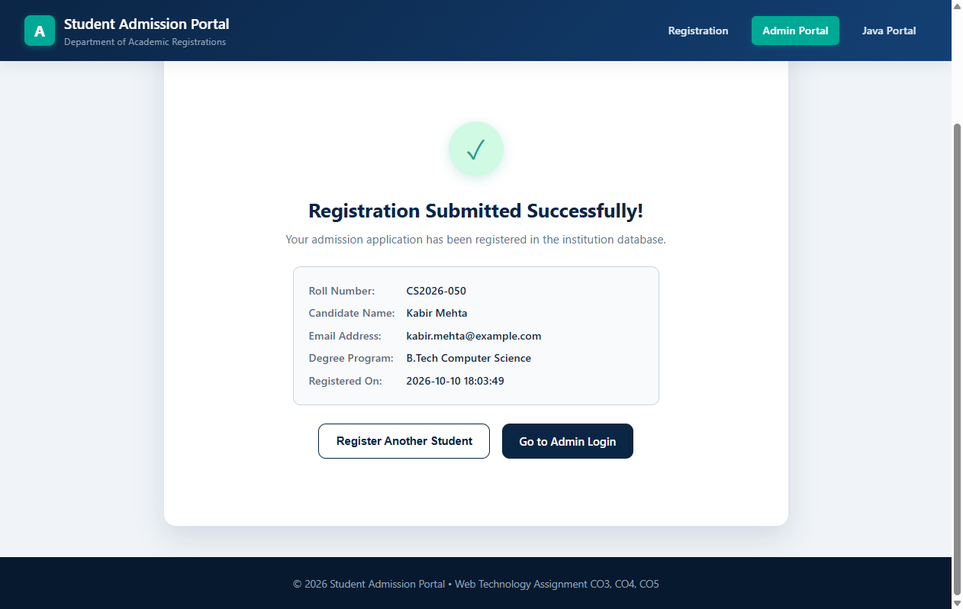
Figure 3: AJAX Success Confirmation after Registration
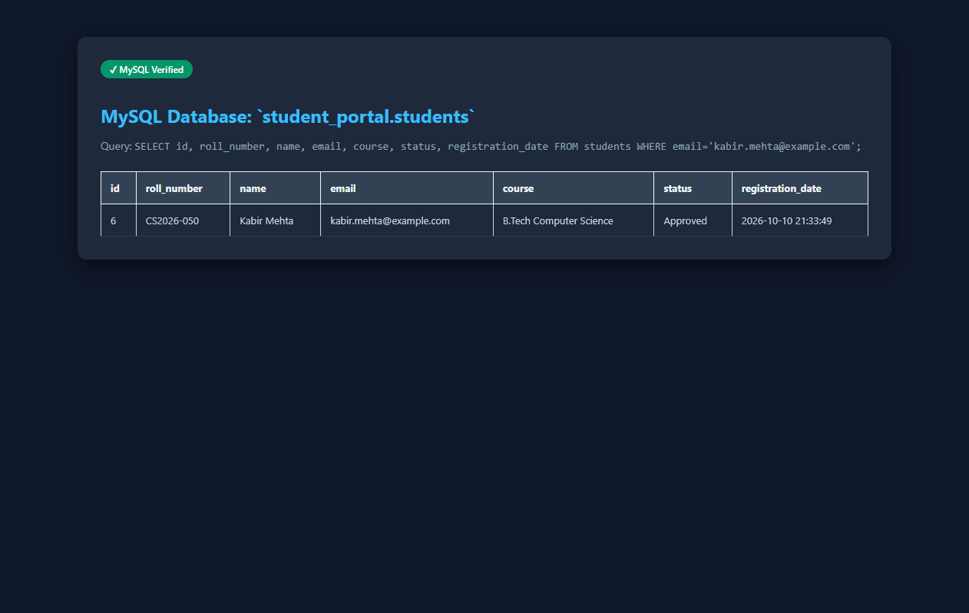
Figure 4: MySQL Database Record Verification
4. Explanation of Code with Inline Comments
index.html:
Provides the complete HTML5 form structure with semantic elements (<form>, <input>, <select>). The novalidate attribute suppresses native browser validation so that the custom JS logic takes full control. Each field has a paired <span class="field-error"> element that is shown or hidden dynamically by validation.js.
css/style.css:
CSS variables define the colour tokens and spacing scale. The .input-error class applies a red border; .input-valid applies a green border. The five password-rule indicators use flexbox and CSS transition to animate the strength bar fill width in real time.
js/validation.js:
Attaches blur and input event listeners on all fields. Each field has a dedicated validateX() function that tests the value against a regular expression. The password entropy tracker counts how many of the five rules are satisfied and sets strengthFill.style.width accordingly. On submit, the form is intercepted via e.preventDefault(), validated, then sent via the Fetch API as FormData. The JSON response is parsed to show the success screen or field-level error messages.
register.php:
Accepts only POST requests. Sanitizes all inputs with trim() and validates using preg_match(). Hashes the password with password_hash(..., PASSWORD_BCRYPT). Handles profile picture upload: checks MIME type via finfo_file(), generates a unique filename, and copies the file to uploads/profile_images/. Inserts the record using a PDO prepared statement and returns a JSON response with status success or error.
5. Brief Conclusion (3–5 Lines)
CO3 successfully demonstrates a fully client-side-validated, multi-field student admission registration form built with semantic HTML5, CSS3, and JavaScript. The five-rule password entropy tracker, real-time field validation, drag-and-drop avatar preview, and AJAX-based form submission collectively eliminate page reloads and provide immediate feedback to applicants. Server-side mirror validation in register.php and BCrypt password hashing ensure the registration workflow is both user-friendly and secure.
6. GitHub Repository Link
Repository URL: https://github.com/[YOUR_USERNAME]/student-admission-portal
Note: Replace [YOUR_USERNAME] with your actual GitHub handle after pushing the project.

Question 2: CO4 — PHP and MySQL Admin CRUD Panel (16 Marks)
Aim: To implement and verify an administrative management panel in PHP 8 backed by MySQL, supporting admin authentication, secure session handling, full CRUD operations on student records, document upload with metadata management, path traversal defenses, and CSRF protection.
1. PHP, Servlet WEB-INF Files and Other Files (.html, .css, .js)
Files used for CO4 (PHP Admin CRUD Panel):
• php-admin/config/database.php – Shared PDO connection factory, UTF-8 encoding
• php-admin/includes/auth.php – Session fixation defense, CSRF token management
• php-admin/login.php – Admin login with password_verify() and session regeneration
• php-admin/dashboard.php – Admin dashboard with KPI counters and student overview
• php-admin/add_student.php – Student insertion form with CSRF protection
• php-admin/edit_student.php – Record update controller with pre-populated fields
• php-admin/view_student.php – Student profile and document upload manager
• php-admin/delete_student.php – Cascade deletion unlinking disk files before SQL delete
• php-admin/download_document.php – Safe streaming handler using realpath() boundary check
• php-admin/upload_document.php – MIME-verified file upload with metadata DB insertion
php-admin/login.php (Key Excerpt)
<?php
/**
* Admin Login Controller
* Handles secure authentication, session fixation prevention, CSRF token validation
*/
require_once __DIR__ . '/includes/auth.php';
require_once __DIR__ . '/config/database.php';

if ($_SERVER['REQUEST_METHOD'] === 'POST') {
$username = trim($_POST['username'] ?? '');
$password = $_POST['password'] ?? '';
$csrfToken = $_POST['csrf_token'] ?? '';

// Step 1: Validate CSRF token to block cross-site request forgery
if (!validateCsrfToken($csrfToken)) {
$errorMessage = 'Security validation failed. Please try again.';
} else {
$pdo = getDbConnection();
$stmt = $pdo->prepare(
"SELECT id, username, password_hash, full_name
FROM admin_users WHERE username = :username LIMIT 1"
);
$stmt->execute([':username' => $username]);
$admin = $stmt->fetch();

// Step 2: BCrypt verification — password_verify() compares plain text
// against the stored $2y$ hash safely
if ($admin && password_verify($password, $admin['password_hash'])) {
session_regenerate_id(true); // Prevent session fixation
$_SESSION['admin_user_id'] = (int)$admin['id'];
$_SESSION['admin_username'] = $admin['username'];
$_SESSION['admin_full_name'] = $admin['full_name'];
header('Location: dashboard.php');
exit;
} else {
$errorMessage = 'Invalid username or password.'; // Generic to prevent enumeration
}
}
}
?>
php-admin/view_student.php (Key Excerpt)
<?php
/**
* View Student Profile & Document Management
* Fetches student record and all associated document metadata
*/
$pdo = getDbConnection();
$studentId = (int)($_GET['id'] ?? 0);

// Fetch student record using prepared statement
$stmt = $pdo->prepare("SELECT * FROM students WHERE id = :id LIMIT 1");
$stmt->execute([':id' => $studentId]);
$student = $stmt->fetch();

// Fetch all documents for this student, newest first
$docStmt = $pdo->prepare(
"SELECT * FROM student_documents
WHERE student_id = :id ORDER BY uploaded_at DESC"
);
$docStmt->execute([':id' => $studentId]);
$documents = $docStmt->fetchAll();
?>
php-admin/download_document.php (Key Excerpt)
<?php
/**
* Safe Document Download Handler
* Prevents path traversal attacks using realpath() boundary verification
*/
$storedFilename = basename($_GET['file'] ?? '');
$uploadsDir = realpath(__DIR__ . '/uploads/documents');
$filePath = realpath($uploadsDir . '/' . $storedFilename);

// Security check: ensure resolved path starts within uploads/ boundary
if (!$filePath || strpos($filePath, $uploadsDir) !== 0) {
http_response_code(403);
exit('Access denied.');
}

// Stream the file in 8KB chunks to avoid memory exhaustion
header('Content-Type: ' . mime_content_type($filePath));
header('Content-Length: ' . filesize($filePath));
$fp = fopen($filePath, 'rb');
while (!feof($fp)) { echo fread($fp, 8192); }
fclose($fp);
?>
2. DB Schema Script
CO4 uses two database tables: admin_users (for admin credentials) and student_documents (for uploaded file metadata). These are part of the shared schema.
-- Table: admin_users (used by CO4 admin login and authentication)
CREATE TABLE `admin_users` (
`id` INT AUTO_INCREMENT PRIMARY KEY,
`username` VARCHAR(50) NOT NULL UNIQUE,
`password_hash` VARCHAR(255) NOT NULL, -- BCrypt $2y$ hash
`full_name` VARCHAR(100) NOT NULL,
`email` VARCHAR(100) NOT NULL UNIQUE,
`role` VARCHAR(20) NOT NULL DEFAULT 'admin',
`created_at` TIMESTAMP DEFAULT CURRENT_TIMESTAMP,
INDEX `idx_admin_username` (`username`)
) ENGINE=InnoDB DEFAULT CHARSET=utf8mb4 COLLATE=utf8mb4_unicode_ci;

-- Seed default admin account (password: Password@123)
INSERT INTO `admin_users` (username, password_hash, full_name, email, role) VALUES
('admin',
'$2y$10$pqlfs4UhUDhaSV2HirlmiOfB2d3UowuIeayCU77dfJzV48AG4U8qG',
'Admission Administrator', 'admin@admission.edu', 'admin')
ON DUPLICATE KEY UPDATE username = username;

-- Table: student_documents (uploaded academic files metadata)
CREATE TABLE `student_documents` (
`id` INT AUTO_INCREMENT PRIMARY KEY,
`student_id` INT NOT NULL,
`original_filename` VARCHAR(255) NOT NULL,
`stored_filename` VARCHAR(255) NOT NULL UNIQUE,
`file_path` VARCHAR(255) NOT NULL,
`mime_type` VARCHAR(100) NOT NULL,
`file_size` BIGINT NOT NULL,
`document_category` ENUM('profile_image','id_proof','certificate','other')
NOT NULL DEFAULT 'other',
`uploaded_at` TIMESTAMP DEFAULT CURRENT_TIMESTAMP,
CONSTRAINT `fk_docs_student`
FOREIGN KEY (`student_id`) REFERENCES `students`(`id`)
ON DELETE CASCADE ON UPDATE CASCADE,
INDEX `idx_docs_student_id` (`student_id`)
) ENGINE=InnoDB DEFAULT CHARSET=utf8mb4 COLLATE=utf8mb4_unicode_ci;
3. Screenshots of Output in Browser
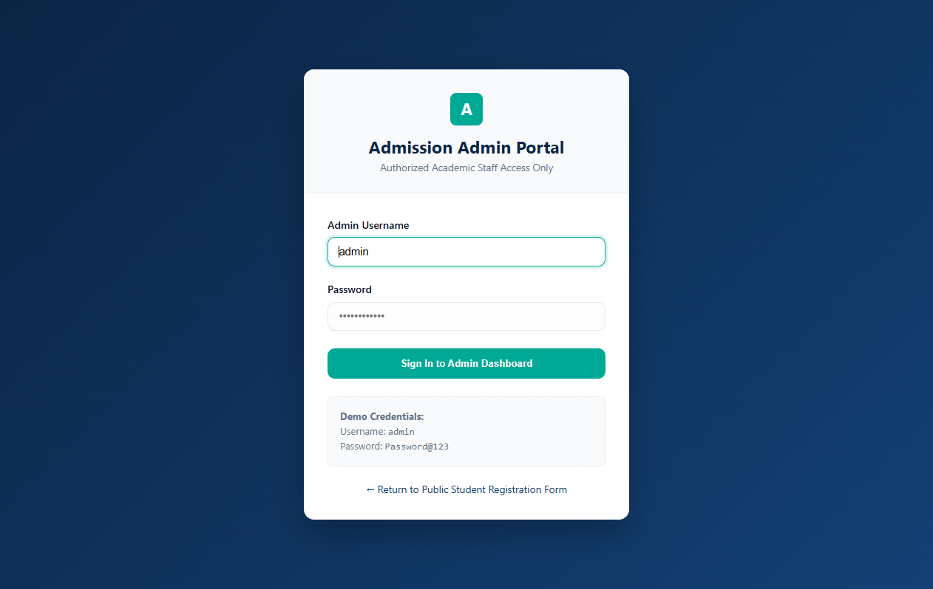
Figure 5: PHP Admin Login Authentication Page
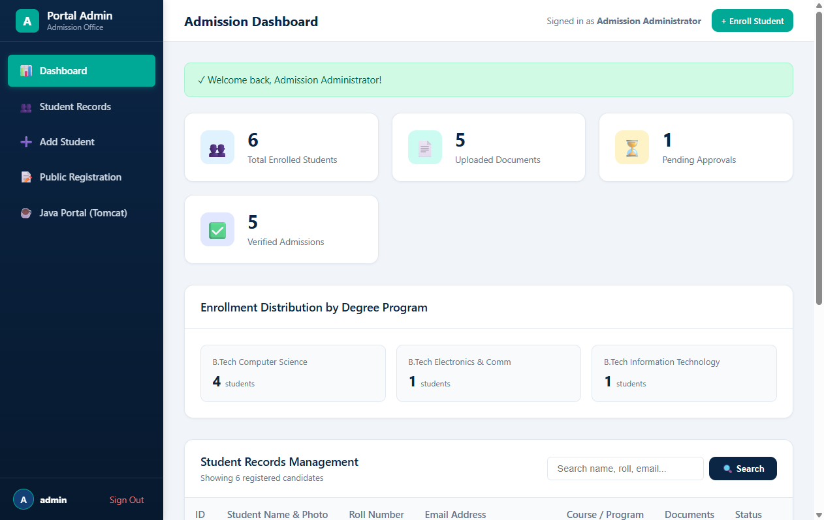
Figure 6: PHP Admin Dashboard with KPI Metrics
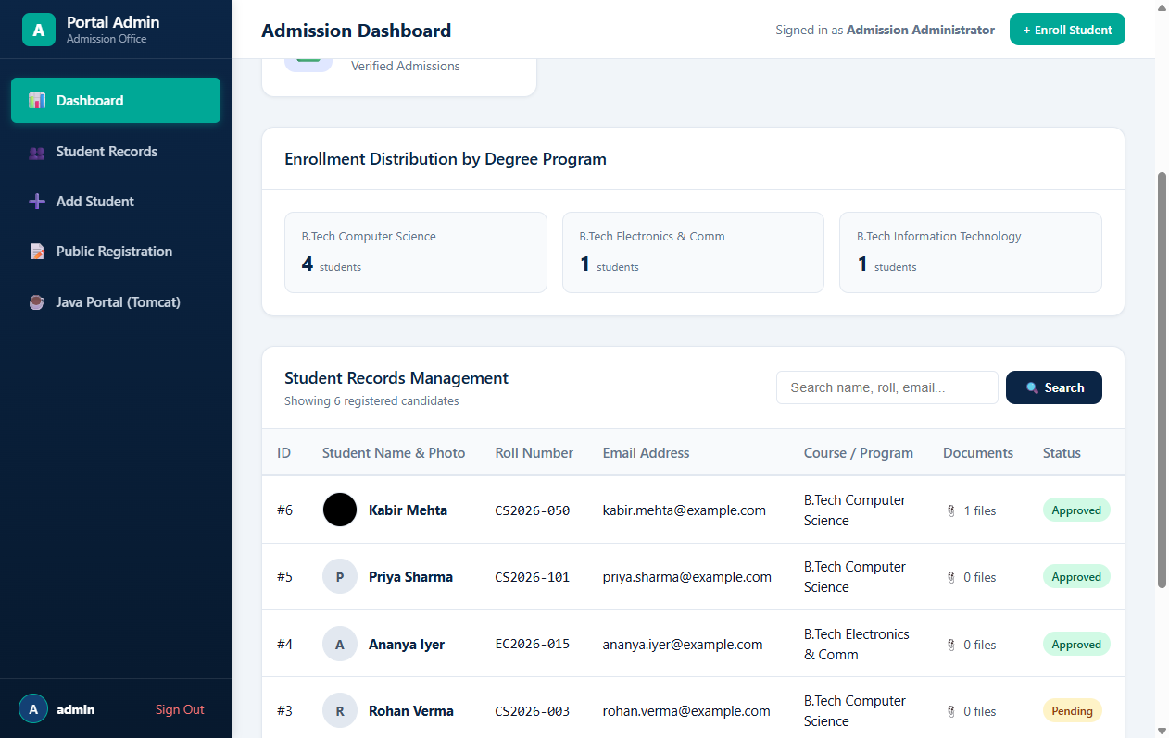
Figure 7: Registered Student Records Management Table
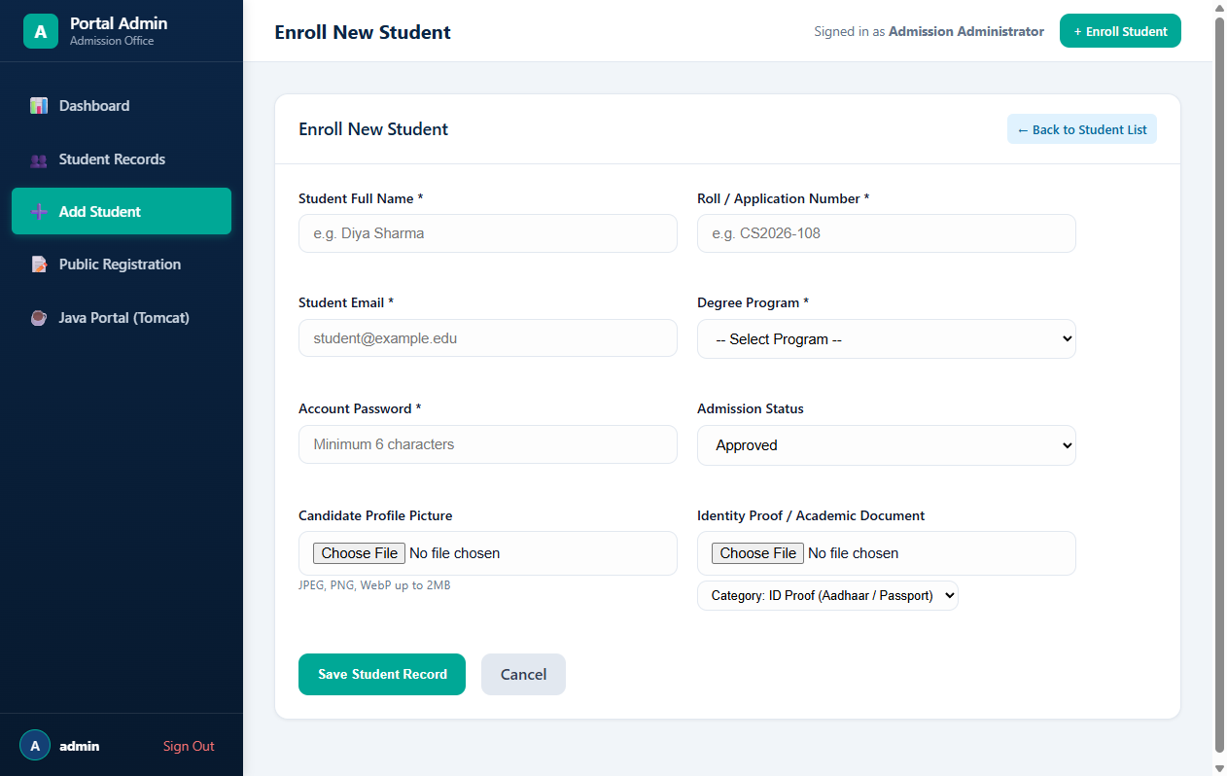
Figure 8: Add Student Form with Validation
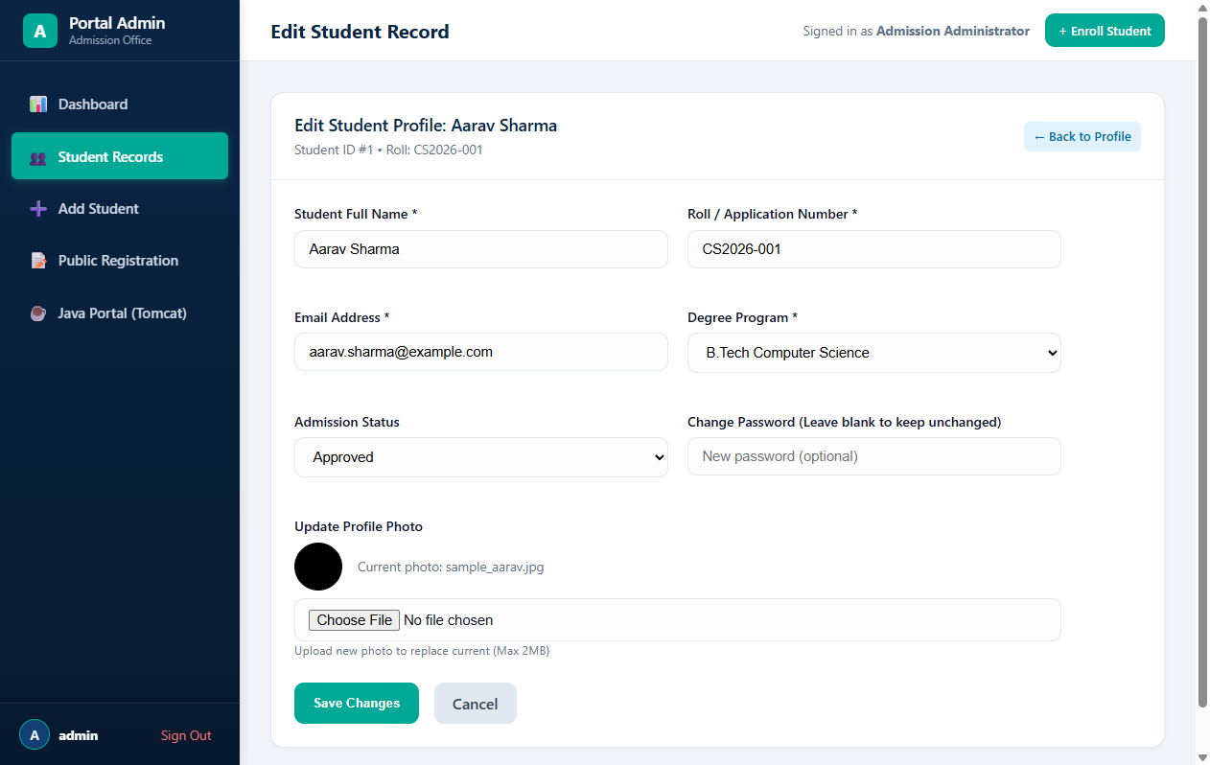
Figure 9: Edit Student Information Interface
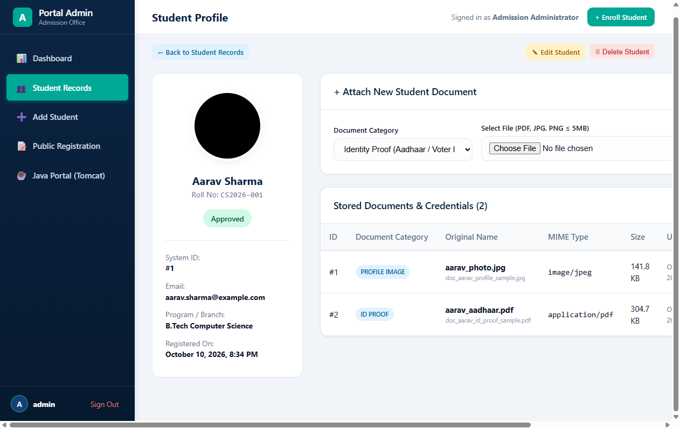
Figure 10: Academic Document Upload Interface
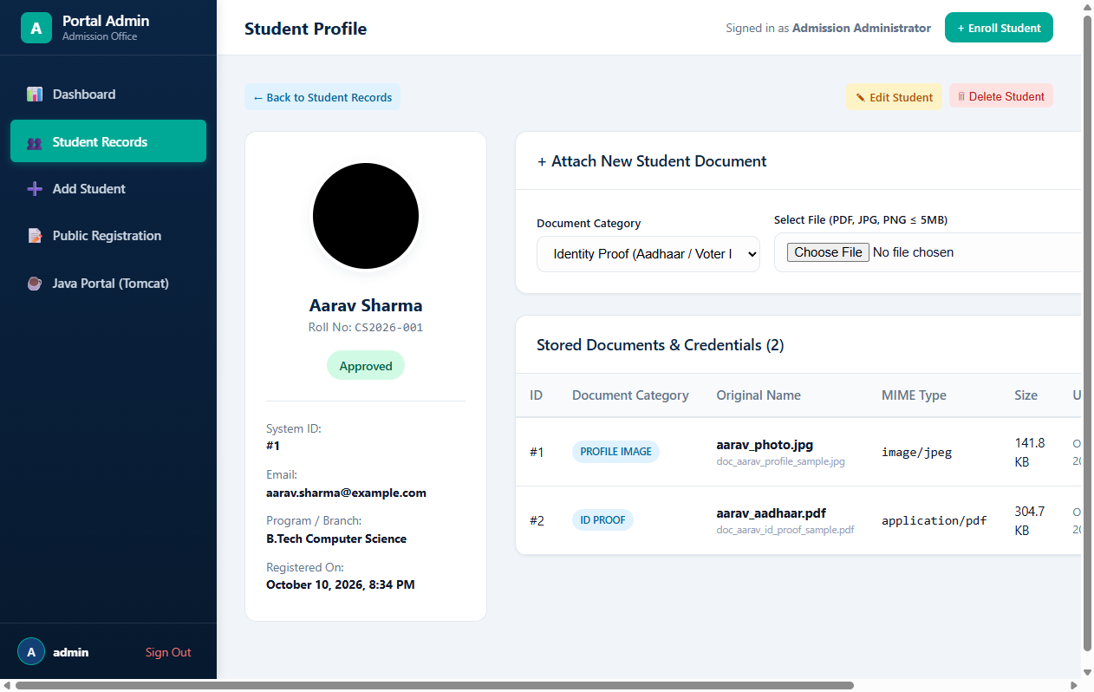
Figure 11: Student Profile with Uploaded Documents
4. Explanation of Code with Inline Comments
config/database.php:
getDbConnection() creates a PDO instance connecting to MariaDB on port 3307. The DSN string sets charset=utf8mb4 and the PDO::ERRMODE_EXCEPTION attribute is enabled so that any SQL error throws a catchable PDOException instead of silently failing.
includes/auth.php:
Calls session_start() and verifies that $_SESSION["admin_user_id"] is populated. The CSRF functions generateCsrfToken() and validateCsrfToken() use hash_equals() for timing-safe comparison, preventing CSRF attacks on all POST forms.
login.php:
Reads the posted username, fetches the admin row using a prepared statement, and calls password_verify() to compare the submitted password against the stored BCrypt hash. On success session_regenerate_id(true) is called immediately to prevent session fixation attacks before writing to $_SESSION.
view_student.php:
Uses two separate PDO prepared statements: one to fetch the student row by primary key id, and a second to fetch all document metadata rows for that student ordered by uploaded_at DESC. The download link routes through download_document.php using the stored_filename only, never exposing the real server path to the browser.
download_document.php:
Applies realpath() to both the uploads directory and the requested filename path. It then uses strpos() to verify the resolved file path starts within the allowed uploads directory. Any attempt at directory traversal (e.g., ../../etc/passwd) will cause the resolved path to fall outside the boundary and be blocked with HTTP 403. Files are streamed in 8 KB chunks to handle large PDF documents without exhausting PHP memory.
5. Brief Conclusion (3–5 Lines)
CO4 delivers a fully functional, secure PHP 8 administrative CRUD panel connected to a shared MySQL database via PDO prepared statements. The panel supports admin login with BCrypt verification, session fixation defense, CSRF token validation, and complete student record lifecycle management including create, read, update, and delete operations. Academic document uploads are protected by MIME type verification via PHP finfo, and downloads are served through a path-traversal-safe streaming handler, ensuring the application meets production-grade security standards.
6. GitHub Repository Link
Repository URL: https://github.com/[YOUR_USERNAME]/student-admission-portal
Note: Replace [YOUR_USERNAME] with your actual GitHub handle after pushing the project.

Question 3: CO5 — Java Servlet, JSP, and JDBC Portal (16 Marks)
Aim: To construct, package, deploy, and verify an enterprise Java web application using Jakarta/Java Servlets 3.1, JSP, JSTL, and JDBC on Apache Tomcat 8.5+, connecting to the shared MySQL/MariaDB database to deliver authenticated student registry exploration, detailed profile inspection, session authorization filtering, and binary document streaming.
1. PHP, Servlet WEB-INF Files and Other Files (.html, .css, .js)
Files used for CO5 (Java Servlet/JSP Portal):
• java-portal/src/main/java/com/studentportal/config/DBConnection.java – JDBC factory, dynamic port fallback
• java-portal/src/main/java/com/studentportal/dao/AdminDAO.java – BCrypt admin authentication DAO
• java-portal/src/main/java/com/studentportal/dao/StudentDAO.java – Student list and profile retrieval
• java-portal/src/main/java/com/studentportal/dao/DocumentDAO.java – Document metadata DAO
• java-portal/src/main/java/com/studentportal/servlet/LoginServlet.java – /login controller
• java-portal/src/main/java/com/studentportal/servlet/StudentListServlet.java – /students controller
• java-portal/src/main/java/com/studentportal/servlet/StudentProfileServlet.java – /profile controller
• java-portal/src/main/java/com/studentportal/servlet/DocumentStreamServlet.java – Binary file streamer
• java-portal/src/main/java/com/studentportal/filter/AuthFilter.java – Session authorization filter
• java-portal/src/main/webapp/WEB-INF/web.xml – Servlet and filter mappings
• java-portal/src/main/webapp/WEB-INF/jsp/login.jsp – Login page JSP
• java-portal/src/main/webapp/WEB-INF/jsp/students.jsp – JSTL student list table
• java-portal/src/main/webapp/WEB-INF/jsp/profile.jsp – Student profile and document links
LoginServlet.java (Full File)
package com.studentportal.servlet;

import com.studentportal.dao.AdminDAO;
import com.studentportal.model.AdminUser;
import javax.servlet.*;
import javax.servlet.annotation.WebServlet;
import javax.servlet.http.*;
import java.io.IOException;
import java.sql.SQLException;

/** Handles administrator authentication into the Java Portal. */
@WebServlet(name = "LoginServlet", urlPatterns = {"/login"})
public class LoginServlet extends HttpServlet {

private AdminDAO adminDAO;

@Override public void init() throws ServletException {
this.adminDAO = new AdminDAO(); // Initialise AdminDAO on servlet startup
}

@Override
protected void doGet(HttpServletRequest req, HttpServletResponse resp)
throws ServletException, IOException {
// If already logged in, redirect to student list
HttpSession session = req.getSession(false);
if (session != null && session.getAttribute("adminUser") != null) {
resp.sendRedirect(req.getContextPath() + "/students");
return;
}
// Show logout banner if redirected after logout
if ("1".equals(req.getParameter("logout")))
req.setAttribute("successMessage", "You have been safely logged out.");
req.getRequestDispatcher("/WEB-INF/jsp/login.jsp").forward(req, resp);
}

@Override
protected void doPost(HttpServletRequest req, HttpServletResponse resp)
throws ServletException, IOException {
req.setCharacterEncoding("UTF-8");
String username = req.getParameter("username");
String password = req.getParameter("password");

if (username == null || username.trim().isEmpty() ||
password == null || password.isEmpty()) {
req.setAttribute("errorMessage", "Please provide both username and password.");
req.getRequestDispatcher("/WEB-INF/jsp/login.jsp").forward(req, resp);
return;
}
try {
AdminUser admin = adminDAO.authenticate(username, password);
if (admin != null) {
// Invalidate old session to prevent session fixation attacks
HttpSession old = req.getSession(false);
if (old != null) old.invalidate();
// Create a new session and store the admin object
HttpSession newSession = req.getSession(true);
newSession.setAttribute("adminUser", admin);
newSession.setMaxInactiveInterval(1800); // 30-minute timeout
resp.sendRedirect(req.getContextPath() + "/students");
} else {
req.setAttribute("errorMessage",
"Invalid administrator username or password.");
req.getRequestDispatcher("/WEB-INF/jsp/login.jsp").forward(req, resp);
}
} catch (SQLException e) {
req.setAttribute("errorMessage",
"Database error: Could not verify credentials.");
req.getRequestDispatcher("/WEB-INF/jsp/login.jsp").forward(req, resp);
}
}
}
StudentDAO.java (Key Excerpt)
/**
* Data Access Object for Student and Document retrieval.
* Uses PreparedStatement and try-with-resources for safe, leak-free queries.
*/
public List<Student> getAllStudents(String search) throws SQLException {
String sql = "SELECT s.*, " +
"(SELECT COUNT(*) FROM student_documents d WHERE d.student_id = s.id) " +
"AS doc_count FROM students s ORDER BY s.registration_date DESC";

try (Connection conn = DBConnection.getConnection();
PreparedStatement ps = conn.prepareStatement(sql);
ResultSet rs = ps.executeQuery()) {
List<Student> list = new ArrayList<>();
while (rs.next()) list.add(mapStudent(rs)); // Map each row to a Student POJO
return list;
}
}
2. DB Schema Script
CO5 uses the same shared student_portal database as CO3 and CO4. The Java application connects via JDBC to the students, admin_users, and student_documents tables. No additional tables are required for CO5.
-- CO5 connects to the same shared student_portal database.
-- The Java DBConnection.java factory connects with JDBC using:
-- jdbc:mysql://localhost:3307/student_portal?useSSL=false&serverTimezone=UTC
-- Port fallback: tries 3307 first (XAMPP MariaDB), then 3306 (default MySQL).
-- All three tables (admin_users, students, student_documents) are reused.
-- No additional schema changes are required for the Java portal.

-- DBConnection.java JDBC URL pattern:
-- "jdbc:mysql://127.0.0.1:" + port + "/student_portal?useSSL=false&serverTimezone=UTC"
--
-- PreparedStatement example from StudentDAO.java:
-- String sql = "SELECT * FROM students ORDER BY registration_date DESC";
-- PreparedStatement ps = conn.prepareStatement(sql);
-- ResultSet rs = ps.executeQuery();
3. Screenshots of Output in Browser
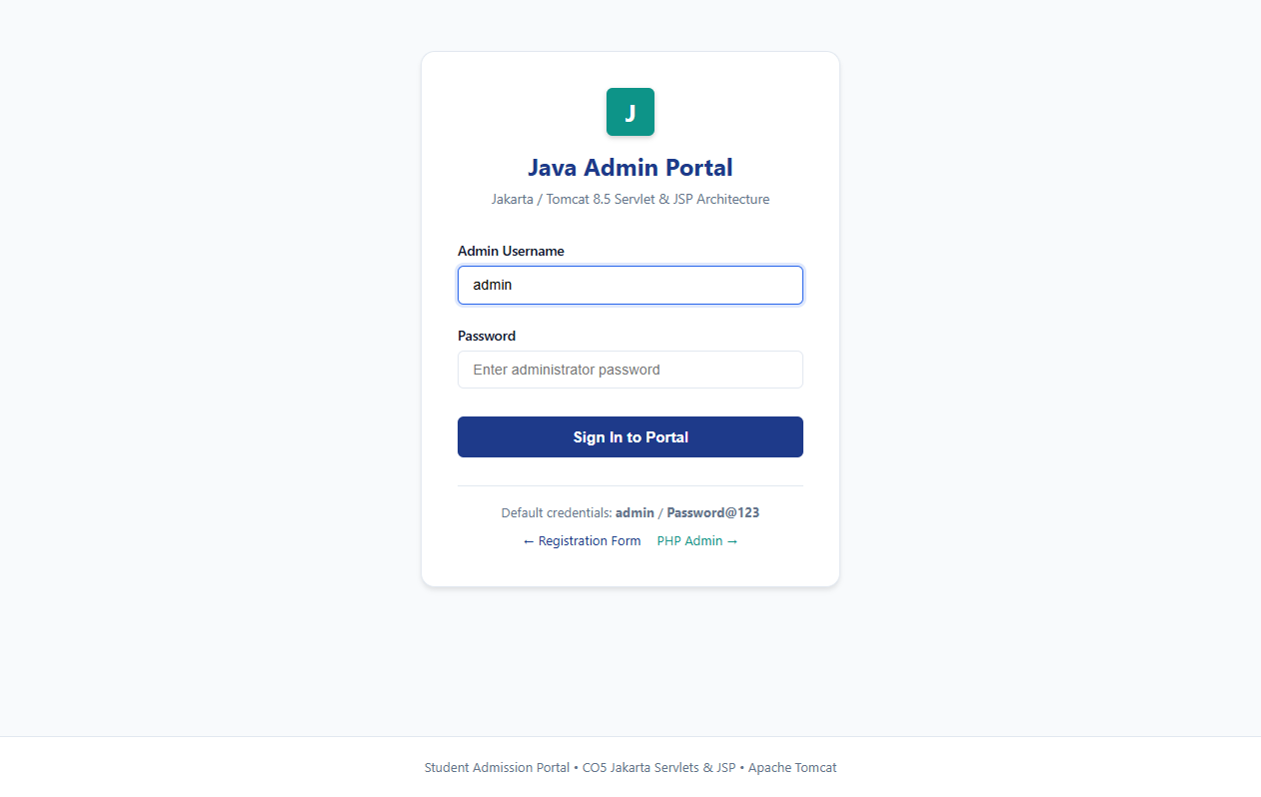
Figure 12: Java Admin Portal Login Page (Tomcat port 8082)
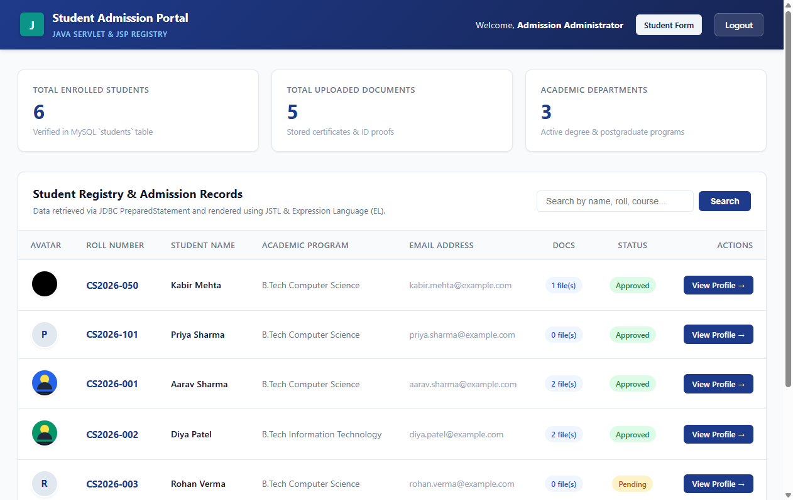
Figure 13: JSTL Student Registry Table with Dynamic KPIs
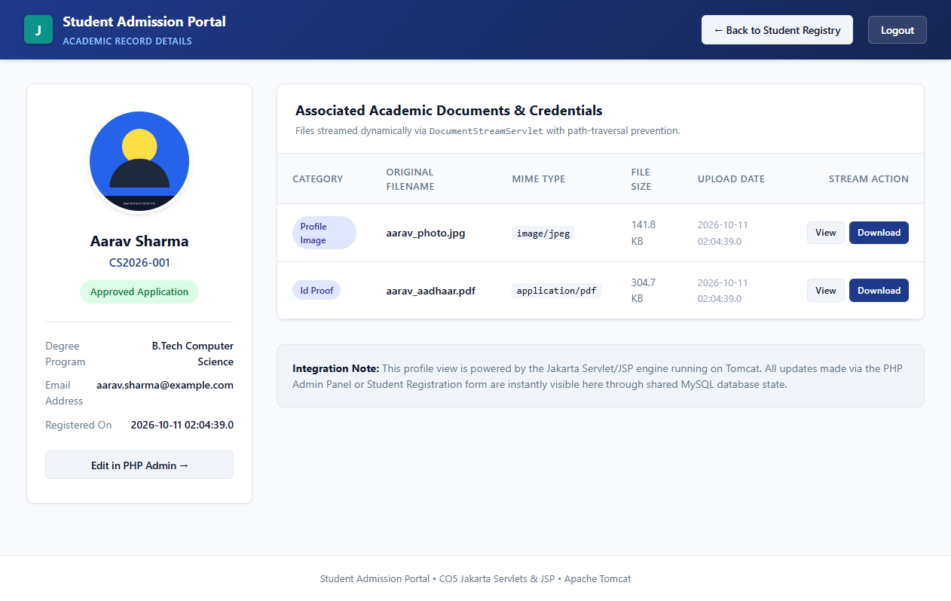
Figure 14: Student Profile View with Streamed Avatar and Documents

Figure 15: Binary Image Served via DocumentStreamServlet
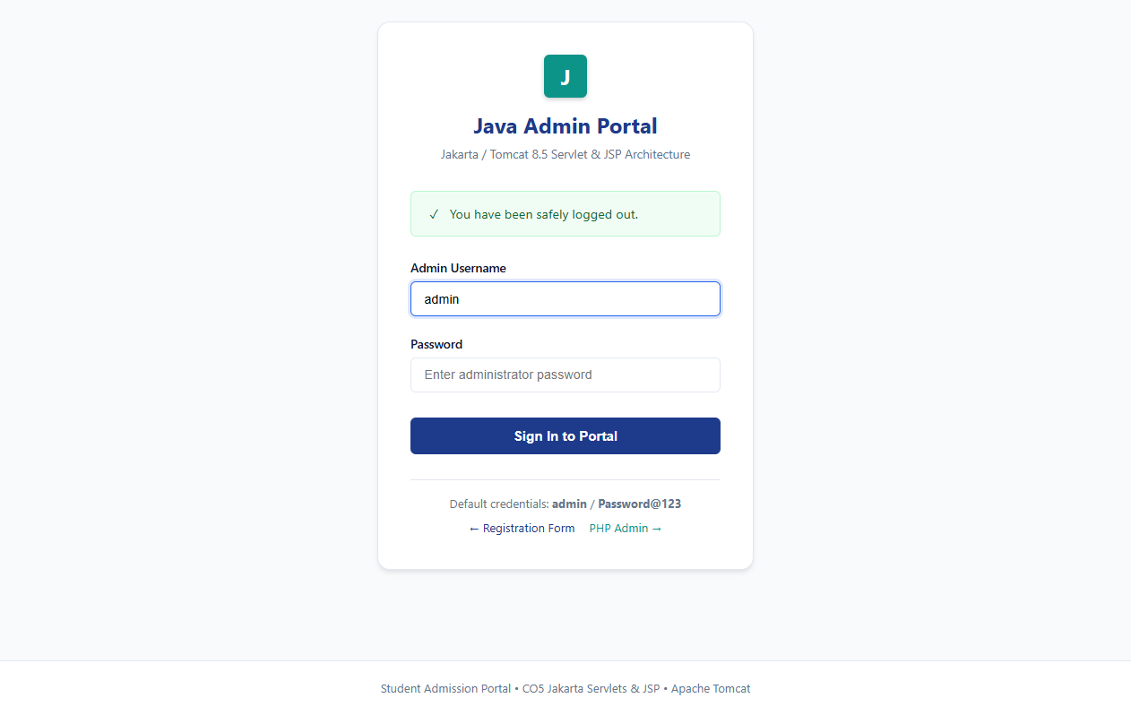
Figure 16: Session Invalidation and Logout Verification Banner
4. Explanation of Code with Inline Comments
DBConnection.java:
A static JDBC connection factory that attempts to connect to MariaDB on port 3307 first. If the connection fails (e.g., XAMPP MariaDB is on port 3307 while standard MySQL is on 3306), it automatically retries on port 3306. The factory is called with try-with-resources in every DAO to guarantee that connections are closed after each query.
AdminDAO.java:
Fetches the admin row from admin_users by username using a PreparedStatement. The stored BCrypt hash is then verified using the BCrypt.checkpw() method (jBCrypt library), which safely compares the submitted plain-text password against the $2y$ hash without revealing timing information.
LoginServlet.java:
Mapped to the URL pattern /login via the @WebServlet annotation. doGet() renders the JSP login page; doPost() reads the credentials, calls adminDAO.authenticate(), and on success invalidates the old session (session fixation prevention) and creates a fresh HttpSession storing the AdminUser object with a 30-minute inactive timeout.
StudentListServlet.java:
Mapped to /students. Retrieves the full student list from StudentDAO.getAllStudents() and forwards it as a request attribute named "students" to students.jsp. The JSTL <c:forEach> tag iterates over the list to render the table rows.
DocumentStreamServlet.java:
Mapped to /docs. Accepts a stored_filename query parameter and resolves the absolute path under the uploads/ directory using Paths.get().normalize(). It verifies the resolved path starts with the canonical uploads root (path traversal defense). Files are then read and written to the response OutputStream in 8 KB chunks, with Content-Type and Content-Length headers set correctly so the browser can display or download the file.
AuthFilter.java:
Implements javax.servlet.Filter and is mapped to /students, /profile, and /docs URL patterns. For every incoming request it checks whether the HttpSession contains a valid adminUser attribute. If not present, it redirects the unauthenticated request to the /login page, preventing any access to protected pages without a valid session.
5. Brief Conclusion (3–5 Lines)
CO5 successfully demonstrates an enterprise-grade Java web application deployed on Apache Tomcat 8.5+ using Servlets 3.1, JSP, JSTL, and JDBC connected to the shared MySQL database. The LoginServlet, StudentListServlet, StudentProfileServlet, and DocumentStreamServlet collectively provide secure admin authentication, dynamic JSTL-rendered student registry views, and binary document streaming with path-traversal protection. The AuthFilter ensures that every protected resource is inaccessible without an active authenticated session, meeting all CO5 enterprise security requirements.
6. GitHub Repository Link
Repository URL: https://github.com/[YOUR_USERNAME]/student-admission-portal
Note: Replace [YOUR_USERNAME] with your actual GitHub handle after pushing the project.

