LRDC Documentation

Hannah Mencer

11/24/2022

## Findings for participants in levels 3 progressing to level 4:

Words

## Linear mixed model fit by maximum likelihood ['lmerMod']  
## Formula: W ~ L1 + as.factor(level_id) + (1 | anon_id) + (1 | question_id)  
## Data: df  
##   
## AIC BIC logLik deviance df.resid   
## 1819.8 1840.8 -902.9 1805.8 142   
##   
## Scaled residuals:   
## Min 1Q Median 3Q Max   
## -1.5963 -0.6187 -0.2515 0.2445 3.5521   
##   
## Random effects:  
## Groups Name Variance Std.Dev.  
## question_id (Intercept) 0.0 0.00   
## anon_id (Intercept) 568.1 23.83   
## Residual 10262.0 101.30   
## Number of obs: 149, groups: question_id, 102; anon_id, 22  
##   
## Fixed effects:  
## Estimate Std. Error t value  
## (Intercept) 154.823 18.228 8.494  
## L1Korean 6.681 23.910 0.279  
## L1Spanish -21.964 25.687 -0.855  
## as.factor(level_id)4 19.903 17.347 1.147  
##   
## Correlation of Fixed Effects:  
## (Intr) L1Korn L1Spns  
## L1Korean -0.594   
## L1Spanish -0.582 0.481   
## as.fctr(_)4 -0.370 -0.175 -0.082  
## optimizer (nloptwrap) convergence code: 0 (OK)  
## boundary (singular) fit: see help('isSingular')

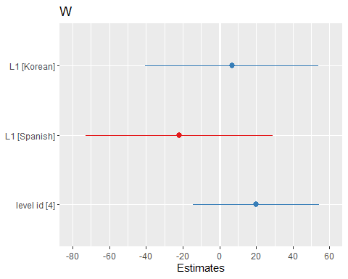

Sentences

## Linear mixed model fit by maximum likelihood ['lmerMod']  
## Formula: S ~ L1 + as.factor(level_id) + (1 | anon_id) + (1 | question_id)  
## Data: df  
##   
## AIC BIC logLik deviance df.resid   
## 1032.6 1053.6 -509.3 1018.6 142   
##   
## Scaled residuals:   
## Min 1Q Median 3Q Max   
## -1.8382 -0.6224 -0.1792 0.3626 3.3422   
##   
## Random effects:  
## Groups Name Variance Std.Dev.  
## question_id (Intercept) 0.00 0.000   
## anon_id (Intercept) 0.00 0.000   
## Residual 54.52 7.383   
## Number of obs: 149, groups: question_id, 102; anon_id, 22  
##   
## Fixed effects:  
## Estimate Std. Error t value  
## (Intercept) 13.32309 1.16217 11.464  
## L1Korean 0.02303 1.46068 0.016  
## L1Spanish -5.25578 1.57929 -3.328  
## as.factor(level_id)4 1.24953 1.23614 1.011  
##   
## Correlation of Fixed Effects:  
## (Intr) L1Korn L1Spns  
## L1Korean -0.587   
## L1Spanish -0.576 0.514   
## as.fctr(_)4 -0.399 -0.205 -0.107  
## optimizer (nloptwrap) convergence code: 0 (OK)  
## boundary (singular) fit: see help('isSingular')

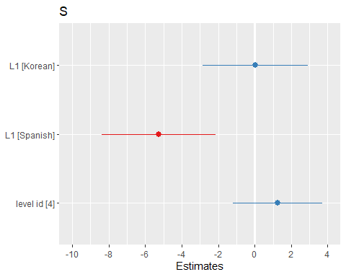

Verb Phrases

## Linear mixed model fit by maximum likelihood ['lmerMod']  
## Formula: VP ~ L1 + as.factor(level_id) + (1 | anon_id) + (1 | question_id)  
## Data: df  
##   
## AIC BIC logLik deviance df.resid   
## 1244.4 1265.4 -615.2 1230.4 142   
##   
## Scaled residuals:   
## Min 1Q Median 3Q Max   
## -1.6845 -0.6226 -0.2159 0.2622 4.2173   
##   
## Random effects:  
## Groups Name Variance Std.Dev.  
## question_id (Intercept) 0.000 0.000   
## anon_id (Intercept) 1.719 1.311   
## Residual 224.128 14.971   
## Number of obs: 149, groups: question_id, 102; anon_id, 22  
##   
## Fixed effects:  
## Estimate Std. Error t value  
## (Intercept) 24.414 2.409 10.135  
## L1Korean 1.074 3.053 0.352  
## L1Spanish -2.858 3.293 -0.868  
## as.factor(level_id)4 3.864 2.517 1.535  
##   
## Correlation of Fixed Effects:  
## (Intr) L1Korn L1Spns  
## L1Korean -0.588   
## L1Spanish -0.577 0.508   
## as.fctr(_)4 -0.394 -0.200 -0.103  
## optimizer (nloptwrap) convergence code: 0 (OK)  
## boundary (singular) fit: see help('isSingular')

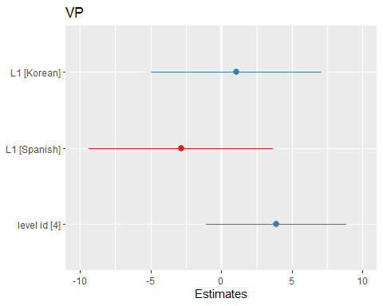

Clauses

## Linear mixed model fit by maximum likelihood ['lmerMod']  
## Formula: C ~ L1 + as.factor(level_id) + (1 | anon_id) + (1 | question_id)  
## Data: df  
##   
## AIC BIC logLik deviance df.resid   
## 1174.5 1195.5 -580.2 1160.5 142   
##   
## Scaled residuals:   
## Min 1Q Median 3Q Max   
## -1.7673 -0.6469 -0.2477 0.4372 3.5149   
##   
## Random effects:  
## Groups Name Variance Std.Dev.  
## question_id (Intercept) 0.0000 0.0000   
## anon_id (Intercept) 0.5134 0.7165   
## Residual 140.7341 11.8631   
## Number of obs: 149, groups: question_id, 102; anon_id, 22  
##   
## Fixed effects:  
## Estimate Std. Error t value  
## (Intercept) 19.5539 1.8873 10.361  
## L1Korean 0.6926 2.3819 0.291  
## L1Spanish -3.7401 2.5721 -1.454  
## as.factor(level_id)4 3.4079 1.9903 1.712  
##   
## Correlation of Fixed Effects:  
## (Intr) L1Korn L1Spns  
## L1Korean -0.587   
## L1Spanish -0.577 0.511   
## as.fctr(_)4 -0.397 -0.202 -0.105  
## optimizer (nloptwrap) convergence code: 0 (OK)  
## boundary (singular) fit: see help('isSingular')

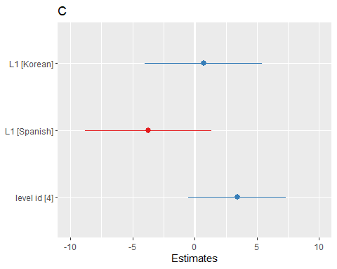

T-units

## Linear mixed model fit by maximum likelihood ['lmerMod']  
## Formula: T ~ L1 + as.factor(level_id) + (1 | anon_id) + (1 | question_id)  
## Data: df  
##   
## AIC BIC logLik deviance df.resid   
## 1069.3 1090.3 -527.7 1055.3 142   
##   
## Scaled residuals:   
## Min 1Q Median 3Q Max   
## -1.7962 -0.6588 -0.1797 0.3152 2.9626   
##   
## Random effects:  
## Groups Name Variance Std.Dev.  
## question_id (Intercept) 0.00 0.000   
## anon_id (Intercept) 0.00 0.000   
## Residual 69.73 8.351   
## Number of obs: 149, groups: question_id, 102; anon_id, 22  
##   
## Fixed effects:  
## Estimate Std. Error t value  
## (Intercept) 14.8667 1.3144 11.311  
## L1Korean 0.5011 1.6520 0.303  
## L1Spanish -4.7398 1.7862 -2.654  
## as.factor(level_id)4 1.1332 1.3981 0.811  
##   
## Correlation of Fixed Effects:  
## (Intr) L1Korn L1Spns  
## L1Korean -0.587   
## L1Spanish -0.576 0.514   
## as.fctr(_)4 -0.399 -0.205 -0.107  
## optimizer (nloptwrap) convergence code: 0 (OK)  
## boundary (singular) fit: see help('isSingular')

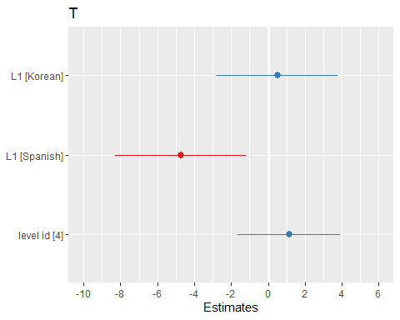

Dependent Clauses

## Linear mixed model fit by maximum likelihood ['lmerMod']  
## Formula: DC ~ L1 + as.factor(level_id) + (1 | anon_id) + (1 | question_id)  
## Data: df  
##   
## AIC BIC logLik deviance df.resid   
## 884.4 905.5 -435.2 870.4 142   
##   
## Scaled residuals:   
## Min 1Q Median 3Q Max   
## -1.5023 -0.5560 -0.2466 0.3398 4.1110   
##   
## Random effects:  
## Groups Name Variance Std.Dev.  
## question_id (Intercept) 1.3017 1.1409   
## anon_id (Intercept) 0.9513 0.9754   
## Residual 18.0909 4.2533   
## Number of obs: 149, groups: question_id, 102; anon_id, 22  
##   
## Fixed effects:  
## Estimate Std. Error t value  
## (Intercept) 4.4931 0.7939 5.659  
## L1Korean 0.1289 1.0152 0.127  
## L1Spanish 1.1319 1.0905 1.038  
## as.factor(level_id)4 2.0281 0.7733 2.623  
##   
## Correlation of Fixed Effects:  
## (Intr) L1Korn L1Spns  
## L1Korean -0.580   
## L1Spanish -0.568 0.488   
## as.fctr(_)4 -0.393 -0.175 -0.087

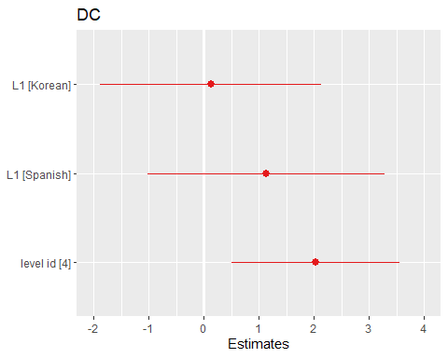

Complex T-units

## Linear mixed model fit by maximum likelihood ['lmerMod']  
## Formula: CT ~ L1 + as.factor(level_id) + (1 | anon_id) + (1 | question_id)  
## Data: df  
##   
## AIC BIC logLik deviance df.resid   
## 810.5 831.6 -398.3 796.5 142   
##   
## Scaled residuals:   
## Min 1Q Median 3Q Max   
## -1.5155 -0.5883 -0.2313 0.3833 4.0544   
##   
## Random effects:  
## Groups Name Variance Std.Dev.  
## question_id (Intercept) 1.374 1.1720   
## anon_id (Intercept) 0.323 0.5683   
## Residual 10.678 3.2677   
## Number of obs: 149, groups: question_id, 102; anon_id, 22  
##   
## Fixed effects:  
## Estimate Std. Error t value  
## (Intercept) 3.95659 0.60139 6.579  
## L1Korean 0.04154 0.74511 0.056  
## L1Spanish 0.18134 0.80074 0.226  
## as.factor(level_id)4 1.54239 0.61490 2.508  
##   
## Correlation of Fixed Effects:  
## (Intr) L1Korn L1Spns  
## L1Korean -0.567   
## L1Spanish -0.556 0.502   
## as.fctr(_)4 -0.417 -0.183 -0.097

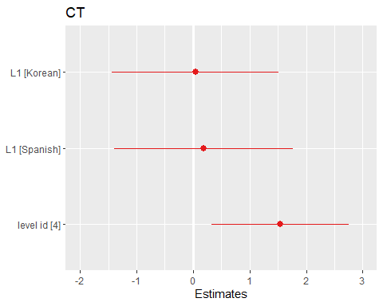

Coordinate Phrases

## Linear mixed model fit by maximum likelihood ['lmerMod']  
## Formula: CP ~ L1 + as.factor(level_id) + (1 | anon_id) + (1 | question_id)  
## Data: df  
##   
## AIC BIC logLik deviance df.resid   
## 895.6 916.6 -440.8 881.6 142   
##   
## Scaled residuals:   
## Min 1Q Median 3Q Max   
## -1.2071 -0.5794 -0.2364 0.3198 6.7798   
##   
## Random effects:  
## Groups Name Variance Std.Dev.  
## question_id (Intercept) 0.1831 0.4279   
## anon_id (Intercept) 1.0681 1.0335   
## Residual 20.6484 4.5440   
## Number of obs: 149, groups: question_id, 102; anon_id, 22  
##   
## Fixed effects:  
## Estimate Std. Error t value  
## (Intercept) 3.22093 0.81619 3.946  
## L1Korean 0.10751 1.06514 0.101  
## L1Spanish 0.02455 1.14424 0.021  
## as.factor(level_id)4 1.00417 0.78364 1.281  
##   
## Correlation of Fixed Effects:  
## (Intr) L1Korn L1Spns  
## L1Korean -0.591   
## L1Spanish -0.580 0.484   
## as.fctr(_)4 -0.374 -0.176 -0.084

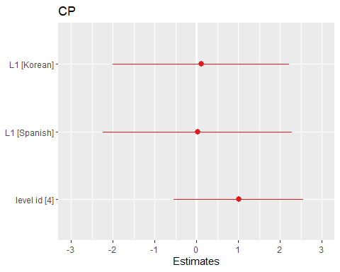

Complex Nominals

## Linear mixed model fit by maximum likelihood ['lmerMod']  
## Formula: CN ~ L1 + as.factor(level_id) + (1 | anon_id) + (1 | question_id)  
## Data: df  
##   
## AIC BIC logLik deviance df.resid   
## 1184.6 1205.6 -585.3 1170.6 142   
##   
## Scaled residuals:   
## Min 1Q Median 3Q Max   
## -1.3448 -0.6933 -0.3335 0.3849 4.0906   
##   
## Random effects:  
## Groups Name Variance Std.Dev.  
## question_id (Intercept) 0.00 0.000   
## anon_id (Intercept) 5.69 2.385   
## Residual 146.19 12.091   
## Number of obs: 149, groups: question_id, 102; anon_id, 22  
##   
## Fixed effects:  
## Estimate Std. Error t value  
## (Intercept) 14.150 2.101 6.733  
## L1Korean 1.333 2.731 0.488  
## L1Spanish -1.721 2.934 -0.587  
## as.factor(level_id)4 1.919 2.060 0.931  
##   
## Correlation of Fixed Effects:  
## (Intr) L1Korn L1Spns  
## L1Korean -0.591   
## L1Spanish -0.581 0.489   
## as.fctr(_)4 -0.378 -0.182 -0.088  
## optimizer (nloptwrap) convergence code: 0 (OK)  
## boundary (singular) fit: see help('isSingular')

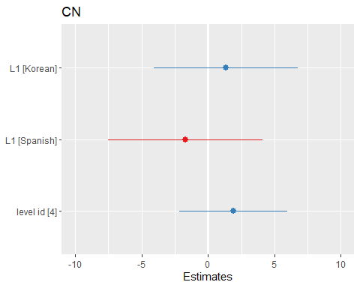

Mean Length of Sentence

## Linear mixed model fit by maximum likelihood ['lmerMod']  
## Formula: MLS ~ L1 + as.factor(level_id) + (1 | anon_id) + (1 | question_id)  
## Data: df  
##   
## AIC BIC logLik deviance df.resid   
## 847.6 868.6 -416.8 833.6 142   
##   
## Scaled residuals:   
## Min 1Q Median 3Q Max   
## -3.8939 -0.6019 -0.0458 0.4330 4.0213   
##   
## Random effects:  
## Groups Name Variance Std.Dev.  
## question_id (Intercept) 0.5617 0.7494   
## anon_id (Intercept) 1.4472 1.2030   
## Residual 14.1008 3.7551   
## Number of obs: 149, groups: question_id, 102; anon_id, 22  
##   
## Fixed effects:  
## Estimate Std. Error t value  
## (Intercept) 12.1107 0.7512 16.122  
## L1Korean 0.5302 0.9926 0.534  
## L1Spanish 4.1513 1.0685 3.885  
## as.factor(level_id)4 0.4696 0.6731 0.698  
##   
## Correlation of Fixed Effects:  
## (Intr) L1Korn L1Spns  
## L1Korean -0.594   
## L1Spanish -0.578 0.469   
## as.fctr(_)4 -0.362 -0.157 -0.072

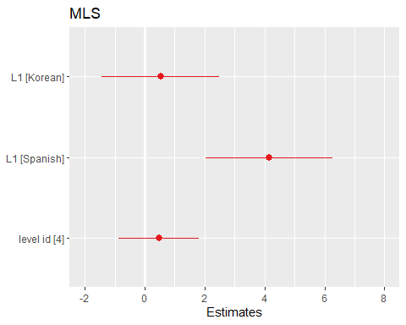

Mean Length of T-unit

## Linear mixed model fit by maximum likelihood ['lmerMod']  
## Formula: MLT ~ L1 + as.factor(level_id) + (1 | anon_id) + (1 | question_id)  
## Data: df  
##   
## AIC BIC logLik deviance df.resid   
## 778.8 799.8 -382.4 764.8 142   
##   
## Scaled residuals:   
## Min 1Q Median 3Q Max   
## -3.9673 -0.5863 -0.0730 0.5104 2.8147   
##   
## Random effects:  
## Groups Name Variance Std.Dev.  
## question_id (Intercept) 1.02861 1.0142   
## anon_id (Intercept) 0.03346 0.1829   
## Residual 8.90546 2.9842   
## Number of obs: 149, groups: question_id, 102; anon_id, 22  
##   
## Fixed effects:  
## Estimate Std. Error t value  
## (Intercept) 10.4612 0.5131 20.387  
## L1Korean 0.2012 0.6232 0.323  
## L1Spanish 2.7642 0.6723 4.112  
## as.factor(level_id)4 0.8309 0.5503 1.510  
##   
## Correlation of Fixed Effects:  
## (Intr) L1Korn L1Spns  
## L1Korean -0.566   
## L1Spanish -0.553 0.520   
## as.fctr(_)4 -0.428 -0.197 -0.109

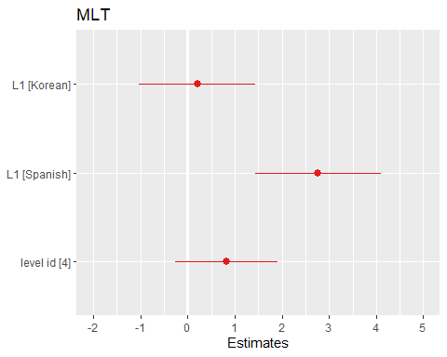

Mean Length of Clause

## Linear mixed model fit by maximum likelihood ['lmerMod']  
## Formula: MLC ~ L1 + as.factor(level_id) + (1 | anon_id) + (1 | question_id)  
## Data: df  
##   
## AIC BIC logLik deviance df.resid   
## 690.8 711.8 -338.4 676.8 142   
##   
## Scaled residuals:   
## Min 1Q Median 3Q Max   
## -3.2064 -0.4190 -0.1268 0.2261 5.2636   
##   
## Random effects:  
## Groups Name Variance Std.Dev.  
## question_id (Intercept) 0.8679 0.9316   
## anon_id (Intercept) 0.5372 0.7329   
## Residual 4.2859 2.0702   
## Number of obs: 149, groups: question_id, 102; anon_id, 22  
##   
## Fixed effects:  
## Estimate Std. Error t value  
## (Intercept) 8.1033 0.4586 17.670  
## L1Korean -0.0196 0.5860 -0.033  
## L1Spanish 0.1626 0.6314 0.257  
## as.factor(level_id)4 -0.4633 0.4173 -1.110  
##   
## Correlation of Fixed Effects:  
## (Intr) L1Korn L1Spns  
## L1Korean -0.575   
## L1Spanish -0.557 0.472   
## as.fctr(_)4 -0.393 -0.150 -0.075

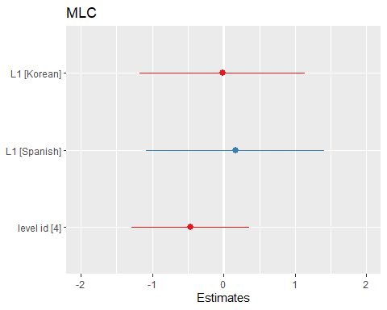

Clauses per Sentence

## Linear mixed model fit by maximum likelihood ['lmerMod']  
## Formula: C.S ~ L1 + as.factor(level_id) + (1 | anon_id) + (1 | question_id)  
## Data: df  
##   
## AIC BIC logLik deviance df.resid   
## 245.3 266.3 -115.6 231.3 142   
##   
## Scaled residuals:   
## Min 1Q Median 3Q Max   
## -3.7013 -0.6094 -0.1362 0.4161 4.6642   
##   
## Random effects:  
## Groups Name Variance Std.Dev.  
## question_id (Intercept) 0.00000 0.0000   
## anon_id (Intercept) 0.01649 0.1284   
## Residual 0.26286 0.5127   
## Number of obs: 149, groups: question_id, 102; anon_id, 22  
##   
## Fixed effects:  
## Estimate Std. Error t value  
## (Intercept) 1.53339 0.09361 16.381  
## L1Korean 0.03129 0.12324 0.254  
## L1Spanish 0.48645 0.13243 3.673  
## as.factor(level_id)4 0.17314 0.08798 1.968  
##   
## Correlation of Fixed Effects:  
## (Intr) L1Korn L1Spns  
## L1Korean -0.595   
## L1Spanish -0.583 0.479   
## as.fctr(_)4 -0.366 -0.172 -0.080  
## optimizer (nloptwrap) convergence code: 0 (OK)  
## boundary (singular) fit: see help('isSingular')

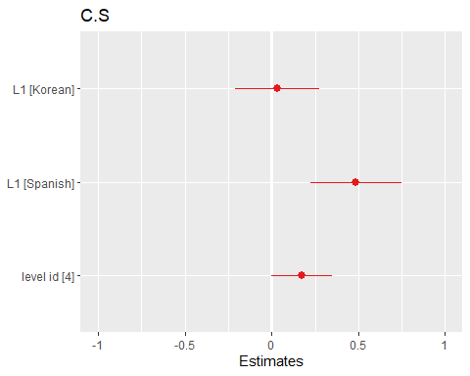

Verb Phrases per T-unit

## Linear mixed model fit by maximum likelihood ['lmerMod']  
## Formula: VP.T ~ L1 + as.factor(level_id) + (1 | anon_id) + (1 | question_id)  
## Data: df  
##   
## AIC BIC logLik deviance df.resid   
## 306.1 327.1 -146.1 292.1 142   
##   
## Scaled residuals:   
## Min 1Q Median 3Q Max   
## -3.1353 -0.5865 -0.1058 0.3983 2.9171   
##   
## Random effects:  
## Groups Name Variance Std.Dev.  
## question_id (Intercept) 0.06723 0.2593   
## anon_id (Intercept) 0.00000 0.0000   
## Residual 0.35307 0.5942   
## Number of obs: 149, groups: question_id, 102; anon_id, 22  
##   
## Fixed effects:  
## Estimate Std. Error t value  
## (Intercept) 1.75940 0.10553 16.673  
## L1Korean -0.03142 0.12505 -0.251  
## L1Spanish 0.45830 0.13497 3.396  
## as.factor(level_id)4 0.17342 0.11500 1.508  
##   
## Correlation of Fixed Effects:  
## (Intr) L1Korn L1Spns  
## L1Korean -0.555   
## L1Spanish -0.540 0.527   
## as.fctr(_)4 -0.445 -0.195 -0.112  
## optimizer (nloptwrap) convergence code: 0 (OK)  
## boundary (singular) fit: see help('isSingular')

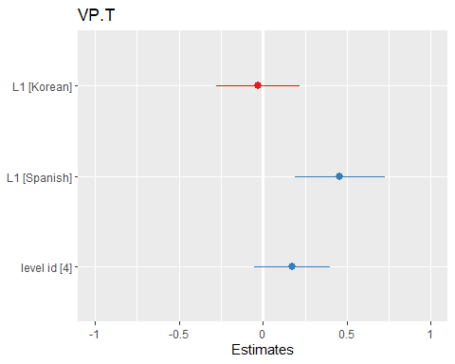

Clauses per T-Unit

## Linear mixed model fit by maximum likelihood ['lmerMod']  
## Formula: C.T ~ L1 + as.factor(level_id) + (1 | anon_id) + (1 | question_id)  
## Data: df  
##   
## AIC BIC logLik deviance df.resid   
## 194.4 215.4 -90.2 180.4 142   
##   
## Scaled residuals:   
## Min 1Q Median 3Q Max   
## -3.5267 -0.5228 -0.1755 0.3444 4.7527   
##   
## Random effects:  
## Groups Name Variance Std.Dev.  
## question_id (Intercept) 0.01388 0.1178   
## anon_id (Intercept) 0.00000 0.0000   
## Residual 0.18304 0.4278   
## Number of obs: 149, groups: question_id, 102; anon_id, 22  
##   
## Fixed effects:  
## Estimate Std. Error t value  
## (Intercept) 1.33077 0.07107 18.724  
## L1Korean -0.02848 0.08700 -0.327  
## L1Spanish 0.29245 0.09399 3.112  
## as.factor(level_id)4 0.21824 0.07644 2.855  
##   
## Correlation of Fixed Effects:  
## (Intr) L1Korn L1Spns  
## L1Korean -0.573   
## L1Spanish -0.560 0.520   
## as.fctr(_)4 -0.421 -0.201 -0.110  
## optimizer (nloptwrap) convergence code: 0 (OK)  
## boundary (singular) fit: see help('isSingular')

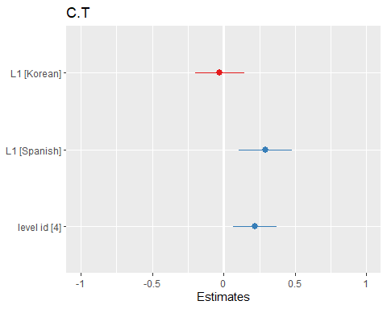

Dependent Clauses per Clause

## Linear mixed model fit by maximum likelihood ['lmerMod']  
## Formula: DC.C ~ L1 + as.factor(level_id) + (1 | anon_id) + (1 | question_id)  
## Data: df  
##   
## AIC BIC logLik deviance df.resid   
## -156.9 -135.8 85.4 -170.9 142   
##   
## Scaled residuals:   
## Min 1Q Median 3Q Max   
## -2.03241 -0.50375 -0.06294 0.47778 2.41426   
##   
## Random effects:  
## Groups Name Variance Std.Dev.  
## question_id (Intercept) 0.0063749 0.07984   
## anon_id (Intercept) 0.0006423 0.02534   
## Residual 0.0124912 0.11176   
## Number of obs: 149, groups: question_id, 102; anon_id, 22  
##   
## Fixed effects:  
## Estimate Std. Error t value  
## (Intercept) 0.23523 0.02482 9.476  
## L1Korean -0.01314 0.02871 -0.458  
## L1Spanish 0.09316 0.03083 3.021  
## as.factor(level_id)4 0.06513 0.02585 2.520  
##   
## Correlation of Fixed Effects:  
## (Intr) L1Korn L1Spns  
## L1Korean -0.529   
## L1Spanish -0.513 0.507   
## as.fctr(_)4 -0.469 -0.164 -0.095

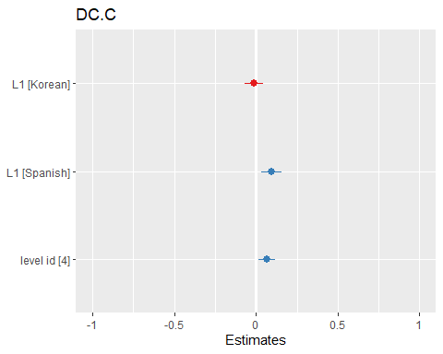

Dependent clauses per T-unit

## Linear mixed model fit by maximum likelihood ['lmerMod']  
## Formula: DC.T ~ L1 + as.factor(level_id) + (1 | anon_id) + (1 | question_id)  
## Data: df  
##   
## AIC BIC logLik deviance df.resid   
## 157.9 178.9 -71.9 143.9 142   
##   
## Scaled residuals:   
## Min 1Q Median 3Q Max   
## -1.5930 -0.5195 -0.1391 0.3288 5.3852   
##   
## Random effects:  
## Groups Name Variance Std.Dev.  
## question_id (Intercept) 0.01139 0.1067   
## anon_id (Intercept) 0.00000 0.0000   
## Residual 0.14274 0.3778   
## Number of obs: 149, groups: question_id, 102; anon_id, 22  
##   
## Fixed effects:  
## Estimate Std. Error t value  
## (Intercept) 0.31194 0.06292 4.957  
## L1Korean -0.02852 0.07693 -0.371  
## L1Spanish 0.31630 0.08310 3.806  
## as.factor(level_id)4 0.20342 0.06771 3.004  
##   
## Correlation of Fixed Effects:  
## (Intr) L1Korn L1Spns  
## L1Korean -0.572   
## L1Spanish -0.559 0.521   
## as.fctr(_)4 -0.422 -0.201 -0.110  
## optimizer (nloptwrap) convergence code: 0 (OK)  
## boundary (singular) fit: see help('isSingular')

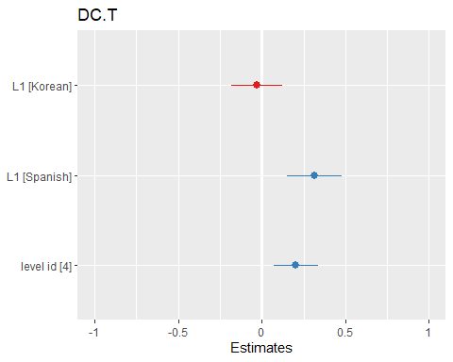

T-units per Sentence

## Linear mixed model fit by maximum likelihood ['lmerMod']  
## Formula: T.S ~ L1 + as.factor(level_id) + (1 | anon_id) + (1 | question_id)  
## Data: df  
##   
## AIC BIC logLik deviance df.resid   
## 40 61 -13 26 142   
##   
## Scaled residuals:   
## Min 1Q Median 3Q Max   
## -4.4756 -0.4813 -0.1737 0.2483 5.6324   
##   
## Random effects:  
## Groups Name Variance Std.Dev.  
## question_id (Intercept) 0.001492 0.03862   
## anon_id (Intercept) 0.002613 0.05111   
## Residual 0.065938 0.25678   
## Number of obs: 149, groups: question_id, 102; anon_id, 22  
##   
## Fixed effects:  
## Estimate Std. Error t value  
## (Intercept) 1.15435 0.04536 25.449  
## L1Korean 0.03082 0.05849 0.527  
## L1Spanish 0.08069 0.06284 1.284  
## as.factor(level_id)4 -0.03438 0.04466 -0.770  
##   
## Correlation of Fixed Effects:  
## (Intr) L1Korn L1Spns  
## L1Korean -0.587   
## L1Spanish -0.576 0.490   
## as.fctr(_)4 -0.385 -0.181 -0.089

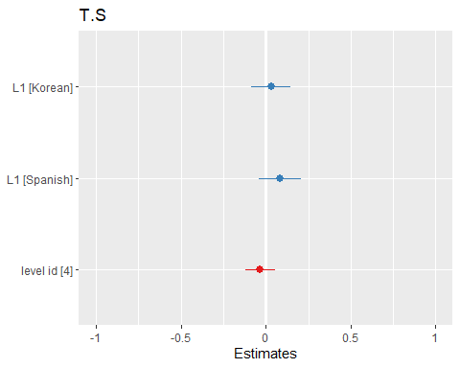

Complex T-unit Ratio

## Linear mixed model fit by maximum likelihood ['lmerMod']  
## Formula: CT.T ~ L1 + as.factor(level_id) + (1 | anon_id) + (1 | question_id)  
## Data: df  
##   
## AIC BIC logLik deviance df.resid   
## -19.9 1.1 17.0 -33.9 142   
##   
## Scaled residuals:   
## Min 1Q Median 3Q Max   
## -2.0205 -0.5826 -0.1466 0.5199 3.3617   
##   
## Random effects:  
## Groups Name Variance Std.Dev.  
## question_id (Intercept) 0.004206 0.06485   
## anon_id (Intercept) 0.000000 0.00000   
## Residual 0.042588 0.20637   
## Number of obs: 149, groups: question_id, 102; anon_id, 22  
##   
## Fixed effects:  
## Estimate Std. Error t value  
## (Intercept) 0.28658 0.03479 8.238  
## L1Korean -0.01597 0.04228 -0.378  
## L1Spanish 0.15098 0.04567 3.306  
## as.factor(level_id)4 0.11149 0.03752 2.971  
##   
## Correlation of Fixed Effects:  
## (Intr) L1Korn L1Spns  
## L1Korean -0.569   
## L1Spanish -0.555 0.522   
## as.fctr(_)4 -0.426 -0.200 -0.111  
## optimizer (nloptwrap) convergence code: 0 (OK)  
## boundary (singular) fit: see help('isSingular')

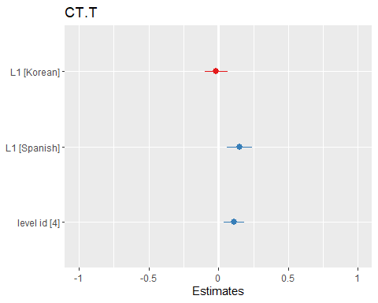

Coordinate Phrases per T-unit

## Linear mixed model fit by maximum likelihood ['lmerMod']  
## Formula: CP.T ~ L1 + as.factor(level_id) + (1 | anon_id) + (1 | question_id)  
## Data: df  
##   
## AIC BIC logLik deviance df.resid   
## -23.0 -1.9 18.5 -37.0 142   
##   
## Scaled residuals:   
## Min 1Q Median 3Q Max   
## -1.4996 -0.5840 -0.1223 0.5103 3.3856   
##   
## Random effects:  
## Groups Name Variance Std.Dev.  
## question_id (Intercept) 0.013549 0.11640   
## anon_id (Intercept) 0.002281 0.04776   
## Residual 0.031772 0.17825   
## Number of obs: 149, groups: question_id, 102; anon_id, 22  
##   
## Fixed effects:  
## Estimate Std. Error t value  
## (Intercept) 0.231458 0.039697 5.831  
## L1Korean 0.007314 0.047231 0.155  
## L1Spanish 0.067445 0.050743 1.329  
## as.factor(level_id)4 0.002870 0.039943 0.072  
##   
## Correlation of Fixed Effects:  
## (Intr) L1Korn L1Spns  
## L1Korean -0.541   
## L1Spanish -0.525 0.496   
## as.fctr(_)4 -0.450 -0.160 -0.090

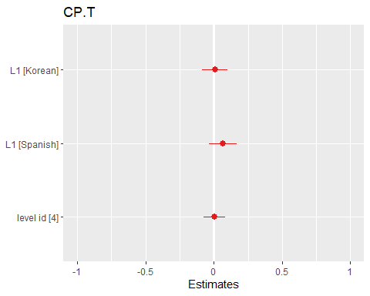

Coordinate Phrases per Clause

## Linear mixed model fit by maximum likelihood ['lmerMod']  
## Formula: CP.C ~ L1 + as.factor(level_id) + (1 | anon_id) + (1 | question_id)  
## Data: df  
##   
## AIC BIC logLik deviance df.resid   
## -102.2 -81.2 58.1 -116.2 142   
##   
## Scaled residuals:   
## Min 1Q Median 3Q Max   
## -1.4034 -0.6111 -0.2411 0.4110 3.4607   
##   
## Random effects:  
## Groups Name Variance Std.Dev.  
## question_id (Intercept) 0.003273 0.05721   
## anon_id (Intercept) 0.001888 0.04345   
## Residual 0.022223 0.14907   
## Number of obs: 149, groups: question_id, 102; anon_id, 22  
##   
## Fixed effects:  
## Estimate Std. Error t value  
## (Intercept) 0.179257 0.030513 5.875  
## L1Korean 0.016020 0.038847 0.412  
## L1Spanish 0.009158 0.041765 0.219  
## as.factor(level_id)4 -0.026211 0.028821 -0.909  
##   
## Correlation of Fixed Effects:  
## (Intr) L1Korn L1Spns  
## L1Korean -0.574   
## L1Spanish -0.560 0.480   
## as.fctr(_)4 -0.397 -0.162 -0.081

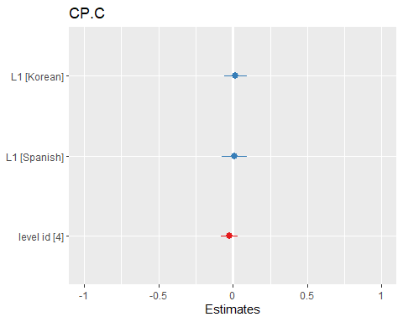

Complex Nominals per T-unit

## Linear mixed model fit by maximum likelihood ['lmerMod']  
## Formula: CN.T ~ L1 + as.factor(level_id) + (1 | anon_id) + (1 | question_id)  
## Data: df  
##   
## AIC BIC logLik deviance df.resid   
## 249.3 270.3 -117.7 235.3 142   
##   
## Scaled residuals:   
## Min 1Q Median 3Q Max   
## -2.0773 -0.6990 -0.1462 0.5212 4.1206   
##   
## Random effects:  
## Groups Name Variance Std.Dev.  
## question_id (Intercept) 0.020745 0.14403   
## anon_id (Intercept) 0.009493 0.09743   
## Residual 0.255503 0.50547   
## Number of obs: 149, groups: question_id, 102; anon_id, 22  
##   
## Fixed effects:  
## Estimate Std. Error t value  
## (Intercept) 0.88981 0.09197 9.675  
## L1Korean 0.05728 0.11613 0.493  
## L1Spanish 0.26652 0.12477 2.136  
## as.factor(level_id)4 0.14381 0.09212 1.561  
##   
## Correlation of Fixed Effects:  
## (Intr) L1Korn L1Spns  
## L1Korean -0.576   
## L1Spanish -0.565 0.496   
## as.fctr(_)4 -0.402 -0.181 -0.093

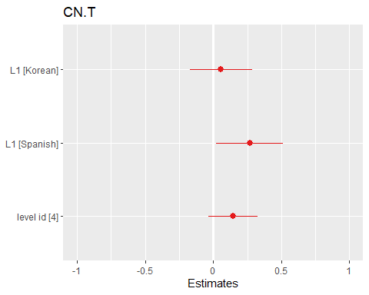

Complex Nominals per Clause

## Linear mixed model fit by maximum likelihood ['lmerMod']  
## Formula: CN.C ~ L1 + as.factor(level_id) + (1 | anon_id) + (1 | question_id)  
## Data: df  
##   
## AIC BIC logLik deviance df.resid   
## 164.9 186.0 -75.5 150.9 142   
##   
## Scaled residuals:   
## Min 1Q Median 3Q Max   
## -1.7104 -0.5735 -0.1696 0.3599 4.5159   
##   
## Random effects:  
## Groups Name Variance Std.Dev.  
## question_id (Intercept) 0.019653 0.14019   
## anon_id (Intercept) 0.009838 0.09919   
## Residual 0.134519 0.36677   
## Number of obs: 149, groups: question_id, 102; anon_id, 22  
##   
## Fixed effects:  
## Estimate Std. Error t value  
## (Intercept) 0.71080 0.07364 9.653  
## L1Korean 0.03373 0.09324 0.362  
## L1Spanish 0.01504 0.10019 0.150  
## as.factor(level_id)4 -0.01557 0.07067 -0.220  
##   
## Correlation of Fixed Effects:  
## (Intr) L1Korn L1Spns  
## L1Korean -0.572   
## L1Spanish -0.559 0.484   
## as.fctr(_)4 -0.401 -0.166 -0.084

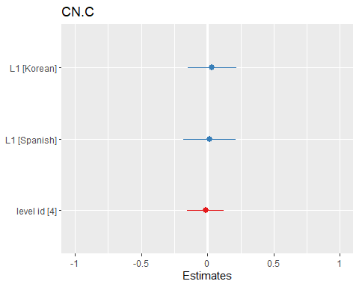

## Findings in levels progressing from level 4 to 5.

Words

## Linear mixed model fit by maximum likelihood ['lmerMod']  
## Formula: W ~ L1 + as.factor(level_id) + (1 | anon_id) + (1 | question_id)  
## Data: df  
##   
## AIC BIC logLik deviance df.resid   
## 9083.7 9115.5 -4534.9 9069.7 688   
##   
## Scaled residuals:   
## Min 1Q Median 3Q Max   
## -1.4171 -0.5612 -0.2526 0.2603 6.0426   
##   
## Random effects:  
## Groups Name Variance Std.Dev.  
## question_id (Intercept) 2856 53.45   
## anon_id (Intercept) 1402 37.44   
## Residual 23617 153.68   
## Number of obs: 695, groups: question_id, 253; anon_id, 61  
##   
## Fixed effects:  
## Estimate Std. Error t value  
## (Intercept) 215.66069 14.41309 14.963  
## L1Korean -0.02968 17.48214 -0.002  
## L1Spanish -29.99904 22.38984 -1.340  
## as.factor(level_id)5 16.35379 14.58653 1.121  
##   
## Correlation of Fixed Effects:  
## (Intr) L1Korn L1Spns  
## L1Korean -0.631   
## L1Spanish -0.473 0.381   
## as.fctr(_)5 -0.477 0.087 0.019

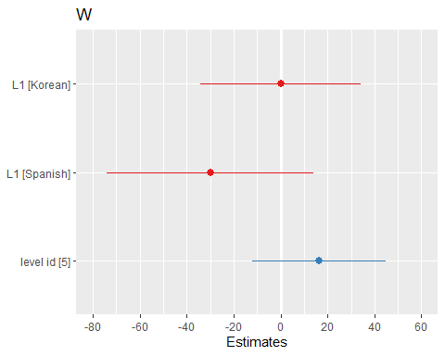

Sentences

## Linear mixed model fit by maximum likelihood ['lmerMod']  
## Formula: S ~ L1 + as.factor(level_id) + (1 | anon_id) + (1 | question_id)  
## Data: df  
##   
## AIC BIC logLik deviance df.resid   
## 5223.4 5255.2 -2604.7 5209.4 688   
##   
## Scaled residuals:   
## Min 1Q Median 3Q Max   
## -1.6349 -0.5740 -0.2619 0.2958 5.8189   
##   
## Random effects:  
## Groups Name Variance Std.Dev.  
## question_id (Intercept) 9.743 3.121   
## anon_id (Intercept) 4.549 2.133   
## Residual 93.006 9.644   
## Number of obs: 695, groups: question_id, 253; anon_id, 61  
##   
## Fixed effects:  
## Estimate Std. Error t value  
## (Intercept) 14.8190 0.8714 17.006  
## L1Korean -0.2402 1.0544 -0.228  
## L1Spanish -4.7864 1.3530 -3.538  
## as.factor(level_id)5 0.2280 0.8949 0.255  
##   
## Correlation of Fixed Effects:  
## (Intr) L1Korn L1Spns  
## L1Korean -0.631   
## L1Spanish -0.471 0.380   
## as.fctr(_)5 -0.485 0.089 0.020

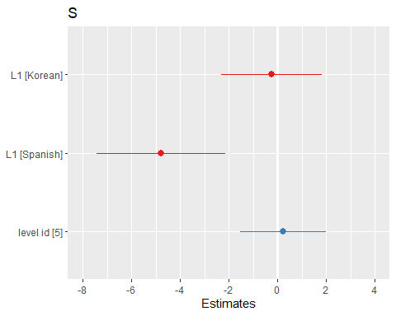

Verb Phrases

## Linear mixed model fit by maximum likelihood ['lmerMod']  
## Formula: VP ~ L1 + as.factor(level_id) + (1 | anon_id) + (1 | question_id)  
## Data: df  
##   
## AIC BIC logLik deviance df.resid   
## 6380.9 6412.7 -3183.4 6366.9 688   
##   
## Scaled residuals:   
## Min 1Q Median 3Q Max   
## -1.5216 -0.5830 -0.2444 0.2859 5.6769   
##   
## Random effects:  
## Groups Name Variance Std.Dev.  
## question_id (Intercept) 62.29 7.892   
## anon_id (Intercept) 28.08 5.299   
## Residual 480.74 21.926   
## Number of obs: 695, groups: question_id, 253; anon_id, 61  
##   
## Fixed effects:  
## Estimate Std. Error t value  
## (Intercept) 33.6863 2.0598 16.354  
## L1Korean -0.3426 2.4880 -0.138  
## L1Spanish -5.0274 3.1882 -1.577  
## as.factor(level_id)5 0.9784 2.0995 0.466  
##   
## Correlation of Fixed Effects:  
## (Intr) L1Korn L1Spns  
## L1Korean -0.629   
## L1Spanish -0.471 0.381   
## as.fctr(_)5 -0.479 0.086 0.018

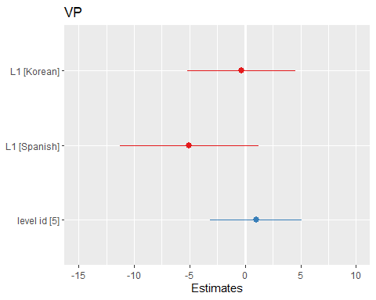

Clauses

## Linear mixed model fit by maximum likelihood ['lmerMod']  
## Formula: C ~ L1 + as.factor(level_id) + (1 | anon_id) + (1 | question_id)  
## Data: df  
##   
## AIC BIC logLik deviance df.resid   
## 5983.8 6015.6 -2984.9 5969.8 688   
##   
## Scaled residuals:   
## Min 1Q Median 3Q Max   
## -1.6439 -0.5793 -0.2616 0.3269 5.7980   
##   
## Random effects:  
## Groups Name Variance Std.Dev.  
## question_id (Intercept) 31.17 5.583   
## anon_id (Intercept) 18.32 4.280   
## Residual 273.21 16.529   
## Number of obs: 695, groups: question_id, 253; anon_id, 61  
##   
## Fixed effects:  
## Estimate Std. Error t value  
## (Intercept) 25.6388 1.5763 16.266  
## L1Korean -0.3455 1.9286 -0.179  
## L1Spanish -3.3306 2.4650 -1.351  
## as.factor(level_id)5 1.0671 1.5620 0.683  
##   
## Correlation of Fixed Effects:  
## (Intr) L1Korn L1Spns  
## L1Korean -0.636   
## L1Spanish -0.478 0.383   
## as.fctr(_)5 -0.468 0.086 0.019

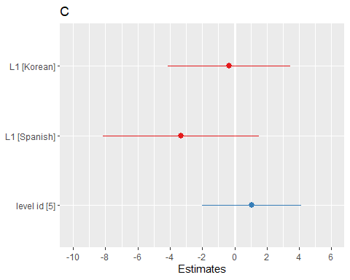

T-units

## Linear mixed model fit by maximum likelihood ['lmerMod']  
## Formula: T ~ L1 + as.factor(level_id) + (1 | anon_id) + (1 | question_id)  
## Data: df  
##   
## AIC BIC logLik deviance df.resid   
## 5420.8 5452.6 -2703.4 5406.8 688   
##   
## Scaled residuals:   
## Min 1Q Median 3Q Max   
## -1.7029 -0.5711 -0.2645 0.3222 5.7917   
##   
## Random effects:  
## Groups Name Variance Std.Dev.  
## question_id (Intercept) 13.37 3.657   
## anon_id (Intercept) 7.03 2.651   
## Residual 122.58 11.072   
## Number of obs: 695, groups: question_id, 253; anon_id, 61  
##   
## Fixed effects:  
## Estimate Std. Error t value  
## (Intercept) 16.7317 1.0267 16.296  
## L1Korean -0.3205 1.2492 -0.257  
## L1Spanish -3.7866 1.5998 -2.367  
## as.factor(level_id)5 0.0767 1.0364 0.074  
##   
## Correlation of Fixed Effects:  
## (Intr) L1Korn L1Spns  
## L1Korean -0.633   
## L1Spanish -0.474 0.382   
## as.fctr(_)5 -0.477 0.087 0.020

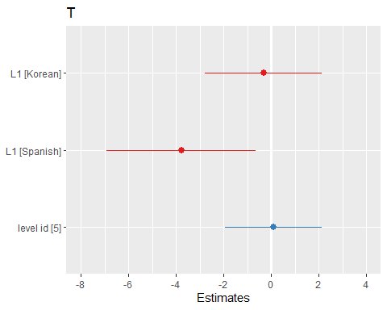

Dependent Clauses

## Linear mixed model fit by maximum likelihood ['lmerMod']  
## Formula: DC ~ L1 + as.factor(level_id) + (1 | anon_id) + (1 | question_id)  
## Data: df  
##   
## AIC BIC logLik deviance df.resid   
## 4655.3 4687.1 -2320.7 4641.3 688   
##   
## Scaled residuals:   
## Min 1Q Median 3Q Max   
## -1.5077 -0.6338 -0.2270 0.4254 5.3710   
##   
## Random effects:  
## Groups Name Variance Std.Dev.  
## question_id (Intercept) 4.500 2.121   
## anon_id (Intercept) 3.356 1.832   
## Residual 40.132 6.335   
## Number of obs: 695, groups: question_id, 253; anon_id, 61  
##   
## Fixed effects:  
## Estimate Std. Error t value  
## (Intercept) 8.57609 0.62830 13.650  
## L1Korean 0.03222 0.77808 0.041  
## L1Spanish 0.13960 0.99119 0.141  
## as.factor(level_id)5 0.75845 0.60081 1.262  
##   
## Correlation of Fixed Effects:  
## (Intr) L1Korn L1Spns  
## L1Korean -0.642   
## L1Spanish -0.485 0.385   
## as.fctr(_)5 -0.453 0.084 0.019

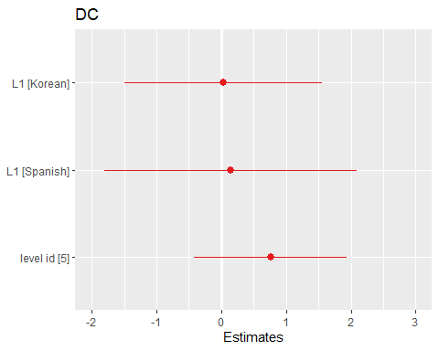

Complex T-units

## Linear mixed model fit by maximum likelihood ['lmerMod']  
## Formula: CT ~ L1 + as.factor(level_id) + (1 | anon_id) + (1 | question_id)  
## Data: df  
##   
## AIC BIC logLik deviance df.resid   
## 4240.1 4271.9 -2113.1 4226.1 688   
##   
## Scaled residuals:   
## Min 1Q Median 3Q Max   
## -1.7833 -0.6228 -0.2138 0.3674 4.7215   
##   
## Random effects:  
## Groups Name Variance Std.Dev.  
## question_id (Intercept) 2.555 1.598   
## anon_id (Intercept) 2.254 1.501   
## Residual 21.817 4.671   
## Number of obs: 695, groups: question_id, 253; anon_id, 61  
##   
## Fixed effects:  
## Estimate Std. Error t value  
## (Intercept) 6.79795 0.48464 14.027  
## L1Korean -0.01004 0.60595 -0.017  
## L1Spanish -0.30941 0.76957 -0.402  
## as.factor(level_id)5 0.40598 0.44791 0.906  
##   
## Correlation of Fixed Effects:  
## (Intr) L1Korn L1Spns  
## L1Korean -0.646   
## L1Spanish -0.491 0.386   
## as.fctr(_)5 -0.438 0.081 0.018

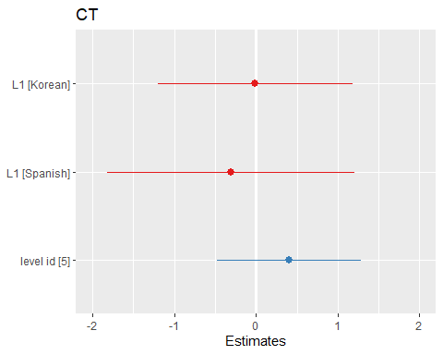

Coordinate Phrases

## Linear mixed model fit by maximum likelihood ['lmerMod']  
## Formula: CP ~ L1 + as.factor(level_id) + (1 | anon_id) + (1 | question_id)  
## Data: df  
##   
## AIC BIC logLik deviance df.resid   
## 4428.7 4460.5 -2207.4 4414.7 688   
##   
## Scaled residuals:   
## Min 1Q Median 3Q Max   
## -1.3410 -0.5401 -0.2725 0.2596 9.0631   
##   
## Random effects:  
## Groups Name Variance Std.Dev.  
## question_id (Intercept) 1.947 1.395   
## anon_id (Intercept) 1.904 1.380   
## Residual 30.339 5.508   
## Number of obs: 695, groups: question_id, 253; anon_id, 61  
##   
## Fixed effects:  
## Estimate Std. Error t value  
## (Intercept) 5.05325 0.50646 9.978  
## L1Korean 0.09766 0.63028 0.155  
## L1Spanish -1.05410 0.80471 -1.310  
## as.factor(level_id)5 0.38387 0.48976 0.784  
##   
## Correlation of Fixed Effects:  
## (Intr) L1Korn L1Spns  
## L1Korean -0.647   
## L1Spanish -0.487 0.384   
## as.fctr(_)5 -0.462 0.088 0.023

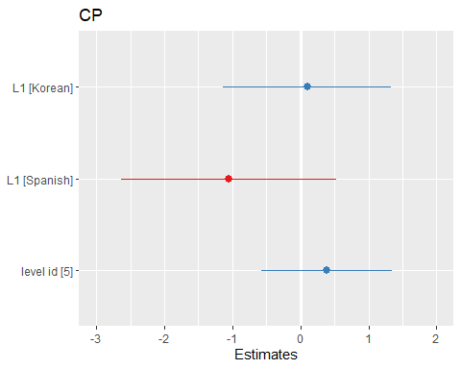

Complex Nominals

## Linear mixed model fit by maximum likelihood ['lmerMod']  
## Formula: CN ~ L1 + as.factor(level_id) + (1 | anon_id) + (1 | question_id)  
## Data: df  
##   
## AIC BIC logLik deviance df.resid   
## 6067.6 6099.4 -3026.8 6053.6 688   
##   
## Scaled residuals:   
## Min 1Q Median 3Q Max   
## -1.4936 -0.5812 -0.2592 0.2674 6.1300   
##   
## Random effects:  
## Groups Name Variance Std.Dev.  
## question_id (Intercept) 35.61 5.967   
## anon_id (Intercept) 15.68 3.959   
## Residual 310.89 17.632   
## Number of obs: 695, groups: question_id, 253; anon_id, 61  
##   
## Fixed effects:  
## Estimate Std. Error t value  
## (Intercept) 21.3327 1.6083 13.264  
## L1Korean 0.1726 1.9408 0.089  
## L1Spanish -1.3422 2.4904 -0.539  
## as.factor(level_id)5 3.1297 1.6553 1.891  
##   
## Correlation of Fixed Effects:  
## (Intr) L1Korn L1Spns  
## L1Korean -0.629   
## L1Spanish -0.470 0.380   
## as.fctr(_)5 -0.485 0.088 0.019

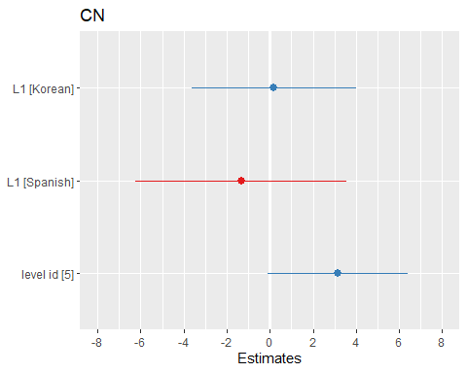

Mean Length of Sentence

## Linear mixed model fit by maximum likelihood ['lmerMod']  
## Formula: MLS ~ L1 + as.factor(level_id) + (1 | anon_id) + (1 | question_id)  
## Data: df  
##   
## AIC BIC logLik deviance df.resid   
## 3916.2 3948.0 -1951.1 3902.2 688   
##   
## Scaled residuals:   
## Min 1Q Median 3Q Max   
## -4.1733 -0.5631 -0.0575 0.4898 4.3681   
##   
## Random effects:  
## Groups Name Variance Std.Dev.  
## question_id (Intercept) 0.000 0.000   
## anon_id (Intercept) 2.591 1.610   
## Residual 14.654 3.828   
## Number of obs: 695, groups: question_id, 253; anon_id, 61  
##   
## Fixed effects:  
## Estimate Std. Error t value  
## (Intercept) 14.7686 0.4337 34.050  
## L1Korean 0.3162 0.5775 0.547  
## L1Spanish 4.6933 0.7249 6.475  
## as.factor(level_id)5 1.0055 0.3188 3.154  
##   
## Correlation of Fixed Effects:  
## (Intr) L1Korn L1Spns  
## L1Korean -0.680   
## L1Spanish -0.529 0.393   
## as.fctr(_)5 -0.360 0.073 0.024  
## optimizer (nloptwrap) convergence code: 0 (OK)  
## boundary (singular) fit: see help('isSingular')

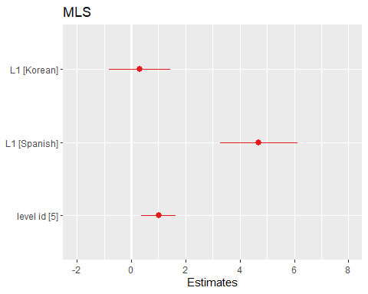

Mean Length of T-unit

## Linear mixed model fit by maximum likelihood ['lmerMod']  
## Formula: MLT ~ L1 + as.factor(level_id) + (1 | anon_id) + (1 | question_id)  
## Data: df  
##   
## AIC BIC logLik deviance df.resid   
## 3839.8 3871.6 -1912.9 3825.8 688   
##   
## Scaled residuals:   
## Min 1Q Median 3Q Max   
## -3.7780 -0.5687 -0.1395 0.4684 6.7089   
##   
## Random effects:  
## Groups Name Variance Std.Dev.  
## question_id (Intercept) 0.000 0.000   
## anon_id (Intercept) 1.352 1.163   
## Residual 13.504 3.675   
## Number of obs: 695, groups: question_id, 253; anon_id, 61  
##   
## Fixed effects:  
## Estimate Std. Error t value  
## (Intercept) 13.1683 0.3587 36.714  
## L1Korean 0.2785 0.4673 0.596  
## L1Spanish 2.0406 0.5911 3.452  
## as.factor(level_id)5 1.0867 0.3016 3.603  
##   
## Correlation of Fixed Effects:  
## (Intr) L1Korn L1Spns  
## L1Korean -0.672   
## L1Spanish -0.515 0.389   
## as.fctr(_)5 -0.410 0.083 0.027  
## optimizer (nloptwrap) convergence code: 0 (OK)  
## boundary (singular) fit: see help('isSingular')

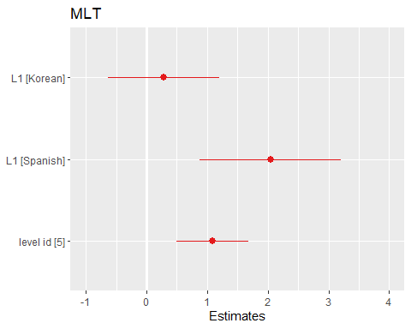

Mean Length of Clause

## Linear mixed model fit by maximum likelihood ['lmerMod']  
## Formula: MLC ~ L1 + as.factor(level_id) + (1 | anon_id) + (1 | question_id)  
## Data: df  
##   
## AIC BIC logLik deviance df.resid   
## 2999.3 3031.1 -1492.6 2985.3 688   
##   
## Scaled residuals:   
## Min 1Q Median 3Q Max   
## -4.5815 -0.5829 -0.1378 0.4702 6.4199   
##   
## Random effects:  
## Groups Name Variance Std.Dev.  
## question_id (Intercept) 0.02997 0.1731   
## anon_id (Intercept) 0.44730 0.6688   
## Residual 3.98022 1.9950   
## Number of obs: 695, groups: question_id, 253; anon_id, 61  
##   
## Fixed effects:  
## Estimate Std. Error t value  
## (Intercept) 8.42870 0.20090 41.955  
## L1Korean 0.12664 0.26214 0.483  
## L1Spanish 0.02662 0.33118 0.080  
## as.factor(level_id)5 0.23070 0.16625 1.388  
##   
## Correlation of Fixed Effects:  
## (Intr) L1Korn L1Spns  
## L1Korean -0.672   
## L1Spanish -0.517 0.390   
## as.fctr(_)5 -0.403 0.081 0.025

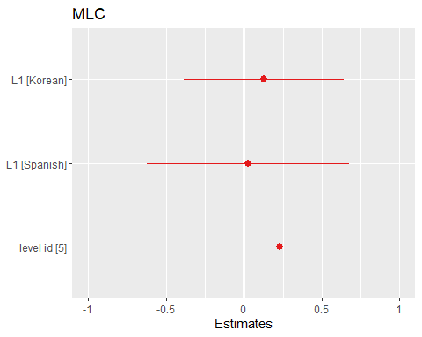

Clauses per Sentence

## Linear mixed model fit by maximum likelihood ['lmerMod']  
## Formula: C.S ~ L1 + as.factor(level_id) + (1 | anon_id) + (1 | question_id)  
## Data: df  
##   
## AIC BIC logLik deviance df.resid   
## 1068.3 1100.1 -527.1 1054.3 688   
##   
## Scaled residuals:   
## Min 1Q Median 3Q Max   
## -3.4268 -0.6545 -0.0932 0.5015 4.2491   
##   
## Random effects:  
## Groups Name Variance Std.Dev.  
## question_id (Intercept) 0.01952 0.1397   
## anon_id (Intercept) 0.03455 0.1859   
## Residual 0.22853 0.4780   
## Number of obs: 695, groups: question_id, 253; anon_id, 61  
##   
## Fixed effects:  
## Estimate Std. Error t value  
## (Intercept) 1.803449 0.053610 33.640  
## L1Korean 0.001811 0.069082 0.026  
## L1Spanish 0.548517 0.087132 6.295  
## as.factor(level_id)5 0.053806 0.044665 1.205  
##   
## Correlation of Fixed Effects:  
## (Intr) L1Korn L1Spns  
## L1Korean -0.661   
## L1Spanish -0.509 0.390   
## as.fctr(_)5 -0.399 0.076 0.019

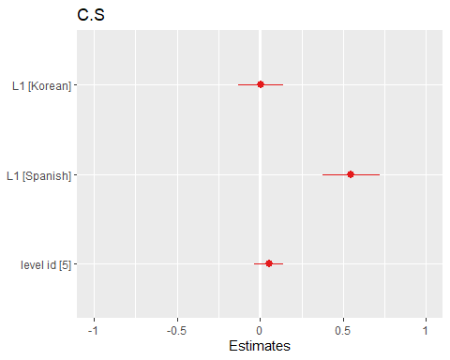

Verb Phrases per T-unit

## Linear mixed model fit by maximum likelihood ['lmerMod']  
## Formula: VP.T ~ L1 + as.factor(level_id) + (1 | anon_id) + (1 | question_id)  
## Data: df  
##   
## AIC BIC logLik deviance df.resid   
## 1327.4 1359.2 -656.7 1313.4 688   
##   
## Scaled residuals:   
## Min 1Q Median 3Q Max   
## -3.2596 -0.5986 -0.1105 0.4207 5.7334   
##   
## Random effects:  
## Groups Name Variance Std.Dev.  
## question_id (Intercept) 0.01091 0.1045   
## anon_id (Intercept) 0.04623 0.2150   
## Residual 0.34875 0.5905   
## Number of obs: 695, groups: question_id, 253; anon_id, 61  
##   
## Fixed effects:  
## Estimate Std. Error t value  
## (Intercept) 2.09876 0.06265 33.502  
## L1Korean 0.01835 0.08161 0.225  
## L1Spanish 0.25167 0.10295 2.445  
## as.factor(level_id)5 0.06978 0.05123 1.362  
##   
## Correlation of Fixed Effects:  
## (Intr) L1Korn L1Spns  
## L1Korean -0.669   
## L1Spanish -0.516 0.390   
## as.fctr(_)5 -0.396 0.078 0.023

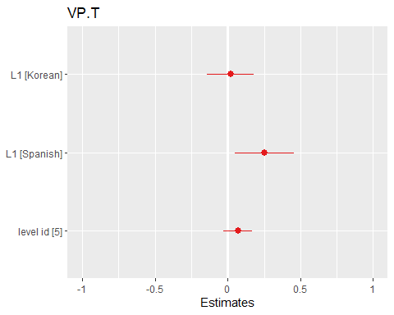

Clauses per T-Unit

## Linear mixed model fit by maximum likelihood ['lmerMod']  
## Formula: C.T ~ L1 + as.factor(level_id) + (1 | anon_id) + (1 | question_id)  
## Data: df  
##   
## AIC BIC logLik deviance df.resid   
## 891.1 922.9 -438.5 877.1 688   
##   
## Scaled residuals:   
## Min 1Q Median 3Q Max   
## -3.5430 -0.6108 -0.1623 0.4133 5.1519   
##   
## Random effects:  
## Groups Name Variance Std.Dev.  
## question_id (Intercept) 0.01302 0.1141   
## anon_id (Intercept) 0.02096 0.1448   
## Residual 0.18126 0.4258   
## Number of obs: 695, groups: question_id, 253; anon_id, 61  
##   
## Fixed effects:  
## Estimate Std. Error t value  
## (Intercept) 1.598193 0.044450 35.955  
## L1Korean 0.008381 0.056757 0.148  
## L1Spanish 0.243208 0.071842 3.385  
## as.factor(level_id)5 0.070740 0.038854 1.821  
##   
## Correlation of Fixed Effects:  
## (Intr) L1Korn L1Spns  
## L1Korean -0.658   
## L1Spanish -0.504 0.388   
## as.fctr(_)5 -0.419 0.080 0.021

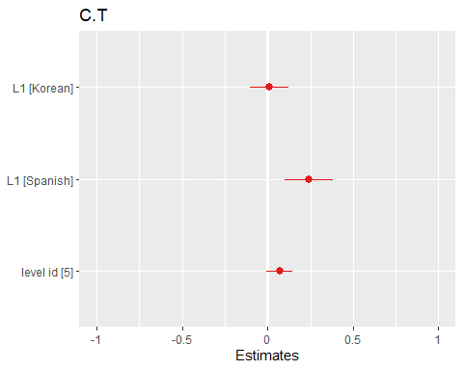

Dependent Clauses per Clause

## Linear mixed model fit by maximum likelihood ['lmerMod']  
## Formula: DC.C ~ L1 + as.factor(level_id) + (1 | anon_id) + (1 | question_id)  
## Data: df  
##   
## AIC BIC logLik deviance df.resid   
## -834.8 -803.0 424.4 -848.8 688   
##   
## Scaled residuals:   
## Min 1Q Median 3Q Max   
## -2.96420 -0.63961 -0.03523 0.61006 2.89285   
##   
## Random effects:  
## Groups Name Variance Std.Dev.  
## question_id (Intercept) 0.0008933 0.02989   
## anon_id (Intercept) 0.0022520 0.04746   
## Residual 0.0150938 0.12286   
## Number of obs: 695, groups: question_id, 253; anon_id, 61  
##   
## Fixed effects:  
## Estimate Std. Error t value  
## (Intercept) 0.330267 0.013594 24.295  
## L1Korean 0.003462 0.017645 0.196  
## L1Spanish 0.056551 0.022241 2.543  
## as.factor(level_id)5 0.020298 0.011107 1.828  
##   
## Correlation of Fixed Effects:  
## (Intr) L1Korn L1Spns  
## L1Korean -0.666   
## L1Spanish -0.514 0.391   
## as.fctr(_)5 -0.393 0.076 0.020

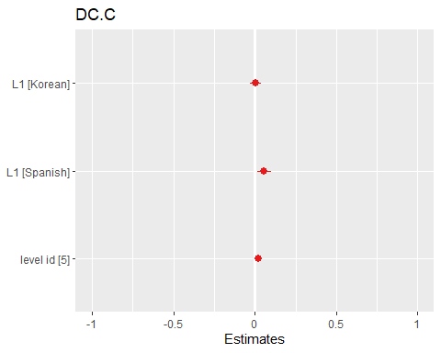

Dependent clauses per T-unit

## Linear mixed model fit by maximum likelihood ['lmerMod']  
## Formula: DC.T ~ L1 + as.factor(level_id) + (1 | anon_id) + (1 | question_id)  
## Data: df  
##   
## AIC BIC logLik deviance df.resid   
## 719.6 751.4 -352.8 705.6 688   
##   
## Scaled residuals:   
## Min 1Q Median 3Q Max   
## -2.0466 -0.6392 -0.1793 0.3833 5.3793   
##   
## Random effects:  
## Groups Name Variance Std.Dev.  
## question_id (Intercept) 0.01422 0.1193   
## anon_id (Intercept) 0.01719 0.1311   
## Residual 0.13789 0.3713   
## Number of obs: 695, groups: question_id, 253; anon_id, 61  
##   
## Fixed effects:  
## Estimate Std. Error t value  
## (Intercept) 0.57916 0.03997 14.491  
## L1Korean 0.01016 0.05071 0.200  
## L1Spanish 0.20657 0.06418 3.218  
## as.factor(level_id)5 0.05378 0.03524 1.526  
##   
## Correlation of Fixed Effects:  
## (Intr) L1Korn L1Spns  
## L1Korean -0.653   
## L1Spanish -0.500 0.388   
## as.fctr(_)5 -0.420 0.078 0.019

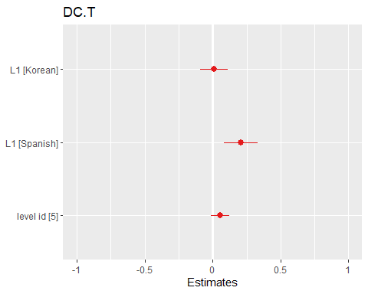

T-units per Sentence

## Linear mixed model fit by maximum likelihood ['lmerMod']  
## Formula: T.S ~ L1 + as.factor(level_id) + (1 | anon_id) + (1 | question_id)  
## Data: df  
##   
## AIC BIC logLik deviance df.resid   
## -313.3 -281.5 163.7 -327.3 688   
##   
## Scaled residuals:   
## Min 1Q Median 3Q Max   
## -5.9243 -0.4969 -0.1127 0.3877 4.9230   
##   
## Random effects:  
## Groups Name Variance Std.Dev.  
## question_id (Intercept) 0.001001 0.03165   
## anon_id (Intercept) 0.003476 0.05896   
## Residual 0.033309 0.18251   
## Number of obs: 695, groups: question_id, 253; anon_id, 61  
##   
## Fixed effects:  
## Estimate Std. Error t value  
## (Intercept) 1.127461 0.018259 61.749  
## L1Korean -0.007227 0.023552 -0.307  
## L1Spanish 0.170574 0.029811 5.722  
## as.factor(level_id)5 -0.009482 0.015706 -0.604  
##   
## Correlation of Fixed Effects:  
## (Intr) L1Korn L1Spns  
## L1Korean -0.665   
## L1Spanish -0.509 0.389   
## as.fctr(_)5 -0.416 0.082 0.024

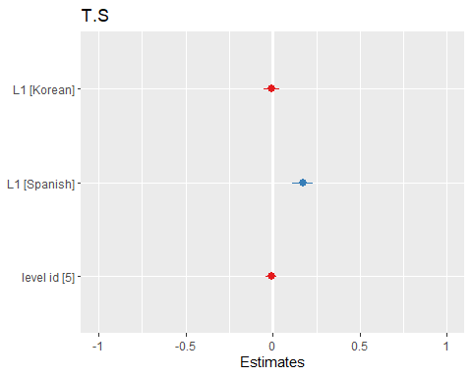

Complex T-unit Ratio

## Linear mixed model fit by maximum likelihood ['lmerMod']  
## Formula: CT.T ~ L1 + as.factor(level_id) + (1 | anon_id) + (1 | question_id)  
## Data: df  
##   
## AIC BIC logLik deviance df.resid   
## -94.3 -62.5 54.2 -108.3 688   
##   
## Scaled residuals:   
## Min 1Q Median 3Q Max   
## -2.5140 -0.7019 -0.1376 0.6006 2.5731   
##   
## Random effects:  
## Groups Name Variance Std.Dev.  
## question_id (Intercept) 0.002336 0.04833   
## anon_id (Intercept) 0.006257 0.07910   
## Residual 0.044140 0.21010   
## Number of obs: 695, groups: question_id, 253; anon_id, 61  
##   
## Fixed effects:  
## Estimate Std. Error t value  
## (Intercept) 0.442496 0.022881 19.339  
## L1Korean 0.007174 0.029687 0.242  
## L1Spanish 0.102544 0.037440 2.739  
## as.factor(level_id)5 0.028550 0.018813 1.518  
##   
## Correlation of Fixed Effects:  
## (Intr) L1Korn L1Spns  
## L1Korean -0.666   
## L1Spanish -0.513 0.390   
## as.fctr(_)5 -0.396 0.077 0.021

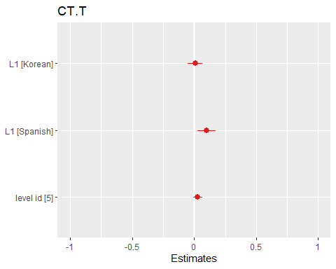

Coordinate Phrases per T-unit

## Linear mixed model fit by maximum likelihood ['lmerMod']  
## Formula: CP.T ~ L1 + as.factor(level_id) + (1 | anon_id) + (1 | question_id)  
## Data: df  
##   
## AIC BIC logLik deviance df.resid   
## -48.0 -16.2 31.0 -62.0 688   
##   
## Scaled residuals:   
## Min 1Q Median 3Q Max   
## -2.0456 -0.6540 -0.1708 0.5033 5.2414   
##   
## Random effects:  
## Groups Name Variance Std.Dev.  
## question_id (Intercept) 0.0007035 0.02652   
## anon_id (Intercept) 0.0055695 0.07463   
## Residual 0.0493089 0.22206   
## Number of obs: 695, groups: question_id, 253; anon_id, 61  
##   
## Fixed effects:  
## Estimate Std. Error t value  
## (Intercept) 0.29321 0.02246 13.054  
## L1Korean 0.01588 0.02924 0.543  
## L1Spanish 0.02456 0.03695 0.665  
## as.factor(level_id)5 0.02842 0.01870 1.520  
##   
## Correlation of Fixed Effects:  
## (Intr) L1Korn L1Spns  
## L1Korean -0.671   
## L1Spanish -0.515 0.390   
## as.fctr(_)5 -0.405 0.081 0.025

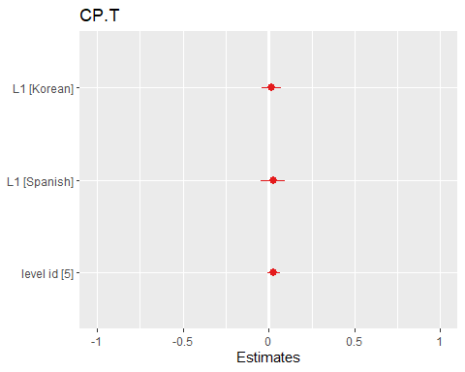

Coordinate Phrases per Clause

## Linear mixed model fit by maximum likelihood ['lmerMod']  
## Formula: CP.C ~ L1 + as.factor(level_id) + (1 | anon_id) + (1 | question_id)  
## Data: df  
##   
## AIC BIC logLik deviance df.resid   
## -683.4 -651.6 348.7 -697.4 688   
##   
## Scaled residuals:   
## Min 1Q Median 3Q Max   
## -1.9617 -0.6806 -0.1916 0.4921 3.8331   
##   
## Random effects:  
## Groups Name Variance Std.Dev.  
## question_id (Intercept) 0.0008105 0.02847   
## anon_id (Intercept) 0.0027003 0.05196   
## Residual 0.0190762 0.13812   
## Number of obs: 695, groups: question_id, 253; anon_id, 61  
##   
## Fixed effects:  
## Estimate Std. Error t value  
## (Intercept) 0.191060 0.014973 12.760  
## L1Korean 0.009873 0.019490 0.507  
## L1Spanish -0.006906 0.024572 -0.281  
## as.factor(level_id)5 0.009143 0.012194 0.750  
##   
## Correlation of Fixed Effects:  
## (Intr) L1Korn L1Spns  
## L1Korean -0.668   
## L1Spanish -0.515 0.391   
## as.fctr(_)5 -0.394 0.077 0.022

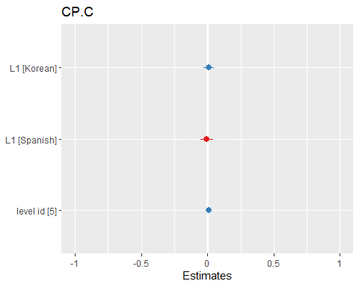

Complex Nominals per T-unit

## Linear mixed model fit by maximum likelihood ['lmerMod']  
## Formula: CN.T ~ L1 + as.factor(level_id) + (1 | anon_id) + (1 | question_id)  
## Data: df  
##   
## AIC BIC logLik deviance df.resid   
## 1533.3 1565.1 -759.7 1519.3 688   
##   
## Scaled residuals:   
## Min 1Q Median 3Q Max   
## -2.4601 -0.5858 -0.0949 0.5066 6.9958   
##   
## Random effects:  
## Groups Name Variance Std.Dev.  
## question_id (Intercept) 0.02635 0.1623   
## anon_id (Intercept) 0.02521 0.1588   
## Residual 0.47665 0.6904   
## Number of obs: 695, groups: question_id, 253; anon_id, 61  
##   
## Fixed effects:  
## Estimate Std. Error t value  
## (Intercept) 1.31260 0.06142 21.369  
## L1Korean 0.03543 0.07619 0.465  
## L1Spanish 0.34235 0.09746 3.513  
## as.factor(level_id)5 0.23245 0.06041 3.848  
##   
## Correlation of Fixed Effects:  
## (Intr) L1Korn L1Spns  
## L1Korean -0.647   
## L1Spanish -0.485 0.383   
## as.fctr(_)5 -0.470 0.090 0.024

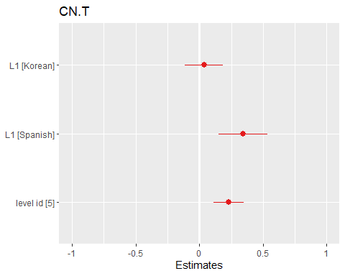

Complex Nominals per Clause

## Linear mixed model fit by maximum likelihood ['lmerMod']  
## Formula: CN.C ~ L1 + as.factor(level_id) + (1 | anon_id) + (1 | question_id)  
## Data: df  
##   
## AIC BIC logLik deviance df.resid   
## 757.6 789.4 -371.8 743.6 688   
##   
## Scaled residuals:   
## Min 1Q Median 3Q Max   
## -2.6513 -0.6132 -0.1515 0.5053 6.6620   
##   
## Random effects:  
## Groups Name Variance Std.Dev.  
## question_id (Intercept) 0.007629 0.08734   
## anon_id (Intercept) 0.014056 0.11856   
## Residual 0.153833 0.39222   
## Number of obs: 695, groups: question_id, 253; anon_id, 61  
##   
## Fixed effects:  
## Estimate Std. Error t value  
## (Intercept) 0.83588 0.03847 21.731  
## L1Korean 0.02003 0.04896 0.409  
## L1Spanish 0.07448 0.06214 1.199  
## as.factor(level_id)5 0.09274 0.03456 2.684  
##   
## Correlation of Fixed Effects:  
## (Intr) L1Korn L1Spns  
## L1Korean -0.658   
## L1Spanish -0.501 0.387   
## as.fctr(_)5 -0.432 0.084 0.023

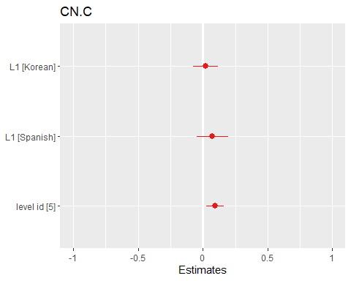

## Findings in levels progressing from level 3 to 5.

Words

## Linear mixed model fit by maximum likelihood ['lmerMod']  
## Formula: W ~ L1 + as.factor(level_id) + (1 | anon_id) + (1 | question_id)  
## Data: df  
##   
## AIC BIC logLik deviance df.resid   
## 1028.7 1048.1 -506.4 1012.7 75   
##   
## Scaled residuals:   
## Min 1Q Median 3Q Max   
## -1.1727 -0.6167 -0.3008 0.1218 3.4020   
##   
## Random effects:  
## Groups Name Variance Std.Dev.  
## question_id (Intercept) 0.0 0.0   
## anon_id (Intercept) 723.5 26.9   
## Residual 11095.8 105.3   
## Number of obs: 83, groups: question_id, 71; anon_id, 8  
##   
## Fixed effects:  
## Estimate Std. Error t value  
## (Intercept) 163.37 28.94 5.646  
## L1Korean -21.01 37.88 -0.555  
## L1Spanish -55.08 38.14 -1.444  
## as.factor(level_id)4 40.61 28.27 1.437  
## as.factor(level_id)5 29.32 31.59 0.928  
##   
## Correlation of Fixed Effects:  
## (Intr) L1Korn L1Spns a.(_)4  
## L1Korean -0.493   
## L1Spanish -0.558 0.423   
## as.fctr(_)4 -0.425 -0.192 -0.048   
## as.fctr(_)5 -0.583 0.111 0.189 0.444  
## optimizer (nloptwrap) convergence code: 0 (OK)  
## boundary (singular) fit: see help('isSingular')

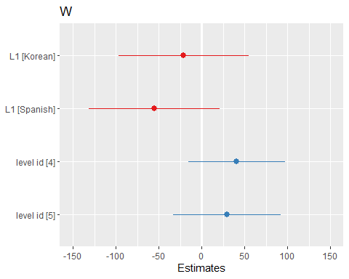

Sentences

## Linear mixed model fit by maximum likelihood ['lmerMod']  
## Formula: S ~ L1 + as.factor(level_id) + (1 | anon_id) + (1 | question_id)  
## Data: df  
##   
## AIC BIC logLik deviance df.resid   
## 568.2 587.6 -276.1 552.2 75   
##   
## Scaled residuals:   
## Min 1Q Median 3Q Max   
## -1.4798 -0.6593 -0.1824 0.4081 3.4024   
##   
## Random effects:  
## Groups Name Variance Std.Dev.  
## question_id (Intercept) 0.000 0.000   
## anon_id (Intercept) 1.834 1.354   
## Residual 43.874 6.624   
## Number of obs: 83, groups: question_id, 71; anon_id, 8  
##   
## Fixed effects:  
## Estimate Std. Error t value  
## (Intercept) 12.798 1.745 7.335  
## L1Korean -1.948 2.212 -0.881  
## L1Spanish -6.176 2.229 -2.770  
## as.factor(level_id)4 2.565 1.777 1.444  
## as.factor(level_id)5 1.271 1.976 0.643  
##   
## Correlation of Fixed Effects:  
## (Intr) L1Korn L1Spns a.(_)4  
## L1Korean -0.485   
## L1Spanish -0.557 0.436   
## as.fctr(_)4 -0.443 -0.206 -0.051   
## as.fctr(_)5 -0.611 0.123 0.206 0.445  
## optimizer (nloptwrap) convergence code: 0 (OK)  
## boundary (singular) fit: see help('isSingular')

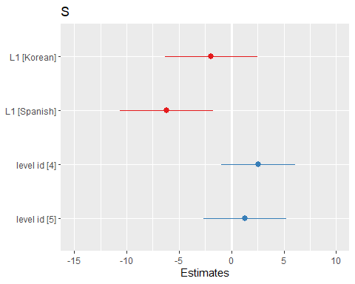

Verb Phrases

## Linear mixed model fit by maximum likelihood ['lmerMod']  
## Formula: VP ~ L1 + as.factor(level_id) + (1 | anon_id) + (1 | question_id)  
## Data: df  
##   
## AIC BIC logLik deviance df.resid   
## 715.2 734.6 -349.6 699.2 75   
##   
## Scaled residuals:   
## Min 1Q Median 3Q Max   
## -1.2720 -0.5844 -0.2444 0.1755 3.6172   
##   
## Random effects:  
## Groups Name Variance Std.Dev.  
## question_id (Intercept) 0.00 0.000   
## anon_id (Intercept) 13.42 3.663   
## Residual 255.94 15.998   
## Number of obs: 83, groups: question_id, 71; anon_id, 8  
##   
## Fixed effects:  
## Estimate Std. Error t value  
## (Intercept) 25.231 4.297 5.871  
## L1Korean -5.067 5.533 -0.916  
## L1Spanish -7.555 5.574 -1.355  
## as.factor(level_id)4 7.032 4.292 1.638  
## as.factor(level_id)5 5.471 4.785 1.143  
##   
## Correlation of Fixed Effects:  
## (Intr) L1Korn L1Spns a.(_)4  
## L1Korean -0.489   
## L1Spanish -0.557 0.430   
## as.fctr(_)4 -0.435 -0.199 -0.049   
## as.fctr(_)5 -0.597 0.117 0.198 0.444  
## optimizer (nloptwrap) convergence code: 0 (OK)  
## boundary (singular) fit: see help('isSingular')

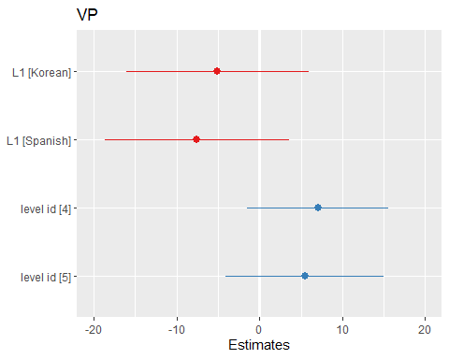

Clauses

## Linear mixed model fit by maximum likelihood ['lmerMod']  
## Formula: C ~ L1 + as.factor(level_id) + (1 | anon_id) + (1 | question_id)  
## Data: df  
##   
## AIC BIC logLik deviance df.resid   
## 665.5 684.9 -324.8 649.5 75   
##   
## Scaled residuals:   
## Min 1Q Median 3Q Max   
## -1.3394 -0.6340 -0.2860 0.2384 3.3888   
##   
## Random effects:  
## Groups Name Variance Std.Dev.  
## question_id (Intercept) 0.000 0.000   
## anon_id (Intercept) 2.772 1.665   
## Residual 144.062 12.003   
## Number of obs: 83, groups: question_id, 71; anon_id, 8  
##   
## Fixed effects:  
## Estimate Std. Error t value  
## (Intercept) 19.773 3.024 6.539  
## L1Korean -3.962 3.685 -1.075  
## L1Spanish -7.862 3.719 -2.114  
## as.factor(level_id)4 6.383 3.219 1.983  
## as.factor(level_id)5 5.137 3.555 1.445  
##   
## Correlation of Fixed Effects:  
## (Intr) L1Korn L1Spns a.(_)4  
## L1Korean -0.476   
## L1Spanish -0.558 0.453   
## as.fctr(_)4 -0.463 -0.223 -0.055   
## as.fctr(_)5 -0.642 0.138 0.229 0.445  
## optimizer (nloptwrap) convergence code: 0 (OK)  
## boundary (singular) fit: see help('isSingular')

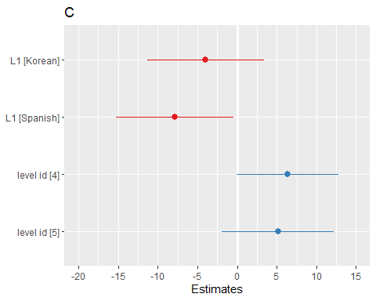

T-units

## Linear mixed model fit by maximum likelihood ['lmerMod']  
## Formula: T ~ L1 + as.factor(level_id) + (1 | anon_id) + (1 | question_id)  
## Data: df  
##   
## AIC BIC logLik deviance df.resid   
## 598.8 618.2 -291.4 582.8 75   
##   
## Scaled residuals:   
## Min 1Q Median 3Q Max   
## -1.6833 -0.6281 -0.2513 0.2894 3.1878   
##   
## Random effects:  
## Groups Name Variance Std.Dev.  
## question_id (Intercept) 0.0000 0.0000   
## anon_id (Intercept) 0.9474 0.9734   
## Residual 64.7577 8.0472   
## Number of obs: 83, groups: question_id, 71; anon_id, 8  
##   
## Fixed effects:  
## Estimate Std. Error t value  
## (Intercept) 14.955 2.008 7.448  
## L1Korean -1.952 2.424 -0.805  
## L1Spanish -7.074 2.447 -2.891  
## as.factor(level_id)4 2.675 2.158 1.240  
## as.factor(level_id)5 2.202 2.380 0.925  
##   
## Correlation of Fixed Effects:  
## (Intr) L1Korn L1Spns a.(_)4  
## L1Korean -0.473   
## L1Spanish -0.558 0.457   
## as.fctr(_)4 -0.468 -0.228 -0.056   
## as.fctr(_)5 -0.649 0.142 0.234 0.445  
## optimizer (nloptwrap) convergence code: 0 (OK)  
## boundary (singular) fit: see help('isSingular')

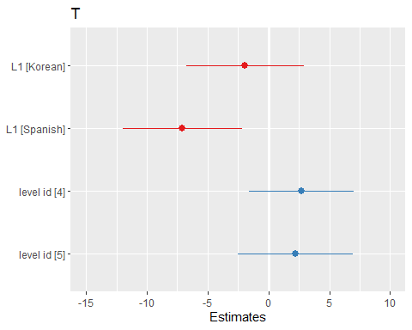

Dependent Clauses

## Linear mixed model fit by maximum likelihood ['lmerMod']  
## Formula: DC ~ L1 + as.factor(level_id) + (1 | anon_id) + (1 | question_id)  
## Data: df  
##   
## AIC BIC logLik deviance df.resid   
## 508.4 527.7 -246.2 492.4 75   
##   
## Scaled residuals:   
## Min 1Q Median 3Q Max   
## -1.2768 -0.6455 -0.0981 0.2900 3.9053   
##   
## Random effects:  
## Groups Name Variance Std.Dev.  
## question_id (Intercept) 0.0000 0.0000   
## anon_id (Intercept) 0.3935 0.6273   
## Residual 21.7119 4.6596   
## Number of obs: 83, groups: question_id, 71; anon_id, 8  
##   
## Fixed effects:  
## Estimate Std. Error t value  
## (Intercept) 4.8282 1.1712 4.122  
## L1Korean -2.0356 1.4242 -1.429  
## L1Spanish -0.7321 1.4373 -0.509  
## as.factor(level_id)4 3.5527 1.2495 2.843  
## as.factor(level_id)5 2.3908 1.3797 1.733  
##   
## Correlation of Fixed Effects:  
## (Intr) L1Korn L1Spns a.(_)4  
## L1Korean -0.475   
## L1Spanish -0.558 0.454   
## as.fctr(_)4 -0.465 -0.224 -0.055   
## as.fctr(_)5 -0.644 0.139 0.230 0.445  
## optimizer (nloptwrap) convergence code: 0 (OK)  
## boundary (singular) fit: see help('isSingular')

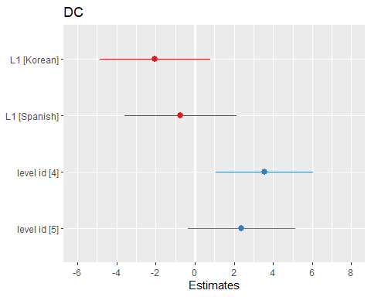

Complex T-units

## Linear mixed model fit by maximum likelihood ['lmerMod']  
## Formula: CT ~ L1 + as.factor(level_id) + (1 | anon_id) + (1 | question_id)  
## Data: df  
##   
## AIC BIC logLik deviance df.resid   
## 476.3 495.7 -230.2 460.3 75   
##   
## Scaled residuals:   
## Min 1Q Median 3Q Max   
## -1.2493 -0.5851 -0.3023 0.4084 3.7686   
##   
## Random effects:  
## Groups Name Variance Std.Dev.  
## question_id (Intercept) 0.0000 0.0000   
## anon_id (Intercept) 0.5303 0.7282   
## Residual 14.5467 3.8140   
## Number of obs: 83, groups: question_id, 71; anon_id, 8  
##   
## Fixed effects:  
## Estimate Std. Error t value  
## (Intercept) 4.3666 0.9945 4.391  
## L1Korean -1.5232 1.2502 -1.218  
## L1Spanish -1.0207 1.2604 -0.810  
## as.factor(level_id)4 2.1853 1.0231 2.136  
## as.factor(level_id)5 1.6118 1.1362 1.419  
##   
## Correlation of Fixed Effects:  
## (Intr) L1Korn L1Spns a.(_)4  
## L1Korean -0.483   
## L1Spanish -0.558 0.440   
## as.fctr(_)4 -0.448 -0.210 -0.052   
## as.fctr(_)5 -0.618 0.126 0.211 0.445  
## optimizer (nloptwrap) convergence code: 0 (OK)  
## boundary (singular) fit: see help('isSingular')

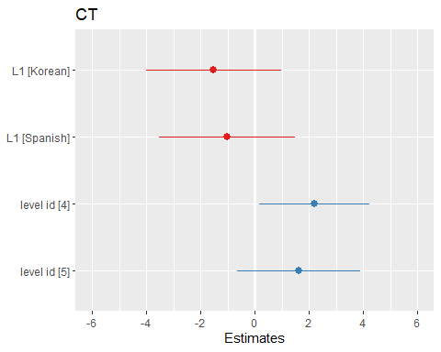

Coordinate Phrases

## Linear mixed model fit by maximum likelihood ['lmerMod']  
## Formula: CP ~ L1 + as.factor(level_id) + (1 | anon_id) + (1 | question_id)  
## Data: df  
##   
## AIC BIC logLik deviance df.resid   
## 520.5 539.9 -252.3 504.5 75   
##   
## Scaled residuals:   
## Min 1Q Median 3Q Max   
## -0.9847 -0.5914 -0.3149 0.3801 6.1607   
##   
## Random effects:  
## Groups Name Variance Std.Dev.   
## question_id (Intercept) 8.219e-09 9.066e-05  
## anon_id (Intercept) 2.195e+00 1.481e+00  
## Residual 2.399e+01 4.898e+00  
## Number of obs: 83, groups: question_id, 71; anon_id, 8  
##   
## Fixed effects:  
## Estimate Std. Error t value  
## (Intercept) 3.4614 1.4045 2.465  
## L1Korean -0.2244 1.8926 -0.119  
## L1Spanish -0.4020 1.9039 -0.211  
## as.factor(level_id)4 2.1236 1.3147 1.615  
## as.factor(level_id)5 1.1589 1.4757 0.785  
##   
## Correlation of Fixed Effects:  
## (Intr) L1Korn L1Spns a.(_)4  
## L1Korean -0.500   
## L1Spanish -0.558 0.412   
## as.fctr(_)4 -0.407 -0.179 -0.045   
## as.fctr(_)5 -0.556 0.101 0.173 0.444  
## optimizer (nloptwrap) convergence code: 0 (OK)  
## boundary (singular) fit: see help('isSingular')

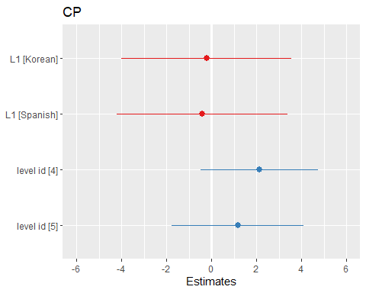

Complex Nominals

## Linear mixed model fit by maximum likelihood ['lmerMod']  
## Formula: CN ~ L1 + as.factor(level_id) + (1 | anon_id) + (1 | question_id)  
## Data: df  
##   
## AIC BIC logLik deviance df.resid   
## 668.4 687.7 -326.2 652.4 75   
##   
## Scaled residuals:   
## Min 1Q Median 3Q Max   
## -1.3088 -0.6474 -0.2396 0.4117 4.0445   
##   
## Random effects:  
## Groups Name Variance Std.Dev.  
## question_id (Intercept) 0.000 0.000   
## anon_id (Intercept) 9.809 3.132   
## Residual 144.203 12.008   
## Number of obs: 83, groups: question_id, 71; anon_id, 8  
##   
## Fixed effects:  
## Estimate Std. Error t value  
## (Intercept) 15.1817 3.3145 4.580  
## L1Korean -0.6382 4.3545 -0.147  
## L1Spanish -4.9835 4.3839 -1.137  
## as.factor(level_id)4 4.5546 3.2225 1.413  
## as.factor(level_id)5 4.2864 3.6036 1.189  
##   
## Correlation of Fixed Effects:  
## (Intr) L1Korn L1Spns a.(_)4  
## L1Korean -0.494   
## L1Spanish -0.558 0.422   
## as.fctr(_)4 -0.423 -0.190 -0.047   
## as.fctr(_)5 -0.580 0.109 0.187 0.444  
## optimizer (nloptwrap) convergence code: 0 (OK)  
## boundary (singular) fit: see help('isSingular')

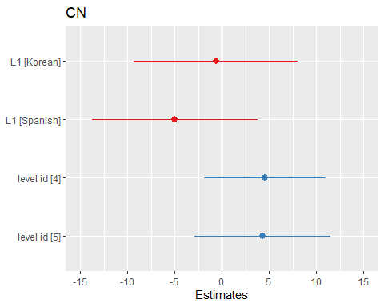

Mean Length of Sentence

## Linear mixed model fit by maximum likelihood ['lmerMod']  
## Formula: MLS ~ L1 + as.factor(level_id) + (1 | anon_id) + (1 | question_id)  
## Data: df  
##   
## AIC BIC logLik deviance df.resid   
## 478.2 497.6 -231.1 462.2 75   
##   
## Scaled residuals:   
## Min 1Q Median 3Q Max   
## -2.41241 -0.45331 0.03852 0.35774 2.79545   
##   
## Random effects:  
## Groups Name Variance Std.Dev.  
## question_id (Intercept) 8.814 2.969   
## anon_id (Intercept) 0.000 0.000   
## Residual 7.461 2.731   
## Number of obs: 83, groups: question_id, 71; anon_id, 8  
##   
## Fixed effects:  
## Estimate Std. Error t value  
## (Intercept) 11.8666 1.0275 11.549  
## L1Korean -0.5252 1.0432 -0.503  
## L1Spanish 2.5070 1.0889 2.302  
## as.factor(level_id)4 2.3039 1.1872 1.941  
## as.factor(level_id)5 2.5769 1.2776 2.017  
##   
## Correlation of Fixed Effects:  
## (Intr) L1Korn L1Spns a.(_)4  
## L1Korean -0.365   
## L1Spanish -0.490 0.546   
## as.fctr(_)4 -0.568 -0.268 -0.099   
## as.fctr(_)5 -0.714 0.119 0.235 0.499  
## optimizer (nloptwrap) convergence code: 0 (OK)  
## boundary (singular) fit: see help('isSingular')

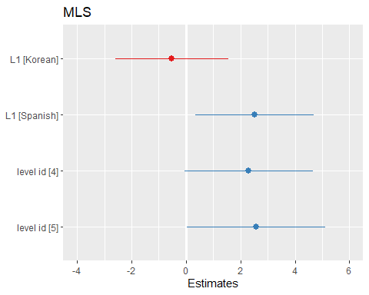

Mean Length of T-unit

## Linear mixed model fit by maximum likelihood ['lmerMod']  
## Formula: MLT ~ L1 + as.factor(level_id) + (1 | anon_id) + (1 | question_id)  
## Data: df  
##   
## AIC BIC logLik deviance df.resid   
## 440.0 459.3 -212.0 424.0 75   
##   
## Scaled residuals:   
## Min 1Q Median 3Q Max   
## -2.08554 -0.43127 -0.00424 0.36656 1.90181   
##   
## Random effects:  
## Groups Name Variance Std.Dev.  
## question_id (Intercept) 7.109 2.666   
## anon_id (Intercept) 0.000 0.000   
## Residual 3.543 1.882   
## Number of obs: 83, groups: question_id, 71; anon_id, 8  
##   
## Fixed effects:  
## Estimate Std. Error t value  
## (Intercept) 10.0990 0.8291 12.181  
## L1Korean -0.7024 0.7910 -0.888  
## L1Spanish 1.7028 0.8415 2.024  
## as.factor(level_id)4 2.3999 0.9664 2.483  
## as.factor(level_id)5 1.9832 1.0407 1.906  
##   
## Correlation of Fixed Effects:  
## (Intr) L1Korn L1Spns a.(_)4  
## L1Korean -0.348   
## L1Spanish -0.467 0.573   
## as.fctr(_)4 -0.590 -0.256 -0.104   
## as.fctr(_)5 -0.718 0.116 0.224 0.508  
## optimizer (nloptwrap) convergence code: 0 (OK)  
## boundary (singular) fit: see help('isSingular')

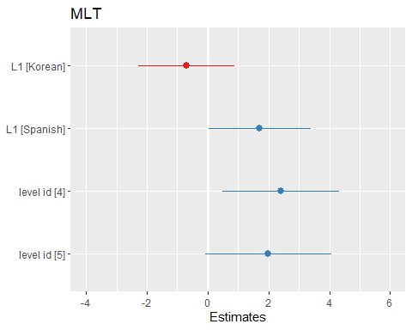

Mean Length of Clause

## Linear mixed model fit by maximum likelihood ['lmerMod']  
## Formula: MLC ~ L1 + as.factor(level_id) + (1 | anon_id) + (1 | question_id)  
## Data: df  
##   
## AIC BIC logLik deviance df.resid   
## 425.9 445.2 -204.9 409.9 75   
##   
## Scaled residuals:   
## Min 1Q Median 3Q Max   
## -2.6065 -0.5320 -0.1323 0.2220 4.2451   
##   
## Random effects:  
## Groups Name Variance Std.Dev.  
## question_id (Intercept) 1.308 1.144   
## anon_id (Intercept) 1.259 1.122   
## Residual 6.160 2.482   
## Number of obs: 83, groups: question_id, 71; anon_id, 8  
##   
## Fixed effects:  
## Estimate Std. Error t value  
## (Intercept) 8.2766 0.8887 9.314  
## L1Korean 0.3769 1.2426 0.303  
## L1Spanish -0.1309 1.2485 -0.105  
## as.factor(level_id)4 -0.2200 0.7716 -0.285  
## as.factor(level_id)5 -0.3324 0.8657 -0.384  
##   
## Correlation of Fixed Effects:  
## (Intr) L1Korn L1Spns a.(_)4  
## L1Korean -0.488   
## L1Spanish -0.545 0.400   
## as.fctr(_)4 -0.398 -0.168 -0.051   
## as.fctr(_)5 -0.520 0.061 0.137 0.475

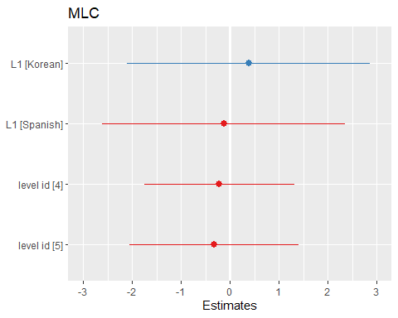

Clauses per Sentence

## Linear mixed model fit by maximum likelihood ['lmerMod']  
## Formula: C.S ~ L1 + as.factor(level_id) + (1 | anon_id) + (1 | question_id)  
## Data: df  
##   
## AIC BIC logLik deviance df.resid   
## 157.1 176.4 -70.5 141.1 75   
##   
## Scaled residuals:   
## Min 1Q Median 3Q Max   
## -3.1811 -0.6398 -0.0657 0.5973 4.3358   
##   
## Random effects:  
## Groups Name Variance Std.Dev.  
## question_id (Intercept) 0.00000 0.00000   
## anon_id (Intercept) 0.00892 0.09445   
## Residual 0.31263 0.55914   
## Number of obs: 83, groups: question_id, 71; anon_id, 8  
##   
## Fixed effects:  
## Estimate Std. Error t value  
## (Intercept) 1.5506 0.1436 10.801  
## L1Korean -0.1075 0.1780 -0.604  
## L1Spanish 0.2915 0.1796 1.623  
## as.factor(level_id)4 0.3369 0.1500 2.247  
## as.factor(level_id)5 0.2141 0.1662 1.288  
##   
## Correlation of Fixed Effects:  
## (Intr) L1Korn L1Spns a.(_)4  
## L1Korean -0.480   
## L1Spanish -0.558 0.445   
## as.fctr(_)4 -0.455 -0.216 -0.053   
## as.fctr(_)5 -0.628 0.131 0.219 0.445  
## optimizer (nloptwrap) convergence code: 0 (OK)  
## boundary (singular) fit: see help('isSingular')

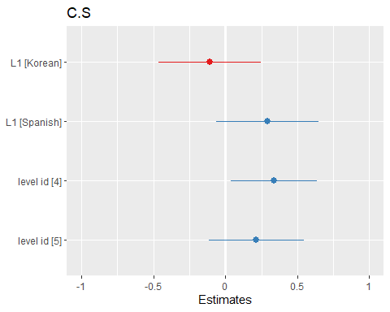

Verb Phrases per T-unit

## Linear mixed model fit by maximum likelihood ['lmerMod']  
## Formula: VP.T ~ L1 + as.factor(level_id) + (1 | anon_id) + (1 | question_id)  
## Data: df  
##   
## AIC BIC logLik deviance df.resid   
## 174.4 193.8 -79.2 158.4 75   
##   
## Scaled residuals:   
## Min 1Q Median 3Q Max   
## -2.9347 -0.5486 -0.1678 0.4291 2.1254   
##   
## Random effects:  
## Groups Name Variance Std.Dev.  
## question_id (Intercept) 0.1113 0.3337   
## anon_id (Intercept) 0.0000 0.0000   
## Residual 0.2895 0.5380   
## Number of obs: 83, groups: question_id, 71; anon_id, 8  
##   
## Fixed effects:  
## Estimate Std. Error t value  
## (Intercept) 1.74998 0.15936 10.981  
## L1Korean -0.16192 0.17484 -0.926  
## L1Spanish 0.43627 0.17831 2.447  
## as.factor(level_id)4 0.27850 0.18115 1.537  
## as.factor(level_id)5 0.02292 0.19564 0.117  
##   
## Correlation of Fixed Effects:  
## (Intr) L1Korn L1Spns a.(_)4  
## L1Korean -0.401   
## L1Spanish -0.523 0.506   
## as.fctr(_)4 -0.532 -0.270 -0.083   
## as.fctr(_)5 -0.702 0.129 0.248 0.481  
## optimizer (nloptwrap) convergence code: 0 (OK)  
## boundary (singular) fit: see help('isSingular')

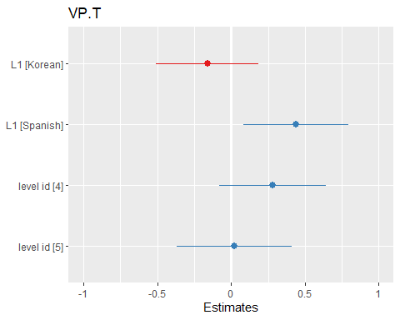

Clauses per T-Unit

## Linear mixed model fit by maximum likelihood ['lmerMod']  
## Formula: C.T ~ L1 + as.factor(level_id) + (1 | anon_id) + (1 | question_id)  
## Data: df  
##   
## AIC BIC logLik deviance df.resid   
## 125.3 144.6 -54.6 109.3 75   
##   
## Scaled residuals:   
## Min 1Q Median 3Q Max   
## -2.30500 -0.52187 -0.09925 0.34889 2.36803   
##   
## Random effects:  
## Groups Name Variance Std.Dev.  
## question_id (Intercept) 0.1061 0.3257   
## anon_id (Intercept) 0.0000 0.0000   
## Residual 0.1217 0.3488   
## Number of obs: 83, groups: question_id, 71; anon_id, 8  
##   
## Fixed effects:  
## Estimate Std. Error t value  
## (Intercept) 1.31480 0.12140 10.831  
## L1Korean -0.08662 0.12664 -0.684  
## L1Spanish 0.19014 0.13106 1.451  
## as.factor(level_id)4 0.33537 0.13962 2.402  
## as.factor(level_id)5 0.13911 0.15030 0.926  
##   
## Correlation of Fixed Effects:  
## (Intr) L1Korn L1Spns a.(_)4  
## L1Korean -0.374   
## L1Spanish -0.500 0.533   
## as.fctr(_)4 -0.557 -0.272 -0.095   
## as.fctr(_)5 -0.711 0.121 0.240 0.494  
## optimizer (nloptwrap) convergence code: 0 (OK)  
## boundary (singular) fit: see help('isSingular')

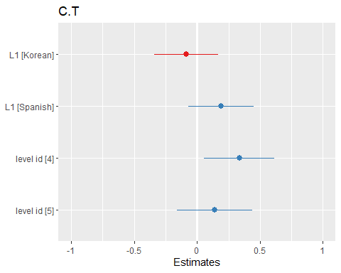

Dependent Clauses per Clause

## Linear mixed model fit by maximum likelihood ['lmerMod']  
## Formula: DC.C ~ L1 + as.factor(level_id) + (1 | anon_id) + (1 | question_id)  
## Data: df  
##   
## AIC BIC logLik deviance df.resid   
## -76.4 -57.0 46.2 -92.4 75   
##   
## Scaled residuals:   
## Min 1Q Median 3Q Max   
## -1.86107 -0.46270 -0.01165 0.36451 1.45918   
##   
## Random effects:  
## Groups Name Variance Std.Dev.  
## question_id (Intercept) 0.0149621 0.12232   
## anon_id (Intercept) 0.0005922 0.02433   
## Residual 0.0059646 0.07723   
## Number of obs: 83, groups: question_id, 71; anon_id, 8  
##   
## Fixed effects:  
## Estimate Std. Error t value  
## (Intercept) 0.23628 0.03892 6.071  
## L1Korean -0.04853 0.04069 -1.193  
## L1Spanish 0.07814 0.04249 1.839  
## as.factor(level_id)4 0.10203 0.04323 2.360  
## as.factor(level_id)5 0.02918 0.04695 0.621  
##   
## Correlation of Fixed Effects:  
## (Intr) L1Korn L1Spns a.(_)4  
## L1Korean -0.362   
## L1Spanish -0.469 0.524   
## as.fctr(_)4 -0.567 -0.228 -0.097   
## as.fctr(_)5 -0.675 0.065 0.172 0.519

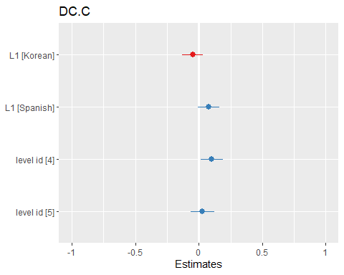

Dependent clauses per T-unit

## Linear mixed model fit by maximum likelihood ['lmerMod']  
## Formula: DC.T ~ L1 + as.factor(level_id) + (1 | anon_id) + (1 | question_id)  
## Data: df  
##   
## AIC BIC logLik deviance df.resid   
## 95.9 115.2 -39.9 79.9 75   
##   
## Scaled residuals:   
## Min 1Q Median 3Q Max   
## -1.4553 -0.3354 -0.1151 0.1346 1.6349   
##   
## Random effects:  
## Groups Name Variance Std.Dev.  
## question_id (Intercept) 0.14575 0.3818   
## anon_id (Intercept) 0.00000 0.0000   
## Residual 0.03501 0.1871   
## Number of obs: 83, groups: question_id, 71; anon_id, 8  
##   
## Fixed effects:  
## Estimate Std. Error t value  
## (Intercept) 0.31950 0.10654 2.999  
## L1Korean -0.05252 0.08970 -0.586  
## L1Spanish 0.23039 0.09849 2.339  
## as.factor(level_id)4 0.29166 0.12602 2.314  
## as.factor(level_id)5 0.10100 0.13607 0.742  
##   
## Correlation of Fixed Effects:  
## (Intr) L1Korn L1Spns a.(_)4  
## L1Korean -0.321   
## L1Spanish -0.424 0.614   
## as.fctr(_)4 -0.629 -0.227 -0.103   
## as.fctr(_)5 -0.722 0.111 0.201 0.522  
## optimizer (nloptwrap) convergence code: 0 (OK)  
## boundary (singular) fit: see help('isSingular')

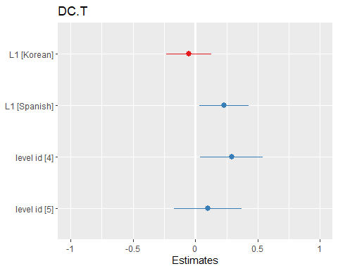

T-units per Sentence

## Linear mixed model fit by maximum likelihood ['lmerMod']  
## Formula: T.S ~ L1 + as.factor(level_id) + (1 | anon_id) + (1 | question_id)  
## Data: df  
##   
## AIC BIC logLik deviance df.resid   
## -6.7 12.6 11.4 -22.7 75   
##   
## Scaled residuals:   
## Min 1Q Median 3Q Max   
## -5.1018 -0.4833 -0.1121 0.4858 2.8519   
##   
## Random effects:  
## Groups Name Variance Std.Dev.  
## question_id (Intercept) 0.003354 0.05791   
## anon_id (Intercept) 0.002175 0.04664   
## Residual 0.039471 0.19867   
## Number of obs: 83, groups: question_id, 71; anon_id, 8  
##   
## Fixed effects:  
## Estimate Std. Error t value  
## (Intercept) 1.149440 0.056176 20.461  
## L1Korean 0.020267 0.071126 0.285  
## L1Spanish 0.003690 0.071686 0.051  
## as.factor(level_id)4 0.008896 0.056935 0.156  
## as.factor(level_id)5 0.056345 0.063136 0.892  
##   
## Correlation of Fixed Effects:  
## (Intr) L1Korn L1Spns a.(_)4  
## L1Korean -0.468   
## L1Spanish -0.547 0.437   
## as.fctr(_)4 -0.453 -0.211 -0.057   
## as.fctr(_)5 -0.611 0.106 0.196 0.460

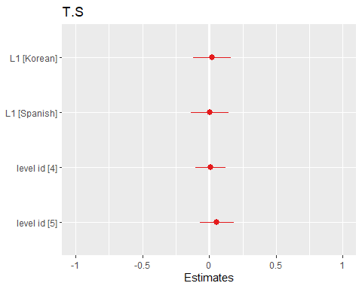

Complex T-unit Ratio

## Linear mixed model fit by maximum likelihood ['lmerMod']  
## Formula: CT.T ~ L1 + as.factor(level_id) + (1 | anon_id) + (1 | question_id)  
## Data: df  
##   
## AIC BIC logLik deviance df.resid   
## 0.9 20.2 7.6 -15.1 75   
##   
## Scaled residuals:   
## Min 1Q Median 3Q Max   
## -1.58725 -0.61881 0.04048 0.41790 2.20537   
##   
## Random effects:  
## Groups Name Variance Std.Dev.  
## question_id (Intercept) 0.02179 0.1476   
## anon_id (Intercept) 0.00000 0.0000   
## Residual 0.02877 0.1696   
## Number of obs: 83, groups: question_id, 71; anon_id, 8  
##   
## Fixed effects:  
## Estimate Std. Error t value  
## (Intercept) 0.29666 0.05713 5.193  
## L1Korean -0.06561 0.06024 -1.089  
## L1Spanish 0.13567 0.06214 2.183  
## as.factor(level_id)4 0.13170 0.06557 2.009  
## as.factor(level_id)5 0.04595 0.07061 0.651  
##   
## Correlation of Fixed Effects:  
## (Intr) L1Korn L1Spns a.(_)4  
## L1Korean -0.379   
## L1Spanish -0.505 0.528   
## as.fctr(_)4 -0.552 -0.272 -0.093   
## as.fctr(_)5 -0.710 0.122 0.241 0.492  
## optimizer (nloptwrap) convergence code: 0 (OK)  
## boundary (singular) fit: see help('isSingular')

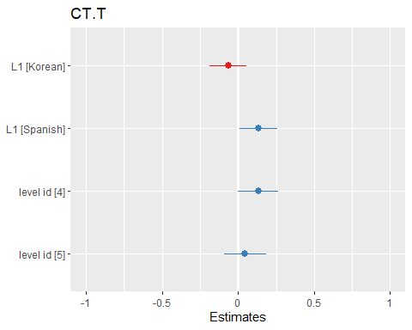

Coordinate Phrases per T-unit

## Linear mixed model fit by maximum likelihood ['lmerMod']  
## Formula: CP.T ~ L1 + as.factor(level_id) + (1 | anon_id) + (1 | question_id)  
## Data: df  
##   
## AIC BIC logLik deviance df.resid   
## 11.6 30.9 2.2 -4.4 75   
##   
## Scaled residuals:   
## Min 1Q Median 3Q Max   
## -1.3171 -0.5659 -0.1792 0.4822 2.7288   
##   
## Random effects:  
## Groups Name Variance Std.Dev.  
## question_id (Intercept) 0.019403 0.13929   
## anon_id (Intercept) 0.007181 0.08474   
## Residual 0.032892 0.18136   
## Number of obs: 83, groups: question_id, 71; anon_id, 8  
##   
## Fixed effects:  
## Estimate Std. Error t value  
## (Intercept) 0.20018 0.07241 2.765  
## L1Korean 0.03856 0.09698 0.398  
## L1Spanish 0.10998 0.09772 1.125  
## as.factor(level_id)4 0.08135 0.06683 1.217  
## as.factor(level_id)5 0.09109 0.07428 1.226  
##   
## Correlation of Fixed Effects:  
## (Intr) L1Korn L1Spns a.(_)4  
## L1Korean -0.457   
## L1Spanish -0.528 0.419   
## as.fctr(_)4 -0.439 -0.186 -0.066   
## as.fctr(_)5 -0.557 0.049 0.138 0.497

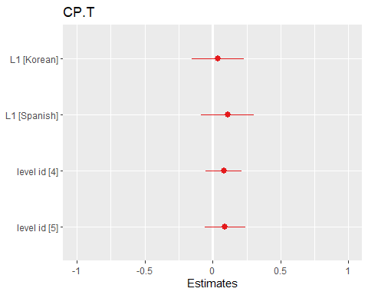

Coordinate Phrases per Clause

## Linear mixed model fit by maximum likelihood ['lmerMod']  
## Formula: CP.C ~ L1 + as.factor(level_id) + (1 | anon_id) + (1 | question_id)  
## Data: df  
##   
## AIC BIC logLik deviance df.resid   
## -25.4 -6.0 20.7 -41.4 75   
##   
## Scaled residuals:   
## Min 1Q Median 3Q Max   
## -1.1172 -0.6344 -0.1929 0.5511 2.4956   
##   
## Random effects:  
## Groups Name Variance Std.Dev.  
## question_id (Intercept) 0.010293 0.10145   
## anon_id (Intercept) 0.008195 0.09052   
## Residual 0.021725 0.14739   
## Number of obs: 83, groups: question_id, 71; anon_id, 8  
##   
## Fixed effects:  
## Estimate Std. Error t value  
## (Intercept) 0.17528 0.06449 2.718  
## L1Korean 0.04556 0.09309 0.489  
## L1Spanish 0.03032 0.09348 0.324  
## as.factor(level_id)4 0.02414 0.05200 0.464  
## as.factor(level_id)5 0.03250 0.05835 0.557  
##   
## Correlation of Fixed Effects:  
## (Intr) L1Korn L1Spns a.(_)4  
## L1Korean -0.491   
## L1Spanish -0.541 0.390   
## as.fctr(_)4 -0.380 -0.153 -0.053   
## as.fctr(_)5 -0.483 0.037 0.111 0.494

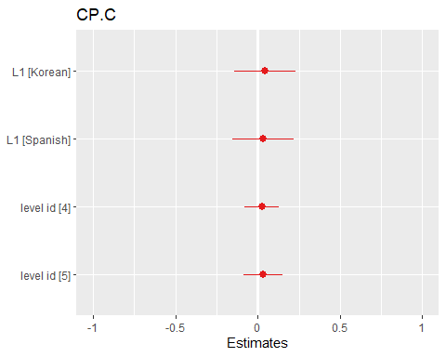

Complex Nominals per T-unit

## Linear mixed model fit by maximum likelihood ['lmerMod']  
## Formula: CN.T ~ L1 + as.factor(level_id) + (1 | anon_id) + (1 | question_id)  
## Data: df  
##   
## AIC BIC logLik deviance df.resid   
## 123.0 142.4 -53.5 107.0 75   
##   
## Scaled residuals:   
## Min 1Q Median 3Q Max   
## -1.9770 -0.5845 -0.1538 0.6783 2.2828   
##   
## Random effects:  
## Groups Name Variance Std.Dev.  
## question_id (Intercept) 0.04441 0.21074   
## anon_id (Intercept) 0.00448 0.06693   
## Residual 0.16592 0.40733   
## Number of obs: 83, groups: question_id, 71; anon_id, 8  
##   
## Fixed effects:  
## Estimate Std. Error t value  
## (Intercept) 0.84164 0.11986 7.022  
## L1Korean 0.03984 0.14069 0.283  
## L1Spanish 0.18839 0.14250 1.322  
## as.factor(level_id)4 0.30784 0.12998 2.368  
## as.factor(level_id)5 0.42216 0.14202 2.973  
##   
## Correlation of Fixed Effects:  
## (Intr) L1Korn L1Spns a.(_)4  
## L1Korean -0.427   
## L1Spanish -0.531 0.472   
## as.fctr(_)4 -0.501 -0.245 -0.073   
## as.fctr(_)5 -0.664 0.111 0.220 0.477

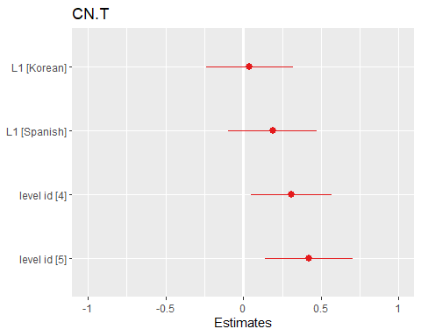

Complex Nominals per Clause

## Linear mixed model fit by maximum likelihood ['lmerMod']  
## Formula: CN.C ~ L1 + as.factor(level_id) + (1 | anon_id) + (1 | question_id)  
## Data: df  
##   
## AIC BIC logLik deviance df.resid   
## 114.7 134.1 -49.4 98.7 75   
##   
## Scaled residuals:   
## Min 1Q Median 3Q Max   
## -1.5154 -0.5063 -0.1463 0.4173 3.8121   
##   
## Random effects:  
## Groups Name Variance Std.Dev.  
## question_id (Intercept) 0.02065 0.1437   
## anon_id (Intercept) 0.03202 0.1789   
## Residual 0.15372 0.3921   
## Number of obs: 83, groups: question_id, 71; anon_id, 8  
##   
## Fixed effects:  
## Estimate Std. Error t value  
## (Intercept) 0.735252 0.137556 5.345  
## L1Korean 0.120423 0.195216 0.617  
## L1Spanish -0.005927 0.196052 -0.030  
## as.factor(level_id)4 0.027604 0.116320 0.237  
## as.factor(level_id)5 0.094757 0.130949 0.724  
##   
## Correlation of Fixed Effects:  
## (Intr) L1Korn L1Spns a.(_)4  
## L1Korean -0.499   
## L1Spanish -0.550 0.394   
## as.fctr(_)4 -0.382 -0.160 -0.046   
## as.fctr(_)5 -0.504 0.064 0.135 0.467

