**Important Milestones:**

* Intermediate delivery @**2023-12-15**
* Final delivery
  + Final Code & Report @ **2024-01-12**
  + Demo @ **2024-01-16 to 2024-01-19**

**Submitting your intermediate and final artifacts?**

To hand in your artifacts, you should do the following after the very last commit:

$ git checkout -b intermediate-delivery  
$ git tag intermediate-delivery  
$ git push origin --tags refs/heads/intermediate-delivery:refs/heads/intermediate-delivery

For the final submission, replace *intermediate-delivery* with *final-delivery* in the commands above.  
  
**Evaluation Criteria (Intermediate Delivery):**

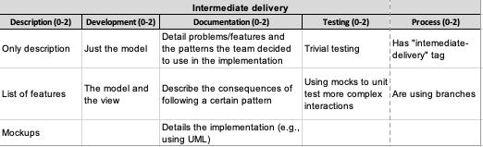

**Evaluation Criteria (Final Delivery):**

